DCU School of Computing
Assignment Submission
Student Name(s): | Shaun Kinsella
Student Number(s): | 14740175
Programme: | BSc in Computer Applications
Project Title: | Lexical & Syntax Analyser
Module code: | CA4003
Lecturer: | Dr David Sinclair
Project Due Date: | 17/12/18

Declaration
I declare that this material, which I now submit for assessment, is entirely my own work and has not been taken from the work of others, save and to the extent that such work has been cited and acknowledged within the text of my work. I understand that plagiarism, collusion, and copying is a grave and serious offence in the university and accept the penalties that would be imposed should I engage in plagiarism, collusion, or copying. I have read and understood the Assignment Regulations set out in the module documentation. I have identified and included the source of all facts, ideas, opinions, viewpoints of others in the assignment references. Direct quotations from books, journal articles, internet sources, module text, or any other source whatsoever are acknowledged and the source cited are identified in the assignment references.
I have not copied or paraphrased an extract of any length from any source without identifying the source and using quotation marks as appropriate. Any images, audio recordings, video or other materials have likewise been originated and produced by me or are fully acknowledged and identified.
This assignment, or any part of it, has not been previously submitted by me or any other person for assessment on this or any other course of study. I have read and understood the referencing guidelines found at http://www.library.dcu.ie/citing&refguide08.pdf and/or recommended in the assignment guidelines.
I understand that I may be required to discuss with the module lecturer/s the contents of this submission.
I/me/my incorporates we/us/our in the case of group work, which is signed by all of us.

Signed:___Shaun Kinsella___

Section 1 :: AST & Symbol Table

To generate the AST, I began to decorate any important production rules from assignment 1 with node descriptions. Some of these rules had to be refactored to allow for this and as a result some Lookaheads were introduced.
I had some difficulty with trying to correctly nest parameter nodes under a parameter_list node due to the way I had written those rules. For every parameter node created another parameter_list node was also created. So instead I opted to have parameter_list return no nodes by decorating it with #void. Instead a function node would have parameter nodes nested directly beneath it as shown below.

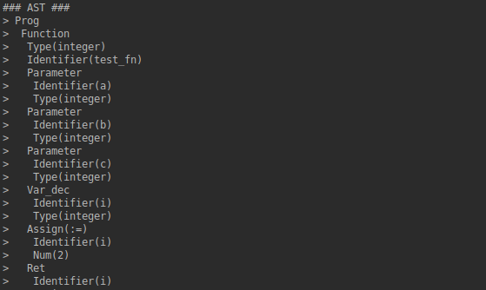
This affected how I checked the correct number of arguments were being supplied according to the function header, as well as the correct types during semantic analysis.

For some of my production rules I also decorated inner elements with nodes, such as function returns. I wanted return to appear and to capture the return variable for checking if it there was one present. This way I could check to see if a void type function was in fact returning nothing
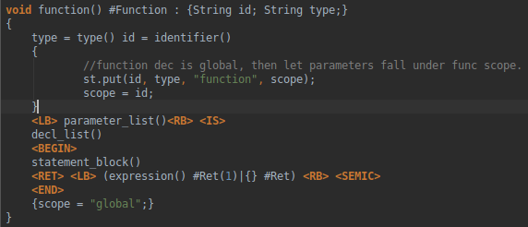

The function production rule also pushes relevant information onto the symbol table,
the function identifier, its return type, its symbol type and the scope. The scope is set by default to global, then is set to the functions name as the current scope after pushing the declaration. This allows the symbol table to correctly mark the function declaration as global and then to have the functions parameters scope noted as local to the function. Upon leaving the function the scope is reset back to “global”.

The Symbol table is made up of a LinkedHashmap containing a linkedlist for each scope, and a hashtable of Symbols objects. When a symbol is pushed onto the symbol table, its scope is checked firstly to see if it exists.

If not, a new scope is created using scope name as a key and a linkedlist added to that bin. The name of every symbol declared in that scope is then added to that linkedlist.

A symbol object is then made consisting of the id, type and symbol_type. To account for symbols with the same name across different scopes, the name of the symbol is combined with the scope of where it was declared. This allows us to uniquely identify each symbol and deal with scope by using it as a key when we push it onto the symbols hashtable.

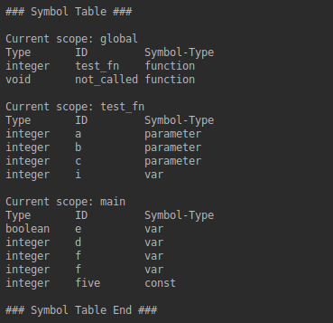

As mentioned before, a function declaration has a scope of global, where as its parameters and any local variables are given a scope belonging to that function. Main is also given its own scope.

Section 2 ::Semantic Analysis
Checks performed:
- Arithmetic operations using only integer or numbers?
- Identifiers declared twice in the same scope?
(Including parameters and local variables)
- Variables assigned correct type?
- Functions are declared before use>
- Every Function has correct number of arguments>
- Every Function called?

Checks not implemented:
- Is every variable written to and read from?
- Boolean operators

Extra Checks:
- Each function parameter is the correct type.
- Each functions return type matches the signature.

For performing Semantic Analysis, I wrote MyVisitor.class which implements the auto-generated Visitor interface. This class contains visit methods for each of the nodes generated for the AST. This class visits each child node by descending down the tree whenever the node.childrenAccept() method is called, beginning at Prog node.

Using a combination of the symbol table and checking the value of these nodes I was able to write several semantic checks as listed above. For example, for checking that a function call has the correct number of arguments for that function, I call jjtGetValue() on the parent node of the function call, which in this case is the function identifier.

Then querying the symbol table I can retrieve all parameters that belong to the scope of that function, which I then compare with the number of arguments in the function call which is calculated again from the current node of the function call. As I retrieved both as lists I can also compare each type to make sure the function is being called with the correct type.

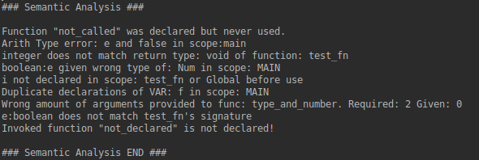
Each error that is generated is added to a corresponding arraylist for that error type, and if that list is not empty when the visitor returns to the Prog node, it’s contents are printed detailing any errors. Otherwise the semanticReporter method declares everything is fine.
Ideally if I had more time I would have created another class to deal with error reporting and to remove some of the bloat from MyVisitor.

Section 3 :: IR code generation

Not implemented.

Section 4 :: Wow factor

https://www.youtube.com/watch?v=rOq7QYpEwaA

Appendices:

- https://www.computing.dcu.ie/~davids/courses/CA4003/CA4003.html
- Pavel Simakov - JJTree Tutorial for Advanced Java Parsing
- https://www.computing.dcu.ie/~hamilton/teaching/CA448/notes/ast4.pdf
- Generating Parsers With JavaCC, Tom Copeland, Centennial Books 2007

