User Guide
Content
Autoencoder + Clustering Pipeline — User Guide 1
What this pipeline does 2
Before you begin 2
Files in the repository 2
Part 1 — Preprocessing (preprocess.py) 2
Preprocessing process 2
Key settings table 2
Running 3
Part 2 — Autoencoder + Clustering (main.py) 3
Model Structure: 3
Hyperparameter table 4
Running 4
Where results are saved 5
Main outputs (what they are & how to use them) 5
Reading the Excel outputs 6
Clustering & evaluation 7
How to choose good hyperparameters 7
Interpreting the visual outputs 7
Troubleshooting 8

What this pipeline does
This two-step pipeline takes a folder of insect images, standardizes them (same size/format), learns a compact ‘fingerprint’ for each image using an autoencoder (a neural network), and then groups similar images together with unsupervised clustering. It also produces visual aids such as activation maps, attention heatmaps, and 2-D plots (t‑SNE/PCA) to help you see how insect images groups.

Before you begin
• Python 3.9+
• Packages: numpy, pandas, pillow (PIL), matplotlib, scikit-learn, tensorflow 2.x, opencv-python, scikit-image, openpyxl, tqdm
Install in one line:
pip install numpy pandas pillow matplotlib scikit-learn tensorflow opencv-python scikit-image openpyxl tqdm

Files in the repository
1) preprocess.py — prepares the image dataset (collect, rename, resize).
2) main.py — trains the autoencoder, extracts features, and runs clustering.

Part 1 — Preprocessing (preprocess.py)
Goal: Walk through all sub‑folders of an input directory, read every image, resize to a fixed size, convert to PNG, and save into a single output directory while also exporting simple statistics.

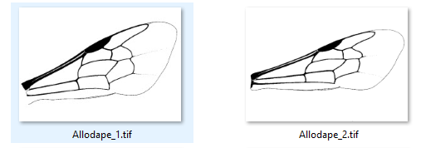
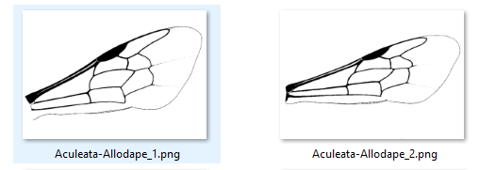
Preprocessing process

Key settings table

Setting | What it means | Suggested value / tip
input_dir | Where your raw images live (the script scans all sub-folders). | D:\\images (change to your path)
output_dir | Where processed images (.png) and CSVs will be written. | D:\\preprocessing
IMAGE_SIZE | Final width × height used for all images. | e.g., (2480, 1748). Use same size you plan to train on.
SUPPORTED_FORMATS | File types accepted. | .png, .jpg, .jpeg, .bmp, .tif (default ok)

Output file name format: “<subfolder>-<originalname>.png”. The subfolder prefix acts as a simple label (family/species).

Running

Run: python preprocess.py
Outputs in output_dir: resized PNGs; errors.log; statistics.csv; family_counts.csv; species_counts.csv; unique_families.txt; unique_species.txt; unique_names.txt.

Part 2 — Autoencoder + Clustering (main.py)

Model Structure:
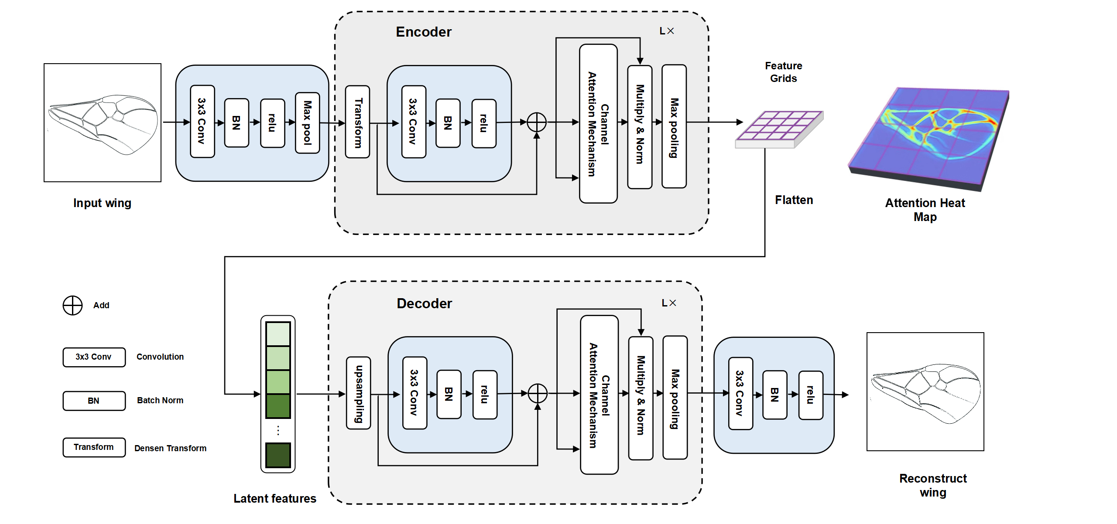
Goal: Train an autoencoder to compress each image into a vector (latent features). Then cluster these features to discover groups. The script also saves visualizations and quality metrics.

Hyperparameter table

Hyperparameter / path | Where it is | What it controls | How to tune
data_folder | in main() | Folder of preprocessed PNGs to train on. | Set to processed image folder (e.g., D:\image).
OUTPUT_DIR | top of file | Where all results/figures/models are saved. | Point to a new/empty folder for each experiment.
IMG_SIZE | top of file | Training image size. | Smaller = faster; larger can improve detail (e.g., 128×128 → 224×224).
LATENT_DIM | top of file | Length of the learned feature vector. | Start 32–128. Larger captures more detail but may overfit.
BATCH_SIZE | top of file | Images per training step. | Use 8–32 depending on memory.
EPOCHS | top of file | Max number of passes over the data. | Try 40–100; EarlyStopping ends training when it plateaus.
REG_FACTOR | top of file | Weight decay (regularization). | Increase slightly if reconstructions overfit/noisy (e.g., 1e-5 → 5e-5).

Running

Run: python main.py

Where results are saved
All outputs are written under your configured OUTPUT_DIR (set near the top of main.py). Use a fresh folder for each experiment to avoid mixing results.

Main outputs (what they are & how to use them)
File / Folder | What it is | Why it matters | How to use | Format / Notes
autoencoder.h5 | Full trained autoencoder (encoder + decoder). | Allows you to reconstruct images and continue training/finetuning. | Load in Keras: tf.keras.models.load_model('autoencoder.h5'); model.predict(imgs) to reconstruct. | Keras HDF5 model.
encoder.h5 | Encoder-only model that maps an image to its feature vector (latent code). | Use to extract compact descriptors for new images; faster than the full autoencoder. | Load and call encoder.predict(img_batch) to get embeddings for clustering/search. | Keras HDF5 model.
image_embeddings.txt | Per-image embeddings (one line per image: filename + vector). | Portable features for clustering without re-running the model. | Parse with Python to get a matrix (n_images × latent_dim); feed into scikit-learn. | Plain text (CSV-like). Each line: name, v1, v2, ...
activations/ | Snapshot images of intermediate feature activations for representative layers. | Gives intuition about what the network attends to internally. | Open images to inspect which filters respond to structures. | PNG/JPEG images.
heatmaps/ | Per-image attention/importance overlays on the original image (final model). | Explains which regions influence reconstruction/features the most. | Use in reports to justify focus on relevant anatomy/texture. | PNG overlays; bright regions = higher importance.
heatmaps_epoch/ | Attention overlays saved across training epochs. | Shows how attention evolves while training (helps diagnose under/over‑fitting). | Compare heatmaps across epochs for stabilization or drift. | PNG sequence per image/epoch.
tsne_plots/ | 2‑D projections of embeddings using t‑SNE / PCA (colored by cluster labels). | Quick visual check for separations, overlaps, outliers, subgroups. | Insert into slides/manuscripts; compare colorings by method. | PNG images (e.g., tsne_optics.png, pca_kmeans.png).
clustering_results.xlsx | Per-image table: filename, parsed labels, cluster IDs (OPTICS/KMeans/Agglo), and 2‑D coords for t‑SNE/PCA. | Central file to review assignments, filter/sort, and trace samples. | Open in Excel; filter by cluster; cross-check with domain labels. | Excel workbook; one row per image.
clustering_metrics.xlsx | Quality metrics per method (Silhouette, Calinski‑Harabasz, Davies‑Bouldin). | Objective comparison across OPTICS / KMeans / Agglomerative. | Prefer higher Silhouette & Calinski–Harabasz, lower Davies–Bouldin. | Excel workbook; one row per method.
clustering_metrics.txt | Plain‑text version of the clustering metrics. | Lightweight copy for quick diff across runs or email. | Open in any editor; good for version control. | UTF‑8 text.
clustering_metrics.png | Bar chart comparing clustering methods on key metrics. | Visual summary for reports/presentations without opening Excel. | Embed directly in slides/manuscripts. | PNG bar chart.

Reading the Excel outputs
clustering_results.xlsx — common columns:
- filename — the saved PNG file name after preprocessing.
- family / species / name — parsed from the filename prefix (if preprocessing used folder labels).
- cluster_optics — cluster label from OPTICS (−1 means noise/unassigned).
- cluster_kmeans — cluster label from KMeans (fixed number, e.g., 30).
- cluster_agglom — cluster label from Agglomerative (same fixed number).
- tsne_x, tsne_y — 2‑D coordinates for plotting; PCA_x, PCA_y if available.
clustering_metrics.xlsx — columns:
- method — optics / kmeans / agglomerative.
- silhouette — higher is better (−1 to 1; >0.2 often indicates structure).
- calinski_harabasz — higher is better (unbounded; higher = denser, well‑separated clusters).
- davies_bouldin — lower is better (≥0; lower = tighter, more separated clusters).

Clustering & evaluation
• OPTICS: variable‑density clustering without choosing the cluster count.
• KMeans (30 clusters) and Agglomerative (30) are also computed for comparison.
• Quality metrics: Silhouette (higher is better); Calinski–Harabasz (higher is better); Davies–Bouldin (lower is better).

How to choose good hyperparameters
1) Start small: IMG_SIZE=128×128, LATENT_DIM=64, BATCH_SIZE=16, EPOCHS=40. Confirm everything runs, then scale up.
2) If reconstructions look blurry: increase LATENT_DIM or EPOCHS. If they look sharp but heatmaps are very noisy: slightly increase REG_FACTOR.
3) Compare clustering metrics across runs and pick settings that yield higher Silhouette/Calinski–Harabasz and lower Davies–Bouldin.
4) If you know the rough number of groups, adjust KMeans/Agglomerative n_clusters and compare results to OPTICS.
5) Keep OUTPUT_DIR separate per experiment so you don’t mix figures/results.

Interpreting the visual outputs
• Activation maps: show which internal filters respond to the image.
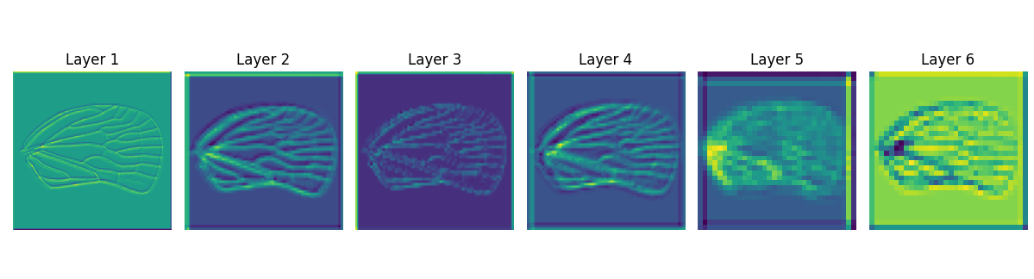
• Attention heatmaps: bright (red) areas most influence reconstruction.
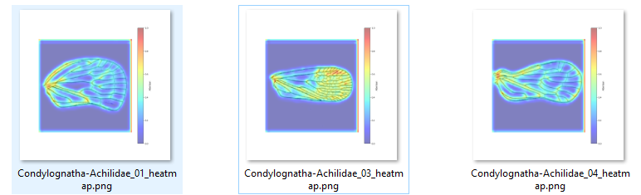
• t‑SNE & PCA plots: each dot is an image; nearby dots are similar in the learned feature space.
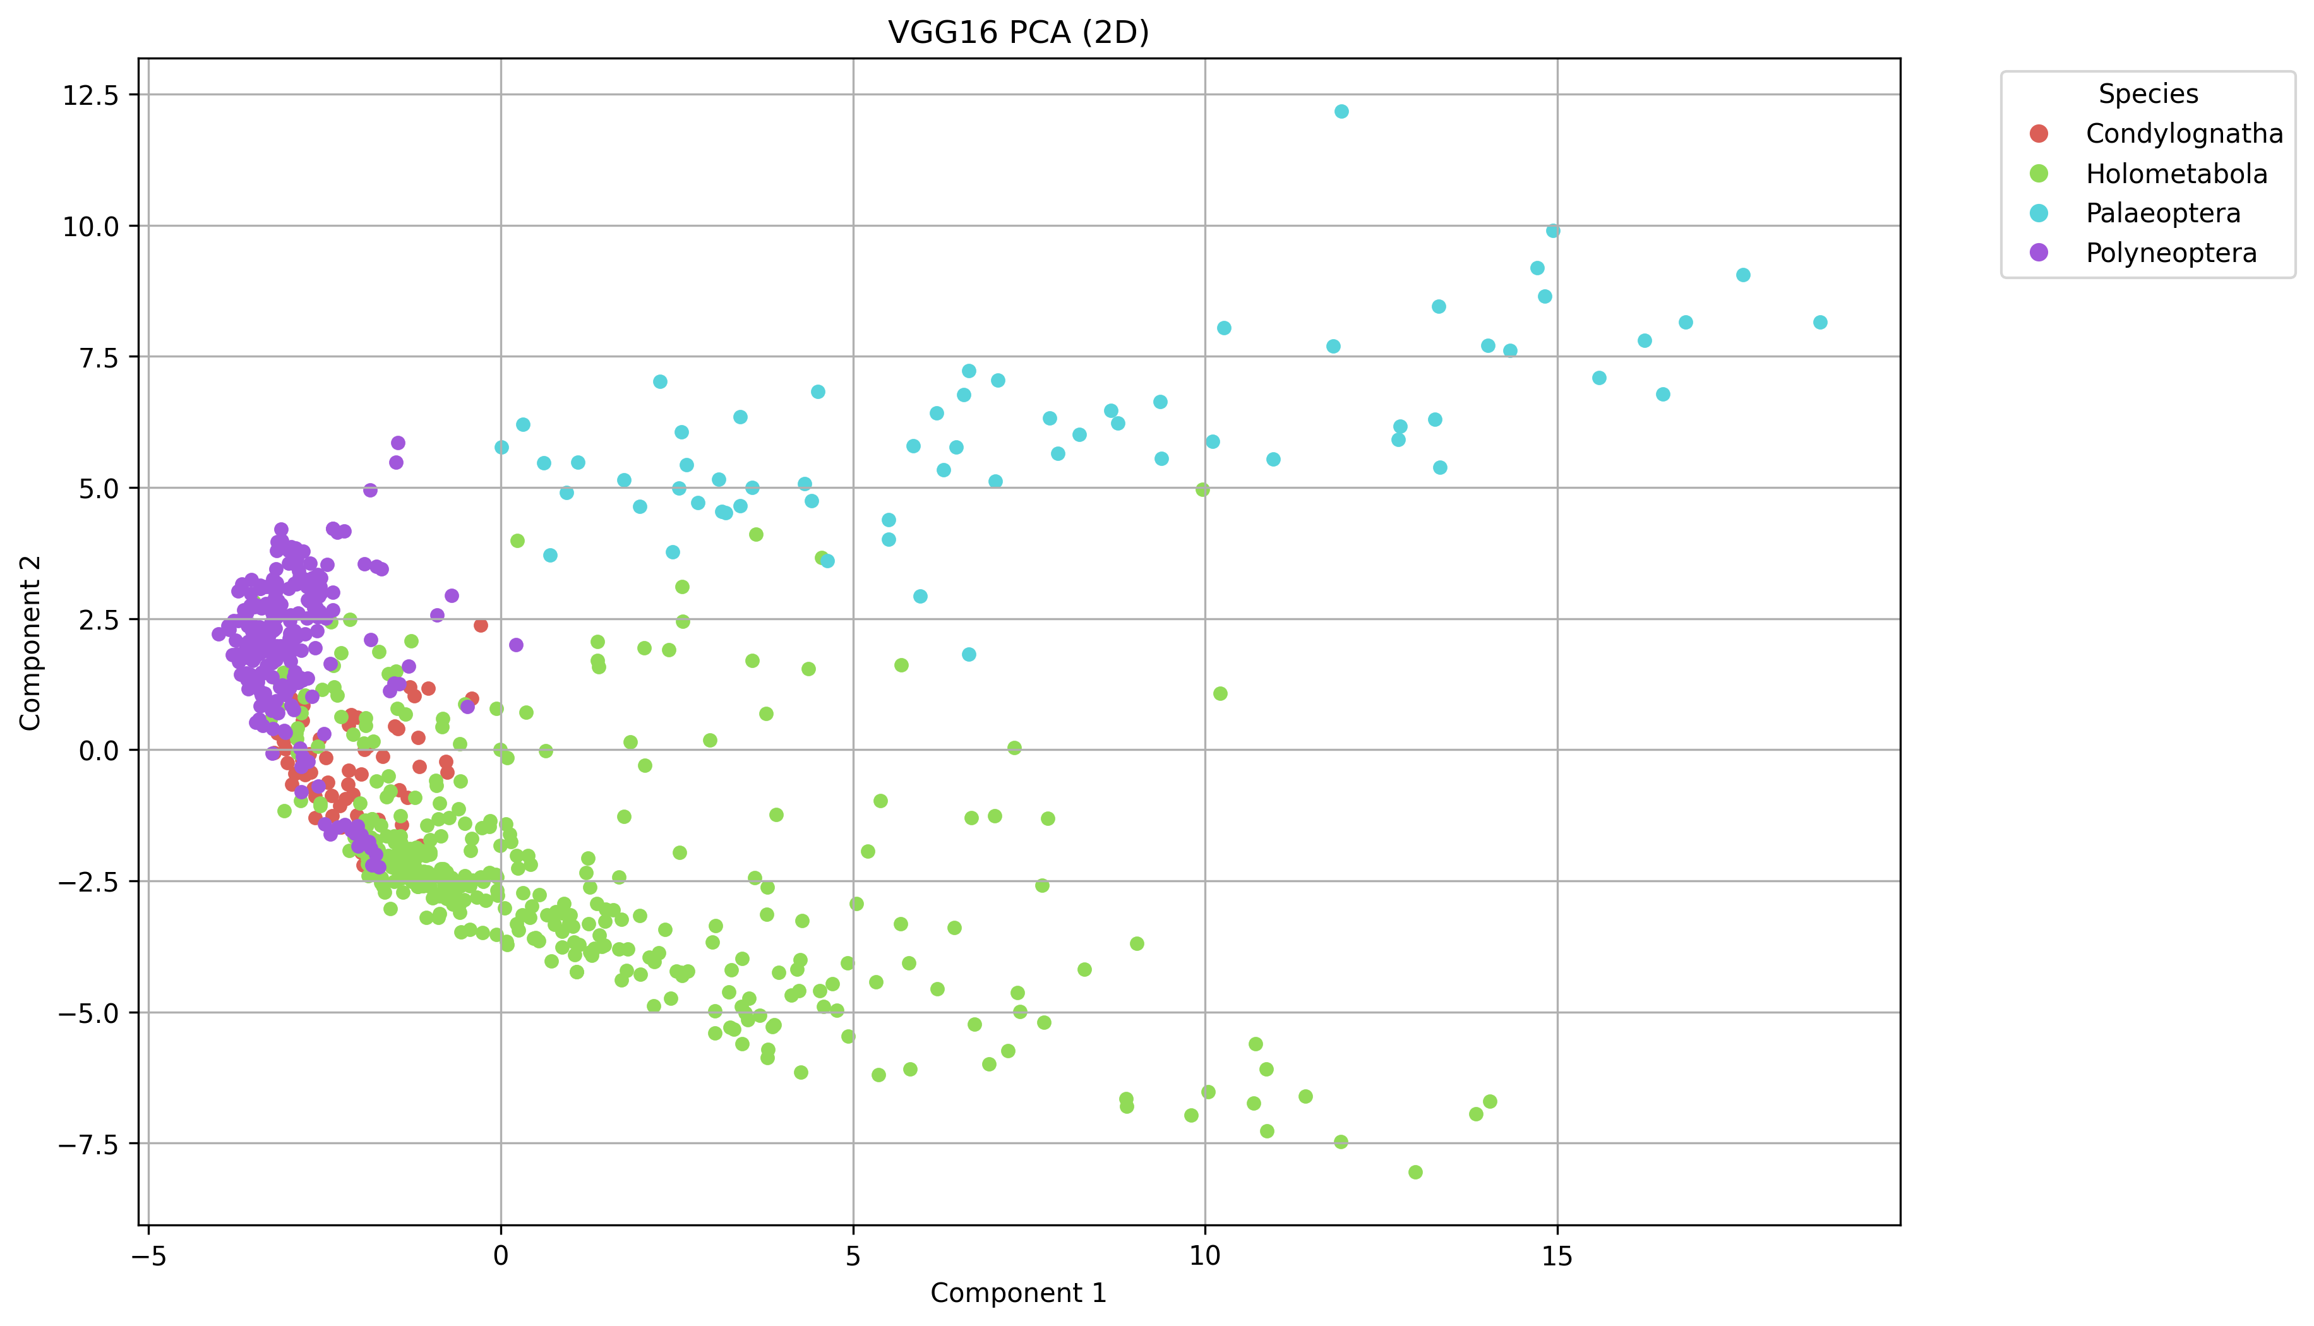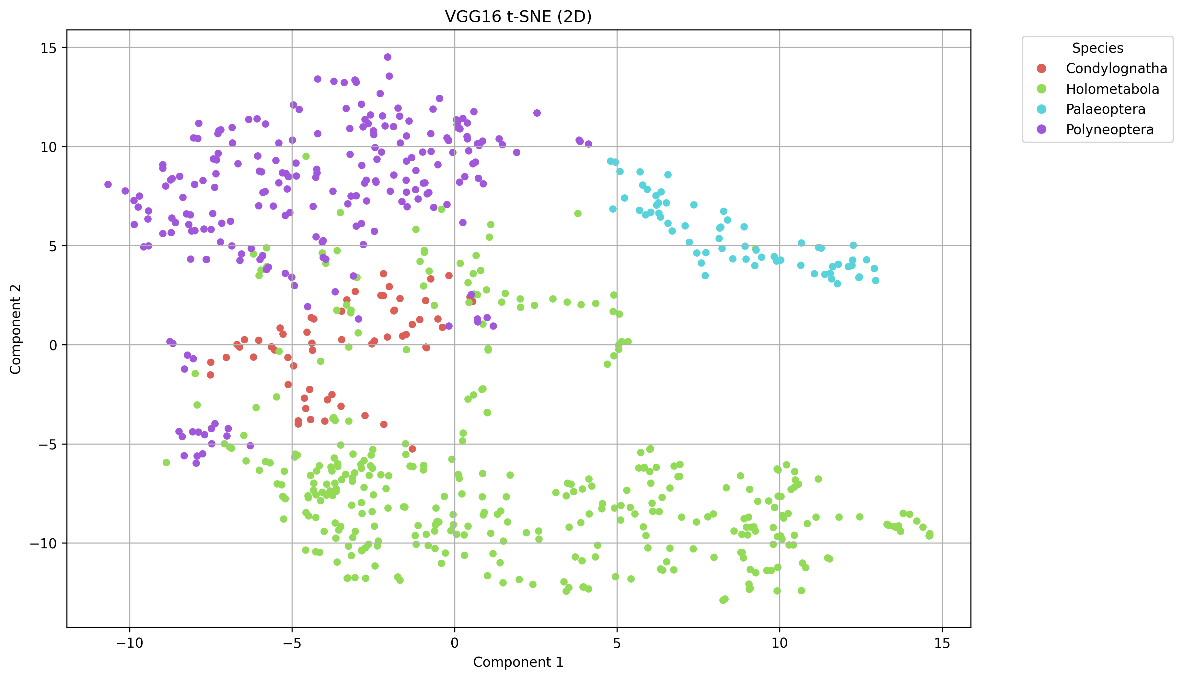

Troubleshooting
• No images found: check data_folder path and file extensions.
• Out of memory: lower IMG_SIZE or BATCH_SIZE, or run on CPU.
• Many OPTICS labels = −1: try cleaner images or use KMeans/Agglomerative and compare metrics.
• Windows paths: use double backslashes (e.g., D:\\data\\images).

