Q1: What are the key limitations of traditional MapReduce that make Spark a preferred choice for modern big data processing?
A.1) Limitations of MapReduce are as follows:
- Reads and writes intermediate results to disk after every stage, making it slow.
- High disk I/O increases execution time.
- Not suitable for iterative algorithms (e.g., Machine Learning).
- Higher latency for interactive analytics.
- Requires more code for complex data processing.
Q2: Explain how Spark uses In-Memory Computing to speed up iterative machine learning algorithms compared to disk-based systems.
A.2.) Spark stores intermediate data in RAM instead of writing it to disk after every operation. Machine learning algorithms repeatedly use the same dataset for multiple iterations. Since Spark keeps data in memory, it avoids expensive disk reads and writes, resulting in much faster execution than MapReduce.
Q3: Write a code snippet to remove all duplicate rows from a DataFrame based on a specific set of columns: user_id and transaction_date.
A.3.) df = df.dropDuplicates(["user_id", "transaction_date"])
Q4: Given a DataFrame df_sales, write a query to filter for rows where the region is 'West' and then group by product_category to find the average sale_amount.
A.4.) df_sales.filter(col("region") == "West").groupBy("product_category")
.agg(avg("sale_amount").alias("Average Sales")).show()
Q5: What is the difference between .na.drop() and .na.fill()? Provide a code example of filling null values in a status column with the string 'Unknown'.
A.5.) The difference between .na.drop() and .na.fill() is that .na.drop() removes rows containing null values whereas .na.fill() replaces null values with specified values.
df = df.na.fill({"status": "Unknown"})
Q6: Write a query to find the total count of records for each city in a DataFrame, but only for cities where the count is greater than 100.
A.6) df.groupBy("city") .agg(count("*").alias("Total Records")).filter(col("Total Records") > 100).show()
Q7: How does the immutability of Spark DataFrames affect how you perform "data cleaning" steps like dropping columns or renaming them?
A.7) Spark DataFrames are immutable, meaning they cannot be modified directly. Every cleaning operation (dropping columns, renaming columns, filtering, etc.) creates a new DataFrame.

Q8: Write a Spark command to filter a dataset for rows where the age is between 18 and 30 (inclusive) and the subscription is 'Premium'.
A.8) df.filter((col("age").between(18, 30)) &(col("subscription") == "Premium")).show()
Q9: When cleaning a dataset, why is it often better to handle null values before performing mathematical aggregations like sum() or avg()?
A.9) Null values can:
- Produce incorrect averages.
- Cause inaccurate sums or counts.
- Lead to unexpected missing results.
- Reduce data quality.
Cleaning null values beforehand ensures more accurate statistical calculations.
Q10: Write the code to revise a column named raw_timestamp by casting it to a TimestampType and renaming it to event_time.
df = df.withColumn("event_time",
col("raw_timestamp").cast(TimestampType())
).drop("raw_timestamp")
Q11: Explain the "Shuffle" process that occurs during a grouping operation. Why is it considered a wide transformation?
A.11) Shuffle is the process of redistributing data across partitions during operations like: groupBy(), join(), distinct(), orderBy()
It is called a wide transformation because data from multiple partitions must be exchanged across the cluster before processing.
Q12: Write a code snippet that identifies and removes rows where the email column contains null values OR the username is an empty string.
A.12) df = df.filter(col("email").isNotNull() &(col("username") != ""))
Q13: How do you use the .agg() function to calculate multiple statistics at once, such as the min, max, and mean of the price column?
A.13) df.agg(
min("price").alias("Minimum Price"),
max("price").alias("Maximum Price"),
avg("price").alias("Average Price")
).show()
Q14: In the context of cleaning a dataset, what is the risk of using inferSchema=true when your source data contains messy or inconsistent date formats?

A.14) When date formats are inconsistent (for example, 2025-07-01, 01/07/2025, and July 1, 2025), Spark may:
- Infer the wrong data type.
- Treat dates as strings.
- Produce null values during parsing.
- Cause errors in filtering or aggregation.
For messy datasets, it is safer to explicitly define the schema or clean date formats before loading.
Q15: Write a final processing pipeline that:
- Filters out duplicates.
- Fills null prices with 0.
- Groups by store_id to calculate total revenue.

A.15) result = (
df.dropDuplicates()
.na.fill({"price": 0})
.groupBy("store_id")
.agg(sum("price").alias("Total Revenue"))
)
result.show()

Data Cleaning
Create a Spark session
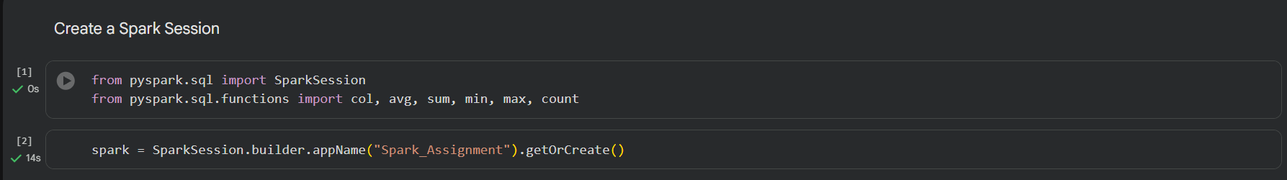
Read csv file
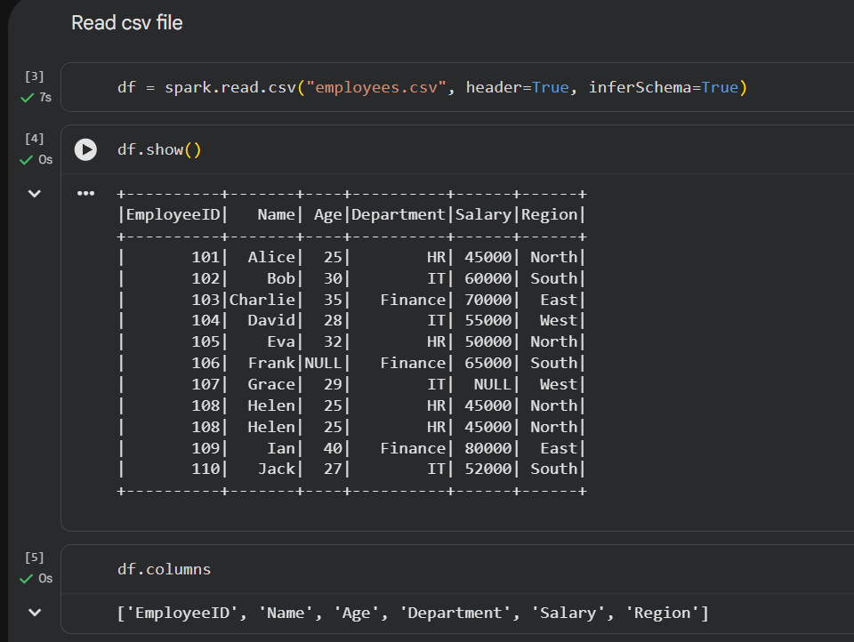
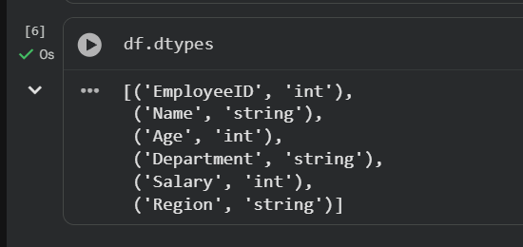

Data Cleaning
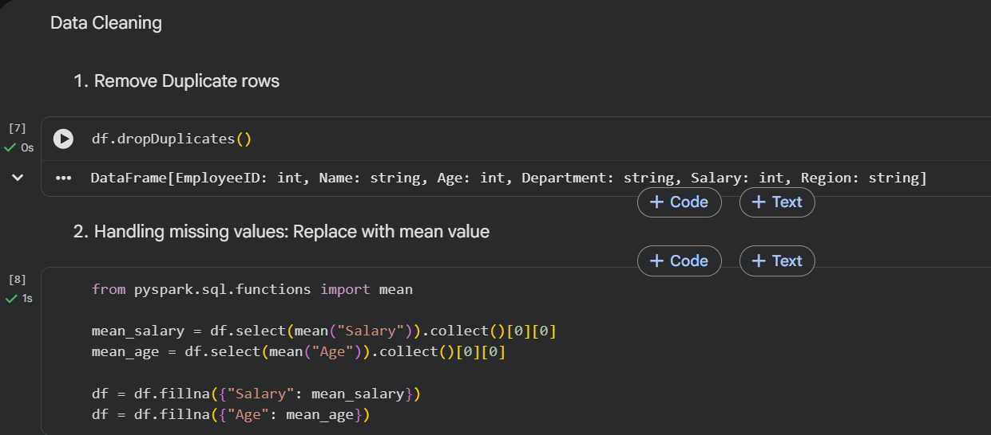
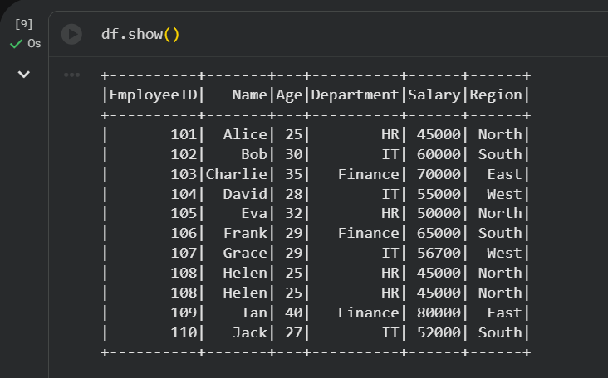
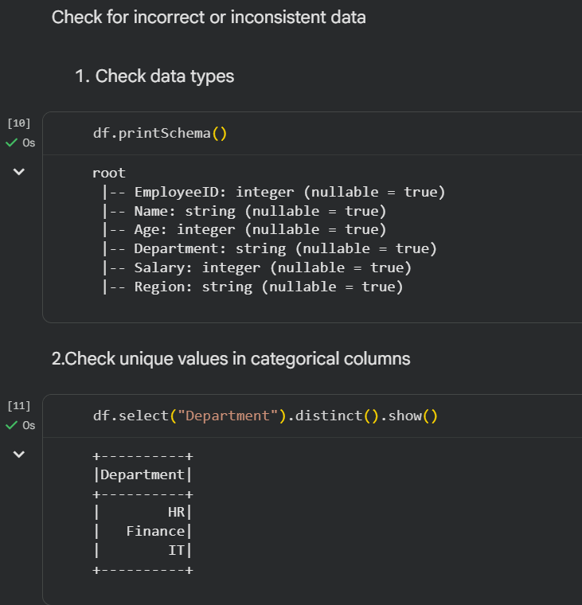
Filter Data
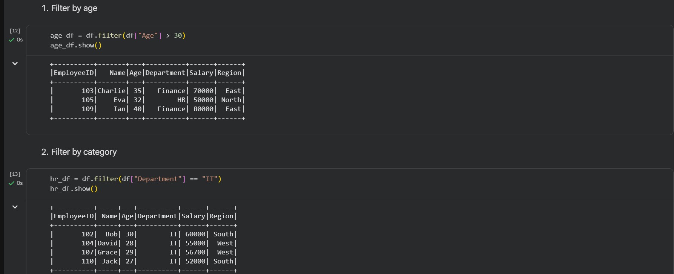
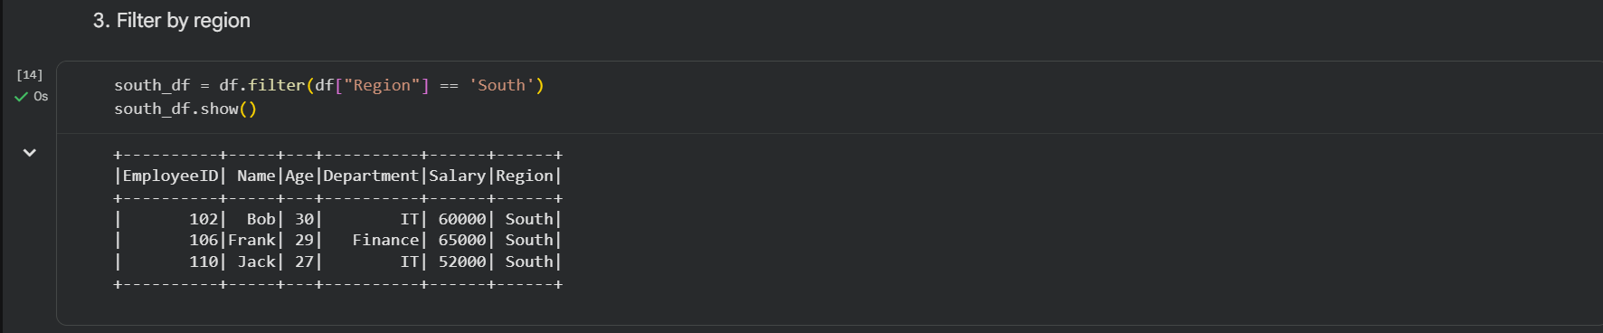
Transform Column
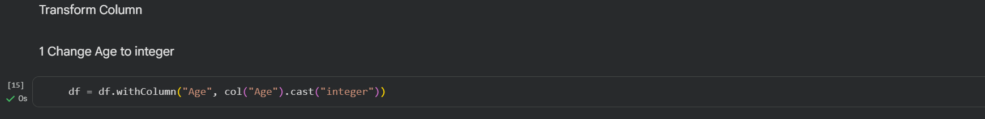
Aggregation
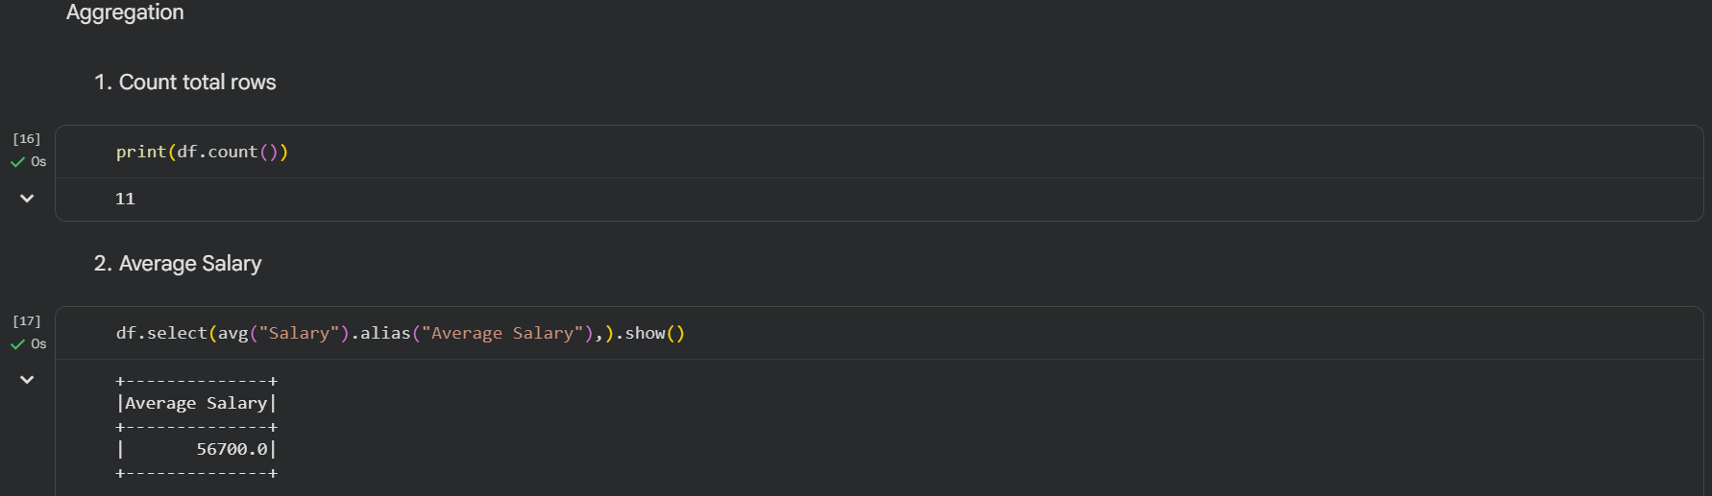
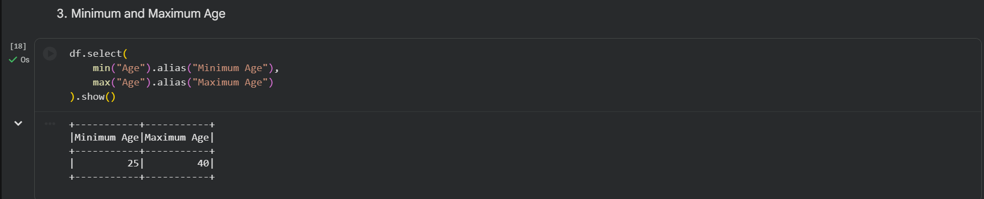

Group Data
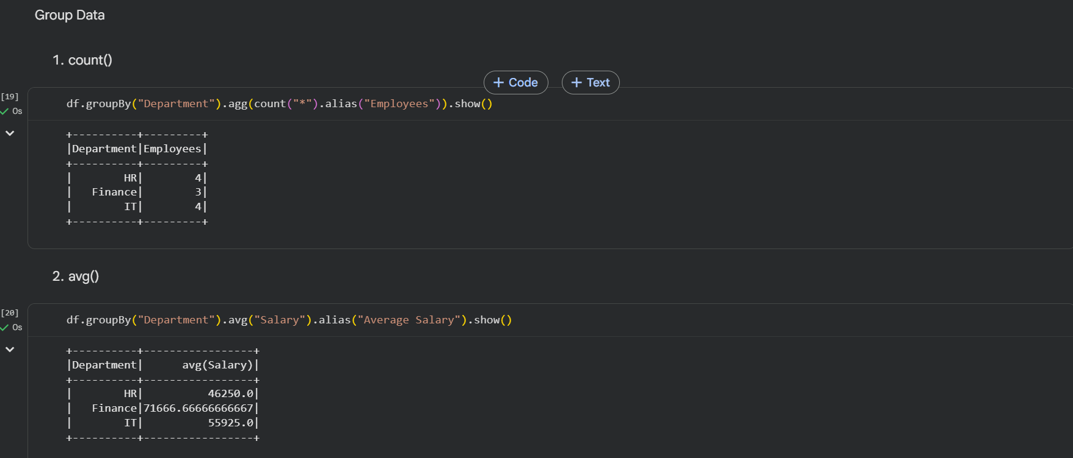
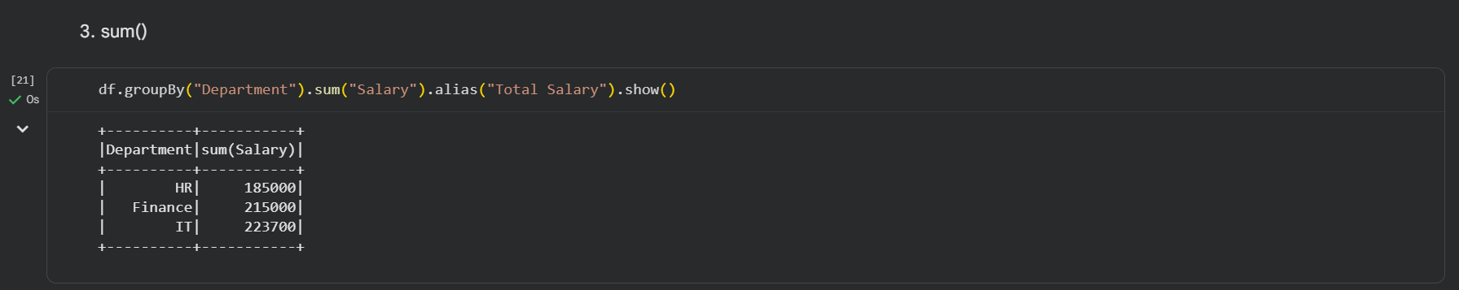
Pipeline
