
CareerOS
AI-Powered Career Intelligence Platform
Connecting Students · Universities · Employers

PRODUCT DOCUMENTATION
TalentBank Hackathon 2026 · Phase 1 Prototype · June 2026

 Table of Contents

1. Executive Summary 4
2. Problem Statement 5
2.1 Students / Candidates 5
2.2 Universities 5
2.3 Employers 5
3. Target Users 6
3.1 Students / Candidates 6
3.2 Employers / Industry Partners 7
3.3 Universities 7
4. Product Positioning 8
4.1 Positioning Statement 8
4.2 How CareerOS Differs 8
4.3 Core Differentiators 8
5. Solution Overview 9
5.1 CareerGraph 9
5.2 Three-Sided Ecosystem 9
5.3 Cross-Side Flywheel 9
6. Product Walkthrough 10
6.1 Student Workspace 10
6.2 University Workspace 11
6.3 Employer Workspace 12
7. Key Features 13
8. Technical Architecture 14
8.1 Frontend 14
8.2 Backend 14
8.3 AI Agent Architecture 14
8.4 Infrastructure 15
8.5 Data Sources 15
9. AI and Intelligence Layer 16
10. Market Opportunity 17
11. Competitive Landscape 18
12. Business Model 19
13. Product Roadmap 20
14. Team 21
15. Setup and Demo Instructions 21
16. Appendix 22

1. Executive Summary
CareerOS is an AI-assisted career operating system that connects student evidence, university programme intelligence, and employer talent workflows through a shared intelligence layer called CareerGraph. Built for the higher education and early talent ecosystem, CareerOS addresses a fundamental breakdown in how students prove readiness, how universities understand market alignment, and how employers evaluate early-career talent.

The platform delivers three purpose-built workspaces — Student, University, and Employer — each powered by AI assistants and unified by a common evidence and intelligence layer. Rather than operating as isolated tools, these workspaces reinforce one another: student evidence improves university intelligence, university interventions raise graduate readiness, and employer engagement feeds outcome data back into the system.

2. Problem Statement
The career readiness ecosystem is broken across three interconnected stakeholders. The scale of the problem is significant:

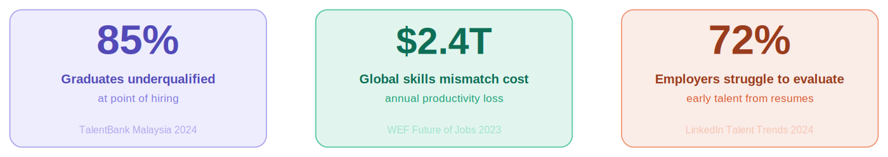
Key market statistics driving the CareerOS problem statement

2.1 Students / Candidates
- Cannot prove readiness beyond a resume — skills are self-reported, unverified, and disconnected from real evidence.
- Face too many generic opportunities with no intelligent filtering based on their actual profile.
- Lack clear, personalised guidance on which skills to build and which career paths match their evidence.
- Track applications across scattered tools with no unified pipeline.

2.2 Universities
- Curriculum cycles are slow and disconnected from real-time employer skill demand.
- Cannot see at-risk cohorts or skill gaps across programmes until outcomes are already poor.
- Event impact — from hackathons to career fairs — is rarely measured or used in decision-making.
- Market data and student evidence are fragmented across systems with no shared intelligence layer.

2.3 Employers
- Resume screening is noisy — early talent is hard to evaluate on keyword-matched documents alone.
- Campus engagement is fragmented with no structured way to create, run, and measure student programmes.
- Applicant pipelines do not connect to verified skill evidence, creating poor hiring signal.

These three broken relationships compound each other. Students graduate underprepared because universities lack market signal. Employers hire inefficiently because candidates cannot prove readiness. Universities cannot improve without outcome data. CareerOS closes this loop.

3. Target Users
CareerOS serves three stakeholder groups, each with a dedicated workspace and representative demo persona.

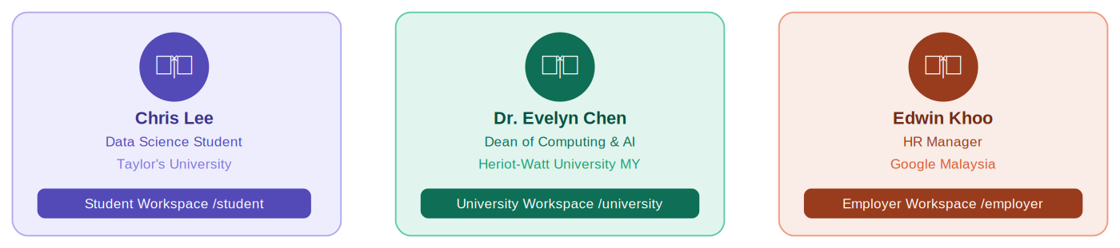
The three CareerOS demo personas — one per stakeholder workspace

3.1 Students / Candidates
Demo persona: Chris Lee — Data Science student, Taylor's University

Who they are: Students preparing for internships, graduate roles, and early career decisions — particularly Malaysian Gen Y and Gen Z graduates entering competitive knowledge economy roles.

Primary goals:
- Understand their career readiness and identify skill gaps.
- Build a Career Memory — an evidence-backed profile from real experiences.
- Find relevant events, internships, and jobs matched to their actual skills.
- Track job applications through a structured pipeline.

3.2 Employers / Industry Partners
Demo persona: Edwin Khoo — HR Manager, Google Malaysia

Who they are: Recruiters, HR managers, university relations teams, and industry partners at companies actively hiring early talent from Malaysian universities.

Primary goals:
- Discover evidence-backed early talent without relying on keyword-filtered resumes.
- Understand candidate fit quickly through AI-generated match explanations.
- Create structured student engagement programmes to build talent pipelines.
- Manage job postings and move applicants through a structured hiring pipeline.

3.3 Universities
Demo persona: Dr. Evelyn Chen — Dean of Computing & AI, Heriot-Watt University Malaysia

Who they are: Deans, programme directors, career teams, curriculum committees, and university leaders responsible for graduate outcomes and programme quality.

Primary goals:
- Understand programme-market alignment and identify curriculum gaps.
- Detect student readiness risks by cohort before graduation.
- Measure the impact of events, collaborations, and interventions.
- Use alumni outcome data to inform curriculum and collaboration decisions.

4. Product Positioning
CareerOS is a career intelligence platform for higher education and early talent ecosystems. It is not a resume builder, a generic job board, a LinkedIn clone, a generic LMS, or a university admin dashboard.

4.1 Positioning Statement
CareerOS is the only platform that turns fragmented career activity into connected intelligence — giving students verified career evidence, universities programme-market insight, and employers transparent talent discovery — all within a single shared ecosystem.

4.2 How CareerOS Differs from Existing Solutions

Competitor | Their Focus | CareerOS Difference
LinkedIn | Public professional networking | Verified evidence and readiness, not public profiles
Handshake | Campus job listings and recruiting | Adds student memory, programme intelligence, post-event impact
Indeed | High-volume job search aggregation | Career preparation and evidence building, not listing volume
Glassdoor | Company reviews and salary transparency | Forward-looking readiness, not backward-looking reviews
JobStreet | SEA job listings | Connects preparation, evidence, matching, and outcomes
Hiredly | Malaysian Gen Y/Z job board with culture fit | Evidence over personality matching; university as stakeholder
LMS Platforms | Course content delivery for institutions | Employability outcomes, market alignment, employer connection

4.3 Core Differentiators
- Evidence-first profiles — skills backed by verified experiences, not self-reported keywords.
- CareerGraph intelligence layer — shared across students, universities, and employers.
- Three-sided ecosystem — all three stakeholders in one connected system.
- Programme-market alignment — showing universities exactly where curriculum lags demand.
- Post-event impact measurement — turning university collaboration activity into strategic intelligence.
- Match explainability — employers see why a candidate fits, not just a percentage score.

5. Solution Overview
CareerOS connects student evidence, university intelligence, and employer talent workflows through CareerGraph — a shared intelligence layer that links skills, experiences, opportunities, employers, university outcomes, and AI recommendations across the platform.

5.1 CareerGraph
CareerGraph is the product's core intelligence layer. It powers skill extraction from student experiences, career path recommendations, programme-market alignment analysis, employer candidate matching, and cross-side outcome feedback.

5.2 Three-Sided Ecosystem
- Student: builds evidence, understands readiness, finds opportunities, tracks applications.
- University: monitors readiness, aligns programmes to market demand, measures event and collaboration impact.
- Employer: discovers verified talent, creates student engagement programmes, manages applicant pipelines.

5.3 Cross-Side Flywheel
Student evidence improves university intelligence. University interventions raise graduate readiness. Employer engagement and event outcomes feed back into student guidance and university decisions. This flywheel makes CareerOS a self-improving system — not a static directory or job board.

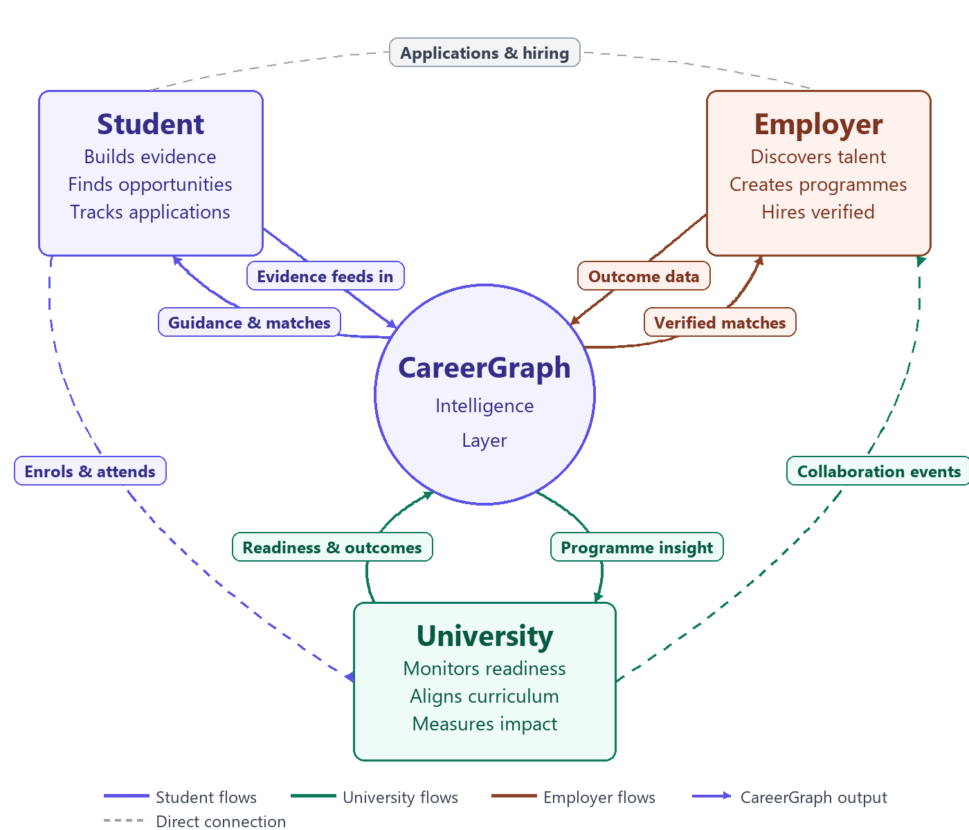
The CareerOS three-sided flywheel — value grows as all stakeholders participate

6. Product Walkthrough
CareerOS exposes three purpose-built workspaces. Each has its own sidebar navigation, AI copilot, and role-specific data. All workspaces share sign-on infrastructure and can be switched from the top-right menu.

6.1 Student Workspace
Persona: Chris Lee — Data Science student, Taylor's University. Accessible at /student.

Overview Dashboard
The home command centre showing the student's current career status. Includes a Career Readiness Score gauge, Monthly Career Actions checklist, Top Career Paths with match percentages, Skill Gap Analysis by role, Application Tracker counts, Research Interests tags, and a curated Recommended for You resource feed.

Career Memory
The student's living career record — the source of truth for skill evidence. Features an Add Experience form with a skills search field and evidence file upload (PDF, images, documents). Displays a filterable Experience Timeline, extracted Top Skills with frequency counts, Career Momentum trend signals, Career Themes detected across entries, and an AI-powered Resume Panel with PDF download.

Career Intelligence
AI-powered analytical insights about the student's skills and career position. Tabbed across Skills, Career Path, and Market Insights. Shows Skill Summary Cards, Skill Clusters by category (Technical, Business, Leadership, Communication), Improvement Opportunities ranked by demand, and live labour market data per role and skill.

Opportunities
Event and job discovery hub. Event Hub tab shows match-scored event cards filterable by category (Hackathons, Case Competitions, Workshops, Talks, Webinars, Networking) with a Deadline Alert Banner for urgent opportunities. Job Market and Saved tabs complete the hub.

Applications
Full application pipeline tracker. KPI tiles show Total Applications, Interview Rate, Response Rate, and Average Match Score. A Kanban board organises applications across Applied, Under Review, Interview, Assessment, and Offer stages.

6.2 University Workspace
Persona: Dr. Evelyn Chen — Dean of Computing & AI, Heriot-Watt University Malaysia. Accessible at /university.

Overview — Career Intelligence Hub
Central command for programme performance. Filters by Programme, Cohort, and Semester. KPI tiles show Market Alignment Score, Graduate Readiness Score, Students at Risk count, and Top Emerging Gap. Includes an AI University Advisor insight block and one-click export.

Programme-Market Alignment
Detailed curriculum-versus-market intelligence. A per-skill table shows Market Demand level, Programme Coverage percentage, and Gap indicator. AI-generated Key Insights panel highlights strengths and urgent gaps. Tabbed across Skills Alignment, Emerging Gaps, and Recommended Actions.

Alumni Signal Intelligence
Graduate outcome tracking. KPI bar covers Employment Rate, Average Starting Salary, Average Time to First Job, and Further Studies rate. Shows Graduate Destinations by role, Top Hiring Companies, Alumni Feedback, and an AI alumni-to-market insight analysis.

Student Readiness
Cohort-level skill progression monitoring. A colour-coded Skill Readiness Heatmap cross-tabulates Skills versus Year cohorts (High / Medium / Low / Not Started). AI Key Insights panel highlights priority intervention areas.

Collaboration Marketplace
Industry-club event discovery and partnership management. Pre-Event tab enables searching and filtering events by partnership needs. Post-Event tab shows impact reports, event history, and Student Spotlights with readiness growth outcomes.

6.3 Employer Workspace
Persona: Edwin Khoo — HR Manager, Google Malaysia. Accessible at /employer.

Talent Discovery
Primary candidate search and evaluation interface. Candidate Cards show name, skill tags, match percentage, and quick Save/Shortlist actions. AI-generated 'Why It's a Strong Match' bullets reference verified evidence. Hiring Confidence indicator, Recommended Action, and Key Risk to Verify help employers make fast, informed decisions.

Create Engagement
Multi-step wizard for creating structured student engagement programmes. Supports Micro-Project and Workshop engagement types. Live preview panel updates in real time. AI Engagement Strength Score explains talent attraction likelihood.

Job and Internship Marketplace
Vacancy management and applicant review hub. KPI bar shows Active Positions, Total Applicants, Interviews Running, Positions Filled, and Average Match Rate. Applicant pipeline allows moving candidates across hiring stages.

7. Key Features

7.1 Student Features
- Career Readiness Score — live gauge of readiness based on skills and experience evidence.
- Career Memory — evidence-backed profile built from real experiences with file upload support.
- AI Skill Extraction — automatic extraction of skills and confidence scores from experience entries.
- Career Intelligence — tabbed view of skill clusters, career path matches, and market insights.
- Opportunity Matching — events and jobs ranked by AI match percentage against student profile.
- Application Pipeline Tracker — Kanban board across five hiring stages.
- AI Career Companion — persistent sidebar assistant providing page-aware contextual guidance.

7.2 University Features
- Programme-Market Alignment — per-skill comparison of curriculum coverage versus employer demand.
- Cohort Readiness Heatmap — cross-tabulation of skill proficiency by year group with colour coding.
- Alumni Signal Intelligence — graduate outcomes including destinations, salaries, and feedback.
- Collaboration Marketplace — discovery and creation of industry-club partnership events.
- Event Impact Reports — post-event intelligence showing readiness uplift, skills closed, and employer pipeline.
- AI University Advisor — executive insight panel with programme-level priority recommendations.

7.3 Employer Features
- Evidence-Based Talent Discovery — candidate search filtered by verified skills and match percentage.
- AI Match Explainability — bullet-point reasons why a candidate fits, with evidence references.
- Hiring Confidence Indicator — AI-generated confidence score and key risk flags per candidate.
- Create Engagement Wizard — multi-step builder for Micro-Projects and Workshops with AI strength scoring.
- Job and Internship Marketplace — vacancy posting, applicant tracking, and suggested candidate surfacing.

8. Technical Architecture
CareerOS is built on a modern, cloud-native stack designed for prototype speed while maintaining a clear path to production scalability.

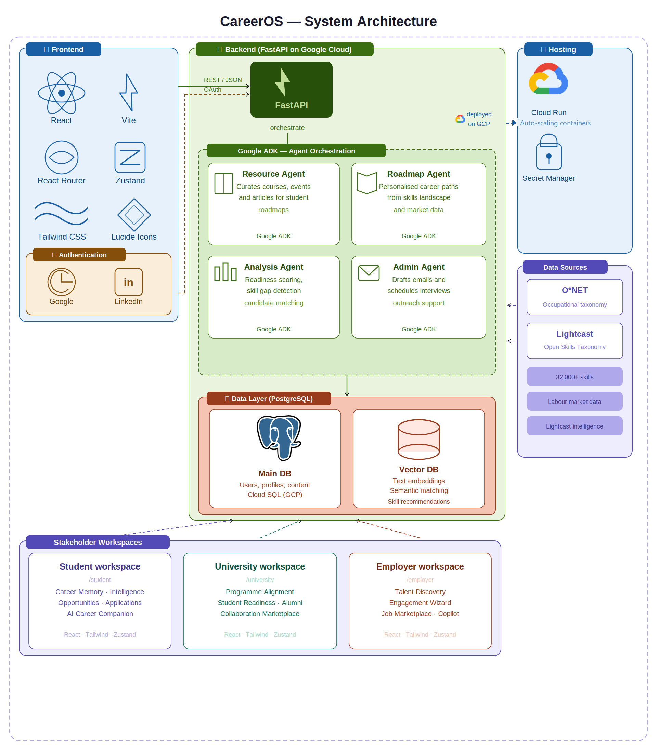
CareerOS full system architecture — zones, agents, data layer, and hosting

8.1 Tech Stack Overview

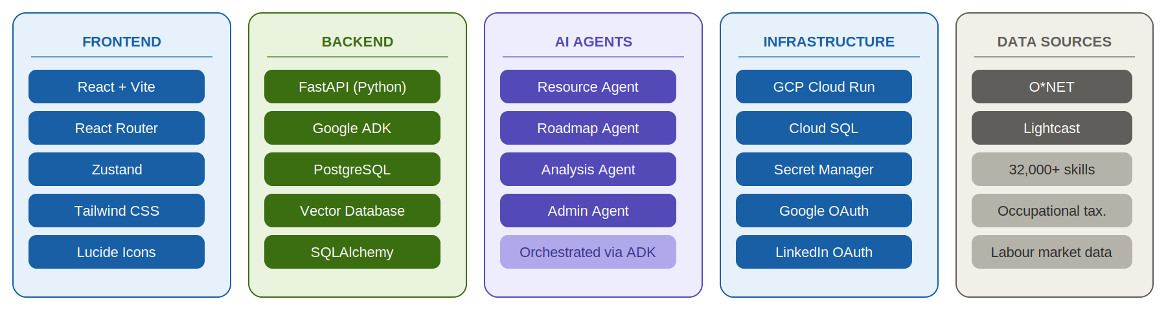
Complete tech stack — Frontend, Backend, AI Agents, Infrastructure, and Data Sources

8.2 AI Agent Architecture (Google ADK)
CareerOS implements a four-agent orchestration system built on Google ADK:

- Resource Agent — extracts and curates relevant resources (courses, events, articles) for student roadmaps based on their skill gaps and career direction.
- Roadmap Agent — generates personalised career roadmaps based on the student's current skills landscape, target role, and market demand signals.
- Analysis Agent — analyses candidate readiness, produces match scores against roles and programmes, and surfaces skill gap insights for students, universities, and employers.
- Admin Agent — assists employers and university staff with email and message drafting, interview scheduling, and engagement outreach.

8.3 Infrastructure
Component | Detail
Cloud Hosting | Google Cloud Run — containerised, auto-scaling serverless deployment
Database | Google Cloud SQL (PostgreSQL) with Cloud SQL Auth Proxy for local development
Secrets | Google Secret Manager for credential and API key management
Authentication | Google OAuth and LinkedIn OAuth for role-based user sign-on

8.4 Data Sources
- O*NET Web Services (US Department of Labor) — occupational taxonomy for skill and role mapping.
- Lightcast Open Skills Taxonomy — 32,000+ skills taxonomy for skill extraction and market demand signals.
- Mock data — all prototype demo data is simulated; no real institutional or employer data is connected in the current prototype.

9. AI and Intelligence Layer
All AI capabilities in the current prototype are simulated using mock logic and pre-defined outputs. The architecture is designed for real AI backend integration in the next development phase.

Capability | Input | Output
Career Memory Skill Extraction | Student experiences, evidence files, organisations | Extracted skills, confidence scores, evidence traces
Career Intelligence | Student skills, target roles, market data | Path recommendations, skill gaps, salary benchmarks
Opportunity Matching | Student profile, event and job metadata | Ranked opportunities with match badges
Programme Alignment Engine | Programme skills, market demand values, gap data | Alignment tables, gap spotlight, recommended actions
AI University Advisor | Programme, cohort, readiness metrics | Executive insight and priority actions
Event Impact Intelligence | Event completion data, skill changes, outcomes | Readiness uplift, skills closed, student spotlights
Candidate Match Advisor | Candidate profile, evidence, match score | Fit reasons, risk flags, recommended next step
AI Engagement Strategist | Engagement type, goals, target audience | Programme recommendations, projected outcomes

10. Market Opportunity
CareerOS targets the intersection of three large and growing markets: HR technology, EdTech, and talent intelligence platforms.

- 85% of graduates are reported to be underqualified for available roles at the point of hiring.
- The global skills mismatch is estimated to cost the economy USD 2.4 trillion annually in lost productivity.
- The average job search for a fresh graduate takes over six months.
- 72% of employers report difficulty evaluating early talent from traditional resumes and interviews alone.

- Global HR technology market: projected to exceed USD 40 billion by 2027.
- Southeast Asia EdTech market: one of the fastest-growing in the world.
- University career services: underdigitised and underserved across Southeast Asia.

Generative AI has made it feasible to extract skills from unstructured experience data, explain candidate fit in natural language, and surface programme gaps from labour market signals — all at a cost structure that was not viable two years ago. CareerOS is positioned to bring this capability to higher education institutions in Southeast Asia at the moment of peak readiness.

11. Competitive Landscape
CareerOS occupies a unique position in the talent and career technology market. No existing platform simultaneously serves students, universities, and employers within a shared evidence and intelligence layer.

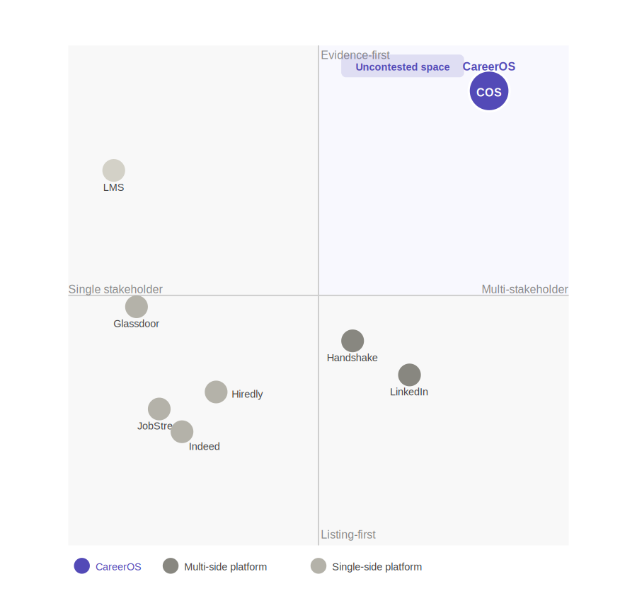
Competitive positioning — CareerOS occupies uncontested space: evidence-first and multi-stakeholder

Platform | Primary Focus | Key Limitation | CareerOS Advantage
LinkedIn | Professional networking | Unverified, keyword-based profiles | Evidence-first, readiness-focused
Handshake | Campus recruiting | No university intelligence layer | Programme alignment and event impact
Indeed | High-volume job search | Listing-first, no readiness system | Career preparation and evidence building
Glassdoor | Company reviews and salary data | Retrospective; no preparation tools | Forward-looking readiness intelligence
JobStreet | SEA job listings | No institutional or evidence layer | Unified three-side ecosystem
Hiredly | Malaysian Gen Y/Z job board | Personality matching, no university workspace | Verified evidence; institutional intelligence
LMS Platforms | Course content delivery | No employer connection or market signal | Employability outcomes, not content delivery

CareerOS's strategic whitespace: the only platform that is simultaneously evidence-first and multi-stakeholder, serving all three sides of the career readiness ecosystem within a connected intelligence layer.

12. Business Model
CareerOS operates a multi-sided SaaS model with differentiated revenue streams per stakeholder group.

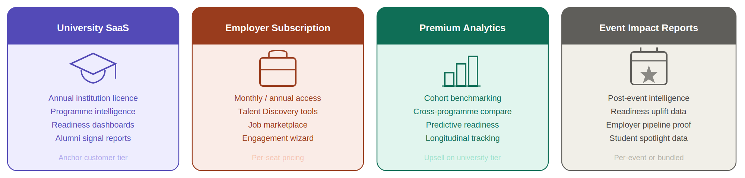
Four revenue streams — University SaaS, Employer Subscription, Premium Analytics, Event Impact Reports

12.1 Revenue Streams
- University SaaS subscription — annual or semester-based licence per institution.
- Employer subscription — monthly or annual access to Talent Discovery, job marketplace, and engagement wizard.
- Premium analytics — advanced cohort benchmarking, cross-programme comparison, and predictive readiness modelling.
- Event impact reporting — packaged post-event reports sold following industry-campus collaboration events.

12.2 Go-to-Market Approach
CareerOS enters through university partnerships, leveraging institutional relationships to onboard both students and employers as secondary stakeholders. This mirrors the Handshake playbook adapted for the Southeast Asian higher education context, with the university as the primary anchor customer.

13. Product Roadmap

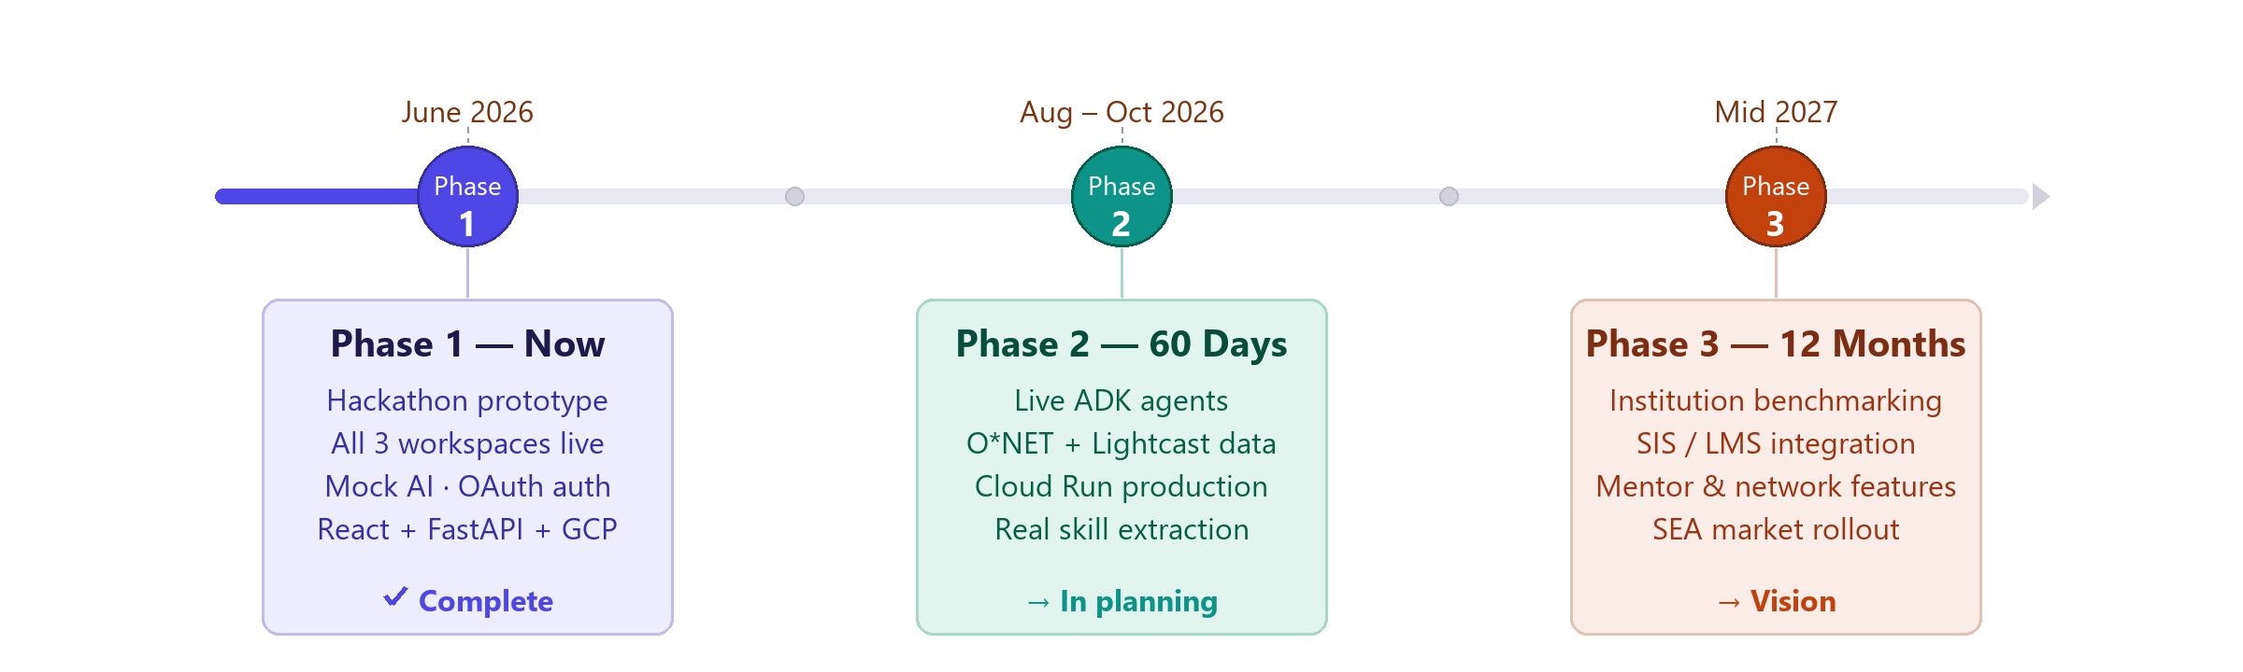
Three-phase roadmap — Prototype now, Live AI in 60 days, SEA rollout in 12 months

Phase 1 — Live Now (Hackathon Prototype)
- Student Workspace: Overview, Career Memory, Career Intelligence, Opportunities, Applications, AI Companion.
- University Workspace: Overview, Programme-Market Alignment, Alumni Signals, Student Readiness, Collaboration Marketplace, Event Impact Reports.
- Employer Workspace: Talent Discovery, Create Engagement Wizard, Job and Internship Marketplace.
- All AI capabilities simulated with mock data and pre-defined outputs.

Phase 2 — Next 60 Days
- Connect real AI backend using Google ADK — activate the four-agent orchestration system.
- Integrate O*NET Web Services and Lightcast Open Skills Taxonomy for live skill and market demand data.
- Deploy production backend on Google Cloud Run with Cloud SQL (PostgreSQL) and Secret Manager.
- Live programme-market alignment using real employer skill demand signals.

Phase 3 — 6 to 12 Month Vision
- Institutional benchmarking — compare readiness and market alignment across faculties and programmes.
- Real university SIS and LMS integration — ingest syllabus and course outlines to map skill coverage automatically.
- Mentor and network features — mentor matching, network graph, and advisory session scheduling.
- CareerOS becomes the career readiness operating system for universities, students, and early talent employers in Southeast Asia.

14. Team
CareerOS was built for TalentBank Hackathon 2026 by a multidisciplinary team combining expertise in AI engineering, full-stack development, product design, and career domain knowledge.

GitHub Repository: https://github.com/Kinston-Chee/Career_OS

15. Setup and Demo Instructions

15.1 Running the Frontend Prototype
- Clone the repository: git clone https://github.com/Kinston-Chee/Career_OS.git
- Navigate to the project directory and install dependencies: npm install
- Start the development server: npm run dev
- Open your browser at the local development URL (typically http://localhost:5173)

15.2 Recommended Demo Sequence
- 1. Student Overview — career readiness score, actions, and top paths.
- 2. Career Memory — experience timeline and evidence-backed skill extraction.
- 3. Career Intelligence — skill clusters, career path matches, and market insights.
- 4. Opportunities — AI-matched events and jobs with deadline alerts.
- 5. Applications — Kanban pipeline with KPI tiles.
- 6. University Overview — programme intelligence hub.
- 7. Programme-Market Alignment — emerging gaps and recommended actions.
- 8. Collaboration Marketplace Post-Event — impact report and student spotlights.
- 9. Employer Talent Discovery — evidence-based candidate search and match explanation.
- 10. Job Marketplace or Create Engagement — vacancy pipeline or engagement wizard.

16. Appendix

16.1 Terminology Glossary

Term | Definition
CareerOS | The product name — the AI-powered career operating system.
CareerGraph | The intelligence layer connecting skills, evidence, opportunities, employers, and university outcomes across all three workspaces.
Career Memory | The student evidence profile built from experiences, skills, and verification signals.
Programme-Market Alignment | University-facing analysis comparing programme skill coverage with employer market demand.
O*NET | Occupational Information Network — US Department of Labor occupational taxonomy used for skill and role mapping.
Lightcast | Labour market intelligence provider. CareerOS uses the Lightcast Open Skills Taxonomy (32,000+ skills).
Google ADK | Google Agent Development Kit — the multi-agent AI orchestration framework powering the CareerOS agent system.

