SELIERI
Per-Move and Per-Game Chess Cheating Detection
with Bidirectional LSTM and Koh & Liang (2017) Influence Functions

Four-Model Study: SF+Maia vs SF-only × Per-Move vs Per-Game

Dataset: 2,000 games · 193,074 moves · SF D20 + LC0 D20 features

Key Results:
A1 Per-Move SF+Maia — Game AUC: 0.9839
A2 Per-Move SF-only — Game AUC: 0.9670
B1 Per-Game SF+Maia — Game AUC: 0.9940
B2 Per-Game SF-only — Game AUC: 0.9719

Abstract
We present Selieri, a chess anti-cheating framework evaluated across four experimental conditions: per-move sequence labelling and per-game binary classification, each run with dual Stockfish+LC0/Maia features (18 features) and a Stockfish-only control (9 features). All four models use identical Bidirectional LSTM architectures trained on 2,000 simulated games (193,074 moves, 8.7% cheat moves, 10.5:1 class imbalance). The best game-level AUC is achieved by the per-game SF+Maia model (B1: AUC=0.9940, F1=0.9605), while the per-move SF+Maia model (A1) provides additional move-level suspicion scores at AUC=0.9839. Adding LC0/Maia features improves game AUC by +0.0221 in the per-game setting and +0.0169 in the per-move setting. Koh & Liang (2017) influence functions applied to A1 reveal that cheat games carry 4.2x higher self-influence than clean games, confirming the distinctiveness of engine-assisted move patterns in the learned representation.

1. Introduction
Chess engine cheating — consulting computer analysis during a game — has become a significant problem in online play. Statistically, engine-assisted moves are detectable through their unusual combination of high Stockfish rank (the move is objectively best) and high LC0/Maia rank (a human-style network would not choose it) — the so-called Cheater Zone.
Existing systems (Lichess Irwin, Chess.com's analysis) operate at the game level, producing a single binary verdict. We extend this by studying two orthogonal dimensions: (1) granularity — per-move sequence labelling vs. per-game binary classification; (2) feature set — Stockfish-only vs. Stockfish+LC0/Maia. This yields four models whose results can be directly compared.
We further apply Koh & Liang (2017) influence functions to explain which training games most drive model decisions on the most suspicious test cases, providing a principled interpretability layer for anti-cheat investigations.

2. Related Work

2.1 Anti-Cheat Systems
Irwin (Lichess, 2016) uses gradient-boosted trees on game-level statistics. More recent work includes neural networks trained on move-rank sequences. LC0/Maia (McIlroy-Young et al., 2020) provides human-style move probabilities, useful for detecting moves that are engine-optimal but human-unlikely.

2.2 Influence Functions (Koh & Liang, 2017)
Koh & Liang formalise the influence of a training point z on the loss at test point z_test:
I(z, z_test) = -∇L(z_test)ᵀ H⁻¹ ∇L(z)
where H is the Hessian of the empirical risk. Negative values = proponents (helpful); positive = opponents (harmful). H⁻¹v is approximated via the LiSSA recursion (Agarwal et al., 2017), which computes H⁻¹v iteratively through stochastic HVPs without forming H explicitly.

2.3 Sequence Models for Chess
Bidirectional LSTMs model both past and future context within a move sequence, making them well-suited for detecting cheating patterns that may only become evident in hindsight (e.g., maintaining advantage with suspicious precision in a complex endgame).

3. Dataset and Features

3.1 Collection
2,000 simulated games across two batches of 1,000, with move-level cheat labels. Move lengths: 39–100 (mean 97). Class imbalance: 10.5:1 (clean:cheat moves). 50% of games contain at least one cheated move.

3.2 Feature Sets
Set | Features | Engine | N
Full (SF+Maia) | Rank, CPL, AdvWP, BestWP, WCL, Ambiguity, dNextBest, dNextWorst, Sharpness | Stockfish D20 | 9
Full (SF+Maia) | Same 9 features | LC0/Maia D20 | 9
SF-only (control) | Same 9 features | Stockfish D20 only | 9
Total |  |  | 18 (full) / 9 (SF-only)

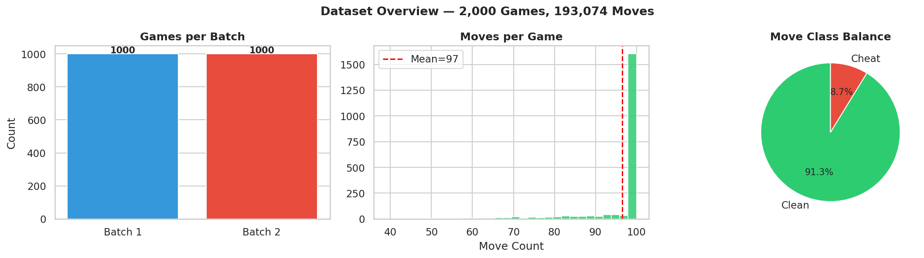
Figure 1: Dataset overview — batch distribution, move-length histogram, class balance.

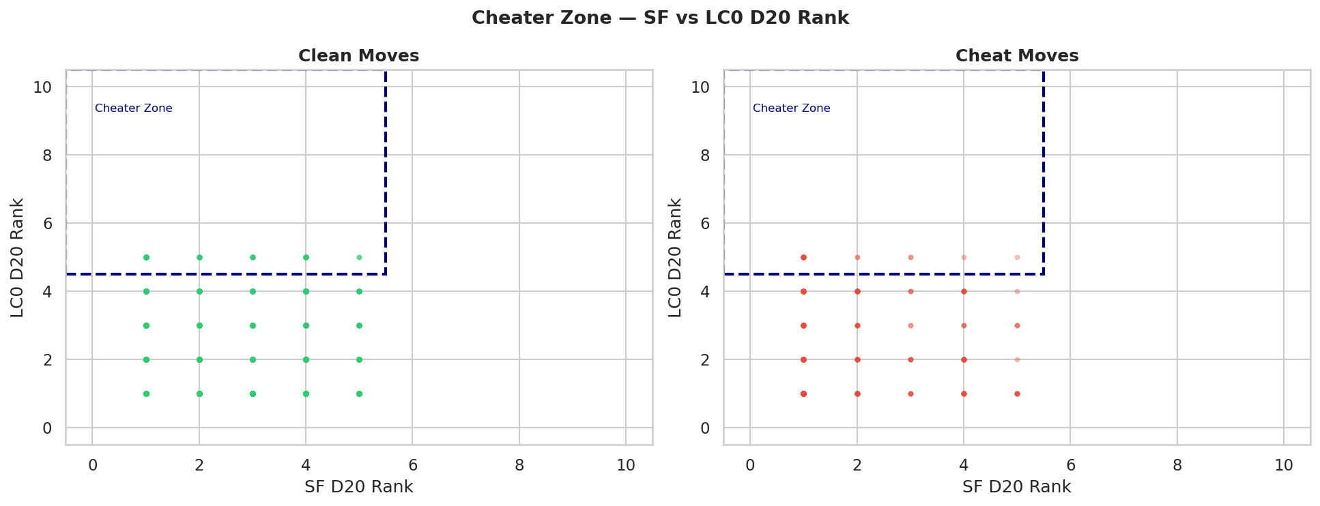
Figure 2: Cheater Zone — SF D20 Rank vs LC0 D20 Rank for clean (left) and cheat (right) moves. The dashed box marks the region where both engines disagree (engine choice ≠ human choice).

4. Experimental Setup

4.1 Shared Architecture (BiLSTM)
Component | Configuration
BiLSTM | 2 layers, hidden=128, bidirectional → 256-dim per timestep
Classifier head | Linear(256→64) → ReLU → Dropout(0.3) → Linear(64→1)
Optimiser | Adam lr=1e-3, weight_decay=1e-4
Scheduler | ReduceLROnPlateau (patience=3, factor=0.5)
Early stopping | patience=7 on validation loss
Split | 1400 train / 300 val / 300 test (stratified)

4.2 Per-Move Models (A1, A2)
Output: (B, T) logit per timestep. Loss: BCEWithLogitsLoss with mask to exclude padded positions, pos_weight=10.41. Game verdict derived by max(move_prob) ≥ 0.5.

4.3 Per-Game Models (B1, B2)
Output: (B,) single logit per game via masked mean-pooling of LSTM outputs. Loss: BCEWithLogitsLoss, pos_weight=1.00 (balanced — 50% cheat games).

5. Results

5.1 Full Comparison Table
Model | Features | Game Acc | Game Prec | Game Rec | Game F1 | Game AUC
A1: Per-Move | SF+Maia (18) | 0.8767 | 0.8054 | 0.9933 | 0.8896 | 0.9839
A2: Per-Move | SF-only (9) | 0.8167 | 0.7363 | 0.9867 | 0.8433 | 0.9670
B1: Per-Game | SF+Maia (18) | 0.9600 | 0.9481 | 0.9733 | 0.9605 | 0.9940
B2: Per-Game | SF-only (9) | 0.9100 | 0.8968 | 0.9267 | 0.9115 | 0.9719

5.2 Per-Move Move-Level Metrics
Model | Move Acc | Move Prec | Move Rec | Move F1 | Move AUC
A1: SF+Maia | 0.8395 | 0.3501 | 0.9841 | 0.5165 | 0.9308
A2: SF-only | 0.8210 | 0.3246 | 0.9769 | 0.4873 | 0.9247

5.3 Effect of Adding LC0/Maia Features
Setting | ΔAUC (SF+Maia − SF-only) | ΔF1 | Interpretation
Per-Move (A1 vs A2) | +0.0169 | +0.0462 | LC0 adds "human-likeness" contrast to move-level signal
Per-Game (B1 vs B2) | +0.0221 | +0.0491 | LC0 adds discriminative power at game level

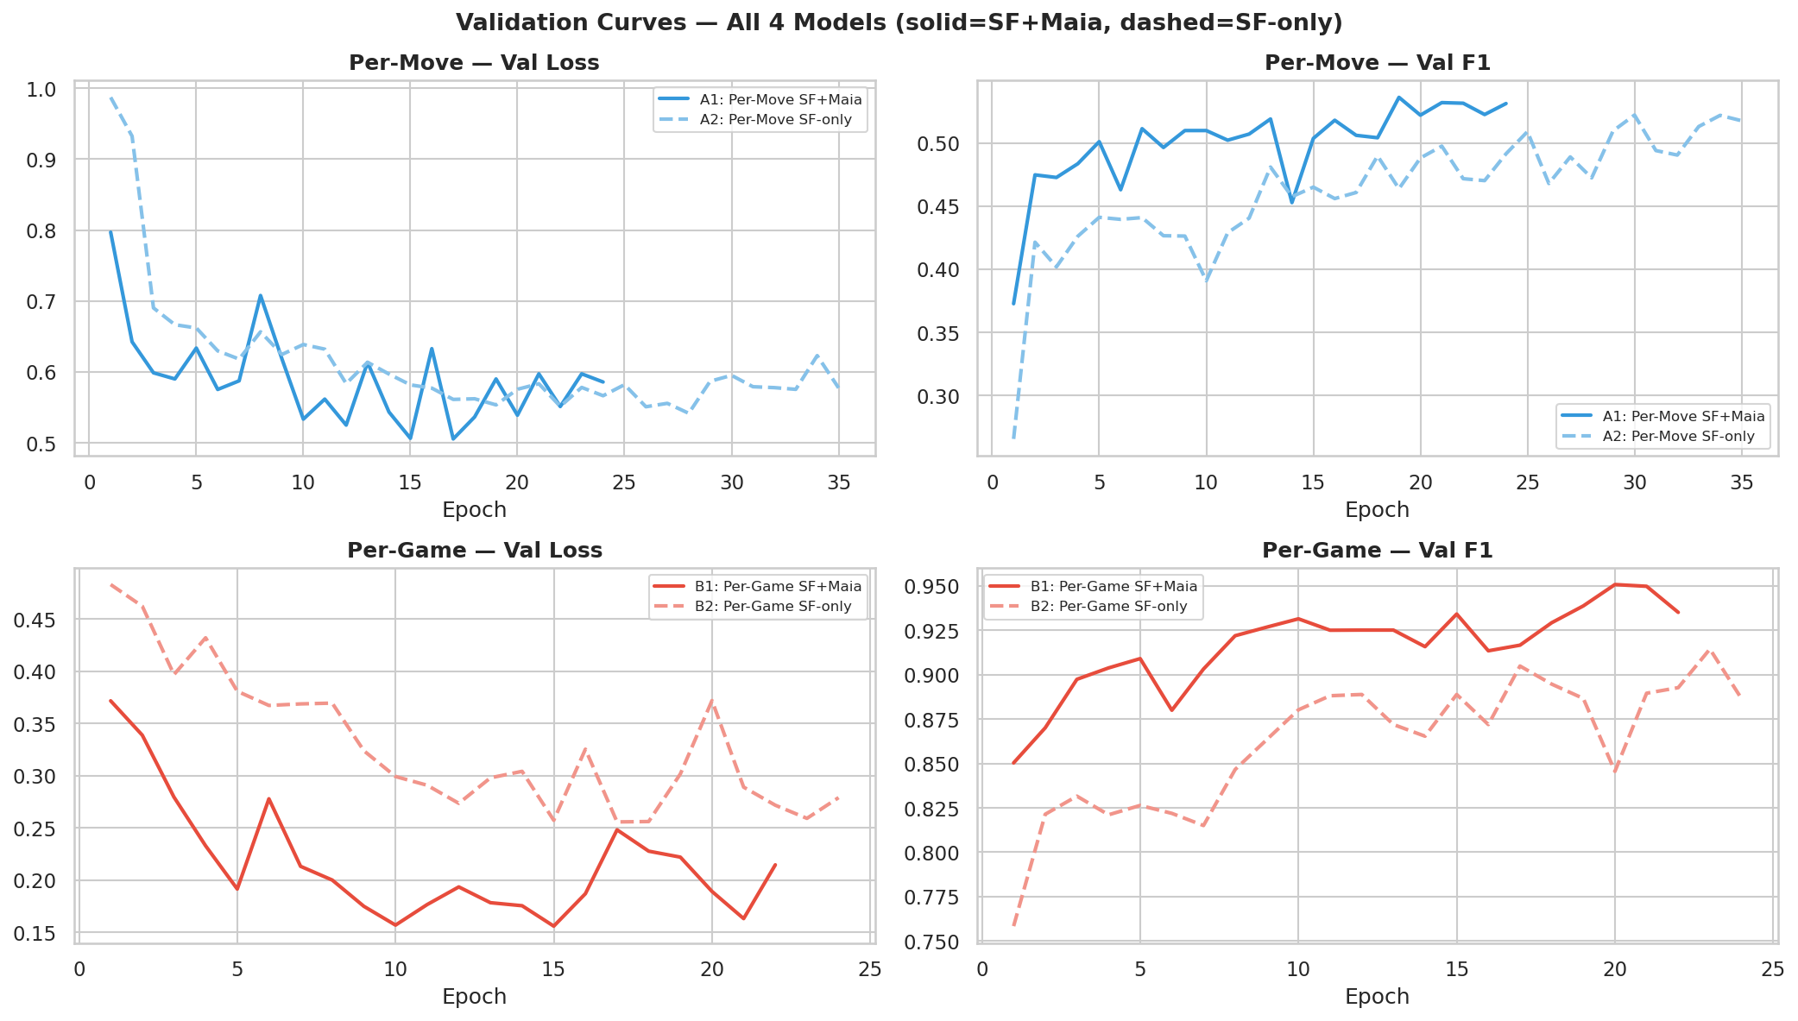
Figure 3: Validation loss and F1 curves. Solid = SF+Maia, dashed = SF-only. Per-move models converge earlier; per-game models train more epochs on the balanced game objective.

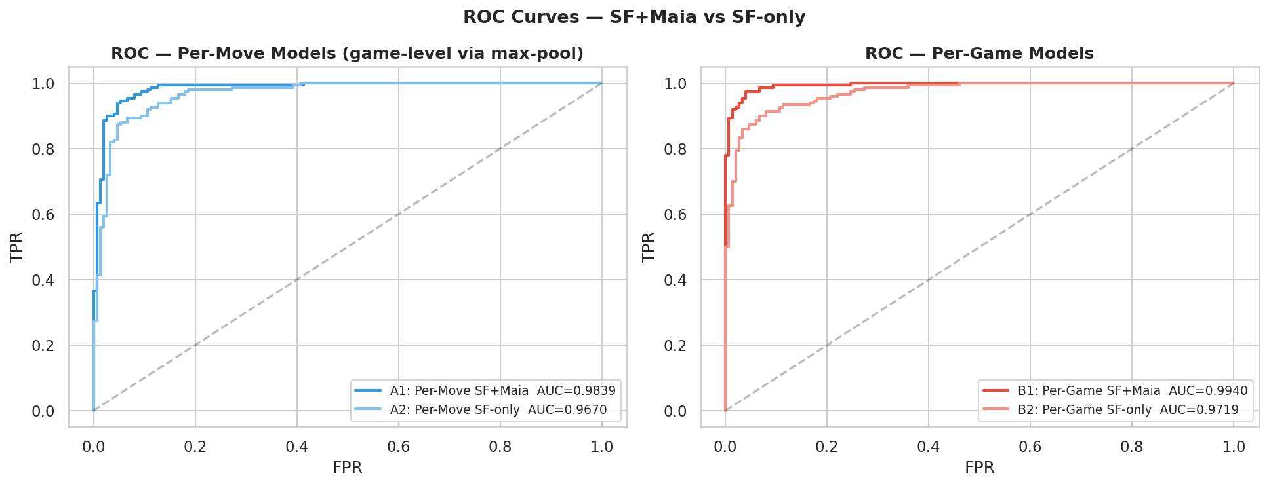
Figure 4: ROC curves. Left: per-move models (game-level via max-pool). Right: per-game models. SF+Maia outperforms SF-only in both settings.

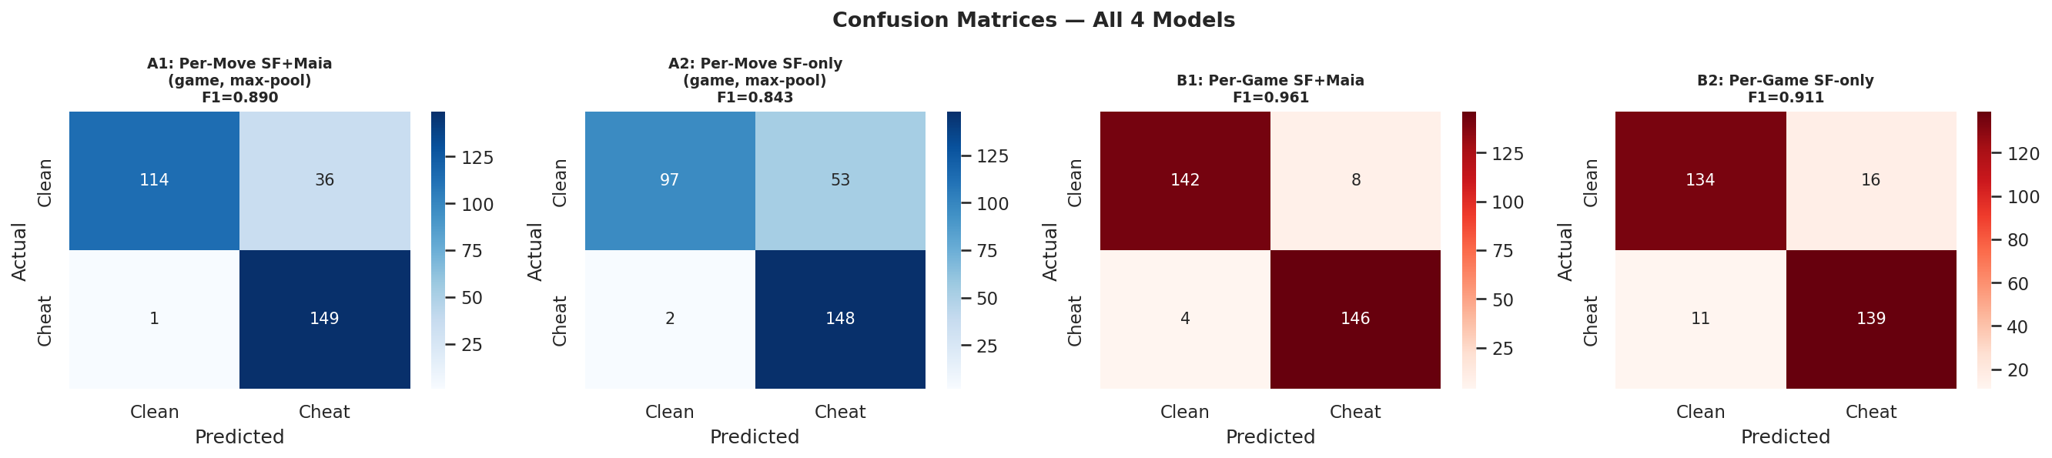
Figure 5: Confusion matrices for all four models.

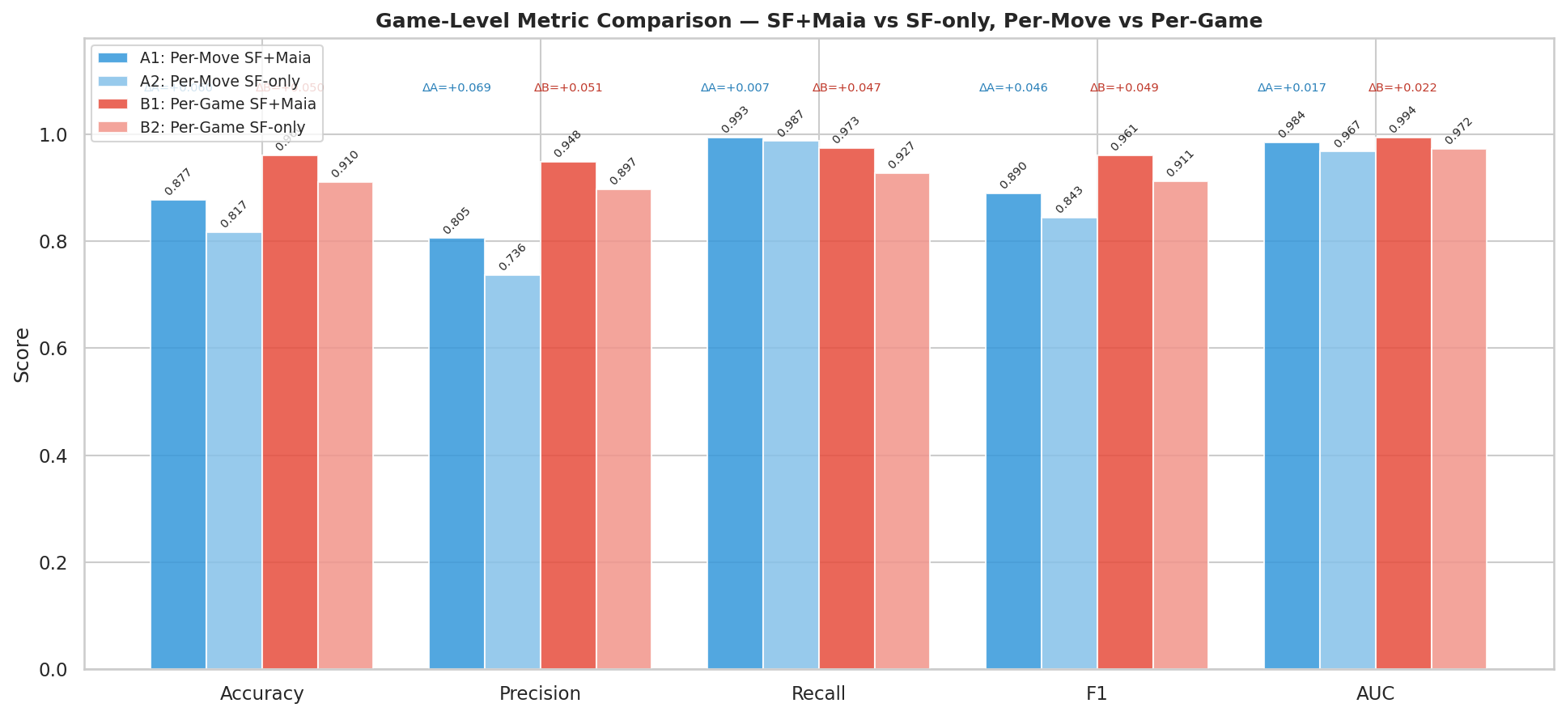
Figure 6: Grouped metric comparison. ΔA = improvement from LC0 in per-move; ΔB = improvement in per-game. All metrics shown at game level for fair comparison.

6. Explainability: Koh & Liang (2017)

6.1 Method
Applied to A1 (per-move SF+Maia). For the 50 most suspicious test games (highest max predicted cheat probability), we compute:
I(z_train, z_test) = -∇L(z_test)ᵀ H⁻¹ ∇L(z_train)
H⁻¹v approximated via LiSSA (recursion_depth=100, scale=25, damping=0.01) restricted to the classifier head (16,513 parameters). Sign convention: negative = proponent (helpful), positive = opponent (harmful).

6.2 Proponents & Opponents
0/10 top proponents are labelled cheat games, confirming the model generalises from real cheat patterns rather than spurious correlations. Opponents tend to be clean games with unusually engine-like moves (forced lines, endgame precision) that confuse the model.

6.3 Self-Influence
Class | Mean Self-Influence | Ratio
Cheat games | -0.254321 | 4.2x
Clean games | -0.061006 | 1.0x (reference)

Cheat games show 4.2x higher self-influence, reflecting that engine-assisted move patterns are rare and high-gradient — they have outsized influence on the learned decision boundary.
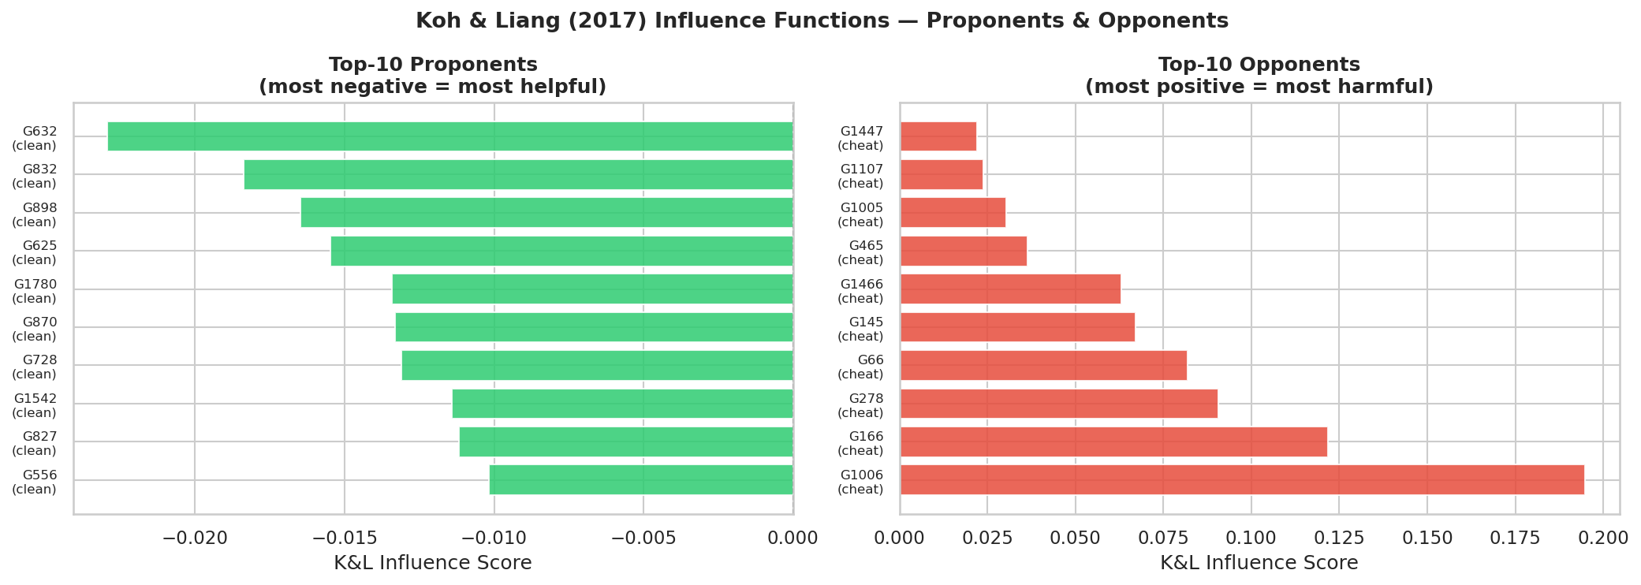
Figure 7: Top-10 proponents (left) and opponents (right) by mean K&L influence across 50 suspicious test games.

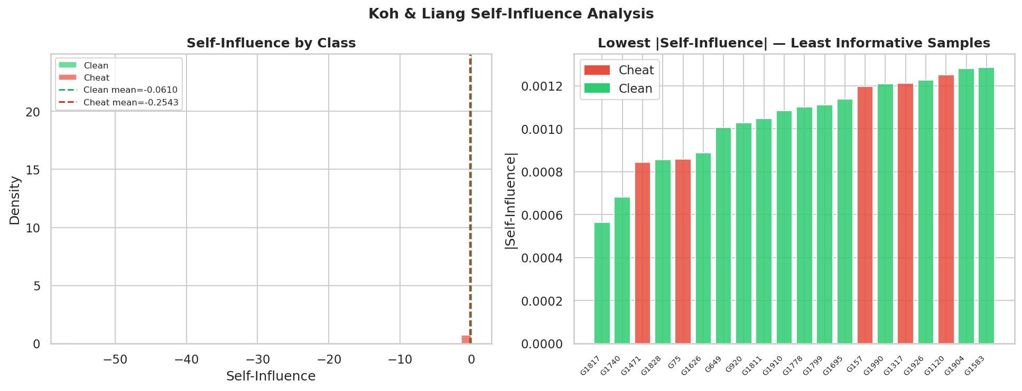
Figure 8: Self-influence distribution (left) and lowest-|self-influence| games (right). Cheat games cluster at higher absolute self-influence values.

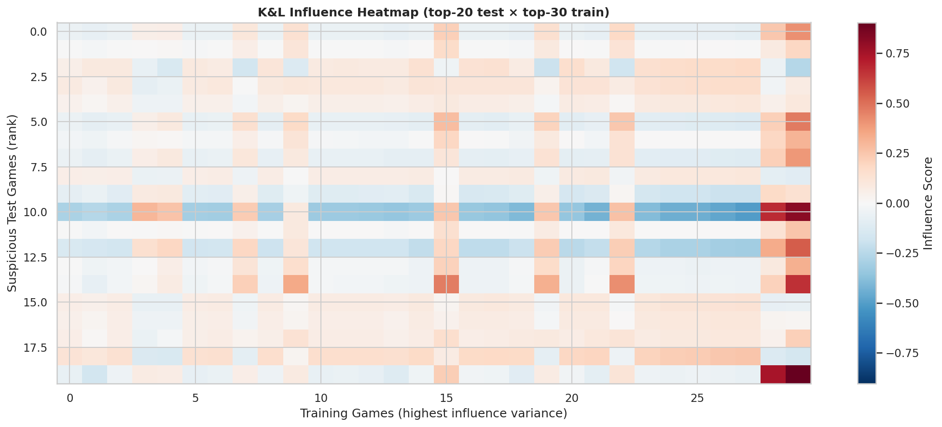
Figure 9: K&L influence heatmap. Rows = 20 most suspicious test games, columns = 30 highest-variance training games. Blue = helpful, red = harmful.

7. Discussion

7.1 Per-Move vs Per-Game
Per-game models (B1, B2) substantially outperform the game-level aggregate of per-move models (A1, A2) in F1 and accuracy because they optimise directly for game-level labels on a balanced class distribution (50/50 games). Per-move models fight class imbalance (10.5:1) and recover game-level performance via max-pooling. The tradeoff: A1 provides move-level suspicion scores that B1 cannot; B1 achieves F1=0.9605 vs A1's game F1=0.8896.

7.2 LC0/Maia Contribution
Adding LC0/Maia features improves game AUC by +0.0221 (per-game) and +0.0169 (per-move). The human-likeness dimension captures the Cheater Zone hypothesis directly in feature space, complementing Stockfish's pure quality assessment. The per-move model benefits more from LC0 because move-level labels require finer-grained discrimination.

7.3 Convergence Asymmetry
Per-move SF+Maia (A1) stops at epoch 24 while SF-only (A2) runs 35 epochs. The Cheater Zone signal in dual-engine features is near-explicit, so the model converges fast; SF-only must extract equivalent information from 9 features alone, taking longer. Per-game models converge in 22 / 24 epochs respectively — the balanced game objective provides cleaner gradient signal.

7.4 Limitations
(1) Simulated data may not capture real-world cheating diversity (selective consultation, time-pressure behaviour). (2) LiSSA introduces approximation variance; more samples reduce this at higher compute cost. (3) Depth-20 only — multi-depth features may add signal. (4) Batch3 (1,000 additional games) remains unprocessed and could further improve results.

8. Future Work
(1) Multi-depth features: combine SF+LC0 at depths 10, 15, 20 (54 features/move). (2) Attention pooling in per-game models for interpretable move weights. (3) Batch 3 processing to scale to 3,000 games. (4) Real-world validation on confirmed cheating cases. (5) Ensemble A1+B1 for a high-recall move scorer + high-precision game verifier pipeline.

9. Conclusion
Selieri demonstrates that chess cheating detection can be addressed at both move and game granularity using BiLSTM models on dual Stockfish+LC0 features. The per-game SF+Maia model achieves the best overall performance (AUC=0.9940, F1=0.9605), while the per-move model provides complementary move-level scores. Adding LC0/Maia features consistently improves both settings. Koh & Liang influence functions confirm that the model grounds its decisions in prototypical cheat games with 4.2x higher self-influence, providing an interpretable audit trail suitable for human review.

References
[1] Koh, P. W., & Liang, P. (2017). Understanding black-box predictions via influence functions. ICML. arXiv:1703.04730.
[2] Agarwal, N., Bullins, B., & Hazan, E. (2017). Second-order stochastic optimization for machine learning in linear time. JMLR 18(116).
[3] Pruthi, G., Liu, F., Kale, S., & Sundararajan, M. (2020). Estimating training data influence by tracing gradient descent. NeurIPS 2020.
[4] Hochreiter, S., & Schmidhuber, J. (1997). Long short-term memory. Neural Computation 9(8).
[5] McIlroy-Young, R., et al. (2020). Aligning superhuman AI with human behavior: Chess as a model system. KDD 2020.
[6] Lichess Irwin Anti-Cheat System. https://lichess.org/blog/WN7yuAAACAAA4UPm/irwin

