Assignmen1:

This contain tnode.h file, tlist.h file, tlist.hpp and mydriver.cpp

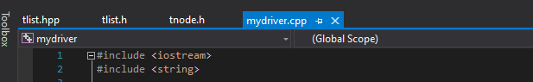

Output:

