**Assignment 3:**

Files are stack.h, stack.hpp, in2post.cpp

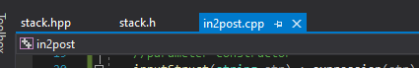

Output:

