VISUAL PROGRAMMING

SMART EDITOR Project Report

KINZA KIRAN

BS-SE V sec B

CMS-ID: 053-18-0011

**Introduction:**

Smart editor is flexible and easy to use. It provides all the functionalities as simple editor and additional functionalities as well.

Following are the main functionalities:

* File (new, Open file, Save File, exit)
* Edit (undo, cut, copy, paste, find, find next, replace, select all, date and time)
* Format (word wrap, font)
* View (status bar)
* Help (view help, about)
* Voice Type(male, female)
* Jarvis mode
* Option of dark mode and light mode.
* User profile (login and create account).
* Send mail.
* Save and open PDF.
* Text to Audio file.
* Read Text (pause and resume).
* Audio File to Text.
* Database:

User can save the state of smart editor and next time don’t need to change the state just login account.

Smart editor state contains mode (dark or light), voice type (male or female), font, font size, font color and font style.

User can view current state and saved state, update state and delete account.

**DESCRIPTION OF FORMS:**

1. **LoginAccount**: User can login into account or create account. User have to enter username and password.

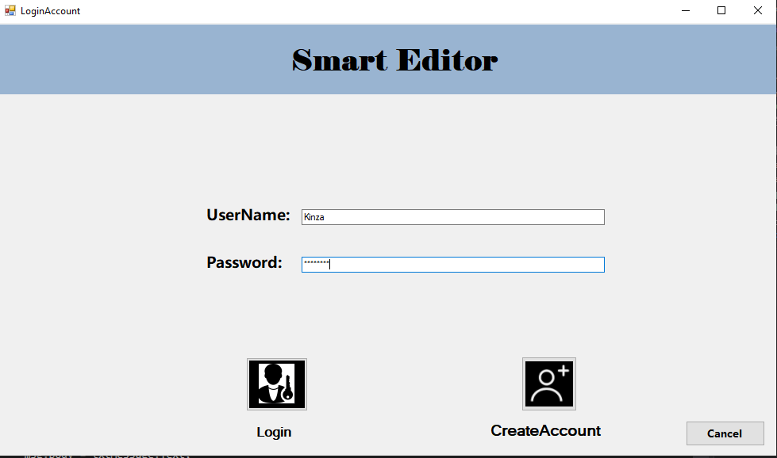

1. **Editor**: (Form1) This form has the main functionalities. User can **send mail**, for sending mail user has two options to send mail and attach any file and another is to save the text written in richtextbox into pdf and send mail.

* User can **save file and open PDF**. To open PDF I have used instances of PdfReader, ITextExtractionStrategy and for extracting text method of pdfTextExtractor is used.
* For saving pdf pdfWriter is used.
* The editor can convert the **speech to text**. For conversion instance and methods of SpeechRecognitionEngine is used.
* **Text to audio file,** when user press button saveFileDialog is used to save the .wav file. Instance of promtBuilder and speechSynthesizer are used.
* Editor is able to **read the text** written in rich text box. Here also SpeechSynthesizer is used and SpeackAsyn(string) method is used to read the text. User can also **pause** and **resume** the voice by pressing button.
* The editor is able to convert the **Audio File into Text**, the audio will be converted into text and written on rich text box.
* Editor has Functionality of Jarvis mode: Editor can open paint, notepad, MS word, power point, google, youTube and command line. Editor will provide options and user has to speak and tell the option to editor and editor will open that option.
* User can save file and open new file.
* User can cut, copy, paste, select all and undo text.
* User can find text and find next.
* User can view current time and date.
* User can change Font (FontDialog is used). User can change font style, font , color etc.
* User can view status bar and view help.
* User can change voice type, user has two options of female voice and male voice.
* User can set dark mode and light mode.

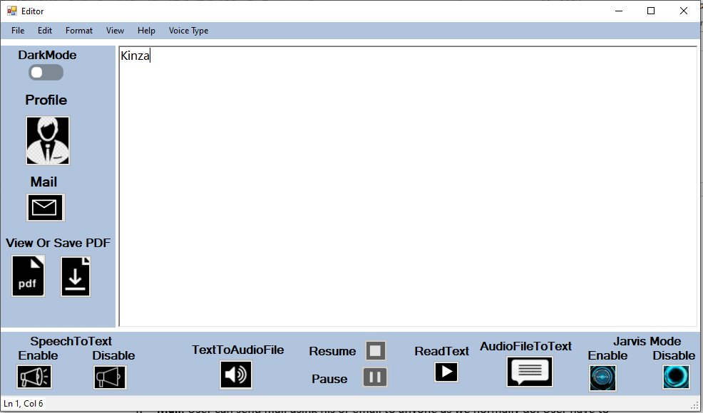

1. ChooseOption: This form provides two options for sending mail. One to send mail another to save and directly attach file of text written in rich text box.

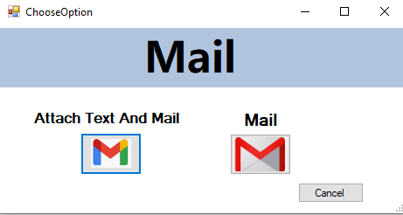

1. **Mail**: User can send mail using his or email to anyone as we normally do. User have to provide email(@gmail.com) and password. Email has the same format like: send to, cc, subject and body. For sending mail user first has to allow less secure apps in google settings then he/she will be able to send mail. For sending mail, I have used instances and methods of SmtpClient, NetworkCredentials and MailMessage.

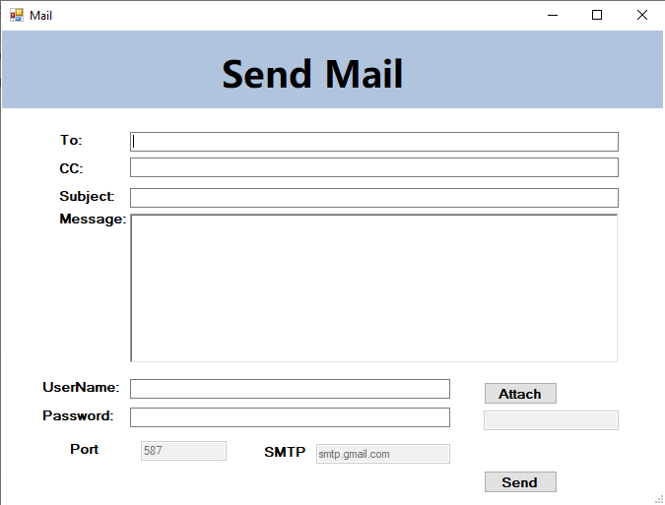

1. **UserProfile**: This form view the information of user. User can view current state, update current state and delete account. Database is used here.

**Below is the dark mode of text editor**.

