LOGIN

Call us: 0331 234567

image

**NAME**

Manager

View profile

**NAME**

Manager

View profile

Alumni

Gallery

Descripton Descripton Descripton

Descripton Descripton Descripton

Descripton Descripton Descripton

Descripton Descripton Descripton

IMAGE

About IBA

Event title

Event title

Event title

Jan 18

Jan 18

Jan 18

**< >**

IMAGES(Slide show)

Events

10-10-2020

Title of the story

_____

10-10-2020

Title of the story

_____

Stories

Contact

Stories

Home

Alumni

Events

Gallery

SUKKUR IBA LOGO

Footer:

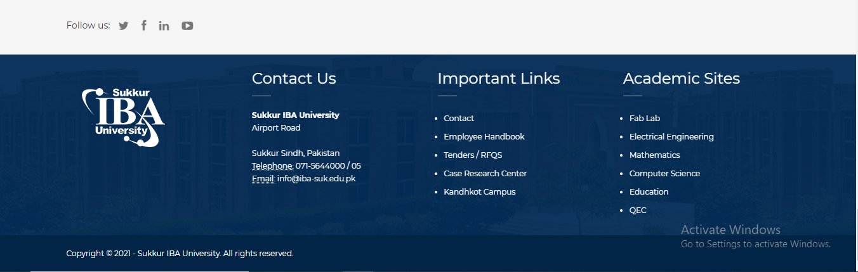

**Login Button have two options Login as student and login as Admin:**

**We will focus on Admin part.**

Sign in

Remember me

Password:

Username:

**Alumni Mangement System**

Sukkur IBA Univeristy

LOGO

Create new account

Forget password

**After successfully login Dashboard will appear.**

**This will scroll down into**

Don’t know what to show here

You have added a student

You have added a student

You have added a student

You have added a student

**You have 10 notifications**

View all

Log out

Profile

**John** designer

Member since 2016

**John**

designer

**After clicking this**

**Home >** Dashboard

**Dashboard**

**Notofication option**

**John**

**Setting option**

**About**

**Contact**

**Gallery**

**Stories**

**Student >**

**Dashboard**

Main navigation

SUKKUR IBA

**All students**

**Add students**

**Student profile**

**Option Student and Student Profile > Activity**

**John**

designer

**Dashboard**

**Notofication option**

**John**

**Setting option**

**About**

**Contact**

**Gallery**

**Stories**

**Student >**

**Dashboard**

Main navigation

SUKKUR IBA

Search option

**Name CMS-ID** **Department**

**Experience:**

**Education:**

**Skills:**

Description

**Activity Update Deatils**

**Name: Department:**

Name department

**Email Phone no:**

Email phone

**Address:**

Address street city country

Image

**Home >** student profile

**Option Student and Add students**

**John**

designer

**Dashboard**

**Notofication option**

**John**

**Setting option**

**About**

**Contact**

**Gallery**

**Stories**

**Student >**

**Dashboard**

Main navigation

SUKKUR IBA

**Home >**Add students

Experience

Education

Skills

Description

Drop image here or click to upload

Select gender >

Address

Date of birth

Mobile no

Department

CMS-ID

Fullname

**Student’s Information**

And at the end footer will be added that is still not decided

Search option

**Option Student and All students**

**John**

designer

**Home >** All students

**Dashboard**

**Notofication option**

**John**

**Setting option**

**About**

**Contact**

**Gallery**

**Stories**

**Student >**

**Dashboard**

Main navigation

SUKKUR IBA

In this way all students will be shown.

And at the end footer will be added that is still not decided

Image

**John**

Web developer

**John**

Web developer

Image

**John**

Web developer

**John**

Web developer

Image

Image

Search option

**Stories**

**John**

designer

**Home >** Stories

**Dashboard**

**Notofication option**

**John**

**Setting option**

**About**

**Contact**

**Gallery**

**Stories**

**Student >**

**Dashboard**

Main navigation

SUKKUR IBA

And at the end footer will be added that is still not decided

**Create account:**

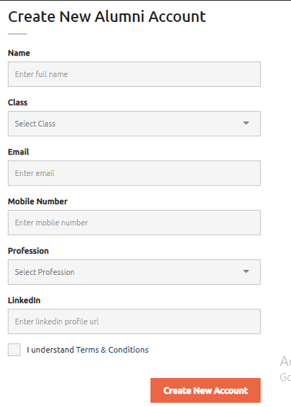

**I think stories and gallery options should be removed. We can add mailings or other useful options.**

**Mailing option can be like:**

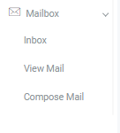

**Inbox:**

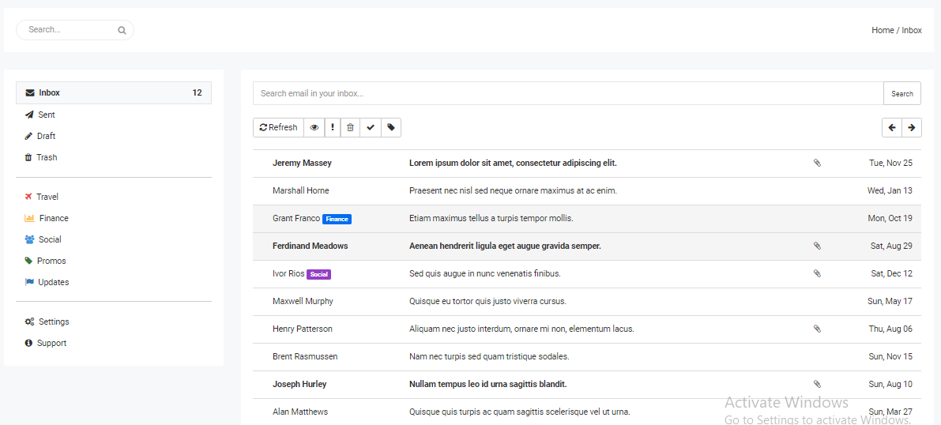

**View mail:**

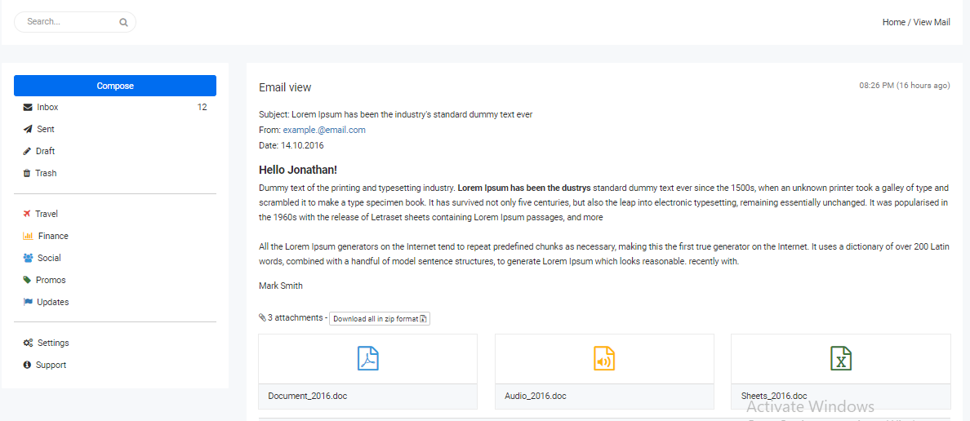

**Compose mail:**

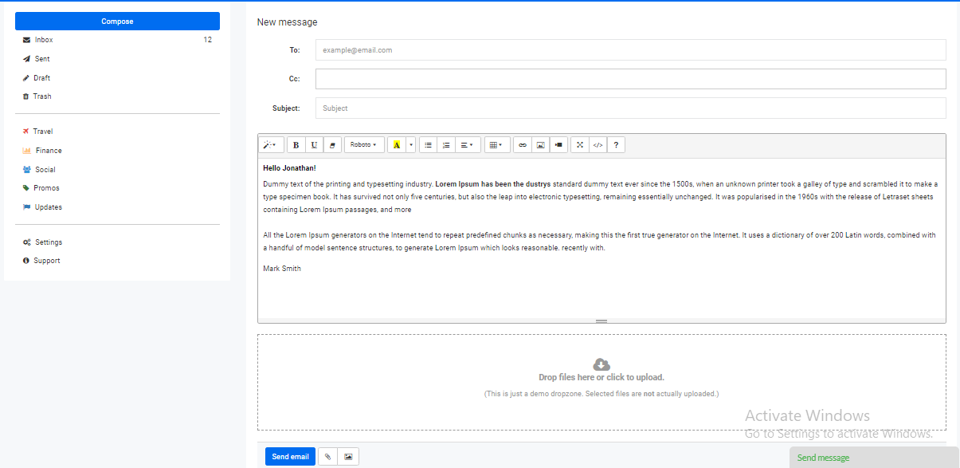

**For contact we can use the mobile numbers of students and send them message if possible.**

**Or can add other options (tell me if you think of any)**

**This template looks good.**

[**https://adminlte.io/themes/AdminLTE/index2.html**](https://adminlte.io/themes/AdminLTE/index2.html)