
WEB TECHNOLOGIES

Lab 02
Responsive Navbar and Grid Drill

Name: KINZA
Roll no: FA24-BCS-136
Section: A

Submitted to: M. Usman Akram

Department of Computer Science
COMSATS University Islamabad (CUI), Lahore Campus

LAB STATEMENT
A focused, smaller-scale rehearsal for Assignment 2: build just a responsive navbar
(logo left, links center, cart icon right, collapsing into a hamburger menu below 768px) and a 4-column-desktop / 2-column-tablet / 1-column-phone product grid, using Flexbox or Grid plus Bootstrap or Tailwind. Content can be placeholder text/images — the point is the responsive mechanics, not the final design.

SCREENSHOTS

Desktop:
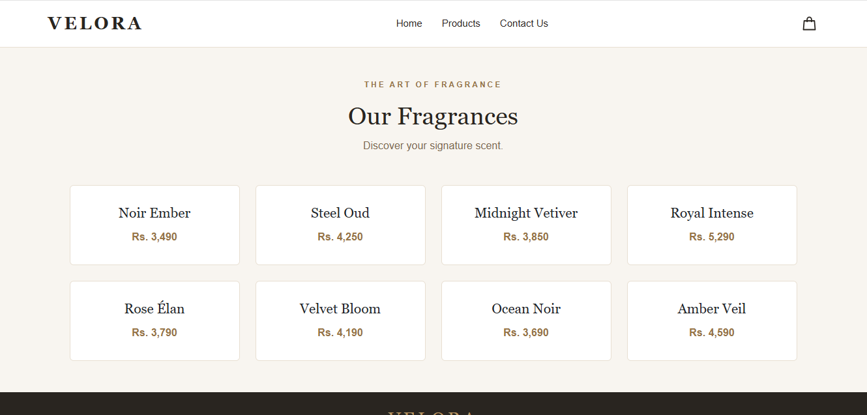


Tablet

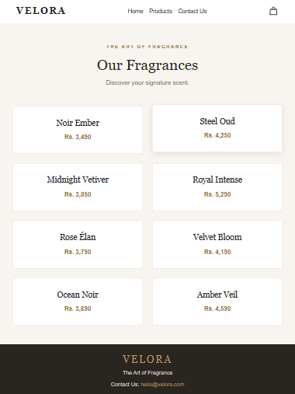

MOBILE
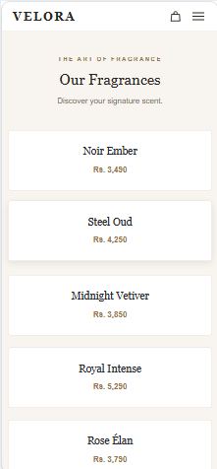

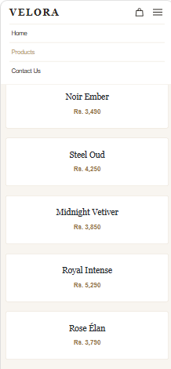
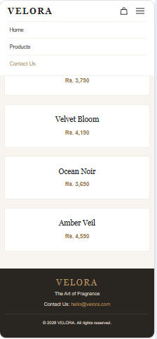

index.html

<!DOCTYPE html>
<html lang="en">
<head>
<meta charset="UTF-8">
<meta name="viewport" content="width=device-width, initial-scale=1.0">

<title>VELORA | Lab 2</title>

<link href="https://cdn.jsdelivr.net/npm/bootstrap@5.3.3/dist/css/bootstrap.min.css" rel="stylesheet">
<link rel="stylesheet" href="styles.css">
</head>
<body>

<!-- Navigation bar -->
<nav class="navbar">

<a href="#" class="logo">VELORA</a>

<input type="checkbox" id="menu-toggle">

<div class="nav-links">
<a href="#">Home</a>
<a href="#products">Products</a>
<a href="#footer">Contact Us</a>
</div>

<div class="nav-right">

<!-- Shopping bag icon -->
<a href="#products" class="cart" aria-label="Shopping bag">
<svg viewBox="0 0 24 24" width="27" height="27"
fill="none" stroke="currentColor"
stroke-width="1.6" stroke-linecap="round"
stroke-linejoin="round" aria-hidden="true">
<path d="M5 8h14l1 12H4L5 8Z"></path>
<path d="M9 9V6a3 3 0 0 1 6 0v3"></path>
</svg>
</a>

<!-- Menu button for mobile screens -->
<label for="menu-toggle" class="hamburger"
aria-label="Toggle navigation">
<span></span>
<span></span>
<span></span>
</label>

</div>
</nav>

<!-- Fragrance products -->
<main class="container py-5" id="products">

<div class="text-center mb-5">
<p class="subtitle">THE ART OF FRAGRANCE</p>
<h1>Our Fragrances</h1>
<p class="intro-text">Discover your signature scent.</p>
</div>

<div class="product-grid">

<div class="card">
<div class="card-body">
<h5 class="card-title">Noir Ember</h5>
<p class="card-text">Rs. 3,490</p>
</div>
</div>

<div class="card">
<div class="card-body">
<h5 class="card-title">Steel Oud</h5>
<p class="card-text">Rs. 4,250</p>
</div>
</div>

<div class="card">
<div class="card-body">
<h5 class="card-title">Midnight Vetiver</h5>
<p class="card-text">Rs. 3,850</p>
</div>
</div>

<div class="card">
<div class="card-body">
<h5 class="card-title">Royal Intense</h5>
<p class="card-text">Rs. 5,290</p>
</div>
</div>

<div class="card">
<div class="card-body">
<h5 class="card-title">Rose Élan</h5>
<p class="card-text">Rs. 3,790</p>
</div>
</div>

<div class="card">
<div class="card-body">
<h5 class="card-title">Velvet Bloom</h5>
<p class="card-text">Rs. 4,190</p>
</div>
</div>

<div class="card">
<div class="card-body">
<h5 class="card-title">Ocean Noir</h5>
<p class="card-text">Rs. 3,690</p>
</div>
</div>

<div class="card">
<div class="card-body">
<h5 class="card-title">Amber Veil</h5>
<p class="card-text">Rs. 4,590</p>
</div>
</div>

</div>

</main>

<!-- Contact information -->
<footer id="footer">

<h3>VELORA</h3>
<p>The Art of Fragrance</p>
<p>
Contact Us:
<a href="mailto:hello@velora.com">hello@velora.com</a>
</p>

<p class="copyright">
&copy; 2026 VELORA. All rights reserved.
</p>

</footer>

</body>
</html>

styles.css

/* Basic page styling */
body {
margin: 0;
background-color: #F8F5F0;
color: #292520;
font-family: Arial, sans-serif;
}

/* Navbar stays at the top */
.navbar {
display: flex;
align-items: center;
justify-content: space-between;
padding: 15px 6%;
background-color: white;
border-bottom: 1px solid #E8DFD2;
position: sticky;
top: 0;
z-index: 1000;
width: 100%;
box-sizing: border-box;
}

.logo {
color: #292520;
font-family: Georgia, serif;
font-size: 27px;
font-weight: bold;
letter-spacing: 4px;
text-decoration: none;
white-space: nowrap;
}

/* Navigation links */
.nav-links {
display: flex;
align-items: center;
gap: 30px;
}

.nav-links a {
color: #292520;
text-decoration: none;
font-size: 15px;
}

.nav-links a:hover {
color: #B49463;
}

/* Shopping bag and menu button */
.nav-right {
display: flex;
align-items: center;
gap: 15px;
}

.cart {
display: flex;
align-items: center;
color: #292520;
text-decoration: none;
}

.cart:hover {
color: #B49463;
}

#menu-toggle {
display: none;
}

.hamburger {
display: none;
flex-direction: column;
justify-content: center;
gap: 5px;
cursor: pointer;
padding: 6px;
}

.hamburger span {
display: block;
width: 24px;
height: 2px;
background-color: #292520;
border-radius: 2px;
}

/* Heading and introductory text */
.subtitle {
color: #967447;
letter-spacing: 3px;
font-size: 12px;
font-weight: bold;
}

h1, h2, h3, .card-title {
font-family: Georgia, serif;
}

h1 {
font-size: 38px;
margin-bottom: 12px;
}

.intro-text {
color: #806A50;
}

/* Product cards */
.product-grid {
display: grid;
grid-template-columns: repeat(4, minmax(0, 1fr));
gap: 24px;
}

.card {
background-color: white;
border: 1px solid #E8DFD2;
border-radius: 6px;
text-align: center;
transition: transform 0.3s, box-shadow 0.3s;
}

.card:hover {
transform: translateY(-4px);
box-shadow: 0 5px 15px rgba(41, 37, 32, 0.10);
}

.card-body {
padding: 30px 15px;
}

.card-title {
font-size: 21px;
margin-bottom: 12px;
}

.card-text {
color: #967447;
font-weight: bold;
margin-bottom: 0;
}

/* Footer */
footer {
background-color: #292520;
color: #F8F5F0;
text-align: center;
padding: 25px 15px;
}

footer h3 {
color: #B49463;
letter-spacing: 4px;
margin-bottom: 8px;
}

footer p {
color: #D8CFC2;
font-size: 14px;
margin: 8px 0;
}

footer a {
color: #B49463;
text-decoration: none;
}

footer a:hover {
text-decoration: underline;
}

footer .copyright {
border-top: 1px solid #51483D;
padding-top: 15px;
margin-top: 18px;
font-size: 12px;
}

/* Tablet layout */
@media (min-width: 768px) and (max-width: 1023px) {
.product-grid {
grid-template-columns: repeat(2, minmax(0, 1fr));
}

.nav-links {
gap: 15px;
}

.logo {
font-size: 23px;
}
}

/* Mobile layout */
@media (max-width: 767px) {
.navbar {
flex-wrap: wrap;
padding: 12px 5%;
}

.logo {
font-size: 23px;
margin-right: auto;
}

.nav-right {
margin-left: 15px;
}

.hamburger {
display: flex;
}

.nav-links {
display: none;
flex-direction: column;
align-items: stretch;
gap: 0;
width: 100%;
order: 3;
padding-top: 12px;
}

.nav-links a {
display: block;
padding: 12px 5px;
border-top: 1px solid #E8DFD2;
}

/* Show menu when clicked */
#menu-toggle:checked ~ .nav-links {
display: flex;
}

.product-grid {
grid-template-columns: 1fr;
}

h1 {
font-size: 30px;
}
}

