
FAIR data engineering – 2024-2025

FAIR LOANs
Fairification of loan data

Kiona Bijker (s1979418)
ragunath seenivasagan ( s3482820)

16-09-2025

Fair LOANS
Fairification of loan data

Kiona Bijker (s1979418)
ragunath seenivasagan ( s3482820)

07-11-2025


TABLE OF CONTENTS

1. Introduction 3
2. FAIRification planning 4
2.1 FAIRification goals 4
2.2 Target resource(s) 4
2.3 Target stakeholders 4
2.4 Reuse stakeholders 4
2.5 FAIRification requirements 5
2.6 Semantic types 5
2.7 Competency questions 6
3. FAIRification process 6
3.1 initial fairness assessment 6
3.2 Semantic data model 7
3.3 Data triplification 9
3.4 Semantic metadata model 11
3.5 Metadata and data publication 12
3.6 Final FAIRness assessment 13
4. discussions and Conclusions 14
5. annexes 15
5.1 The metadata shacl 15
5.2 DATA SHACL 20

Introduction
Within this project we will be FAIRifying the ‘Lending Club’ dataset. This is a financial dataset of various loans containing 27 columns and a little over a million rows in a csv format. The dataset is available at https://datasetsearch.research.google.com/search?query=lending%20club%20-site%3Akaggle.com&docid=L2cvMTFzand2ZHJzYg%3D%3D and published under the CC0 Public domain license.
We have some financial expertise in the team as Ragunath Seenivasagan used to be a Data Steward in the banking sector. To reduce workload we will filter to records including unique/rare values (such as ‘Joint App’) and add from the remaining rows at random. In this project we will be using 1000 rows and the following columns:
Name column | Description | Type
issue_d | Issue date of loan | Date
sub_grade | Grade awarded to person requesting loan, seems to determine interest rate | String, may be enumerable
term | Time to pay back loan | Integer “months”
home_ownership | Seems to be MORTGAGE or RENT | String, may be enumerable
fico_range_low | Low end of the credit score | Integer
pub_rec | Public records on person (criminal, bankruptcy, etc. anything filed in courts) | Integer
revol_util | Revolving credit line utilisation rate (use loan as source for other loan application or as a balance to take from as needed) | Decimal number
int_rate | Interest rate | Decimal number
application_type | Mainly ‘Individual’ some ‘Joint App’, describes number of people applying | String, may be enumerable
verification_status | Verified, Not Verified, or Source Verified. ID and other truth checks in loan application | String, may be enumerable
addr_state | State the registered address of applicant is located in | String, may be enumerable
fico_range_high | High end of the credit score | Integer
id | ID of loan application | Integer
emp_length | Duration of total employment | Integer
loan_status | Loan approved or not | 1 or 0, boolean

FAIRification planning

FAIRification goals
- G1 (Findable): Assign W3ID persistent identifiers (PIDs) for the dataset, its versions, and key entities such as loans and applicants. Publish indexable metadata with globally resolvable URIs to improve discoverability.
- G2 (Accessible): Release both CSV and RDF/JSON-LD representations via HTTPS, ensuring permanent open access to metadata. Maintain versioned snapshots for traceability and reproducibility.
- G3 (Interoperable): Convert the dataset into RDF using OpenRefine (RDF extension) and align its schema in Protégé with FIBO–Loan and Schema.org vocabularies for semantic interoperability.
- G4 (Reusable): Provide a clear license (CC0), data card, and documentation of data quality and fairness metrics. Validate structural integrity and constraints using SHACL and publish the validation reports.

Target resource(s)
Resource | Description
train-lending-club-filtered1000.csv | Main dataset with loan information (issue date, sub-grade, term, etc.)
train-lending-club-filtered1000-csv.rdf | RDF/JSON-LD exports created with OpenRefine RDF extension
Protégé FAIR Data Group12.owx | Ontology designed in Protégé linking dataset fields to FIBO and schema.org
Shacl-train-lending-club-filtered1000-csv.ttl | SHACL constraints and validation results
FAIR_Loan_Dataset.ttl | FAIR metadata record describing the dataset
/.htaccess (w3id repo) | Redirect rules mapping w3id URIs to live dataset locations

Target stakeholders
- Data owners or stewards: Course/research data stewards; dataset maintainers.
- Data engineers: People building features, pipelines, and models on Lending Club data.
- Subject Matter Experts: Credit risk analysts, economists.
- Governance/compliance: Research ethics boards, DPOs, EU AI Act/GDPR compliance teams
- Educators or students: Using the corpus for teaching ML/fairness

Reuse stakeholders
- Academia: Fairness/bias researchers; reproducibility studies
- Industry: FinTech risk teams, explainability tooling vendors
- Policy & audit: Auditors/regulators evaluating model fairness & documentation
- Open-source community: Benchmark creators
- Civic tech & NGOs: Consumer-rights orgs studying credit access equity

FAIRification requirements
- Ensure that any columns containing personal or identifying information remain pseudonymized.
- Use controlled vocabularies, particularly FIBO, to describe financial and credit-related concepts.
- Apply SHACL constraints to validate required fields and datatype/range restrictions.
- Release all resources under the CC0 license, including clear provenance metadata.
- Maintain data accessibility through HTTPS and verify file integrity using checksums.
- Document all OpenRefine transformation steps in a provenance file for transparency and reproducibility.

Semantic types
Classes:
Class | Description
Loan_Application | A loan request/record containing terms, status, subgrade, interest rate, FICO, etc.
Applicant | The person associated with the loan application.
Subgrade | Letter–number credit grade used for pricing (e.g., A1, B3).
Fico_Range | Numeric FICO score bounds (low/high) tied to a loan/application.

Data Properties:
Property | Domain | Datatype | Description
ID | Loan_Application | string | Unique identifier for the loan/application.
issue_date | Loan_Application | date | Date the loan/application was issued.
term | Loan_Application | int | Term in months (e.g., 36, 60).
interest_rate | Loan_Application | decimal | Percentage rate (e.g., 13.49).
loan_status | Loan_Application | boolean | 1 = approved/current; 0 = rejected/closed (as defined).
application_type | Loan_Application | string | “Individual”, “Joint”, etc.
revolving_utilisation | Loan_Application | decimal | Revolving utilization ratio/percent.
public_record | Loan_Application | int | Count of public records.
sub_grade | Subgrade | string | Code like A1, B3.
fico_range_low | Fico_Range | int | Lower FICO bound.
fico_range_high | Fico_Range | int | Upper FICO bound.
employment_length | Applicant | int | Years of employment.
home_ownership_status | Applicant | string | “MORTGAGE”, “RENT”, “OWN”, etc.
verification_status | Applicant | string | “Verified”, “Source Verified”, “Not Verified”.
state | Applicant | string | Two-letter state code (or region).

Object properties:
Property | Domain | Range | Description
hasApplicant | Loan_Application | Applicant | Link each loan/application to its applicant.
hasEmployment | Applicant | Record/concept | Use if you model employment as a node; else keep as data property employment_length.
hasFicoRange | Loan_Application | Fico_Range | Connects a loan/application to its FICO bounds.
hasHomeOwnershipStatus | Applicant | record | Use if modeling status as a node; else use data property home_ownership_status.
hasInterestRate | Loan_Application | subgrade | Optional conceptual link; numeric value is interest_rate.
hasSubgrade | Loan_Application | Subgrade | Assigns the subgrade (A1…G5).
influencedBy | Subgrade | Fico_Range | Optional: capture that subgrade is influenced by FICO.

Competency questions
- How can a user query for all approved loans (loan_status = 1) issued after a specific date?
- What is the average interest rate grouped by sub_grade or application_type?
- How can we retrieve the FICO score range and associated interestRate for a given loan?

FAIRification process

initial fairness assessment
Principle # | Criteria | Conformance | Note
F1 | Globally unique identifier | partially | Identifier is unique within dataset but likely no longer unique when combining data across banks
F1 | Persistent identifier | no | Unknown, no persistence policy given
F2 | Has metadata | yes | Found on kaggle and figshare
F2 | Has rich metadata | partially | Provides license and some provenance
F3 | Has data identifier in metadata | yes | Link provided
F3 | Has data identifier with clear predicate in metadata | no | Just DOI under “unique identifier” predicate
F4 | Indexed/registered in search resource | yes | Google dataset search
A1 | Has resolution protocol | yes | HTTP
A1.1 | Protocol is open, free and universally implementable | yes
A1.2 | Protocol has authentication and authorisation mechanisms | yes | HTTPS has these
A2 | Metadata has longer persistency than data | no | There is no clear policy to retain metadata after the dataset is no longer available
I1 | (meta)data | no | Column names are unclear, do seem to be somewhat common use

Semantic data model
Based on our joint knowledge of the domain we came up with the following initial sketched model (made with draw.io).

As existing vocabularies we used FIBO, especially the loan applications module (https://spec.edmcouncil.org/fibo/ontology/LOAN/LoansGeneral/LoanApplications/ ) and wikidata. The exact links can be found in the data shacl in the annexes as well as the rdf.
We added the following structure using Protege to extend the existing vocabularies.

Using this, below is the updated semantic model (again made with draw.io) using the ontology names. For readability the hasValue fields and the full links have been left out.

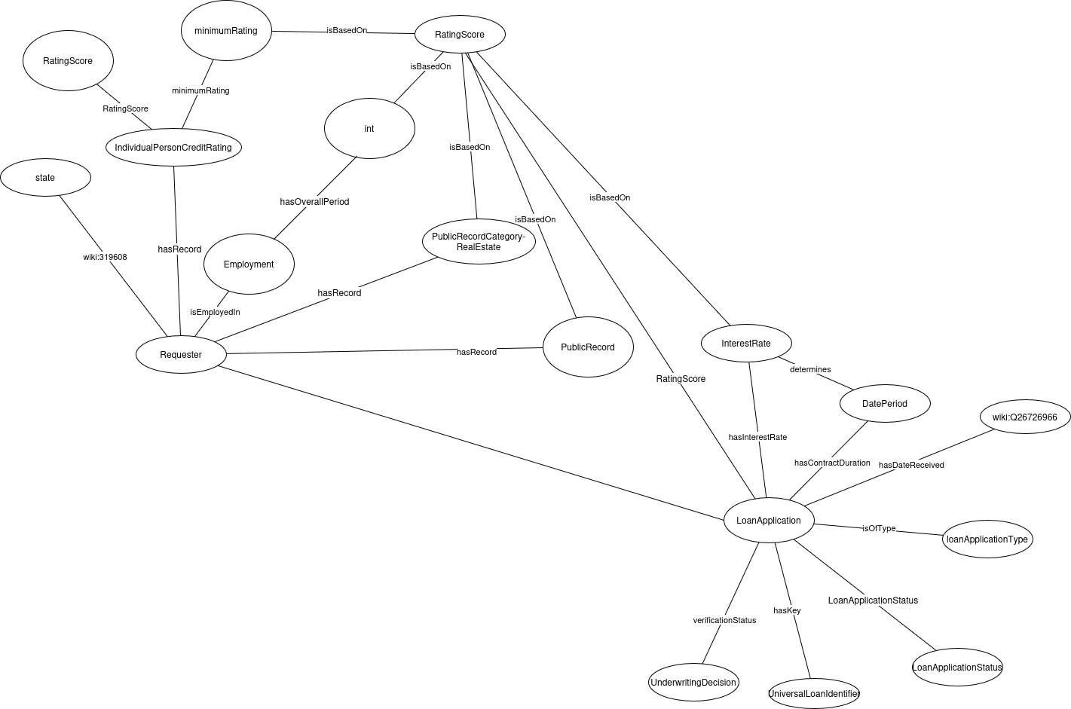

Data triplification
Within the triplification we did not include the current and previous employment as there we could not find URIs for such relations. Instead employment directly connects to employment length.
See the OpenRefine screenshots below for triplification.
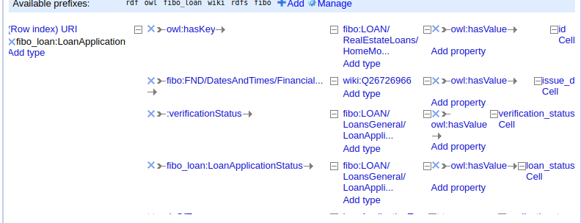

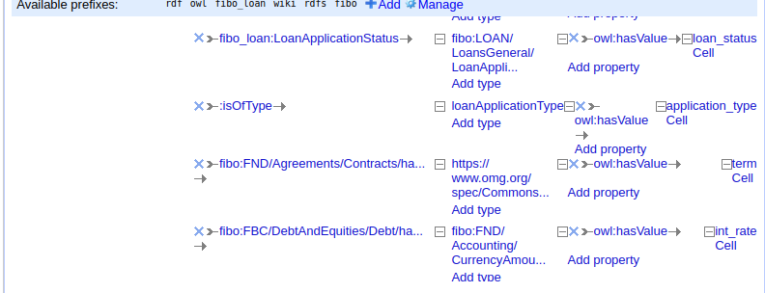
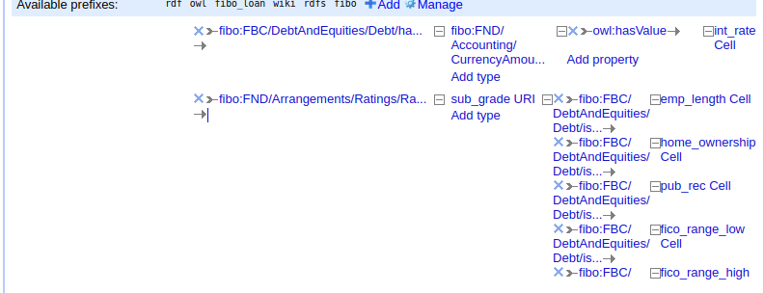

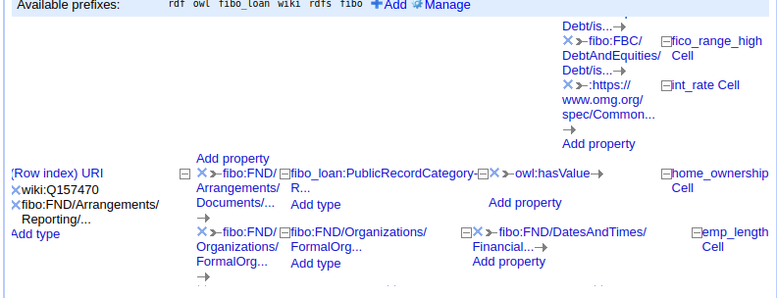

Semantic metadata model
See the metadata SHACL in the annex.
For the metadata we assumed that each dataset for loans will have differing amounts of information available. Next to the standard UI language, license and dates available we added the following fields:
Contact person (name & email) | This information allows a future user to contact the data steward for this data set with questions and issues regarding the dataset. We assume no dataset metadata form will be perfect for each use of the dataset. A way to contact a person who may have or know how to find the information for such uses, or can say it does not exist, saves future users time and guesswork.
Semantic model (URI) | Here the semantic model of the dataset can be linked. This improves accessibility and interoperability. By linking the model it does not have to be a Turtle or XML file but can also be a picture of a hand drawn graph.
Data source (URI) | An optional field for datasets based on other datasets. This is the link to the dataset pre-modification
Data provenance (text) | An explanation of how and why the dataset was created or modified. A text field allows for links without making a link to an outside project necessary.
Vocabularies used (URI) | This field adds context to the dataset and its semantic model. Adding the vocabularies used by the dataset also makes possible connections to other datasets (interoperability) more clear.
Data sample (text) | A simple excerpt from a record in the dataset. This gives a user a case to work from when programming.
Sample queries (text) | Example queries the database could answer.
Data management policy (text) | Indicates how long data and metadata will be available and how they may be used or changed over time. This can be a plain text explanation or a link to an external document
AI flag (Boolean) | If true the data is synthetic data
Language(s) of the data (URI) | The language(s) used within the data restrict who can understand both the records and query results.
Extra information (text) | A complete form is rare. This text space allows the dataset uploader to add any notable information that did not fit other categories.

Metadata and data publication
Metadata Record:
The metadata describing the dataset is published in RDF (Turtle) format and is accessible through the FAIR Data Point and GitHub repository.
  - GitHub metadata file:
🔗https://github.com/KionaB/FAIRscripts/tree/785e84beccf7b95cef719e16d544e0e0fdbf318c/FAIR%20Data%20Point
Dataset Publication:
The FAIRified dataset is openly available on GitHub and can be accessed using the persistent W3ID link.
- Dataset file on GitHub:
🔗https://github.com/KionaB/FAIRscripts/tree/785e84beccf7b95cef719e16d544e0e0fdbf318c/fairified/data
Notes:
- The .htaccess file in the W3ID namespace ensures persistent redirection to these resources.
- Metadata and data are publicly accessible and linked through globally unique identifiers.
- Both are released under the CC0 license, ensuring unrestricted reuse.

Final FAIRness assessment
Principle # | Criteria | Conformance pre FAIRification | Conformance post FAIRification | Note
F1 | Globally unique identifier | partially | partially | The data uses identifiers unique within the dataset. The dataset has a globally unique identifier
F1 | Persistent identifier | no | yes | W3id was added to provide globally resolvable, persisitent identifiers that remain valid even if the data’s location changes
F2 | Has metadata | yes | yes | Metadata is available and maintained; it provided descriptive information for discovery and reuse
F2 | Has rich metadata | partially | yes | Rich metadata was created including context, schema and FAIR- compliant descriptive properties, improving findability
F3 | Has data identifier in metadata | yes | yes | The metadata explicitly includes the dataset’s unique identifier, ensuring proper linkage between data and metadata
F3 | Has data identifier with clear predicate in metadata | no | yes | Added htaccess file and a readme explaining the namespace and linking predicates for identifiers
F4 | Indexed/registered in search resource | yes | yes | The dataset is published in Github, which allows indexing and discovery visa search engines and metadata registries
A1 | Has resolution protocol | yes | yes | The dataset can be accessed over HTTP/HTTPS, providing a standardized resolution protocol
A1.1 | Protocol is open, free and universally implementable | yes | yes | HTTP/HTTPS protocol is open and universally supported across platforms and clients
A1.2 | Protocol has authentication and authorisation mechanisms | yes | yes | HTTPS supports authentication and authorization where required, ensuring controlled data access
A2 | Metadata has longer persistency than data | no | yes | Metadata is preserved and accessible independently (via GitHub/W3iD) even if data is removed or relocated
I1 | (meta)data use a formal, accessible, shared, and broadly  applicable language for knowledge representation | no | yes | Metadata and data were represented using RDF/Turtle and validated via SHACL, ensuring interoperability
I2 | (meta)data use vocabularies that follow FAIR principles; | no | partially | Controlled vocabularies from FIBO and Wikidata were reused, improving semantic alignment though not to completion. Whether the vocabularies fully follow FAIR is unclear.
I3 | (meta)data include qualified references to other (meta)data; | no | partially | The vocabularies used allow for easy referencing and linking to data within the same domain
R1 | (meta)data are richly described with a plurality of accurate and  relevant attributes | partially | yes | SHACL shapes and extended metadata descriptions were added to provide more accurate and machine-readable attributes
R1.1 | (meta)data are released with a clear and accessible data  usage license | Yes (CC0) | Yes (CC0) | The dataset and metadata were released under the CC0 license, ensuring open reuse without restrictions
R1.2 | (meta)data are associated with detailed provenance; | partially | yes | Provenance information (eg., source repositories from kaggle and Figshare) was included to trace data origin and transformations

discussions and Conclusions
In this project we FAIRified the Lending Club Loan dataset of loans. This dataset had a CC0 license which we preserved. The existing provenance was also preserved. We added semantic structure to the data using the Financial Industry Business Ontology (FIBO) and WikiData vocabularies. Since the dataset’s relations and entities were not all fully covered by these vocabularies some concepts were added using Protégé. Finding these vocabularies and deciding when to define our own concepts was one of our most significant challenges. While loan concepts, especially mortgages, are covered in many ontologies, concepts for loan applications are less so. When we found FIBO we found an ontology that covered loan applications but did not fully cover the specific way Lending Club set up their database. Especially the loan application types (joint or individual) and the lack of requester ID made finding a fitting vocabulary difficult. By using FIBO and WikiData the FAIRified dataset has improved interoperability and semantic clarity.

With the combined vocabulary the dataset could be triplified, creating a linked dataset. Linking the data has made the relations between entities machine readable. To improve the findability for future use we implemented globally unique and persistent identifiers using a W3ID namespace (https://w3id.org/FAIR-course-UT/2025/group12/main). The dataset had internally unique identifiers for loan applications, not for requesters. Since the requesters were not clearly identified we could not add unique identifiers for them. We did add metadata identifiers linking the data and metadata together so the data can be found from the metadata. The W3ID namespace guarantees stable long-lasting identifiers that can be redirected to where the data is. We did so through an htaccess file meaning that even if the location of the data or metadata changes the W3ID identifiers will still work (simply redirecting to a new location).

To ensure the structure of both the data and the metadata we created a shacl definition for each. The metadata shacl ensures that the metadata for the dataset is consistent with each following version of it. The form defined by the metadata shacl provides a structure for rich metadata which results in a machine-readable Turtle file of the metadata without a need to write such a file. The shacl of the dataset allows for adding records to the dataset that follow the FAIRified structure of the current dataset. This way the current 1000 records can be extended.

The FAIRification process for this dataset was challenging in ways we did not foresee when we started. We learned that structuring the data was relatively easy once we had the vocabularies we needed. Trying to find those vocabularies showed us why so many datasets use a new vocabulary specific to that dataset or no (official) vocabulary at all. We also saw how much work goes into FAIR data maintenance including updating redirects and keeping the metadata current enough. Through our FAIRification process we gained a better understanding of Linked Data technologies and how to create a machine-readable and usable dataset. We also learned that a FAIRified dataset does not need to be perfectly FAIR, it rarely can be if based on an existing dataset. Even though our FAIRified dataset does not have globally unique identifiers on each level, nor references other datasets; we still improved this dataset significantly.

annexes

The metadata shacl
@prefix sh: <http://www.w3.org/ns/shacl#> .
@prefix schema: <http://schema.org/> .
@prefix rdfs: <http://www.w3.org/2000/01/rdf-schema#> .
@prefix xsd: <http://www.w3.org/2001/XMLSchema#> .
@prefix dash: <http://datashapes.org/dash#> .
@prefix foaf: <http://xmlns.com/foaf/0.1/> .
@prefix vcard: <http://www.w3.org/2006/vcard/ns#> .
@prefix ex: <http://example.com/> .
@prefix lexvo: <http://lexvo.org/id/iso639-1/> .
@prefix fair: <http://fairdatapoint.org/> .
@prefix dash: <http://datashapes.org/dash#> .
@prefix dct: <http://purl.org/dc/terms/> .
@prefix fdp: <https://w3id.org/fdp/fdp-o#> .
fair:FDPShape
a sh:NodeShape ;
sh:targetClass fdp:FAIRDataPoint ;
rdfs:label "Fair Data Point metadata";
sh:property fair:StartDateProperty,
fair:EndDateProperty,
fair:UILanguageProperty,
fair:MetaDataIdentifierProperty,
fair:MetaDataIssuedProperty,
fair:MetaDataModifiedProperty,
fair:ContactPersonProperty,
fair:SemanticModelProperty,
fair:DataSourceProperty,
fair:DataProvenanceProperty,
fair:DataVocabularyProperty,
fair:DataSampleProperty,
fair:DataSampleQueriesProperty,
fair:DataManagementPolicyProperty,
fair:DataAIgeneratedFlagProperty,
fair:DataLanguageProperty,
fair:LicenseProperty,
fair:ExtraInformationProperty;
.
#Groups are used to cluster questions together
fair:ContactPropertyGroup
a sh:PropertyGroup ;
rdfs:label "Contact";
.
fair:ContactPersonProperty
a sh:PropertyShape ;
sh:group fair:ContactPropertyGroup ;
sh:minCount 0;
dash:editor dash:DetailsEditor ;
dash:viewer dash:DetailsViewer ;
sh:name "Contact Person" ;
sh:node fair:ContactPersonDeets ;
sh:nodeKind sh:BlankNode .
fair:ContactPersonDeets
a sh:NodeShape ;
rdfs:label "Value with weight" ;
sh:property fair:NameProperty, fair:EmailProperty;
.
#E-mail of the contact person for the data
fair:EmailProperty
a sh:PropertyShape ;
sh:path schema:email;
rdfs:label "E-mail address";
sh:datatype xsd:string ;
dash:editor dash:TextFieldEditor ;
dash:viewer dash:LiteralViewer ;
sh:minCount 0 ;
sh:order 45;
.
#Name of the contact person for the data
fair:NameProperty
a sh:PropertyShape ;
sh:path schema:name ;
rdfs:label "Name";
sh:datatype xsd:string ;
dash:singleLine true ;
dash:editor dash:TextFieldEditor ;
dash:viewer dash:LiteralViewer ;
sh:maxCount 1 ;
sh:minCount 0 ;
sh:order 44 ;
.
fair:MetaDataPropertyGroup
a sh:PropertyGroup ;
rdfs:label "Metadata";
.
fair:StartDateProperty
sh:path fdp:startDate ;
sh:group fair:MetaDataPropertyGroup;
sh:datatype xsd:date ;
sh:maxCount 1 ;
dash:editor dash:DatePickerEditor ;
dash:viewer dash:LiteralViewer ;
sh:order 40 ;
.
fair:EndDateProperty
sh:path fdp:endDate ;
sh:group fair:MetaDataPropertyGroup;
sh:datatype xsd:date ;
sh:maxCount 1 ;
dash:editor dash:DatePickerEditor ;
dash:viewer dash:LiteralViewer ;
sh:order 41 ;
.
#UI language for FDP
fair:UILanguageProperty
sh:path fdp:uiLanguage ;
sh:group fair:MetaDataPropertyGroup;
sh:nodeKind sh:IRI ;
sh:maxCount 1 ;
sh:defaultValue <http://id.loc.gov/vocabulary/iso639-1/en>;
dash:editor dash:URIEditor ;
dash:viewer dash:LabelViewer ;
sh:order 42 ;
.
#ID that resolves to the metadata
fair:MetaDataIdentifierProperty
sh:path fdp:metadataIdentifier ;
sh:group fair:MetaDataPropertyGroup;
sh:nodeKind sh:IRI ;
sh:maxCount 1 ;
dash:editor dash:URIEditor ;
dash:viewer dash:LabelViewer ;
sh:order 43 ;
.
#When this metadata was uploaded
fair:MetaDataIssuedProperty
sh:path fdp:metadataIssued ;
sh:group fair:MetaDataPropertyGroup;
sh:datatype xsd:dateTime ;
sh:maxCount 1 ;
dash:viewer dash:LiteralViewer ;
.
#When the metadata was last modified
fair:MetaDataModifiedProperty
sh:path fdp:metadataModified ;
sh:group fair:MetaDataPropertyGroup;
sh:datatype xsd:dateTime ;
sh:maxCount 1 ;
dash:viewer dash:LiteralViewer ;
.
fair:DataPropertyGroup
a sh:PropertyGroup ;
rdfs:label "Data properties";
.
#License info
fair:LicenseProperty
sh:path fair:licenseProperty;
rdfs:label "Data license";
rdfs:comment "Add a license to the data";
sh:group fair:DataPropertyGroup;
sh:minCount 1;
sh:datatype xsd:string ;
dash:editor dash:TextFieldEditor ;
dash:viewer dash:LiteralViewer ;
.
#link to the semantic model(s)
fair:SemanticModelProperty
sh:path fair:semanticModel;
rdfs:label "Semantic model link";
rdfs:comment "The semantic model for the data and/or the domain of the data";
sh:group fair:DataPropertyGroup;
sh:minCount 0;
sh:datatype xsd:anyURI ;
dash:editor dash:URIEditor ;
dash:viewer dash:HyperlinkViewer ;
.
#link to the source of the data
fair:DataSourceProperty
sh:path dct:source;
rdfs:label "Data source";
rdfs:comment "Source of the data before current modification";
sh:group fair:DataPropertyGroup;
sh:datatype xsd:string ;
dash:editor dash:URIEditor ;
dash:viewer dash:HyperlinkViewer ;
.
#description of how dataset came to be / was changed
fair:DataProvenanceProperty
sh:path fair:provenance;
rdfs:label "Data provenance";
rdfs:comment "How was this data obtained and/or modified";
sh:group fair:DataPropertyGroup;
sh:datatype xsd:string ;
dash:editor dash:TextAreaEditor ;
dash:viewer dash:LiteralViewer ;
.
#List of vocabularies used
fair:DataVocabularyProperty
sh:path fair:vocabularies;
rdfs:label "Vocabularies used";
rdfs:comment "Links to any vocabularies used in the data or metadata ";
sh:group fair:DataPropertyGroup;
sh:datatype xsd:anyURI ;
sh:minCount 0;
dash:editor dash:URIEditor ;
dash:viewer dash:URIViewer ;
.
#Sample of data
fair:DataSampleProperty
sh:path fair:dataSample;
rdfs:label "Sample of data";
sh:group fair:DataPropertyGroup;
sh:data xsd:string ;
dash:editor dash:TextAreaEditor ;
dash:viewer dash:LiteralViewer ;
.
#Example queries
fair:DataSampleQueriesProperty
sh:path fair:sampleQueries;
rdfs:label "Example queries";
rdfs:comment "Examples of queries this dataset answers and/or how to query the dataset";
sh:group fair:DataPropertyGroup;
sh:datatype xsd:string ;
dash:editor dash:TextAreaEditor ;
dash:viewer dash:LiteralViewer ;
.
#Data management policy
fair:DataManagementPolicyProperty
sh:path fair:managementPolicy;
rdfs:label "Data management policy";
rdfs:comment "Describe or provide a link to the data management policy";
sh:group fair:MetaDataPropertyGroup;
sh:datatype xsd:string ;
dash:editor dash:TextAreaEditor ;
dash:viewer dash:LiteralViewer ;
.
#AI generated flag
fair:DataAIgeneratedFlagProperty
sh:path fair:aiFlag;
rdfs:label "AI generated/synthetic data";
sh:group fair:MetaDataPropertyGroup;
sh:datatype xsd:boolean ;
sh:minCount 1;
sh:maxCount 1;
dash:editor dash:BooleanSelectEditor ;
dash:viewer dash:LiteralViewer ;
.
#Language(s) of the data
fair:DataLanguageProperty
sh:path fair:dataLanguage;
rdfs:label "Language(s) used in the data";
sh:group fair:DataPropertyGroup;
sh:nodeKind sh:IRI ;
sh:minCount 0;
sh:defaultValue <http://id.loc.gov/vocabulary/iso639-1/en>;
dash:editor dash:URIEditor ;
dash:viewer dash:LabelViewer ;
.
#Space for additional information
fair:ExtraInformationProperty
sh:path fair:extraInformation;
rdfs:label "Additional information about the data";
rdfs:comment "Any additional information that may be useful to future users of this dataset";
sh:group fair:DataPropertyGroup;
sh:datatype xsd:string ;
dash:editor dash:TextAreaEditor ;
dash:viewer dash:LiteralViewer ;
.

DATA SHACL

@prefix sh: <http://www.w3.org/ns/shacl#> .
@prefix schema: <http://schema.org/> .
@prefix rdfs: <http://www.w3.org/2000/01/rdf-schema#> .
@prefix xsd: <http://www.w3.org/2001/XMLSchema#> .
@prefix ex: <http://example.org/> .
@prefix rdf: <http://www.w3.org/1999/02/22-rdf-syntax-ns#> .
@prefix owl: <http://www.w3.org/2002/07/owl#> .
@prefix fibo_loan: <https://spec.edmcouncil.org/fibo/ontology/LOAN/LoansGeneral/LoanApplications/> .
@prefix wiki: <https://www.wikidata.org/wiki/> .
@prefix fibo: <https://spec.edmcouncil.org/fibo/ontology/> .
@prefix local: <http://localhost:3333/> .
local:0 a fibo_loan:LoanApplication;
ex:isVerified "Not Verified".
fibo:Requester a rdfs:Class, sh:NodeShape ;
sh:targetClass <fibo:FND/Arrangements/Reporting/Requester> ;
sh:name "Applicant" ;
sh:property [
sh:path <https://spec.edmcouncil.org/fibo/ontology/FND/Arrangements/Documents/hasRecord> ;
sh:minCount 3 ;
sh:maxCount 3 ;
sh:property [
sh:path <fibo_loan:PublicRecordCategory-RealEstate> ;
sh:name "Home ownership type" ;
sh:minCount 1 ;
sh:maxCount 1 ;
sh:datatype xsd:string ;
sh:in (
"MORTGAGE"
"OWN"
"RENT"
)
];
sh:property [
sh:path fibo_loan:IndividualPersonCreditRating ;
sh:minCount 1 ;
sh:maxCount 1 ;
sh:property [
sh:path <fibo:BP/SecuritiesIssuance/AgencyMBSIssuance/minimumRating> ;
sh:name "Minimum fico value" ;
sh:minCount 1 ;
sh:maxCount 1 ;
sh:property [
sh:path owl:hasValue ;
sh:minCount 1 ;
sh:maxCount 1 ;
sh:datatype xsd:int ;
sh:minInclusive 300 ;
sh:maxInclusive 850 ;];
];
sh:property [
sh:path <fibo:FND/Arrangements/Ratings/RatingScore> ;
sh:name "Maximum fico value" ;
sh:minCount 1 ;
sh:maxCount 1 ;
sh:property [
sh:path owl:hasValue ;
sh:minCount 1 ;
sh:maxCount 1 ;
sh:datatype xsd:int ;
sh:minInclusive 300 ;
sh:maxInclusive 850 ;
];
];
];
], [
sh:path <fibo:FND/Organizations/FormalOrganizations/Employment> ;
sh:name "Total employment duration in years" ;
sh:minCount 1 ;
sh:maxCount 1 ;
sh:property [
sh:path owl:hasValue ;
sh:minCount 1 ;
sh:maxCount 1 ;
sh:datatype xsd:int ;
sh:minInclusive 0 ;
];
], [
sh:path wiki:319608 ;
sh:name "Address state" ;
sh:minCount 1 ;
sh:maxCount 1 ;
sh:datatype xsd:string ;
], [
sh:path fibo_loan:PublicRecord ;
sh:name "Number of public records" ;
sh:minCount 1 ;
sh:maxCount 1 ;
sh:property [
sh:path owl:hasValue ;
sh:minCount 1 ;
sh:maxCount 1 ;
sh:datatype xsd:int ;
sh:minInclusive 0 ;
];
], [
sh:path fibo_loan:LoanApplication;
sh:name "Application" ;
sh:minCount 1 ;
sh:nodeKind fibo_loan:LoanApplication ;
sh:class fibo_loan:LoanApplication ;
] .
fibo_loan:LoanApplication a rdfs:Class, sh:NodeShape ;
sh:targetClass fibo_loan:LoanApplication ;
sh:name "Loan application" ;
sh:property [
sh:path owl:hasKey;
sh:name "Loan ID" ; #TODO
sh:minCount 1 ;
sh:maxCount 1 ;
], [
sh:path <https://spec.edmcouncil.org/fibo/ontology/FND/DatesAndTimes/FinancialDates/hasDateReceived> ;
sh:name "Loan issue date" ;
sh:minCount 1 ;
sh:maxCount 1 ;
], [
sh:path local:verificationStatus ;
sh:name "Verification status" ;
sh:minCount 1 ;
sh:maxCount 1 ;
], [
sh:path fibo_loan:LoanApplicationStatus ;
sh:name "Loan approval status" ;
sh:minCount 1 ;
sh:maxCount 1 ;
], [
sh:path local:isOfType ;
sh:name "Loan application type" ;
sh:minCount 1 ;
sh:maxCount 1 ;
], [
sh:path <https://spec.edmcouncil.org/fibo/ontologyFND/Agreements/Contracts/hasContractDuration> ;
sh:name "Loan term" ;
sh:minCount 1 ;
sh:maxCount 1 ;
], [
sh:path <https://spec.edmcouncil.org/fibo/ontologyFBC/DebtAndEquities/Debt/hasInterestRate> ;
sh:name "Loan interest rate" ;
sh:minCount 1 ;
sh:maxCount 1 ;
], [
sh:path <https://spec.edmcouncil.org/fibo/ontologyFND/Arrangements/Ratings/RatingScore> ;
sh:name "Loan sub-grade" ;
sh:minCount 1 ;
sh:maxCount 1 ;
sh:in (
local:A1
local:A2
local:A3
local:A4
local:A5
local:B1
local:B2
local:B3
local:B4
local:B5
local:C1
local:C2
local:C3
local:C4
local:C5
local:D1
local:D2
local:D3
local:D4
local:D5
local:E1
local:E2
local:E3
local:E4
local:E5
local:F1
local:F2
local:F3
local:F4
local:F5
local:G1
local:G2
local:G3
local:G4
local:G5
) ;
] .
<fibo:LOAN/RealEstateLoans/HomeMortgageDisclosureActCoveredMortgages/UniversalLoanIdentifier> a rdfs:Class , sh:NodeShape ;
sh:property [ sh:path owl:hasValue;
sh:minCount 1 ;
sh:maxCount 1 ;
sh:datatype xsd:int;
].
<https://spec.edmcouncil.org/fibo/ontology/FND/DatesAndTimes/FinancialDates/hasDateReceived> a rdfs:Class , sh:NodeShape ;
sh:name "Loan issue date";
sh:property [
sh:path <wiki:Q26726966>;
sh:minCount 1 ;
sh:maxCount 1 ;
].
<wiki:Q26726966> a rdfs:Class ,sh:NodeShape;
sh:property [
sh:path owl:hasValue ;
sh:minCount 1 ;
sh:maxCount 1 ;
sh:datatype xsd:dateTime] .
<fibo:LOAN/LoansGeneral/LoanApplications/UnderwritingDecision> a rdfs:Class , sh:NodeShape ;
sh:name "Verification status" ;
sh:property [
sh:path owl:hasValue ;
sh:minCount 1 ;
sh:maxCount 1 ;
sh:datatype xsd:string ;
sh:in (
"Not Verified"
"Source Verified"
"Verified"
) ;].
fibo_loan:LoanApplicationStatus a rdfs:Class , sh:NodeShape ;
sh:name "Loan approval status" ;
sh:property [sh:path owl:hasValue ;
sh:minCount 1 ;
sh:maxCount 1 ;
sh:datatype xsd:boolean ;].
local:loanApplicationType a rdfs:Class , sh:NodeShape ;
sh:name "Loan application type" ;
sh:property [
sh:path owl:hasValue ;
sh:minCount 1 ;
sh:maxCount 1 ;
sh:datatype xsd:string ;
sh:in (
"Individual"
"Joint App"
) ;
].
<https://spec.edmcouncil.org/fibo/ontologyFND/Agreements/Contracts/hasContractDuration> a rdfs:Class , sh:NodeShape ;
sh:name "Loan term" ;
sh:property [
sh:path owl:hasValue ;
sh:minCount 1 ;
sh:maxCount 1 ;
sh:datatype xsd:int ;
sh:minInclusive 1 ;
].
<https://spec.edmcouncil.org/fibo/ontologyFBC/DebtAndEquities/Debt/hasInterestRate> a rdfs:Class , sh:NodeShape ;
sh:name "Loan interest rate" ;
sh:property [
sh:path owl:hasValue ;
sh:minCount 1 ;
sh:maxCount 1 ;
sh:datatype xsd:double ;
sh:minInclusive "0.0"^^xsd:double ;
].

We also endeavored to make the metadata form accessible to differing levels of technical know-how. While there is space for github links, official vocabularies, shacl files, and so on; it is also possible to upload a new dataset with text explanations and a public google drive link to the model.

