Data Analysis And Visualization On Hotel Booking

Introduction
Have you ever wondered when the best time of year to book a hotel room is? Or the optimal length of stay in order to get the best daily rate? What if you wanted to predict whether or not a hotel was likely to receive a disproportionately high number of special requests? This hotel booking dataset can help you explore those questions!
This data set contains booking information for a city hotel and a resort hotel, and includes information such as when the booking was made, length of stay, the number of adults, children, and/or babies, and the number of available parking spaces, among other things. All personally identifying information has been removed from the data.

Analysis

EXPLORATORY DATA ANALYSIS

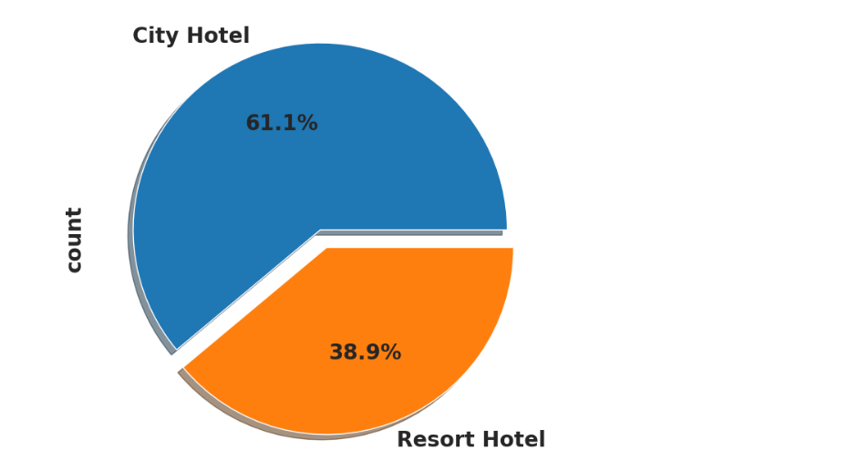
the Pie chart below shows which hotel is mostly prefered by the Guests
its clear that most guests 61.1% prefer city hotel than resort hotel for bookings

Which Agent made the most Bookings?
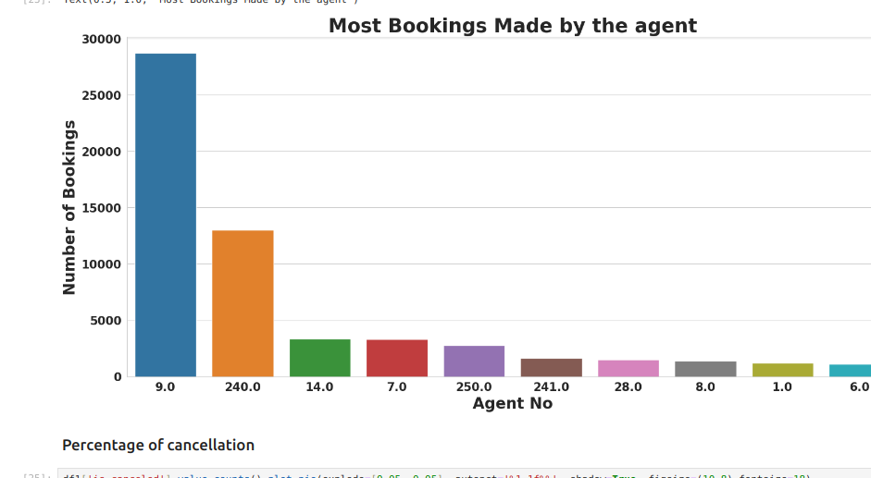
Agent id no.9 made the highest bookings

percentage cancelation
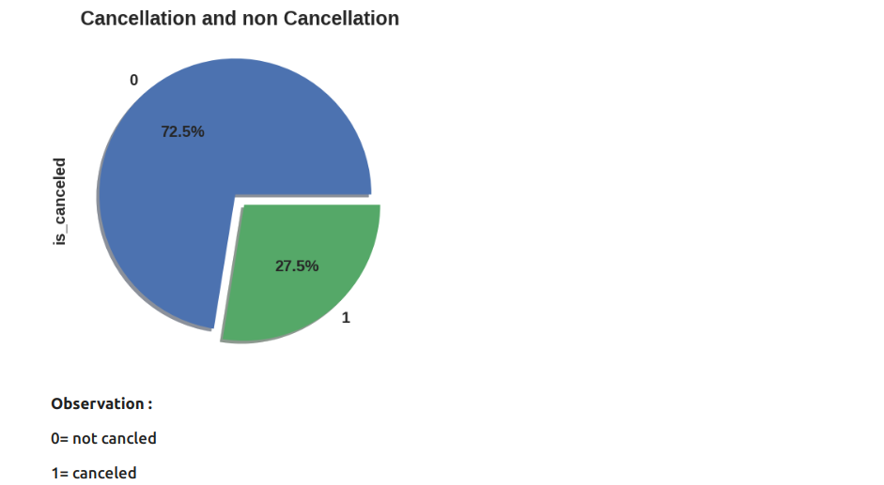
using 0 for not canceled and 1 to represent canceled it is observed that 75.5% of the total bookings were cancelled

Percentage of repeated guests
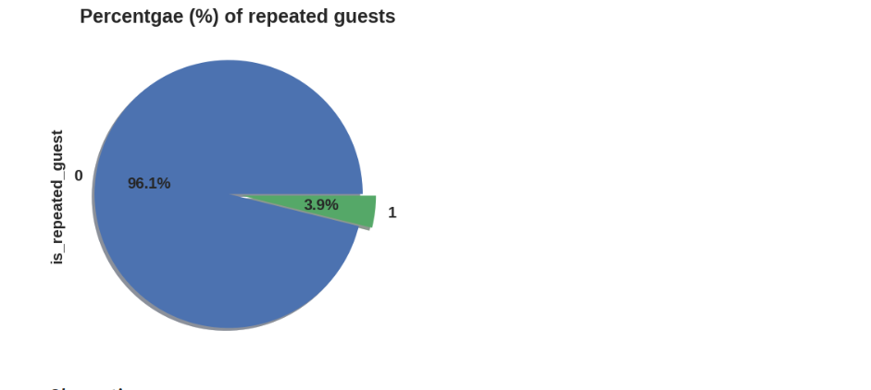
it is observed from above piechart that lower percentage/ very few 3.9% repeated guests therefore using this statistics its cleare that both hotels receive a fewer number of repeated guests

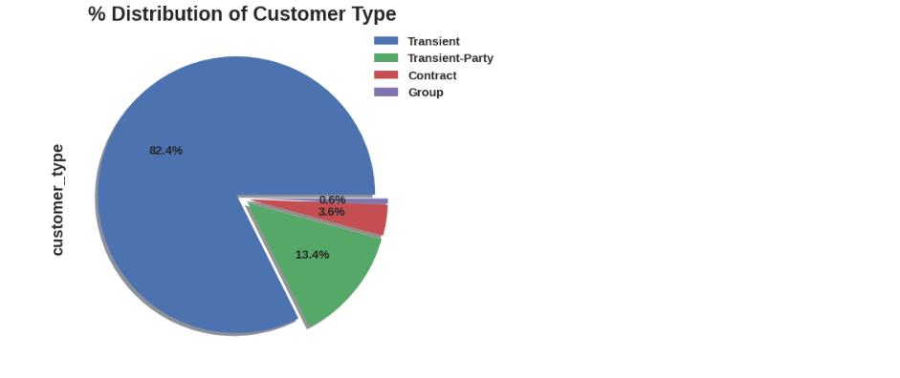
1. contract
when the booking has an allotment or other type of contract associated to it
2.Group
when the booking is associated to a group
3.Transient
when the booking is not part of a group or contract, and is not associated to other transient booking
4. Transient-Party
when the booking is transient, but is associated to at least other transient booking
This indicates that percentage of booking associates by a group is very low while transient is very high at 82.4%

What Percentage Distribution requires car parking spaces
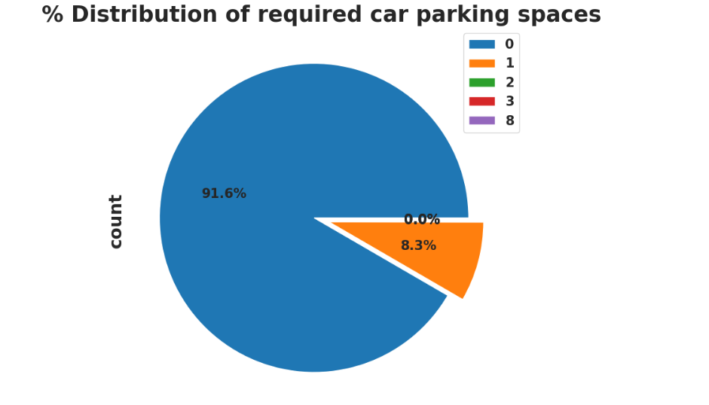
observation: 91.6% of the guests requires parking space . Therefore it is vital to consider parking space for the guests since only 8.3% doesn’t require parking space

What percentage distribution of Deposit type

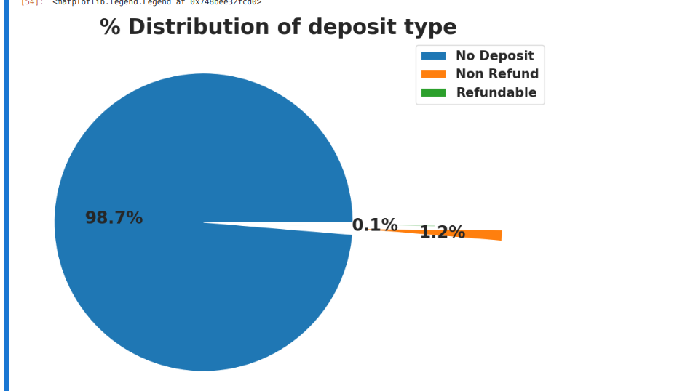
98.7% of the guests prefer No deposit type of deposit

which type of foof mostly prefered by guests?
Food id : types of meal in the hoteliers
BB: -(Bed and Breakfast)
HB -(Half board)
FB- (Full Board)
SC – (self Catering)
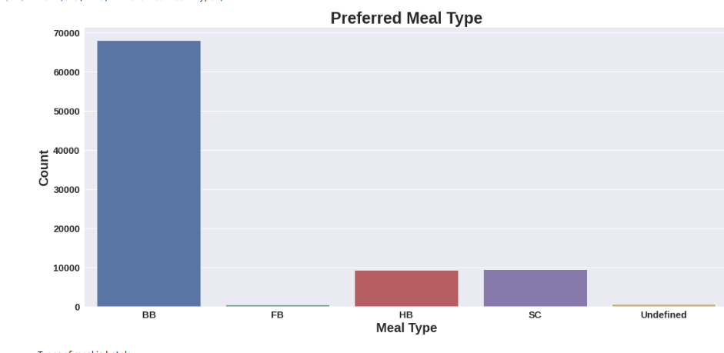
most prefered meal type by guest is BB
HB and SC are are equally prefered in this case

Which month had the most number of bookings

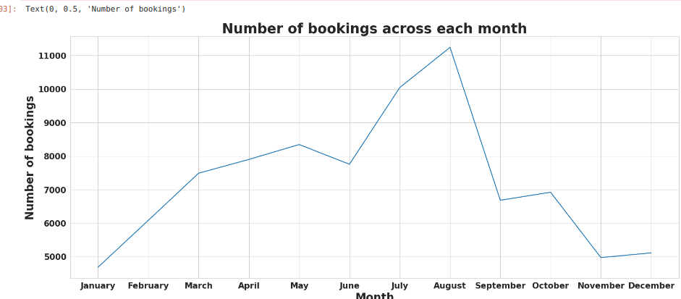
It indicates that the month of july and august had the most bookings
summer vaccation can be the reason for the high number of bookings

Mostly used Distribution Channel For Hotel Booking
Which channel of Distribution is is mostly used for hotel Booking?
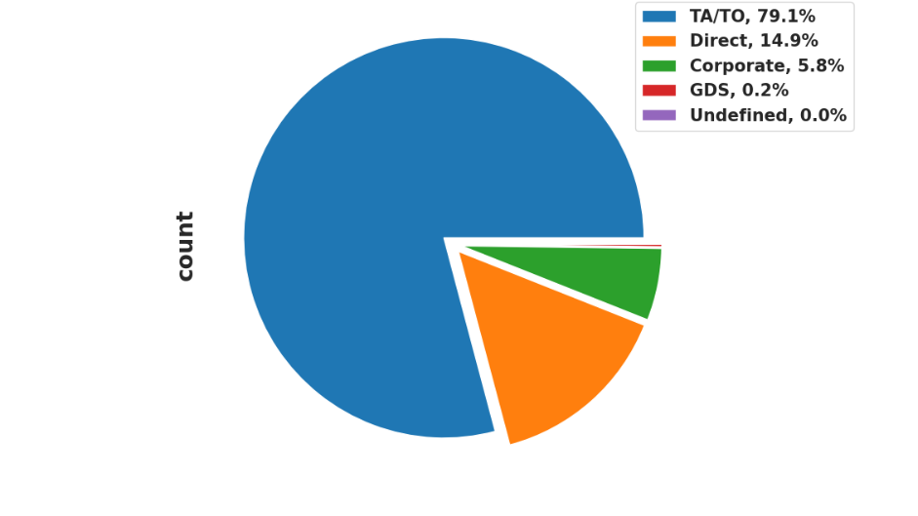
To/TA is mostly used for booking hotels

Which Year had the most number of bookings?
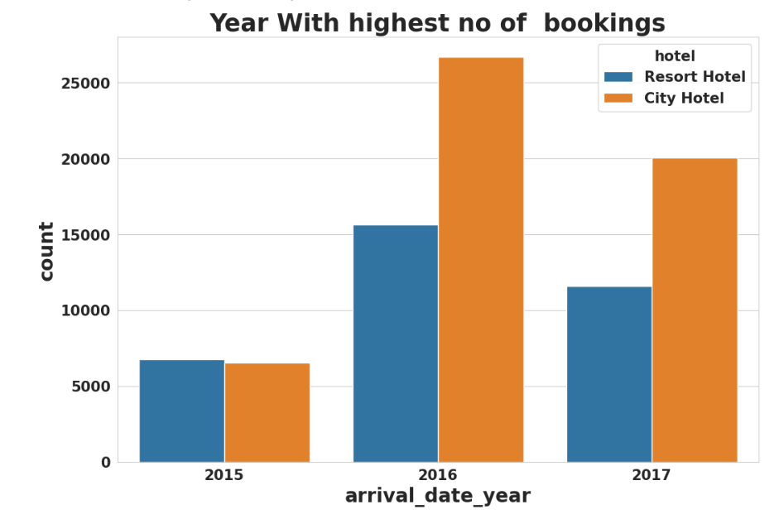
In Both resort and city Hotel its clear that on the year 2016 had the highest number of bookings while 2015 had lowest number of bookings
ovarall city Hotels had the most bookings by the guest

Bivariate and Multivariate Analysis
Which Hotel has the more lead time?
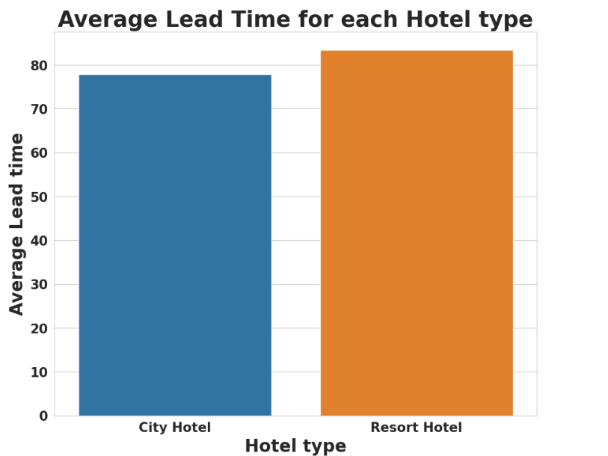
Resort hotels has slightly higher avg lead time. Which means their customers plan ther trips very early

Which Hotel has the highest percentage of Booking Cancellations?
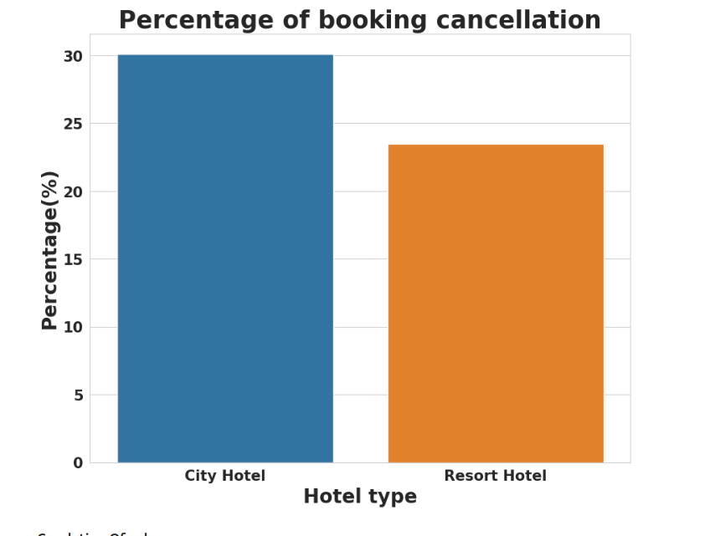
From above it is observed that city hotel has higher percentage cancellation30%

Correlation of Numeric Columns
is_canceled and same_room_alloted_or_not are negatively corelated.That means customer is unlikely to cancel his bookings if he don't get the same room as per reserved room. We have visualized it above ead_time and total_stay is positively corelated.That means more is the stay of cutsomer more will be the lead time. adults,childrens and babies are corelated to each other. That means more the people more will be adr. is_repeated guest and previous bookings not canceled has strong corelation. may be repeated guests are not more likely to cancel their bookings.

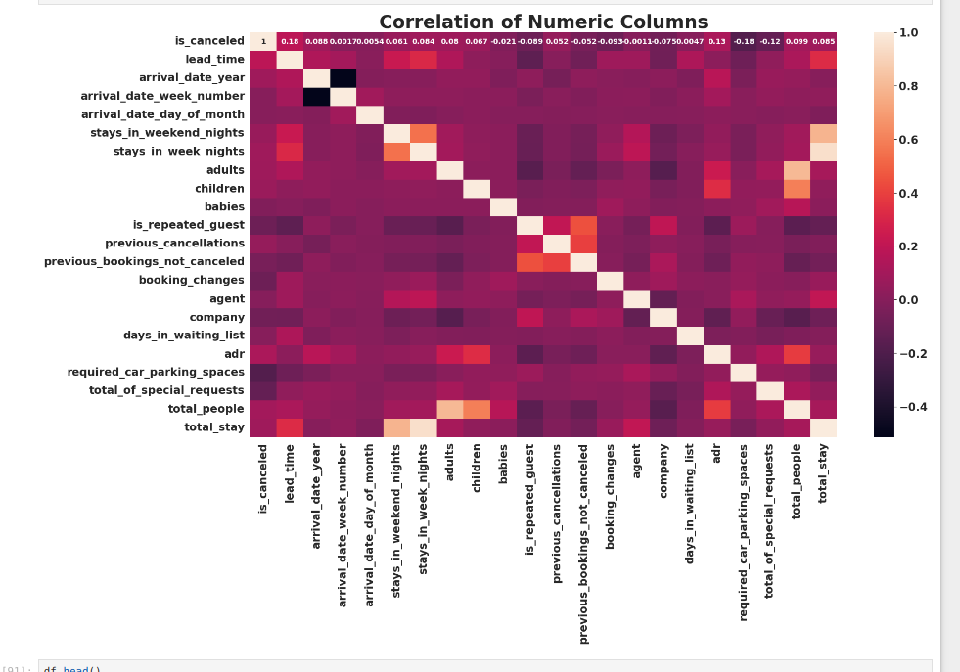
.
Relationship between repeated guests And previous bookings nor cancelled
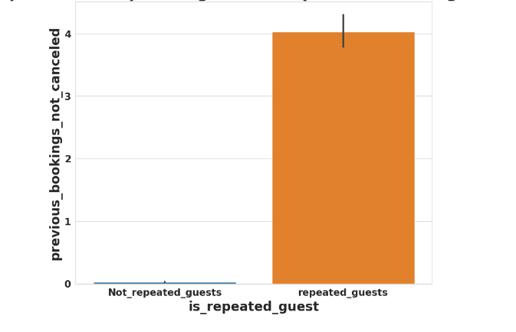
the relationship between not repeated guests and there previous bookings not cancelled is is that,Not repeated guests are more likely to cancel there bookings
Using scatter
Relationship between adr and total stay

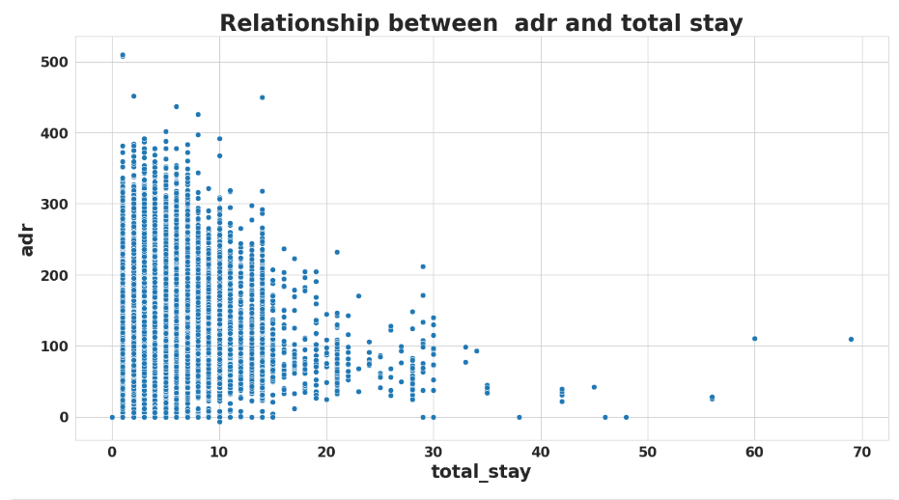
From above scatter we can say that as the stay increases adr is decreasing.Thus for longer stays customer can get good adr.

What is optimum stay length in both hotels and there relationships

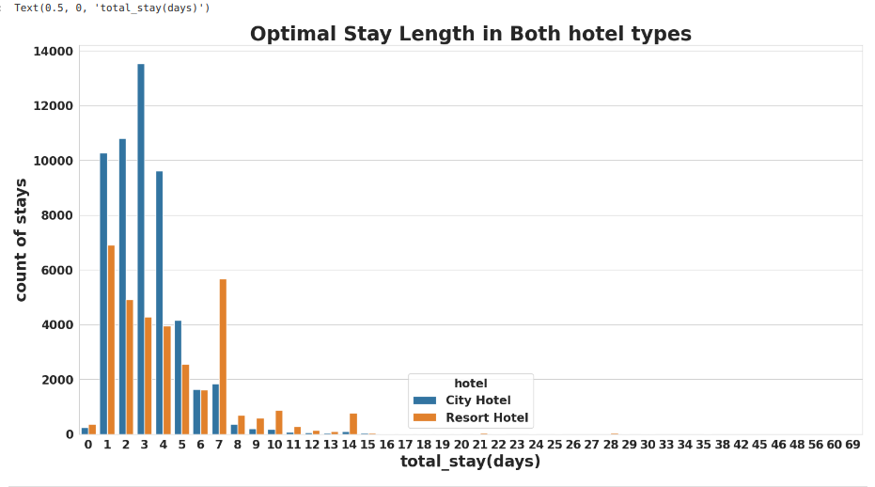
From above scatter we can say that as the stay increases adr is decreasing. Thus for longer stays customer can get good adr.

Adr relationship with total number of people
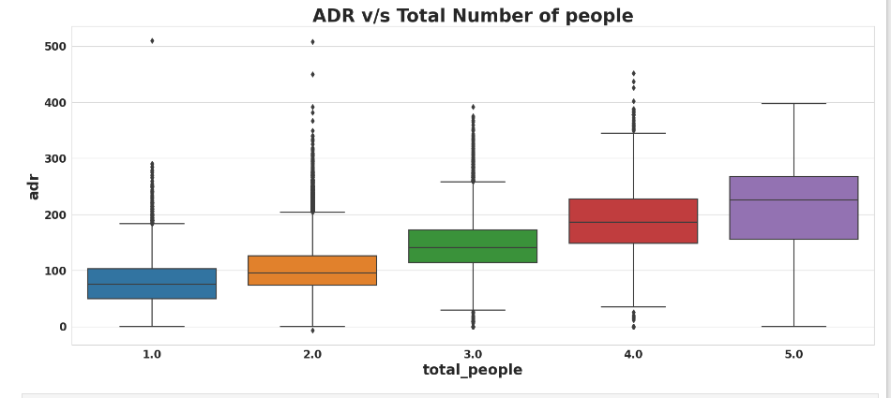
As the total number of people increases adr also increases. Thus adr and total people are directly proportional to each other.

CONCLUSIONS
City hotels are the most preferred hotel type by the guests. We can say City hotel is the busiest hotel.
27.5 % bookings were got cancelled out of all the bookings.
Only 3.9 % people were revisited the hotels. Rest 96.1 % were new guests. Thus retention rate is low.The percentage of 0 changes made in the booking was more than 82 %. Percentage of Single changes made was about 10%.
Most of the customers (91.6%) do not require car parking spaces.
79.1 % bookings were made through TA/TO (travel agents/Tour operators).
BB( Bed & Breakfast) is the most preferred type of meal by the guests.
Maximum number of guests were from Portugal, i.e. more than 25000 guests.
Most of the bookings for City hotels and Resort hotel were happened in 2016.
Average ADR for city hotel is high as compared to resort hotels. These City hotels are generating more revenue than the resort hotels.
Optimal stay in both the type hotel is less than 7 days. Usually people stay for a week.
Waiting time period for City hotel is high as compared to resort hotels. That means city hotels are much busier than Resort hotels.
Almost 19 % people did not cancel their bookings even after not getting the same room which they reserved while booking hotel. Only 2.5 % people cancelled the booking.

