**KPI’s REQUIREMENT**

**PROBLEM STATEMENT**

We need to analyze key indicators for our pizza sales data to gain insights into our business performance. Specifically, we want to calculate the following metrics:

1. **Total Revenue:** The sum of the total price of all pizza orders.
2. **Average Order Value:** The average amount spent per order, calculated by dividing the total revenue by the total number of orders.
3. **Total Pizzas Sold:** The sum of the quantities of all pizzas sold.
4. **Total Orders:** The total number of orders placed.
5. **Average Pizzas Per Order:** The average number of pizzas sold per order, calculated by dividing the total number of pizzas sold by the total number of orders.

**PROBLEM STATEMENT**

**CHARTS REQUIREMENT**

We would like to visualize various aspects of our pizza sales data to gain insights and understand key trends. We have identified the following requirements for creating charts:

1. **Hourly Trend for Total Pizzas Sold:**

Create a stacked bar chart that displays the hourly trend of total orders over a specific time. This chart will help us identify any patterns or fluctuations in order volumes on an hourly basis.

1. **Weekly Trend for Total Orders:**

Create a line chart that illustrates the weekly trend of total orders throughout the year. This chart will allow us to identify peak weeks or periods of high order activity.

1. **Percentage of Sales by Pizza Category:**

Create a pie chart that shows the distribution of sales across different pizza categories. This chart will provide insights into the popularity of various pizza categories and their contribution to overall sales.

1. **Percentage of Sales by Pizza Size:**

Generate a pie chart that represents the percentage of sales attributed to different pizza sizes. This chart will help us understand customer preferences for pizza sizes and their impact on sales.

1. **Total Pizzas Sold by Pizza Category:**

Create a funnel chart that presents the total number of pizzas sold for each pizza category. This chart will allow us to compare the sales performance of different pizza categories.

1. **Top 5 Best Sellers by Revenue, Total Quantity and Total Orders:**

Create a bar chart highlighting the top 5 best-selling pizzas based on the Revenue, Total Quantity, Total Orders. This chart will help us identify the most popular pizza options.

**7. Bottom 5 Best Sellers by Revenue, Total Quantity and Total Orders:**

Create a bar chart showcasing the bottom 5 worst-selling pizzas based on the Revenue, Total Quantity, Total Orders. This chart will enable us to identify underperforming or less popular pizza options.

1. KPI’s

Pizza Sales SQL Queries

1. **Total Revenue:**

SELECT SUM (total_price) AS Total_revenue FROM pizza_sales;

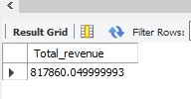

1. **Average Order Value:**

SELECT sum(total_price)/count (DISTINCT (order_id)) AS AVG_order FROM pizza_sales

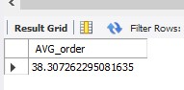

1. **Total Pizzas Sold:**

SELECT SUM (quantity) as Total_pizza_sold FROM pizza_sales;

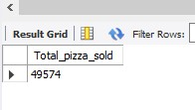

1. **Total Orders:**

SELECT count(distinct(order_id)) as Toatal_orders FROM pizza_sales;

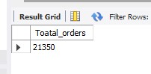

1. **Average Pizzas Per Order:**

SELECT cast(sum(quantity)/count (distinct order_id) as DECIMAL (10,2)) as Avg_pizzas_per_order FROM pizza_sales;

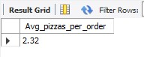

**--Hourly Trend for Total Pizzas Sold:**

SELECT HOUR (order_time) as Hour_order, SUM (quantity) as Total_pizzas_sold FROM pizza_sales

GROUP BY HOUR (order_time) ORDER BY HOUR (order_time)

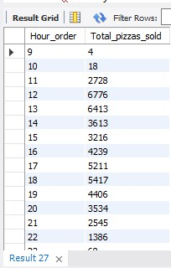

**--Weekly Trend for Total Pizzas Sold:**

SELECT WEEK(str_to_date(order_date,'%m/%d/%Y'),1) AS Week_number,

YEAR (str_to_date(order_date,'%m/%d/%Y')) as year,

COUNT(DISTINCT order_id) AS Total_orders

FROM pizza_sales_csv

GROUP BY WEEK(str_to_date(order_date,'%m/%d/%Y'),1),YEAR (str_to_date(order_date,'%m/%d/%Y'))

ORDER BY WEEK(str_to_date(order_date,'%m/%d/%Y'),1), YEAR (str_to_date(order_date,'%m/%d/%Y'));

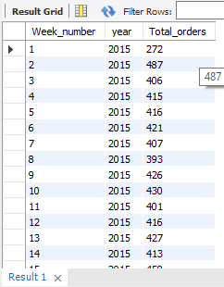 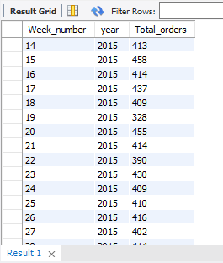

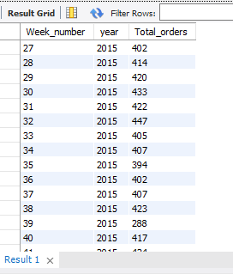 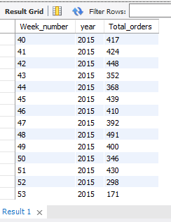

**--PERCENT OF SALES BY PIZZA CATEGORY:**

SELECT pizza_category, CAST(SUM(total_price) AS DECIMAL(10,2)) as Total_sales, CAST(SUM(total_price)*100/(SELECT SUM(total_price) FROM pizza_sales_csv) as DECIMAL(10,2)) AS PCT

FROM pizza_sales_csv

GROUP BY pizza_category;

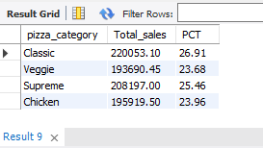

**--Percent Sales by Pizza Size:**

SELECT pizza_size, CAST(SUM(total_price) AS DECIMAL(10,2)) as Total_sales, CAST(SUM(total_price)*100/(SELECT SUM(total_price) FROM pizza_sales_csv) as DECIMAL(10,2)) AS PCT

FROM pizza_sales_csv

GROUP BY pizza_size

ORDER BY PCT DESC;

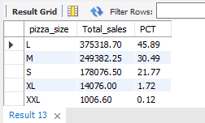

**--TOP 5 PIZZAS BY REVENUE**

SELECT pizza_name, SUM(total_price) as Total_revenue

FROM pizza_sales_csv

GROUP BY pizza_name

ORDER BY Total_revenue DESC LIMIT 5;

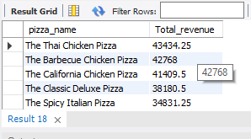

**--BOTTOM 5 PIZZAS BY REVENUE**

SELECT pizza_name, SUM(total_price) as Total_revenue

FROM pizza_sales_csv

GROUP BY pizza_name

ORDER BY Total_revenue ASC LIMIT 5;

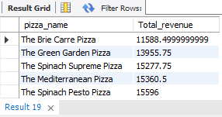

**--TOP 5 PIZZAS BY QUANTITY**

SELECT pizza_name, SUM(quantity) as Total_quantity

FROM pizza_sales_csv

GROUP BY pizza_name

ORDER BY Total_quantity DESC LIMIT 5;

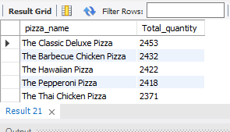

**--BOTTOM 5 PIZZAS BY QUANTITY**

SELECT pizza_name, SUM(quantity) as Total_quantity

FROM pizza_sales_csv

GROUP BY pizza_name

ORDER BY Total_quantity ASC LIMIT 5;

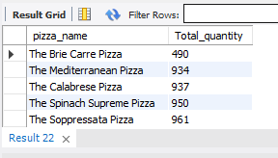

**--TOP 5 PIZZAS BY TOTAL ORDER**

SELECT pizza_name, COUNT(DISTINCT order_id) as Total_order

FROM pizza_sales_csv

GROUP BY pizza_name

ORDER BY Total_order DESC LIMIT 5;

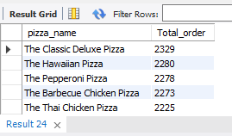

**--BOTTOM 5 PIZZAS BY TOTAL ORDER**

SELECT pizza_name, COUNT(DISTINCT order_id) as Total_order

FROM pizza_sales_csv

GROUP BY pizza_name

ORDER BY Total_order ASC LIMIT 5;

