**Bandit beginner CTF**

Level 0 -> level 1

Level Goal:

The password for the next level is stored in a file called **readme** located in the home directory. Use this password to log into bandit1 using SSH. Whenever you find a password for a level, use SSH (on port 2220) to log into that level and continue the game.

Commands I used:

ssh , or secure shell; used to connect to a host server

ls , lists contents of dir.

cd , change dir

cat , concatenates stored data and displays

file , type of file

du , size of dir/file

find , searches for specified items.

grep , to find patterns or to select a particular line that comes after specified characters

sort – sorts the lines of a text file

uniq – filters input and writes to the output

base64 – encodes binary strings into text representations using base64 encoding format.

strings – finds human-readable strings in file.

Approach:

logged into server using credentials

-ssh bandit1@bandit.labs.overthewire.org -p 2220

Password is stored in readme file. Used “cat readme” to display password.

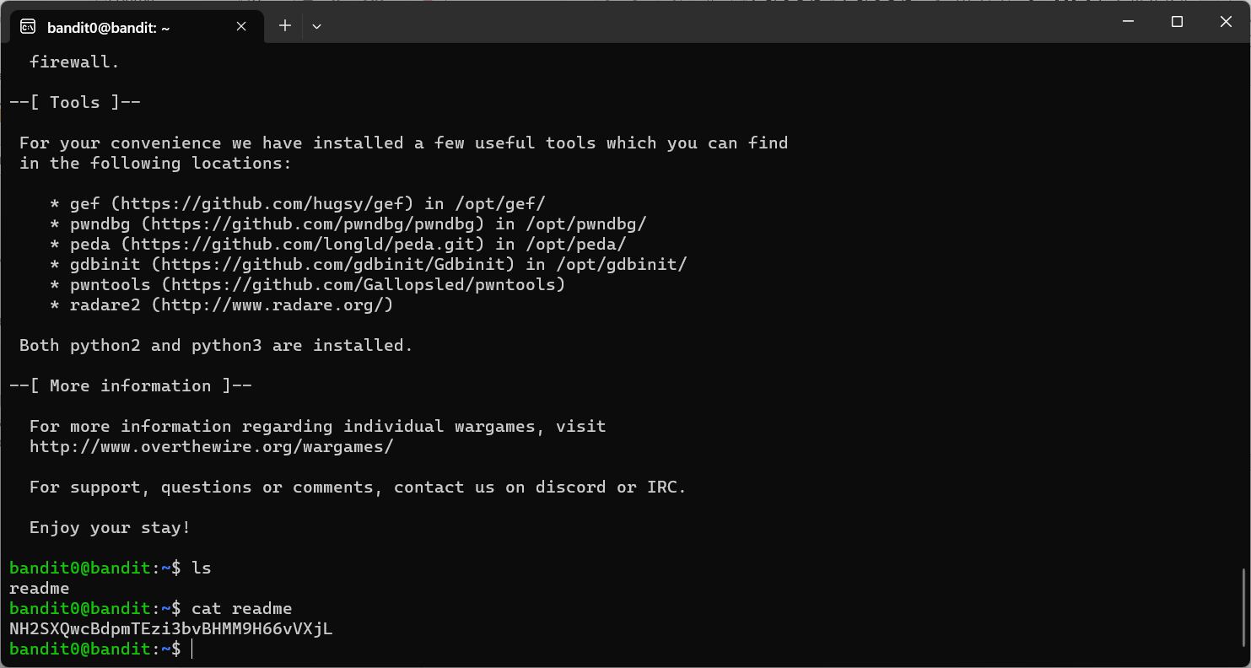

Bandit level 1 -> level 2

Approach:

logged into server using credentials

-ssh bandit1@bandit.labs.overthewire.org -p 2220

Password is stored in ***–*** file.

Special command is required to open this, namely

“cat < -filename” (here filename is “- “)

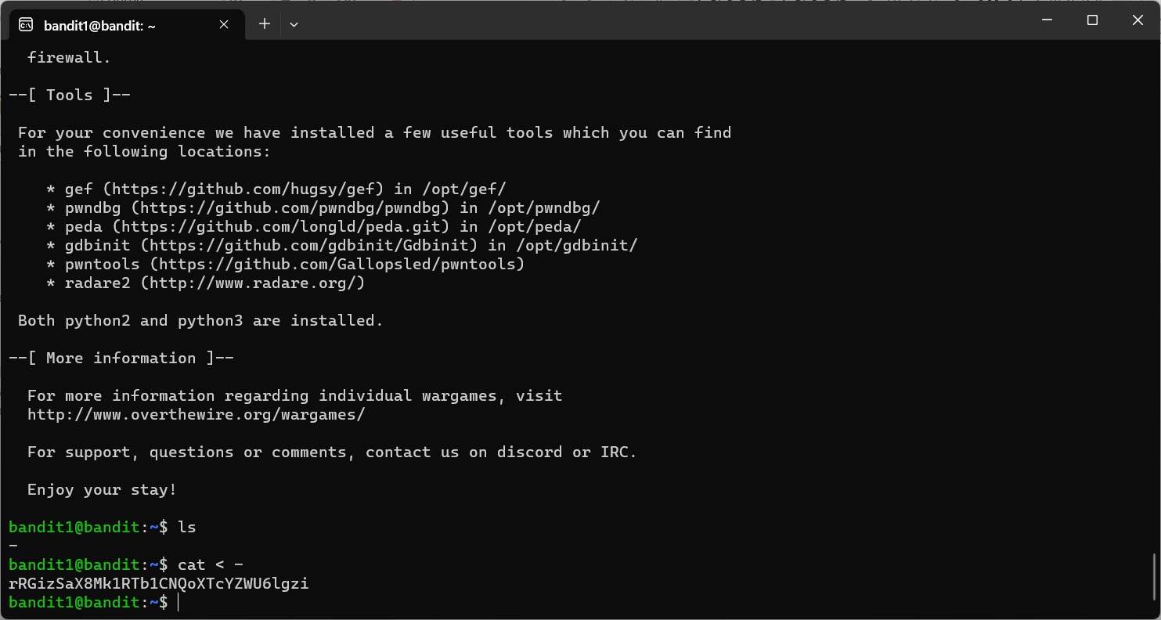

Bandit lvl 2 -> lvl 3

Level Goal:

The password for the next level is stored in a file called ***spaces in this filename*** located in the home directory

Approach:

logged into server using credentials

-ssh bandit2@bandit.labs.overthewire.org -p 2220

Password can be accessed in two ways;

“**cat spaces\ in\ this\ filename\”**  or

“**cat “spaces<press Tab and entry completes automatically>” ”**

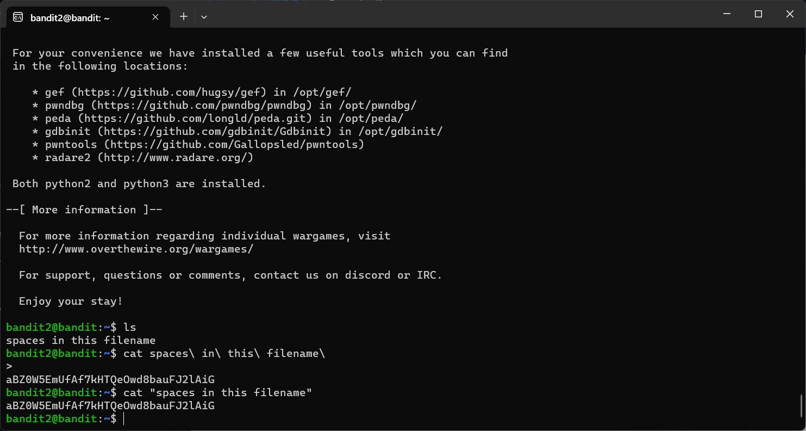

Bandit lvl 3 -> lvl 4

Level Goal

The password for the next level is stored in a hidden file in the **inhere** directory.

Approach:

ssh bandit3@bandit.labs.overthewire.org -p 2220

Used cd to change dir from **~** to **inhere**.

“ls -a” is used to display hidden files.

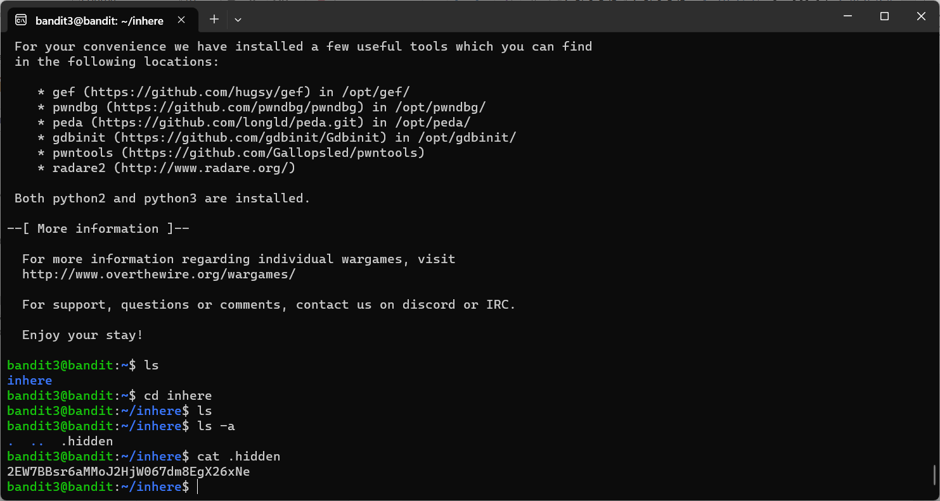

Bandit lvl 4 -> lvl 5

Level Goal:

The password for the next level is stored in the only human-readable file in the **inhere** directory. Tip: if your terminal is messed up, try the “reset” command.

Approach:

ssh bandit4@bandit.labs.overthewire.org -p 2220

file stored in different directory, therefore used “cd.”

*Human readable file* means it shouldn’t have special characters like the ones in following screenshot.

Used cat cmd.

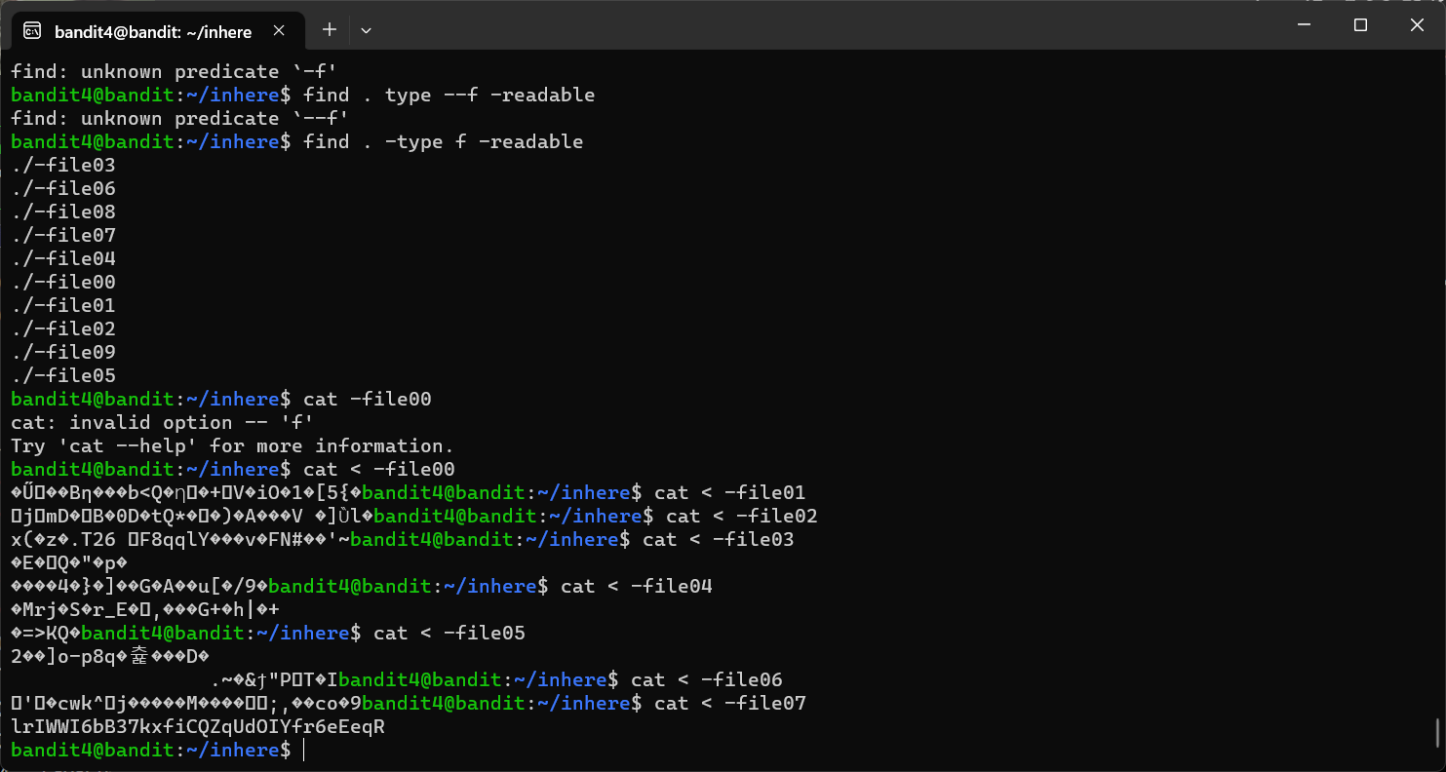

Bandit lvl 5 -> lvl 6

Level Goal:

The password for the next level is stored in a file somewhere under the **inhere** directory and has all of the following properties:

* human-readable
* 1033 bytes in size
* not executable

Approach:

ssh bandit5@bandit.labs.overthewire.org -p 2220

changed directory to **inhere.** Used “find” cmd to search for specific file as mentioned in level goal.

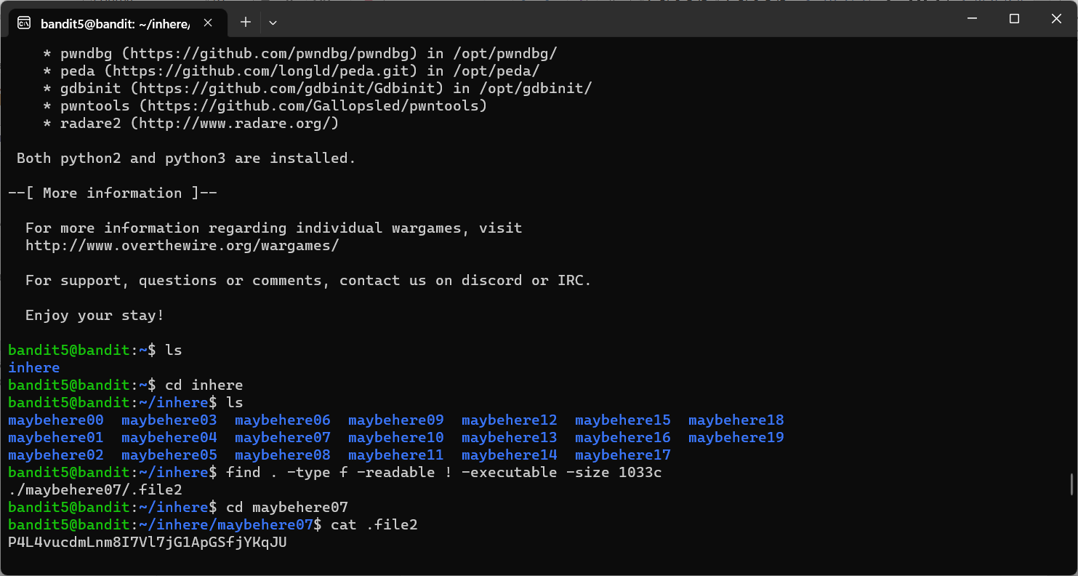

(ofc I referred Google)

Bandit lvl 6 ->lvl 7

Level Goal:

The password for the next level is stored **somewhere on the server** and has all of the following properties:

* owned by user bandit7
* owned by group bandit6
* 33 bytes in size

Approach:

ssh bandit6@bandit.labs.overthewire.org -p 2220

Searched for file in “/” directory using “find” cmd.

Applied some modifications based on requirements.

!!! server shows permission denied, this is for safety reasons, I believe.

So, appended the cmd with “2>/dev/null” to ignore the warnings.

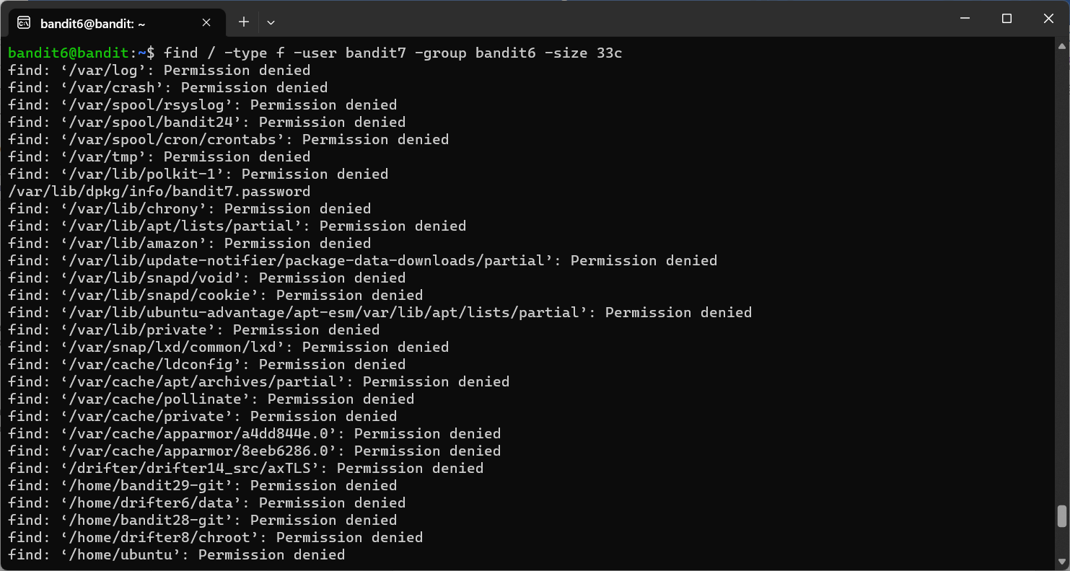

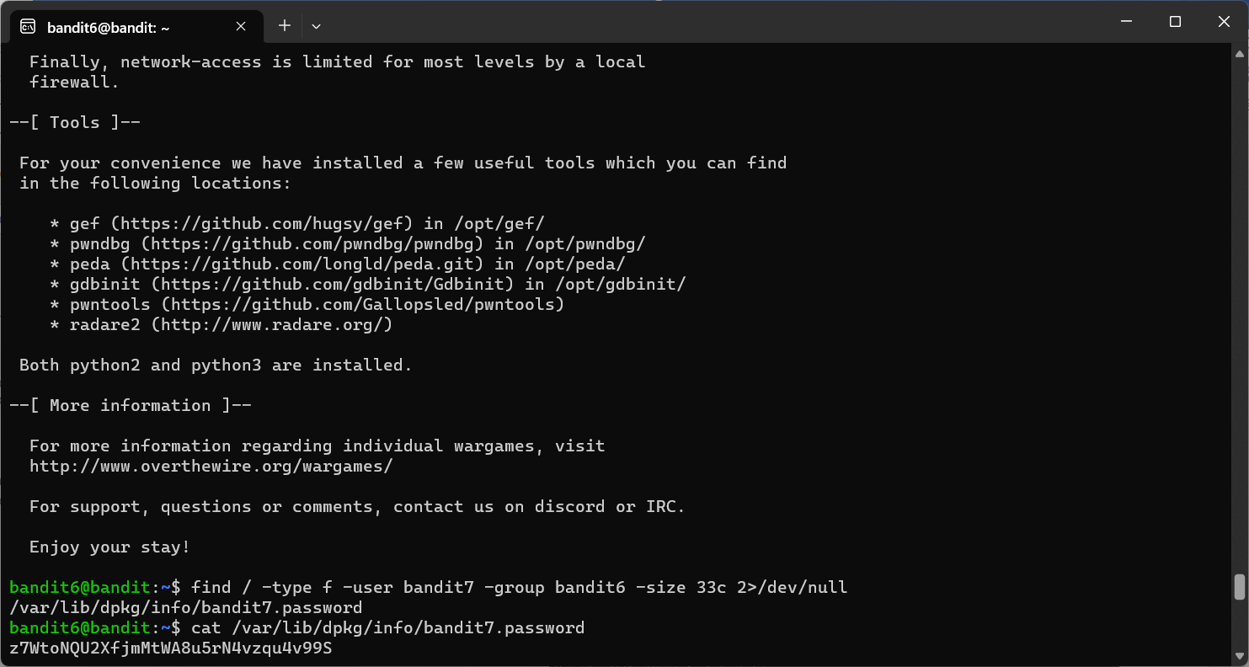

Bandit lvl 7 -> lvl 8

Level Goal:

The password for the next level is stored in the file **data.txt** next to the word **millionth.**

Approach:

ssh bandit7@bandit.labs.overthewire.org -p 2220

data.txt is a big file with many words in it, it’s impossible to manually search for the password, which is next to the word “millionth.” This is where “piping” comes in handy.

“cat data.txt | grep millionth”

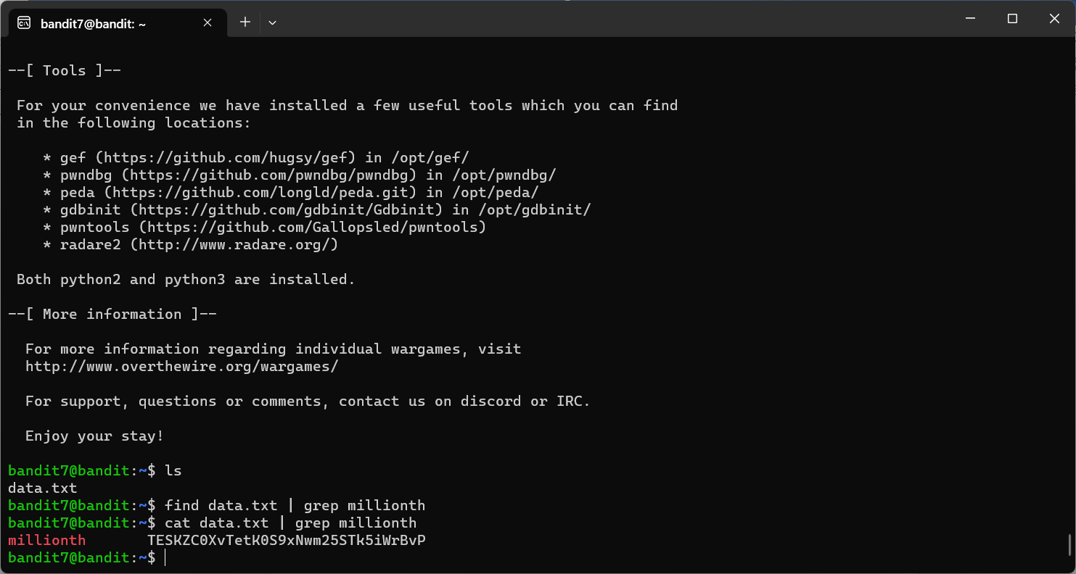

Bandit lvl 8 -> lvl 9

Level Goal:

The password for the next level is stored in the file **data.txt** and is the only line of text that occurs only once.

Approach:

ssh bandit8@bandit.labs.overthewire.org -p 2220

“sort” cmd can be used to sort the lines of a text file.

“sort data.txt | uniq -u”

The flag *-u* is used to filter for unique lines.

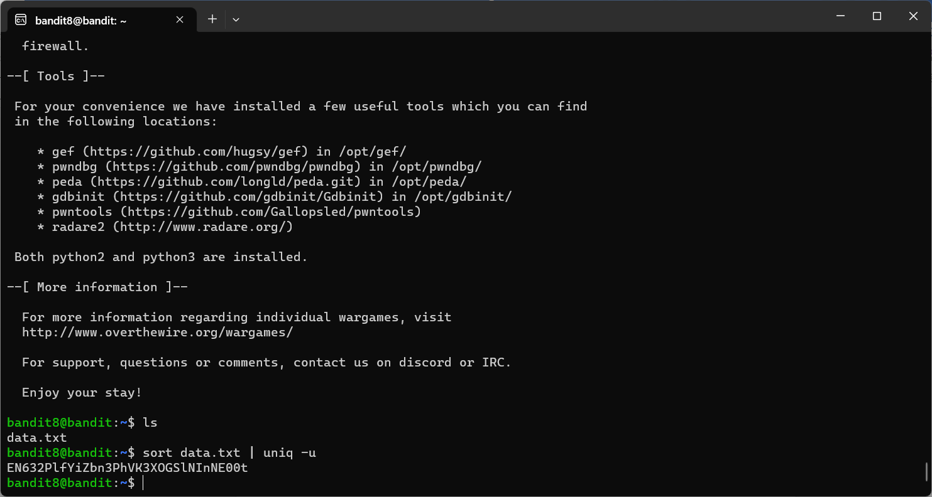

Bandit lvl 9 -> lvl 10

Level Goal:

The password for the next level is stored in the file **data.txt** in one of the few human-readable strings, preceded by several ‘=’ characters.

Approach:

ssh bandit9@bandit.labs.overthewire.org -p 2220

Here the password is stored as binary or machine interpretable language; base64 can be used to convert.

“strings data.txt | grep ===” (preceded by a lot of “=” characters)

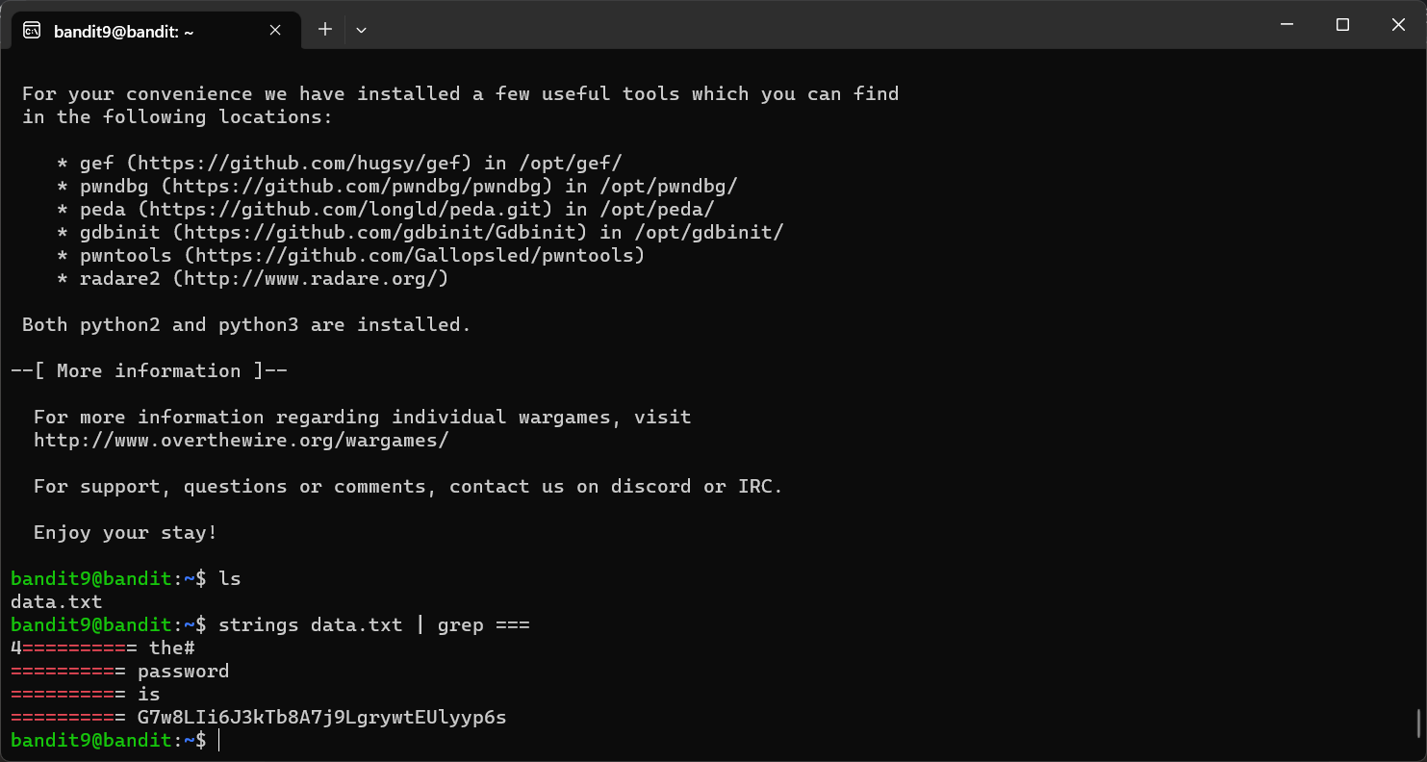

Bandit lvl 10

Level Goal:

The password for the next level is stored in the file **data.txt**, which contains base64 encoded data.

Approach:

ssh bandit10@bandit.labs.overthewire.org -p 2220

this was quite an easy one, base64 decoding was required. “base64 -d data.txt” did the trick.

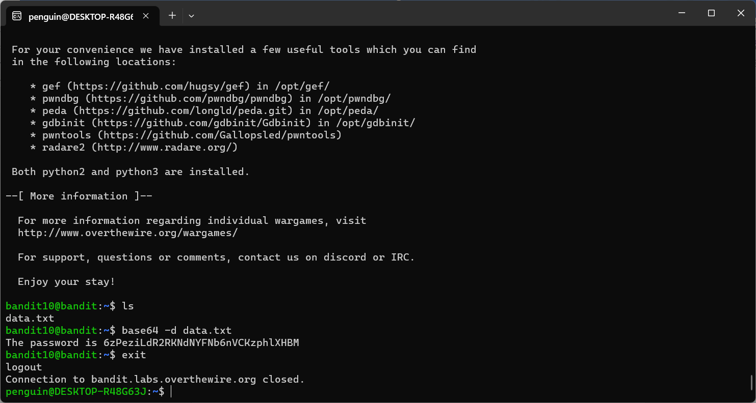

Thank you

:)