QUERY-CONDITIONED DEEP LEARNING FOR ADAPTIVE MULTI-SOURCE MUSIC SEPARATION
A PROJECT REPORT
Submitted by
ACHINTYA TR (Reg. No. CH.SC.U4AIE24003)
BJ KIRANESH (Reg. No. CH.SC.U4AIE24006)
HITHESH R (Reg. No. CH.SC.U4AIE24027)
PARINITHA KANDULA (Reg. No. CH.SC.U4AIE24052)
in partial fulfillment for the award of the degree of
BACHELOR OF TECHNOLOGY IN COMPUTER SCIENCE AND ENGINEERING
Under the guidance of
Dr. [GUIDE NAME]
Department of Computer Science & Engineering

AMRITA VISHWA VIDYAPEETHAM
AMRITA SCHOOL OF COMPUTING
CHENNAI – 601103
October 2026

BONAFIDE CERTIFICATE
Certified that this project report entitled “QUERY-CONDITIONED DEEP LEARNING FOR ADAPTIVE MULTI-SOURCE MUSIC SEPARATION” is the bonafide work of “ACHINTYA TR (Reg. No. CH.SC.U4AIE24003), BJ KIRANESH (Reg. No. CH.SC.U4AIE24006), HITHESH R (Reg. No. CH.SC.U4AIE24027) & PARINITHA KANDULA (Reg. No. CH.SC.U4AIE24052)”, who carried out the project work under my supervision.
SIGNATURE SIGNATURE
Dr. S. BAGHAVATHI PRIYA Dr. [GUIDE NAME]
CHAIRPERSON SUPERVISOR
Department of CSE Dept. of CSE
Amrita School of Computing Amrita School of Computing
Chennai – 601103. Chennai – 601103.
INTERNAL EXAMINER EXTERNAL EXAMINER

DECLARATION BY THE CANDIDATES
We declare that the report entitled “QUERY-CONDITIONED DEEP LEARNING FOR ADAPTIVE MULTI-SOURCE MUSIC SEPARATION” submitted by us for the degree of Bachelor of Technology in Computer Science and Engineering is the record of the project work carried out by us under the guidance of “Dr. [GUIDE NAME]” and this work has not formed the basis for the award of any degree, diploma, associateship, fellowship, titled in this or any other University or other similar institution of higher learning.
SIGNATURE OF THE CANDIDATES
ACHINTYA TR (CH.SC.U4AIE24003)
BJ KIRANESH (CH.SC.U4AIE24006)
HITHESH R (CH.SC.U4AIE24027)
PARINITHA KANDULA (CH.SC.U4AIE24052)
Department of Computer Science & Engineering (AIE)
Amrita School of Computing, Chennai Campus.

ABSTRACT
Most music source separation systems return a fixed list of stems, usually vocals, drums, bass and a catch-all "other". A listener who wants a violin, a mridangam or a ghatam gets nothing from them, and a listener who selects one instrument often still hears the others. Indian classical instruments are the clearest example, because the pretrained separators were built and trained on Western music.
This project builds a system that detects which instruments are present in a recording and returns the stems the user selects while suppressing the others. A small convolutional detector is trained for six classes (vocals, drums, bass, violin, mridangam, ghatam) and reaches a macro-F1 of 0.798 across them. Guitar and piano presence is estimated from the energy outputs of a pretrained 6-source Demucs model, because neither training corpus labels them separately. A single query-conditioned U-Net (8.8 million parameters, FiLM at four encoder levels) is trained on MUSDB18-HQ and Saraga, with 20% of its requests naming stems that are absent. A competitive mask then divides every time-frequency bin among the Demucs and U-Net sources so that unselected stems are attenuated.
Repairing faults found in the data raised best validation SI-SDR from -8.48 dB to +2.53 dB. On 12 Carnatic validation tracks the trained U-Net scored 0.8, 2.8 and 4.4 dB above the best-matching Demucs output for vocals, violin and mridangam. On four MUSDB test tracks the final system reached an SIR of 28.2 dB for vocals and 27.6 dB for drums, with residual leakage that is largest for bass at 11.0 dB. Ghatam is not recovered, violin is modest at about 1 dB, requests for absent violin and mridangam still return audible output, and performance on real, unsummed Carnatic mixes is not measured. A web application accepts audio and video files.
Keywords: Music Source Separation, Query-Conditioned Separation, FiLM, U-Net, Stem Detection, Carnatic Music, Mridangam, Competitive Masking, SI-SDR, Absent-Query Training.

ACKNOWLEDGEMENT
This project work would not have been possible without the contribution of many people. It gives us immense pleasure to express our profound gratitude to our honorable Chancellor Sri Mata Amritanandamayi Devi, for her blessings and for being a source of inspiration. We are indebted to extend our gratitude to our Administrative Director, Swami Vinayamritananda Puri and Campus Director, Mr. I B Manikantan, Amrita School of Computing and Engineering, for facilitating us all the facilities and extended support to gain valuable education and learning experience.
We register our special thanks to Dr. V. Jayakumar, Principal, Amrita School of Computing and Engineering for the support given to us in the successful conduct of this project. We wish to express our sincere gratitude to Dr. S. Baghavathi Priya, Chairperson, Dr. Annamalai R, Program Chair, and to our supervisor Dr. [GUIDE NAME], Department of Computer Science and Engineering, for their inspiring guidance, personal involvement, and constant encouragement during the entire course of this work.
We are grateful to the Project Coordinator, Review Panel Members, and the entire faculty of the Department of Computer Science & Engineering, for their constructive criticisms and valuable suggestions which have been a rich source to improve the quality of this work.
ACHINTYA TR (CH.SC.U4AIE24003)
BJ KIRANESH (CH.SC.U4AIE24006)
HITHESH R (CH.SC.U4AIE24027)
PARINITHA KANDULA (CH.SC.U4AIE24052)
Department of Computer Science & Engineering (AIE)
Amrita School of Computing, Chennai Campus.

TABLE OF CONTENTS
TITLE | PAGE NO.
Abstract | iv
List of Figures | viii
List of Tables | ix
List of Symbols and Abbreviations | x
CHAPTER 1 INTRODUCTION | 1
1.1 Background and Evolution of Music Source Separation | 1
1.2 Problem Statement | 1
1.3 Motivation for Query-Conditioned Deep Learning | 2
1.4 Objectives of the Project | 3
1.5 Scope and Operational Boundaries | 3
1.6 Organization of the Report | 4
CHAPTER 2 LITERATURE REVIEW | 5
2.1 Query-Conditioned and Conditioned Source Separation | 5
2.2 Architectures and Training for Music Source Separation | 6
2.3 Indian Art Music and Non-Western Audio | 7
2.4 Data, Bleed and Training-Set Construction | 8
2.5 Evaluation, Surveys and Tools | 8
2.6 Critical Synthesis and Identified Research Gaps | 9
CHAPTER 3 MATHEMATICAL MODELING & THEORETICAL FORMULATIONS | 11
3.1 Signal Model and Time-Frequency Representation | 11
3.2 Query-Conditioned Masking with FiLM | 11
3.3 Training Objective | 12
3.4 Absent-Query Training | 13
3.5 Stem Detector Formulation | 14
3.6 Competitive Mask Filtering | 14
3.7 Evaluation Metrics | 15
CHAPTER 4 SYSTEM ARCHITECTURE AND IMPLEMENTATION | 16
4.1 Platform Architecture Overview | 16
4.2 Datasets and Data Pipeline | 17
4.3 Stem Detector Implementation | 18
4.4 Query-Conditioned Separator Implementation | 19
4.5 Inference Pipeline | 20
4.6 Web Application and Video Input | 21
4.7 Software Environment and Reproducibility | 22
CHAPTER 5 RESULTS, BENCHMARKS, AND DISCUSSION | 24
5.1 Experimental Setup and Evaluation Protocol | 24
5.2 Effect of Data Repair on Validation SI-SDR | 25
5.3 Separator Quality per Stem | 25
5.4 Stem Detector Performance | 27
5.5 Comparison with the Pretrained Backend on Carnatic Stems (H1) | 27
5.6 Leakage Suppression (H3) | 29
5.7 Requests for Absent Stems (H2) | 30
5.8 Qualitative Examples | 31
5.9 Discussion | 32
CHAPTER 6 CONCLUSION AND FUTURE SCOPE | 34
6.1 Summary of Completed Contributions | 34
6.2 Key Theoretical and Practical Takeaways | 34
6.3 Limitations | 35
6.4 Future Research Directions | 35
REFERENCES | 36

LIST OF FIGURES
FIGURE NO. | TITLE | PAGE NO.
Figure 3.1 | Query-Conditioned U-Net with FiLM Modulation at Every Encoder Level | 12
Figure 3.2 | Competitive Mask. Each Time-Frequency Bin Is Shared by All Sources and the Selected Stem Keeps Only Its Share | 15
Figure 4.1 | System Architecture. Orange Marks What Was Trained in This Project, Blue the Trained Detector, Grey Pretrained or Interface Components | 16
Figure 4.2 | Dataset Composition. Left: Tracks per Split. Right: Stems with Ground Truth in Each Corpus | 17
Figure 4.3 | Stem Detector Architecture | 18
Figure 4.4 | Web Interface after Detection on a Carnatic Recording (Violin Selected for Extraction) | 22
Figure 5.1 | Best Validation SI-SDR at Each Stage of the Project | 25
Figure 5.2 | SI-SDR of the Raw Mixture, the Trained U-Net and the Ideal Mask | 26
Figure 5.3 | Validation F1 of the Stem Detector for Each Instrument | 27
Figure 5.4 | Trained U-Net against the Best of the Six Pretrained Demucs Outputs on Carnatic Validation Tracks | 28
Figure 5.5 | SIR of the U-Net Masks Alone and of the Final System | 29
Figure 5.6 | Spectrograms of the Mixture, the System Output and the Ground-Truth Stem for Vocals, Drums and Mridangam | 32

LIST OF TABLES
TABLE NO. | TITLE | PAGE NO.
Table 2.1 | The Two Closest Published Systems and the Proposed Model | 10
Table 4.1 | Data Audit, Evidence and Repair | 18
Table 4.2 | Separator Training Configuration | 20
Table 4.3 | Inference Constants | 21
Table 5.1 | Best Validation SI-SDR at Each Stage | 25
Table 5.2 | Per-Stem SI-SDR of the Trained U-Net on Validation Clips (dB) | 26
Table 5.3 | Stem Detector F1 on Validation Data and Tuned Thresholds | 27
Table 5.4 | SI-SDR against the True Stem on Carnatic Validation Tracks (dB) | 28
Table 5.5 | Leakage of Unselected Stems, SIR (dB, Higher Is Better) | 29
Table 5.6 | SIR of Independent Demucs Extraction and of the Competitive Mask, Earlier Run (dB) | 30
Table 5.7 | Level of the Returned Audio Relative to the Mixture (dB) | 30

LIST OF SYMBOLS AND ABBREVIATIONS
MSS | - Music Source Separation
STFT | - Short-Time Fourier Transform
iSTFT | - Inverse Short-Time Fourier Transform
FiLM | - Feature-wise Linear Modulation
U-Net | - Encoder-decoder convolutional network with skip connections
CNN | - Convolutional Neural Network
SI-SDR | - Scale-Invariant Signal-to-Distortion Ratio
SDR | - Signal-to-Distortion Ratio
SIR | - Source-to-Interference Ratio
SNR | - Signal-to-Noise Ratio
IRM | - Ideal Ratio Mask
BCE | - Binary Cross-Entropy
F1 | - Harmonic mean of precision and recall
MUSDB18-HQ | - Uncompressed Western multitrack music corpus (stereo, 44.1 kHz)
Saraga | - Open multitrack corpus of Indian art music (Carnatic collection)
Sanidha | - Studio-recorded Carnatic multitrack dataset
Demucs | - Family of music separation models (hybrid spectrogram and waveform)
htdemucs_6s | - Six-source HT Demucs model: drums, bass, vocals, guitar, piano, other
Mel | - Perceptual frequency scale used for the detector input
AdamW | - Adam optimiser with decoupled weight decay
AMP | - Automatic Mixed Precision
A/B | - Side-by-side comparison of original and separated audio
X, S, M | - Mixture magnitude, target magnitude, predicted mask
q, e | - Stem query index and its 64-dimensional embedding

CHAPTER 1
INTRODUCTION
1.1 Background and Evolution of Music Source Separation
Music source separation (MSS) is the task of recovering the individual sources in a recording, such as the vocals or the drums, from the mixed signal. The field has more than thirty years of history [21]. It moved from hand-designed signal processing methods to deep networks that predict a time-frequency mask or a waveform for each source, and the arrival of multitrack training sets made that shift possible.
The standard benchmark, MUSDB18, defines four stems: vocals, drums, bass and a catch-all "other" [26]. Most systems, including recent efficient designs such as SCNet [6] and Moises-Light [7] and the entries to the Sound Demixing Challenge [8], are trained for that list. Some work goes further. Banquet separates beyond four stems with a single decoder [1], and a 2025 challenge system handles eight instrument classes [9]. In all of these the vocabulary of stems is fixed when training ends, and it is drawn from Western pop and rock.
1.2 Problem Statement
A person who wants to hear one instrument from a recording meets three problems with existing tools. They are described below, and they are the reason this project was started.
1.2.1 Fixed Stem Vocabularies
A separator trained on four stems returns four stems. A listener who wants the second guitar, the violin or the mridangam gets nothing from it, and anything outside the list ends up in "other" together with every other unlisted instrument. Query-based systems relax this by letting the user say which sound to extract [1], [2], [3], but the published ones take an audio example or an embedding as the query and are trained on Western data.
1.2.2 Missing Indian Instruments
Carnatic music is performed with vocals, violin, mridangam, ghatam and a tanpura drone. Separators trained on Western repertoire transfer poorly to it because the timbres, the playing techniques and the recording conditions differ [10]. Work on Carnatic separation exists, but it returns a fixed set of layers, for example vocals, mridangam and a violin-plus-tanpura layer, and it does not take a query [10], [12]. Clean training data is also scarce. The studio-quality Sanidha dataset has about eight hours of audio [11], and the larger Saraga collection contains bleed between the multitrack stems, so the authors of [10] and [11] consider it unsuitable as exact ground truth.
1.2.3 Leakage and Noise in Unselected Stems
When a user asks for one instrument and still hears others, the separator has failed in a way that is easy to notice. This kind of leakage is not captured by an SNR figure alone, and evaluation work argues that leakage and self-distortion should be reported separately [19]. It was also the main practical problem in this project. The first version of the separator returned a layer of hiss for every request, and a request for a stem that was not in the song still returned sound. Removing that behaviour took more work than building the network.
1.3 Motivation for Query-Conditioned Deep Learning
A query-conditioned network receives the mixture and a description of what to extract, and it outputs only that source. One set of weights serves every stem, so the architecture can take on further instrument classes without a separate network, provided the embedding table is extended, suitable data is added and the model is retrained or fine-tuned. In this project the query is the index of a stem, mapped through a learned embedding to a 64-dimensional vector. The vector modulates the feature maps of a U-Net through feature-wise linear modulation (FiLM) [24]. Conditioned U-Nets have been shown to compete with band-split models on Western stems [3].
Two further ideas shape the design. First, a query can name a stem that is not in the song, a case that most query-based music papers do not study and that has been examined for environmental sounds [5]. Training on such requests with a silent target teaches the model to return silence. Second, a small detector that reports which instruments are present lets the interface offer only meaningful choices, and it removes the need for the user to guess.
1.4 Objectives of the Project
The goal of the project is to build and evaluate a system that detects the instruments present in a recording and returns the instruments the user selects while suppressing the others, for Western and Carnatic music. The specific objectives are:
1. Detect: to build a multi-label detector for the six classes that have training labels (vocals, drums, bass, violin, mridangam, ghatam), and to estimate guitar and piano presence from the pretrained backend, because neither corpus labels those two instruments separately.
2. Separate: to extract any selected stem with a single query-conditioned model trained on MUSDB18-HQ and Saraga.
3. Cover Carnatic instruments: to include violin, mridangam and ghatam as query classes beside the Western stems, and to measure the result against the best output of a pretrained Western separator.
4. Suppress leakage: to make sure that stems the user did not select do not appear in the output, and to measure the leakage.
5. Audit the data and deploy: to find and repair faults in the training data, and to deliver a web application that accepts audio and video files and returns the selected stems.
1.5 Scope and Operational Boundaries
The system has eight query classes: vocals, drums, bass, guitar, piano, violin, mridangam and ghatam. The detector is trained for six of them, and guitar and piano presence is estimated from the pretrained backend. Training uses MUSDB18-HQ (100 training and validation tracks, 50 test tracks) and the Saraga 1.5 Carnatic collection (168 concert recordings). The separator and the detector operate on 22.05 kHz mono audio in 6 s windows. The final system produces 44.1 kHz stereo output through a pretrained 6-source Demucs model for vocals, drums, bass, guitar and piano, and through the trained U-Net for violin, mridangam and ghatam.
The evaluation uses SI-SDR and SIR on held-out tracks and clips. Three limits apply and are repeated where they matter. The Carnatic ground truth is a sum of multitrack stems that contain some bleed. No listening test with human participants was run. Performance on fully real, unsummed Carnatic mixes was not measured. Training and evaluation were done on a laptop with a single NVIDIA GeForce RTX 3050 GPU.
1.6 Organization of the Report
Chapter 2 reviews 23 papers published between 2024 and 2026 and states the research gaps. Chapter 3 gives the mathematical formulation: the signal model, FiLM conditioning, the training objective, absent-query training, the detector, the competitive mask and the metrics. Chapter 4 describes the datasets, the data audit, the implementation of the detector, the separator and the inference pipeline, and the web application. Chapter 5 reports the experiments and discusses them with their limits. Chapter 6 summarises the work and lists future directions.

CHAPTER 2
LITERATURE REVIEW
This chapter reviews 23 papers published between 2024 and 2026, grouped into five categories: query-conditioned separation, architectures and training for music separation, Indian art music and non-Western audio, data and bleed, and evaluation and tools. Depth varies. The full texts of [1], [5], [11] and [12] were read, so those reviews give settings and numbers. The other papers are described from their abstracts and publication records, and the limitations given for them are gaps visible from the abstracts, not results the team verified. Four older works that define methods used here, FiLM [24], SI-SDR [25], MUSDB18-HQ [26] and HT Demucs [27], are cited for those definitions only.
2.1 Query-Conditioned and Conditioned Source Separation
Banquet [1] is a query-based separator that handles an arbitrary number of stems with one decoder. It extends a band-split model with a query pathway. The query is a 10 s clip of the target stem, embedded by a frozen PaSST encoder and mapped by a single FiLM layer to a stem-specific embedding. Training used MoisesDB, 240 songs, with a five-fold split by genre, 6 s chunks and an L1SNR loss, and the model has 24.9 million trainable parameters. The authors report separation above the oracle ideal ratio mask for drums and bass, and they state that SIR and SAR were not computed because the projection needed for them is unreliable when the number of stems is large. The query is an audio clip from a Western corpus, and no evaluation on Indian instruments or on requests for absent stems was identified in the paper.
The follow-up paper on hyperellipsoidal queries [2] replaces the point query of Banquet with a region in the embedding space whose location and spread the user controls, so that one model can extract a single instrument or a group of related sounds. It reports state-of-the-art SNR on MoisesDB. A stem index cannot express such groups without extra training, which marks a limit of the approach taken in this project.
QSCNet [3] adds audio-query conditioning to SCNet, a U-Net variant, and argues against the claim in [1] that U-Nets are unsuited to conditioned separation. On the tasks reported it beats Banquet by more than 1 dB SNR with less than half the parameters. It is the closest published relative of the separator in this report, since both place FiLM conditioning inside a U-Net. The query, the data and the metric differ, and the abstract reports no ablation of the conditioning mechanism.
CLAPSep [4] adapts the CLAP language-audio model for target sound extraction with text or audio queries, positive or negative. It shows zero-shot and few-shot generalisation on five datasets. A pretrained embedding shares one space across text and audio, while a stem index is simpler and cannot describe anything outside its eight entries. The abstract reports no results on requests for sounds absent from the mixture.
Sato et al. [5] treat the case most extraction papers skip: a query that names sounds that are not in the mixture. They define fully matched, partially matched and fully unmatched queries and add an activity estimate that drops inactive classes from the query. On FSDKaggle2018 mixtures at 16 kHz with about 13 million parameters, the baseline loses SNR improvement as inactive classes are added, from 15.65 dB with one active class to 10.96 dB with one active and three inactive. A baseline trained with silent targets handles the fully unmatched case better, with 78 dB of attenuation against 32 dB, but loses about 0.9 dB on matched queries. This is the most direct evidence for the absent-query training used here, and it shows that the approach has a cost.
2.2 Architectures and Training for Music Source Separation
SCNet [6] splits the spectrogram into subbands and compresses less informative ones more. It reports 9.0 dB SDR on MUSDB18-HQ without extra data and a CPU inference time that is 48% of HT Demucs. Moises-Light [7] is a lightweight band-split U-Net that reaches SDRs comparable to models with up to 13 times more parameters. Both handle the fixed four-stem setting only, and both show that a modest parameter count can be enough, which fits student-scale hardware.
The report on the Sound Demixing Challenge 2023 [8] introduces robust music source separation as a named task, meaning training when the data contains errors such as label noise and bleed, and releases simulated sets for both. The best system gained more than 1.6 dB SDR over the 2021 winner. Bleed is treated there as a property of the training data that a method must survive. This project meets the same problem in Saraga and chose a different remedy, which is to train on the exact sum of the stems.
The SJTU X-LANCE system [9] chains several BS-RoFormer models for separation, denoising and dereverberation, starting from public checkpoints and fine-tuning them for eight instrument classes. It ranked first on the 2025 music source restoration challenge. It follows the same strategy as this project, building on a pretrained separator, although the task is restoration and it takes no query.
2.3 Indian Art Music and Non-Western Audio
Schweinitz [10] fine-tunes an SCNet pretrained on MUSDB18 to separate vocals, mridangam and a violin-plus-tanpura layer. The thesis states that state-of-the-art separators perform poorly on Carnatic music, and it narrows the gap with violin sampling, simulated microphone bleed and room impulse responses. The best configuration beats the baselines by a large margin in SDR on a clean benchmark derived from Sanidha. Its output is three fixed layers, ghatam is not a target, and the abstract gives no numeric SDR.
Sanidha [11] is a studio-recorded Carnatic multitrack dataset of five concerts and about eight hours, with each musician in an isolated room. The authors say that Saraga has significant leakage, for example violin audible on the vocal track, and conclude that it is unsuitable as accurate ground truth. A two-stem Spleeter trained on Sanidha scored 7.87 dB SDR and one trained on Saraga scored 7.67 dB on a Sanidha validation concert, a difference that a listening test with 14 participants did not find significant. The authors call the experiments preliminary. This paper names the problem the project had to work around: Saraga has the track count and the bleed, and Sanidha is clean and small.
The SSN College manuscript [12] trains an SVM, a CNN and a PANN-based classifier on a set of 10,050 one-minute tracks of ten Indian instruments, and it separates Sanidha recordings into vocals, mridangam and a violin-plus-tanpura layer with SCNet, BS-RoFormer and HTDemucs. The CNN reaches 99.42% validation accuracy and generalises poorly to audio outside the dataset. That result is a warning for any detector trained on clean isolated clips. Ghatam is excluded and the output is three fixed layers.
Papaioannou et al. [13] evaluate five audio foundation models on six corpora including Indian classical music and find that performance drops for traditions far from the training data. A frozen foundation model with a light classifier is a credible alternative to the small CNN detector used here, although the evaluation covers tagging and not instrument presence inside a polyphonic mixture. Esfangereh et al. [14] build a Persian instrument classifier from isolated recordings and a culturally informed augmentation that sums monophonic samples into polyphonic mixtures. The detector in this report uses the same logic.
2.4 Data, Bleed and Training-Set Construction
Hive [15] argues that weak labels in wild datasets make query-based separators learn spurious links between background and target. It mines high-purity single-event segments and mixes them into a 2.4k hour synthetic set, and models trained on it are competitive with SAM Audio, which used a set about 500 times larger. Label purity can stand in for volume. The dataset covers general sound events and makes no music-specific claim.
The Spheres dataset [16] holds multitrack orchestral recordings captured with 23 microphones, which allows mixes with controlled bleed and a debleeding task. SynthSOD [17] builds bleed-free multitrack orchestral data by simulation with soundfonts. Roa-Dabike et al. [18] trained one ConvTasNet per instrument on a synthetic woodwind ensemble set. Average SDR was 6.2 dB (causal) and 6.9 dB (non-causal) on the synthetic validation data and fell to 0.3 dB and 0.4 dB on real recordings. This is the most relevant caution in the set. A system trained and validated on stem sums, as the Carnatic part of this project is, should not assume the same quality on real mixes.
2.5 Evaluation, Surveys and Tools
MAPSS [19] introduces measures that score leakage from competing sources and distortion of the target separately, and it placed first or second in correlation with subjective scores against 18 existing measures. Sarkar et al. [20] ran a listening test across 6-stem separation and found that SDR generally tracks perceptual ratings but misses some errors that listeners hear, and that SDR variance depends strongly on the test set. They recommend reporting distributions and error categories. The survey by Araki et al. [21] covers methods, metrics such as SDR, SIR and SAR, and datasets, and it lists query-conditioned and adaptive separation as an emerging direction.
MSST [22] packages training and inference for many separation models, including sliding-window inference with cross-fading, which is how long songs are processed by models trained on short clips. SAM Audio [23] is a diffusion-transformer foundation model that takes text, visual and temporal prompts and reports state-of-the-art results across general sound, speech, music and instrument separation. It sets the upper bound on prompt flexibility among the reviewed papers, at a scale far above that of a student project, and its abstract does not examine Indian instruments.
2.6 Critical Synthesis and Identified Research Gaps
Reading the 23 papers together shows that fixed-stem separation is well served by small and accurate models [6], [7], that query-based separation is active but concentrated in Western music and general audio [1] to [5], and that Carnatic separation has been approached with fixed outputs and with ground truth that is either contaminated or small [10] to [12]. Table 2.1 compares the two closest published systems with the model built here. Six gaps follow from the literature.
1. One model for Western and Carnatic stems: the query-based music systems [1] to [3] are trained on Western data, and the Carnatic systems [10], [12] produce three fixed layers. No reviewed paper conditions one model on both repertoires.
2. Contaminated Carnatic ground truth: Saraga has the track count and the bleed, and Sanidha is clean but small [11]. Results on either set carry a caveat.
3. Requests for absent stems: only [5] studies queries for sounds that are not in the mixture, and it does so with environmental sounds. No evaluation of this case was identified for the music query systems in the abstracts and full texts reviewed.
4. Leakage of unselected stems: evaluation papers [19], [20] separate leakage from distortion, while the query-based music papers report SNR [1]. A user who selects guitar and hears vocals has a leakage problem that SNR can hide.
5. Combining a pretrained separator with a model for uncovered stems: existing work fine-tunes a pretrained separator [9], [10]. None of the reviewed papers keeps a pretrained separator unchanged for the stems it handles well and routes the missing stems to a second model under one joint filter.
6. Synthetic training audio and real mixtures: the gap between synthetic and real recordings can be large [18], and averages over few clips hide the spread [20].
The project responds to these gaps with one stem-conditioned network for eight stems, a detector, absent-query training and a competitive filter around a pretrained backend. It does not claim a new architecture. A FiLM-conditioned U-Net is QSCNet [3], single-decoder separation beyond four stems is Banquet [1], fine-tuning a Western separator for Carnatic music is [10], and silent-target training is the practice described in [5]. Within the reviewed literature, no system was identified that combines these components in one configuration and evaluates them together. The research contributions are the cross-domain query-conditioned model, absent-query training, competitive masking and the data audit with its Carnatic evaluation. The engineering contributions are the detector, the hybrid Demucs and U-Net pipeline, the video handling and the web interface.
Table 2.1: The Two Closest Published Systems and the Proposed Model
 | Banquet [1] | Carnatic fine-tuning [10] | Proposed
Backbone | Band-split encoder, single decoder, 24.9 M parameters | SCNet pretrained on MUSDB18 | U-Net, 8.8 M parameters, plus Demucs backend
Query | 10 s audio clip, frozen PaSST encoder | None, three fixed outputs | Stem index (0 to 7), learned embedding
Fusion | One FiLM layer on the bottleneck | Not applicable | FiLM at each of four encoder levels
Targets | MoisesDB stems, Western | Vocals, mridangam, violin and tanpura | Vocals, drums, bass, guitar, piano, violin, mridangam, ghatam
Data | MoisesDB, 240 songs | Clean Carnatic multitracks plus out-of-domain data | MUSDB18-HQ and Saraga, stem sums
Absent targets | Not reported | Not applicable | Trained on 20% silent-target requests

CHAPTER 3
MATHEMATICAL MODELING & THEORETICAL FORMULATIONS
This chapter defines the signal model, the query-conditioned network, the training objective, absent-query training, the detector, the competitive mask and the evaluation metrics. Every quantity defined here is used in the implementation described in Chapter 4, and the constants are the ones used in the released code.
3.1 Signal Model and Time-Frequency Representation
A mixture x(t) is the sum of K source signals s_{k}(t), where k indexes the instruments present in the recording.
x(t) = ∑_{k=1}^{K} s_{k}(t) (3.1)
The separator works on the short-time Fourier transform (STFT) of the mixture. At a sample rate of 22,050 Hz it uses a Hann window w(n) of N = 1024 samples and a hop of H = 256 samples, which gives F = 513 frequency bins. A 6 s clip contains 517 frames.
X(f, τ) = ∑_{n=0}^{N−1} w(n) · x(n + τH) · e^{−j2πfn/N} (3.2)
The network predicts a real mask M with values in [0, 1] for every time-frequency bin. The estimate keeps the phase of the mixture and replaces the magnitude with the masked one.
ŝ_{q} = iSTFT( M_{q} ⊙ |X| ⊙ e^{j∠X} ) (3.3)
Reusing the mixture phase is a deliberate simplification. It limits the quality that a mask can reach, and an oracle reference is measured in Chapter 5 with an ideal ratio mask.
3.2 Query-Conditioned Masking with FiLM
The query q is an integer from 0 to 7 that names a stem. A learned embedding table E maps it to a vector e_{q} of 64 dimensions. Raw STFT magnitudes span about five orders of magnitude, so quiet bins, where hiss and bleed live, are nearly invisible to the first convolution. The magnitude is therefore log-compressed before it enters the encoder, while the mask is still applied to the raw magnitude.
X̃ = log( 1 + 10 · |X| ) (3.4)
At every encoder level l the feature maps h_{l} with C_{l} channels are modulated by a scale and a shift that a linear layer computes from the query embedding. This is feature-wise linear modulation (FiLM) [24].
h'_{l,c} = γ_{l,c}(e_{q}) · h_{l,c} + β_{l,c}(e_{q}) (3.5)
Four encoder blocks (4x4 convolutions with stride 2, batch normalisation and LeakyReLU) have 64, 128, 256 and 512 channels. A 3x3 bottleneck follows. Four decoder blocks with transposed convolutions restore the resolution, and skip connections concatenate the encoder features of the matching level. A 1x1 convolution and a sigmoid produce the mask. Figure 3.1 shows the structure.
M_{q} = σ( f_{θ}(X̃, e_{q}) ) (3.6)
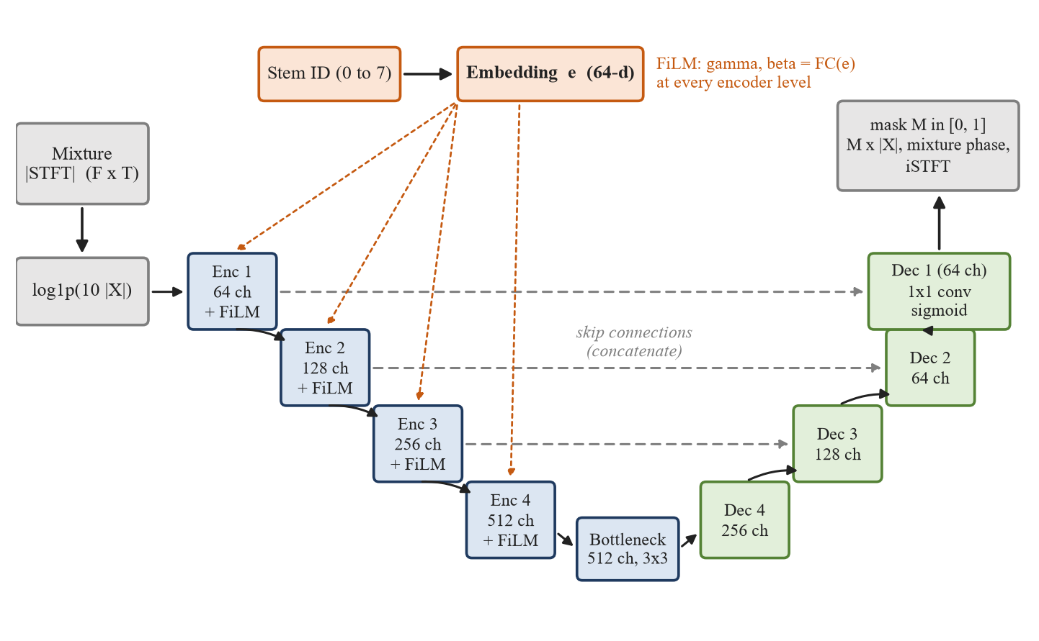
Figure 3.1: Query-Conditioned U-Net with FiLM Modulation at Every Encoder Level
3.3 Training Objective
Let S be the magnitude STFT of the target stem, let x̄ be the mean of |X| over the clip, and let ε be a small constant (10⁻⁶ added to x̄, 10⁻⁸ in the ratio mask). Five terms are combined. The first compares the masked magnitude with the target, normalised by the loudness of the mixture so that the term has no absolute scale.
L_{rel} = mean( | M · |X| − S | ) / ( x̄ + ε ) (3.7)
The second term works on a log-compressed magnitude. It penalises residual noise in quiet bins, which the first term barely sees.
L_{log} = mean | log(1 + 100 · M · |X|) − log(1 + 100 · S) | (3.8)
The third term is the squared error to the ideal ratio mask, and the fourth penalises mask energy in bins where the mixture contains energy that does not belong to the target.
L_{irm} = mean[ ( M − clip( S / (|X| + ε), 0, 1 ) )² ] (3.9)
L_{int} = mean( M ⊙ ReLU(|X| − S) ) / ( x̄ + ε ) (3.10)
The last term works on the waveform. SI-SDR in decibels is clipped to [−30, 30] and negated, and it is applied only when the target is not silent, because SI-SDR is undefined for an empty reference.
L_{sdr} = − clip( SI-SDR(ŝ, s), −30, 30 ) (3.11)
L = L_{rel} + 0.5 L_{log} + 0.5 L_{irm} + 0.2 L_{int} + 0.05 L_{sdr} (3.12)
The small weight on L_{sdr} matters. An earlier version gave the SI-SDR term a weight of 0.1 per decibel. That term was about a hundred times larger than the L1 term, and because SI-SDR ignores scale, the mask drifted to arbitrary gains and a hissy noise floor. With the scale-free terms above and a weight of 0.05, the waveform term applies pressure without taking over.
3.4 Absent-Query Training
With probability p = 0.2, a training sample asks for a stem that is not in the clip, for example a mridangam on a Western pop excerpt, and its target is set to zero. When S = 0, the terms L_{rel}, L_{log}, L_{int} and L_{irm} all reduce to penalties on the mask itself, and L_{sdr} is switched off. The only minimum of the remaining loss is a mask close to zero.
S = 0 ⇒ L = L_{rel} + 0.5 L_{log} + 0.5 L_{irm} + 0.2 L_{int} ⇒ M → 0 (3.13)
The consequence at inference time is that a request for an instrument that is not in the song returns near-silence and not a copy of the mixture or a layer of noise. Sato et al. [5] describe the same practice for sound extraction and report that it costs about 0.9 dB on matched queries, a trade-off to keep in mind in Chapter 5.
3.5 Stem Detector Formulation
The detector network maps a log-mel spectrogram of a 6 s window to eight logits z_{k}, one per stem, and six of the eight are trained. Training uses a binary cross-entropy that is weighted per class and masked per label. Neither corpus has separate guitar and piano ground truth, so those two labels have m_{k} = 0, receive no gradient and are not used at inference.
L_{det} = ∑_{k} m_{k} · w_{k} · BCE(z_{k}, y_{k}) / ∑_{k} m_{k} (3.14)
The class weights w_{k} are 1 for the Western stems, 1.5 for violin and mridangam and 2 for ghatam, to offset their lower frequency in the data. At inference the logits of up to ten windows spread over the song are averaged, and each class has a tuned threshold τ_{k} that is selected on validation data to maximise F1. The logit is shifted so that its tuned threshold maps to probability 0.5.
p_{k} = σ( z̄_{k} − logit(τ_{k}) ), stem k is reported if p_{k} ≥ 0.5 (3.15)
3.6 Competitive Mask Filtering
Running each stem through its own mask lets bleed through, because nothing forces the masks of different stems to share a bin. The final system treats the bin as a quantity that is divided among all sources. Let A_{s}(f, τ) be the magnitude of source s in the 44.1 kHz STFT (n_fft 2048, hop 512), whose frame grid equals the 22.05 kHz grid used by the U-Net. Let c be the total mask claimed by the U-Net stems, clipped to [0, 1] so that the remaining share 1 − c cannot become negative, and let p = 2. Each source gets a weight, and the output keeps the share of the selected stems.
c = clip( M_{violin} + M_{mridangam} + M_{ghatam}, 0, 1 ) (3.16)
W_{s} = ( A_{s} · (1 − c) )^{p}, W_{u} = ( M_{u} · |X| )^{p} (3.17)
Y = ∑_{s ∈ S_{sel}} S_{s} ⊙ W_{s} / ( ∑_{j} W_{j} + ε ) (3.18)
In Equation (3.18) the sum over j runs over all competing sources, drums, bass, vocals, guitar and piano from the Demucs-6 model and violin, mridangam and ghatam from the U-Net, and S_{sel} is the set of stems the user selected. The "other" output of Demucs competes only for the U-Net stems, because it holds real content such as synthesisers and would otherwise take energy that belongs to guitar and piano. Figure 3.2 illustrates the idea.
A last step restores loudness. If the peak of the output is above 0.95 it is scaled to 0.92. If the peak is at least 0.03, a gain of min(0.89 / peak, 6) is applied. An output below that peak is treated as an absent stem and left alone, so that residue is not amplified into noise.
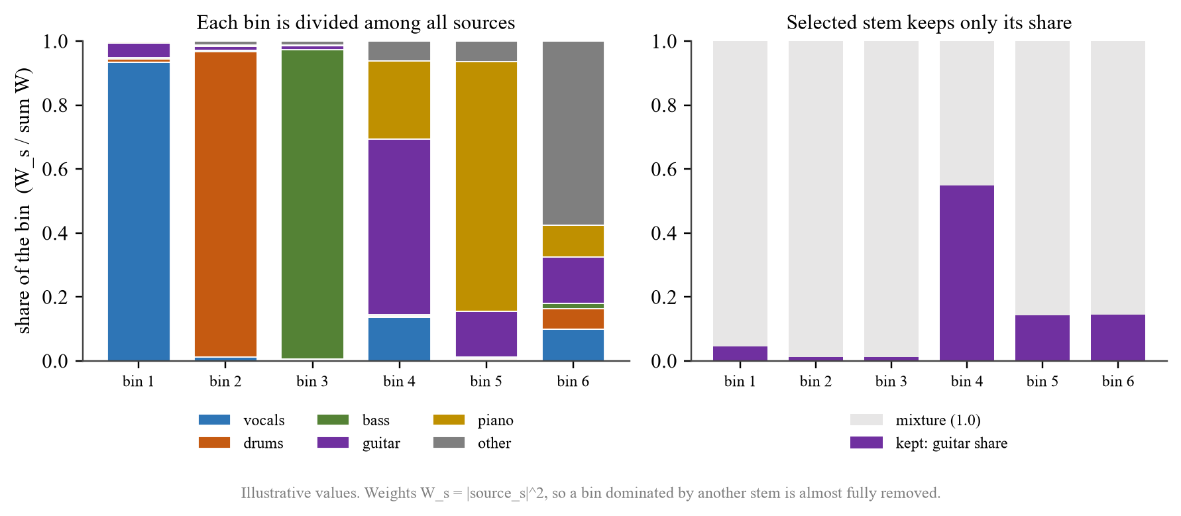
Figure 3.2: Competitive Mask. Each Time-Frequency Bin Is Shared by All Sources and the Selected Stem Keeps Only Its Share
3.7 Evaluation Metrics
Separation quality is reported as scale-invariant SDR [25]. The estimate is projected on the reference to remove any difference in gain.
SI-SDR = 10 · log₁₀( ‖αs‖² / ‖αs − ŝ‖² ), α = ⟨ŝ, s⟩ / ‖s‖² (3.19)
Leakage is reported as the source-to-interference ratio (SIR). The estimate is regressed on the ground-truth stems of the track by least squares, and SIR is the energy of the part explained by the target stem over the energy of the part explained by the other stems. A higher value means less bleed.
SIR = 10 · log₁₀( ‖c_{target}‖² / ‖∑_{j ≠ target} c_{j}‖² ), ŝ ≈ ∑_{j} c_{j} (3.20)
Two reference values put these numbers in context. The raw mixture used as the estimate is the trivial baseline. The ideal ratio mask, computed from the true stem and applied to the mixture while keeping the mixture phase, is an oracle reference. It is not a strict upper bound for every possible mask model. The detector is scored with F1 per class and the macro average over the six classes that have ground truth.

CHAPTER 4
SYSTEM ARCHITECTURE AND IMPLEMENTATION
This chapter describes how the system is built: the datasets and the audit that repaired them, the detector, the separator, the inference pipeline and the web application. File and function names refer to the project repository.
4.1 Platform Architecture Overview
The system runs in three stages, shown in Figure 4.1. The detector scans the uploaded recording and reports which instruments are present. The user selects any combination of stems. Separation then runs two backends in parallel on the same mixture, a pretrained 6-source Demucs model for vocals, drums, bass, guitar and piano and the trained U-Net for violin, mridangam and ghatam, and the competitive mask combines them so that only the selected stems remain.
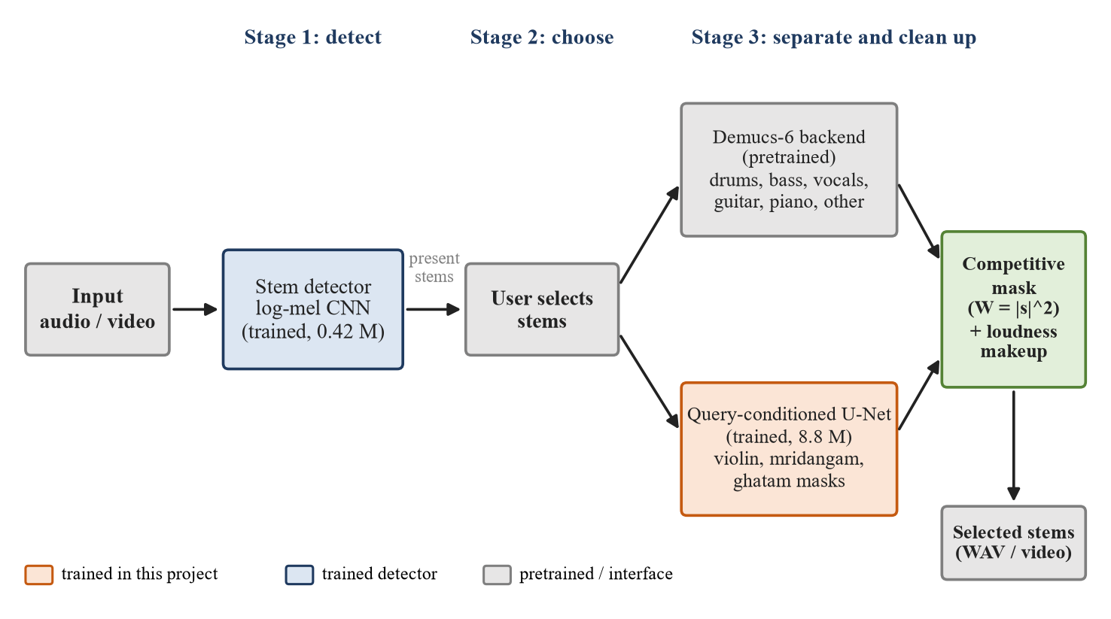
Figure 4.1: System Architecture. Orange Marks What Was Trained in This Project, Blue the Trained Detector, Grey Pretrained or Interface Components
Two pretrained models are used and neither was modified. The 6-source model (htdemucs_6s from the demucs package, a variant of HT Demucs [27]) supplies the five Western sources and an "other" output. A 4-source Hybrid Demucs model from torchaudio is used only to cross-check detector outputs. All parts that handle Carnatic instruments, the detector, the query-conditioned network, the training procedure and the filter were built for this project.
4.2 Datasets and Data Pipeline
Two corpora are used. MUSDB18-HQ provides 100 training and 50 test Western tracks with stems for vocals, drums, bass and other. After the repair described below, 84 of the training tracks are used for training and 16 for validation. The Saraga 1.5 Carnatic collection provides 168 concert recordings with separate microphone tracks for the vocal, violin, mridangam (left and right) and ghatam. Saraga was split by track into 132 training and 36 validation recordings. Ghatam appears in only 46 of the recordings. Audio is resampled to 22.05 kHz mono and cut into 6 s clips, and clips are cached in memory as float16.
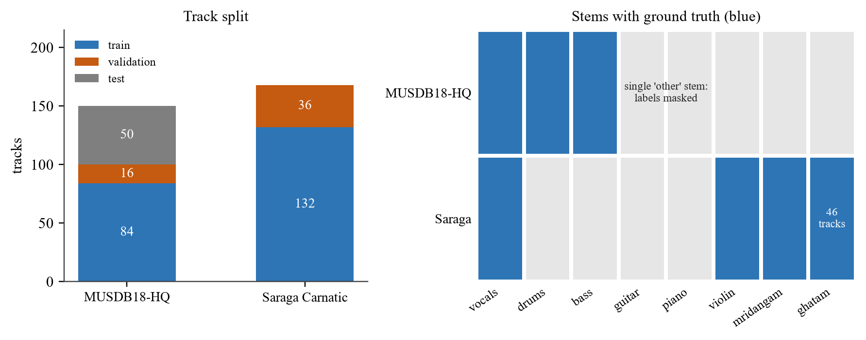
Figure 4.2: Dataset Composition. Left: Tracks per Split. Right: Stems with Ground Truth in Each Corpus
An audit of the data before any further tuning found three faults. Table 4.1 lists them. Together they explain why the first trained model scored a validation SI-SDR of −8.48 dB, and Section 5.2 measures how much each repair was worth.
Table 4.1: Data Audit, Evidence and Repair
Finding | Evidence | Repair
Validation folder duplicates training tracks | All 16 MUSDB "valid" tracks also appeared in "train", so scores were measured on training data | The 16 tracks are removed from training and kept for validation
Saraga mixture does not match the microphone stems | An ideal mask scored −15 to −23 dB SI-SDR against the released mix | Training mixtures are built as the exact sum of the stems
No guitar or piano ground truth | MUSDB gives one "other" stem for both instruments | Those two labels are masked out of the detector loss

Saraga stems also contain bleed, because the microphones were in the same room. This cannot be repaired with the data available. It limits the Carnatic results and is discussed with them in Chapter 5.
4.3 Stem Detector Implementation
The detector (models/stem_detector.py) is a small convolutional network of 0.42 million parameters. It takes a 128-band log-mel spectrogram, passes it through four blocks of convolution, batch normalisation, ReLU and max-pooling with 32, 64, 128 and 256 channels, applies global average pooling, and ends with two fully connected layers that output eight logits. Six of the eight outputs are trained. The other two, guitar and piano, are never trained and are not used. Figure 4.3 shows the layers.
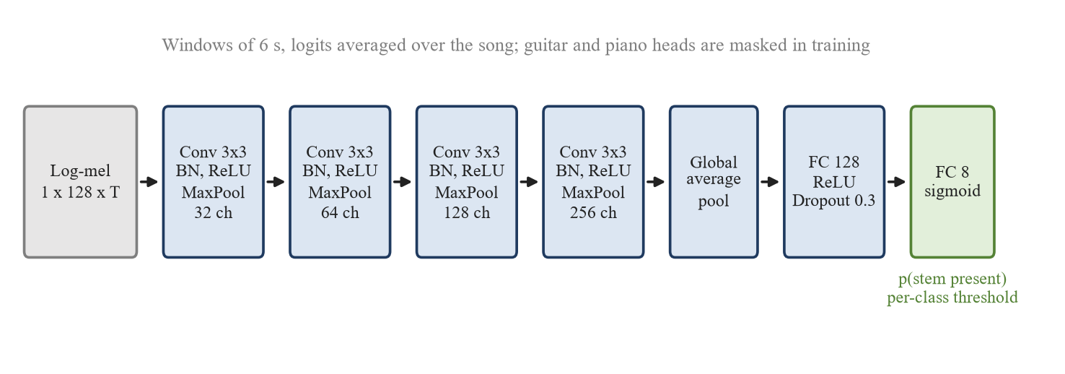
Figure 4.3: Stem Detector Architecture
Two choices in training address a problem found early in the project: a detector trained only on the real corpora learned the dataset and not the instrument, because every MUSDB clip had Western instruments and every Saraga clip had Carnatic ones. The first choice is synthetic cross-corpus mixing. With probability 0.6 a training sample is a sum of clean stem clips drawn from both corpora with random gains between −8 and +3 dB, labelled by the stems that went in. The second is the label mask described in Section 3.5. Training used AdamW with a learning rate of 1e-3, weight decay 1e-4, a cosine schedule, gradient clipping at 5.0 and 40 epochs with a batch of 16. The checkpoint with the best validation macro-F1 was kept, which was epoch 31 with a macro-F1 of 0.798.
At inference (inference/pipeline.py, detect_stems) the network scores between 3 and 10 windows spread across the song and averages the logits. The Demucs energy shares then check the result. Vocals, drums and bass are fused as 0.7 times the detector probability plus 0.3 times a scaled energy share, and a stem whose energy share is below 0.035 is vetoed. Violin, mridangam and ghatam use the detector alone, because Demucs has no such classes. The guitar and piano outputs of the detector were never trained, so their probabilities come from the energy share of the guitar and piano outputs of the 6-source model. If the detector recognises Carnatic audio (violin, mridangam or ghatam at 0.5 or above and drums below 0.5), the guitar probability is capped at 0.2.
4.4 Query-Conditioned Separator Implementation
The separator (models/separator.py, class QueryConditionedSeparator) follows Figure 3.1. The released version uses 64 base channels and has 8.78 million parameters. Decoder dropout is 0.2 at the first block and 0.1 at the second. The stem embedding has 64 dimensions and one FiLM layer sits after each of the four encoder blocks. Table 4.2 lists the training settings.
Table 4.2: Separator Training Configuration
Setting | Value
Optimiser | AdamW, learning rate 1e-3, weight decay 1e-4
Schedule | Cosine annealing to 1e-5 over 150 epochs
Batch size, precision | 8 clips of 6 s, mixed precision, gradient clipping at 5.0
Audio used per track | Up to 150 s per MUSDB track and 90 s per Saraga track
Absent-query samples | 20% of training samples, zero target
Augmentation | Random gain between −6 and +6 dB
Mixtures | Saraga: exact sum of stems. MUSDB: released mixture
Checkpoint selection | Best validation SI-SDR (epoch 116 of 150, 2.53 dB)

The final-epoch weights were not used. Validation SI-SDR at epoch 150 was 1.62 dB against 2.53 dB at epoch 116, so selection by validation score matters. Validation uses no absent queries and no gain augmentation, so the number measures separation of present stems.
4.5 Inference Pipeline
The default mode ("hybrid") of MusicSeparationPipeline.separate follows Section 3.6. The recording is resampled to 44.1 kHz stereo. The 6-source model runs on the full song with an overlap of 0.25 and one random shift. The U-Net runs over 6 s chunks of the 22.05 kHz mono signal with 50% overlap, a Hann-weighted overlap-add and a 3x3 average filter over the resulting mask. Its masks are placed on the 44.1 kHz frame grid, which has the same frame rate and bin width, and the bins above 11 kHz reuse the top U-Net bin. Because the U-Net works at 22.05 kHz, frequencies above about 11 kHz are not modelled by it, and the extension of its highest mask value over that region is an engineering approximation that may limit high-frequency separation of violin, mridangam and ghatam. The competitive mask of Equation (3.18) is then applied and the loudness step runs. Table 4.3 lists the constants.
Table 4.3: Inference Constants
Constant | Value | Purpose
COMPETE_POWER | 2.0 | Exponent of the source weights W
DEMUCS_OVERLAP, DEMUCS_SHIFTS | 0.25, 1 | Overlap and random shifts of the 6-source model
MASK_SMOOTH | 3 | Average filter size on the U-Net mask
MAKEUP_MIN_PEAK, MAKEUP_MAX_GAIN | 0.03, 6.0 | Loudness step, and the level below which a stem counts as absent
MELODIC_INCLUDES_OTHER | True | Guitar or piano requests also keep the remaining accompaniment

The last constant explains a behaviour that can look like a fault. With it set to True, a request for guitar or piano also returns the part of the accompaniment that Demucs puts in "other", so the output of the two stems sounds similar. Both instruments share that accompaniment because MUSDB has no separate labels for them. Guitar and piano outputs should therefore be read as approximate melodic and accompaniment extractions, and not as isolated instrument stems.
4.6 Web Application and Video Input
The interface is a Flask application (ui/app.py) with a single-page front end named StemQuery. It follows four steps: upload a file, run detection, select stems from the detected cards, and listen to the result against the original with a WaveSurfer.js player that allows A/B switching. Figure 4.4 shows the detection step on a Carnatic recording. The routes are /detect, /separate, /original, /audio, /remux and /video.
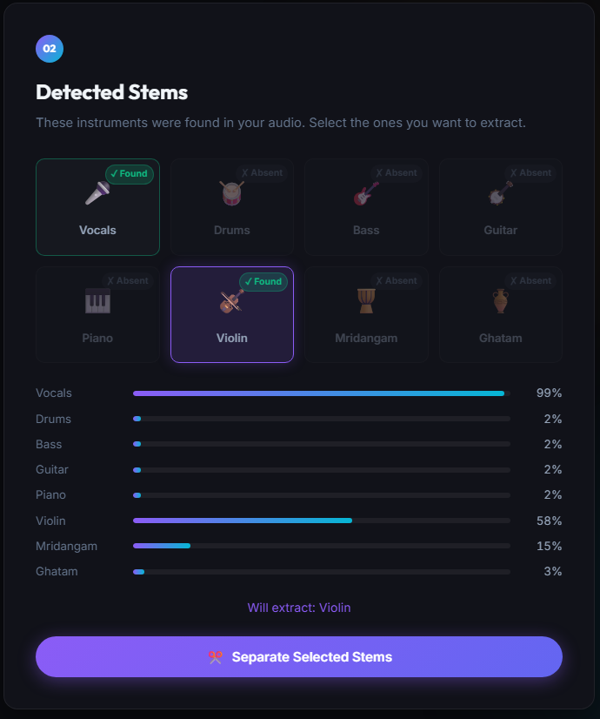
Figure 4.4: Web Interface after Detection on a Carnatic Recording (Violin Selected for Extraction)
Video files (MP4, MKV, MOV, WEBM, AVI, M4V) are accepted. The server extracts the first audio track to a 44.1 kHz stereo WAV with ffmpeg, limited to 12 minutes, and from there the flow is unchanged. A "download video" action then replaces the soundtrack of the original video with the separated audio, copying the video stream without re-encoding. Downloading audio from video-sharing links was prototyped and removed, because those sites increasingly demand a signed-in session from automated clients.
4.7 Software Environment and Reproducibility
The system was developed and evaluated on Windows 11 with Python 3.12, PyTorch 2.6.0 with CUDA 12.4, torchaudio 2.6.0, demucs 4.1.0 and Flask 3.1, on a laptop with an NVIDIA GeForce RTX 3050 GPU. Training scripts accept a tag, so a new run writes separator_<tag>_best.pt and never overwrites the checkpoint that the application loads. The diagnostic script diagnose_separator.py reports, for each dataset and stem, the SI-SDR of the raw mixture, of the ideal mask and of the model, which is how the data faults in Section 4.2 were located.

CHAPTER 5
RESULTS, BENCHMARKS, AND DISCUSSION
This chapter reports what was measured and what the measurements allow us to say. All numbers come from validation clips, validation tracks or test tracks that were not used for training, except where stated. Each result is given together with the size of the sample behind it, because several of the samples are small.
5.1 Experimental Setup and Evaluation Protocol
Experiments ran on the laptop described in Section 4.7. The separator is validated on 6 s clips drawn from 16 MUSDB18-HQ validation tracks and 36 Saraga validation recordings, and each stem is scored on between 11 and 30 clips. Three further evaluations use longer excerpts: a comparison with the pretrained backend on 12 Saraga validation tracks (20 s windows, full inference path), a leakage study on four MUSDB test tracks (40 s excerpts), and a check of absent-stem requests on four pop songs. Every figure is compared with two references, the raw mixture used as the estimate and the ideal ratio mask. Three terms are used consistently. "U-Net only" is the trained query-conditioned network alone. "Demucs backend" is the pretrained 6-source model. "Final system" is the hybrid pipeline of Section 4.5 with the competitive mask and the loudness step. Checkpoint selection and the detector thresholds used the validation sets, so the validation scores are model-selection scores and not independent test estimates. The leakage and absent-query studies use MUSDB test tracks, and Saraga has no separate test split. The project tests three hypotheses, which follow from the research gaps in Chapter 2.
H1. Transfer to Carnatic stems: the trained U-Net gives higher SI-SDR than the best-matching output of the pretrained Western Demucs backend on the evaluated Saraga validation tracks. This measures transfer to Carnatic stem separation and does not show that the complete system is better overall.
H2. Absent-query training: training with silent-target requests makes the final system return a much quieter output for a stem that is not in the song than for a stem that is.
H3. Competitive mask: dividing each time-frequency bin among all sources lowers the leakage of unselected stems compared with extracting each stem independently.
5.2 Effect of Data Repair on Validation SI-SDR
Table 5.1 lists the best validation SI-SDR after each stage of the work, and Figure 5.1 plots it. The first score on repaired validation data, measured after the duplicated validation tracks were removed from training, was −8.48 dB. Training Saraga on the exact sum of its stems raised the score to +1.81 dB without any change to the network, a gain of 10.3 dB. Longer training clips and a larger network added a further 0.7 dB. Best validation SI-SDR therefore improved from −8.48 dB in the first repaired-validation configuration to +2.53 dB in the final configuration, and the data repair was worth far more than any architectural change.
Table 5.1: Best Validation SI-SDR at Each Stage
Stage | Change | SI-SDR (dB)
1 | Validation tracks removed from training; Saraga targets still misaligned | −8.48
2 | Saraga mixtures built as the exact sum of the stems | +1.81
3 | Longer clips per track (120 s MUSDB, 60 s Saraga) | +2.15
4 | 64 base channels (8.8 M parameters), 150 s and 90 s per track, 150 epochs | +2.53

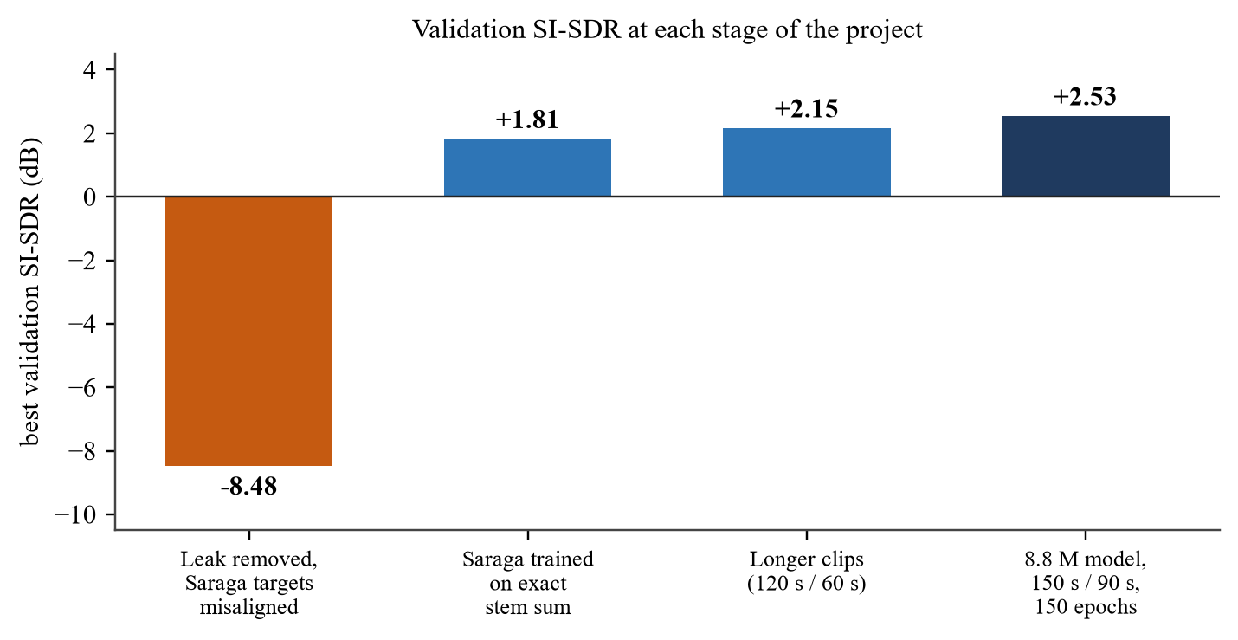
Figure 5.1: Best Validation SI-SDR at Each Stage of the Project
5.3 Separator Quality per Stem
Table 5.2 reports the trained U-Net alone on 6 s validation clips, together with the raw mixture and the ideal-mask oracle reference. Figure 5.2 shows the same values. The model improves on the raw mixture for every stem that has ground truth, by between 4.8 and 8.8 dB. It is 4 to 6 dB below the oracle for the MUSDB stems and for Saraga vocals, 2.7 dB below it for violin and 0.6 dB below it for mridangam. Guitar and piano are excluded from this table because neither corpus provides independent ground-truth stems for them. Scoring them against the single MUSDB "other" stem would not measure guitar or piano separation.
Table 5.2: Per-Stem SI-SDR of the Trained U-Net on Validation Clips (dB)
Dataset | Stem | Raw mixture | U-Net | Ideal mask | Gain over mixture
MUSDB18-HQ | Vocals | −3.6 | 4.2 | 10.1 | +7.8
MUSDB18-HQ | Drums | −6.5 | 2.3 | 6.5 | +8.8
MUSDB18-HQ | Bass | −6.6 | 0.2 | 4.2 | +6.8
Saraga | Vocals | 0.8 | 5.6 | 9.7 | +4.8
Saraga | Mridangam | −2.4 | 5.2 | 5.8 | +7.6
Saraga | Violin | −5.9 | 1.1 | 3.8 | +7.0
Saraga | Ghatam | not scored | silence | not scored | not applicable

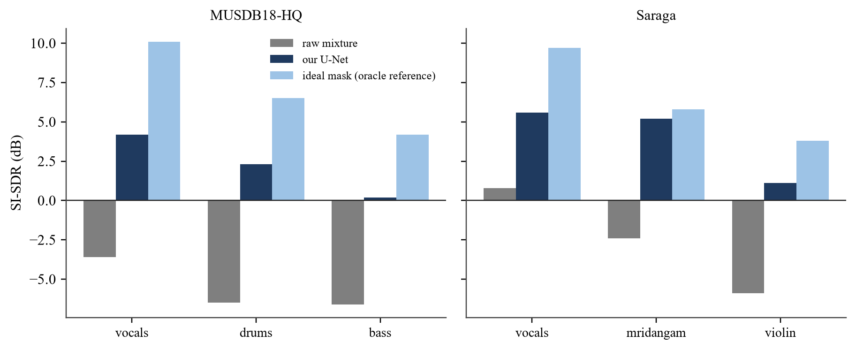
Figure 5.2: SI-SDR of the Raw Mixture, the Trained U-Net and the Ideal Mask
Three points stand out. The oracle reference is itself low for several stems, 4.2 dB for bass and 3.8 dB for violin, which shows that mixture-phase reuse and the overlap of sources in frequency impose a substantial limit on the reconstruction quality of a mask. Mridangam is the best case, and a plausible reason is that a percussive instrument occupies a narrow set of time-frequency bins that a mask can pick out. Ghatam returns silence in the validation clips. It appears in only 46 training recordings, with heavy bleed from the other instruments, and the model has not learned to pick it out. The U-Net is therefore used in the final system only for the three stems that the pretrained backend lacks, and the five Western stems come from the backend, which leaks less (Table 5.5).
5.4 Stem Detector Performance
Table 5.3 gives the validation F1 of the detector for the six stems that have ground truth, together with the thresholds selected for every class. Validation uses the real validation items plus 300 synthetic mixtures built from validation stems. The macro-F1 is 0.798 across the six classes with ground-truth labels. Ghatam is the weakest class at 0.65, which agrees with the separator, and vocals, drums and bass are all near 0.85 to 0.89. Guitar and piano are not scored because there is no ground truth for them, and their probabilities in the application come from the energy share of the 6-source model.
Table 5.3: Stem Detector F1 on Validation Data and Tuned Thresholds
Stem | Vocals | Drums | Bass | Violin | Mridangam | Ghatam | Macro
F1 | 0.85 | 0.89 | 0.88 | 0.78 | 0.74 | 0.65 | 0.798
Threshold | 0.35 | 0.25 | 0.45 | 0.45 | 0.55 | 0.50 | n/a

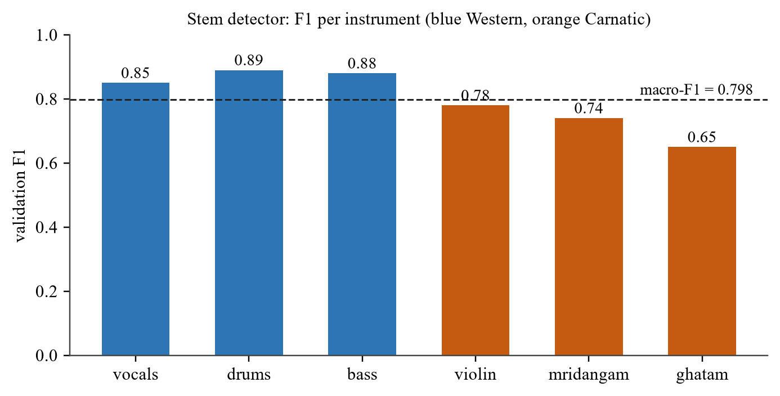
Figure 5.3: Validation F1 of the Stem Detector for Each Instrument
5.5 Comparison with the Pretrained Backend on Carnatic Stems (H1)
To test H1, the 6-source Demucs model and the trained U-Net were run on 12 Saraga validation tracks, using 20 s windows and the full inference path. For each target stem the comparison takes the best-matching of the six Demucs outputs, which is chosen with the ground truth and therefore favours Demucs. Table 5.4 and Figure 5.4 show the result. The trained U-Net scores higher on all three stems, by 0.8 dB for vocals, 2.8 dB for violin and 4.4 dB for mridangam, and the difference is larger for instruments that Demucs has no class for. The comparison measures transfer to Carnatic stem separation and not the overall superiority of either complete system.
Table 5.4: SI-SDR against the True Stem on Carnatic Validation Tracks (dB)
Stem | Best of six Demucs outputs | Trained U-Net | Difference
Vocals | 4.50 | 5.28 | +0.8
Violin | −1.85 | 0.98 | +2.8
Mridangam | −4.35 | 0.06 | +4.4

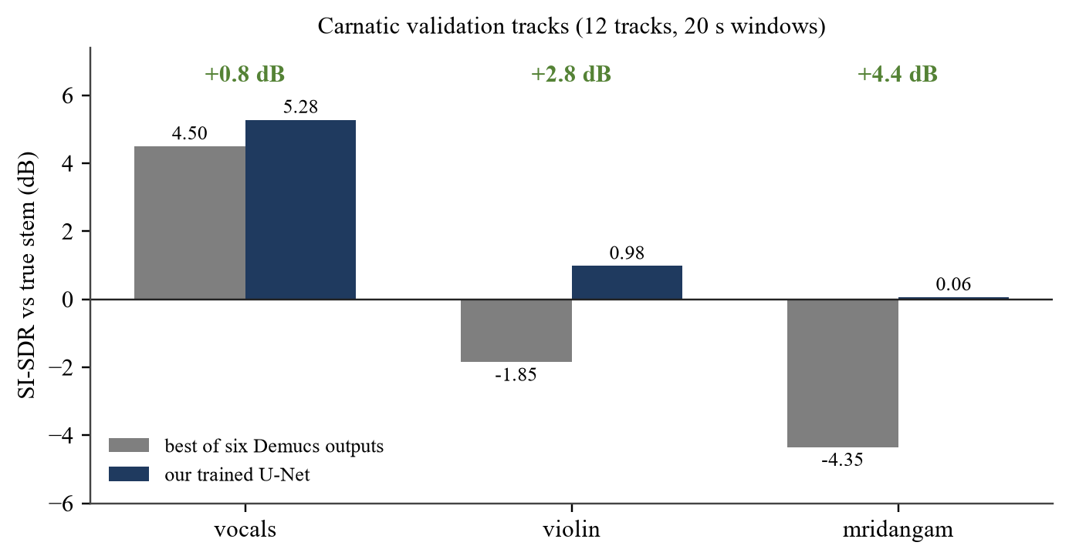
Figure 5.4: Trained U-Net against the Best of the Six Pretrained Demucs Outputs on Carnatic Validation Tracks
Two cautions apply. The absolute values are lower than in Table 5.2 because the windows are longer and the whole inference path is used. The mixtures are sums of the Saraga stems, so the result says how well the model separates stem sums, and it does not establish the same gain on real mixes, as the 6 dB fall reported in [18] for synthetic-to-real transfer makes clear. A mridangam score of 0.06 dB is an improvement over the pretrained output, and it is still a modest absolute value.
5.6 Leakage Suppression (H3)
5.6.1 U-Net only compared with the final system
Table 5.5 compares the leakage of the U-Net masks used on their own with the final system on four MUSDB test tracks of 40 s each. The competitive mask raises SIR by 12 dB for vocals, 22 dB for drums, 6.5 dB for bass and 22 dB for guitar plus piano. Guitar plus piano is the instructive case. The U-Net alone returned an output that explained more of the other stems than of the target (−1.7 dB), and the final system returns 20.2 dB.
Table 5.5: Leakage of Unselected Stems, SIR (dB, Higher Is Better)
Selected stem | U-Net masks alone | Final system | Change
Vocals | 16.1 | 28.2 | +12.1
Drums | 5.3 | 27.6 | +22.3
Bass | 4.5 | 11.0 | +6.5
Guitar + piano | −1.7 | 20.2 | +21.9

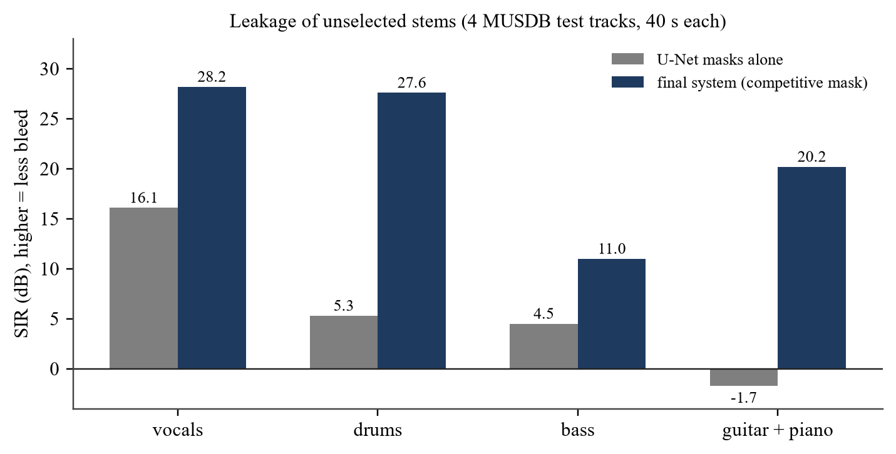
Figure 5.5: SIR of the U-Net Masks Alone and of the Final System
5.6.2 Competitive masking of the Demucs outputs
A second comparison, from an earlier and separate run on the same four tracks, isolates the effect of the competitive mask on the pretrained backend. Table 5.6 gives the result. The competitive mask cost about 1 dB of SI-SDR on the core stems. Together with Table 5.5, the results provide empirical support for H3 on the four evaluated MUSDB test tracks. With four tracks and no confidence intervals they should not be read as a statistical test.
Table 5.6: SIR of Independent Demucs Extraction and of the Competitive Mask, Earlier Run (dB)
Selected stem | Independent extraction | Competitive mask | Change
Vocals | 25.4 | 28.3 | +2.9
Drums | 22.5 | 27.5 | +5.0
Guitar + piano | 13.8 | 21.5 | +7.7

Harder settings were also tried: larger exponents, sharper shares, an ensemble with the 4-source model and a second pass of the filter. They gave at most 1 dB more SIR for 0.5 to 4 dB less SI-SDR, so the exponent stayed at 2. Bass leakage of about 11 dB is a limit of the backend, because bass and the lowest harmonics of other instruments overlap in frequency.
5.7 Requests for Absent Stems (H2)
To test H2, violin, mridangam and ghatam were requested from the final system on four MUSDB test tracks (30 s excerpts) that contain none of them, and vocals, which is present, served as the reference. Table 5.7 gives the level of the returned audio relative to the level of the mixture, after the loudness step. An earlier informal check with a previous checkpoint had reported outputs 27 to 178 dB below the mixture. That figure is not reproduced by the final system and is superseded by Table 5.7.
Table 5.7: Level of the Returned Audio Relative to the Mixture (dB)
Test track | Violin | Mridangam | Ghatam | Vocals (present)
Al James - Schoolboy Facination | −38.5 | −13.6 | −211.1 | −0.1
AM Contra - Heart Peripheral | −11.6 | −12.7 | −208.4 | 2.0
Angels In Amplifiers - I'm Alright | −12.6 | −16.5 | −204.2 | −0.4
Arise - Run Run Run | −15.0 | −9.9 | −218.0 | −1.3
Mean (SD) | −19.4 (12.8) | −13.2 (2.7) | −210.4 (5.8) | 0.0 (1.4)

H2 is only partly supported. Ghatam is returned as silence, but it is also returned as silence on recordings that contain it (Section 5.3), so this is a failure of coverage and not evidence of selective absent-query behaviour. Violin and mridangam are returned between 10 and 17 dB below the mixture on three of the tracks, which is quieter than a present stem but clearly audible, and 38 dB below on one track. The loudness step can raise a quiet residue by up to 15.6 dB, which contributes to this. The cost on present stems was not isolated, so the 0.9 dB cost that [5] reports for matched queries is neither confirmed nor ruled out here.
5.8 Qualitative Examples
Figure 5.6 shows spectrograms for three clips: vocals and drums from the second MUSDB test track (60 to 72 s) and mridangam from the first Saraga validation clip with audible mridangam. They were not chosen for quality. The vocals and drums outputs come from the pretrained backend through the competitive mask, and the mridangam output comes from the trained U-Net. The SI-SDR against the ground-truth stem is +11.7 dB for vocals, +4.3 dB for drums and +11.2 dB for mridangam. The mridangam clip is well above the validation average of 5.2 dB, so it should be read as a single example. In the drums panel, bursts of the other instruments are visible between 0 and 7 s of the output, which is the residual leakage that Table 5.5 counts.
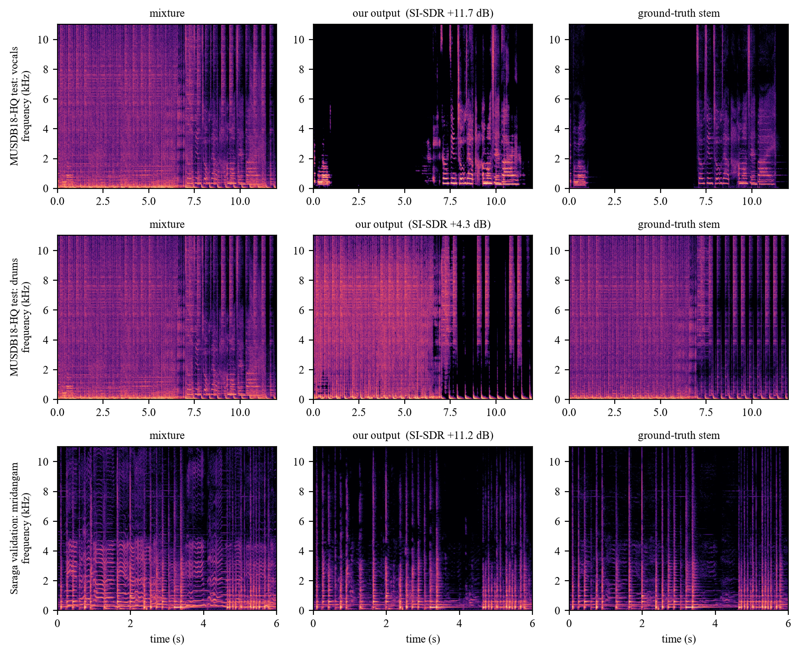
Figure 5.6: Spectrograms of the Mixture, the System Output and the Ground-Truth Stem for Vocals, Drums and Mridangam
5.9 Discussion
The results support the three hypotheses within the limits of the samples. The largest gain came from repairing the data, which fits the observation in [8] that bleed and label errors are properties of the training set that a method has to survive. The trained model beats the pretrained one on Carnatic stems, and the benefit is largest where the pretrained model has no class. The competitive mask substantially reduces the leakage that independent extraction leaves, although residual interference remains.
The weak points are as clear as the strong ones. Violin separation is modest at about 1 dB. Ghatam is included as a query class, but the current model does not recover it, and violin and mridangam requests on songs that lack them still return audible output. The Carnatic ground truth contains bleed [11], so even a perfect model would be scored against imperfect stems. The training and validation mixtures are stem sums, so performance on fully real mixes is not measured [18]. Each stem is scored on 11 to 30 clips, and a mean over so few clips hides the spread that [20] asks for. The Western stems depend on a pretrained backend. The guitar and piano outputs sound alike because both include the remaining accompaniment, a design choice that follows from the missing ground truth. They should be read as approximate melodic extractions and not as isolated instrument stems. Finally, the newly trained U-Net has been evaluated mainly on Carnatic stems, and the Western stems of the final system come from the pretrained backend, so the results do not show equal performance of a trained model across both traditions.

CHAPTER 6
CONCLUSION AND FUTURE SCOPE
6.1 Summary of Completed Contributions
The project delivers a working system that detects the instruments present in a recording and returns the stems the user selects while suppressing the others. The detector is trained for six classes and reaches a macro-F1 of 0.798 across them, and guitar and piano presence is estimated from the pretrained backend. A single query-conditioned U-Net with 8.8 million parameters, trained on MUSDB18-HQ and Saraga, extracts violin, mridangam and ghatam masks, and a competitive mask combines them with a pretrained 6-source model for the Western stems. A web application with audio and video input exposes the pipeline.
The measured outcomes are these. Best validation SI-SDR rose from −8.48 dB in the first repaired-validation configuration to +2.53 dB in the final configuration, and the largest step came from repairing the data. On 12 Carnatic validation tracks the trained model beat the best pretrained output by 0.8 dB for vocals, 2.8 dB for violin and 4.4 dB for mridangam. The competitive mask raised leakage suppression to 28.2 dB SIR for vocals and 27.6 dB for drums on four test tracks. The competitive mask substantially reduces leakage from unselected instruments, although residual interference remains, and requests for absent violin or mridangam still return audible output. Leakage was the practical problem that started the work, and it is reduced and not solved.
6.2 Key Theoretical and Practical Takeaways
Three lessons stand out. First, in a task with scarce and noisy ground truth, auditing the data gave more than changing the network. The faults were found with a simple diagnostic that scores the raw mixture and the ideal mask next to the model. Second, a mask model should be trained on requests it should refuse. Absent-query examples were added because the separator otherwise answered every request with sound, and they reduce that behaviour without removing it for violin and mridangam. Third, leakage is a property of how masks are combined, and sharing each bin among all sources was more effective than making each mask more accurate.
6.3 Limitations
The limits are listed here so that the results can be read correctly. Ghatam is a supported query class, but the model returns silence for it, because only 46 training recordings contain it. Violin separation is about 1 dB on mixed recordings. Saraga stems contain bleed, so the Carnatic scores are measured against imperfect ground truth. Carnatic training and validation use summed stems, and the quality on real concert mixes is unmeasured. The validation sets hold 11 to 30 clips per stem. No listening test was run. Guitar and piano cannot be trained or scored separately because MUSDB provides one "other" stem for both, so their outputs are approximate melodic extractions. The U-Net does not model frequencies above about 11 kHz. The five Western stems rely on a pretrained model that was not trained in this project.
6.4 Future Research Directions
Future work follows the limits above. The first direction is better Carnatic data: the studio-quality Sanidha recordings [11] for clean training and evaluation, and more ghatam and violin recordings. The second is real labels for guitar and piano from multitrack collections that name the two instruments separately, which would also allow an independent held-out test set. The third is evaluation: a listening test, per-clip distributions as recommended in [20], and perceptual measures such as MAPSS [19]. The fourth is the model itself, with a complex-valued or waveform-domain separator to remove the phase ceiling and fine-tuning on real concert mixes. The fifth is richer queries, such as groups of instruments [2], and a detector built on a frozen audio foundation model [13].

REFERENCES
[1] Watcharasupat, K. N., & Lerch, A. (2024). A stem-agnostic single-decoder system for music source separation beyond four stems. In Proceedings of the 25th International Society for Music Information Retrieval Conference (ISMIR), San Francisco, CA, USA. arXiv:2406.18747.
[2] Watcharasupat, K. N., & Lerch, A. (2025). Separate this, and all of these things around it: Music source separation via hyperellipsoidal queries. arXiv:2501.16171.
[3] O'Hanlon, K., Woods, B., Wang, L., & Sandler, M. (2025). A conditioned UNet for music source separation (QSCNet). In Proceedings of the 17th International Symposium on Computer Music Multidisciplinary Research (CMMR), pp. 322-333. arXiv:2512.15532.
[4] Ma, H., Peng, Z., Li, X., Shao, M., Wu, X., & Liu, J. (2024). CLAPSep: Leveraging contrastive pre-trained model for multi-modal query-conditioned target sound extraction. IEEE/ACM Transactions on Audio, Speech, and Language Processing, 32. doi:10.1109/TASLP.2024.3497586.
[5] Sato, R., Haruta, C., Hiruma, N., & Imoto, K. (2025). Context-aware query refinement for target sound extraction: Handling partially matched queries. In Proceedings of the IEEE Workshop on Applications of Signal Processing to Audio and Acoustics (WASPAA). arXiv:2509.08292.
[6] Tong, W., Zhu, J., Chen, J., Kang, S., Jiang, T., Li, Y., Wu, Z., & Meng, H. (2024). SCNet: Sparse compression network for music source separation. In Proceedings of the IEEE International Conference on Acoustics, Speech and Signal Processing (ICASSP). arXiv:2401.13276.
[7] Hung, Y.-N., Pereira, I., & Korzeniowski, F. (2025). Moises-Light: Resource-efficient band-split U-Net for music source separation. arXiv:2510.06785.
[8] Fabbro, G., et al. (2024). The Sound Demixing Challenge 2023: Music demixing track. Transactions of the International Society for Music Information Retrieval, 7(1), 63-84. doi:10.5334/tismir.171.
[9] Zhu, J., Qiu, H., Zhu, H., Yu, J., Yu, K., & Chen, X. (2026). The SJTU X-LANCE Lab system for MSR Challenge 2025. arXiv:2602.09042.
[10] Schweinitz, S. (2025). A fine tuning strategy to improve musical source separation quality for Indian Carnatic music. M.Sc. thesis, Sound and Music Computing, Universitat Pompeu Fabra, Barcelona, Spain. doi:10.5281/zenodo.17304796.
[11] Krishnan, V. V., Alben, N., Nair, A., & Condit-Schultz, N. (2024). Sanidha: A studio quality multi-modal dataset for Carnatic music. In Proceedings of the 25th International Society for Music Information Retrieval Conference (ISMIR), pp. 705-712. arXiv:2501.06959.
[12] Srinivasan, R., Rajagopal, A., & Hayden, C. (2026). Audio separation and classification of Indian classical instruments from monophonic and polyphonic audio clips. Manuscript, SSN College of Engineering, Chennai, India (venue not stated).
[13] Papaioannou, C., Benetos, E., & Potamianos, A. (2025). Universal music representations? Evaluating foundation models on world music corpora. In Proceedings of the 26th International Society for Music Information Retrieval Conference (ISMIR). arXiv:2506.17055.
[14] Esfangereh, D., Sameti, M. H., Moridani, S., Javidpour, L., & Soleymani, M. (2025). Persian musical instruments classification using polyphonic data augmentation. In NeurIPS 2025 Workshop on AI for Music: Where Creativity Meets Computation, San Diego, CA, USA.
[15] Li, K., Cheng, J., Zeng, C., Yan, Z., Wang, H., Su, Z., Zheng, B., & Hu, X. (2026). A semantically consistent dataset for data-efficient query-based universal sound separation. In Proceedings of the International Conference on Machine Learning (ICML). arXiv:2601.22599.
[16] Garcia-Martinez, J., Diaz-Guerra, D., Anderson, J., Falcon-Perez, R., Cabanas-Molero, P., Virtanen, T., Carabias-Orti, J. J., & Vera-Candeas, P. (2026). The Spheres dataset: Multitrack orchestral recordings for music source separation and information retrieval. IEEE Transactions on Audio, Speech, and Language Processing, 34, 2622-2634. arXiv:2511.21247.
[17] Garcia-Martinez, J., Diaz-Guerra, D., Politis, A., Virtanen, T., Carabias-Orti, J. J., & Vera-Candeas, P. (2025). SynthSOD: Developing an heterogeneous dataset for orchestra music source separation. IEEE Open Journal of Signal Processing, 6, 129-137. arXiv:2409.10995.
[18] Roa-Dabike, G., Cox, T. J., Barker, J. P., Akeroyd, M. A., Bannister, S., Fazenda, B., Firth, J., Graetzer, S., Greasley, A., Vos, R. R., & Whitmer, W. M. (2025). Source separation of small classical ensembles: Challenges and opportunities. arXiv:2505.17823.
[19] Ivry, A., Cornell, S., & Watanabe, S. (2026). MAPSS: Manifold-based assessment of perceptual source separation. In Proceedings of the International Conference on Learning Representations (ICLR). arXiv:2509.09212.
[20] Sarkar, S., Moomijan, V., Woods, B., Benetos, E., & Sandler, M. (2025). Perceptual errors in music source separation: Looking beyond SDR averages. In Proceedings of the 26th International Society for Music Information Retrieval Conference (ISMIR).
[21] Araki, S., Ito, N., Haeb-Umbach, R., Wichern, G., Wang, Z.-Q., & Mitsufuji, Y. (2025). 30+ years of source separation research: Achievements and future challenges. In Proceedings of the IEEE International Conference on Acoustics, Speech and Signal Processing (ICASSP). arXiv:2501.11837.
[22] Solovyev, R., Kiselev, I., Stempkovskiy, A., & Gabruseva, T. (2026). Music-Source-Separation-Training (MSST): A unified framework for training and evaluating music demixing models. arXiv:2607.23395.
[23] Shi, B., et al. (2025). SAM Audio: Segment anything in audio. arXiv:2512.18099.
[24] Perez, E., Strub, F., de Vries, H., Dumoulin, V., & Courville, A. (2018). FiLM: Visual reasoning with a general conditioning layer. In Proceedings of the AAAI Conference on Artificial Intelligence. arXiv:1709.07871.
[25] Le Roux, J., Wisdom, S., Erdogan, H., & Hershey, J. R. (2019). SDR: Half-baked or well done? In Proceedings of the IEEE International Conference on Acoustics, Speech and Signal Processing (ICASSP). arXiv:1811.02508.
[26] Rafii, Z., Liutkus, A., Stoter, F.-R., Mimilakis, S. I., & Bittner, R. (2019). MUSDB18-HQ: An uncompressed version of MUSDB18. Zenodo. doi:10.5281/zenodo.3338373.
[27] Rouard, S., Massa, F., & Defossez, A. (2023). Hybrid transformers for music source separation. In Proceedings of the IEEE International Conference on Acoustics, Speech and Signal Processing (ICASSP). arXiv:2211.08553.

