**PROGRESS IN POLYMER SCIENCE**

AN INTERNATIONAL REVIEW JOURNAL

|  |  |  |
| --- | --- | --- |
| Editorial Office*Progress in Polymer Science* Department of Chemistry  Carnegie Mellon University  Pittsburgh, PA 15213 USA  Tel: (412) 268-1059  Fax: (412) 268-6897  [prog-poly-sci@andrew.cmu.edu](mailto:prog-poly-sci@andrew.cmu.edu)  <https://www.editorialmanager.com/pps/> | Proposal form to request permission to submit a review to *Progress in Polymer Science* |  |

**Journal Mission**

Progress in Polymer Science is devoted to the publication of definitive critical reviews of progress in the research area addressed, supported by relevant citations to the published literature, including a majority of citations to literature of the preceding decade. With modern search engines, papers of interest may be readily identified; the value of a review is to help the interested reader evaluate this literature and the path forward; direct quotations from the published literature should be avoided. The goal is to make each paper a splendid starting point to understand the state-of-the-art of its subject. The journal publishes full reviews (10,000-20,000 words) and a few Trend articles (ca. 5,000 words), with the latter emphasizing a topic of currently developing interest.

*The Editors will review proposals for reviews for submission to the journal, and will notify the author(s) on whether a review manuscript is invited on the proposed topic for further consideration. Unsolicited review manuscripts that are not preceded by an accepted proposal will not be reviewed.*

A proposal for submission of review to Progress in Polymer Science should provide the following information, presenting it in the order given.

**Date:**_06 May 2020_

**1. Proposal Title**

Polymers for Near-Field Electrospinning with Spatial Control

**2. Names, affiliations and email addresses of the author(s)**

Alán Aguirre-Soto <alan.aguirre@tec.mx>1  
Dora Iliana Medina <dora.medina@tec.mx>1  
Osamu Katagiri-Tanaka <A01212611@itesm.mx>1

1School of Engineering and Sciences, Tecnologico de Monterrey, Av. Eugenio Garza Sada 2501 Sur, N.L., Monterrey, Mexico

**3. Topical Outline** (300-500 words)

A statement giving the significance and current relevance of the topic, along with the scope of the review.

Near-field electrospinning (NFES) is identified to be a technique able to fabricate polymer nano and microfibers with accurate placement. In the past years (2006-2020). Several polymer solutions have been successfully electrospun into fibers through several variants of the conventional NFES process, where the needle tip to collector distance is in the order of millimeters. Each NFES variant intents to tailor the process parameters in order to improve the fibers’ properties. This review presents a collection of research and synthesis of electrospun fibers, emphasizing the used polymers, solvents, process parameters and fiber characteristics.

The achieved NFES fiber diameters and relevant process parameters used in literature are compiled in a data set for further analysis. If the data is not presented as a table within the reviewed article, then the data is fetched from the provided figures (plots and SEM images) using computer vision techniques. The proposal intends to analyze the collected data about NFES publications to understand the effect of the process parameters and polymer solution properties in the electrospun fiber morphology.

**4. Table of Contents**

A numbered list with principal topics 1, 2, 3, etc., and subtopics 1.1, 1.2, etc. The titles of the principal and subtopics should be explicit representations of content of the relevant sections and subsections.

1. Fabrication Processes of Polymer Fibers
   1. Stretching forces
      1. Electric Field
      2. Centrifugal force
      3. Blowing forces
      4. Mechanical force
      5. Microfluidic forces
   2. Dispensing nozzle
   3. Polymer Reservoir (Polymer Melt & Polymer Solution)
   4. Polymer Solution
      1. Polymers
      2. Solvents
2. Properties that Improve Accuracy of Nano-Fiber Deposition
   1. Nozzle spinneret
   2. Applied Voltage
   3. Nozzle-to-substrate distance
   4. Substrate
3. Discussion & NFES Challenges
4. References

**5. Reviews on the topic published in the preceding decade**

Provide a list of reviews on closely related topics, with the author(s), title, journal, year, volume and page number.

[1] J. Han, L. Xiong, X. Jiang, X. Yuan, Y. Zhao, D. Yang, Bio-functional electrospun nanomaterials: From topology design to biological applications, Prog. Polym. Sci. 91 (2019) 1–28. https://doi.org/10.1016/j.progpolymsci.2019.02.006.

[2] J. Xue, T. Wu, Y. Dai, Y. Xia, Electrospinning and Electrospun Nanofibers: Methods, Materials, and Applications, Chem. Rev. 119 (2019) 5298–5415. https://doi.org/10.1021/acs.chemrev.8b00593.

[3] G. Yang, X. Li, Y. He, J. Ma, G. Ni, S. Zhou, From nano to micro to macro: Electrospun hierarchically structured polymeric fibers for biomedical applications, Prog. Polym. Sci. 81 (2018) 80–113. https://doi.org/10.1016/j.progpolymsci.2017.12.003.

[4] X.-X. He, J. Zheng, G.-F. Yu, M.-H. You, M. Yu, X. Ning, Y.-Z. Long, Near-Field Electrospinning: Progress and Applications, J. Phys. Chem. C. 121 (2017) 8663–8678. https://doi.org/10.1021/acs.jpcc.6b12783.

[5] M.K.R. Begum,Hosne Ara and Khan, Study on the Various Types of Needle Based and Needleless Electrospinning System for Nanofiber Production, Int. J. Text. Sci. 6 (2017) 110–117. https://doi.org/10.5923/j.textile.20170604.03.

[6] L. Persano, A. Camposeo, D. Pisignano, Active polymer nanofibers for photonics, electronics, energy generation and micromechanics, Prog. Polym. Sci. 43 (2015) 48–95. https://doi.org/10.1016/j.progpolymsci.2014.10.001.

[7] B. Sun, Y.Z. Long, H.D. Zhang, M.M. Li, J.L. Duvail, X.Y. Jiang, H.L. Yin, Advances in three-dimensional nanofibrous macrostructures via electrospinning, Prog. Polym. Sci. 39 (2014) 862–890. https://doi.org/10.1016/j.progpolymsci.2013.06.002.

[8] S. Agarwal, A. Greiner, J.H. Wendorff, Functional materials by electrospinning of polymers, Prog. Polym. Sci. 38 (2013) 963–991. https://doi.org/10.1016/j.progpolymsci.2013.02.001.

[9] V. Pillay, C. Dott, Y.E. Choonara, C. Tyagi, L. Tomar, P. Kumar, L.C. Du Toit, V.M.K. Ndesendo, A review of the effect of processing variables on the fabrication of electrospun nanofibers for drug delivery applications, J. Nanomater. 2013 (2013). https://doi.org/10.1155/2013/789289.

[10] S.K. Nataraj, K.S. Yang, T.M. Aminabhavi, Polyacrylonitrile-based nanofibers—A state-of-the-art review, Prog. Polym. Sci. 37 (2012) 487–513. https://doi.org/10.1016/J.PROGPOLYMSCI.2011.07.001.

**6. Five publications by the author(s)**

List five (5) publications by the author(s) most closely related to the topic of proposed review.

**7. Author publication record**

Total number of publications of each author plus the number for each related to the proposed topic.

**8. Names of ten internationally recognized experts on the topic**

The names suggested should not include persons with whom any of the authors have collaborated in the preceding 7 years (such names may appear in item 5).

Madou, Marc J.

Kameoka, Jun

Xia, Younan

Hutmacher, Dietmar W.

Aminabhavi, Tejraj M.

Greiner, Andreas

Wendorff, Joachim Heinz

Jiang, Xingyu

Wei, Suying

Steckl, Andrew J.

**9. Estimated statistics on the review**

Provide estimates of the number of references and estimated percentage of references published within the last decade, the number of double-spaced pages, figures/schemes, and a tentative submittal date.

In the last decade, over 1738 articles indexed by Scopus mention near-field electrospinning (NFES). Most articles were in the category of Material Science (1055), Physics and Astronomy (695), Engineering (632), and Chemistry (583). Coincidentally, these are among the categories that publish the most articles.

Of the top 150 cited articles in the past decade, Progress in Polymer Science published 9, then appears Journal of Materials Chemistry (6), Nanoscale (6), Acta Biomaterialia (5), Advanced Materials (5), and Nano Letters (5). Journals with less than 5 publications in the matter are not mentioned above.

As of April 2020, an article entitled "Direct-write piezoelectric polymeric nanogenerator with high energy conversion efficiency" was cited 812 times, which was more than any other article that referred to near-field electrospinning. The figure below shows the tendency of the number of NFES publications in a yearly basis.

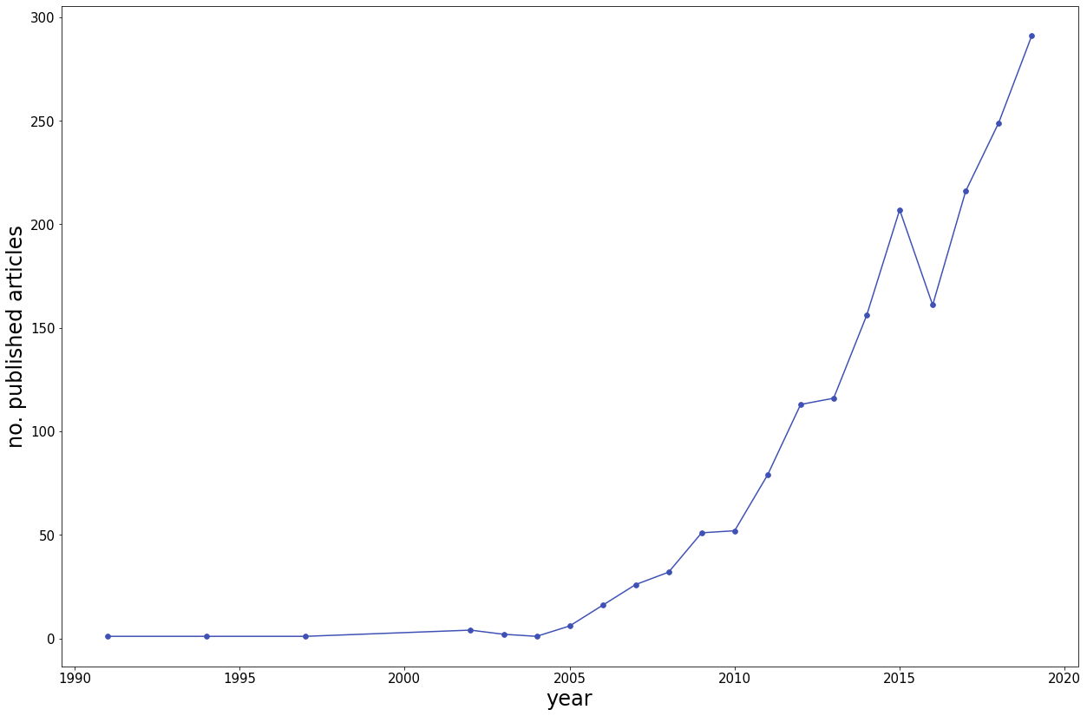

**10. Information from the Editors**

Submission of a manuscript to ‘Progress in Polymer Science’ is contingent on the agreement by all the authors that the submitted work has not received prior publication and that no portion of this or any other closely related work is under consideration for publication elsewhere in any medium, including electronic journals, computer databases, and publicly accessible preprint Web sites.

Given the nature of sources and continuity of availability, citations to Wikipedia should be avoided and the use of websites from and on the products of commercial organizations is discouraged.

*All submissions are routinely examined for the use of excerpts from the published literature, and may be rejected if such are found in excess of standard nomenclature and phrases. Aside from potential legal complications, the practice of copying published excerpts tends to frustrate the critical evaluation of the topic of interest that is an essential part of a useful review.*

All papers published in Progress in Polymer Science receive the benefit of a peer review. If your proposal is accepted the notice of acceptance will be accompanied by detailed instructions to facilitate preparation of a manuscript in the format required by the journal. In particular, ***the requirement for full titles of journal articles, patents, book chapters, etc., in the bibliography, along with the requirement for copyright permissions if use is made of copyright material***; with respect to copyright material, a review should avoid more than incidental direct quotes from the literature, in favor of a presentation that offers your critical discussion and analysis of the topics of interest.

Finally, proposals should be submitted via our submission platform [Editorial Manager](https://www.editorialmanager.com/pps/). Please select “Proposal” as the Article Type when submitting.

G. C. Berry

K. Matyjaszewski

*Editors-in-Chief*

M. R. Bockstaller

*Senior Editor*

Progress in Polymer Science

e-mail: [prog-poly-sci@andrew.cmu.edu](mailto:prog-poly-sci@andrew.cmu.edu)

<https://www.editorialmanager.com/pps/>

=============================