**Electrospinning Oxygen-Less Polymers To Fabricate Carbon-Based Nanostructures**

Osamu Katagiri, Alán Aguirre

Antonio Osamu Katagiri Tanaka: A01212611@itesm.mx

1ITESM CEM, Cd López Mateos, 52926, Méx.

2 ITESM MTY, Monterrey, N.L, 64849, Méx.

Carbon nanomaterials are subjected to great interest for research purposes due to their various potential applications in diverse areas that take advantage of the nano-scale properties. Carbon nanomaterials are suitable for catalysis, adsorption, carbon capture, energy and hydrogen storage, drug delivery, bio-sensing, and cancer detection. Some matchless properties that allow carbon nanomaterials to be utilized within multiple functionalities include high porosity, distinguished structures, uniform morphologies, high stability, high magnetic properties, and high conductivity. [3]

This conference event bestows the engineering and design of a polymer solution to achieve mass scale manufacturing of high conductive carbon nanowires with a reduced diameter in an inexpensive, continuous, simple and reproducible manner. The research intends to involve several manufacturing processes such as near field electrospinning, photopolymerization, pyrolization, and carbonization, as they have shown to be promising methods for the fabrication of carbon nanomaterials. [1] See Figure 1. A few processes have been developed for specific purposes of polymeric nanofibers, some include surface deposition, composites, and chemical adjustments. Polymeric nanofibers must be also pyrolyzed to generate carbon nanowires with conductive capabilities [2] for electrochemical sensing and energy storage purposes.

Traditional near-field electrospinning or NFES allows large scale manufacturability combined with spatial control of material deposition. However, the reported efforts required the use of electric fields in excess of 200 kV/m for continuous operation, resulting in limited control for nano-fiber patterning in traditional NFES processes. Madou et al. [2] conclude that the current state-of-the-art synthesis processes for polymer nano-fibers lack to yield precise, inexpensive, fast, and continuous manufacturing properties.

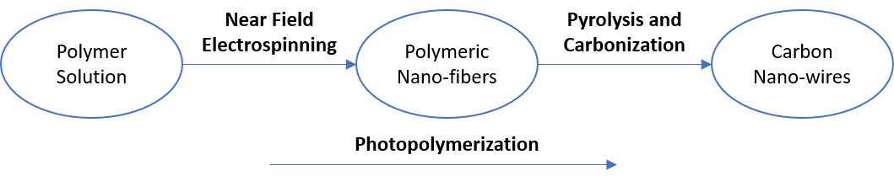

**Figure 1:** Fabrication process of conductive carbon nanowires to achieve through the dissertation

**References**:

[1] Braulio Cárdenas. “Advanced Manufacturing Techniques for the Fabrication and Surface Modification of Carbon Nanowires”. In: (2017), p. 160.

[2] Marc J. Madou et al. “Controlled Continuous Patterning of Polymeric Nanofibers on Three-Dimensional Substrates Using Low-Voltage Near-Field Electrospinning”. In: Nano Letters 11.4 (2011), pp. 1831–1837. ISSN: 1530-6984. DOI: 10. 1021/nl2006164.

[3] M.T.H Siddiqui et al. “Fabrication of advance magnetic carbon nano-materials and their potential applications: A review”. In: Journal of Environmental Chemical Engineering 7.1 (Feb. 2019), p. 102812. ISSN: 2213-3437. DOI: 10.1016/J. JECE.2018.102812. URL: https://0-www-sciencedirect-com.millenium. itesm.mx/science/article/pii/S2213343718307358.