**Tribometer** - Work Instruction

The following is a synthesis of the manuals and documentation provided by the manufacturer “TA Instruments”. Processes are amended to fit the laboratory environment at Tecnológico de Monterrey Campus Estado de México.

**History of changes:**

13Mar2019 - 1st version of the document

**Edited by:**

Antonio Osamu Katagiri Tanaka <A01212611@itesm.mx>

**Revised by:**

Nora Argelia Tafoya Medina <nuorriael@itesm.mx>

Dora Iliana Medina Medina <dora.medina@tec.mx>

Table of Contents

Startup Procedure 3

Shutdown Procedure 4

Install a Geometry 5

Install the Lower Stage 6

Remove the Lower Stage 8

# Start-up Procedure

1. **Ensure** that the air supply is turned on.  
     
   **Open** the **black** ball/T valve and then the **orange** ball/T valve.  
   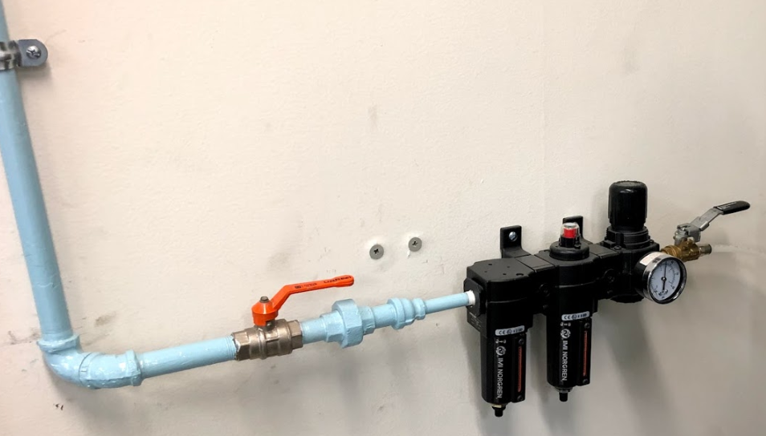  
   The valves in the figure above are in their open position  
     
   **Ensure** the gauge meter reads 30 (±2) psi-+  
   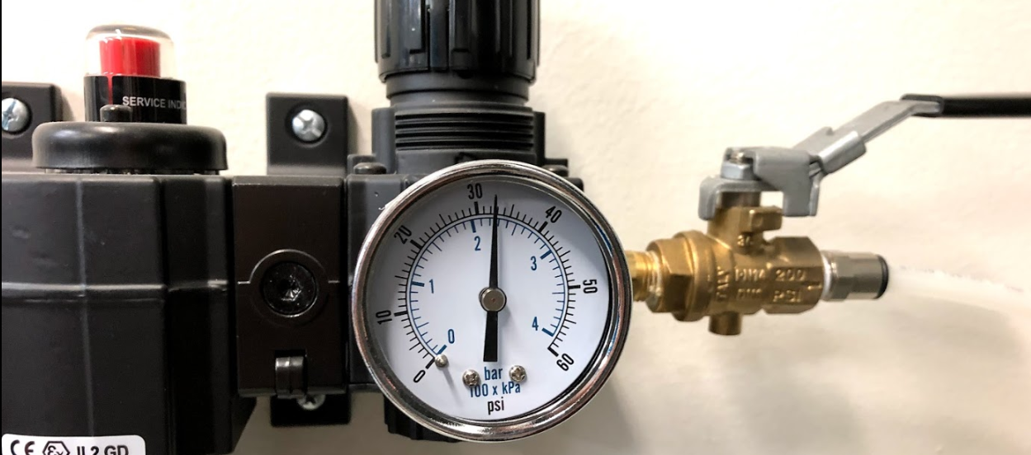  
     
   **Plug** the instruments to the orange (isolated ground) outlet  
   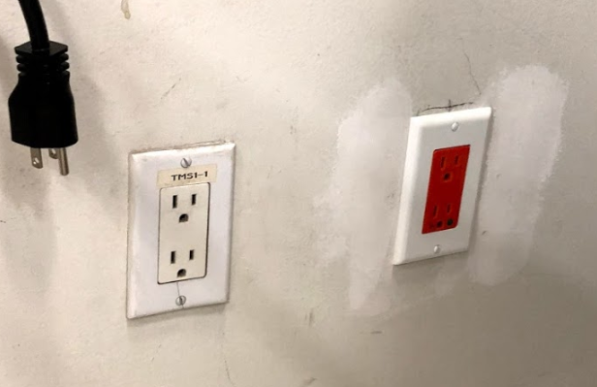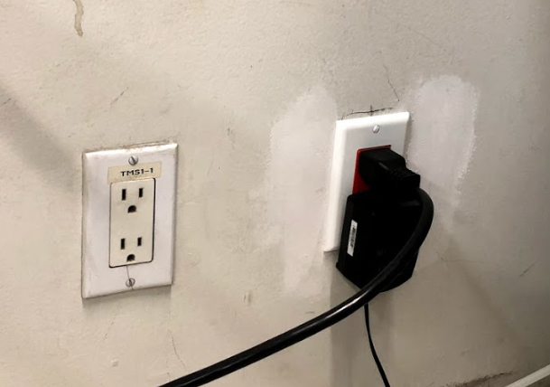
2. **Turn** on fluid circulation.
3. **Remove** bearing clamp if fitted.
4. **Power** on the system by pressing the power switch on the electronics box to the On “I” position.
5. **Connect** the instrument to the software.

# Shutdown Procedure

1. **Turn** off the power to the system by pressing the power switch on the electronics box to the Off “0” position.
2. **Turn** off any fluid circulation.
3. **Fit** the air bearing clamp.
4. **Turn** off the air supply.

# Install a Geometry

1. **Ensure** the compresses air supply is turned on.
2. **Ensure** the instrument is powered on and initialized.
3. **Remove** the bearing clamp by turning the draw rod counter clockwise
4. **Push** the geometry up the spindle and hold.
5. **Rotate** the draw rod clockwise  
     
   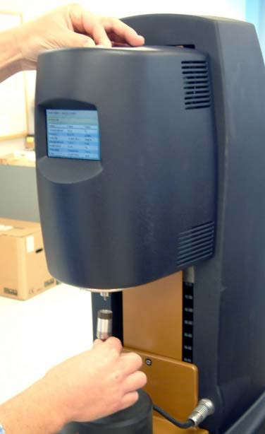  
     
   The draw rod shall pull the geometry up into position. (tight but not forced)

Draw rod

Spindle

Geometry

# Install the Lower Stage

The following sections explain how to **attach** temperature modules using “Smart Swap”. The **installation** procedure is typically the same for all modules.

TIP: Make use of disposable gloves and tissue paper as some liquid may stain.  
The lower stage attachments are stored in black containers/boxes.

1. **Press** the “release button” on the control panel, as described in the figures below.  
     
   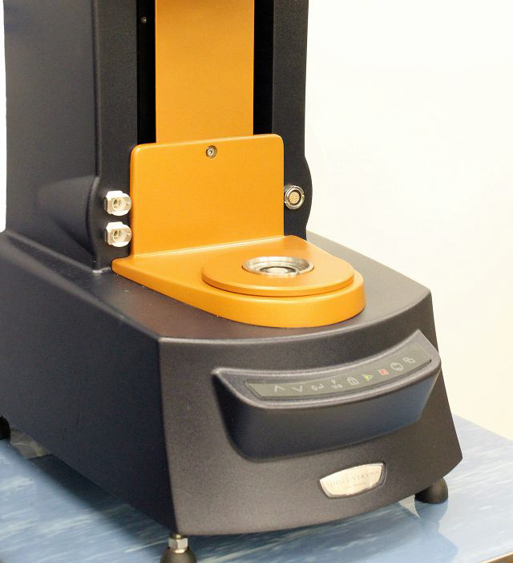  
     
   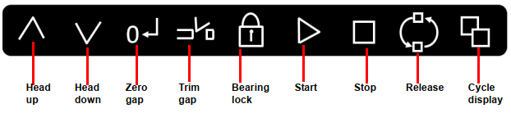  
     
   A continuous green light indicates that the attachment can be fitted.  
   **Notice** that the release state will only stay active for 10 seconds after the “release button” is pressed.

Release button

1. **Fit** the attachment as shown below.  
     
   **Ensure** the mark and slot are align.  
   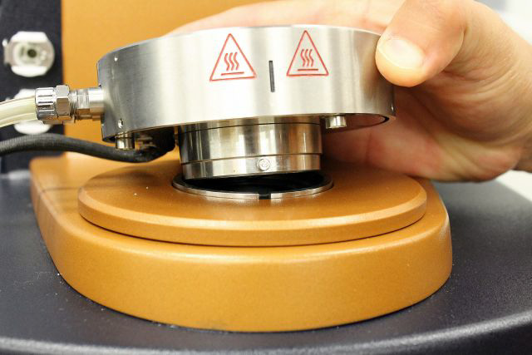  
   The installation shall fit as follows:  
   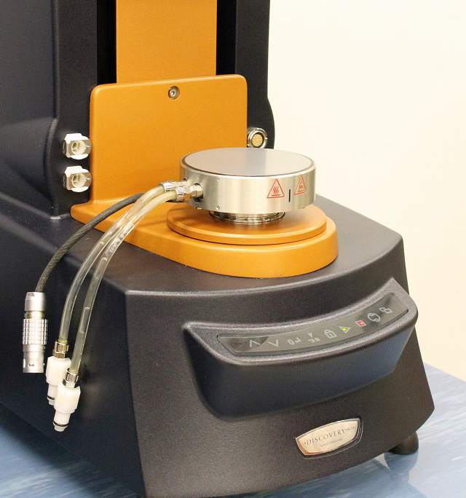

Mark

Slot

1. Connect the power cable and the fluid hoses.  
   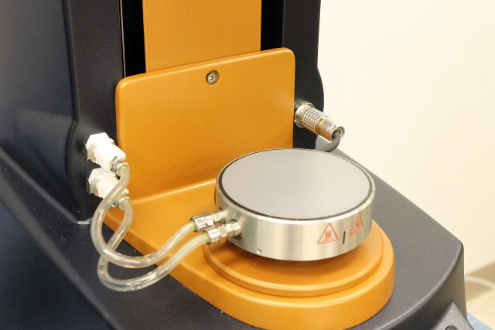

Power cable

Fluid hoses

# Remove the Lower Stage

The following sections explain how to **detach** temperature modules using “Smart Swap”. The **removal** procedure is typically the same for all modules.

TIP: Make use of disposable gloves and tissue paper as some liquid may stain

1. **Press** the “release button” on the control panel, as described in the figures below.  
     
     
     
   

Release button

1. **Disconnect** the power cable and the fluid hoses.  
   

Power cable

Fluid hoses

1. **Press** the “release button” again in the front panel.  
     
     
   **Notice** that the release state will only stay active for 10 seconds.
2. **Remove** the attachment from the instrument.
3. **Store** the removed attachment in its black container/box.