Tec.Nano 2018
Effect of Physical Treatment in Electrical Conductivity of SU-8-based Carbon Structures
Saeed Beigiborouleniª, Antonio Osamu Katagiri Tanakaaª
ªITESM MTY, Av. Eugenio Garza Sada Sur, Monterrey, 2501, N.L., Mexico
Abstract
The effects of physical treatment in electrical conductivity of SU-8 films are investigated. SU-8 films were fabricated through mechanical treatment and stabilization followed by py- rolyzation and characterized by four-point-probe method. Based on previous evidence, it is expected that the induced stress to increase the electrical conductivity of the carbon films. However, the SU-8 carbon films amendment after pyrolysis is mainly due to degassing losses, rather than strain induced forces, hence the small to none differences between the stress-induced and control samples.
© 2019 Elsevier Ltd. All rights reserved.
Peer-review under responsibility of the scientific committee of the International Conference on Nanotechnology Tec.Nano 2018.
Keywords:
- Introduction
Nanostructures and nanostructured materials such as nanotubes, thin films, suspended nanofibers, and nanofiber mats exhibit unique properties that make them suitable as circuitry elements, structural materials and analytical sensors within micro-mechanical systems. Carbon-based nanostructures have been of interest due to their low reactivity, good electrical and thermal properties with electrochemical stability [1]. One technique to fabricate carbon structures is through heat treatment/carbonization of organic materials. Organic materials decompose into simpler compounds when exposed to high temperatures in an inert atmosphere or vaccum [2]; this process is known as pyrolysis. SU-8 is a well-known negative high transparency UV photoresist (see Figure 1) used as a carbon precursor in recent works [2–4].
Cardenas-Benitez et al. [2] studied the pyrolysis-induced shrinkage of photocured SU-8 structures due to the volatilized material/degassing and surface area of the microstructures, where the structures shrank about70% of their original size. Canton et al. [4] reported that the shrinkage and elongation of suspended SU-8 fibers during pyrolysis influences the resulting electrical properties. In Canton et al. deposited fibers in supporting walls, as the walls shrink during pyrolysis strain forces elongate the fibers. Evidence states that the electrical conductivity increases when fibers are elongated/stretched with a decrease of their diameter [4].

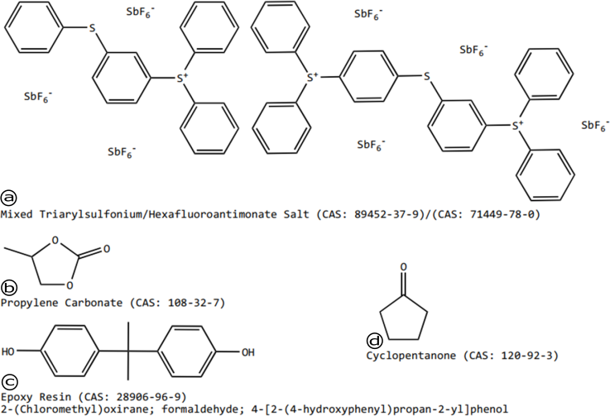
Fig. 1. SU-8 2000 Series Resists Composition. (a) photo initiator; (b-c) epoxy groups of different SU-8 monomers; (d) solvent.

On the other hand, literature suggest that the electrical conductivity of carbon electrodes is enhanced with the execution of mechanical treatments, as the precursor polymer chains align within the fibers. Recent efforts [5, 6] report carbon fibers with superior electrical conductivity, where the polymer chains are aligned with the aid of carbon nanotubes and hydro-electromechanical strain via electrospinning processes.
In this paper, the effects of physical treatment in electrical conductivity of SU-8 films. SU-8 films were fabricated through mechanical treatment and stabilization followed by pyrolyzation and characterized by the four-point-probe method. Based on previous evidence, it is expected that the induced stress to increase the electrical conductivity of the carbon films.

- Materials and Methods
SU-8 2100 was obtained from MicroChem (USA). For the experiments, all reactants were used as they arrived.

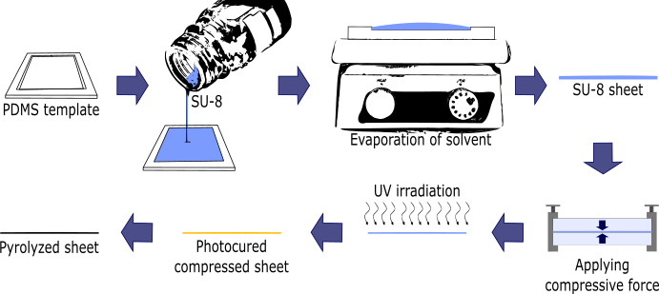
Fig. 2. Schematic diagram of the SU-8 carbon film fabrication process.

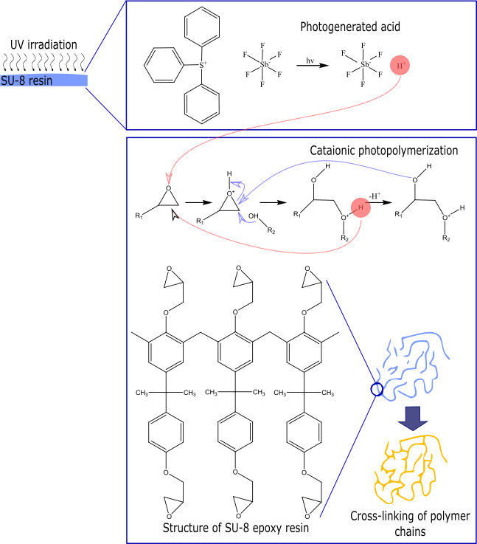
Fig. 3. SU-8 photopolymerization process.

- Results and discussion
SU-8 2100 was obtained from MicroChem (USA). For the experiments, all reactants were used as they arrived.

Nomenclature
PDMS Polydimethylsiloxane
UV Ultraviolet
Acknowledgements
Acknowledgements and Reference heading should be left justified, bold, with the first letter capitalized but have no numbers. Text below continues as normal.

References
[1] R. L. McCreery, Advanced Carbon Electrode Materials for Molecular Electrochemistry, Chemical Re- views 108 (7) (2008) 2646–2687. doi:10.1021/cr068076m.
[2] B. Cardenas-Benitez, C. Eschenbaum, D. Mager, J. G. Korvink, M. J. Madou, U. Lemmer, I. D. Leon,
S. O. Martinez-Chapa, Pyrolysis-induced shrinking of three-dimensional structures fabricated by two- photon polymerization: experiment and theoretical model, Microsystems {&amp;} Nanoengineering 5 (1) (2019). doi:10.1038/s41378-019-0079-9.
[3] B. Y. Park, L. Taherabadi, C. Wang, J. Zoval, M. J. Madou, Electrical Properties and Shrinkage of Carbonized Photoresist Films and the Implications for Carbon Microelectromechanical Systems Devices in Conductive Media, Journal of The Electrochemical Society 152 (12) (2005) 136. doi:10.1149/1.2116707.
[4] G. Canton, T. Do, L. Kulinsky, M. Madou, Improved conductivity of suspended carbon fibers through integration of C-MEMS and Electro-Mechanical Spinning technologies, Carbon 71 (2014) 338–342. doi:10.1016/j.carbon.2014.01.009.
[5] S. Holmberg, M. Ghazinejad, E. Cho, D. George, B. Pollack, A. Perebikovsky, R. Ragan, M. Madou, Stress-activated pyrolytic carbon nanofibers for electrochemical platforms, Electrochimica Acta 290 (2018) 639–648. doi:10.1016/j.electacta.2018.09.013.
[6] M. Ghazinejad, S. Holmberg, O. Pilloni, L. Oropeza-Ramos, M. Madou, Graphitizing Non-graphitizable Carbons by Stress-induced Routes, Scientific Reports 7 (1) (2017) 16551. doi:10.1038/s41598-017-16424- z.
Instructions to Authors for Word template
1. Locking of Copyright:
The copyright line is locked in the templates. The author may not edit the same and making it editable only PSMs. If there are any copyright changes required, you are requested to contact Journal Manager through Guest Editors. For editable the below mentioned steps must be followed:

Steps:
- Click on copyright statement
- Click on Properties in Developer tab
- Remove the checks from Content control cannot be deleted and Contents cannot be edited under Locking and then Press ok
2. Docm format:
We have added macros in the Word templates for the below mentioned features. And since macros are not supported in doc and docx format we created the templates of all titles in .docm format.

- Removal of all highlights
- Accept track change
- Locking of Rules

If .docm format needs to convert in docx format then the following steps must be performed:

Steps:
- Press Alt F11
- Click on Project (JID_Template)
- Enter "thomson" in Project Password
- Click on Microsoft Word Objects
- Click on ThisDocument under Microsoft Word Objects
- Delete all macros under General
- After deletion close the Code and Project (JID_Template) windows
- From File menu click on save as type .docx option
3. Comments added in the margin in Word master templates:
There are instances where author raising queries on what to do with key information lines such as “volume, page numbers”, “Conference title per issue” and “Copyright entity, year, copyright company Elsevier Ltd./B.V./Inc. and Organizer Name” in the copyright statement and for these concerns the comments have been inserted in the Word template to guide Author/JM about the information to be inserted by them in these fields.
Comments removal from Print: In Word 2007 and 2010 the comments present in a document get printed by default. If the authors do not want to get the comments appearing in print, the authors must remove the comments from the Word template before printing by changing the Print markup setting of word using the following steps:
Steps:
- Click the File tab
- Click Print
- Under Settings, click the arrow next to Print All Pages
- Click Print Markup to clear the check mark
Instructions to Authors pages to be excluded from Print:
- Click the File tab
- Click Print
- Under Setting, Type page numbers and/or page ranges separated by commas counting from the start of the document or the section. For example, type 1, 3, 1-5
4. PDF creation from Word master template:
While creating PDF from Word template the below given steps should be followed to avoid difference in trim size and margins and to avoid decrease in resolution and size of the figure images of the Word template and the PDF created.

Steps in Word 2007 and 2010:
- Click the File tab
- Click Print
- Under Printer tab, select Adobe PDF
- Click Printer Properties link
- Under Adobe PDF Settings tab, click on Edit button
- Click on Images folder under Standard
- Make Downsample and Compression fields under Color Images and Grayscale Images "Off". And in Monochrome Images field make only Downsample "Off'
- Then click on OK and given name of the setting in File name tab and click on save
- Then again Under Adobe PDF Settings tab, click on Edit button
- Then click on Color folder
- Choose Leave Color Unchanged option under Color Management Policies tab then click on OK
- Lastly click on OK in Adobe PDF Settings tab
- Click Save As
- Under Save as type, click the arrow next to PDF (*.pdf)
- Click Save

In Word 2003 the PDF can be created by using “Convert to Adobe PDF” symbol in tool bar or the required paper size can be adjusted in the Adobe PDF settings given in the Properties tab on the Print option. Please follow the above steps to avoid decrease in resolution and size of the figure images.
5. Reference styles used in the master templates:
Title Reference style
AASPRO 2 Harvard
AASRI Procedia 3 Vancouver Numbered
APCBEE Procedia 3 Vancouver Numbered
EGYPRO 3 Vancouver Numbered
FINE 2 Harvard
IERI Procedia 3 Vancouver Numbered
MATPR 1a Numbered without article titles
MSPRO 2 Harvard
PHPRO 2 Harvard
PIUTAM 3a Embellished Vancouver
Procedia CIRP 3 Vancouver Numbered
PROCHE 3a Embellished Vancouver
PROCS 3a Embellished Vancouver
PROENG 1 Numbered
PROENV 3a Embellished Vancouver
PROEPS 3a Embellished Vancouver
PROFOO 3a Embellished Vancouver
PROMFG 1a Numbered without article titles
PROTCY 3 Vancouver Numbered
PROVAC 3a Embellished Vancouver
SBSPRO 5 APA
SEPRO 3a Embellished Vancouver
AQPRO 2 Harvard
UMKPRO 5 APA

* Corresponding author. Tel.: ; fax: . E-mail address:

