Polymers for Near-field Electrospinning with Spatial Control

Antonio Osamu Katagiri Tanaka, Héctor Alán Aguirre Soto

# Abstract

Near-field electrospinning (NFES) is identified to be a technique able to fabricate polymer nano and micro fibers with accurate placement. In the past years (2006-2020), several polymer solutions have been successfully electrospun into fibers through several variants of the conventional NFES process. Each NFES variant intents to tailor the process parameters in order to improve the fibers’ properties. This paper presents a review on the research and related development of electrospun fibers, emphasizing the used polymers, solvents, and fiber characteristics. Relevant summary of polymer solutions and near-field electrospinning processing conditions is provided in this paper.

*Keywords:* polymer, solvent, near-field electrospinning, NFES, fibers, spatial control

# Contents

# Fabrication Processes of Polymer Fibers 1

* 1. Stretching forces 2
     1. Electric Field 2
     2. Centrifugal force 3
     3. Blowing forces 3
     4. Mechanical force 4
     5. Microfluidic forces 4
  2. Dispensing nozzle 4

|  |  |  |
| --- | --- | --- |
| 1.3 | Polymer Reservoir (Polymer | Melt |
| 1.4 | & Polymer Solution) . . . .  Polymer Solution . . . . . . | . . .  . . . |
|  | * + 1. Polymers . . . . . . .     2. Solvents . . . . . . . | . . .  . . . |

. 5

. 6

. 7

. 7

1. Properties that Improve Accuracy of Nano-Fiber Deposition 8
   1. Nozzle spinneret 10
   2. Applied Voltage 11
   3. Nozzle-to-substrate distance 11
   4. Substrate 12

*Email addresses:* [oskatagiri@gmail.com](mailto:oskatagiri@gmail.com) (Antonio Osamu Katagiri Tanaka), [alan.aguirre@tec.mx](mailto:alan.aguirre@tec.mx) (Héctor Alán Aguirre Soto)

1. Discussion & NFES Challenges 12

References 13

# Fabrication Processes of Polymer Fibers

Even though electrospinning is an old inven- tion [1], it is currently a trending topic among researchers [2–4]. One of the reasons electrospin- ning is to be studied is its potential to fabri- cate polymer nano fibers from a variety of poly- mers. The technique allows the production of thin continuous fibers with ease, with micro and sub- micrometer diameters, which is something diffi- cult to achieve by other techniques. Furthermore, the basic setup can be modified with ease to fabri- cate different fibers with diversified functionalities with different materials. The produced fibers can be aligned or unaligned. Besides, the electrospin- ning equipment is inexpensive and of small size, compared to the equipment of standard spinning techniques [5]. On the other hand, the under- standing of the electrospinning process has im- proved in the last years.

Current literature dictates the typical spinning setup is comprised by three main components: a polymer reservoir, a fiber collector, and some way to dispense the fibers onto the collector. The spin-

ning process is an electro-hydrodynamic (EHD) technique that yields continuous polymer fibers. Other EHD techniques are spraying and atomiza- tion which produce polymer droplets and polymer particles respectively, seeFigure 1.

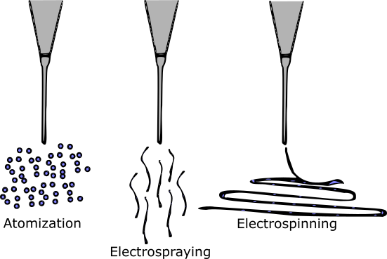

Figure 1: Electrohydro-dynamic techniques

* 1. *Stretching forces*
     1. *Electric Field*

Electrospinning (electrostatic fiber spinning) is a fiber fabrication approach that implements an electric field produce fibers by an electrical po- tential difference between the syringe needle and the collector. With the influence of high electric fields, the fibers are prone to brake into sepa- rate layers due to the whipping instabilities as the jet travels to the substrate. The instability can be mitigated by adding additional ring elec- trodes between the spinneret and the grounded collector. [6]

The typical electrospinning setup applies an electrostatic charge to the polymer fluid at the tip of the needle nozzle, which results in the for- mation of the Taylor cone [7], from which a single polymer jet is ejected to the grounded collector. From the Taylor cone, the supplied polymer jet (typically a polymer solution) accelerates and re- duces in diameter. The fiber finally develops with the complete solvent evaporation. Electrospun fibers are prone to splitting with the increase in acceleration due to high applied voltages, where

multiple fibers are yield in a process known as electrospraying [8].

The electrospinning process starts with charg- ing a polymer solution droplet. When a polymer solution is administrated with a syringe pump, solution droplets will fall under the influence of gravity. The solution dripping stops when the electric field is strong enough to break the so- lution’s surface tension, causing the droplet to change shape forming a polymer solution jet [9].

Shin et al. [10] reported that the growth of the whipping instability is one important element within the electrospinning technique. As detailed in Shin’s work, weak electric fields produce a sin- gle uniformly thinning jet, and strong electric fields the jet becomes unstable after traveling a short distance.

*High voltage power supply: DC & AC - .* Direct current (DC) is typically used in electrospinning with the electrons flowing in one direction. Alter- nate current (AC) implementations are also stud- ied as the AC creates a change in the direction of the current flow. Kessick et al. [11] demonstrated the implementation of AC power supplies in the production of polymer fibers.

The AC electrospinning setup is similar to that for the DC variant. AC electrospinning appara- tus do not require a grounded collector as the current alternates. In AC, the produced fibers are prone to carry an electric charge, while those generated shortly after have an opposite charge. The difference in charges lead the fibers to dis- charge on each other, creating an aerogel plume of fibers [12]. The optimal AC frequency depends on the materials used and is typically within 50*Hz* and 1*kHz* [13].

The AC technique has been studied for drug loaded related applications. Balogh et al. [14] compared fibers fabricated by DC and AC spin- ning techniques. Their work reports that AC and DC electrospinning can produce fibers with all three polymers, where the AC process allowed the implementation of faster flow rates than in the DC setup. The DC electrospinning technique gener- ated fibers with a maximum flow rate of 5 *ml/h*; on the other hand, the AC setup allowed an in-

crease in flow rate up to 40 *ml/h*.

* + 1. *Centrifugal force*

The spinning processes require the implemen- tation of a force to break the polymer source into a polymer jet. Centrifugal spinning intends to produce fibers by the use of a rotating polymer source. The centrifugal force generated from typ- ical rotatory speeds above 2000*rpm*, results in fiber formation. [15,](#_bookmark48) [16].

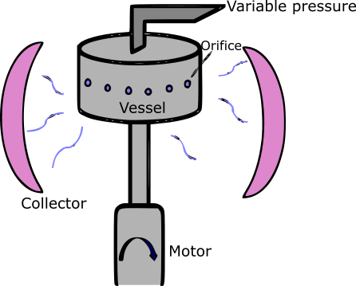

Figure 2: Typical setup used in pressurized gyration pro- cesses

The centrifugal force technique has been ap- plied to polymer solutions and melts. This ap- proach is used in applications were the precise deposition of the fibers is not relevant and pro- duction rate is to be maximized [17]. Efforts in centrifugal spinning are focused on drug de- livery applications. Zander [18] fabricated poly- caprolactone (PCL) fibers using the solution and melt variants of the centrifugal approach. Zan- der’s fibers were produced with rotatory speed between three and 18 thousand revolutions per minute with 10*µm* in diameter.

On the other hand, PCL and PVP fibers were generated by Amalorpava et al. [19]. Amalorpava achieved sub micron/size fiber diameters for drug release purposes and bacteria growth inhibition properties. Literature [20] has shown that cen- trifugal approach has a simple setup that promises

a large scale fabrication of fibers.

In some cases the centrifugal force implemen- tations and pressurized gyration can be com- bined with an electric field. The implementa- tion of two stretching forces (centrifugal and elec- trical forces), can help solvent evaporation [21]. Centrifugal electrospinning implements the same setup as the standard centrifugal spinning with the addition of a high voltage power supply be- tween the rotating dispensing nozzle and the col- lector. The combined method has evidence to yield parallel fibers [22–25] at a higher rate [22](#_bookmark56), [23] than the standard electrospinning approach.

* + 1. *Blowing forces*

Nano fibers can be produced with the imple- mentation of pressurized gas with a polymer so- lution. The setup used for blow spinning is similar to the one used in coaxial electrospinning, where the polymer precursor is dispensed at a controlled rate. Unlike traditional electrospinning, in the solution blow spinning setup the needle nozzle applies pressurized gas to the polymer solution through an outer spinneret [26], see Figure 3.

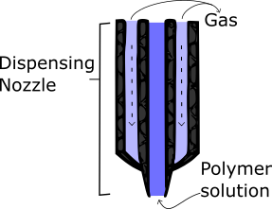

Figure 3: Dispensing nozzle used for solution blow spin- ning or melt blowing. [26]

Poly(lactic acid) (PLA) fibers have been pro- duced by solution blow spinning. Oliveira et al. [27] fabricated the fibers from 6*wt*% PLA solu- tions with progesterone for live stock reproductive cycle regulation applications. On the other hand, Souza et al. [26] conducted a study to compare the standard electrospinning and the solution blow

spinning techniques. Poly(3-hydroxybutyrate-co- 3-hydroxyvalerate) were fabricated by both meth- ods. The fibers produced by traditional electro- spinning had thicker diameters and the size uni- formity was higher in the fibers produced by so- lution blow spinning. The experimental setup re- quires a coaxial needle nozzle with a pressurized gas flow along with a potential difference between the dispensing needle and the grounded collector.

* + 1. *Mechanical force*

Mechanical drawing comprises the simple tech- nique to produce fibers by stretching the poly- mer solution with a glass pipette. [28] Neverthe- less, the drawing technique is not scalable or with practical applications. [29] Touch-spinning meth- ods have been developed to introduce a scalable technique for the production of nano fibers where the fiber is created by stretching the polymer pre- cursor with a moving collector, as depicted in Fig- ure 4. Touch-spinning is another mechanical tech- nique that comprises a moving stage with an em- bedded glass rod (Figure 5). Where a polymer solution is supplied from a syringe needle such that the tip of the glass rod makes contact with the polymer solution as it rotates, creating fibers. The rotation stretches the fiber, causing the fiber to increase in length and decrease in diameter. The increase in length causes the fiber surface are to increase and therefore making the polymer so- lution solvent to volatilize, ending with a dry fiber within the collector.

The touch spinning technique implies that the fiber diameter can be controlled by the moving collector’s speed and the polymer solution con- centration. The main difference relays on the fact that the touch spinning method implements me- chanical control to manipulate and stretch the fibers during the fabrication process, guiding the fiber in the collector enabling better control over fiber alignment. [30]

* + 1. *Microfluidic forces*

The microfluidic spinning technique manipu- lates and controls the polymer solution in net- works of micrometer channels. The channel net- work are typically embedded in a microfluidic

chip, where the solution deposition rate is con- trolled by active components (pumps and valves) with a computer. Cheng et al. [31] compared and combined the microfluidic spinning and elec- trospinning techniques. Heterogeneous materials and cell patterning within a single microfiber can be designed by the integration microfluidic chan- nels. Therefore, microfluidic spinning is more suitable for cell encapsulation and tissues genera- tion [31].

On the other hand, Kang et al. [32] managed to fabricate micro fibers by imitating the "silk spinning" process of spiders. Kang’s micro fibers properties were modified using a microfluidic sys- tem with a programmable flow control (See Fig- ure 6). The current microfluidic spinning ap- proach is not scalable to a large fiber production, however it enables the fabrication of high-complex fibers that are not easily achieved by other meth- ods.

Microfluidic techniques offer the possibility to embed several components into a single fiber, where each component can be released at different parts of the fiber.

* 1. *Dispensing nozzle*

Unlike traditional electrospinning, coaxial elec- trospinning (co-electrospinning) requires de im- plementation of a dual needle nozzle, where one needle is nested concentrically inside an- other needle, see Figure 7 [33,](#_bookmark66) [34]. The pur- pose of the co-electrospinning setup is to pro- duce core/shell fibers, unlike mono axial electro- spinning that yields monolithic fibers. Sun et al. [35]. Addressed electrospinning setups, where both the core and shell are comprised by PEO (poly(ethylene oxide)) and for a PEO shell with a poly(dode-cylthiophene) core. Sun et al. state that co-electrospinning has the potential to ex- tend the range of materials that can be used for electrospinning. The shell solution can be mod- ified to make the core solution spunable. It was also discovered that non-spunable solutions can by implemented as shell solutions in conjunction with a spunable core solution. [36]

Some advantages that co-electrospinning setups can break the polymer drop surface tension, initi-

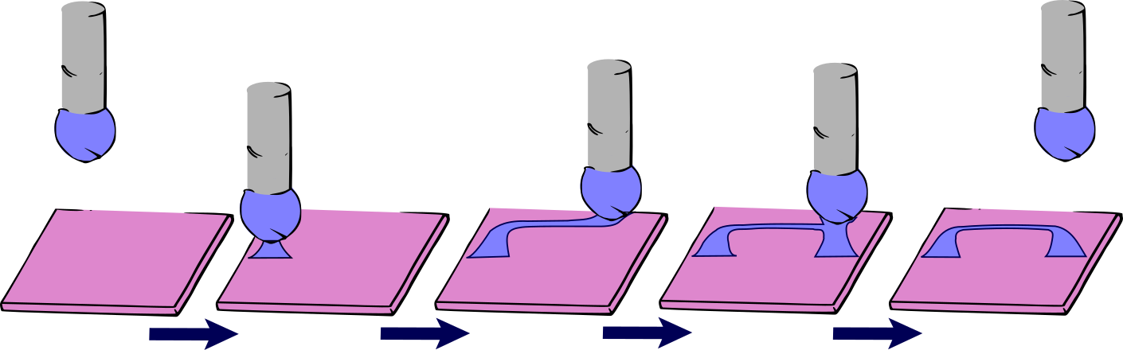

Figure 4: Typical mechanical fiber drawing process. First the needle makes contact with the substrate to break the polymer drop. Then the needle leaves the substrate and the collector moves to create and deposit the fiber. Once the fiber is written the needle makes contact witht the collector to fix the fiber deposition.

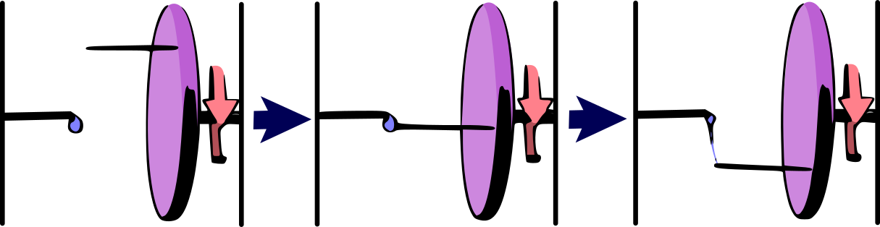

Figure 5: Touch-spinning technique. First rod is attached to a rotating stage and a polymer solution droplet is adminis- trated through a needle. Then the rotating rod ’touches’ the polymer precursor. Finally, as the rod rotates, the polymer solution is stretched and creates a fiber between the rod and the needle.

ating the jet burst from the spinneret nozzle. On the other hand, as the morphology and shape of the fibers depend on the polymer solution proper- ties, the use of a co-axial nozzle allows the amend- ment of the material properties by producing bub- bles, scaffolds and particles. [37,](#_bookmark71) [38]. As in con- ventional NFES, in co-electrospinning, the needle tip is connected to a high voltage power supply with a grounded collector.

* 1. *Polymer Reservoir (Polymer Melt & Poly- mer Solution)*

Electrospinning processes can be classified on the polymer reservoir type. As Brown et al. [39] discussed, the polymer melt is equivalent to the polymer solution electrospinning (in place of a

polymer solution a melt is used). The use of a polymer melt increases the complexity of the pro- cess, because the nozzle syringe and spinneret re- quired to be heated to maintain the polymer in a liquid state. The fibers produced in melt spin- ning are typically found to have larger diameters than those from the polymer solutions due to the higher viscosity of a polymer melt than its solu- tion. The apparatus used by Brown et al. [39] is depicted in Figure 8.

Despite the added complexity and thicker diam- eters, melt electrospinning gets around the need to handle volatile solvents, making the process safer to be performed on larger scales. Further- more, polymer melt reservoirs get rid of any sol-

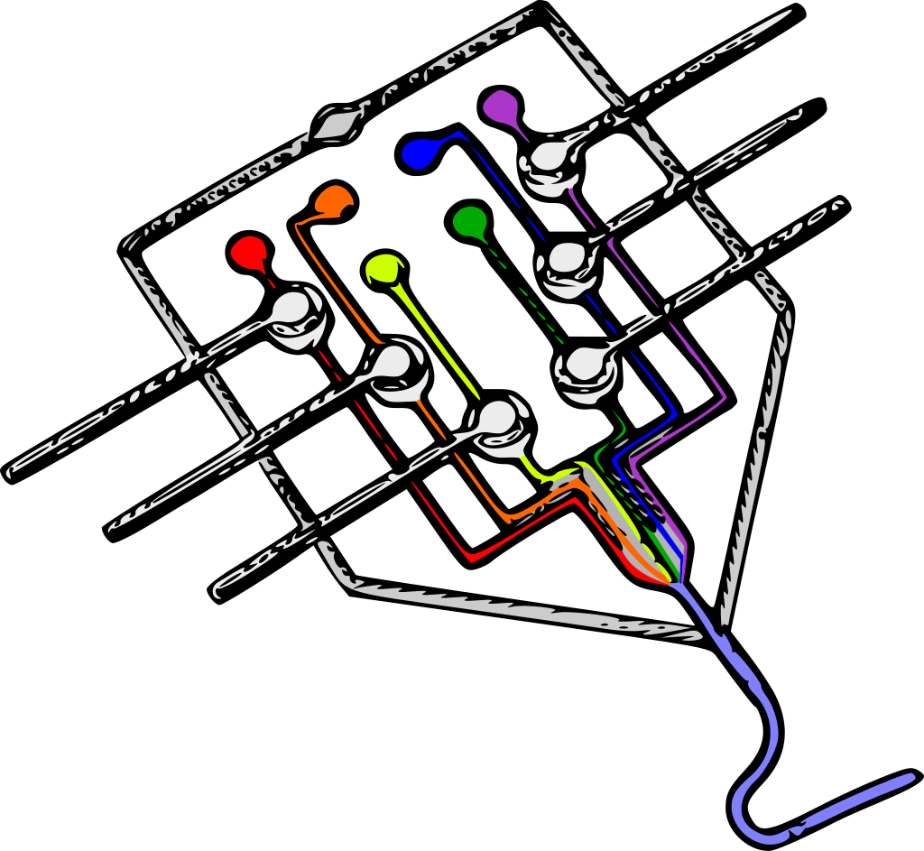

Figure 6: Microfluidic device used by Kang et al. [32]

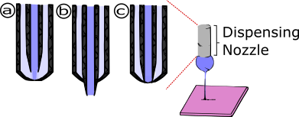

Figure 7: Needle configurations in coaxial electrospinning.

(a) the outer needle encasing the inner; (b) the inner needle protruding from the outer; (c) both needles inline with each other;

vent contamination.

The first report of a melt electrospun drug de- livery system came from Nagy et al. [40], who prepared fibers by melt electrospinning of Eu- dragit EPO with carvedilol. The drug and poly- mer were melted and mixed to form a homoge- neous solid mixture prior to spinning. The melt- spun fibers reached diameters of 5–30 *µm*, com- pared to 300–1000 *nm* diameters produced from solution-spun fibers [40].

Balogh et al.’s work has been built on to blend plasticizes with the polymer Eudragit EPO and carvedilol active ingredient. [41] The plasticizes Triacetin, Tween 80 and Polyethylene Glycol were investigated in order to reduce the melting point of the polymer-drug mixture. The temperature

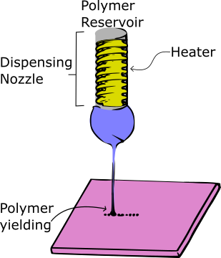

Figure 8: Typical Melt Electrospinning Setup

drop is desirable to minimize the occurring drug degradation.

Lian and Meng [42] performed a comparison of poly(*ε*-caprolactone) (PCL) fibers fabricated by the melt and solution electrospinning techniques. They arrived to the conclusion that melt spin- ning is preferable when the polymer presents a low solubility. On the other hand the melt fibers were produced in a slower release rate. Ger- not et al. [43] demonstrated that submicron-size fibers are possible through melt electrospinning. In their effort, they achieved a precise deposition of PCL fibers with diameters of 817 165*nm*.

*±*

In literature, melt electrospinning has less evi- dence than the solution approach. However, melt electrospinning arises to be as flexible as its so- lution counterpart in handling multiple polymers, as reported in McCann’s work [44]. Currently, the melt electrospinning setup is harder to determine and the lack of research on this technique explains its unexplored potential.

* 1. *Polymer Solution*

In electrospinning, it is typically agreed that the diameter of the fibers increased with higher

concentration due to greater viscosity which with- stands stretching. In near field electrospin- ning, similar observations have been reported where concentration increases, fiber diameter in- creased [45, 46], seeFigure 20.

Table 1: Approximation process to estimate the critical polymer concentration. Several polymer concentrations are tried and the resulting jets are observed until a con- tinuous stream is achieved. Observation Concentration

Adjustment

*1.4.2. Solvents*

The solvent used must be capable of dissolving the polymer of interest at an appropriate concen- tration to form fibers, and must posses a suitable volatility. A low-volatility solvent like water may fail to evaporate completely over the distance be- tween the spinneret and the collector. When the fibers form, they will hence contain residual wa- ter owing to this incomplete evaporation. The residue solvent will subsequently evaporate from the fibers upon storage, resulting in ribbon-like

Dripping, no stream Splitting small droplets

Increase

Increase slightly

(flattened) fibers, wrinkles on the fiber surface or fused fibers. On the other hand, a high-volatility solvent may evaporate very quickly, leading to larger fiber diameters (less time for elongation be-

Steady stream No concentration

adjustment

fore solidification) and clogging of the spinneret

(due to drying of the liquid at the spinneret be-

Splitting large globs

Decrease slightly

fore jetting, or drying of the Taylor cone during jetting). Solvents commonly used for electrospin-

Nozzle clogging Decrease

ning include ethanol, chloroform, trichloroethane

and hexafluoroisopropanol [3,](#_bookmark35) [48,](#_bookmark82) [49].

*1.4.1. Polymers*

The polymer selection is in function on the in- tended application. For example, a fast dissolv- ing hydrophilic polymer such as poly(ethylene ox- ide) (PEO) is used for fast drug delivery sys- tems. Otherwise, slow dissolving polymers such as poly(*ε*-caprolactone) (PCL) or poly(lactic-co- glycolic acid) (PLGA) are implemented. [47]

The polymer molecular weight along with the polymer concentration and solvent selection have a direct effect on the solution viscosity, conductiv- ity and surface tension, hence the solution behav- ior in the electrospinning process. The spunable viscosity range varies with the polymer and sol- vent.

Solutions with low viscosity are prone to insuf- ficient polymer chain entanglements to produce fibers. [47] On the other hand, if the solution is too viscous, then the surface tension cannot easily be overcome by the electric field. In both cases, the result can be droplets or particles forming rather than fibers as described inTable 1.

Mixtures of miscible solvents can be used to ensure that sufficient polymer can be dissolved to give a solution of appropriate viscosity and volatility with suitable dielectric constant range to allow fiber formation. However, care must be taken because using a mixture of solvents with very different volatilities can result in porous fiber structures. As reported by Katsogiannis et al. for organic solvent mixtures with dimethyl sulfox- ide (DMSO). [50] DMSO evaporates much more slowly than the organic solvents used, which re- sults in its incorporation into the fibers. The DMSO will eventually evaporate, yielding porous fibers.

It is also important to take into account the surface tension of the solution. Solvents with very high surface tensions (e.g. water) can result in in- stability arising during the spinning process, and a broad range of fiber diameters in the products. If necessary, a surfactant can be added to reduce the surface tension, but this will be incorporated into the fibers produced.

# Properties that Improve Accuracy of Nano-Fiber Deposition

Near-field electrospinning is considered to be an outstanding technique to fabricate polymer fibers with spatial control and it has suffered several modifications to improve the precision and accu- racy of the fiber deposition. This paper intents to collect the NFES variants of electrospunable polymer solutions with spatial control in recent research. Table S1 is a collection of the relevant NFES process parameters and achieved fiber mor- phology.

Some differences have been discovered between LV-NFES and conventional NFES. Low voltage near field electrospinning produces thinner fibers with lower voltages; as shown inFigure 17. More- over, when implementing a moving stage, the fibers are affected by the mechanical stretching. Bisht et al. and Chang et al. [51,](#_bookmark85) [52] reported that thinner diameters are yield with the increase of the x-y stage velocity, and larger diameters by decreasing the stage velocity.

Bisht and Chang’s work [51,](#_bookmark85) [52] reports a controlled technique to fabricate polymeric nano fibers in a continuous manner, using a low volt- age setup. Their purpose is to find a workaround to the drawbacks of traditional NFES by using a superelastic polymer precursor, which allow con- tinuous patterning without breaking. In low volt- age near-field electrospinning (LV NFES), a visco- elastic polymer is used to allow continuous spin- ning at about 200*V* .

Kim et al. [52] experimented with a NFES vari- ation where the fiber deposition is guided by con- ductive rails, see Figure 9. As stated by the au- thors, the induced electric field is enhanced by the conductive pattern, which allows the fibers to fol- low the desired deposition path. As the fibers are prone to follow the conductive pattern, additional fibers can be stacked on each other. The stacking process was successfully achieved in high electric field conditions at: 750*µm* substrate to collector distance, and a 600 *µm* needle to rail (offset) dis- tance, see Figure 9.

Gupta et al. [53] introduced a new technique to fabricate polymer scaffolds for tissue engineer-

ing applications and organ development. As de- scribed by Gupta et al. [53], the fiber deposition equipment is comprised by a stainless steel needle with a internal diameter of 750 *µm* , connected to a high voltage power supply of up to 30 *kV* with a deposition rate of about 1*µLmin−*1. The setup was embedded to a motorized collec- tor capable of controlled programmable motions, see Figure 10. The proposed technique was able to produce fibers of 150*µm* in diameter with pre- designed patterns.

Wang, et al., Huang, et al., and Chen, et al. [54–](#_bookmark88) [56] experimented with several multi-nozzle near- field electrospinning of aligned nano fibers. The multi nozzle NFES apparatus is similar to the one used in conventional NFES with some modifica- tions to the needle nozzle, see Figures 11 and 12. The authors implemented similar NFES setups where the installed linear array of nozzles is sup- plied with a constant flow rate of solution.

*≥*

The authors came to the conclusion that the distance between the deposited fibers increase with the increase of the needle-to-collector dis- tance, as the influence of the applied voltage dis- sipates.

Huang, et al. [57] studied the mechanoelectro- spinning (MES) technique for the fabrication of nano fibers. The MES technique tries to improve deposition accuracy by the introduction of a me- chanical drawing force. The MES is predomi- nantly controlled by the collector stage velocity, the nozzle-to-collector distance, and the applied voltage. The authors believe that MES can com- pete as a low-cost, high precision fabrication of electronics and enable the direct writing of struc- tures for nano scale lithography. Figure 13 shows the polymer jet behavior when a mechanical force is implemented within the NFES process.

Micro and nano fibers have been written us- ing AC pulse-modulated electrospinning by Bu et al. with polyehtylene terephthalate (PET) as sub- strate [58]. The AC electrical field influences the electrospinning jet. The alternate current tends to decrease the repulsive electrical force allowing a stable straight jet between the dispensing noz- zle and the insulating PET substrate. Bu et al. varied the stage velocity; faster stage velocities

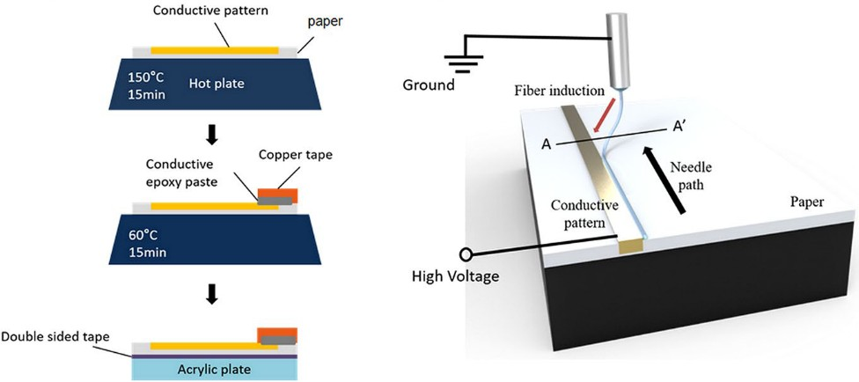

Figure 9: NFES setup for controlled fiber deposition on pre-patterned conductive electrodes. [52]

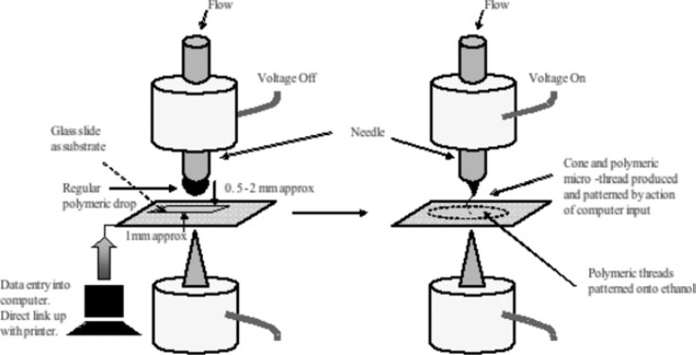

Figure 10: Schematic illustration of the electrohydrody- namic process. [53]

enable the deposition of straighter fibers [58].

A mechano-electrospinning technique was pre- sented by Nagle et al. [59]. With the implementa- tion of a mechanical drawing force, a higher reso- lution nano fibrous pattern can be produced with lower voltages as the Taylor cone becomes more stable. Nagle et al. studied PEO fibers at differ- ent nozzle to collector distances. Evidence suggest that better patterning accuracy increases with in- creasing nozzle to collector distance as the solu- tion is effectively dried [59]. Near field mechano- electrospinning enables the collection of non wo- ven fibers over large areas.

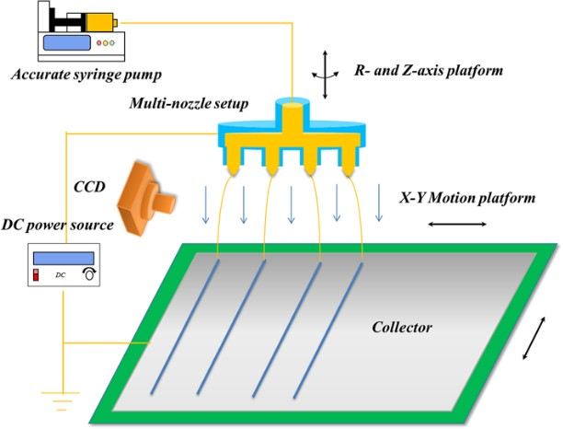

Figure 11: Schematic of multi-nozzle near-field electrospin- ning system [55]

To spin nano fibers at close distances, the initial diameter of the jet is required to be as small as possible since stretching of the thread is limited. Kameoka et al. [60] demonstrated that a small initial spinning radius can be achieved using an atomic force microscope tip with a small polymer solution drop at the tip.

Near-field electrospinning, has exhibited to be

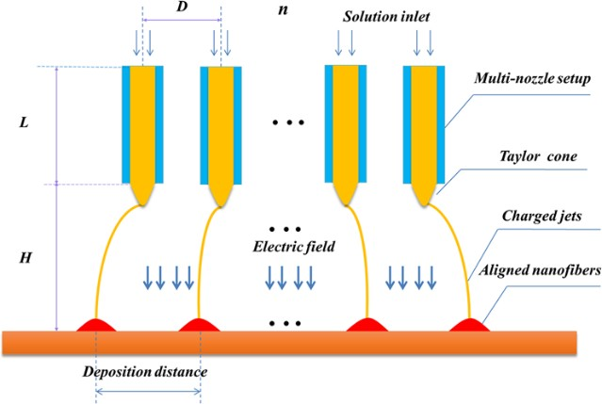

Figure 12: The geometry distribution of linear array multi- nozzle system [55]

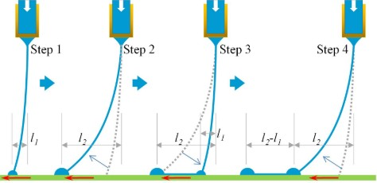

Figure 13: schematic diagram of leap direct-writing: the ink first accumulates at contact point and then gets stretched by mechanical drawing force. At a critical dis- tance, the ink leaps to the next contact point, and gets stretched again [57]

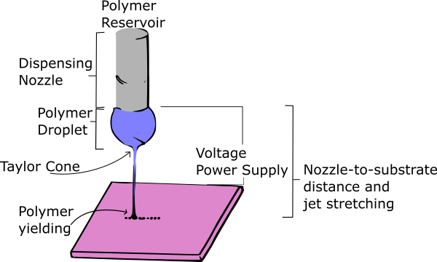

Figure 14: Near-Field ES Process Parameters

capable fabricate nano fibers and nano fiber pat- terns [61]. Nevertheless, having a small polymer solution drop at the nozzle tip limits the length of the fibers that can be fabricated in a contin- uous manner. Using a spinneret with a reservoir (e.g. syringe) of solution generally produces fibers with diameter of a few micrometers [53,](#_bookmark87) [62], since it creates a limit to which the nozzle inner diam- eter can be reduced to allow the solution to flow through. As shown inFigure 18, the implemen- tation of thicker needle nozzles translate into an increase of the resulted fiber diameter

Coppola et al. [63] have showed a NFES variant that allows polymer nano fibers to be deposited directly from a polymer drop, averting the is- sue of nozzle clogging. The fibers are also prone soaking after deposition thus giving the fibers a semi-circular cross-section as depicted in Xue et al.’s [62] work.

* 1. *Nozzle spinneret*

The thinnest nozzles in literature so far are about 50*nm* in diameter, by Chang et al. [45] who used a 100*µm* inner diameter needle tip to electrospin poly(ethylene oxide) (PEO). Camillo et al. [64] used a micro-diameter tip Tungsten spinneret in a 26G needle to electrospin co-polymer, poly[2-methoxy-5-(2- ethylhexyloxy)-1,4-phenylenevinylene] (MEH- PPV) with poly(ethylene oxide) (PEO). The noz- zle most commonly comprises a simple narrow- bore, blunt-end metal needle. The diameter of the needle can vary, but most commonly re- searches work with internal diameters below 1 *mm* . This translates to needles of gauge 18–22. In general, this simple spinneret design can be used to achieve successful spinning. A blunt- end rather than a tapered-end for the needle exit is important as the size distribution of the products increase with an increase in needle tip angle. However, it should be noted that there will be some interactions between the solvent and polymer molecules in the solution and the metal surface of the spinneret. There will exist some attractive forces between the polar groups in the polymer and the electro-positive metal surface, which can act counter to the drawing force of the

electric field and can pull the polymer solution back into the spinneret. It has been found that coating the spinneret exterior in a non-conductive and non-stick polymer such as Teflon or epoxy coating can reduce these interactions. [65,](#_bookmark99) [66] As a result, the electrical energy can be more efficiently used to elongate and narrow the poly- mer jet, and narrower fibers can be produced. In addition, strong attractive forces between the polymer jet and the metal spinneret can result in fibers becoming attracted to the needle, leading to lower yields and potentially to blocking of the exit orifice.

* 1. *Applied Voltage*

In recent literature, near field electrospinning has been studied to reduce the fiber diameter and to improve the fiber deposition accuracy. Madou et al. [51] and Chang et al. [45] came to the conclu- sion higher voltages yield thicker micro-fibers with a loss in jet stability. This relationship between the applied voltage and resulting fiber diameter is influenced by other variables such as nozzle-to- substrate distance and solution deposition rate. For instance, if a high voltage is applied at a low deposition rate then electrospraying is achieved, meaning the formation of several non-continuous fibers. The applied voltage shall be sufficient to break the surface tension and initiate the jet, but low enough to avoid multiple jets at the nozzle tip.

Madou et al. [51] achieved the fabrication of thinner fibers with spatial control by reducing the applied voltage to 200-600 *V* at a nozzle-to- substrate distance of 0.5-1 *mm*. The low voltage setting does not create enough charge to break the polymer solution surface tension to initiate the electrospinning process.

Madou et al. [51] and Chang et al. [45] initi- ated the electrospun fibers by mechanically pull the polymer solution at the nozzle tip using a micro-probe tip. Chang and coworkers reduced the applied voltage from 1.5 *kV* to 600 *V* with a nozzle-to-substrate distance of 500 *µm* to yield a fiber diameter between 3 *µm* and 50 *nm* . With an applied voltage of 200 *V* and a nozzle-to-substrate distance of 1 *mm*.

In near-field electrospinning, the applied volt- age has an impact on the produced fiber morphol- ogy. For instance, a voltage higher or lower to the optimum voltage will translate into an increase in fiber diameter. Song et al. [67] demonstrated that a decrease in voltage from 400 to 500 *V* can reduce the fiber diameter from 160 to about 60 *nm*with a nozzle-to-substrate distance of 20 *µm*. A workaround to break the polymer solution sur- face tension is to initialize the NFES process with a higher voltage and then lower the voltage once the jet is created. Huang et al. [57] implemented the previous and yield ordered fibers with a dis- tance between adjacent fibers of 50 *µm*.

* 1. *Nozzle-to-substrate distance*

Figure 15.a, depicts the typical setup for the conventional far-field electrospinning (FFES). As stated in previous sections, the precursor polymer droplet becomes charged with the employment of an electric field between the polymer solution and the collector [68]. When the polymer solution surface tension is overcome by the electric field potential difference a jet is formed, starting the electrospinning process. The electrospinning pro- cess can be break down into two steps: i) first the jet travels in a straight line, and ii) the jet be- gins to curl due to bending and whipping instabil- ities [11,](#_bookmark44) [69]. The fiber spatial control in far-field electrospinning is limited due to the instabilities, inhibiting the precise deposition of fibers.

In the intent to achieve controlled fiber depo- sition, Sun et al. [61] reported an electrospin- ning variation known as near-field electrospinning (NFES),Figure 15.b, describes the near-field elec- trospinning setup, where the distance between the dispensing nozzle and the collector is reduced to write fibers while the jet travels in a straight line. Moreover, some mechanical influence is required to deposit fibers precisely. The mechanical force is introduced by moving collector. If the polymer solution jet speed is faster than the speed of the moving collector, the written fiber will curl; on the other hand, if the collector moves faster than the polymer jet, the fiber will gradually dimin- ish [62,](#_bookmark96) [70]. Currently, due to the lack of theoret- ical models, the near-field electrospinning process

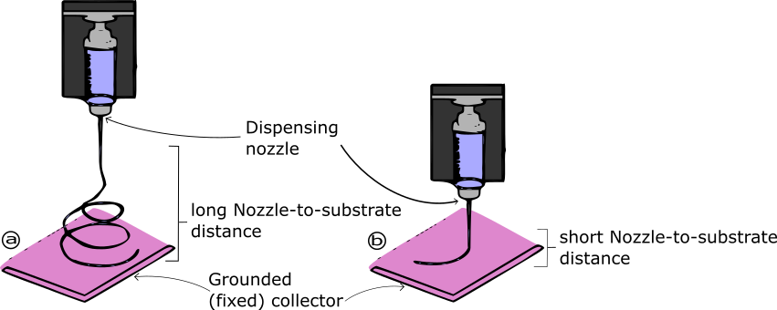

Figure 15: a) Typical Far-field Electrospinning (FFES) Setup. b) Typical Near-field Electrospinning (NFES) Setup.

parameters (such as the collector speed) are typ- ically tuned by experience and experimentation only.

The main difference between NFES and FFES is the distance between the needle and the collec- tor which is higher in FFES (about 10 cm) com- pared to NFES which ranges in the mm scale. The short distance allow the production of well aligned fibers within particular designs. In NFES, the fiber morphology can be altered by the control of the distance between the nozzle and the substrate (collector). With the decrease of the nozzle-to- substrate distance, the electric field strength in- creases; however it can cause incomplete solvent volatilisation and possible short circuits between the collector and the nozzle tip.

An optimal nozzle-to-substrate distance shall be defined to ensure the fabrication of dry contin- uous fibers. If the solvent is not well evaporated, the produced fibers are prone to defects; on the other hand if solidification happens too fast, the solids can block the spinneret which can prevent a continuous fiber yield. Furthermore, the poly- mer jet will discharge itself as soon as possible, therefore long distances can result in low yields.

* 1. *Substrate*

Due to the close distance between the grounded substrate and the charged spinneret in NFES, the

set up is prone to electrical shorts. In NFES, when a short circuit takes place, the electrospinning process is interrupted resulting in the fabrication of discontinuous fibers. Two workarounds to avoid electrical shorts is to lower the applied voltage and to use less conductive substrates [71,](#_bookmark105) [72].

Liu et al. [71] discovered that the fiber align- ment is improved by using a glass-cooper foil substrate, however the well aligned fibers are spoiled after prolonged depositions due to resid- ual charges. Additionally, the effect of resid- ual charges is amplified with the used collector substrate contains a conductive layer and a non- conductive layer [71].

On the other hand, Choi et al. [72] implemented a hydrophilic substrate to deposit the fibers with plasma treatment to increase the conductivity of selected areas. NFES was carried put with precise deposition as the fibers were placed as per the desired design within the hydrophilic substrate.

# Discussion & NFES Challenges

Helix electrodynamic printing (HE-printing) was presented by Duan et al. [73] with the in- tention of depositing aligned fibers. The authors fabricated a stretchable piezoelectric device using micro and nano fibers to demonstrate the pos- sible applications of HE-printinh for electronics

manufacturing. Duan et al. concluded that the fiber morphology is mainly driven by: the stage velocity, the applied voltage, and the nozzle-to- collector distance.

Electrohydrodynamic (EHD) jet printing is a direct-writing technique which ejects ink through a fine nozzle using an electric field, which has the advantages of high-resolution, rapid print- ing speed and a wide range of ink selectivity. The effect of parameters such as ink concentra- tion, working distance, applied voltage, and stage speed on the diameter of the printed nano fibers was investigated.

Near-field electrospinning (NFES) is widely rec- ognized as a versatile nano fabrication method, one suitable for applications in tissue engineer- ing. Rapid developments in this field have given rise to layered nano fibrous scaffolds. However, this electrostatic fabrication process is limited by the electric field inhibitory effects of polymer de- position. This leads to a major challenge: how to surpass this limitation on planar/layered con- structs. While the current focus in this area largely lies with the investigation of new materi- als, techniques and increasing precision of NFES systems and patterning, exploration of complex collector substrates is often restricted by (i) avail- able technology and (ii) access to complex elec- trode manufacturing tools.

Although electrospinning (ES) allows the pro- duction of unsurpassed nano scale polymer fibers, the major drawbacks are the nozzle-clogging and single-jet spinneret, respectively. This is a real limitation in terms of usable polymers and for patterning active organics. Nowadays the micro- engineering of smart materials could represent a new route for many fields of technology ranging from the production of electronic and photonic devices [1 3] to regenerative medicine and tissue engineering. [4 7] An enormous technological in- terest is related to the possibility of patterning fibers directly in well-ordered patterns avoiding the deposition of nonwoven sub micrometer mats often occurring in ES. [8,9] In the past decade several attempts have been made using field- in- duced [10 13] and near-field ES, [14,15] but only very recently, with the introduction of mechano

*−*

*−*

*−*

ES, [16] has the production of well- ordered fiber patterns been achieved. Nevertheless, some draw- backs related to the complexity of the setup, the operating temperature, and the selection of us- able materials for problems related to nozzle clog- ging still persist. Moreover, high temperature can cause deterioration of the optical and electronic properties of active organic materials eventually embedded in the functionalize [d fibers. On the other side, interfering effects due to closeness of multiple electrified nozzles ban working with mul- tiple spinnerets.

# References

1. F. Anton, Process and apparatus for preparing artifi- cial threads (1930). doi:https://patents.google. com/?q=D01D5\ 2f0076.
2. Z.-M. Huang, Y. Z. Zhang, M. Kotaki, S. Ramakr- ishna, A review on polymer nanofibers by electro- spinning and their applications in nanocomposites, Composites Science and Technology 63 (15) (2003) 2223–2253. [doi:10.1016/S0266-3538(03)00178-7](https://doi.org/10.1016/S0266-3538(03)00178-7).
3. D. H. Reneker, A. L. Yarin, Electrospinning jets and polymer nanofibers, Polymer 49 (10) (2008) 2387– 2425. [doi:10.1016/J.POLYMER.2008.02.002](https://doi.org/10.1016/J.POLYMER.2008.02.002).
4. J. D. Schiffman, C. L. Schauer, A Review: Elec- trospinning of Biopolymer Nanofibers and their Ap- plications, Polymer Reviews 48 (2) (2008) 317–352. [doi:10.1080/15583720802022182](https://doi.org/10.1080/15583720802022182).
5. Q. Li, Chapter 7: Liquid Crystal-Functionalized Nano- and Microfibers Produced by Electrospin- ning - Liquid Crystals Beyond Displays: Chemistry, Physics, and Applications, John Wiley &amp; Sons, 2012. [doi:9781118078617](https://doi.org/9781118078617).
6. L. Zhang, T. Si, A. J. Fischer, A. Letson, S. Yuan,

C. J. Roberts, R. X. Xu, Coaxial electrospray of ranibizumab-loaded microparticles for sustained re- lease of anti-VEGF therapies, PLoS ONE 10 (8) (2015) 1–16. [doi:10.1371/journal.pone.0135608](https://doi.org/10.1371/journal.pone.0135608).

1. G. I. Taylor, Disintegration of water drops in an electric field, Proceedings of the Royal Society of London. Series A. Mathematical and Physical Sci- ences 280 (1382) (1964) 383–397. [doi:10.1098/](https://doi.org/10.1098/rspa.1964.0151) [rspa.1964.0151](https://doi.org/10.1098/rspa.1964.0151).
2. J. Doshi, D. H. Reneker, Electrospinning process and applications of electrospun fibers, Journal of Electro- statics 35 (2-3) (1995) 151–160. [doi:10.1016/0304-](https://doi.org/10.1016/0304-3886(95)00041-8) [3886(95)00041-8](https://doi.org/10.1016/0304-3886(95)00041-8).
3. A. Cisquella-Serra, M. Magnani, Álvaro Gual- Mosegui, S. Holmberg, M. Madou, M. Gamero- Castaño, Study of the electrostatic jet initiation in near-field electrospinning, Journal of Colloid and In-

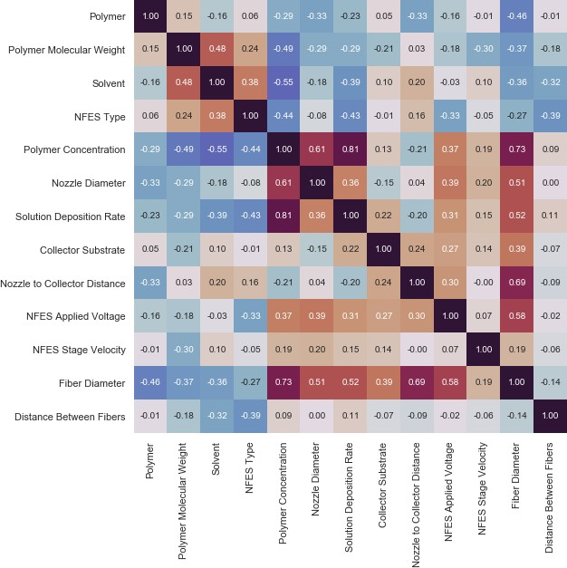

Figure 16:

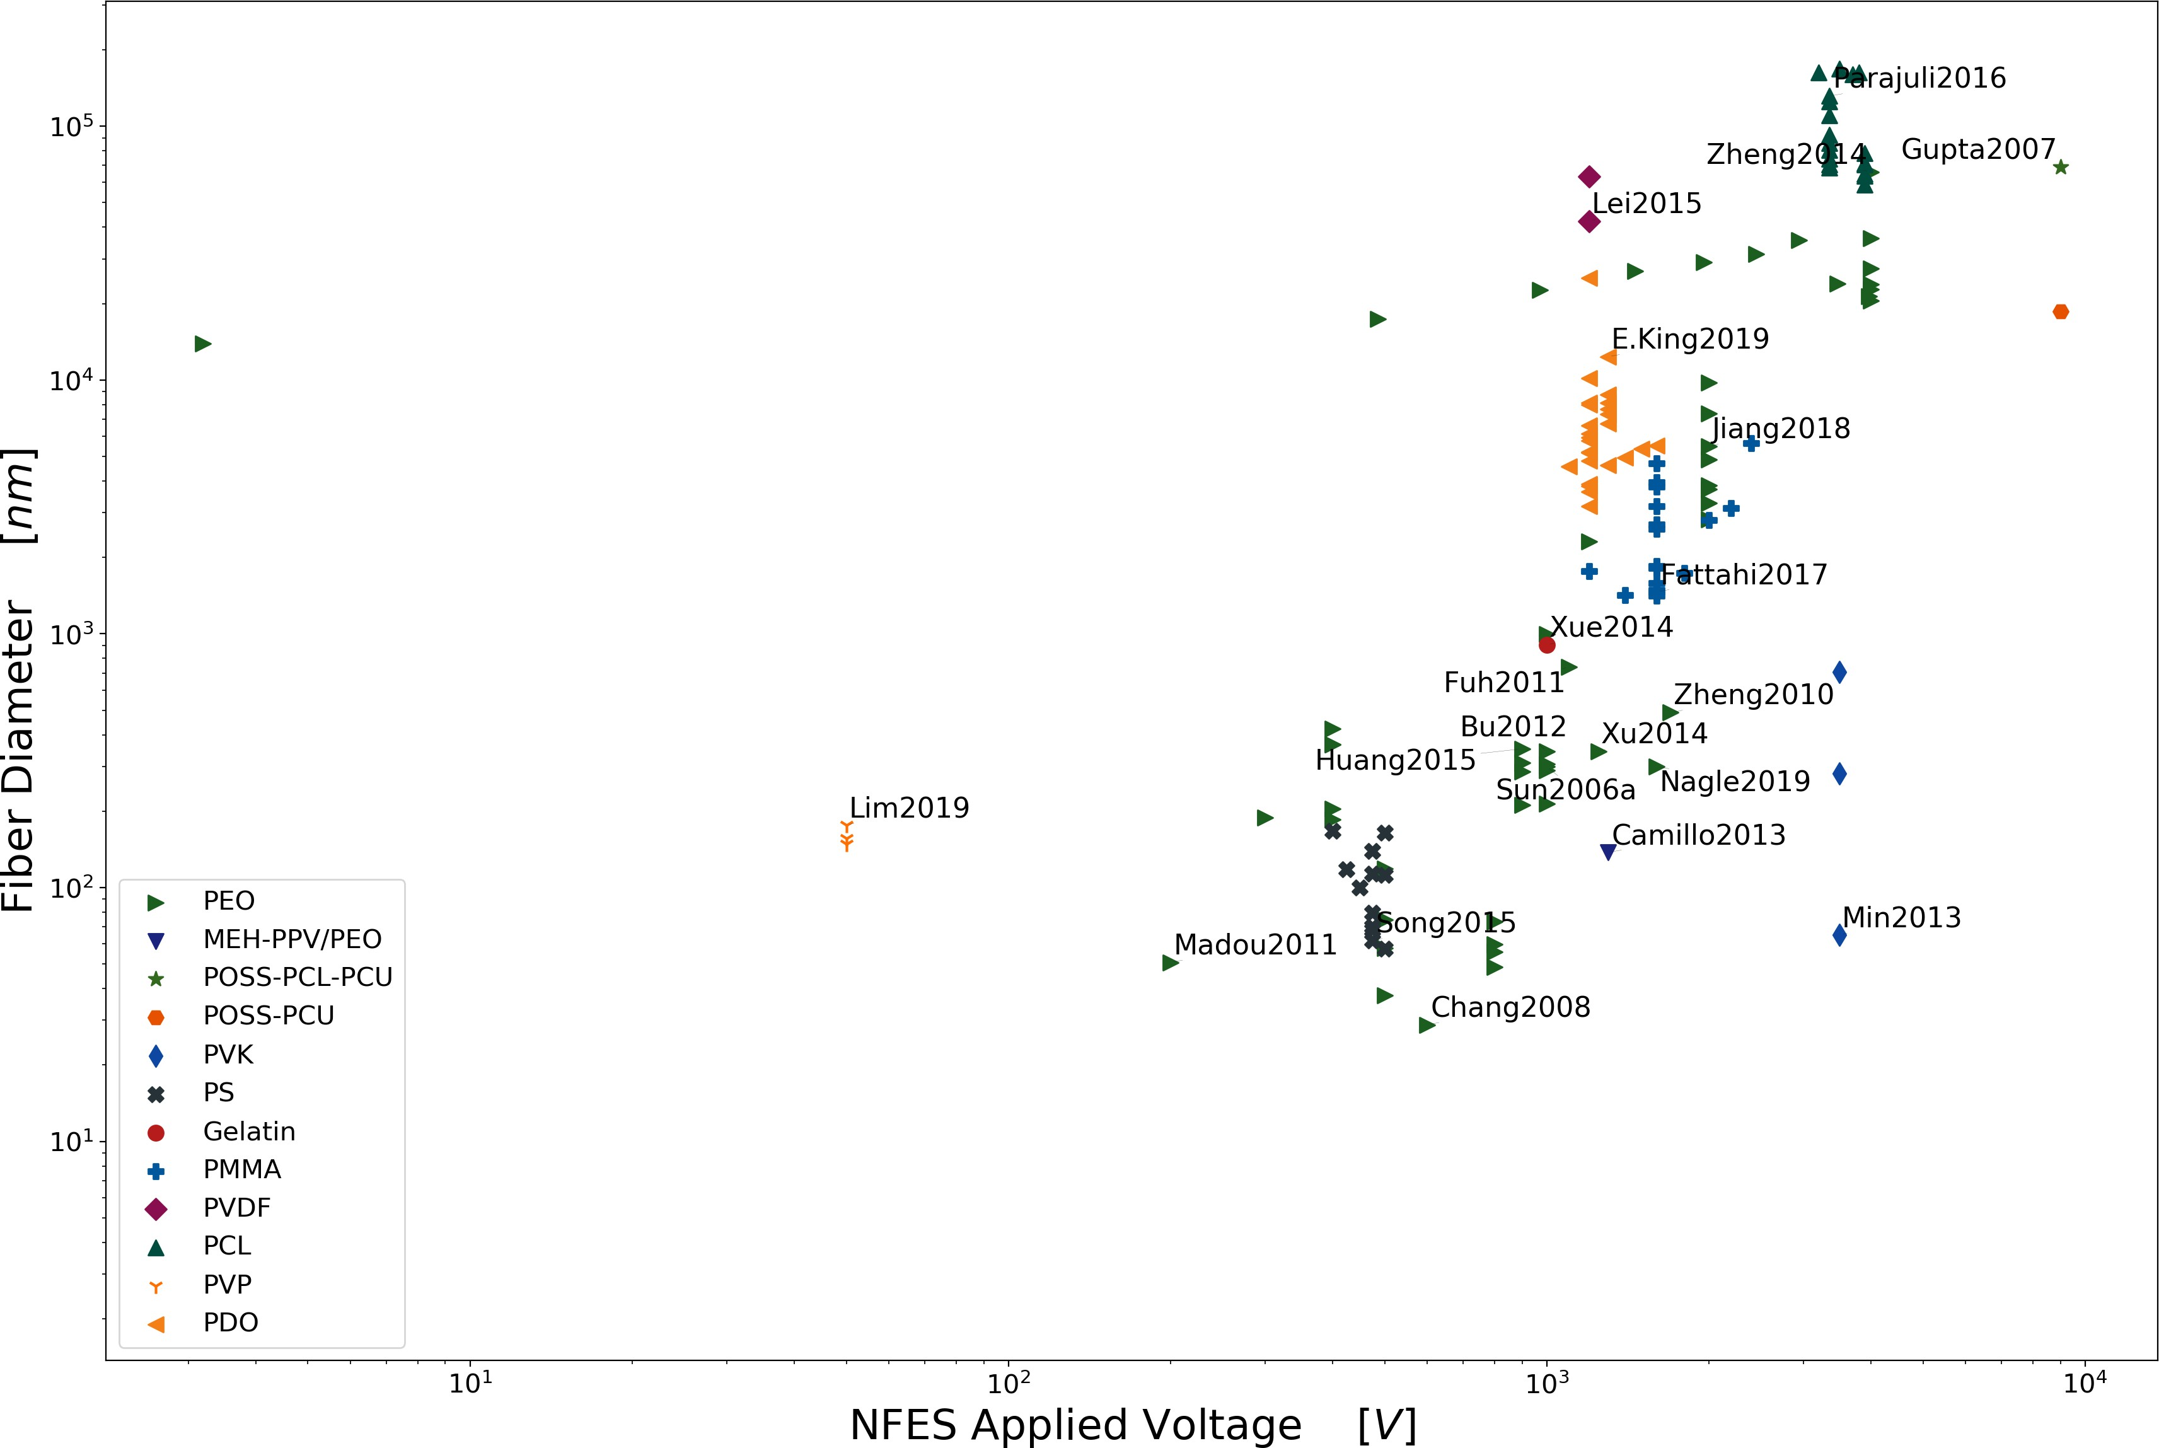

Figure 17: NFES Applied Voltage vs. Fiber Diameter

terface Science 543 (2019) 106–113. [doi:10.1016/J.](https://doi.org/10.1016/J.JCIS.2019.02.041) [JCIS.2019.02.041](https://doi.org/10.1016/J.JCIS.2019.02.041).

1. Y. M. Shin, M. M. Hohman, M. P. Brenner, G. C. Rutledge, Electrospinning: A whipping fluid jet gen- erates submicron polymer fibers, Applied Physics Letters 78 (8) (2001) 1149–1151. [doi:10.1063/1.](https://doi.org/10.1063/1.1345798) [1345798](https://doi.org/10.1063/1.1345798).
2. R. Kessick, J. Fenn, G. Tepper, The use of AC poten- tials in electrospraying and electrospinning processes, Polymer 45 (9) (2004) 2981–2984. [doi:10.1016/j.](https://doi.org/10.1016/j.polymer.2004.02.056) [polymer.2004.02.056](https://doi.org/10.1016/j.polymer.2004.02.056).
3. G. R. Williams, B. T. Raimi-Abraham, C. J. Luo, Alternative nanofibre fabrication approaches, Nanofi- bres in Drug Delivery (2018) 160–186[doi:10.2307/](https://doi.org/10.2307/j.ctv550dd1.10) [j.ctv550dd1.10](https://doi.org/10.2307/j.ctv550dd1.10).
4. S. Sarkar, S. Deevi, G. Tepper, Biased AC electro- spinning of aligned polymer nanofibers, Macromolec- ular Rapid Communications 28 (9) (2007) 1034–1039. [doi:10.1002/marc.200700053](https://doi.org/10.1002/marc.200700053).
5. C. Attila, R. Demuth, null Balazs, G. Verreck,

J. Mensch, G. Marosi, Z. Nagy, null Kristof, [Al- ternating current electrospinning for preparation](http://dx.doi.org/10.1016/j.ijpharm.2015.08.069)

[of fibrous drug delivery systems,](http://dx.doi.org/10.1016/j.ijpharm.2015.08.069) International Journal of Pharmaceutics 495 (1) (2015) 75–80, Alternating current electrospinning,Dissolution enhancement,Electrospinning,Poorly water-soluble drugs. Solid dispersion. [doi:10.1016/j.ijpharm.](https://doi.org/10.1016/j.ijpharm.2015.08.069) [2015.08.069](https://doi.org/10.1016/j.ijpharm.2015.08.069).

URL [http://dx.doi.org/10.1016/j.ijpharm.2015.08.](http://dx.doi.org/10.1016/j.ijpharm.2015.08.069) [069](http://dx.doi.org/10.1016/j.ijpharm.2015.08.069)

1. K. Sarkar, C. Gomez, S. Zambrano, M. Ramirez,

E. D. Hoyos, H. Vasquez, K. Lozano, Electrospinning to ForcespinningTM, Materials Today 13 (11) (2010) 12–14. [doi:10.1016/S1369-7021(10)70199-1](https://doi.org/10.1016/S1369-7021(10)70199-1).

1. S. Mahalingam, M. Edirisinghe, Forming of polymer nanofibers by a pressurised gyration process, Macro- molecular Rapid Communications 34 (14) (2013) 1134–1139. [doi:10.1002/marc.201300339](https://doi.org/10.1002/marc.201300339).
2. M. R. Badrossamay, H. A. McIlwee, J. A. Goss, K. K. Parker, Nanofiber Assembly by Rotary Jet-Spinning, Nano Letters 10 (6) (2010) 2257–2261. [doi:10.1021/](https://doi.org/10.1021/nl101355x) [nl101355x](https://doi.org/10.1021/nl101355x).
3. N. E. Zander, Formation of melt and solution spun polycaprolactone fibers by centrifugal spinning, Jour-

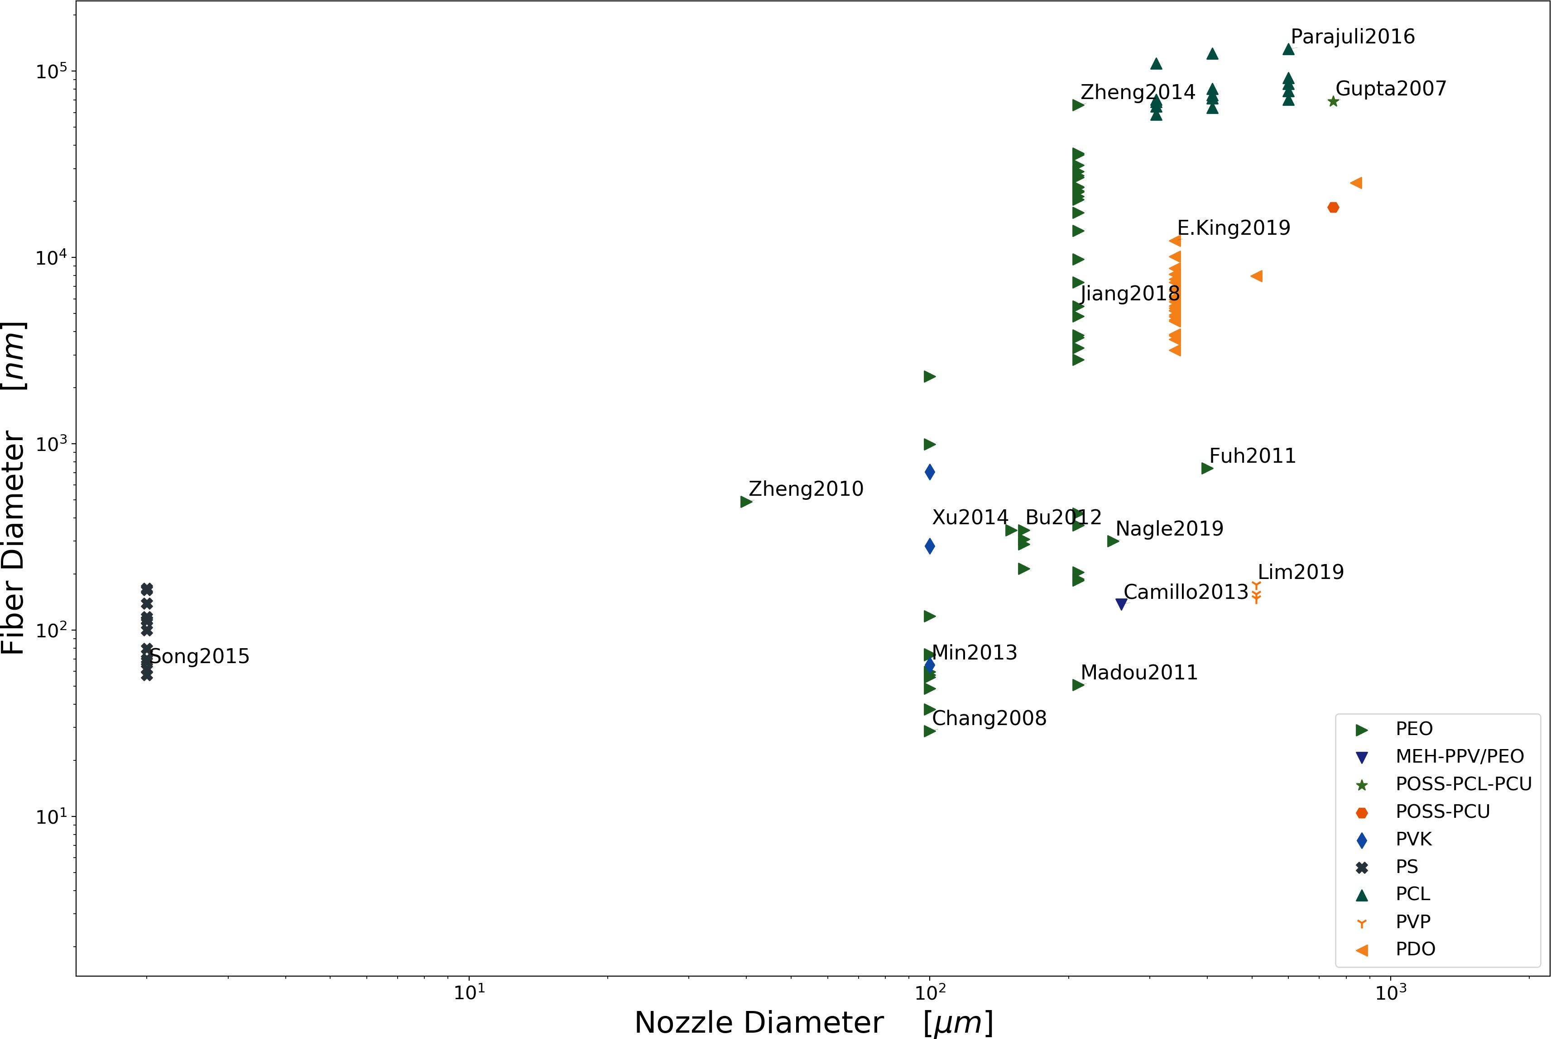

Figure 18: Nozzle Diameter vs. Fiber Diameter

nal of Applied Polymer Science 132 (2) (2015) 1–9.

[doi:10.1002/app.41269](https://doi.org/10.1002/app.41269).

1. L. A. Mary, T. Senthilram, S. Suganya, L. Nagara- jan, J. Venugopal, S. Ramakrishna, V. R. G. Dev, Centrifugal spun ultrafine fibrous web as a potential drug delivery vehicle, Express Polymer Letters 7 (3) (2012) 238–248. [doi:10.3144/expresspolymlett.](https://doi.org/10.3144/expresspolymlett.2013.22) [2013.22](https://doi.org/10.3144/expresspolymlett.2013.22).
2. X. Zhang, Y. Lu, Centrifugal spinning: An alterna- tive approach to fabricate nanofibers at high speed and low cost, Polymer Reviews 54 (4) (2014) 677– 701. [doi:10.1080/15583724.2014.935858](https://doi.org/10.1080/15583724.2014.935858).
3. O. O. Dosunmu, G. G. Chase, W. Kataphinan, D. H. Reneker, Electrospinning of polymer nanofibres from multiple jets on a porous tubular surface, Nanotech- nology 17 (4) (2006) 1123–1127. [doi:10.1088/0957-](https://doi.org/10.1088/0957-4484/17/4/046) [4484/17/4/046](https://doi.org/10.1088/0957-4484/17/4/046).
4. M. Kancheva, A. Toncheva, N. Manolova, I. Rashkov, Advanced centrifugal electrospinning setup, Materi- als Letters 136 (2014) 150–152. [doi:10.1016/j.](https://doi.org/10.1016/j.matlet.2014.08.045) [matlet.2014.08.045](https://doi.org/10.1016/j.matlet.2014.08.045).
5. A. E. Erickson, D. Edmondson, F. C. Chang,

D. Wood, A. Gong, S. L. Levengood, M. Zhang, High- throughput and high-yield fabrication of uniaxially- aligned chitosan-based nanofibers by centrifugal elec- trospinning, Carbohydrate Polymers 134 (2015) 467– 474. [doi:10.1016/j.carbpol.2015.07.097](https://doi.org/10.1016/j.carbpol.2015.07.097).

1. C. C. Liao, C. C. Wang, K. C. Shih, C. Y. Chen, Elec- trospinning fabrication of partially crystalline bisphe- nol A polycarbonate nanofibers: Effects on conforma- tion, crystallinity, and mechanical properties, Euro- pean Polymer Journal 47 (5) (2011) 911–924. [doi:](https://doi.org/10.1016/j.eurpolymj.2011.01.006) [10.1016/j.eurpolymj.2011.01.006](https://doi.org/10.1016/j.eurpolymj.2011.01.006).
2. D. Edmondson, A. Cooper, S. Jana, D. Wood,

M. Zhang, Centrifugal electrospinning of highly aligned polymer nanofibers over a large area, Jour- nal of Materials Chemistry 22 (35) (2012) 18646. [doi:10.1039/c2jm33877g](https://doi.org/10.1039/c2jm33877g).

1. M. A. Souza, K. Y. Sakamoto, L. H. C. Mattoso, Release of the diclofenac sodium by nanofibers of poly(3-hydroxybutyrate- co -3-hydroxyvalerate) ob- tained from electrospinning and solution blow spin- ning, Journal of Nanomaterials 2014 (2014). [doi: 10.1155/2014/129035](https://doi.org/10.1155/2014/129035).

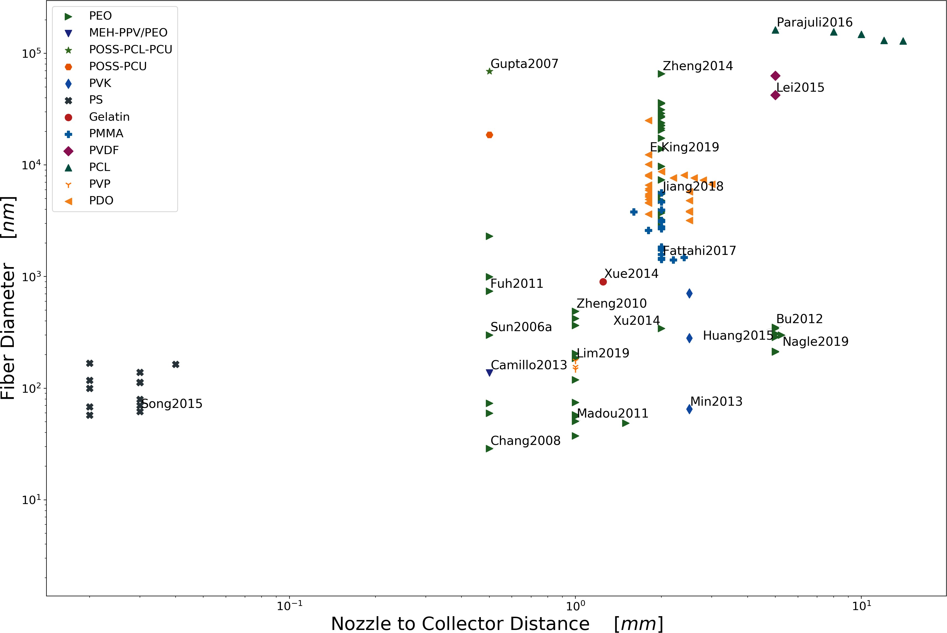

Figure 19: Nozzle to Collector Distance vs. Fiber Diameter

1. J. E. Oliveira, E. S. Medeiros, L. Cardozo, F. Voll,

E. H. Madureira, L. H. C. Mattoso, O. B. G. As- sis, Development of poly(lactic acid) nanostructured membranes for the controlled delivery of progesterone to livestock animals, Materials Science and Engineer- ing C 33 (2) (2013) 844–849. [doi:10.1016/j.msec.](https://doi.org/10.1016/j.msec.2012.10.032) [2012.10.032](https://doi.org/10.1016/j.msec.2012.10.032).

1. T. Ondarçuhu, C. Joachim, Drawing a single nanofi- bre over hundreds of microns, Europhysics Letters (EPL) 42 (2) (1998) 215–220. [doi:10.1209/epl/](https://doi.org/10.1209/epl/i1998-00233-9) [i1998-00233-9](https://doi.org/10.1209/epl/i1998-00233-9).
2. A. S. Nain, J. C. Wong, C. Amon, M. Sitti, Drawing suspended polymer micro-/nanofibers using glass mi- cropipettes, Applied Physics Letters 89 (18) (2006). [doi:10.1063/1.2372694](https://doi.org/10.1063/1.2372694).
3. A. Tokarev, D. Asheghali, I. M. Griffiths, O. Trot- senko, A. Gruzd, X. Lin, H. A. Stone, S. Minko, Touch- and Brush-Spinning of Nanofibers, Advanced Materials 27 (41) (2015) 6526–6532. [doi:10.1002/](https://doi.org/10.1002/adma.201502768) [adma.201502768](https://doi.org/10.1002/adma.201502768).
4. J. Cheng, Y. Jun, J. Qin, S. H. Lee, Electrospin- ning versus microfluidic spinning of functional fibers

for biomedical applications, Biomaterials 114 (2017)

121–143. [doi:10.1016/j.biomaterials.2016.10.](https://doi.org/10.1016/j.biomaterials.2016.10.040)

[040](https://doi.org/10.1016/j.biomaterials.2016.10.040).

1. E. Kang, G. S. Jeong, Y. Y. Choi, K. H. Lee,
   1. Khademhosseini, S. H. Lee, Digitally tunable physicochemical coding of material composition and topography in continuous microfibres, Nature Materi- als 10 (11) (2011) 877–883. [doi:10.1038/nmat3108](https://doi.org/10.1038/nmat3108).
2. J. E. Díaz, A. Barrero, M. Márquez, I. G. Loscertales, Controlled encapsulation of hydrophobic liquids in hydrophilic polymer nanofibers by co-electrospinning, Advanced Functional Materials 16 (16) (2006) 2110– 2116. [doi:10.1002/adfm.200600204](https://doi.org/10.1002/adfm.200600204).
3. I. G. Loscertales, A. Barrero, I. Guerrero, R. Cor- tijo, M. Marquez, A. M. Gañán-Calvo, Micro/nano encapsulation via electrified coaxial liquid jets, Sci- ence 295 (5560) (2002) 1695–1698. [doi:10.1126/](https://doi.org/10.1126/science.1067595) [science.1067595](https://doi.org/10.1126/science.1067595).
4. Z. Sun, E. Zussman, A. L. Yarin, J. H. Wen- dorff, A. Greiner, Compound Core-Shell Polymer Nanofibers by Co-Electrospinning, Advanced Mate- rials 15 (22) (2003) 1929–1932. [doi:10.1002/adma.](https://doi.org/10.1002/adma.200305136)

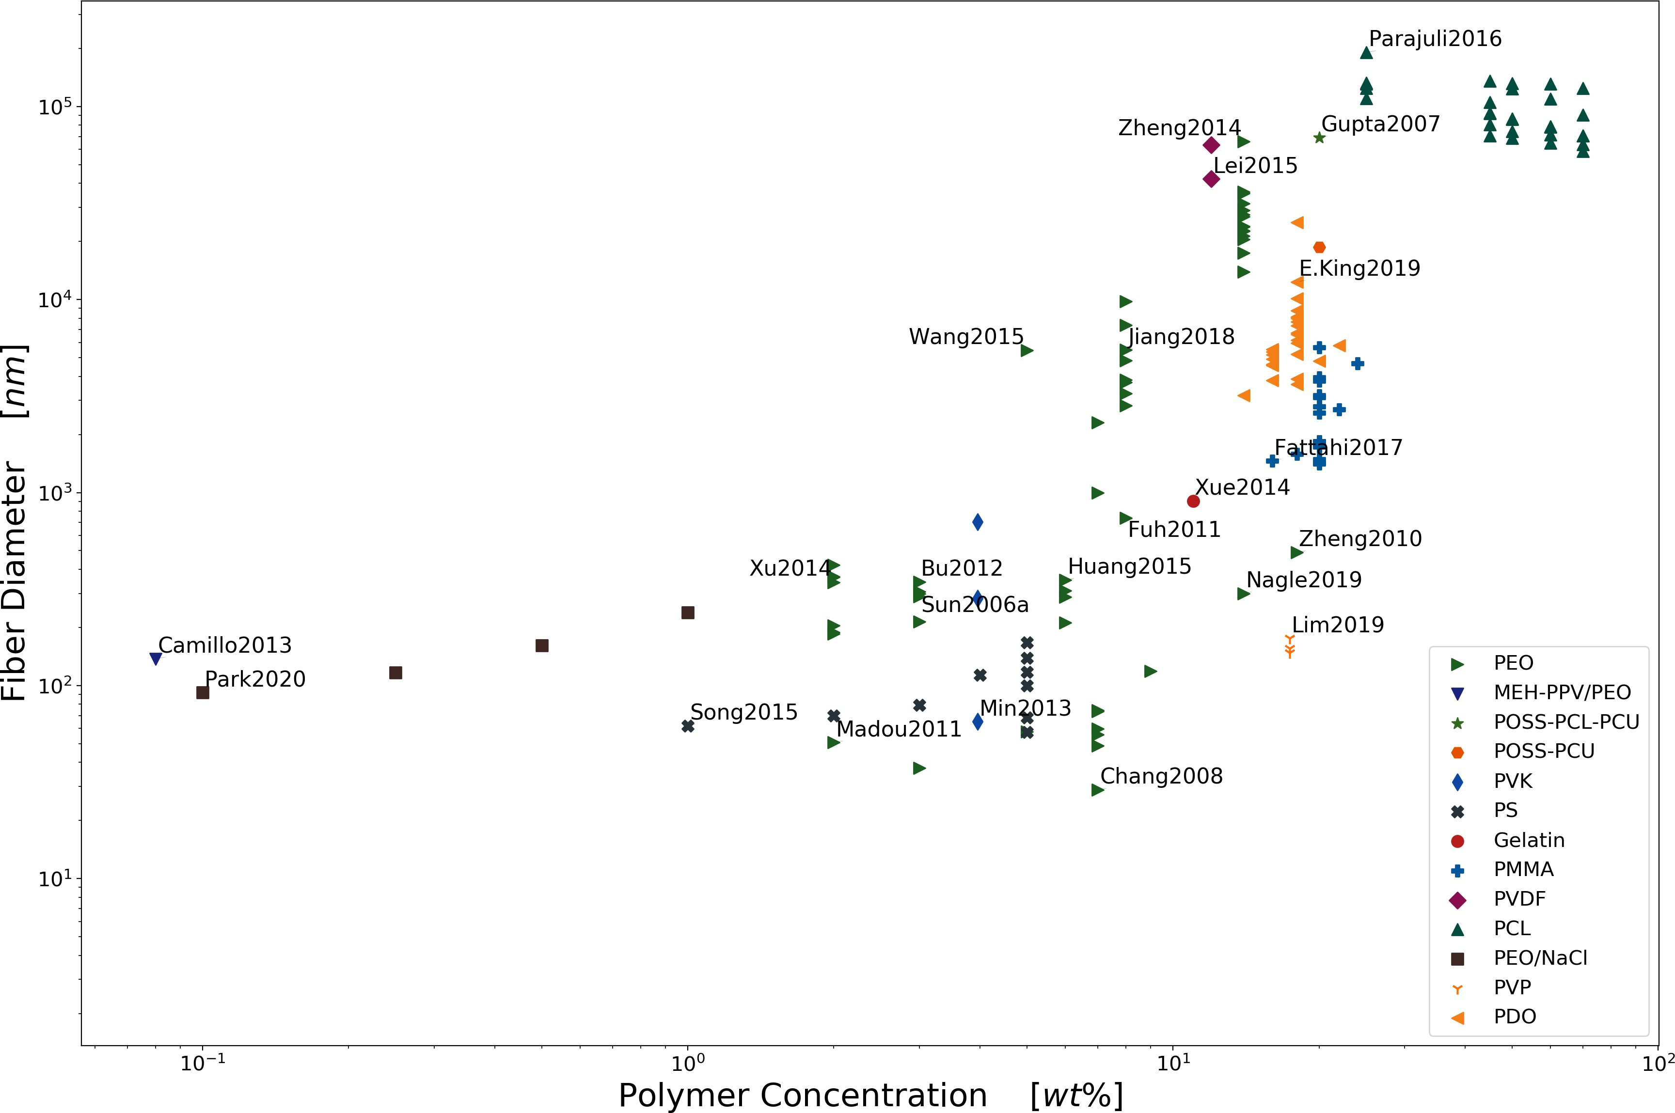

[Figure 20: Polymer Concentration vs. Fiber Diameter](https://doi.org/10.1002/adma.200305136)

[200305136](https://doi.org/10.1002/adma.200305136).

1. P. Sofokleous, W. K. Lau, M. Edirisinghe, E. Stride, The effect of needle tip displacement in co-axial elec- trohydrodynamic processing, RSC Advances 6 (79) (2016) 75258–75268. [doi:10.1039/c6ra08877e](https://doi.org/10.1039/c6ra08877e).
2. Z. Ahmad, H. B. Zhang, U. Farook, M. Edirisinghe,

E. Stride, P. Colombo, Generation of multilayered structures for biomedical applications using a novel tri-needle coaxial device and electrohydrodynamic flow, Journal of the Royal Society Interface 5 (27) (2008) 1255–1261. [doi:10.1098/rsif.2008.0247](https://doi.org/10.1098/rsif.2008.0247).

1. Z. Ahmad, H. B. Zhang, U. Farook, M. Edirisinghe,

E. Stride, P. Colombo, Generation of multilayered structures for biomedical applications using a novel tri-needle coaxial device and electrohydrodynamic flow, Journal of the Royal Society Interface 5 (27) (2008) 1255–1261. [doi:10.1098/rsif.2008.0247](https://doi.org/10.1098/rsif.2008.0247).

1. T. D. Brown, P. D. Dalton, D. W. Hutmacher, Melt electrospinning today: An opportune time for an emerging polymer process, Progress in Poly- mer Science 56 (2016) 116–166. [doi:10.1016/j. progpolymsci.2016.01.001](https://doi.org/10.1016/j.progpolymsci.2016.01.001).
2. Z. K. Nagy, A. Balogh, G. Drávavölgyi, J. Ferguson,

H. Pataki, B. Vajna, G. Marosi, Solvent-Free Melt Electrospinning for Preparation of Fast Dissolving Drug Delivery System and Comparison with Solvent- Based Electrospun and Melt Extruded Systems, Jour- nal of Pharmaceutical Sciences 102 (2) (2013) 508– 517. [doi:10.1002/jps.23374](https://doi.org/10.1002/jps.23374).

1. A. Balogh, G. Drávavölgyi, K. Faragó, A. Farkas,

T. Vigh, P. L. Sóti, I. Wagner, J. Madarász,

H. Pataki, G. Marosi, Z. K. Nagy, Plasticized drug- loaded melt electrospun polymer mats: Characteriza- tion, thermal degradation, and release kinetics, Jour- nal of Pharmaceutical Sciences 103 (4) (2014) 1278– 1287. [doi:10.1002/jps.23904](https://doi.org/10.1002/jps.23904).

1. H. Lian, Z. Meng, Melt electrospinning vs. solution electrospinning: A comparative study of drug-loaded poly ($*ε*$-caprolactone) fibres, Materials Science and Engineering C 74 (2017) 117–123. [doi:10.1016/j.](https://doi.org/10.1016/j.msec.2017.02.024) [msec.2017.02.024](https://doi.org/10.1016/j.msec.2017.02.024).
2. G. Hochleitner, M. Kessler, M. Schmitz, A. R. Boc- caccini, J. Te$*β*$mar, J. Groll, Melt electrospin- ning writing of defined scaffolds using polylactide-

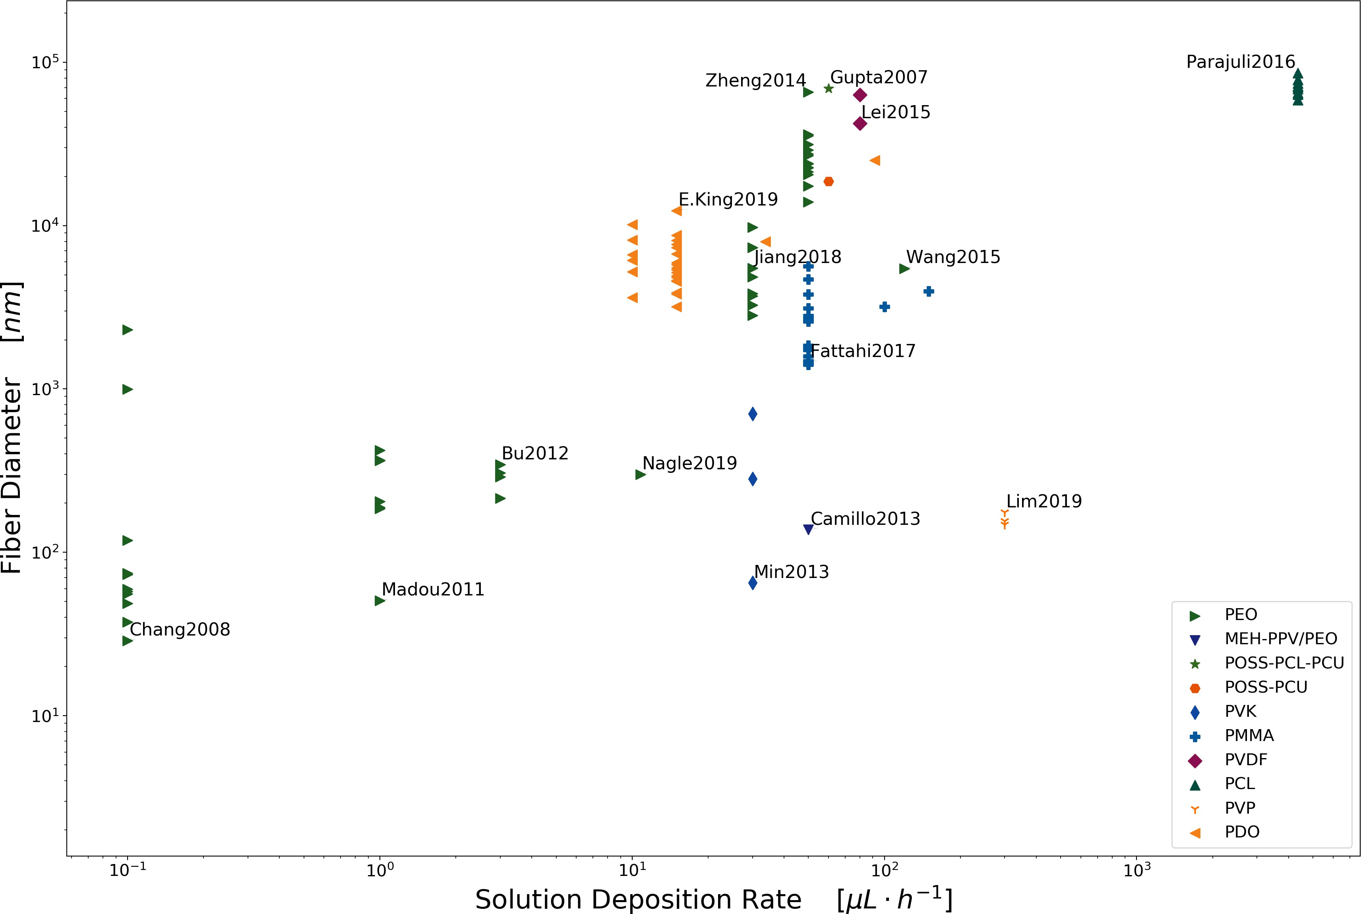

Figure 21: Solution Deposition Rate vs. Fiber Diameter

poly(ethylene glycol) blends with 45S5 bioactive glass particles, Materials Letters 205 (2017) 257–260. [doi:](https://doi.org/10.1016/j.matlet.2017.06.096) [10.1016/j.matlet.2017.06.096](https://doi.org/10.1016/j.matlet.2017.06.096).

1. †Jesse T. McCann, ‡, M. Marquez, †Younan Xia*, Melt Coaxial Electrospinning: A Versatile Method for the Encapsulation of Solid Materials and Fabrication of Phase Change Nanofibers (2006). [doi:10.1021/](https://doi.org/10.1021/NL0620839) [NL0620839](https://doi.org/10.1021/NL0620839).
2. C. Chang, K. Limkrailassiri, L. Lin, Continuous near-field electrospinning for large area deposition of orderly nanofiber patterns, Appl Phys Lett (2008) 3[doi:10.1063/1.2975834](https://doi.org/10.1063/1.2975834).
3. J. Zheng, Y. Z. Long, B. Sun, Z. H. Zhang, F. Shao,

H. D. Zhang, Z. M. Zhang, J. Y. Huang, Polymer nanofibers prepared by low-voltage near-field elec- trospinning, Chinese Physics B 21 (4) (2012) 1–6. [doi:10.1088/1674-1056/21/4/048102](https://doi.org/10.1088/1674-1056/21/4/048102).

1. S. Chakraborty, I.-C. Liao, A. Adler, K. W. Leong, Electrohydrodynamics: A facile technique to fabri- cate drug delivery systems, Advanced Drug Delivery Reviews 61 (12) (2009) 1043–1054. [doi:10.1016/j. addr.2009.07.013](https://doi.org/10.1016/j.addr.2009.07.013).
2. J. Xue, T. Wu, Y. Dai, Y. Xia, Electrospinning and Electrospun Nanofibers: Methods, Materials, and Applications, Chemical Reviews 119 (8) (2019) 5298– 5415. [doi:10.1021/acs.chemrev.8b00593](https://doi.org/10.1021/acs.chemrev.8b00593).
3. G. R. Williams, B. T. Raimi-Abraham, C. J. Luo, Monoaxial electrospinning, Nanofibres in Drug De- livery (2018) 60–105[doi:10.2307/j.ctv550dd1.7](https://doi.org/10.2307/j.ctv550dd1.7).
4. K. A. G. Katsogiannis, G. T. Vladisavljević, S. Geor- giadou, Porous electrospun polycaprolactone (PCL) fibres by phase separation, European Polymer Jour- nal 69 (2015) 284–295. [doi:10.1016/j.eurpolymj.](https://doi.org/10.1016/j.eurpolymj.2015.01.028) [2015.01.028](https://doi.org/10.1016/j.eurpolymj.2015.01.028).
5. G. S. Bisht, G. Canton, A. Mirsepassi, L. Kulinsky,

S. Oh, D. Dunn-Rankin, M. J. Madou, Controlled Continuous Patterning of Polymeric Nanofibers on Three-Dimensional Substrates Using Low-Voltage Near-Field Electrospinning, Nano Letters 11 (4) (2011) 1831–1837. [doi:10.1021/nl2006164](https://doi.org/10.1021/nl2006164).

1. J. Kim, B. Maeng, J. Park, Characterization of 3D electrospinning on inkjet printed conductive pattern on paper, Micro and Nano Systems Letters 6 (1) (2018) 12. [doi:10.1186/s40486-018-0074-1](https://doi.org/10.1186/s40486-018-0074-1).
2. A. Gupta, A. M. Seifalian, Z. Ahmad, M. J. Edirisinghe, M. C. Winslet, Novel Electrohydro- dynamic Printing of Nanocomposite Biopolymer Scaffolds, Journal of BIOACTIVE AND COM- PATIBLE POLYMERS 22 (2007). [doi:10.1177/](https://doi.org/10.1177/0883911507078268) [0883911507078268](https://doi.org/10.1177/0883911507078268).
3. H. Wang, S. Huang, F. Liang, P. Wu, M. Li, S. Lin,

X. Chen, Research on Multinozzle Near-Field Electro- spinning Patterned Deposition, Journal of Nanoma- terials 2015 (2015) 1–8. [doi:10.1155/2015/529138](https://doi.org/10.1155/2015/529138).

1. Z. Wang, X. Chen, J. Zeng, F. Liang, P. Wu,

H. Wang, Controllable deposition distance of aligned pattern via dual-nozzle near-field electrospinning, AIP Advances 7 (3) (2017) 035310. [doi:10.1063/](https://doi.org/10.1063/1.4974936) [1.4974936](https://doi.org/10.1063/1.4974936).

1. Z. Wang, X. Chen, J. Zhang, Y.-J. Lin, K. Li,

J. Zeng, P. Wu, Y. He, Y. Li, H. Wang, Fabrica- tion and evaluation of controllable deposition dis- tance for aligned pattern by multi-nozzle near-field electrospinning, AIP Advances 8 (7) (2018) 075111. [doi:10.1063/1.5032082](https://doi.org/10.1063/1.5032082).

1. Y. Huang, Y. Duan, Y. Ding, N. Bu, Y. Pan,

N. Lu, Z. Yin, Versatile, kinetically controlled, high precision electrohydrodynamic writing of mi- cro/nanofibers, Scientific Reports 4 (1) (2015) 5949. [doi:10.1038/srep05949](https://doi.org/10.1038/srep05949).

1. N. Bu, Y. Huang, X. Wang, Z. Yin, Materi- als and Manufacturing Processes Continuously Tun- able and Oriented Nanofiber Direct-Written by Mechano-Electrospinning Continuously Tunable and Oriented Nanofiber Direct-Written by Mechano- Electrospinning (2012). [doi:10.1080/10426914.](https://doi.org/10.1080/10426914.2012.700145) [2012.700145](https://doi.org/10.1080/10426914.2012.700145).
2. A. R. Nagle, C. D. Fay, Z. Xie, G. G. Wallace,

X. Wang, M. J. Higgins, A direct 3D suspension near- field electrospinning technique for the fabrication of polymer nanoarrays, Nanotechnology 30 (19) (2019) 195301. [doi:10.1088/1361-6528/ab011b](https://doi.org/10.1088/1361-6528/ab011b).

1. J. Kameoka, H. G. Craighead, Fabrication of oriented polymeric nanofibers on planar surfaces by electro- spinning, Applied Physics Letters 83 (2) (2003) 371– 373. [doi:10.1063/1.1592638](https://doi.org/10.1063/1.1592638).
2. D. Sun, C. Chang, S. Li, L. Lin, Near-Field Electro- spinning (2006). [doi:10.1021/nl0602701](https://doi.org/10.1021/nl0602701).
3. N. Xue, X. Li, C. Bertulli, Z. Li, A. Patharag- ulpong, A. Sadok, Y. Y. S. Huang, Rapid Pattern- ing of 1-D Collagenous Topography as an ECM Pro- tein Fibril Platform for Image Cytometry, PLoS ONE 9 (4) (2014) e93590. [doi:10.1371/journal.pone.](https://doi.org/10.1371/journal.pone.0093590) [0093590](https://doi.org/10.1371/journal.pone.0093590).
4. S. Coppola, V. Vespini, G. Nasti, O. Gennari,

S. Grilli, M. Ventre, M. Iannone, P. A. Netti, P. Fer- raro, Tethered Pyro-Electrohydrodynamic Spinning for Patterning Well-Ordered Structures at Micro-and Nanoscale, Chem. Mater 26 (2014) 3360. [doi:10. 1021/cm501265j](https://doi.org/10.1021/cm501265j).

1. D. D. Camillo, V. Fasano, F. Ruggieri, S. Santucci,

L. Lozzi, A. Camposeo, D. Pisignano, Near-field electrospinning of conjugated polymer light-emitting nanofibers, Nanoscale 5 (2013) 11637–11642. [doi:](https://doi.org/10.1039/C3NR03094F) [10.1039/C3NR03094F](https://doi.org/10.1039/C3NR03094F).

1. Q. Xiang, Y.-M. Ma, D.-G. Yu, M. Jin, G. R. Williams, Electrospinning using a Teflon-coated spin- neret, Applied Surface Science 284 (2013) 889–893. [doi:10.1016/j.apsusc.2013.08.030](https://doi.org/10.1016/j.apsusc.2013.08.030).
2. Q. Wang, D. G. Yu, S. Y. Zhou, C. Li, M. Zhao, Elec- trospun amorphous medicated nanocomposites fabri- cated using a Teflon-based concentric spinneret, E- Polymers 18 (1) (2018) 3–11. [doi:10.1515/epoly-](https://doi.org/10.1515/epoly-2017-0110) [2017-0110](https://doi.org/10.1515/epoly-2017-0110).
3. C. Song, J. A. Rogers, J.-M. Kim, H. Ahn, Patterned polydiacetylene-embedded polystyrene nanofibers based on electrohydrodynamic jet print- ing, Macromolecular Research 23 (1) (2015) 118–123. [doi:10.1007/s13233-015-3024-2](https://doi.org/10.1007/s13233-015-3024-2).
4. G. Taylor, Electrically Driven Jets, Proceedings of the Royal Society A: Mathematical, Physical and En- gineering Sciences 313 (1515) (1969) 453–475. [doi:](https://doi.org/10.1098/rspa.1969.0205) [10.1098/rspa.1969.0205](https://doi.org/10.1098/rspa.1969.0205).
5. J. J. Feng, The stretching of an electrified non- Newtonian jet: A model for electrospinning, Physics of Fluids 14 (11) (2002) 3912–3926. [doi:10.1063/1.](https://doi.org/10.1063/1.1510664) [1510664](https://doi.org/10.1063/1.1510664).
6. G. Zheng, W. Li, X. Wang, D. Wu, D. Sun, L. Lin, Precision deposition of a nanofibre by near-field elec- trospinning, Journal of Physics D: Applied Physics 43 (41) (2010) 415501. [doi:10.1088/0022-3727/43/](https://doi.org/10.1088/0022-3727/43/41/415501) [41/415501](https://doi.org/10.1088/0022-3727/43/41/415501).
7. Z. H. Liu, C. T. Pan, L. W. Lin, J. C. Huang,

Z. Y. Ou, Direct-write PVDF nonwoven fiber fab- ric energy harvesters via the hollow cylindrical near- field electrospinning process (2014) 25003–25014[doi:](https://doi.org/10.1088/0964-1726/23/2/025003) [10.1088/0964-1726/23/2/025003](https://doi.org/10.1088/0964-1726/23/2/025003).

1. W. S. Choi, G. H. Kim, J. H. Shin, G. Lim, T. An, Electrospinning onto Insulating Substrates by Con- trolling Surface Wettability and Humidity, Nanoscale Research Letters 12 (2017). [doi:10.1186/s11671-](https://doi.org/10.1186/s11671-017-2380-6) [017-2380-6](https://doi.org/10.1186/s11671-017-2380-6).
2. Y. Duan, Y. Ding, Z. Xu, Y. Huang, Z. Yin, He- lix Electrohydrodynamic Printing of Highly Aligned Serpentine Micro/Nanofibers., Polymers 9 (9) (sep 2017). [doi:10.3390/polym9090434](https://doi.org/10.3390/polym9090434).