Effect of Physical Treatment in Electrical Conductivity of SU-8-based Carbon Structures

Saeed Beigiboroulenia, Antonio Osamu Katagiri Tanakaa

*a ITESM MTY, Av. Eugenio Garza Sada Sur, Monterrey, 2501, N.L., Mexico*

# Abstract

[TODO: Re-write when the other sections are completed ...]

The effects of physical treatment in electrical conductivity of SU-8 films are investigated. SU-8 films were fabricated through mechanical treatment and stabilization followed by py- rolyzation and characterized by four-point-probe method. Based on previous evidence, it is expected that the induced stress to increase the electrical conductivity of the carbon films. However, the SU-8 carbon films amendment after pyrolysis is mainly due to degassing losses, rather than strain induced forces, hence the small to none differences between the stress-induced and control samples. [AGREE?]

# Introduction

Nanostructures and nanostructured materials such as nanotubes, thin films, suspended nanofibers, and nanofiber mats exhibit unique properties that make them suitable as cir- cuitry elements, structural materials and analytical sensors within micro-mechanical sys- tems. Carbon-based nanostructures have been of interest due to their low reactivity, good electrical and thermal properties with electrochemical stability [1]. One technique to fab- ricate carbon structures is through heat treatment/carbonization of organic materials. Or- ganic materials decompose into simpler compounds when exposed to high temperatures in an inert atmosphere or vaccum [2]; this process is known as pyrolysis. SU-8 is a well-known negative high transparency UV photoresist (see Figure 1) used as a carbon precursor in recent works [2–4].

Cardenas-Benitez et al. [2] studied the pyrolysis-induced shrinkage of photocured SU-8 structures due to the volatilized material/degassing and surface area of the microstructures, where the structures shrank about70% of their original size. Canton et al. [4] reported that the shrinkage and elongation of suspended SU-8 fibers during pyrolysis influences the resulting electrical properties. In Canton et al. deposited fibers in supporting walls, as the walls shrink during pyrolysis strain forces elongate the fibers. Evidence states that the

*Email addresses:* [saeed.beigi@tec.mx](mailto:saeed.beigi@tec.mx) (Saeed Beigiborouleni), [oskatagiri@gmail.com](mailto:oskatagiri@gmail.com) (Antonio

Osamu Katagiri Tanaka)

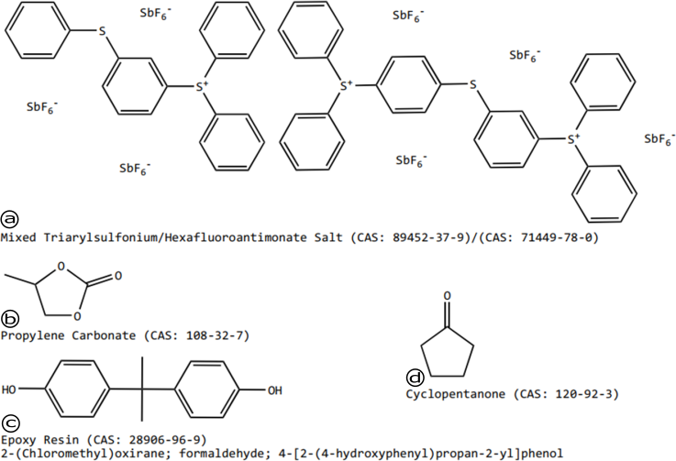

Figure 1: SU-8 2000 Series Resists Composition. a) photo initiator; b-c) epoxy groups of different SU-8 monomers; d) solvent

electrical conductivity increases when fibers are elongated/stretched with a decrease of their diameter [4].

On the other hand, literature suggest that the electrical conductivity of carbon electrodes is enhanced with the execution of mechanical treatments, as the precursor polymer chains align within the fibers. Recent efforts [5, 6] report carbon fibers with superior electrical conductivity, where the polymer chains are aligned with the aid of carbon nanotubes and hydro-electromechanical strain via electrospinning processes.

In this paper, the effects of physical treatment in electrical conductivity of SU-8 films. SU-8 films were fabricated through mechanical treatment and stabilization followed by py- rolyzation and characterized by the four-point-probe method. Based on previous evidence, it is expected that the induced stress to increase the electrical conductivity of the carbon films.

# Materials and Methods

[TODO: List used materials and their origin]

[TODO: Detailed preparation of the photoresist films]

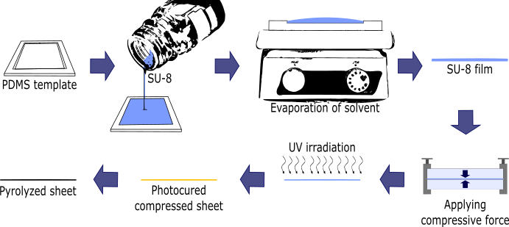

Figure 2: Schematic diagram of the SU-8 carbon film fabrication process.

# Results and discussion

[TODO: Depict the characterization evidence]

# Nomenclature

[TODO: Add used acronyms and their meaning]

# PDMS UV

Polydimethylsiloxane Ultraviolet

# Acknowledgments

[TODO: Don’t know if this is required ...]

# References

1. R. L. McCreery, Advanced Carbon Electrode Materials for Molecular Electrochemistry, Chemical Re- views 108 (7) (2008) 2646–2687. doi:10.1021/cr068076m.
2. B. Cardenas-Benitez, C. Eschenbaum, D. Mager, J. G. Korvink, M. J. Madou, U. Lemmer, I. D. Leon,

S. O. Martinez-Chapa, Pyrolysis-induced shrinking of three-dimensional structures fabricated by two- photon polymerization: experiment and theoretical model, Microsystems {&amp;} Nanoengineering 5 (1) (2019). doi:10.1038/s41378-019-0079-9.

1. B. Y. Park, L. Taherabadi, C. Wang, J. Zoval, M. J. Madou, Electrical Properties and Shrinkage of Carbonized Photoresist Films and the Implications for Carbon Microelectromechanical Systems Devices in Conductive Media, Journal of The Electrochemical Society 152 (12) (2005) 136. doi:10.1149/1.2116707.
2. G. Canton, T. Do, L. Kulinsky, M. Madou, Improved conductivity of suspended carbon fibers through integration of C-MEMS and Electro-Mechanical Spinning technologies, Carbon 71 (2014) 338–342. doi:10.1016/j.carbon.2014.01.009.
3. S. Holmberg, M. Ghazinejad, E. Cho, D. George, B. Pollack, A. Perebikovsky, R. Ragan, M. Madou, Stress-activated pyrolytic carbon nanofibers for electrochemical platforms, Electrochimica Acta 290 (2018) 639–648. doi:10.1016/j.electacta.2018.09.013.
4. M. Ghazinejad, S. Holmberg, O. Pilloni, L. Oropeza-Ramos, M. Madou, Graphitizing Non-graphitizable Carbons by Stress-induced Routes, Scientific Reports 7 (1) (2017) 16551. doi:10.1038/s41598-017-16424- z.