**3. SOLICITUD DE REGISTRO DE PROPUESTA**

Matrícula: A01212611

Aspirante (nombre completo): Antonio Osamu Katagiri Tanaka

email: A01212611@itesm.mx

Teléfonos:personal <no disponible> celular 552 300 91 76

Título de la tesis:

Fabrication of graphitic-carbon suspended nanowires through mechanoelectrospinning of photocrosslinkable polymers

**Antecedentes:**

Carbon nanowires have been fabricated with a photoresist by multiple-photon polymerization techniques. However little is known about polymers that can produce conductive carbon nano-wires after pyrolysis, as it is generally believed that most polymers do not form significant amounts of graphitic carbon when carbonized. In the past years, photopolymerization processes have been applied to the fabrication of nano-structures with the use of an epoxy based photoresist. [2] Photopolymerization techniques deliver patterning resolutions with nano-scale tolerances through two-photon lithography to produce highly detailed structures [4].

On the other hand, electrospinning has been acknowledged as a process with promising results at nano-structure fabrication [2], yet there is little research regarding the implementation of electrospinning for the fabrication of carbon nano-wires. Electrospinning has the potential to be a more straightforward process for the design and fabrication of nano-structures, as it can achieve mass scale manufacturing in a continuous, simple and reproducible manner. Cardenas [3] showed that electrospinning can be implemented with ease for carbon nano-wire synthesis. Mechano-electrospinning, a new variant of electrospinning shows promising results in the production of ordered carbon nano-wires. As stated in [3], mechano-electrospinning is an early technology invention and brings new challenges, such as the reproducibility of carbon nano-wire production. Furthermore, the study of a new fabrication process to produce carbon nanowires that involves mechano-electrospinning will enable spatial control of the structures’ patterning.

Since electrospinning seems to be a better alternative for carbon nano-wire fabrication processes; and for that purpose of its implementation, it is required to develop polymer solutions that can be mechano-electrospun, photopolymerized and pyrolyzed into conducting carbon nano-wires. Carbon nano-materials have been subjected to research due to their various potential applications in diverse areas that take advantage of the nano-scale properties. [6] Carbon nano-materials are suitable for the catalysis, adsorption, carbon capture, energy and hydrogen storage, drug delivery, bio-sensing and cancer detection. [6] However most applications are not currently feasible due to the lack of a continuous, simple and reproducible fabrication method with inexpensive processes. With the newly designed polymer solution, it would be possible to produce carbon nano-wires in large quantities, and therefore more applications will become feasible. On the other hand, the new technique will overcome some limitations of other methods such as lithography currently has. For instance, patterns created by lithography processes cannot be originated, only replicated, all constituent points of the pattern can only be addressed at the same time, and the process requires the pattern to be encoded into a mask. [5]

**Objetivo general:**

Study the practice and feasibility of a new fabrication process to achieve mass scale manufacturing of carbon nano-wires in an inexpensive, continuous, simple and reproducible manner; by the integration of mechano-electrospinning technique.

**Objetivos específicos:**

* Design polymer solutions that can be electrospun by NFES, photopolymerized, and then pyrolyzed.
* Through rheological analyses, determine if polymer solutions can be easily employed for conducting carbon nano-wire synthesis.
* Determine and control the polymer solution rheological properties along with the process parameters of carbon nano-wire synthesis.
* Discover a PEO-similar material to allow the electrospinning process as well as input favourable properties to the carbon nano-wire yield.

**Materiales y métodos:**

The following describes the proposed work to be done to fulfil the objectives stated in this document. The tasks are grouped in several work packages as described below:

**Preliminary Literature Review**

The first step to the thesis development is the study of preliminary literature and related work. The purpose of this work package is the familiarization of the existing techniques such as: far and near field electrospinning, lithography, pyrolysis, carbonization and photopolymerization. On the other hand, some research is to be done in order to recognize if there are any efforts in the design of electrospun-able, photopolymerizable and pyrolysable polymer solutions. Furthermore, the motive of this work package is to find common parameters that could link the techniques mentioned above for the fabrication of carbon nano-wires from polymer solutions that can be electrospun by NFES, photopolymerized and then pyrolyzed. This work package is to be carried out through the entire thesis development process, as the state-of-the-art may change within that period of time.

**Evaluation of Fabrication Parameters**

As the polymer solution is the principal input to the proposed technique (See Figure 1.1), it is required to identify and understand the fabrication parameters that have an impact on the quality of the carbon nano-wires. For that reason, two tasks are to be executed:

• Study and identify the process parameters that influence the fabrication of carbon nano-wires

• Study and identify the rheological properties in polymer solutions that affect the electrospinning and pyrolysis techniques

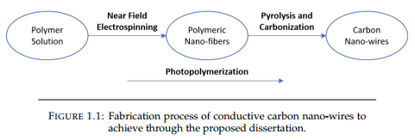

**Polymer Solution Design**

Once the process parameters and rheological properties that affect the fabrication of carbon nano-wires are identified, the design process shall take place. This work package is to study polymer solutions that can be electrospun by NFES, photopolymerized and pyrolyzed. The polymer solution design will comprise of two steps:

• Prepare and test various polymer solutions with specific distinctions according to the identified solution properties and process parameters.

• Perform rheological analyses to determine if the prepared polymer solutions can be employed for the fabrication of carbon nano-wires.

**Fabrication of Carbon Nano-wires**

From the rheological analyses, determine and control the polymer solution

properties and fabricate carbon nano-wires.

This work package intends to involve several manufacturing processes (near field electrospinning, photopolymerization, pyrolization and carbonization) for the fabrication of carbon nano-wires. This task will require the integration of several techniques:

• Electrospinning - to convert the polymer solution into polymer nanofibers

• Photopolymerization - to change the chemical properties of the polymer solution and crosslink its molecules. This is to prevent the polymer to melt during pyrolysis [1].

• Pyrolysis - to transform the polymer nano-fibers into conductive carbon nano-wires.

**Data Collection and Analysis of Results**

The data collection work package comprehends the study of the created carbon nano-wires using the new design polymer solution. The purpose is to characterize the carbon nano-wires and compare them to the carbon nanostructures produced by existing techniques.

**Documentation**

Finally, the documentation refers to the Thesis writing tasks. This task is intended to carry out through the entire thesis development process, as every work package above is to be referenced within the thesis document.

**Cronograma de actividades:**

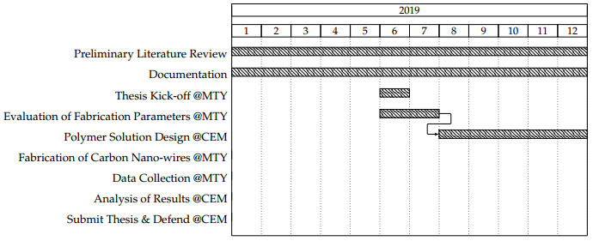

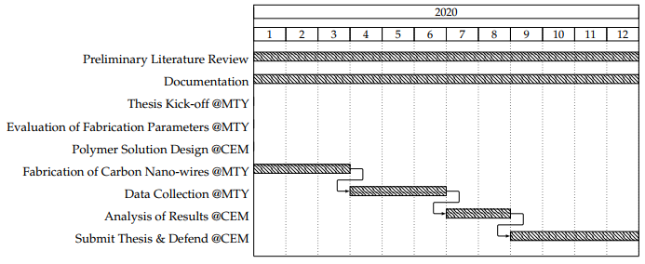

**Referencias:**

[1] Prabir Basu. Biomass Gasification, Pyrolysis and Torrefaction - Practical Design and Theory. 3rd Editio. Elsevier, 2018. URL: https://app.knovel.com/hotlink/ pdf/id:kt011PGVNJ/biomass-gasification/biomass-ga-historical

[2] Jan Boer and Clemens Blitterswijk. Tissue Engineering. Ed. by Academic Press of Elsevier AP. 2nd. Safary O Reilly, 2014. URL: https://learning.oreilly. com / library / view / tissue - engineering - 2nd / 9780124201453 / XHTML / B9780124201453000109/B9780124201453000109.xhtml.

[3] Braulio Cárdenas. “Advanced Manufacturing Techniques for the Fabrication and Surface Modification of Carbon Nanowires”. In: (2017), p. 160.

[4] Kolin C Hribar et al. “Light-assisted direct-write of 3D functional biomaterials.” In: Lab on a chip 14.2 (Jan. 2014), pp. 268–75. ISSN: 1473-0189. DOI: 10. 1039/c3lc50634g. URL: http://www.ncbi.nlm.nih.gov/pubmed/24257507.

[5] Stefan. Landis. Nano-lithography. ISTE, 2011, p. 325. ISBN: 9781848212114. URL: https://learning.oreilly.com/library/view/nano-lithography/9781118621707/.

[6] M.T.H Siddiqui et al. “Fabrication of advance magnetic carbon nano-materials and their potential applications: A review”. In: Journal of Environmental Chemical Engineering 7.1 (Feb. 2019), p. 102812. ISSN: 2213-3437. DOI: 10.1016/J. JECE.2018.102812. URL: https://0-www-sciencedirect-com.millenium. itesm.mx/science/article/pii/S2213343718307358.

Atentamente,

_______________________________

**Firma del aspirante**

______________________________________

**Nombre y firma del director de tesis**