**Semester Thesis Report and Update**

# Antonio Osamu Katagiri Tanaka1

1 *School of Engineering and Sciences, Tecnologico de Monterrey, Av. Eu- genio Garza Sada 2501 Sur, N.L., Monterrey, Mexico*

# Gantt

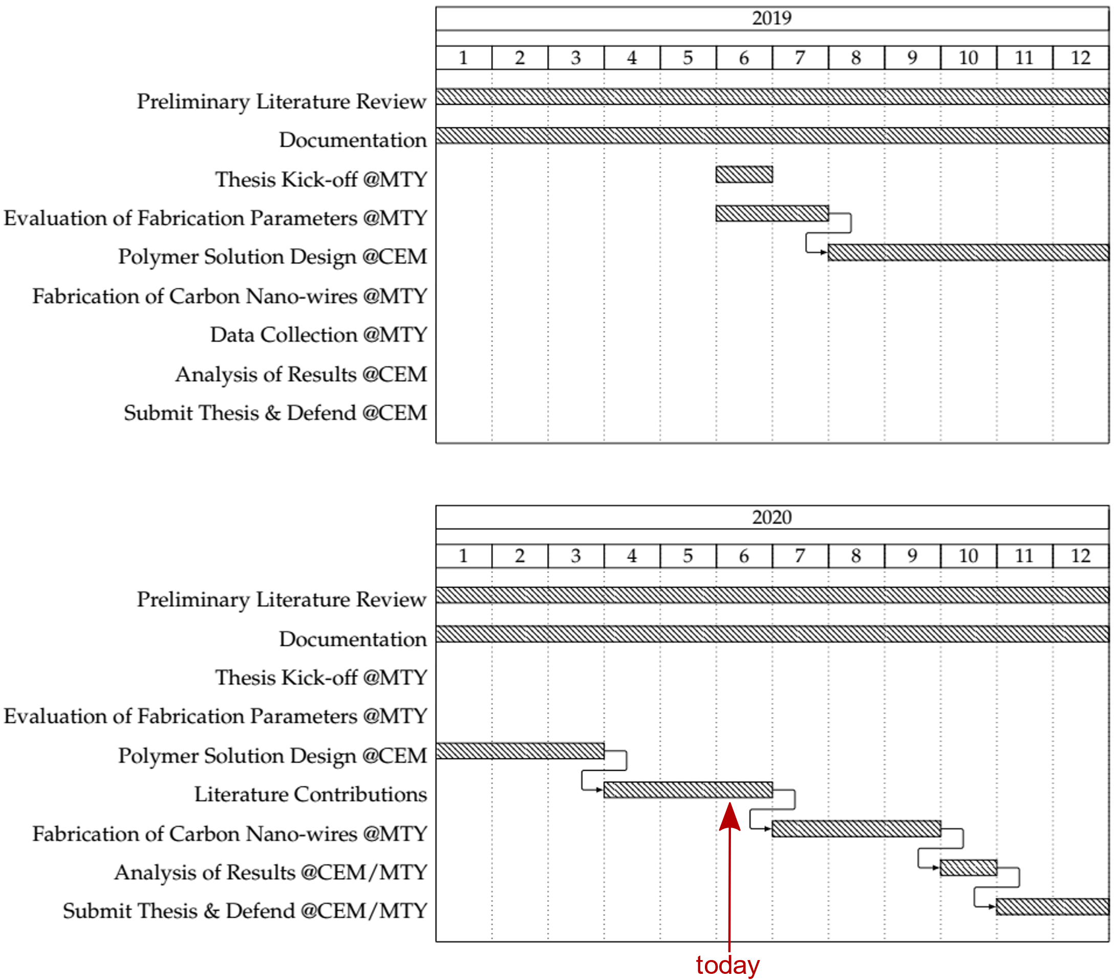

# What semester are you in? How many semesters are there left to finish according to your project plans?

Currently in 3rd semester, one more to finish.

# What goals were completed before the start of the last semester (before February 2020)?

* Thesis proposal (motivation, problem statement, hypothesis, objectives)
* Polymer & solvent selection to replace the SU-8 system for NFES
* Lab trainings at CEM & MTY
* Image analysis software for NFES review paper
* Tec-Nano (Electrospinning Oxygen-less Polymers to Fabricate Carbon-based Nanostructures)
* Preliminary Rheological Analysis

# What goals were accomplished during this period?

* Participation in Saeed’s paper (Exploring the effect of Mechanical Compressive Treatment in Electrical Conductivity of SU-8-based Carbon Structures) [Apr/2020]
* Writing of the article on NFES [due by the end of Jun/2020]
* Writing of the first three thesis chapters (Introduction, Near-Field Electrospinning as an Affordable Way to Gain Spatial Control, Selection of Compatible Polymer-Solvent Combinations for Near-Field Electrospinning and Pyrolysis)

# What goals are left to finish in the remaining of your program?

* Writing of the collaborative paper (Controlling diameter of photopolymerizable micro fibers spun by low-voltage near-field electrospinning) [due before Nov/2020]
* Fabrication of fibres with NFES
* Study the fibres to compare with the ones of SU-8 (higher conductivity, thinner diameters, higher reproducibility)
* Work the missing rheological analysis
* Review & publish the articles