**INSTITUTO TECNOLÓGICO DE ESTUDIOS SUPERIORES DE MONTERREY**

**CAMPUS ESTADO DE MÉXICO**



**Leadership for Sustainable Development**

**Masters in Nanotechnology**

Dra. Rosamaría López-Franco/Dr. Diego Fabián Lozano García

**Ecological and Water Footprint**

Antonio Osamu Katagiri Tanaka (A01212611)

Bruno González Soria (A01169284)

Carlos Cardoso Isidoro (A01750267)

**Due date: April 06, 2019, 11:59PM**

**Possible Actions to Reduce Our Ecologic Footprint**

To reduce our Carbon Footprint:

* We can start using cleaner transport to get to school and other nearby places. These may include walking, biking, or taking public and scholar transportation whenever possible.
* Whenever we use the car, we can turn off the engine whenever we are just waiting for someone or something outside traffic. This can be applied for drive-thru restaurants and stores.
* We can check our car's air filter monthly, and keep the tires adequately inflated to maximize gas mileage in order to reach an optimal performance whenever we use it.
* We can start adding energy-saving features to our homes, like more efficient light bulbs and investing in solar panels and windmills.
* We could switch to tankless water heaters, so our water will be heated only as we use it, or to solar water heaters to save more energy.
* An easy habit to start developing is unplugging our electronics when not in use.
* We could also dry our clothes outside whenever possible since Mexico has a very hot and sunny weather most of the year and we could use it for our advantage.

To reduce our Food Footprint:

* We can easily compromise to eat more local, organic, in-season foods, since near our homes there are regular local markets. This can be better than going to the supermarket.
* In the case of some of us that have a garden, we could invest in planting our own crops.
* We can choose foods with less packaging to reduce waste.

To reduce our Housing Footprint:

* We must start investigating the products we buy in order to choose sustainable materials, furnishings, and cleaning products.
* Installing solar heaters, rainwater catchment or grey water recycling systems are great improvements to our homes. This would require investment, but this investment will pay off in the long run.
* We must inform ourselves about the efficiency of our current appliances and try to use them in the best way possible to improve them or even think about upgrading them to more efficient ones. These include low flow shower heads, faucets, and toilets.
* We can also start making compost instead of simply using the garbage disposal. Garbage not contaminated with biological waste is more easily recycled and sorted. This will also help to decrease the amount of methane gas produced by this type of waste when stored in a landfill.

To reduce our Goods and Services Footprint:

* We can start reducing our print by consuming less; buying only those things we really need and recycling all the materials possible as much as possible.

**Result Comparison**

All the teammates performed individual tests on different online tools to calculate their ecological footprint. Our results were as follows:

**Osamu:**

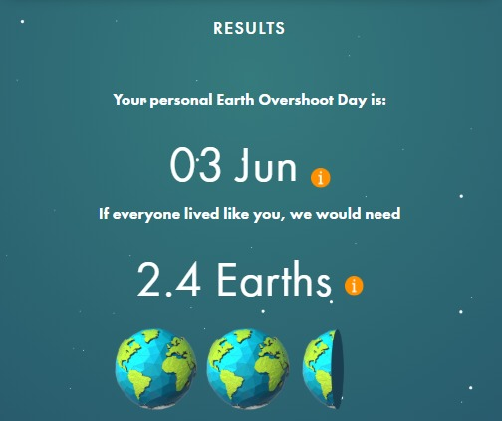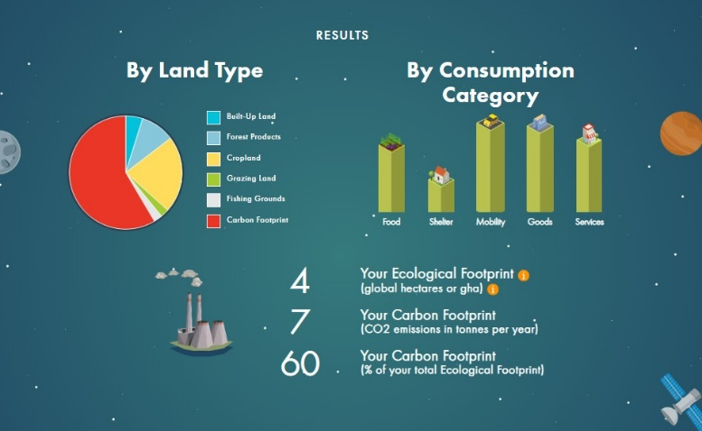

**Figure 1.** Osamu’s footprint according to footprintcalculator.org calculator.

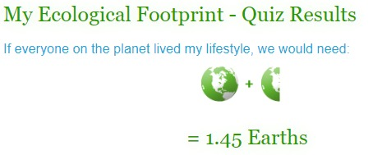

**Figure 2.** Osamu’s footprint according to myfootprint.org calculator.

**Bruno:**

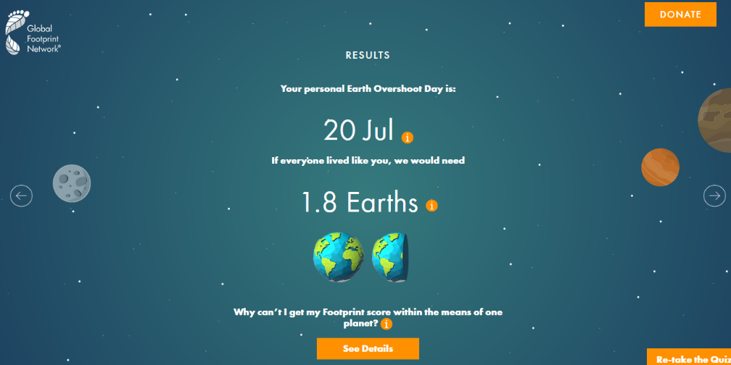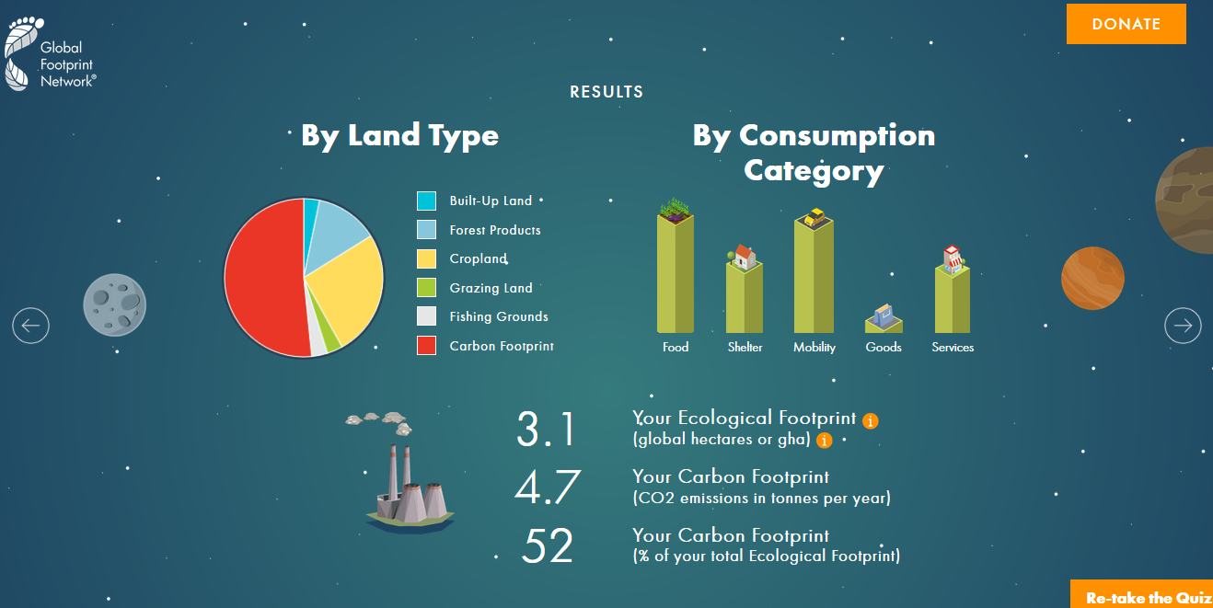

**Figure 3.** Bruno’s footprint according to footprintcalculator.org calculator.

**Figure 4.** Bruno’s footprint according to myfootprint.org calculator.

**Carlos:**

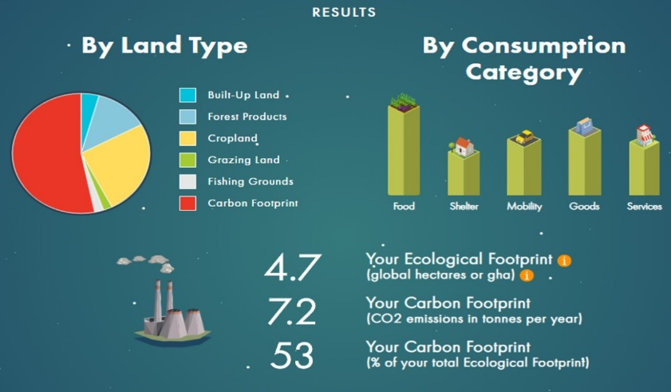

**Figure 5.** Carlos’s footprint according to footprintcalculator.org calculator.

**Figure 6.** Carlos’s footprint according to myfootprint.org calculator.

Myfootprint.org calculator was a little more relaxed on the results since in all cases we received better predictions than those obtained using footprintcalculator.org.

Note that Earth Day’s footprint calculator is currently under maintenance, hence that footprint calculation was not approximated. See Figure 7.

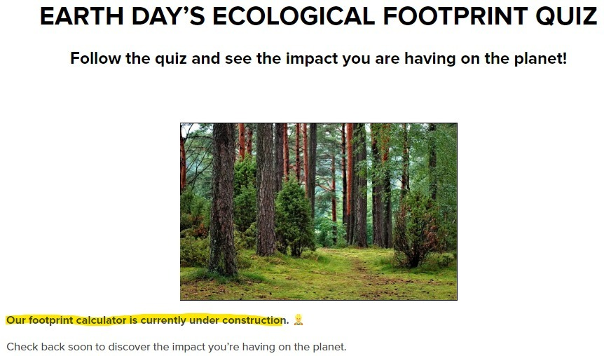  
**Figure 7.** Earth day’s ecological footprint quiz and calculator.