**INSTITUTO TECNOLÓGICO DE ESTUDIOS SUPERIORES DE MONTERREY**

**CAMPUS ESTADO DE MÉXICO**



**GI5000 Metodología de Investigación e Innovación**

**(Research Methodology and Innovation)**

Dr. Raúl Monroy B./Dr. Francisco J. Cantú O.

**Assessed Exercise # 03**

**Research and Innovation**

Antonio Osamu Katagiri Tanaka (A01212611)

Bruno González Soria (A01169284)

Jonathan Rafael Núñez Gálvez (A01750271)

**Date of assignment: February 18, 2019**

**Due date: March 12, 2019, 11:59PM**

**Articles to Read and Questions to Answer**

## [1] **From the reading of article “Lancho-Barrantes, B.S. & Cantú-Ortiz, F.J. (2019). What is the situation of science in Mexico with respect to strategic countries and how could it be improved?**

This article develops the theme about the actual situation of the researching on Mexico and how is the situation with collaboration with other countries, in special with countries considered how strategic by CONACYT [1].

The strategic countries recognized by CONACYT to the research are United States, Spain, France, United Kingdom, Germany, Canada, Brazil, Colombia, China, Russian Federation, Argentina, India, Chile, Japan, South Korea, Turkey, South Africa and Israel. These are main collaborative countries consider by CONACYT. And between them, the countries which collaborate the most with Mexico are United States, with 28,535 articles; Spain with 15,003 articles and France with 8249 articles. Spain is the country with most coincidences about the themes of investigation with Mexico, and it is followed by United States, Canada and Israel.

About the situation of the research on Mexico; the collaborative scientific production between Mexico and his strategic countries have been increasing between the years 2007-2016, there are a graphic that shows how the number of papers produced on Mexico have increased on these years, and the total number of articles is 8023 on 2016. The main obstacles that Mexico has on the research topic are the low investment on science and the small number of researchers per million inhabitants. And other important thing is that the main investor for research is the government and the private sector rarely invest on that.

So, for increase the number or scientific articles and researching on Mexico is necessary to increase the investment on first place, but also, it should invest more in the creation of a scientific culture and the development of research universities, recruiting talent from all over the world. This is the key point to improve the investigation on this country because the countries with the most quantity of articles produced per year invest big resources on universities for the researching.

## [2] **From the reading of article “****Ceballos, H. G., Garza, S.E., & Cantu-Ortiz, F. J. (2018)”. What strategy can be defined for establishing research groups within an organization?**

Scientific productivity and impact have become an important indicator of academic quality and a leading factor of innovation. Scientists and researchers all around the world are constantly incentivized and motivated by governments and universities to continue pursuing and releasing new publications. These publications are the product of a collaborative effort by research partners working together from different facilities in different parts of the world. The importance of correctly matching compatible members for the formation of successful research groups has been identified by multiple authors. Institutions interested in improving their prestige and ranking among other institutions have been developing strategies to assure the success of their research groups. [2]

Based on this necessity for improved collaboration and adequate research partner matching, Ceballos, H. G., Garza, S.E., & Cantu-Ortiz, F. J. investigate techniques that can help in the establishment of successful groups obtaining and profiling researchers’ information present in the networks. Some of the reasons considered by any researcher before collaborating with another partner are the scientific recognition of the partner, their specialization in science, their need of training, and the geographic distance between them.

The paper presented demonstrates that it is possible to develop strategies to consider the characteristic traits of each researcher from the information available in scientific social networks from which they are already members. Based on this information and correlated data between each of the researchers, the authors have established an algorithm proven to create more successful teams compared to randomly created teams in terms of Adjusted Rand Index (ARI). This strategy can be very useful for the correct assembly of research groups, assuring their success and improving their performance within their institutions. The reported results in this article were observed in the Tecnológico de Monterrey research infrastructure, and they give an optimistic approach towards the replication of this technique in other institutions. [2]

## [3] **From the reading of article “Cantu-Ortiz, F. J., Galeano, N., Mora-Castro, P., & Fangmeyer, J. (2017)”, What is the importance of developing an entrepreneurial mentality? Are you thinking about becoming an entrepreneur now or after graduation, if you are not an entrepreneur already?**

Entrepreneurship is an important skill that must be developed on Mexican colleges in order to improve the economy and the level of technology, innovation and development of Mexico. There are three deficiencies in Mexico’s entrepreneurship ecosystem which are: Research skills, high technology and technology transfer.

Academic entrepreneurship refers to university researchers commercializing university research through new business enterprises.

“The CONACYT coordinates an innovation program named FINNOVA that connects applied research with entrepreneurs and companies” [3]. Additional to that, it helps to transfer technology between academics and business. So, it’s important to increase the entrepreneurship on colleges on first time to people use this advantage and start to create new business, but also, for create new employees and improve the economy of the country. This is the best strategy to increase the economy of Mexico.

About the second question; I want to be an entrepreneur when I will finish my master’s degree, in fact, I was planned to start my own business some years ago because I prefer to work for me and my dreams and do not do that for others. I don’t think that have an employment and work on a business is a waste of time; I think that it’s important to develop skills and get experience, but nevertheless, is important that Mexican people start to develop an entrepreneurial mentality because a good way to increase the economy of the country and the families is that people start to have their own business, this is the key why Chinese economy has grown so much on the last years; because there are more and more people starting up their own business.

## [4] **From the reading of article “Ceballos, H. G., Fangmeyer, J., Galeano, N., Juarez, E., & Cantu-Ortiz, F. J. (2017)”, How important is collaborative work? What are the disadvantages of collaborative work?**

This article starts to talk about the knowledge and collaborative research, mainly by interdisciplinary laboratory teams and how the latter are more available to create knowledge on most disciplines that monodisciplinary teams. Nevertheless, a nest step of the interdisciplinary teams are the networks; that on the article are called how “network of knowledge” or “research networks”, and it’s denoted the importance of them on the researching field.

Collaborative work is important due to with it is possible to compare different points of view and have a reference from other areas about the investigation on a specific field. For example, on CEDETEC there are a group of researches looking for a material that is available to react with certain proteins of people that have cancer, but they need help of other areas for applying tests to the new materials in order to check the behavior the these material, these test could not be applied for the first group due to their field are not on the biology; they are experts on advanced materials.

About the networks, there are two kind of networks: Dense networks and sparse networks, these networks are the main form of collaborative work, because on them, the knowledge is interchanged by researchers of different disciplines, and it is applied to investigation on different fields.

Dense networks have a lot of redundant contacts, this is an important advantage because as more people are working into a network as more knowledge will be interchanged by people of the network and the results of the researches will be meaningful, also people from the network are closely connected with all other people. On by other hand, spare networks people are not closely with others and there are not collaboration circuits connected between people, also people of a sparse network have contacts, but they are from different groups and there aren’t connected between them like dense networks.

In addition to the above; the main advantages that dense networks have are “trust and the capacity to transfer large amounts of complex information” [4]. Main disadvantages of that are for example “group think and lack of innovation” [4]. This last point is important due to sometimes people follow trends (on this case, research trends) and stop to think “out of the box” and try to research about new themes or other topic different to the rest of their colleges. By other hand, people from spare network “have access to a greater array of information, but may lack strong relationships” [4], it could promote that people of a sparse network try to dabble on other areas of researching and don’t follow tends like the other kind of networks. “From this perspective, network structure affects knowledge held by individuals in the network” [4], and this is a big reason whereby is important to take care about what kind of network a researcher is part.

## [5] **From the reading of article “Cantú-Ortiz, F. J. (2015)”, What role eco-innovation systems play for the socioeconomic development of an institution and its surrounding region?**

Universities have been centers of knowledge accumulation, generation and propagation since the very beginning of their creation. These institutions have influenced and forged humankind trajectory through the centuries playing an important role as the torch that guides our species forward. The social and economic impact that universities have had though out history may be on the limit of incalculable measures. Universities concentrated in the generation of fundamental knowledge, during the twentieth century, enhancing the advancement of sciences and becoming engines of economic development through “Ecosystems of Innovation” [5].

Research Innovation Ecosystems (RIE) refer to the aggregate of factors and resources that surround and nourish research and innovation. These factors include the natural and economic resources and the groups of people that make this formation and accumulation of knowledge possible. [5] The term “Triple Helix” has been used to refer to the three main stakeholders in this environment: universities, industry and government. [5] It is well known that these three gears have been working together as a single engine with the objective to improve and innovate technologies. This is since innovation is strongly linked to economic development as well as national power growth. Industries and government give huge incentives to universities so that they can develop the knowledge to create new and better industries that result in jobs and taxes, as well as exports and markets.

Nevertheless, Research Innovation Ecosystems require constant funding and assessment by the involved parties to continue working and delivering in the promise of growth and development. They constitute a key factor for the survival of universities, industry and government as well, since the lack of research and innovation is prone to result in the devaluation of markets, the loss of competitiveness against other nations and the departure of talent from the local universities. This is a crisis present in most Latin American countries and governments and institutions must do something to reverse these tendencies and start taking care of these vital ecosystems. [5] An example of the positive impact that can be obtained by investing due resources into these ecosystems has been measured by the ITESM, proving that it is possible to create globally competitive institutions, individuals and technologies.

## [6] **From the reading of article “Cantú, F. J., & Ceballos, H. G. (2010)”, How important it is to deploy an integrated information system to manage and communicate internally progress on institution’s research and development? How important is the use of a Data Science Strategy to promote institution’s competitiveness?**

Article title: A multiagent knowledge and information network approach for managing research assets

The paper describes a knowledge and information approach for managing research assets using a multiagent system. The approach is to provide decision makers a knowledge management framework to generate benefits from the knowledge assets developed by the research groups within an institution. The research assets that are evaluated within the paper are:

* Research products (e.i. journal articles, research-based books, patents, technology licensing, trademarks, incubation of technology-based startup companies),
* Intellectual capital (e.i. talent and expertise of research professors, students and researchers), and
* Research programs (e.i. academic curricula, research units, research infrastructure, business incubators)

Some benefits of the new approach is the availability of means for distributing existing research assets within and outside an organization. The knowledge and information generated by the proposed system aids managers in defining strategies on competitiveness such as rankings, benchmarking and intellectual property. The generated system has been operational at Tecnológico of Monterrey since August 2004 and has proved useful for both acquiring research knowledge and for stimulating entrepreneurial science activities.

A system able to integrate information to manage and communicate internally within an organization can be beneficial to handle research assets. Several outcomes can be generated from the use of a knowledge and information network, for instance, research documentation, increased awareness of the research assets, as well as an accurate record of the scientific work. According to the paper, due to the use of the implemented system, people (researchers) are now aware of the significant conferences and journals related to their work.

Additionally, the system enables professors a means to fil patents derived from their inventive problem solving and teaching new students to follow the same steps. On the other hand, research centres have access to historical reports with statistical data on their scientific activities. Moreover, the system generates awareness of external entities around a university research and innovation capabilities. The system has proved its usefulness in creating awareness and consciousness of the importance of research assets and in measuring those research and scientific assets.

## [7] **From the reading of article “Cantu, F. J., Bustani, A., Molina, A., & Moreira, H. (2009)”, How important is for a knowledge-based organization to define and deploy a research and innovation strategy to remain competitive?**

Article title: A knowledge-based development model: the research chair strategy

The article states an employed approach to set up research groups leaded by an investigator. The paper new approach consists of the following steps:

* Research program plan (including the impact on development)
* Implementation, and
* The analysis of the corresponding processes and results

Through the paper, the authors introduce a model for a knowledge-based development of a region using a research strategy at Tecnológico of Monterrey. The introduction is to describe the model’s impact and to eager its use in organizations that generate scientific and technological knowledge.

Cantu’s paper demonstrates that the research outcomes at universities, research centers and other institutes can benefit from an organized knowledge-based model and a knowledge-information computer system that supports the model. The model outcomes are to serve the organization by propagating knowledge assets through inventive problem solving.in several regions; and by creating value for researchers and organizations.

The knowledge-based development model presented by Cantu has been useful in economic and social development regards. The presented model is based on research chairs and was introduced in 2003. The authors agree that the model is based on human values and integral conceptions of the human being. The paper presents a social commitment to those with low living standards with the support of highly-talented individuals with economic limitations.

The presented model can benefit:

* Universities that generate scientific and technological knowledge
* Professors and student through knowledge awareness

Knowledge environments that need a cooperative model of work with leadership support.

## **Resources**

[1] B. S. Lancho-Barrantes and F. J. Cantú-Ortiz, “Science in Mexico: a bibliometric analysis,” *Scientometrics*, vol. 118, no. 2, pp. 499–517, 2019.

[2] H. G. Ceballos, S. E. Garza, and F. J. Cantu, “Factors influencing the formation of intra-institutional formal research groups: group prediction from collaboration, organisational, and topical networks,” *Scientometrics*, vol. 114, no. 1, pp. 181–216, 2018.

[3] F. J. Cantu-Ortiz, N. Galeano, P. Mora-Castro, and J. Fangmeyer, “Spreading academic entrepreneurship: Made in Mexico,” *Bus. Horiz.*, vol. 60, no. 4, pp. 541–550, 2017.

[4] H. G. Ceballos, J. Fangmeyer, N. Galeano, E. Juarez, and F. J. Cantu-Ortiz, “Impelling research productivity and impact through collaboration: A scientometric case study of knowledge management,” *Knowl. Manag. Res. Pract.*, vol. 15, no. 3, pp. 346–355, 2017.

[5] F. J. Cantú-Ortiz, “A Research and Innovation Ecosystem Model for Private Universities,” in *Private Universities in Latin America*, New York: Palgrave Macmillan US, 2015, pp. 109–130.

[6] F. J. Cantú and H. G. Ceballos, “A multiagent knowledge and information network approach for managing research assets,” *Expert Syst. Appl.*, vol. 37, no. 7, pp. 5272–5284, 2010.

[7] F. J. Cantú, A. Bustani, A. Molina, and H. Moreira, “A knowledge-based development model: The research chair strategy,” *J. Knowl. Manag.*, vol. 13, no. 1, pp. 154–170, 2009.

**Evidence of Google Scholar and ResearchGate**

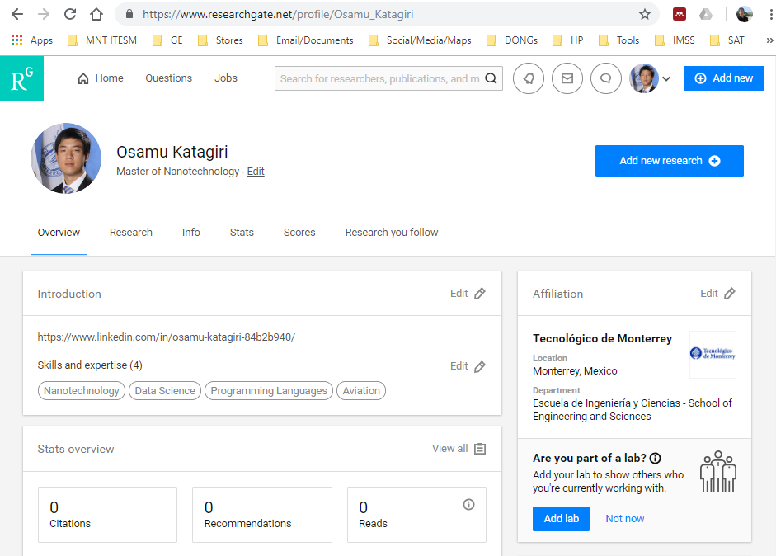

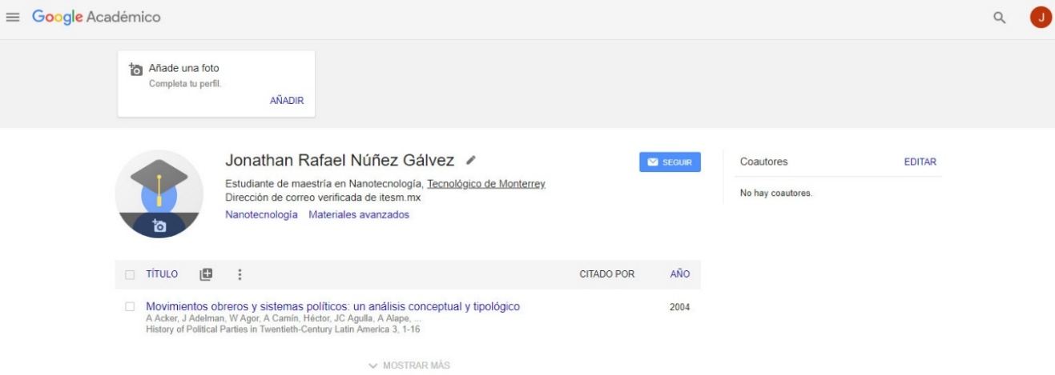

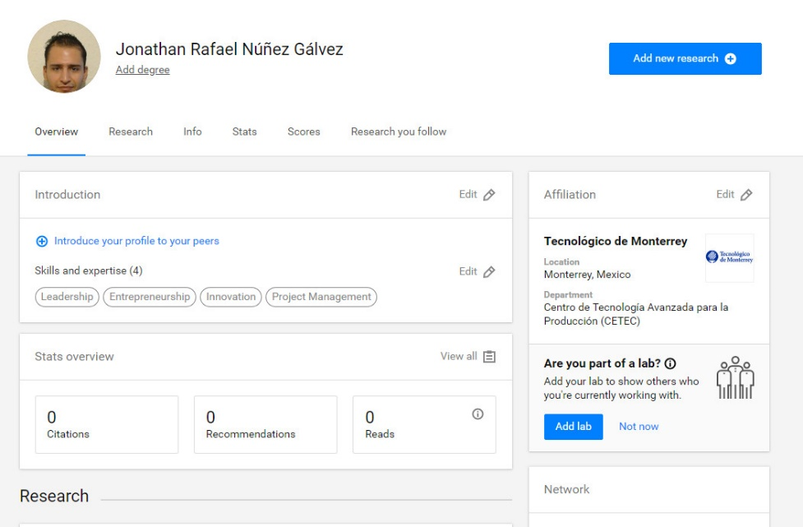

**Reflections on Steve Job’s Legacy**

Steve Jobs was a remarkable character. There is no doubt that his life’s work and his perspective of the world have had an important impact in human kind history. He was a businessman and a visionary. We believe that it was his creativity and his passion the reasons he became such a success. He had the ability to imagine beyond anyone else, and the will power to bring his ideas to life. As far as his professional life went, he never backed down, not even when they threw him out of his own company. He was smart and courageous enough to stand up and create more and incredibly competitive ventures. He even won back his company and took it the highest level, making Apple the first company in the world to be worth more than a trillion dollars. From what we can see in the videos about his last words and his speech in Stanford University, Jobs was also very aware of the importance of succeeding in the personal aspects of his life. He spreads the idea that being successful in business and profession is not the same as being successful in life. He explains how alone you can be even when you have everything you could imagine if you don’t have anybody to share it with. Jobs said you will always regret having chosen work over family and friends. We cannot say if Steve Jobs was church religious, but he did believe that there is some sort of force that guides us through the right way if we let it. He motivates us all to listen to our hearts and intuition and let the dots connect themselves, because somehow our journey has already been designed and we just need the courage to let it all fall into place. We wouldn’t say Christianity is an answer to the existential dilemmas posed by Jobs. It is clear he believes in God and destiny in a certain way, but it is much clearer that he first believes in himself. Although Jobs philosophy and Christianity do find some common ground. They both reinforce the importance of love to oneself and others, but Christianity is not the only religion to profess about love. Any religion can be a resourceful place to gather strength and faith, but we believe that Jobs was more convinced that we can find this place within ourselves.

**Video Resources**

Badabun, Estas fueron las últimas palabras de Steve Jobs minutos antes de morir. 2017.

N. Flores, Steve Jobs Discurso en Stanford Sub Español HD YouTube. 2012.

E. Terán, [NatGeo]-Mentes Brillantes. Steve Jobs vs Bill Gates. 2015.