**Implementation Proposal Based on the Theoretical Knowledge from the Course of Nanostructured Materials**

# Antonio Osamu Katagiri Tanaka1

1 *School of Engineering and Sciences, Tecnologico de Monterrey, Av. Eu- genio Garza Sada 2501 Sur, N.L., Monterrey, Mexico*

[Jan-Jun 2020] The Nanostructured Materials course taught by Jaime Bonilla Ríos1, an elective class for MNT (*Maestría en Nanotecnología* or Master of Science in Nan- otechnology) students, is a transformative experience. The class teaches MNT students the basics of nanotechnology, various manufacturing techniques, and tools used for the fabrication and characterization of nanomaterials, including nanostructured surfaces, nanoparticles, nanofibers, among others. Despite last-minute challenges (creating a course for teaching in a full online distance-learning environment and working with students remotely), the course goals were met as students learned to manipulate ma- terials at the nanoscale. The following describes how the content of the Nanostruc- tured Materials course apply to the thesis entitled "Fabrication of Graphitic-Carbon Sus- pended Nanowires Through Mechano-Near-Field Electrospinning of Photocrosslinkable Polymers".

Carbon nanowires are versatile materials composed of carbon chains with a wide range of applications due to their high conductivity (2) as carbon structures allow the propagation of slowly decaying surface plasmon waves (3). Regardless of the high in- terest in the implementation of carbon nanowires in several applications and devices, no feasible processes have been developed to fabricate carbon nanowires with spatial control at a reasonable cost and manufacturing speed. Carbon nanowires have been fab-

E-mail: [A01212611@itesm.mx](mailto:A01212611@itesm.mx)



1Jaime Bonilla Ríos : Associate Dean of Continuing Education, R. Tec. Mty. [(E:jbonilla@tec.mx](mailto:jbonilla@tec.mx) T:83 284 175)

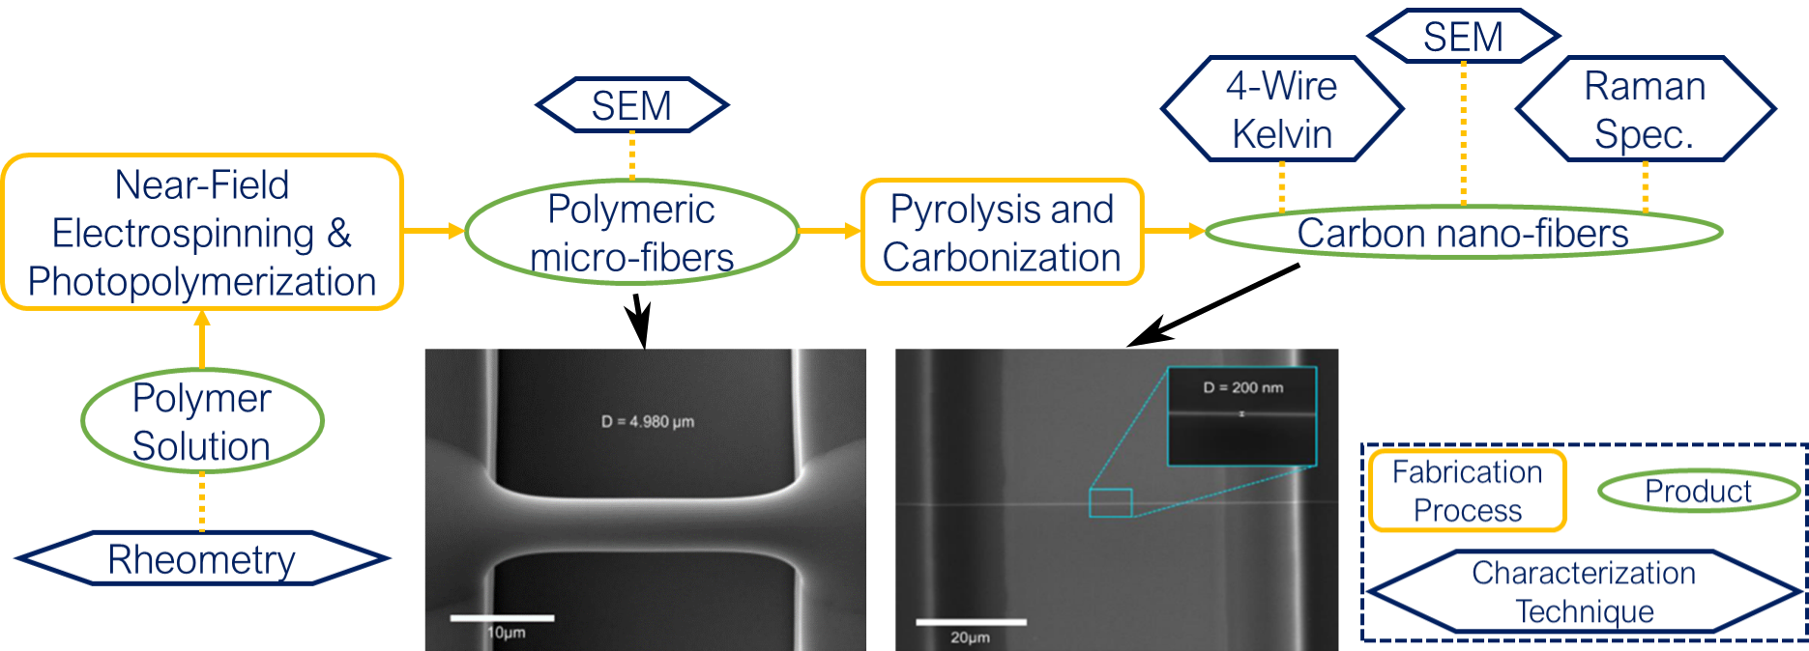

**FIGURE 1**

Fabrication process of conductive carbon nanowires. SEM images adapted from (1).

ricated with the use of a photoresist such as SU-8 (4; 5; 6; 7; 1; 8), but there is a lack in research about polymers that can produce more conductive carbon nanowires after py- rolysis. Various polymer solutions have been tested in near field electrospinning (NFES) and photopolymerization separately, however, few have been tested for nanowire fab- rication purposes through pyrolysis. The intention behind the thesis ("Fabrication of Graphitic-Carbon Suspended Nanowires Through Mechano-Near-Field Electrospinning of Photocrosslinkable Polymers") is to implement rheology analyses of different poly- mer solutions to determine if they can be easily electrospun and then fabricate carbon nanowires with them. Figure 1 shows the intended fabrication and characterization pro- cesses of this dissertation. The thesis work arises from the need to test a greater variety of polymers with the goal to select a polymer solution to fabricate carbon nanowires with better conductivity than the current SU-8 polymeric nanofibers. The research pro- cess includes the selection of polymer solutions that can be electrospun, photopolymer- ized, and then pyrolyzed into conducting carbon nanowires. In other words, the inten- tion is to discover a polymer solution to achieve mass scale manufacturing of conductive carbon nanowires in an inexpensive, continuous, simple and reproducible manner.

Since graphitic materials often have a distribution of crystalline domains, their elec- trochemical behavior considerably depends on the microstructure. Recently, different chemical and physical methods have been applied to increase the graphitization and enhance the electrochemical properties (4; 9; 10). In this regard, physical-stress treat- ment has been considered as a simple method to increase the electrical conductivity of

carbon structures. Cardenas-Benitez et al. (11) studied the pyrolysis-induced shrink- age of photocured SU-8 structures arisen from the volatilized material/degassing and surface area of the microstructures, where the structures shrank about 70% of their original size. The shrinkage and elongation of suspended SU-8 fibers during pyroly- sis influences the resulting electrical properties (4). Canton et al. (4) deposited SU-8 fibers in supporting SU-8 walls, as the walls shrink during pyrolysis strain forces elon- gate the fibers. Evidence states that the electrical conductivity increases when fibers are elongated/stretched with a decrease of their diameter.

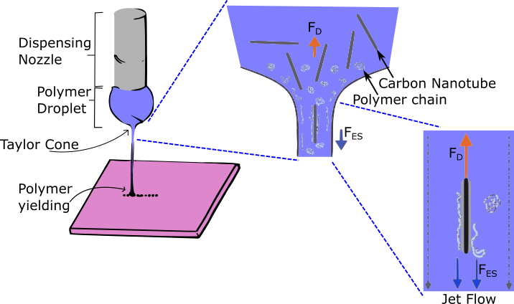

**FIGURE 2**

Unwinding polymer chains during CNT electrospinning process. *FES* is the external electrostatic force pulling the polymer jet to the receiving plate and *FD* is the molecular drag force resisting the *FES*. Figure adapted from (12).

Furthermore, Ghazinejad et al. (12) investigated the effect of electro-mechanical as- pects on increasing the graphitization and molecular alignment in a polymer precursor. In this regard, they unwound and orient the molecular polymer chains with the help of carbon nanotubes and after stabilization they pyrolyzed the samples. The results showed a significant enhancement in structure and properties of pyrolytic carbons as depicted in Figure 2. From the course Nanostructured Materials, carbon nanotubes

can be fabricated through *Lawn* techniques from metal nanodots. Besides the molec- ular alignment, Carbon nanotubes (CNTs) chirality can also influence the carbon fiber electrical conductivity. Further, as depicted in Salazar et al.’s work (13), the molecular alignment of the polymer chains have an effect on the carbon structure after pyroly- sis. Figure 3 shows evidence that winded polymer chain results in fullerenic structures when pyrolyzed at high temperatures for relatively a short time. Unwound polymer chains preserve the molecular alignment, which result in graphitic structures after py- rolysis with small temperature ramps.

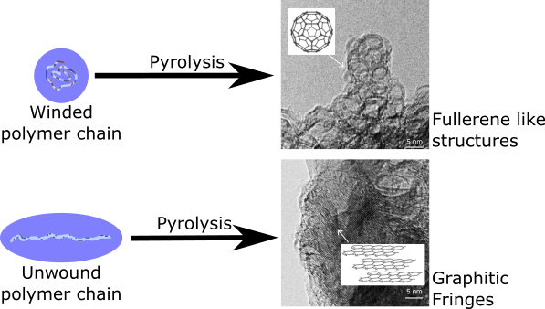

**FIGURE 3**

Pyrolysis of winded polymer chain results in fullerenic structures. Electrospun fibers (unwound polymer chain) during the stabilization preserves the molecular alignment, which results in graphitic structures after pyrolysis. Figure adapted from (13)

From the previous statements and results from scientific literature, the implemen- tation proposal based on the Nanostructured Materials course is as follows: Imple- ment near-field electrospinning to fabricate conductive suspended nanowires with spa- tial control and at a faster rate than other techniques such as vapor-liquid-solid growth. Increase the fiber electrical conductivity and thus the graphitic carbon yield by the intro- duction of CNT to the NFES polymer ink. Further, the fabrication process could ensure conductive chirality of the added carbon nanotubes to promote electrical conductivity in the final carbon product. Multi-wall carbon nanotubes (MTCNTs) can be used in this exercise as they are cheaper to produce than single-wall carbon nanotubes (SWCNTs)

even though in general MTCNT are less conductive than SWCNT (3) since the main contributor to the electrical conductivity is given by the pyrolyzed polymer chains. On the other hand, the unwound polymer chains can be also achieved by the near-field electrospinning of liquid crystal polymers as they are not prone to curl due to their ordered and oriented molecular phase nature between an isotropic liquid phase and a crystalline solid.

# References

1. Braulio Cárdenas Benítez. Advanced Manufacturing Techniques for the Fabrication and Surface Modification of Carbon Nanowires. page 160, 2017.
2. M. T. H Siddiqui, Sabzoi Nizamuddin, Humair Ahmed Baloch, N. M. Mubarak, Maha Al-Ali, Shaukat A Mazari, A. W Bhutto, Rashid Abro, Madapusi Srinivasan, and Gregory Griffin. Fabrication of advance magnetic carbon nano-materials and their potential applications: A review. *Journal of Environmental Chemical Engi- neering*, 7(1):102812, feb 2019. 10.1016/J.JECE.2018.102812
3. Antonio Maffucci, Sergey A. Maksimenko, Giovanni Miano, and Gregory Ya. Slepyan. Electrical Conductivity of Carbon Nanotubes: Modeling and Character- ization, Carbon Nanotubes for Interconnects, 2017. 10.1007/978-3-319-29746- 0_4
4. G. Canton, T. Do, L. Kulinsky, and M. Madou. Improved conductivity of suspended carbon fibers through integration of C-MEMS and Electro-Mechanical Spinning technologies. *Carbon*, 71:338–342, may 2014. 10.1016/j.carbon.2014.01.009
5. Domingo Ricardo Flores. Role of rheological properties in near field electrospun fibers morphology. page 130, 2017.
6. Albert Cisquella-Serra, Marco Magnani, Álvaro Gual-Mosegui, Sunshine Holm- berg, Marc Madou, and Manuel Gamero-Castaño. Study of the electrostatic jet initiation in near-field electrospinning. *Journal of Colloid and Interface Science*, 543:106–113, may 2019. 10.1016/J.JCIS.2019.02.041
7. Jongwan Lee, Seung Yong Lee, Jinah Jang, Young Hun Jeong, and Dong-Woo Cho. Fabrication of Patterned Nanofibrous Mats Using Direct-Write Electrospin- ning. *Langmuir*, 28(18):7267–7275, may 2012. 10.1021/la3009249
8. Jufeng Deng, Chong Liu, and Marc Madou. Ultra-thin carbon nanofibers based on graphitization of near-field electrospun polyacrylonitrile. *Nanoscale*, 2020. 10. 1039/D0NR00031K
9. Nan Liu, Kwanpyo Kim, Hu Young Jeong, Po Chun Hsu, Yi Cui, and Zhenan Bao. Effect of Chemical Structure on Polymer-Templated Growth of Graphitic Nanorib- bons. *ACS Nano*, 9(9):9043–9049, 2015. 10.1021/acsnano.5b03134
10. A. Allaoui, S. V. Hoa, and M. D. Pugh. The electronic transport properties and mi- crostructure of carbon nanofiber/epoxy composites. *Composites Science and Tech- nology*, 68(2):410–416, feb 2008. 10.1016/j.compscitech.2007.06.028
11. Braulio Cardenas-Benitez, Carsten Eschenbaum, Dario Mager, Jan G. Korvink, Marc J. Madou, Uli Lemmer, Israel De Leon, and Sergio O. Martinez-Chapa. Pyrolysis-induced shrinking of three-dimensional structures fabricated by two- photon polymerization: experiment and theoretical model. *Microsystems {&amp;}*

*Nanoengineering*, 5(1), 2019. 10.1038/s41378-019-0079-9

1. Maziar Ghazinejad, Sunshine Holmberg, Oscar Pilloni, Laura Oropeza-Ramos, and Marc Madou. Graphitizing Non-graphitizable Carbons by Stress-induced Routes.

*Scientific Reports*, 7(1):16551, dec 2017. 10.1038/s41598-017-16424-z

1. Arnoldo Salazar, Samira Hosseini, Margarita Sanchez-Domínguez, Marc J. Madou, Alejandro Montesinos-Castellanos, and Sergio O. Martinez-Chapa. Sub-10 nm nanogap fabrication on suspended glassy carbon nanofibers. *Microsystems*

*{&amp;} Nanoengineering*, 6(1):9, dec 2020. 10.1038/s41378-019-0120-z

# Author biography

**Antonio Osamu Katagiri Tanaka** . MNT16

A01212611