Nano-Structured Materials

Midterm Examination

April 22nd, 2020

# Part 1

## What are the main challenges that should be overcome in the fabrication of nanomaterials and nanostructure?

1. *Overcoming high surface energy of nanostructures:*

Bulk materials are thermodynamically stable because of their low surface energy (γ). When trying to fabricate nanomaterials from the top-down approach, structural fragmentation requires a huge amount of energy to make nano-sized structures. This fragmentation results in a significant increase in the surface energy (which is proportional to Gibbs free energy), making the nanoparticles thermodynamically unstable.

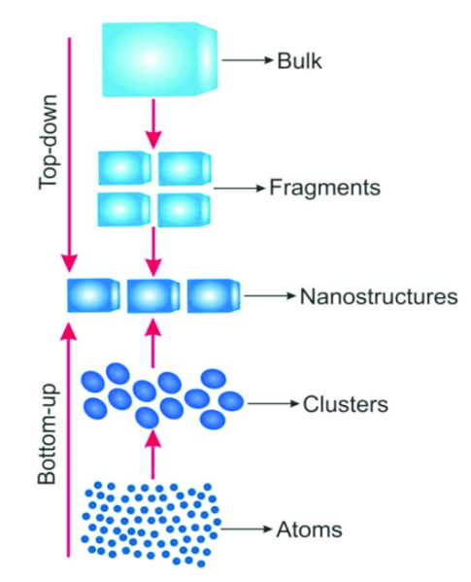

High surface energy of nanostructures should be overcome, which may cause the arise of another issue of prevention of nanostructures or nanomaterials from growth in size, driven by reduction of overall surface energy. The challenge is to control the surface energy as it plays a significant role in thermal stability.

1. *Preventing of materials from coarsening through Ostwald ripening and agglomeration.*

To decrease the surface energy (minimize the Gibbs free energy), nano-sized structures try to come into the vicinity of each other. Agglomeration is one of the main challenges in the industry to have stabilized nano-sized structures for a long period of time.

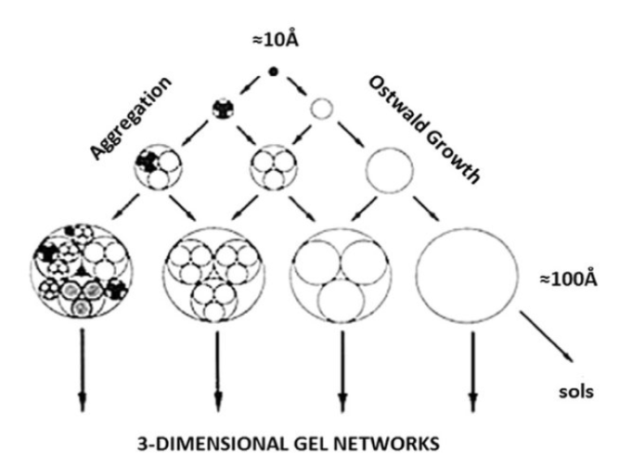

Another phenomenon happening with nanostructures, in which nanoscale non-homogenous structures club over the time to make one more prominent homogeneous structure, is known as the Ostwald ripening effect. This phenomenon can be explained as per the above paragraph that thermodynamically larger particles are more favorable than smaller. But here, crystal structure comes into an explanation. Molecules on the surface have lesser energy stability then molecules inside the crystal structure. Nanostructures have more surface area, which consequently relates to higher surface molecules and thereby lesser stability. [figure-(Qiao & Swihart, 2017)]. Various external factors, like solvent and temperature, play a vital role in the stabilization of the suspension. Challenge is to halt nanomaterials and nanostructures from coarsening.

1. *Ensuring to have materials with the uniform size, same morphology, and crystallinity:*

For any practical application, nanoparticles need to have identical size, identical shape and morphology, and identical crystal structure and chemical composition. So coming with proper synthesizing methods which can ensure the narrow size distribution and other aforementioned requirements are essential in nanotechnology (Guozhong, 2004). Challenge is to tailor the current fabrication techniques to ensure the product to have the desired properties consistently.

1. *Requirement of sensitive instrumentation for measuring the physical properties of nanomaterials.*

The small size and complexity of nanostructures, and keeping noise level very low, makes the development of new Nano measurement tools so challenging.

## What is the role of the chemical potential on the Ostwald ripening effect? Please justify your answer.

Ostwald ripening is the process of dissolution of smaller particles and the growth of larger particles at the expense of the smaller particles. This process of merging the smaller particles into the larger ones will cause the surface energy to decrease.

Macroscopically, the driven force of Ostwald ripening is the reduction of total surface energy, and microscopically, the differential surface energy of surfaces with different surface curvature is driven force of mass transport during Ostwald ripening.

In nanoscale, the properties of surface atoms will be increased as the dimension goes to nanoscale. Higher surface area translates into higher number of surface atoms which increases the surface energy and as mentioned above, needs to be reduced. The bigger the size of nanoparticles, the lowest surface energy within the material (Guozhong, 2004).

From the Young-Laplace equation, which shows the relation of the radius of curvature of a surface and the chemical potential (1), we can reach to the Gibbs-Thomson equation which shows the dependence of solubility on surface curvature (2). And we explained

before and according to (Kabalnov, 2001), the driving force of the Ostwald ripening is the dependence of the solubility of the particle on its size which means curvature.

So From Ostwald definition, we know that bigger particles will be formed at the expense of the smaller ones. And as we see from the Young- Laplace equation and Gibbs- Thompson equation as particles grow in size, the chemical potential and solubility decrease which means that bigger particles thermodynamically are more stable than smaller ones, since that, in Ostwald ripening the smaller particles merge into one bigger particle.

For example, when two particles with different radii, R1 >> R2, are put into a solvent, each particle will develop an equilibrium with the surrounding solvent. Then the solubility of the smaller particle will be larger than that of the larger particle. Therefore, there would be a net diffusion of solute from the proximity of the small particle to the proximity of the large particle. To maintain the equilibrium, solute will deposit onto the surface of the large particles, whereas the small particle must continue dissolving to compensate for solute diffused away. As a result, the small particle gets smaller, while the large particle gets larger, this is the Ostwald ripening effect (Guozhong, 2004). And Here is the equation that depicts the change of the chemical potential of an atom transferring from a spherical surface of radius R1 to R2:

Ostwald ripening occurs at a wide range of temperature ad it can result in a single uniform structure(Guozhong, 2004).

Oswald ripening cab be avoided by:

1. Stabilizers: . Ostwald ripening can be prevented by stabilizers since this can reduce the interfacial tension between the solid particles and liquid medium (Voorhees, 2001).
2. Adding a surfactant: Surfactants with high surface modulus lead to much slower rate of Ostwald ripening which cause the partially prevention of particles to grow in size.(Tcholakova et al., 2011)
3. Viscosity change: by decreasing the concentration, the interaction between particles may be decreased which cause to partially reduce the Oswald ripening effect.
4. Narrowing particle size distribution: Ostwald ripening can be partially inhibited by narrowing [particle size distribution](https://www.sciencedirect.com/topics/pharmacology-toxicology-and-pharmaceutical-science/particle-size-distribution), which minimizes the saturation solubility difference (Deshpande et al., 2017).

Thermodynamic-wise, the chemical potential decreases when mass is transferred from a flat surface to a concave surface. Meaning that a convex surface (small particle) possesses higher chemical potential, than a concave surface (large particle). In solution, the solubility of the small particle is larger than the solubility of the large particle, as the solute is deposited onto the large particle and the small particle continues to dissolve. Dissolution of the small particles will halt when the concentration of solid in the solvent equals to the equilibrium solubility of the large particles.

## You have a job interview and in the last round of interviews you are asked the following question: “tell me how would you measure surface tension of a solution with suspended nanoparticles”. Write down your answer(s)

Surface tension is the energy, or work, required to increase the surface area of a liquid due to [intermolecular forces](https://chem.libretexts.org/Bookshelves/Physical_and_Theoretical_Chemistry_Textbook_Maps/Supplemental_Modules_(Physical_and_Theoretical_Chemistry)/Physical_Properties_of_Matter/Atomic_and_Molecular_Properties/Intermolecular_Forces). In theory and as the fundamental basics, Surface tension can be calculated by two approaches presented in the class which can measure the surface between the solid and the liquid (the solution).

1. *measuring the wetting contact angles of the solution containing the nanoparticles.*

Contact angle and surface tension are related by Young’s equation, shown as below: (Parameters are shown in the figure below.)

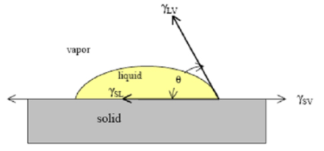

, in which .

1. *measuring the surface tension by using solid wall-liquid interaction as below*

[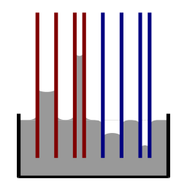](http://upload.wikimedia.org/wikipedia/commons/8/85/CapillaryAction.svg)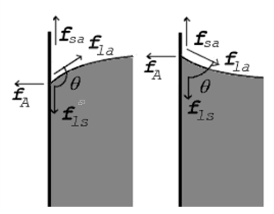

As we mentioned the theory behind many of devices which are used now to measure surface tension. The figure below illustrates multiple techniques available for the measurement of surface tension (ST) of a liquid/nanofluids.

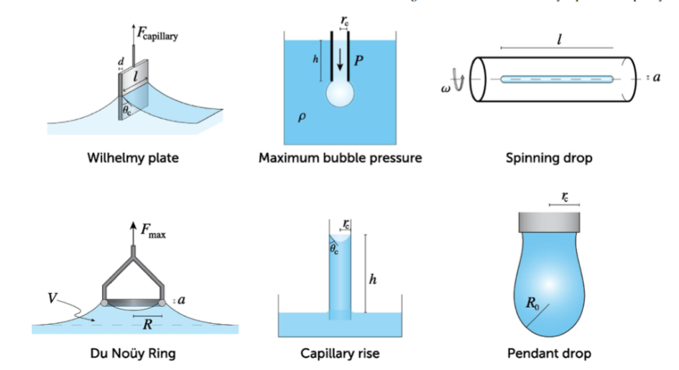

For simplicity and ease of use, the contact angle method can be implemented:

1. Ensure the nanoparticles are well dispersed
2. Measure the surface tension by contact angle. Lower contact angles (a), refer to increased wetting and therefore lower surface tension. A higher contact angle (b) indicate a higher surface tension.

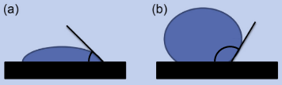

1. Once the contact angle is obtained, the surface tension can be calculated with Young's equation.

However, the surface tension measurement for nanoparticles solution with single specific method is hard to define as ST for a solution vary with various parameters listed in the figure below. (Estellé, Cabaleiro, Żyła, Lugo, & Murshed, 2018)

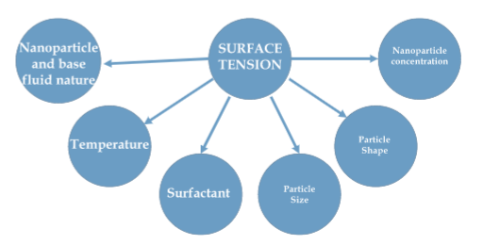

ST and wetting capability are strongly dependent on temperature of the solution, surfactant addition, type and content of the nanoparticles, size distribution and loading concentration of nanoparticles in a solution. Some of these factors are explained as below:

1. Temperature: The surface tension decreases with rise in temperature, since increasing the temperature can cause solution molecules to gain energy and move more rapidly, which result in less molecular adsorption (weaker band) which makes surface energy to decrease.
2. Concentration: Adding more nanoparticles (increasing the concentration) can increase the surface tension.
3. Impurities: Adding surfactant and soap (sparingly soluble substances) to a solution decreases the surface tension, whereas, adding salt (highly soluble substances) increases it.
4. Polarity: Increasing of the polarity of water as an example, can cause water molecules to strongly attract one another which causes higher surface tension.

Although contact angle measurement and capillary rise and fall measurements can be one of the most common techniques for surface tension measurements, such measurements in nanofluids is not straight forward and requires consideration of multiple parameters as mentioned above. A more complete measurement can be achieved with a rheometer, since the nanoparticles may change the fluid viscosity with applied stress, i.e. shear thinning or thickening behaviors.

## You want to sell an oil solution loaded with paramagnetic nanoparticles (CoFeO4), but the particles do not form a stable suspension. How could you make them stable, so you can make a profitable business?

In nanotechnology, magnetic nanoparticles in general have been used widely in areas such as drug delivery, biomedicine, and for remediation of pollutants (generally Cr(VI), As(V), Ni(II). For these application approaches for the solubility and stabilization of magnetic nanoparticles in aqueous media is so important. MNPs, transferred to water or organic solvents, or synthesized directly in situ, could be present in these phases for a long time or short, depending on some factors like, **surfactant/coating/functionalizing agent, temperature, particle size, aggregation and sedimentation** which can significantly affect MNPs mobility and reactivity, and subsequently influence the interaction between them and environmental contaminants (Chaudhary & Chaudhary, 2018).

Some treatments for stabilization of the magnetic particles are mentioned as below (Chaudhary & Chaudhary, 2018):

1. *Ultrasonic treatment:* This can cause a temporal dispersion
2. *Magnetic fields:* magnetic fields can be applied both for the aggregation of MNPs.
3. *Repulsive forces:* acting on one or both repulsive forces: electrostatic and steric repulsion which are controlled by the applied forces. For instance, Electric repulsive force stabilization works based on changing the surface potential
4. *Surface modification for MNPs:* Without surface coating, iron oxide MNPs have hydrophobic surface with a large surface area to volume ratio. This huge surface energy and the hydrophobic interaction between the nanoparticles can initiate particle agglomeration. When two large particle clusters approach one another, each of them comes into the magnetic field of the neighbor. Therefore, the adherence of remnant MNPs results in a mutual magnetization, resulting in increased aggregation properties. Hence, to prevent agglomeration and providing some functional groups for drug delivery and catalysis and other applications, surface coating is required. Some common stabilizers which have reports so far are listed as; (a) Organic materials: Gold, Silica, (b) Monomeric stabilizers: Phosphates, Carboxylates (i.e. citric acid), Sulfates and (c) Polymer stabilizers: Dextran, Chitosan. For instance, a polymer stabilizer such as PMA-dodecylamine complex , PVP or PVA can be used as an polymeric stabilizer (Cao & Wang, 2004). The polymer stabilizer can prevent nanoparticles to agglomerate, but it can also affect the growth process of nanoparticles depending on the solid chemistry, the solvent and temperature.

For CoFe2O4, one of the ways to ensure a good stability is to use surfactants like, Oleic acid and oleylamine for organic solvent and citric acid for water phase. For instance, one study has shown using CoFe2O4 treated with dilute nitric acid could form porous viscous layers on particle surface, where sodium citrate could be absorbed. The adsorbed citrate turned NPs surface from positive to negative charged, resulting in an NPs colloid solution stable over a wide pH range. It is reported that these MNPs can be stable for a long time of 2 months(F. Liu, Laurent, Roch, Vander Elst, & Muller, 2013).

## Prove that droplets with small radius have a higher vapor pressure than the ones with higher radius.

This is related to question 2. Concave surfaces in a material have lower surface energy than convex surfaces, this difference influences the equilibrium vapor pressure. The relationship between particle radius and vapor pressure can be described by the Kevin equation (Guozhong, 2004).

Where; is the equilibrium vapor pressure of the curved solid surface,  
 is the equilibrium vapor pressure of flat solid surface,  
 is the surface energy,  
 is the atomic volume,  
 is the Boltzmann constant,  
 is the radii of curvature, and  
 is the temperature.

As depicted if the equation, if the radius increases, the overall equilibrium vapor pressure decreases.

The Kevin equation is derived from the chemical potential as a function of surface curvature. For a spherical particle, its volume change is equal to the atomic volume Ω times , as follows: . On the other hand, the work per atom transferred is the change of chemical potential . Combining both equations, we have that: (known as Young–Laplace equation). For any curved surface, the Young–Laplace equation can be generalized by two main radii of curvatures and as follows: . Assuming the vapor of solid phase behaves as an ideal gas, the following describes the change in chemical potential for a flat surface: . Similarly for a curved surface the following is obtained: . By combining the previous two equations, we obtain: . The Kevin equation is obtained once the latest equation is simplified for a spherical particle(Guozhong, 2004).

Where; are the transferred atoms from a flat surface to a particle with radius ,  
 is the atomic volume,  
 is the change of chemical potential,  
 is the chemical potential of a vapor atom,  
 is the chemical potential of an atom on the curved surface,  
 is the chemical potential of an atom on the flat surface, and  
 is the equilibrium vapor pressure of the curved solid surface.

## You are in charge of a nanoparticles production line and there is a problem with the size distribution that is too widespread, and the client is asking you to narrow it down or She will look for another provider. Your boss asks you to make recommendations on how to make the distribution narrower. What would you recommend? (Justify your answer and list any assumptions you make).

The problem can be tackled by three approaches: Ostwald ripening, fast synthesizing of nanoparticles, and diffusion-limited growth.

1. Ostwald ripening can be implemented to narrow the size distribution of nanoparticles by removing small particles as large particles grow at the expense of the smaller particles. With this approach, will narrow the size distribution, but will also increase the final size of the nanoparticles
2. For achieving uniform size distribution in nanoparticle synthesis, it is suggested to have all nuclei generation at the same and quick time interval. This process will ensure the nuclei size to be similar as they are made under like conditions along with their subsequent growth later. For this to happen the concentration of growth species should be increased abruptly to a very high supersaturation value and then quickly brought below the minimum nucleation concentration value which will cease the formation of nuclei further and only the step of growth of formed nuclei will continue until the equilibrium concentration value for growth species. The size distribution of initial nuclei may rise or stall as per the kinetics of the growth process, and therefore growth can be controlled to get monodispersed size distribution (Cao & Wang, 2004).

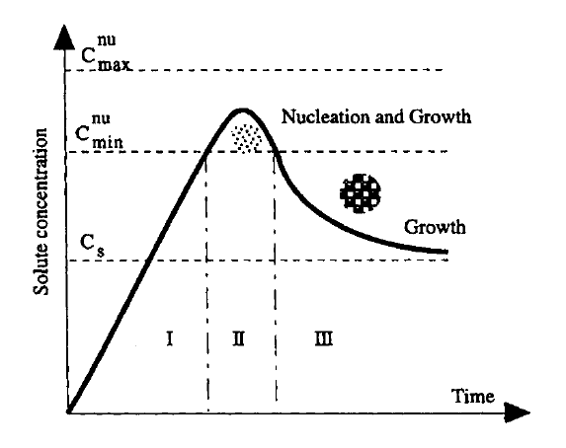 where,

1. Growth controlled by diffusion, then we end up having the equation mentioned above, which indicates that there are decreases in radius difference with the increase of nuclei radius and prolonged growth time diffusion-limited growth would reduce the size distribution of the nanoparticles. Diffusion-limited growth can be achieved by:
   1. Increasing the solution viscosity,
   2. Introducing of a diffusion barrier (polymer layer) to limit the nanoparticles to further growth,
   3. Keeping the concentration of growth species at low levels, and/or
   4. Controlling the supply of growth species as the rate of reaction can be manipulated through the control of the concentration of the reactants.

However, some considerations are to be considered. Solutions a) and b) could introduce new reagents to the process which may increase the cost and/or composition of the final product, though the viscosity can me amended by temperature changes. Solutions c) and d) may not require additional reagents but may slow down the production (Cao & Wang, 2004).

## You want to produce a nanoporous silica glass; please explain how would you prepare such glass.

**First Method:**

Preparation of nanoporous silica glasses (NSGs) based on sol-gel process.(G. Liu, Li, & Jonas, 1991; Yi & Jonas, 1996)

*Required materials:*

HCL acid, Ammonium hydroxide (NH4OH), tetraethylorthosilicate (TEOS), ethanol alcohol.

*The synthesis of NSG will follow the process bellow:*

1. Preparation of the mixture of TEOS, ethanol, water.

* In order to prepare clear solutions without any precipitation, TEOS was diluted with half the amount of ethanol, and then the mixed solution consisting of a small amount of water, another half of the ethanol and HCI in a molar ratio of 1:3.5:0.0007, was added drop by drop to the TEOS-ethanol mixture solution at 40 ·C. The solution composition up to this point was in the TEOS/ethanol/ water/HCI ratio of 1:7:1:0.0007. This ratio will be fixed during the whole experiment.

1. Stirring for 90 mins.
2. Addition of Ammonium hydroxide as catalyst for hydrolysis of tetraethylorthosilicate.

* Additional water and a controlled amount of NH4OH were added to give a final 1: 10 molar ratio of TEOS to water (By changing the amount of this catalysis, glasses with different pore sizes can be obtained)

1. Gelation

* Keeping the whole solution in a low temperature of 5oC to prevent fast gelation

1. After gelation, resulting gels were tightly sealed and left at room temperature for 3-4 weeks/
2. Drying produced gels at 80 °C with a carefully controlled drying rate.
3. heating gel in a high-temperature oven from room temperature up to 800 °C. The slow temperature increase of 18 °C per hour was used in order to produce large monolithic glasses.

**Second method:**

The method involves the addition of an anionic silicate source such as tetraethylorthosilicate (TEOS) to an aqueous solution with a template/surfactant. Once the formation of the silica hydrogel is formed, the template is removed by calcination. Surfactants will be used in the synthesis of nanoporous silica glass (NSG) due to their tendency to form micelles. Silica sources tend to aggregate and form silica networks around these micelles (Grün, Unger, Matsumoto, & Tsutsumi, 1999).

*The synthesis of NSG will follow the process bellow:*

1. Dissolve the surfactant/template in deionized water,
2. While stirring add TEOS slowly to the surfactant solution to create a gel,
3. Separate/filter the white precipitate,
4. Wash the product with deionized water, and
5. Remove the template by drying and heating the sample.

## Explain how come Pluronics can act as a surfactant.

Pluronic, also known as poloxamers, are synthetic nonionic triblock copolymers comprising of single **hydrophobic (HYPO)** poly(propylene oxide)-PPO chain at center

surrounded by double **hydrophilic (HYPI)** poly(ethylene oxide)-PEO chain aligned in PEO-PPO-PEO pattern. Surfactants have an HYPI head and HYPO tail attached to it, which is helpful in the formation of micelles when used in bulk. These micelles form a globular structure with HYPO tails facing towards the center, and HYPI heads arranged on the surface. Pluronic also similarly arrange themselves to form micellar structures as seen below in the figure. They are arranged with having HYPO-PPO chains arranged outside on the surface and HYPI-PEO chains arranged inside the globule towards the center. Pluronic has more complex behavior in terms of hydrophobicity and hydrophilicity, which is related to the length of PPO and PEO segments. It’s also noted to have enhanced wettability by having a higher number of PEO chains; thereby, similarly to surfactants, Pluronic has a variable degree of wettability. Pluronics do foam, have emulsifying tendencies, and have cleansing properties over substrates like surfactants(Schmolka, 1977).

Application: An antiseptic skin cleaning ointment was developed containing 25% poloxamer 187. There was a problem encountered in handwash formulations. The cationic or antiseptic was inactivated in the micelles of the surfactant being used. This problem was ended by using poloxamer as the wetting agent in the form of nonionic surfactant and being least inactivated (Schmolka, 1977).

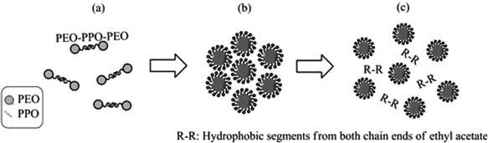  
Figure: Micelles formed by Pluronic (Lin & Chang, 2013)

# Part 2

## Explain the differences and similarities between homogeneous nucleation and heterogeneous nucleation for the synthesis of nanoparticles.

Nucleation is the process where a nuclei (or seed) act as a template for crystal growth and can describe several chemical syntheses. However, the formation of porous solids does not always follow the typical crystallization process in solution. Homogeneous nucleation occurs when nuclei form uniformly throughout the parent phase, whereas heterogeneous nucleation forms at structural deformities (container surfaces, impurities, grain, etc.) In a liquid phase, heterogeneous nucleation happens with ease, since a stable nucleating surface is already present(Cao & Wang, 2004).

The process of homogeneous nuclei formation can be described thermodynamically by studying the total free energy and the bulk free energy. The formation of nanoparticles by homogeneous nucleation requires a supersaturation of growth species. When the concentration of a solute in a solvent exceeds its equilibrium solubility or temperature decreases below the phase transformation point, homogeneous nucleation takes place with the development of a new phase. Since a supersaturated solution has a high Gibbs free energy, the energy of the system shall decrease by segregating the solute from the solution. The reduction of Gibbs free energy if the driving force for nucleation and particle growth(Thanh, Maclean, & Mahiddine, 2014).

Heterogeneous nucleation happens when a new phase develops on the surface of another material. Like homogeneous nucleation, the Gibbs free energy decreases with an increase in surface energy. The energy barrier for heterogeneous nucleation is always smaller than that of homogeneous nucleation, which explains the fact that heterogeneous nucleation is more likely to happen than homogeneous nucleation (Thanh et al., 2014).

## <Q2>

# References

1. Cao, G., & Wang, Y. (2004). Zero-dimensional nanostructures: nanoparticles. *Nanostructures and nanomaterials. Synthesis, properties and applications. Edited by G. Cao. Ed: Imperial College Press: London*, 51-109.
2. Chaudhary, V., & Chaudhary, R. (2018). Magnetic Nanoparticles: Synthesis, Functionalization, and Applications. *Encyclopedia of Nanoscience and Nanotechnology, 28*, 153-183.
3. Deshpande, A., Mohamed, M., Daftardar, S. B., Patel, M., Boddu, S. H., & Nesamony, J. (2017). Solid Lipid Nanoparticles in Drug Delivery: Opportunities and Challenges. In *Emerging Nanotechnologies for Diagnostics, Drug Delivery and Medical Devices* (pp. 291-330): Elsevier.
4. Estellé, P., Cabaleiro, D., Żyła, G., Lugo, L., & Murshed, S. S. (2018). Current trends in surface tension and wetting behavior of nanofluids. *Renewable and Sustainable Energy Reviews, 94*, 931-944.
5. Grün, M., Unger, K. K., Matsumoto, A., & Tsutsumi, K. (1999). Novel pathways for the preparation of mesoporous MCM-41 materials: control of porosity and morphology. *Microporous and mesoporous materials, 27*(2-3), 207-216.
6. Guozhong, C. (2004). *Nanostructures and nanomaterials: synthesis, properties and applications*: World scientific.
7. Kabalnov, A. (2001). Ostwald ripening and related phenomena. *Journal of Dispersion Science and Technology, 22*(1), 1-12.
8. Lin, H. R., & Chang, P. C. (2013). Novel pluronic‐chitosan micelle as an ocular delivery system. *Journal of Biomedical Materials Research Part B: Applied Biomaterials, 101*(5), 689-699.
9. Liu, F., Laurent, S., Roch, A., Vander Elst, L., & Muller, R. N. (2013). Size-controlled synthesis of CoFe2O4 nanoparticles potential contrast agent for MRI and investigation on their size-dependent magnetic properties. *Journal of Nanomaterials, 2013*.
10. Liu, G., Li, Y., & Jonas, J. (1991). Confined geometry effects on reorientational dynamics of molecular liquids in porous silica glasses. *The Journal of chemical physics, 95*(9), 6892-6901.
11. Qiao, L., & Swihart, M. T. (2017). Solution-phase synthesis of transition metal oxide nanocrystals: Morphologies, formulae, and mechanisms. *Advances in colloid and interface science, 244*, 199-266.
12. Schmolka, I. R. (1977). A review of block polymer surfactants. *Journal of the American Oil Chemists' Society, 54*(3), 110-116.
13. Tcholakova, S., Mitrinova, Z., Golemanov, K., Denkov, N. D., Vethamuthu, M., & Ananthapadmanabhan, K. (2011). Control of Ostwald ripening by using surfactants with high surface modulus. *Langmuir, 27*(24), 14807-14819.
14. Thanh, N. T., Maclean, N., & Mahiddine, S. (2014). Mechanisms of nucleation and growth of nanoparticles in solution. *Chemical reviews, 114*(15), 7610-7630.
15. Voorhees, P. (2001). Coarsening, Modeling Grain Growth.
16. Yi, J., & Jonas, J. (1996). Raman Study of Vibrational and Rotational Relaxation of Liquid Benzene-d 6 Confined to Nanoporous Silica Glasses. *The Journal of Physical Chemistry, 100*(42), 16789-16793.