1. **➤ Define light diffraction**

Is the interference and trajectory deviation when wavelengths find an obstacle. Also known as the bending of light around obstacles or slits of similar size to the incident wavelength.

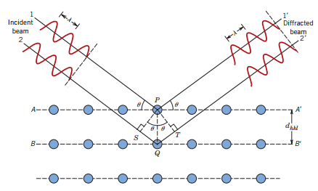

1. **➤ What are x-rays? who discover them, and when? Why are they called “x-rays”?**

They are high energy electromagnetic (ionizing) radiation with wavelengths between 0.01 and 10nm. (frequencies between 3x10ˆ16 to 3x10ˆ19 Hz and possessed energy between 100 eV and 100 KeV).

Discovered by Wilhelm Conrad Roentgen (Nobel Prize in Physics, 1901) in 1895.

They are called X-Rays because Wilhelm Roentgen called the phenomena “X-radiation” because he didn't know what it was. ...

1. **➤ How are x-rays produced?**

They are the product of the collision of high-speed electrons against a metal target.

X rays are produced whenever highspeed electrons collide with a metal target. A source of electrons-hot W filament, a high accelerating voltage between the cathode (W) and the anode and a metal target, Cu, Al, Mo, Mg. The another is a water-cooled block of Cu containing desired target metal.

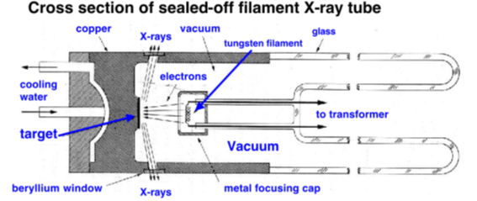

**4. What are radiations Kα, Kβ, Lα, Lβ in x-rays? What is the in Kα Cu?**

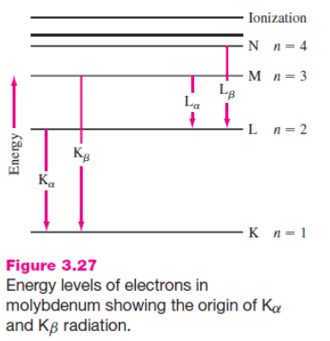

**5. ➤ What are some general applications of x-rays?**

Photographs made with X rays are known as radiographs or skiagraphs. Radiography has applications in both medicine and industry, where it is valuable for diagnosis and nondestructive testing of products for defects

X-rays can also be used to kill cancer cells, but also kill healthy cells, so must be used with much care.

Other uses are in industry, at airports to check customers and baggage and by art historians to see if a picture has been painted on top of an older one.

X-ray diffraction is also very important in spectroscopy and as a basis for X-ray crystallography. The diffraction of X-rays by a crystal where the wavelength of X-rays is comparable in size to the distances between atoms in most crystals is used to disperse X-rays in a spectrometer and to determine the structure of crystals or molecules.

**6. ➤ Why can x-rays be used in characterization of materials?**

The origin of X-ray is from the radiation of electrons outside the nucleus. The energy of X-rays is thus comparable with the energy level of the electrons in the atoms. When it comes to a sample, it interacts with the electrons bound in an atom.

Also because it is a non-destructive analytical method which can be used to identify phase and orientation, determine structural properties, measure the thickness of thin film, estimate the size of nanoparticles, etc..

**➤ Describe the Von Loue’s experiment**

Max Von Laue considered that if x-rays were waves, then they should be diffracted by the atoms in a crystal

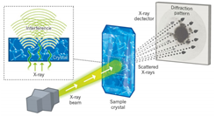

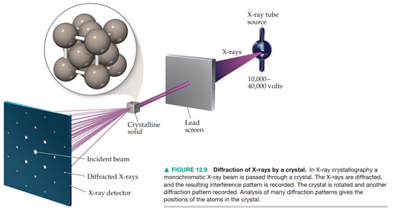

**➤ What is the difference in patterns between single crystals and polycrystalline materials? Explain that difference**

X-rays diffracted from a single crystal produce a series of spots in a sphere around the crystal

Polycrystals (Powders): Continuos Debye rings

Linear diffraction patterns with discrete reflections obtained by scanning through arc that intersects each Deby cone at a single point

**➤ Explain the W.L Bragg experiment**

**➤ Why W.L Bragg and his son won the Nobel prize in 1915?**

W. Henry and W. L. Bragg performed the first diffraction measurements.  
They found diamond’s crystalline structure by XRD in 1913, showing that **carbon is tetravalent**, winning the Nobel Prize in 1915.

**➤ Explain Bragg’s Law**

**➤ What is it used for?**

**➤ What are the components of an x-ray diffractometer?**

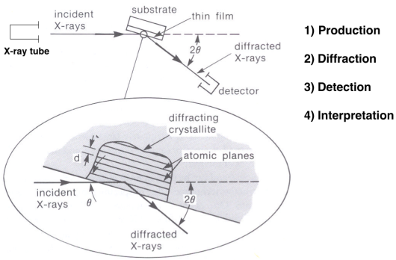

**➤ What is an x-ray pattern?**

**➤ What kind of information can be obtained from an x-ray pattern?**

**➤ Solve examples on slides 29 - 31**

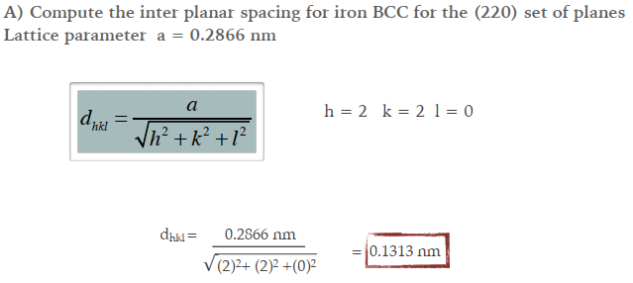

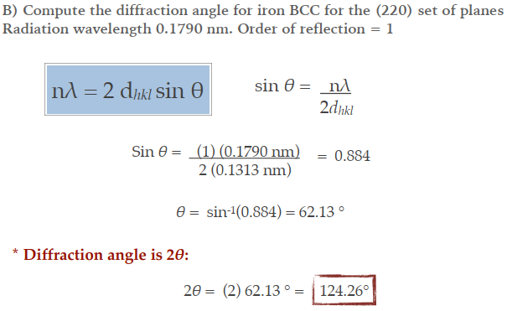

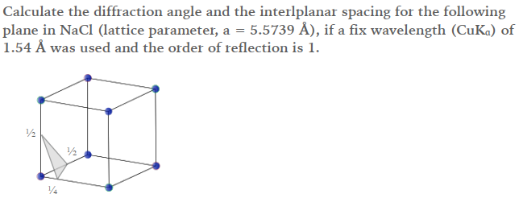

**➤ What are the applications of x-rays in characterization of materials?**

* Phase determination through the identification of crystalline phases
* Calculation of lattice parameters as the structure varies under different conditions
* Analysis of crystallite size and strain (crystallite domain and disorder)
* Quantitative phase analysis through the relative composition of mixed phases