**Dynamic Light Scattering Discussion Questions**

1. **What is DLS?**

It’s a technique in physics that can be used to determine the size distribution profile of small particles in suspension or polymers in solution. To use this technique is necessary a light source, a light detector, and a scattered light detector.

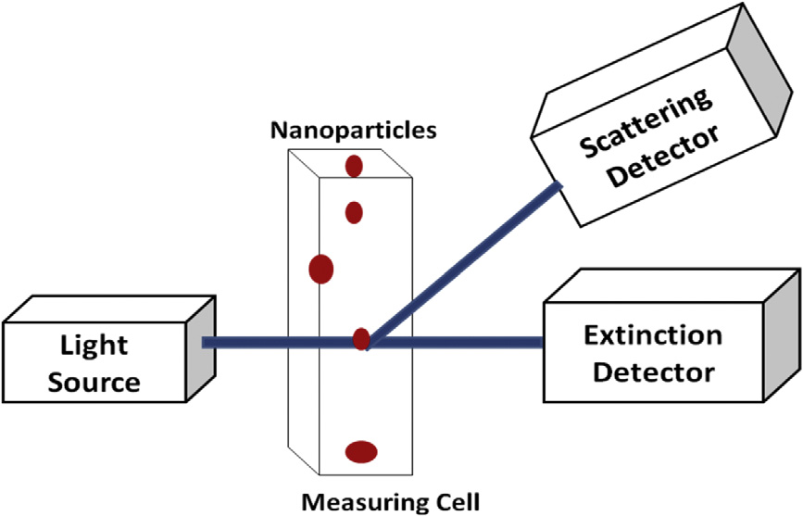

* 1. **Explain the basic principle**

The sample is illuminated by a laser beam and the fluctuations of the scattered light are detected at a known scattering angle θ by a fast photon detector. Simple DLS instruments that measure at a fixed angle can determine the mean particle size in a limited size range. More elaborated multi-angle instruments can determine the full particle size distribution.



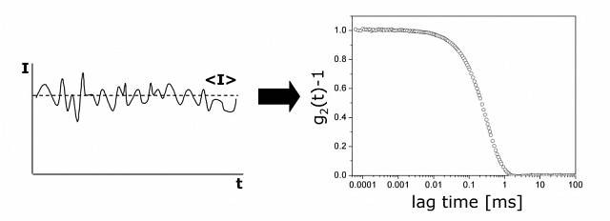



* 1. **How light interacts with nanoparticles during DLS measurements?**

Particles are exited with a laser, whose scatter some of the light that hits them. The particles scatter the light and thereby imprint information about their motion. Analysis of the fluctuation of the scattered light thus yields information about the particles. If the particles are completely still, we will measure a constant intensity of scattered light. However, in dispersion diffusion causes the intensity of the scatted light to fluctuate.

1. **Describe how DLS is used for materials and nanomaterials characterization Osamu**

DLS is used to characterize particle size and size distribution, as well as growth kinetics (changes in particle size due to aggregation). This technique also provides a means to measure molar mass of macromolecules with size and shape information. The light scattering intensity can be related to solution concentration.

1. **What are the range of size that DLS can measure?**

Lower size limit around 1nm. Can measure particles up to few microns in size.

1. **What does it mean, or what does a DLS measurement of particles indicate?** DLS measurement canbe used to determine the size of the particles and their distribution in emulsions, sols, nanoparticles, powders, polymers or latexes. It can also tell us if the particles have aggregated or give a signal of polymer chains growth in emulsion polymerization.
2. **Can DLS measure non-spherical particles?**

Yes, DLS can also give information about particle shape and in the case of non-spherical particles, the hydrodynamic radius (which is not an actual radius for these particles) is used as an estimate. The hydrodynamic radius is defined as the size of a spherical particle that diffuses at the same rate as the actual particle.

1. **What is Z-potential? Montse**

Zeta-potential (ζ) measures surface charge for particles in a specific liquid medium

•Charged particles are surrounded by an ionic double layer (nearer ion layer attached to particle; a diffuse layer away from surface)

•Slipping plane: boundary between electric double layer and ions in equilibrium in the solution

Zeta potential is the potential (mV) at the slipping plane.

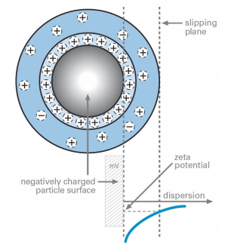

Zeta potential is a scientific term for electrokinetic potential in colloidal dispersions. In the colloidal chemistry literature, it is usually denoted using the Greek letter zeta (ζ), hence ζ-potential.

The usual units are volts (V) or millivolts (mV).

From a theoretical viewpoint, the zeta potential is the electric potential in the interfacial double layer (DL) at the location of the slipping plane relative to a point in the bulk fluid away from the interface. In other words, zeta potential is the potential difference between the dispersion medium and the stationary layer of fluid attached to the dispersed particle.

The zeta potential is caused by the net electrical charge contained within the region bounded by the slipping plane, and also depends on the location of that plane.

* 1. **What is the relation between Z potential and stability of nanoparticle suspension?**

The zeta potential is a key indicator of the stability of colloidal dispersions. The magnitude of the zeta potential indicates the degree of electrostatic repulsion between adjacent, similarly charged particles in a dispersion. For molecules and particles that are small enough, a high zeta potential will confer stability, i.e., the solution or dispersion will resist aggregation. When the potential is small, attractive forces may exceed this repulsion and the dispersion may break and flocculate. So, colloids with high zeta potential (negative or positive) are electrically stabilized while colloids with low zeta potentials tend to coagulate or flocculate as outlined in the table

Particle suspensions are usually stable if | ζ | > 25-30 mV