Angel Manuel Villalba-Rodríguez <A00828035@itesm.mx>

Constanza Alvarez-Lopez <A00829469@itesm.mx>

Osamu Katagiri-Tanaka <A01212611@itesm.mx>

Juan Jesús Rocha-Cuervo <A01752555@itesm.mx>

**Viscoelasticity Maxwell Model & Molecular Weight Distribution**

# 3a. Viscoelasticity Maxwell Model

INSTRUCTIONS

Fit the relaxation modulus G(t) of the two materials (PBR8, HDPE) using as many Maxwell elements as needed. Plot each Maxwell element in the same plot of G(t) vs. time to show that by adding them up one can fit the experimental curve.

AVAILABLE DATA

* Relaxation modulus G(t) of two materials (PBR8, HDPE).

ASSUMPTIONS

* Relaxation does not occur at a single time, but a distribution of times.
* Three elements are enough to fit the data provided.
* The data provided is at constant temperature.

ALGORITHM

1. Define the Generalized Maxwell model.
2. Fit the model to the given G versus t data
3. Save the fitting parameters for each Maxwell element
4. Plot the data and the model using the fitting parameters

SOLUTION

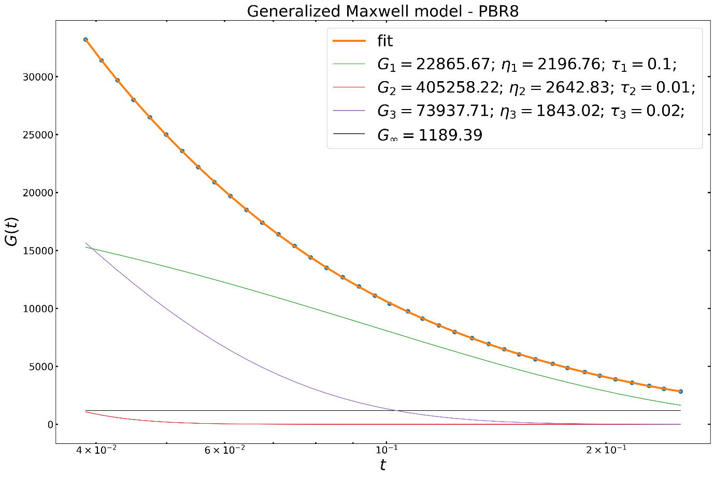

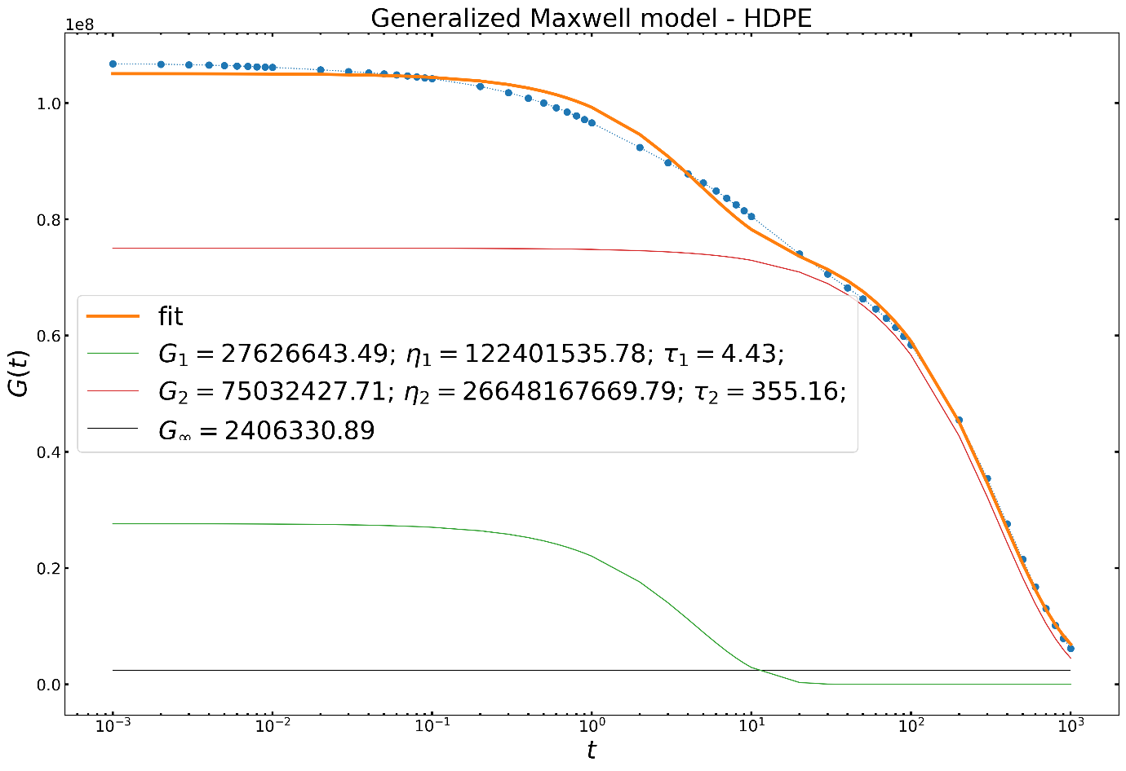

* A higher number of Maxwell elements (n) value may achieve a higher fitting accuracy, but also involves more complexity.

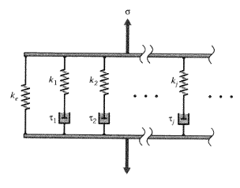

The Generalized Maxwell model also known as the Maxwell–Wiechert model (after James Clerk Maxwell and E Wiechert) is the most general form of the linear model for viscoelasticity. It uses springs and dashpots to represent the viscoelastic behavior of polymer fluids: the spring represents the elastic behavior of the polymer (the elastic model acts as a metal and has fully recoverable strain) and the dashpot represents the viscous behavior of the polymer (the viscous portion act as a fluid and has unrecoverable strain). The model involves a spring and dashpot in parallel and several Maxwell elements are assembled in parallel. It considers that the relaxation does not occur at a single time, but in a set of times. Due to the presence of molecular segments of different lengths, with shorter ones contributing less than longer ones, there is a varying time distribution. The model shows this by having as many spring–dashpot Maxwell elements as are necessary to accurately represent the distribution [2].

REFERENCES

[1] D. Roylance, Engineering Viscoelasticity, in: D. of M.S. and Engineering (Ed.), Massachusetts Institute of Technology, Cambridge, MA, 2001: pp. 1–38. <http://web.mit.edu/course/3/3.11/www/modules/visco.pdf>.

[2] Viscous _ Elastic Behavior of Polymers Video (2:20): <https://www.youtube.com/watch?v=q9emsMcG8cc>

# 3b. Molecular Weight Distribution

INSTRUCTIONS

Given the data listed below: a) calculate the Mn, Mw, Mz and PDI for the PAR0, PAR5, PBR0 and PBR8 resins. Report the results in table; b) plots for the molecular weight distribution of the pairs “PAR0 & PAR5” and “PBR0 & PBR8”; and c) Report the observations of the calculated average molecular weights and MWDs.

AVAILABLE DATA

* Molecular weight of the ith chain (Mwi) of several samples (PAR0, PAR5, PBR0, PBR8).
* Weight fraction (Xi) of each Mwi for several samples (PAR0, PAR5, PBR0, PBR8).

ASSUMPTIONS

* Je(t) and Jr(t) are the same thing.
* In graph (2) the X axis should be time, and not shear rate.
* In graph (4) the Y axis should be Jr(t), and not N1.

ALGORITHM

1. Ensure the weight fraction Xi is normalized. (The sum should give 100 grs)
2. Compute the number of molecules of size Mi
3. Compute the number average molecular weight Mn
4. Compute the weight average molecular weight Mw
5. Compute the higher average molecular weight Mz
6. Compute the polydispersity index PDI
7. Build the requested table containing the previous calculations
8. Plot the MWD in pairs for each sample series

SOLUTION

|  |  |  |  |  |
| --- | --- | --- | --- | --- |
| Sample | Mn | Mw | Mz | PDI |
| PAR0 | 48574.56 | 459847.2 | 1.81E+06 | 9.466832 |
| PAR5 | 42193.67 | 157422.4 | 4.01E+05 | 3.730948 |
| PBR0 | 49563.78 | 295124.7 | 9.50E+05 | 5.954444 |
| PBR8 | 41689.22 | 161689.9 | 4.07E+05 | 3.878458 |

Where:

$$M_{n}=\frac{\sum{X_{i}}}{\sum{\frac{X_{i}}{M_{i}}}}; M_{W}=\frac{\sum{X_{i}M_{i}}}{\sum{X_{i}}}; M_{Z}=\frac{\sum{X_{i}M_{i}^{2}}}{\sum{X_{i}M_{i}}}; PDI=\frac{M_{W}}{M_{n}}$$

The MWDs are created from the number of molecules Ni of size Mi, where:

$$N_{i}=\frac{X_{i}}{M_{i}}$$

See calculations at <https://tecmx-my.sharepoint.com/:u:/g/personal/a01212611_itesm_mx/EcApVEoMr9JNooXyIt-d5p8BYIsvKZuTaMxFJnb6knlWIg?e=JLTsRl>

## 3c. Molecular weight distribution plots

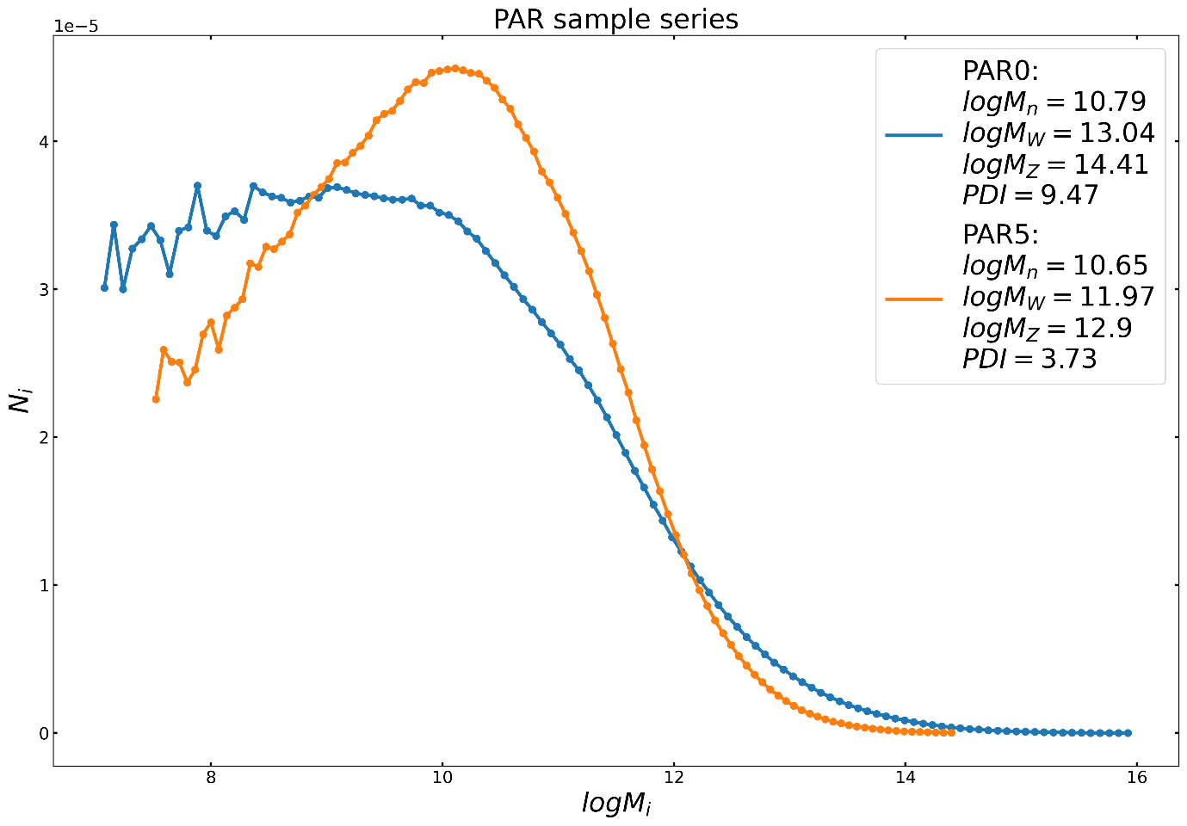

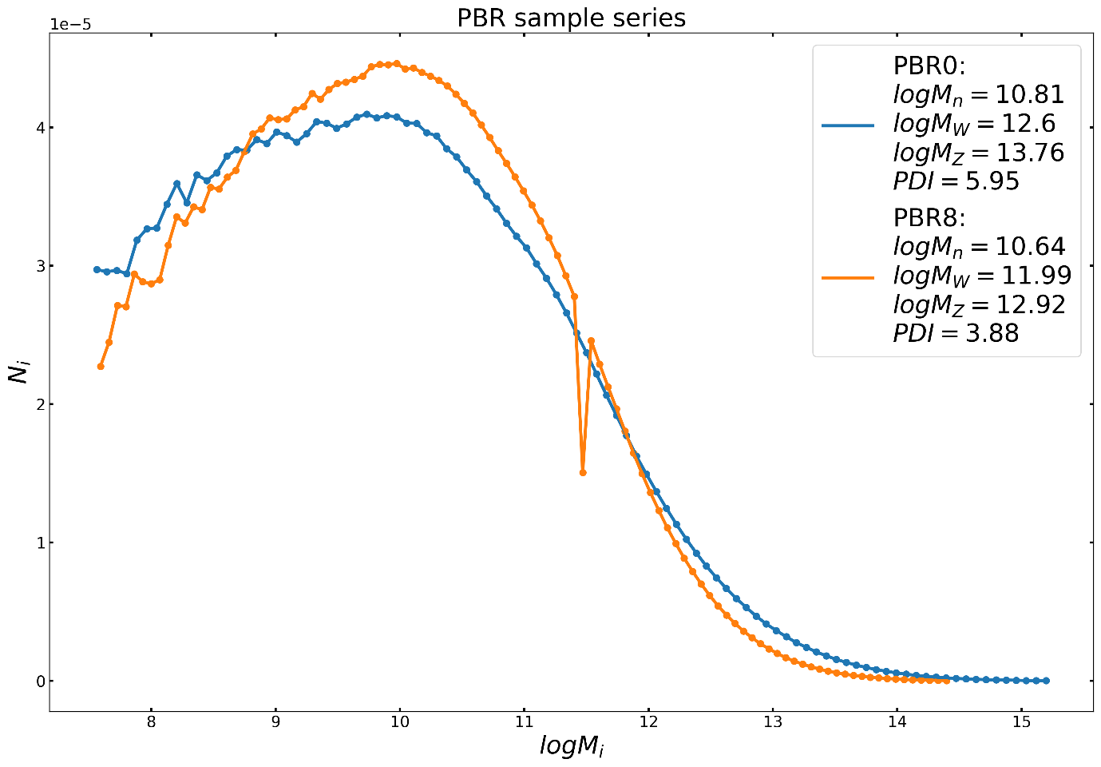

* Amount of peroxide added shifts the graph to the left and makes the dispersity narrower.
* PDI is proportionally related to the width of the curve.

## 3d. Correlations

### Interpretation of the creep compliance modulus

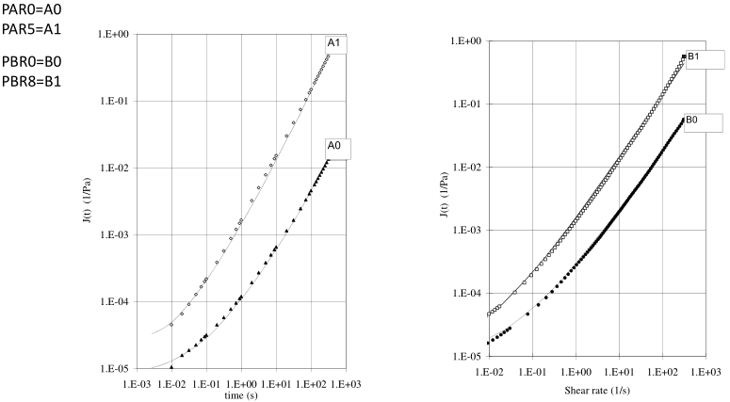

* Experimental analysis of creep compliance typically assumes particular linear viscoelastic models to fit the creep response.
* The shear creep compliance J(t) is strictly defined as the change in strain as a function of time under instantaneous application of a constant stress and provides a means to quantify the capacity of a material to flow in response to a sudden applied stress [4].

### The dependence of steady state compliance on molecular weight distribution

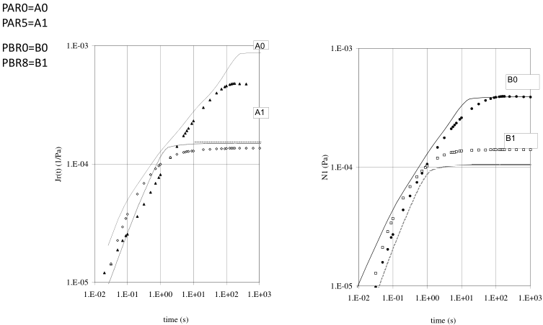

* The steady-state compliance Je is a parameter that describes the chain elastic deformation capacity between entanglements (a.k.a. the accumulated deformation that is recoverable when the stress is removed)
* Je is dependent on molecular weight and on the width of the MWD, described by the PDI. As the stable state is reached at higher values with increasing PDI and Mn.
* The presence of these very high Mw should have an important impact in Je.
* The steady state value is reached earlier in narrower distributions (low PDI). [2]

### Correlation between the Normal stress difference and the MWD

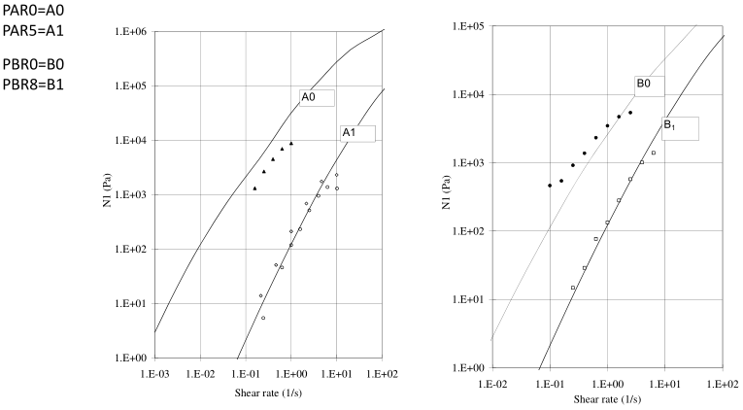

* The normal stress is the stress measured perpendicular to the surface when a force is applied.
* At higher shear rates the stresses can go through a maximum as the chains disentangle. Eventually equilibrium between entangling and disentangling is reached, generating steady stresses. At lower shear rates the steady state stresses decrease because there is more time for entanglement.
* At low shear rates the normal stresses increase linearly with the shear rate squared.
* For polymer melts normal stresses are very sensitive to molecular weight and molecular weight distribution [3].
* As can be observed in PAR0 has higher PDI, higher Mw and similar Mn obtaining higher normal stresses than PAR5 at the same shear rates. The same can be said from PBR0, it has higher PDI and higher Mw, and it obtains higher normal stresses than PBR8.

REFERENCES

[2] J. Otegui, J. Ramos, J.F. Vega, J. Martínez-Salazar, Effect of high molar mass species on linear viscoelastic properties of polyethylene melts, Eur. Polym. J. 49 (2013) 2748–2758. <https://doi.org/10.1016/j.eurpolymj.2013.06.015>.

[3] A.J. Franck, Normal stresses in shear flow, TA instruments.

[4] C.A. Tweedie, K.J. Van Vliet, Contact creep compliance of viscoelastic materials via nanoindentation, J. Mater. Res. 21 (2006) 1576–1589. <https://doi.org/10.1557/jmr.2006.0197>.