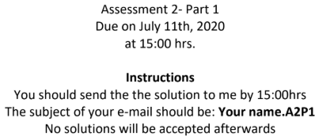

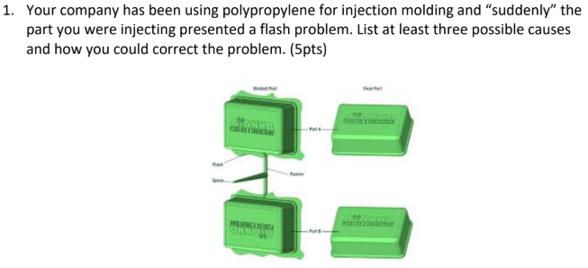

Causes of flashes:

* Mould cast are sliding or do not fit well
* Injection pressure is too high
* Clamping/locking force is not enough

Solutions:

* Lower the injection pressure to reduce the injection speed
* Increase the clamping force
* Redesign the mound parts to prevent sliding

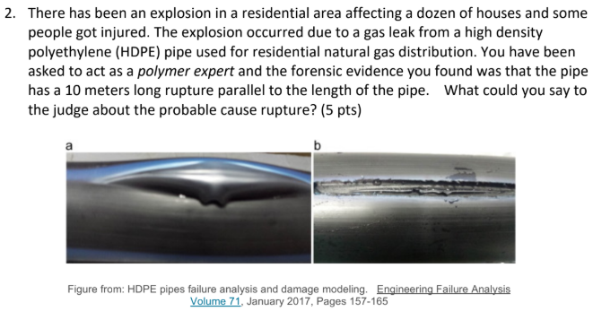

The fracture makes sense as the polymer chains are prone to be aligned lengthwise the pipe, and the fracture happens in that direction. It is possible that during the cooling step within the extrusion process is not set correctly, causing undesired crystallization.

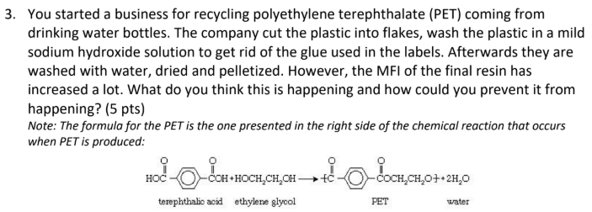

The solution is the implementation of additives to improve the characteristics of the polymer. During processing (repetitive recycling) polymers experience both thermal and mechanical stress. Depending on the structure, bonds break or low molar mass molecules are replaced. For example, the use of stabilizers help to repress undesirable reactions. The purpose is to maintain the desired characteristics of the polymer over a longer time.

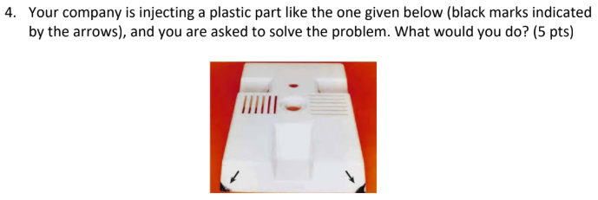

When injecting polymer into a mould, air needs to escape the mould by small windows (aka. vents). The air escaping process is known as venting. If the air does not escape fast enough, pressure builds up inside the mould. Polymers (aka. hydrocarbons) under pressurized conditions heat up and the "diesel effect" takes place, carbonizing some of the polymer. The result is charcoal-like edges in the final product. The solution would be to redesign/clean the air vent to allow proper air circulation.

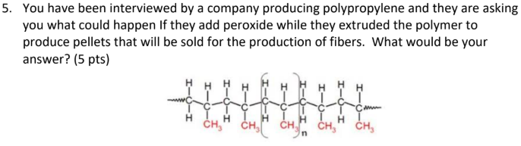

Free radical polymerization will take place. Peroxides are organic radical sources. During free radical polymerization, a radical (created from the decay of peroxides) adds to the double carbon to carbon bonds of a monomer, resulting in a new radical extending from the monomer unit. The result would be polymeric pellets with a higher molecular weight.

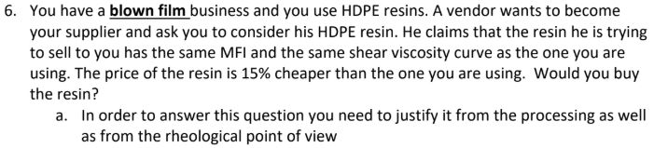

* Yes. In blown film his processes are used to manufacture very thin films. As it is not possible to make the profile of the extruder die as thin as desired without the back pressure becoming too high so that these very thin films cannot be extruded directly, in such a way that the rheological properties of the melt play an important role. As soon as the film leaves the tool it is inflated by pressurized air. Depending on the speed of the extrusion and the pressure of the air flow, the film become thinner. The tubular film is then cooled while maintaining a blown form. The viscosity of the polymer melt dictates the size of the die and therefore the features of the final product, in this case is imperative to ensure the MFI is the same. A sample may be requested for prior testing.





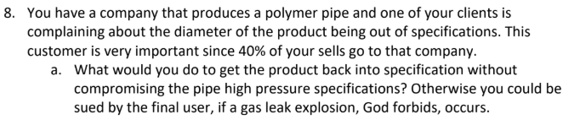

Ensure that the crosslinking of polymer chains are well form to have better mechanical and thermal properties

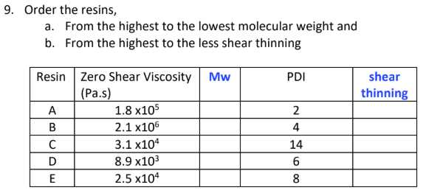

Mw ranking from high to low:

* D
* C
* E
* B
* A

Mw ranking from high to low:

* C
* E
* D
* B
* A

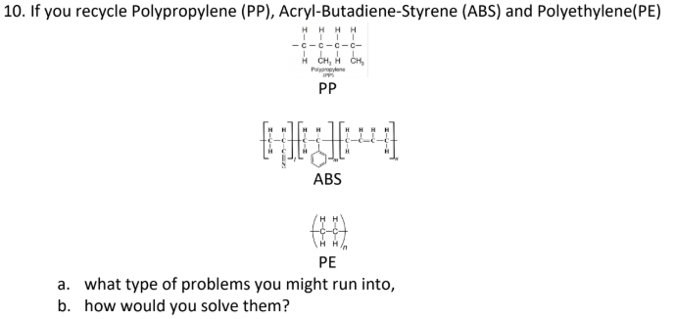

The mixing of the polymers would yield unexpected properties depending on the quantities of each polymer. The properties can be adjusted with the use of additives.

Additives:

• Stabilizers – prevent undesirable reactions / maintain the polymer desired characteristics over a longer time such as antioxidants.  
• Lubricants – help to the reduction of friction between the polymer and the reactor wall • UV-stabilizers – protect organic materials from the visible and UV light  
• Plasticizers – harden the mechanical characteristics of the polymer  
• Fillers – aid in the ease of stretching and weight lightening of the polymer material  
• Antistatic agents – modifies the polymer surface structure, such as fungicides.  
• Fire retardants – reduce the flammability of the material  
• Blowing agents – used to transform polymer materials into foam (by the increase in flexibility)