Assessment 2- Part 2 (Team 5)

Due any time before 17:00 hrs on July 13th, 2020

**Instructions**

**This assessment will require to work again in the first part (the one you sent to me early on) but as a team. Besides, in the next page there are two problems requiring calculations**

# Instructions for working again in the Assessment 2-Part 1

1. **You should get together with your teammates to solve as a group, the questions you answered in the Assessment 2-Part 1 and have to write down for each question the following:**
2. *Rephrase the problem indicating very clearly what you have been asked to do.*
3. *List all the data provided.*
4. *Make a list of the assumptions. justifying each of them.*
5. *Write down an algorithm for the solution you are proposing (no calculations are needed at this stage)*
6. *Answer the question*
7. *if needed check in the web for technical papers to support your answer.*
8. *List the references used in the solution of the problem.*

## Question 1

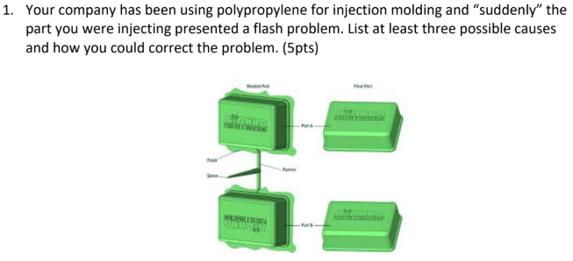

Causes of flashes:

* Mold cast are sliding or do not fit well
* Injection pressure is too high
* Clamping/locking force is not enough

Solutions:

* Lower the injection pressure to reduce the injection speed
* Increase the clamping force
* Redesign/change the mould parts to prevent sliding

## Question 2

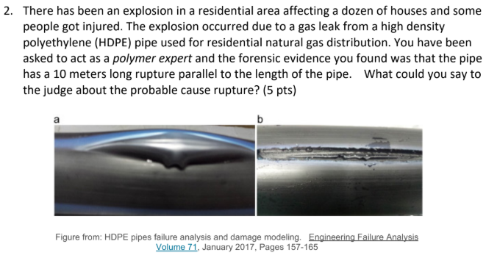

The fracture makes sense as the polymer chains are prone to be aligned lengthwise the pipe, and the fracture happens in that direction. It is possible that during the cooling step within the extrusion process is not set correctly, causing undesired crystallization.

## Question 3

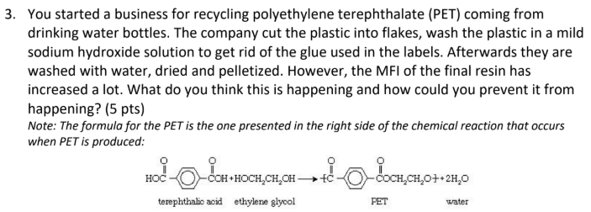

The solution is the implementation of additives to improve the characteristics of the polymer. During processing (repetitive recycling) polymers experience both thermal and mechanical stress. Depending on the structure, bonds break or low molar mass molecules are replaced. For example, the use of stabilizers helps to repress undesirable reactions. The purpose is to maintain the desired characteristics of the polymer over a longer time.

## Question 4

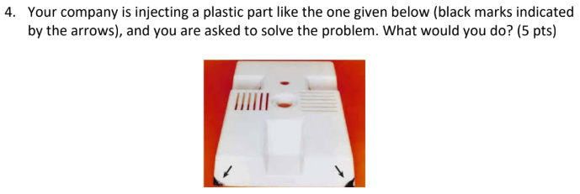

When injecting polymer into a mould, air needs to escape the mould by small windows (aka. vents). The air escaping process is known as venting. If the air does not escape fast enough, pressure builds up inside the mould. Polymers (aka. hydrocarbons) under pressurized conditions heat up and the "diesel effect" takes place, carbonizing some of the polymer. The result is charcoal-like edges in the final product. The solution would be to redesign/clean the air vent to allow proper air circulation.

## Question 5

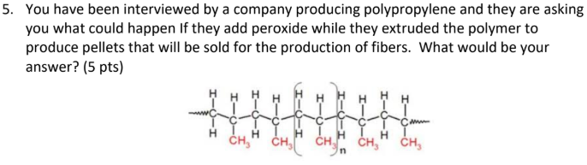

Free radical polymerization will take place. Peroxides are organic radical sources. During free radical polymerization, a radical (created from the decay of peroxides) adds to the double carbon to carbon bonds of a monomer, resulting in a new radical extending from the monomer unit. The result would be polymeric pellets with a higher molecular weight.

## Question 6

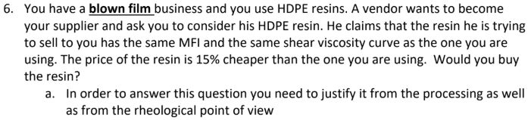

Yes. In blown film his processes are used to manufacture very thin films. As it is not possible to make the profile of the extruder die as thin as desired without the back pressure becoming too high so that these very thin films cannot be extruded directly, in such a way that the rheological properties of the melt play an important role. As soon as the film leaves the tool it is inflated by pressurized air. Depending on the speed of the extrusion and the pressure of the air flow, the film become thinner. The tubular film is then cooled while maintaining a blown form. The viscosity of the polymer melt dictates the size of the die and therefore the features of the final product, in this case is imperative to ensure the MFI is the same. A sample may be requested for prior testing.

## Question 7

  
 

## Question 8

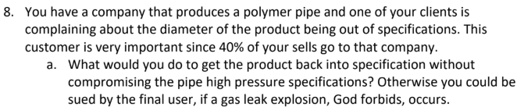

Ensure that the crosslinking of polymer chains is well form to have better mechanical and thermal properties

## Question 9

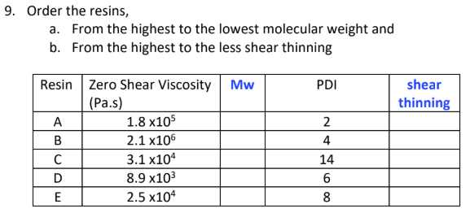

Mw ranking from high to low:

* D
* C
* E
* B
* A

Mw ranking from high to low:

* C
* E
* D
* B
* A

## Question 10

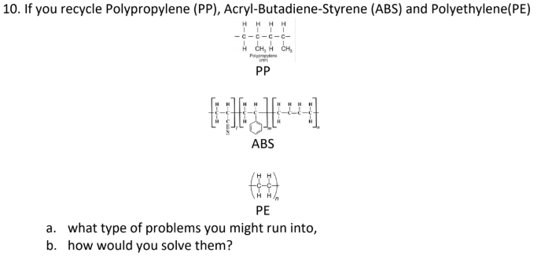

The mixing of the polymers would yield unexpected properties depending on the quantities of each polymer. The properties can be adjusted with the use of additives, such as:

* Stabilizers - prevent undesirable reactions / maintain the polymer desired characteristics over a longer time such as antioxidants.
* Lubricants - help to the reduction of friction between the polymer and the reactor wall
* UV-stabilizers - protect organic materials from the visible and UV light
* Plasticizers - harden the mechanical characteristics of the polymer
* Fillers - aid in the ease of stretching and weight lightening of the polymer material
* Antistatic agents - modifies the polymer surface structure, such as fungicides.
* Fire retardants - reduce the flammability of the material
* Blowing agents - used to transform polymer materials into foam (by the increase in flexibility)

# Instructions for working again in the Assessment 2-Part 2

1. **You should get together with your teammates to solve as a group, the questions you answered in the Assessment 2-Part 1 and have to write down for each question the following:**
2. *Rephrase the problem indicating very clearly what you have been asked to do.*
3. *List all the data provided.*
4. *Make a list of the assumptions. justifying each of them.*
5. *Write down an algorithm for the solution you are proposing (no calculations are needed at this stage)*
6. *Solve the problem*
7. *Ask yourself if the result is reasonable and, if needed check in the web for technical papers to support your answer.*
8. *List the references used in the solution of the problem.*

I strongly suggest to you to work on your own in steps A to D so you can make an honest contribution to the team, *afterwards you can work E to G with the other members of the group.*

**PROBLEMS**

## Problem 1 (Filling a mold)

1. Calculate the pressure required to fill the mold.



* The dimensions (in cm) of each cavity are 10x10x1
* The runners’ diameter is 1 cm and their length are indicated in the drawing.
* The polymer is a polypropylene (PP) with a density of 0.9 g/cm3
* The viscosity curve for the resins is given in the document called PPVIS 2020:
  + Groups 1 and 3 should work with resin PAR0
  + Groups 2 and 4 should work with resin PAR3
  + Groups 5 and 6 should work with resin PAR5
* The injection is done at the red dot.

The following is adapted from the problem-solving reasoning of Dantzing et al. [1].

### The Viscous Flow Model

Several models have been proposed in literature with different number of fitting parameters. The purpose of these models is to obtain analytical solutions in polymer processing, and to measured data. The flow behavior of different fluids, different models better fit them as some fluids may be shear thinning and/or experience a yield stress.

Complex models such as the Carreau-Yasuda model better represent the rheological behavior of the polymer but can add significant difficulty to the analysis of the data. As depicted in the following figure, the Carreau-Yasuda model better fits the given data than the Power Law model.

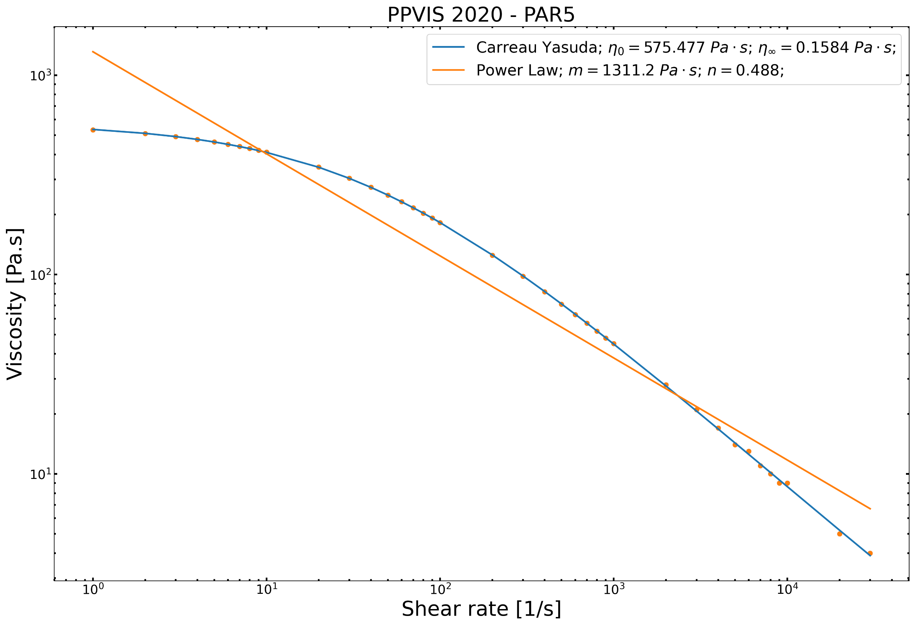

#### The Carreau-Yasuda Model

Where:

*is the viscosity*

*is the shear rate*

*, is the infinite shear rate viscosity*

*, is the zero-shear rate viscosity*

*, is the time constant*

*, is the Power Law index*

*, is the width of the transition region between the zero-shear viscosity and the Power Law region.*

#### The Power Law Model

Where:

*is the viscosity*

*is the shear rate*

*, is the consistency index*

*, is the Power Law index*

For this examination, the Power Law model is used for simplicity. Its imperative to mention that the Power Law model assumes that: *a) , b) , c) , d) , and e)*  [2]. If n < 1 the fluid is shear thinning, and if n > 1 it has a shear-thickening behavior.

### Pressure Flow Within the Runners

#### Define the Cylindrical Boundaries

From the power law model, let us consider the flow of a power law fluid in a circular tube to describe the mold runners and assume that the density of the material is constant. From Appendix B.2 in [1], let us define the tube boundaries by selecting the continuity equation for constant density, in cylindrical coordinates:

Where:

is the flow velocity through the wall

is the flow velocity at the circular plane

is the flow velocity in the z-direction (lengthwise)

Assuming the flow is identical in every plane (asymmetric flow), the second term , and in the assumption that the flow is fully developed (same/constant velocity along the cylinder at a given pressure), then . Giving: . By integrating the previous, the following is given:

Where the constant because is zero since no fluid is leaking the boundary. Also, due to axisymmetric flow, . Therefore, the given assumptions and boundary conditions conclude that the only velocity is in the z-direction.

#### Calculate the shear stress through the movement of the fluid

Again, from Appendix B.2 in [1] let us define the momentum equation in the z-direction to describe the flow/motion of the fluid:

Again, the asymmetry assumption makes , and the fully developed flow assumption makes . Also, as the effect of gravity or electromagnetic fields are neglected. With a constant due to the fully developed flow assumption. Giving the following z-direction momentum equation:

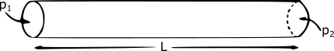

Following the shape in the figure above, the change in pressure can be described as:

Where:

is the pressure leaving the cylinder

is the pressure entering the cylinder

is the length of the cylinder

is negative as the shear stress is not in the positive direction of z

By substituting the previous two equations:

Integrating the previous, gives: Where the constant to prevent the infinite values of shear stress when the radius . Such that the shear stress is given by the following for a steady, fully developed axisymmetric flow in cylindrical boundaries.

#### Calculate the strain rate

For cylindrical coordinates (Appendix B.3 in [1]) and the Power Law, the strain rate can be described as , with and as a function of the radius .

By substituting in the Power Law model, we have: . On the other hand, the velocity at the tube wall shall decrease from its maximum value (at ) to zero, hence . Therefore, the shear stress can be written as

#### Calculate flow velocity in the z-direction

By matching the values of of the previous sections, we have: . If , then:

Integrating the radius from 0 to we have:

According to the Power Law model fitting parameters we have and

For a Newtonian fluid, , in this case as we are dealing with a shear thinning fluid.

#### Calculate volume flow rate passing through the runner

The calculation is to be done by integrating the velocity over the cross section over , as follows:

The represents a significant level of shear thinning. When , is proportional to , meaning that doubling the pressure drop will quadruple the flow rate. The higher stress near the walls leads to a lower viscosity, and the lower viscosity requires an increased shear rate to sustain the higher shear stress. At the center of the tube the shear stress is small, so the viscosity is high in that point. Shear-thinning behavior is advantageous in the extrusion of polymers. Inside the runner the shear rate is large, so the polymer has a relatively low viscosity, and the pressure drop across the runner is not too high. However, once the polymer exits the die it is subjected only to stresses from its own weight, which are small. Under these low stresses the polymer has a high viscosity, which helps it holds its shape as it cools in the cavities.

Therefore, the pressure entering the runner can be solved from the previous equation as:

|  |  |
| --- | --- |
|  | (1) |

### Pressure Flow Within a Cavity (between parallel plates): velocity, shear stress & flow rate

Following a similar reasoning as in the running/cylindrical geometry, the pressure flow in the z-direction between parallel plates is described as follows. Id to plates are separated by a distance , the pressure difference is applied over a distance , and is the width of the plates. The shear stress is described as:

The velocity is in function of and is given by:

The volume flow rate is given by:

Therefore, the entering pressure to fill the cubic cavity can be solved from the previous equation as:

|  |  |
| --- | --- |
|  | (2) |

### Analyze the pressures at different points of the mold

As stated by Farotti et al. [5], the typical volume flow rate is about with a packing pressure of .

Now let us calculate the pressures at each intersection within the mold, so let us dive the mold in sections as follows:

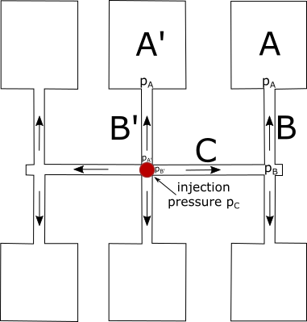

1. Compute the pressure using equation (2)

*Where:*

*,*

*,*

*,*

*,*

*,*

*,*

*,*

*, is the packing pressure.*

1. Compute the pressure using equation (1)

*Where:*

*, we are multiplying by two since the pressure in is divided into two equal cavities (up and down).*

*,*

*,*

*,*

*,*

*,*

*.*

and

1. Compute the pressure using equation (1)

*Where:*

*,*

*,*

*,*

*,*

*,*

*,*

*.*

1. Finally, the injection pressure is given by :

[1] J.A. Dantzig, C.L. Tucker, Modeling in Materials Processing, Cambridge University Press, 2001. https://doi.org/10.1017/CBO9781139175272.

[2] T. Osswald, N. Rudolph, T. Osswald, N. Rudolph, Generalized Newtonian Fluid (GNF) Models, Polym. Rheol. (2014) 59–99. https://doi.org/10.3139/9781569905234.003.

[3] H. Zhou, Z. Hu, D. Li, Mathematical Models for the Filling and Packing Simulation, in: Comput. Model. Inject. Molding, John Wiley & Sons, Inc., Hoboken, NJ, USA, 2013: pp. 49–70. https://doi.org/10.1002/9781118444887.ch3.

[4] C. Fernandes, A.J. Pontes, J.C. Viana, A. Gaspar-Cunha, Modeling and Optimization of the Injection-Molding Process: A Review, Adv. Polym. Technol. 37 (2018) 429–449. https://doi.org/10.1002/adv.21683.

[5] E. Farotti, M. Natalini, Injection molding. Influence of process parameters on mechanical properties of polypropylene polymer. A first study., Procedia Struct. Integr. 8 (2018) 256–264. https://doi.org/10.1016/j.prostr.2017.12.027.

## Problem 2 (Capillary rheometer correction)

1. You have the following information from a capillary rheometer for a HDPE resin (this is real data so several runs were made at the same velocity due to possible variabilities in the instrument)

|  |  |  |  |  |  |  |  |
| --- | --- | --- | --- | --- | --- | --- | --- |
| Velocidad (in/s) | | Average load (lbf) for the L/D=40 die | | Average load (lbf) for the L/D=20 die | | Average load (lbf) for the L/D=10 die | |
| 0.061 | 170.3 | | 92.6 | | 55.9 | |
| 0.061 | 171.7 | | 92.6 | | 54.1 | |
| 0.307 | 420.5 | | 216.9 | | 121.3 | |
| 0.307 | 417.5 | | 214.4 | | 119.4 | |
| 0.614 | 579.1 | | 296.5 | | 164.6 | |
| 0.614 | 575.8 | | 294.1 | | 162.9 | |
| 3.07 | 848.4 | | 390.7 | | 261.6 | |
| 6.14 | 626.8 | | 360.6 | | 233.8 | |
| 6.14 | 623.6 | | 377.8 | | 264.3 | |
| 13.8 | 939.4 | | 552.4 | | 368.5 | |
| 18.4 | 1098.4 | | 640.3 | | 418.0 | |

* Some of the dimensions are:
* Barrel diameter 0.68 cm
* Capillary diameter: 0.05 inches
* Die Lengths: 2 in; 1 in; 0.5 in
* The piston moves at constant velocity (inches/second)
* The load is given pound force (lbf) and the force sensor is at the top of the piston.

You are asked to:

1. Get the real shear viscosity
2. The pressure at the entrance
3. The elongational viscosity

The first thing we need to do is calculate the *volumetric flow* (Q) which is given by *the piston velocity* (V) times the *piston cross-section area* (A).

To obtain A we have the *barrel diameter* (0.68 cm) we convert it to inches dividing by 2.54 which gives us a diameter of 0.2575 in.

Since we have different velocities, we will obtain different *volumetric flows*,

|  |  |
| --- | --- |
| **V (in/s)** | **Q (in3/s)** |
| 0.061 | 0.003179 |
| 0.307 | 0.015997 |
| 0.614 | 0.031994 |
| 3.07 | 0.15997 |
| 6.14 | 0.31994 |
| 13.8 | 0.719083 |
| 18.4 | 0.958777 |

Once we have the *volumetric flows* for each *velocity* used, we can obtain the *apparent shear rate* (Γ) given by:

Where the *die radius* R = 0.025 in.

|  |  |  |
| --- | --- | --- |
| **V (in/s)** | **Q (in3/s)** | **Γ (1/s)** |
| 0.061 | 0.003179 | 259.0119 |
| 0.307 | 0.015997 | 1303.552 |
| 0.614 | 0.031994 | 2607.104 |
| 3.07 | 0.15997 | 13035.52 |
| 6.14 | 0.31994 | 26071.04 |
| 13.8 | 0.719083 | 58596.14 |
| 18.4 | 0.958777 | 78128.19 |

Once we have all the apparent shear rates, we need to obtain the