**TEAM 5**

Angel Manuel Villalba-Rodríguez <A00828035@itesm.mx>  
Constanza Alvarez-Lopez <A00829469@itesm.mx>  
Osamu Katagiri-Tanaka <A01212611@itesm.mx>  
Juan Jesús Rocha-Cuervo [<A01752555@itesm.mx](mailto:%3cA01752555@itesm.mx)>

**FINAL - Plastics and Composites Engineering**

Due any time before 22:00 hrs on August 1st, 2020

**Instructions**

**Solve the problems following the next steps:**

1. Rephrase the problem indicating very clearly what you have been asked to do.
2. List all the data provided.
3. Make a list of the assumptions, justifying each of them.
4. Write down an algorithm for the solution you are proposing (no calculations are needed at this stage)
5. Solve the problem.
6. Ask yourself if the result is reasonable and, if needed check in the web for technical papers to support your answer.
7. List the references used in the solution of the problem.

This procedure is a must for this part of the exam to be considered for grading.

1. Work by yourself from A to D, afterwards you will work E to G with your team.
2. Upload your individual proposal in the Google Drive in the folder 10 Final Assessment in your personal folder, as: MY NAME. FINAL EXAMINATION PART ABCD.
3. Upload your team´s solution with the Subject: TEAM NUMBER FINAL EXAMINATION PART EFG

**Problems (60 points)**

## Q1: The manufacturing plant where you work, The Mexico Supply Chain, has been requested, by the China Car Company, to inject a flat piece with the following dimensions (W=10 cm, L=20 cm y H= 0.5 cm) **{20 pts}**

W

L

y

z

x

The injection can be done in a multicavity die and the plant manager wants to produce 10 specimens per minute, considering two different type of resins, but before he accepts the request of the China Car Company, he asks you

1. To determine the pressure required to produce those pieces using the resin that requires the lowest pressure drop.
2. To propose he best multicavity configuration (justify your answer)

Consider that the injection happens at 200oC and that the density of the material at that temperature is 0.75; the viscosity can be represented by a power law and their respective parameters are given below.

|  |  |  |  |  |
| --- | --- | --- | --- | --- |
| Resin | MFI | ηo (poises) | Critical shear rate (s-1) | Power law index |
| **1** | 1.5 | 54000 | 1.5 | 0.48 |
| **2** | 2.5 | 29000 | 2.5 | 0.48 |

A. REPHRASE

We have been requested to produce 10 flat pieces per minute by injection molding. It can be done in multicavity die and we have 2 different resins. We need to a) determine the pressure required to produce ten flat pieces using the resin that requires the lowest pressure drop; and b) propose the best multicavity configuration.

B. AVAILABLE DATA

* Process: injection moulding
* Mould: Multicavity
* Dimensions of the flat piece: W=10 cm, L=20 cm and H= 0.5 cm
* Pieces per minute: 10
* Polymer: 2 resins
* Injection temperature: 200 C
* Densities, MFI, Viscosities, critical shear rates, power law indexes
* Number of cavities: to determine
* Arrangement of cavities: to determine
* Pressure required: to be determined from resin with less pressure drop

C. ASSUMPTIONS

* The Power Law model fits well the viscosity modulus of the resins
* The plant manager is interested in spending the least amount of energy in the production of the pieces.
* The process is carried out at a constant pressure, constant temperature
* The material density remains constant through the process
* Isothermal, laminar and steady state flow
* The filling time
* The surface of the mold cavity reproduces its condition on a molded part. A significant advantage of the molding processes is the fact that different surface polishes and textures can be molded into the part, and we will assume that no secondary surface-finishing operations are required.
* The surface finish of the runner system should be as good as that in the cavity. A good surface finish not only keeps the pressure drop low, but also prevents the tendency of the runner to stick to either half of the mold. Such sticking would aggravate the high stress in the area of the gate.

D. ALGORITHM

1. Obtain viscosity of each resin using the Power Law equation for different shear rates
2. Graph the viscosity curves of each resin
3. Select the resin with the lowest zero-shear viscosity, it will require the least pressure drop
4. Design the runner diameter to match the part and provide a proper filling
5. Scale the mould into a multicavity configuration and select the best runner lengths
6. Calculate the pressure needed to produce the pieces.
7. Plot the different pressures obtained at different filling times.

E. SOLUTION

F. VALIDATION

G. REFERENCES

## Q2: You have decided to start a plastic recycling company and Mr. Good Die is selling you an extruder with a 500 holes die, each of them has a length of 1.25 inches and an radius of 0.05 inches **{20 pts}**





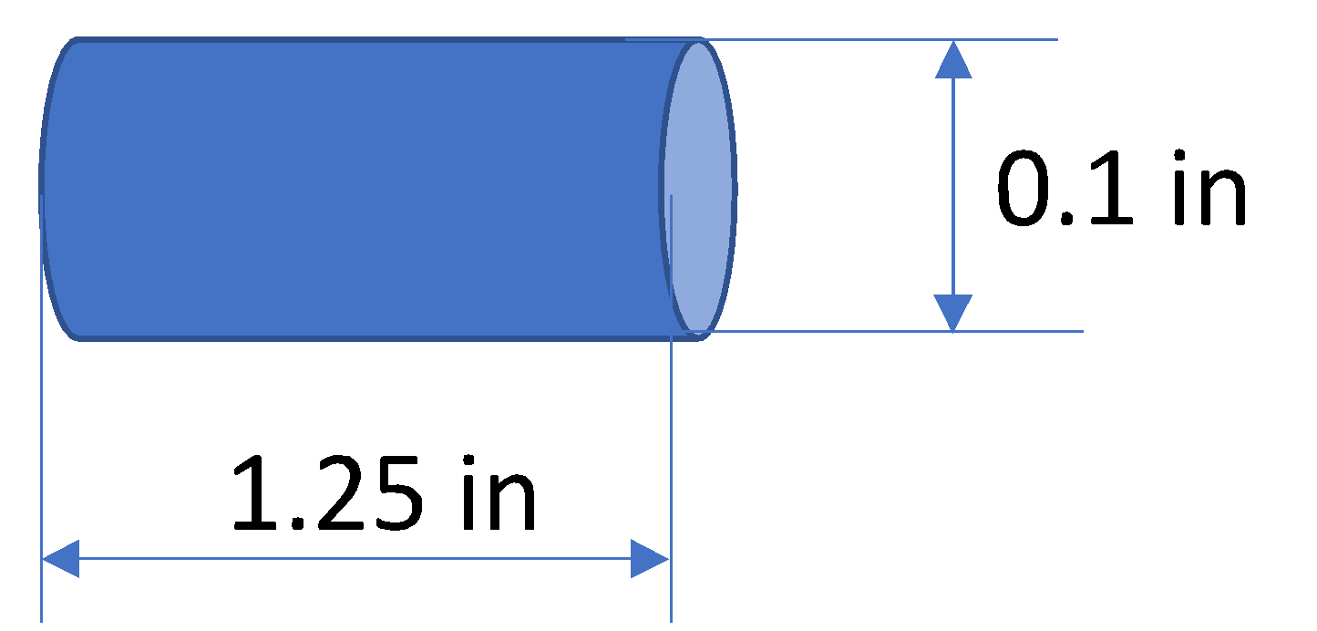

You need to *estimate the pressure drop* across the die since that information is needed to determine how much energy/ton of recycled plastic you have to pay. You will use that information together with other data (energy for platicizing the plastic, extruder maintenance, etc.) to estimate the investment and the ROI. You want to make sure that can get recycled pellets at 1,000 kgs/hour. The viscosity curve is that given in the first problem for resin 2.

A. PARAPHRASE

We will recycle plastics (resin 2 from problem 1). We have to calculate the pressure drop across an extruder die with 500 holes, to determine the energy/ton of the recycled plastic we need to pay. With that and other information we will obtain the investment and the ROI. We want to recycle 1,000 kgs of pellets per hour with a good ROI balance.

B. AVAILABLE DATA

* Process: extrusion
* Polymer: Recycled material (resin 2)
* Die: 500 holes
* Single hole dimensions: length of 1.25 in and radius of 0.05 in
* Recycle 1,000 kgs of pellets per hour
* Viscosity curve: resin 2
* Pressure drop across die: obtain
* energy/ton of recycled plastic to pay: obtain
* Investment: obtain
* ROI: obtain

C. ASSUMPTIONS

* The applied pressure is constant
* The resin density remains constant
* The flow in the extruder is at constant velocity, laminar, steady state.
* Viscous heating at the wall and entrance effects as the flow changes are neglected
* Use of plasticizers and other elements
* The energy needed increases with the shear stress into the polymer
* Making less than 1,000 kgs of recycled pellets per hour is not worth the investment
* We have all the money needed to do the investment
* We will take the energy costs of Mexico
* We will sell the pellets at a selected price, and they will be bought

D. ALGORITHM

1. Plot the viscosity vs. shear rate curve at 200C from previous problem.
2. Use the Navier-Stokes equation to approximate the basic shapes (cylinders) as the pressure is increased with hole length but decreases with the radius.
3. Calculate the stress at the wall, which depends on the pressure drop
4. Solve the pressure drop from the previous step

E. SOLUTION

F. VALIDATION

G. REFERENCES

## Q3: You are requested to get the master curve of the HDPE resins at the reference temperature of T=210oC and get the complex viscosity curve at 200oC. Also, using the master curve of the G”(w) at T=210oC ,  you are requested to get the First normal stress difference at steady state, for shear rates 0.1, 1, 10 and 100 1/s, using the Wagner Model. Make any comments/observations you consider important. **(20 pts)**

A. PARAPHRASE

Describe the TTS and modelling procedure to get the first normal stress difference at steady state from complex viscosity curves, with a reference temperature of 210°C from a PP-HDPE Copolymer with an MFI of 2 g/10 min.

B. AVAILABLE DATA

* Process: TTS
* Polymers: PP-HDPE copolymer
* MFI: 2g/10min
* Objective temperature: 200°
* Reference temperature: 210°C
* Time: infinite
* Shear rates: 0.1, 1, 10 and 100 1/s
* Master curves: obtain G* and G’’
* N1: obtain

C. ASSUMPTIONS

* Reference temperature: 210°C
* The given data was obtained under the same conditions at different temperatures
* There will be no environmental activity on the polymer that affects the performance in time
* The data from shear viscosity comes from a capillary test and the relaxation modulus comes from an oscillatory test

D. ALGORITHM

1. Calculate tan delta
2. Plot tan delta vs. frequency to get the horizontal shift factors (aT) by superposing manually the curves to the chosen reference temperature
3. Plot tan delta vs. G* to get the vertical shift factors (bT) manually
4. Obtain activation energies to get the horizontal and vertical shifts for the objective temperature
5. Apply the shift to the data at each temperature to obtain the master curve at the objective temperature
6. Fit the master curve into the Wagner model
7. From Wagner fit obtain the fitting parameters: as, lambdas, n1, n2 and f1
8. With the fitting parameters, calculate N1 at the steady state for the given shear rates.

E. SOLUTION

The complete solution (source code) can be found at <https://tecmx-my.sharepoint.com/:u:/g/personal/a01212611_itesm_mx/EdsBCPRq6sVAtk95i6zAsPIBO364BytEiHC1XD8xH8xgfQ?e=1x6iNp>, the following explains the problem solving process.

1. Calculate and , and graph vs. frequency and vs. .

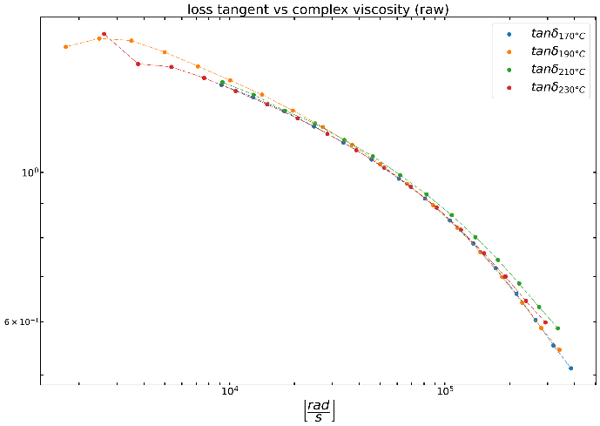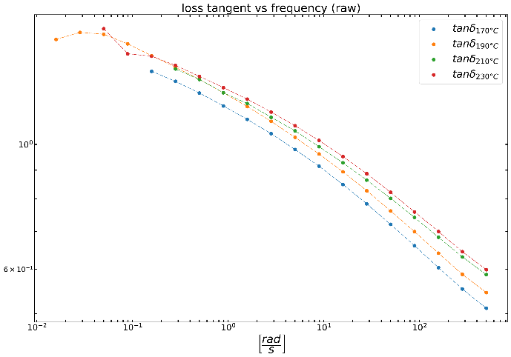

1. Calculate the vertical and horizontal shift factors by hand until all the curves overlap the 210°C curve.

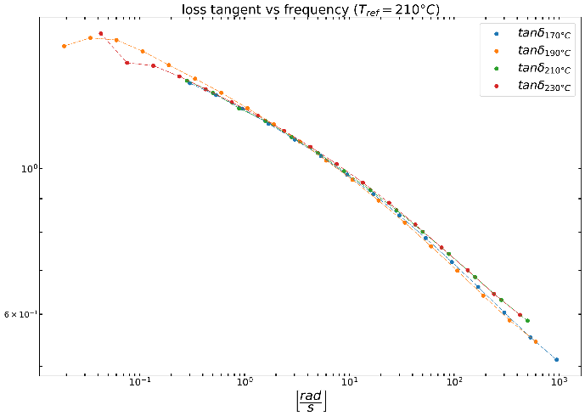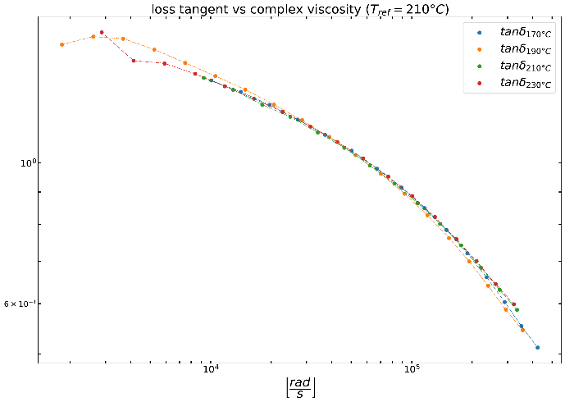

|  |  |  |
| --- | --- | --- |
| Temperature [°C] | Horizontal shift factor aT | Vertical shift factor bT |
| 170  190  210  230 | 1.900000  1.200000  1.000000  0.850000 | 1.100000  1.050000  1.000000  1.100000 |

1. Get the activation energies and by plotting . Then do a linear regression as the slopes of the linear fit are the activation energies.

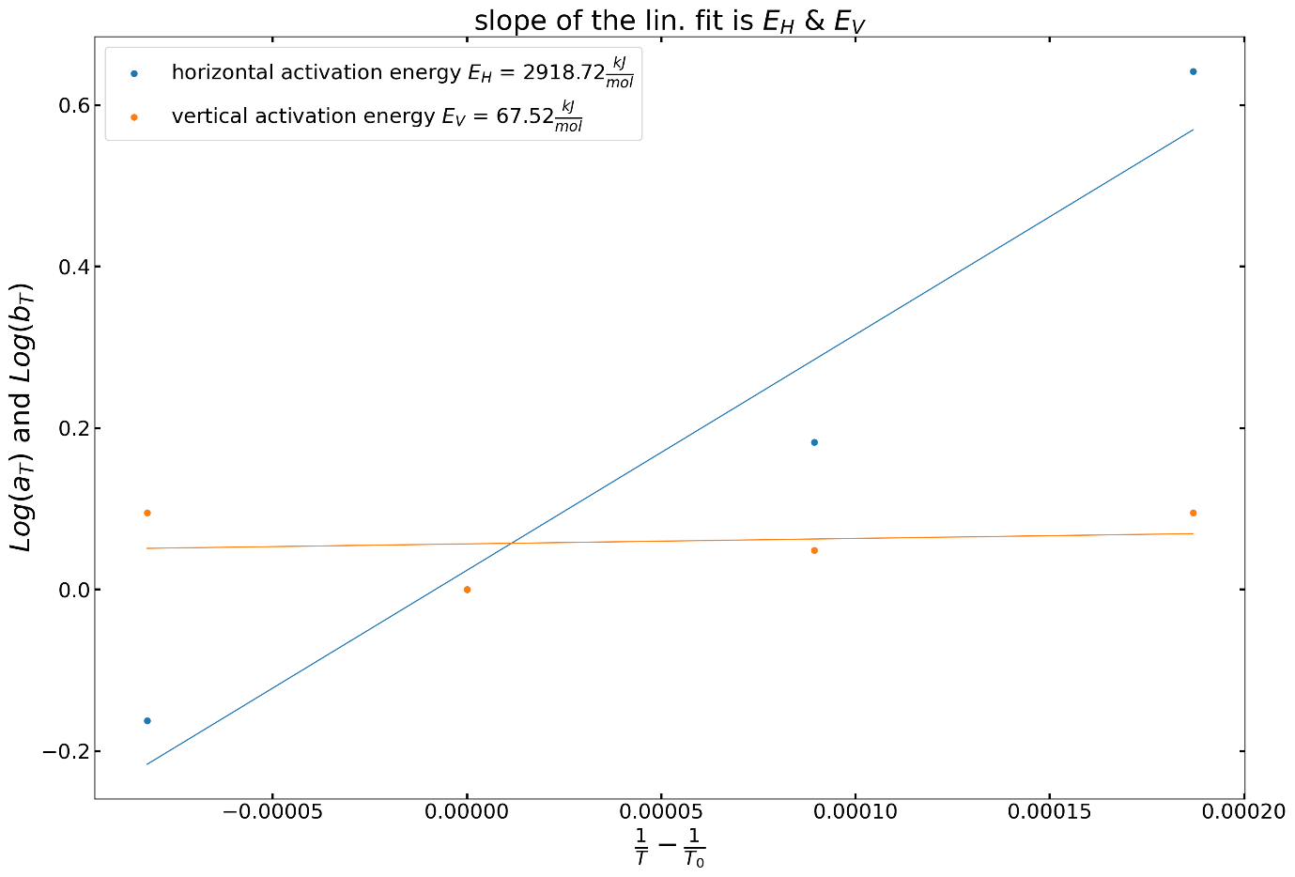

1. Compute the shift factor and for an arbitrary temperature of 200°C with the Williams-Landell-Ferry (WLF) equation

|  |  |  |
| --- | --- | --- |
| Temperature [°C] | Horizontal shift factor aT | Vertical shift factor bT |
| 200 | 1.136186 | 1.002958 |

1. Calculate the complex viscosity master curve at 210°C using the master curve with:

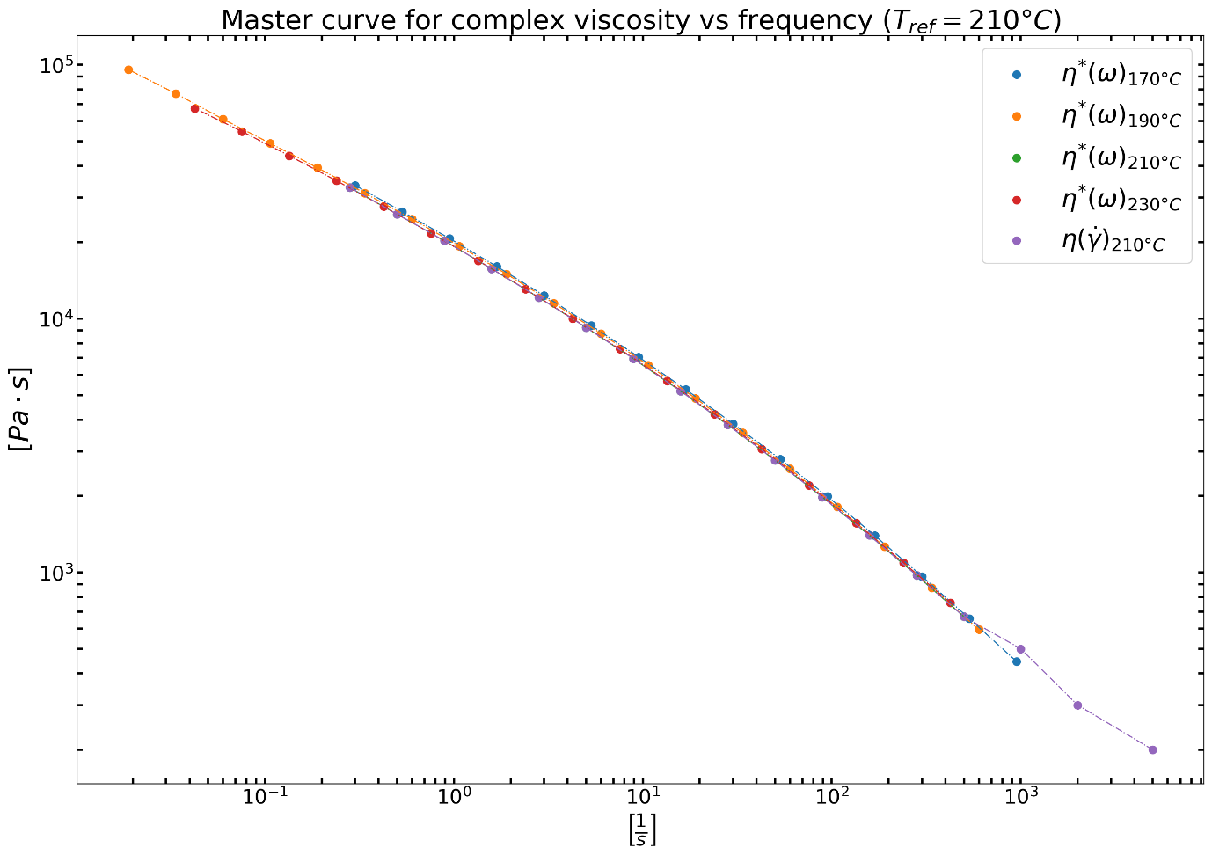

Note that the data is plotted without shifting as it is already measured at the reference temperature.

1. Plot the complex viscosity curve against shear rate at 200°C

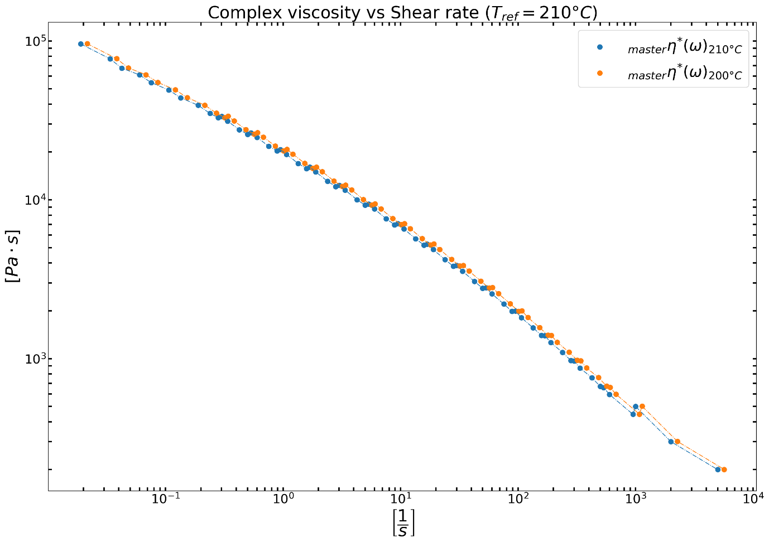

Notice that the lower temperature curve (200°C) as higher viscosity values at a given shear rate.

1. Compute fitting curve with the Wagner model with the master curve at 210°𝐶. The shear viscosity as a function of shear rate , is:

Where:

The Wagner model gives the shear viscosity vs. time of a single shear rate. The steady state shear viscosity at several shear rates at is given by:

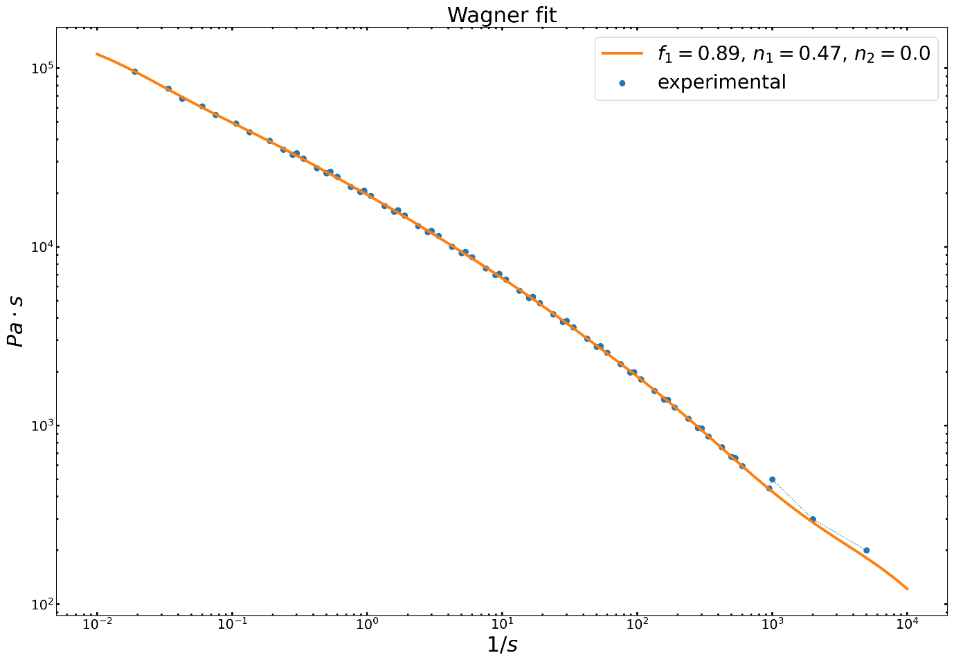

The following are the fitting values for the Wagner model (with five Maxwell elements) to match the experimental data within the master curve at 210°C.

2.68425342e+08

1.09191259e+06

2.57623389e+05

9.67069909e+03

2.04877643e+02

8.96633937e-03

1.74375415e-01

1.74521550e-01

6.30348573e+00

8.07822062e+01

8.89712169e-01

4.69519418e-01

4.83767742e-03

1. Calculate the steady state first normal stress difference 𝑁1 at

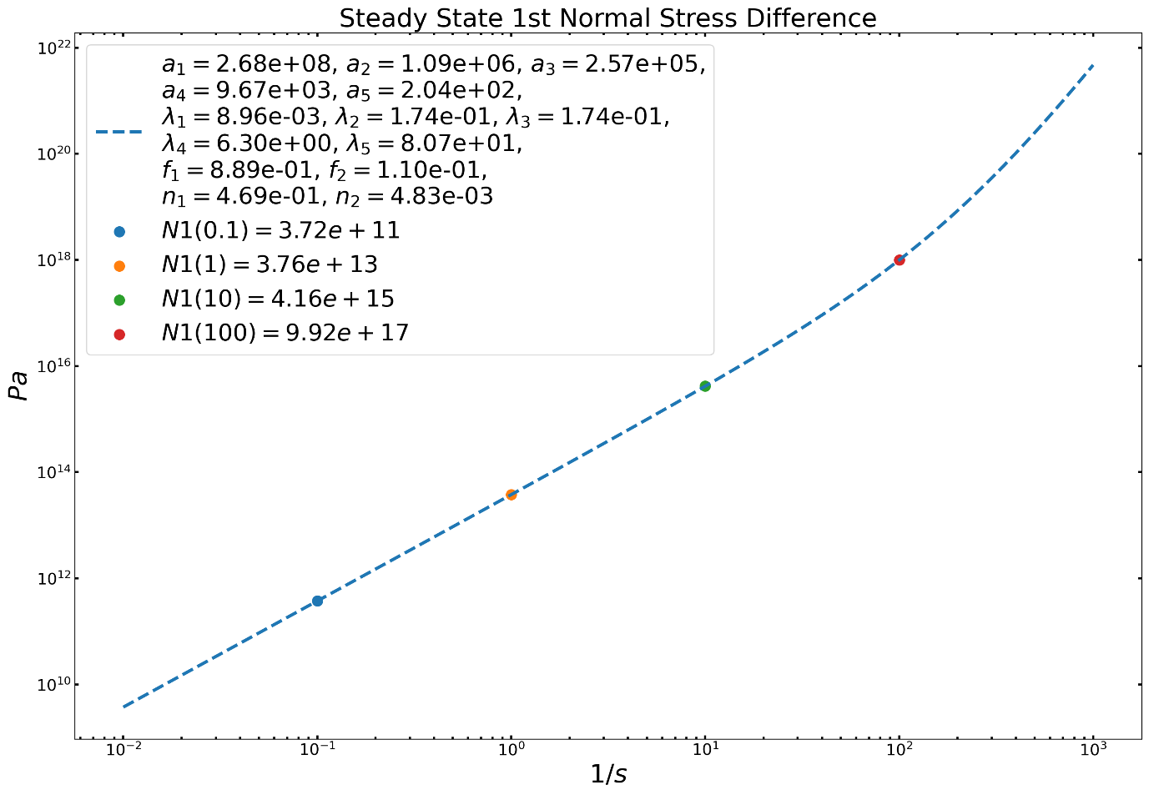

The figure above plots and displays the first normal stress difference at steady state, for shear rates 0.1, 1, 10 and 100 1/s.

F. VALIDATION

G. REFERENCES

Bonilla-Rios Jaime, ESTIMATION OF THE FIRST NORMAL STRESS DIFFERENCE (N1) AND CREEP COMPLIANCE(J(t)) OF POLYPROPYLENE (PP) RESINS USING A CONSTITUTIVE EQUATION. (2020)

J. Ahmed, Time–Temperature Superposition Principle and its Application to Biopolymer and Food Rheology, in: Adv. Food Rheol. Its Appl., Elsevier, 2017: pp. 209–241. <https://doi.org/10.1016/B978-0-08-100431-9.00009-7>.

A. Oseli, A. Aulova, M. Gergesova, I. Emri, Time-Temperature Superposition in Linear and Non-linear Domain, Mater. Today Proc. 3 (2016) 1118–1123. <https://doi.org/10.1016/j.matpr.2016.03.059>.

H. Mavridis, R.N. Shroff, Temperature dependence of polyolefin melt rheology, Polym. Eng. Sci. 32 (1992) 1778–1791. <https://doi.org/10.1002/pen.760322307>.

## Q4: What type of melt distortions can be observed in polymers, give some examples on different polymer extrusión processeses and how can be avoided. **{10 pts} BONUS**

|  |  |
| --- | --- |
| Defect | Solution |
| Bubbles | Bubbles are cause by humidity; therefore, it would be necessary to dry the material |
| Shrinkage | The cause is due to excessive stress in the material. Slower cooling, lower speeds and a die with lower drag may solve this issue |
| pimples | The decrease of extrusion speed sorts out this problem, which is caused by the use of gels |
| Shark skin | Due to melt overheating, solution would be to increase the die temperature and decrease the extrusion speed |
| Surging | The puller may be at irregular speeds; the screw rotation would be at inconsistent velocities; or due to uneven polymer feed |
| Lumpiness | Due to low temperature. Rising the temperature would solve the problem. |