**FINAL - Plastics and Composites Engineering**

**Instructions**

**Solve the problems following the next steps:**

A) Rephrase the problem indicating very clearly what you have been asked to do.  
B) List all the data provided.  
C) Make a list of the assumptions, justifying each of them.  
D) Write down an algorithm for the solution you are proposing (no calculations are needed at this stage)  
E) Solve the problem  
F) Ask yourself if the result is reasonable and, if needed check in the web for technical papers to support your answer.  
G) List the references used in the solution of the problem.

This procedure is a must for this part of the exam to be considered for grading.

1. Work by yourself from A to D, afterwards you will work E to G with your team.
2. Upload your individual proposal in the Google Drive in the folder 10 Final Aseessment in your personal folder, as: MY NAME. FINAL EXAMINATION PART ABCD.
3. Upload your team´s solution with the Subject: TEAM NUMBER FINAL EXAMINATION PART EFG

**Problems(60 points) PROBLEMS**

## Q1: The manufacturing plant where you work, The Mexico Supply Chain, has been requested, by the China Car Company, to inject a flat piece with the following dimensions (W=10 cm, L=20 cm y H= 0.5 cm) **{20 pts}**



The injection can be done in a multicavity die and the plant manager wants to produce 10 specimens per minute, considering two different type of resins, but before he accepts the request of the China Car Company, he asks you

1. To determine the pressure required to produce those pieces using the resin that requires the lowest pressure drop.
2. To propose he best multicavity configuration (justify your answer)

Consider that the injection happens at 200oC and that the density of the material at that temperature is 0.75; the viscosity can be represented by a power law and their respective parameters are given below.

|  |  |  |  |  |
| --- | --- | --- | --- | --- |
| Resin | MFI | ηo (poises) | Critical shear rate (s-1) | Power law index |
| **1** | 1.5 | 54000 | 1.5 | 0.48 |
| **2** | 2.5 | 29000 | 2.5 | 0.48 |

A. INSTRUCTIONS

Given a injection mould process, a) determine the pressure required to produce ten flat pieces using the resin that requires the lowest pressure drop; and b) propose the best multicavity configuration.

B. AVAILABLE DATA

* Dimensions of the flat piece (W=10 cm, L=20 cm y H= 0.5 cm)
* 10 pieces shall be produced at a time
* MFI, zero-shear viscosity, critical shear rate and power law index of two resins

C. ASSUMPTIONS

* The Power Law model fits well the viscosity modulus of the resins
* The plant manager is interested in spending the least amount of energy in the production of the flats.

D. ALGORITHM

1. Plot the given data of each resin into the Power Law model
2. Graph the viscosity curves of each resin
3. Select the resin with the lowest zero-shear viscosity
   1. As it will require the least pressure drop
4. Decide the design of a single cavity to minimize injection defects (flashes, warpages, jetting, sink marks, short shots, etc.)
5. Scale the mould into a multicavity configuration
6. Calculate the strain and stress of the melt
7. Calculate the pressure needed to produce the flats.

## Q2: You have decided to start a plastic recycling company and Mr. Good Die is selling you an extruder with a 500 holes die, each of them has a length of 1.25 inches and an radius of 0.05 inches **{20 pts}**





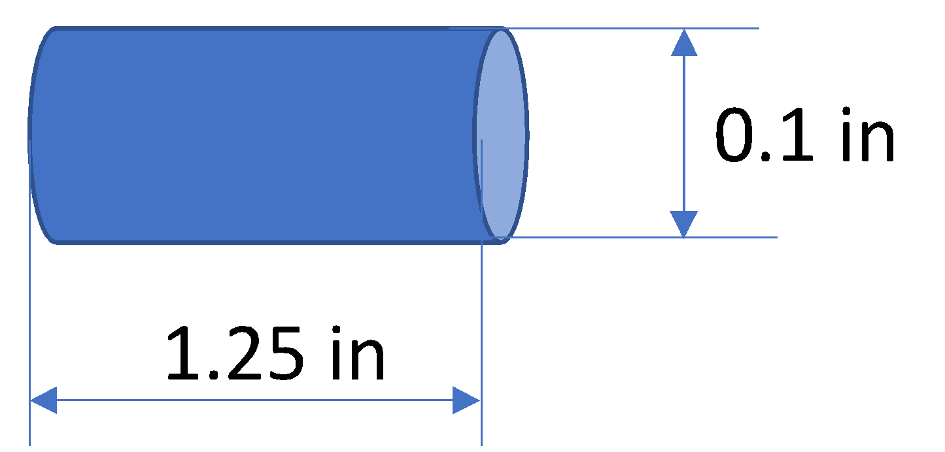

You need to *estimate the pressure drop* across the die since that information is needed to determine how much energy/ton of recycled plastic you have to pay. You will use that information together with other data (energy for platicizing the plastic, extruder maintenance, etc.) to estimate the investment and the ROI. You want to make sure that can get recycled pellets at 1,000 kgs/hour. The viscosity curve is that given in the first problem for resin 2.

A. INSTRUCTIONS

Calculate the pressure drop across the extruder die.

B. AVAILABLE DATA

* Extruder with a 500-holes die
* Dimensions of a single hole (length of 1.25 in and an radius of 0.05 in)
* 1,000 kgs of material shall be recycled per hour
* Viscosity curve of resin 2

C. ASSUMPTIONS

* The applied pressure is constant
* The resin density remains constant
* Constant temperature at 200C
* The energy increases with the shear stress into the polymer
* viscous heating at the wall and entrance effects as the flow changes are neglected

D. ALGORITHM

1. Determine the viscosity vs. shear rate curve at 200C
2. Use the Navier-Stokes equation to approximate the basic shapes (cylinders) as the pressure is increased with hole length but decreases with the radius.
3. Calculate the stress at the wall, which depends on the pressure drop
4. Solve the pressure drop from the previous step

## Q3: You are requested to get the TTS curve of a PP-HDPE Copolymer (MFI of 2 g/10 min) and its composite loaded with 3% of CNT to get their complex viscosity curves at 195oC. Also, using the master curve of the G”(ω) you are requested to get the First normal stress difference at steady state. Make any comments/observations you consider important.**(20 pts)**

A. INSTRUCTIONS

Describe the TTS and modelling procedure to get the first normal stress difference at steady state from complex viscosity curves.

B. AVAILABLE DATA

* Description of a PP-HDPE copolymer
* Description of a CNT composite

C. ASSUMPTIONS

* The complex viscosity experimental data is available

D. ALGORITHM

1. Decide the reference temperature (195C)
2. Calculate tan delta
3. Plot tan delta vs. frequency to get the horizontal shift factors
4. Plot tan delta vs. G* to get the vertical shift factors
5. Apply the shift to the data at each temperature
6. Fit the Wagner model to the master curve
7. From the Wagner fit, obtain the as, lambdas, ns and fs fitting parameters
8. With the fitting parameters, calculate N1 at the steady state.

## Q4: What type of melt distortions can be observed in polymers, give some examples on different polymer extrusión processeses and how can be avoided. **{10 pts} BONUS**

|  |  |
| --- | --- |
| Defect | Solution |
| Bubbles | Bubbles are cause by humidity; therefore, it would be necessary to dry the material |
| Shrinkage | The cause is due to excessive stress in the material. Slower cooling, lower speeds and a die with lower drag may solve this issue |
| pimples | The decrease of extrusion speed sorts out this problem, which is caused by the use of gels |
| Shark skin | Due to melt overheating, solution would be to increase the die temperature and decrease the extrusion speed |
| Surging | The puller may be at irregular speeds; the screw rotation would be at inconsistent velocities; or due to uneven polymer feed |
| Lumpiness | Due to low temperature. Rising the temperature would solve the problem. |