1-2- 3

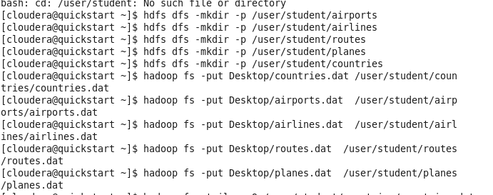

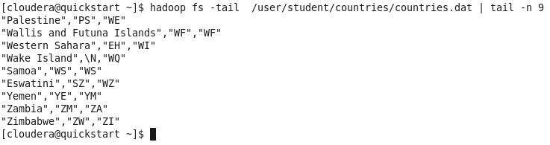

4

No difference in MD5

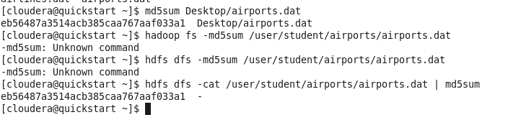

5 replicas

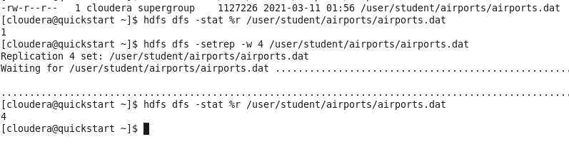

6 space

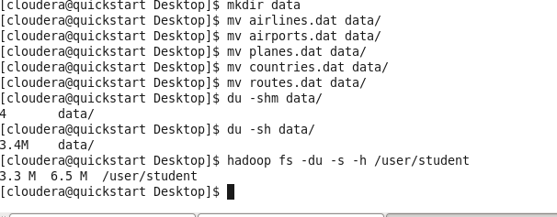

I think it takes 6.5 M on Hadoop because the files were spread thought the nodes using the block size 128 KB which might eventually lead to increasing of the file size

(hdfs getconf -confKey dfs.blocksize)

7 file system check

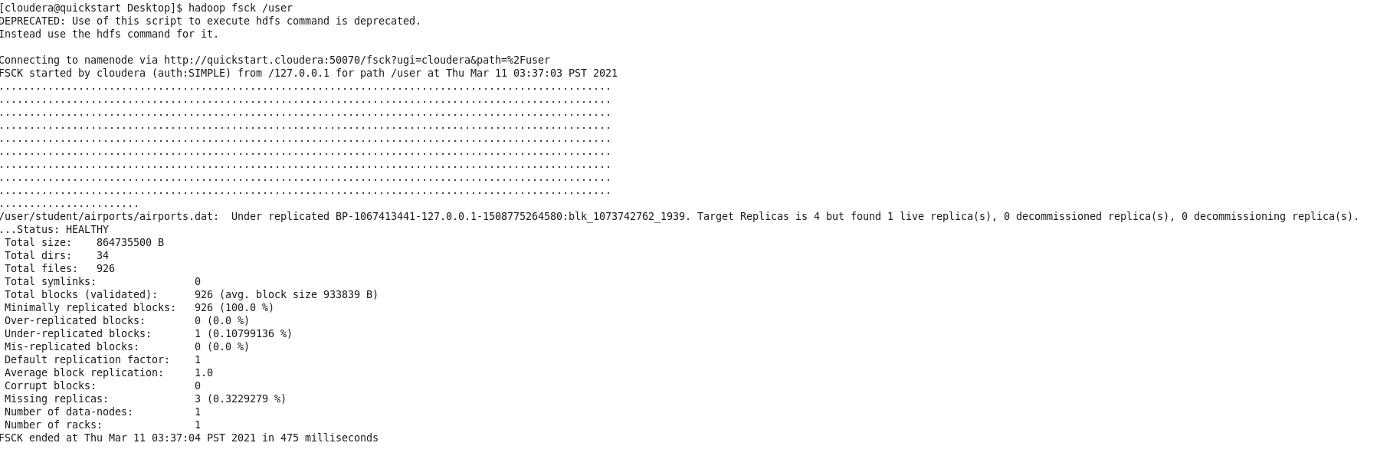

* Are there any corrupted files and blocks?  
  no
* Are there any missed blocks?  
  no
* How HDFS is configured? How many Data Nodes and Racks are in place?  
  1/1
* Where the blocks are located? (block path)  
  Hadoop fsck /user -locations gave nothing