1.  
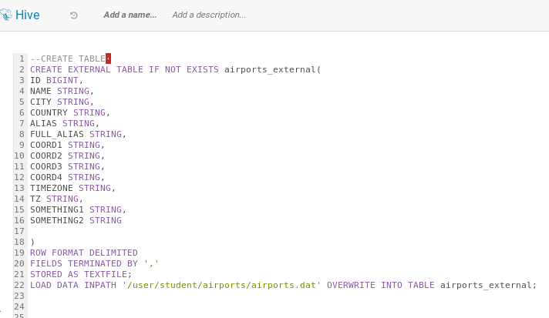

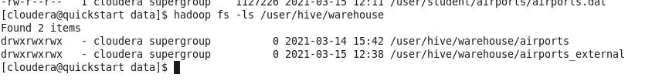

2.

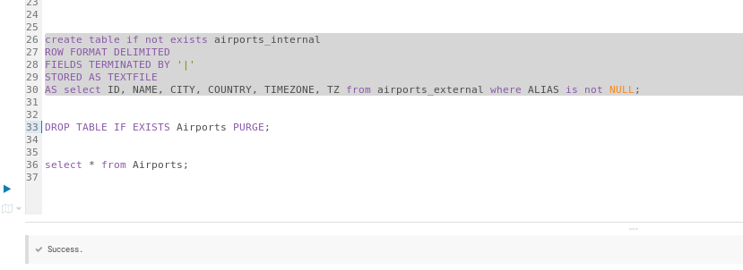

[cloudera@quickstart data]$ hadoop fs -ls /user/hive/warehouse

Found 4 items

drwxrwxrwx - cloudera supergroup 0 2021-03-15 12:48 /user/hive/warehouse/.hive-staging_hive_2021-03-15_12-47-44_487_8227259310510891249-2

drwxrwxrwx - cloudera supergroup 0 2021-03-14 15:42 /user/hive/warehouse/airports

drwxrwxrwx - cloudera supergroup 0 2021-03-15 12:38 /user/hive/warehouse/airports_external

drwxrwxrwx - cloudera supergroup 0 2021-03-15 12:48 /user/hive/warehouse/airports_internal

3.

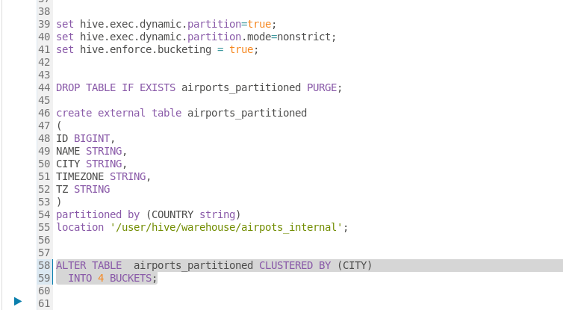

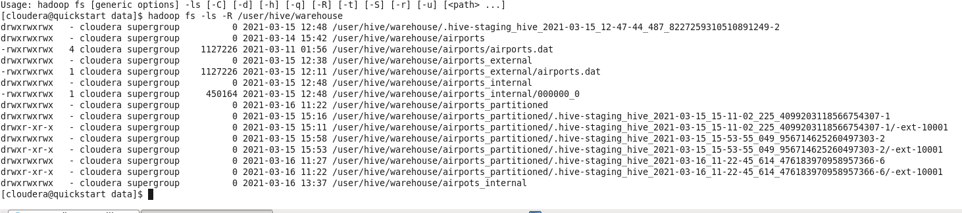

4.

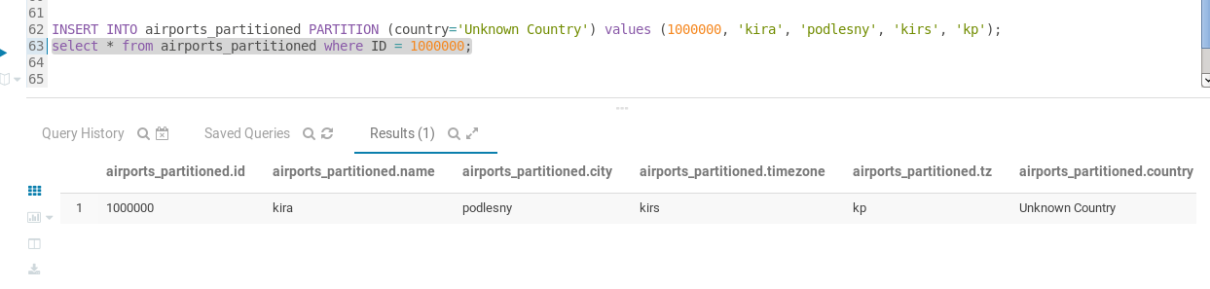

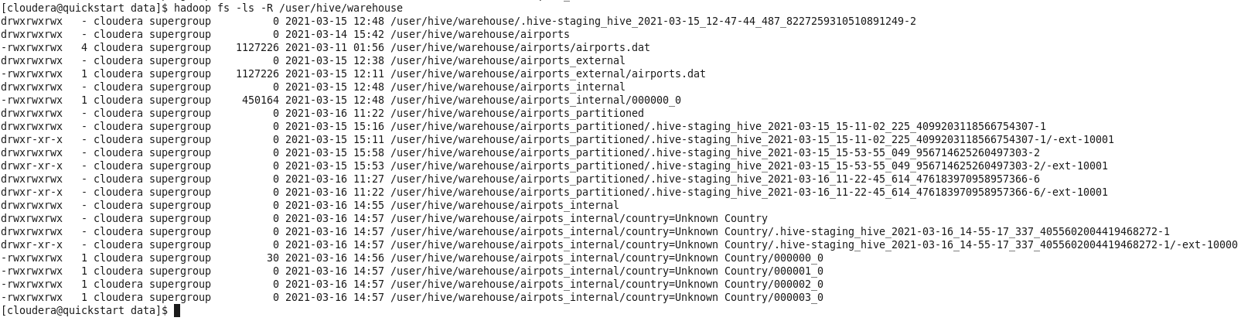

5.

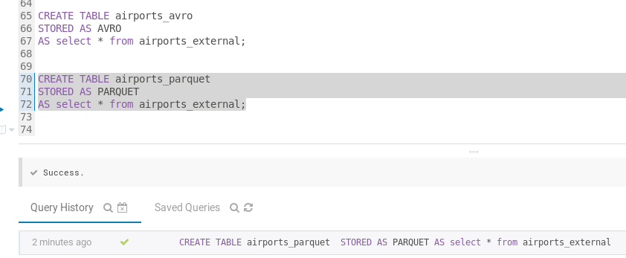

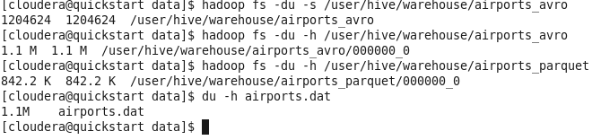

Parquet is compressed

6.

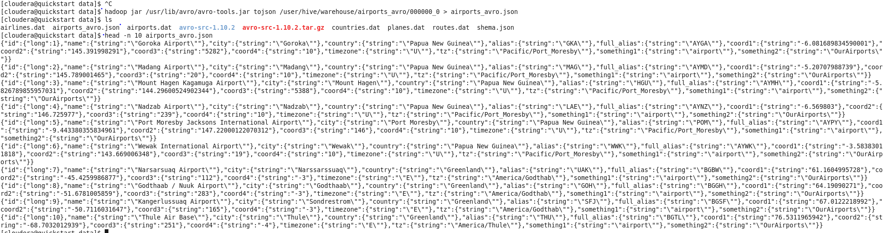

7.

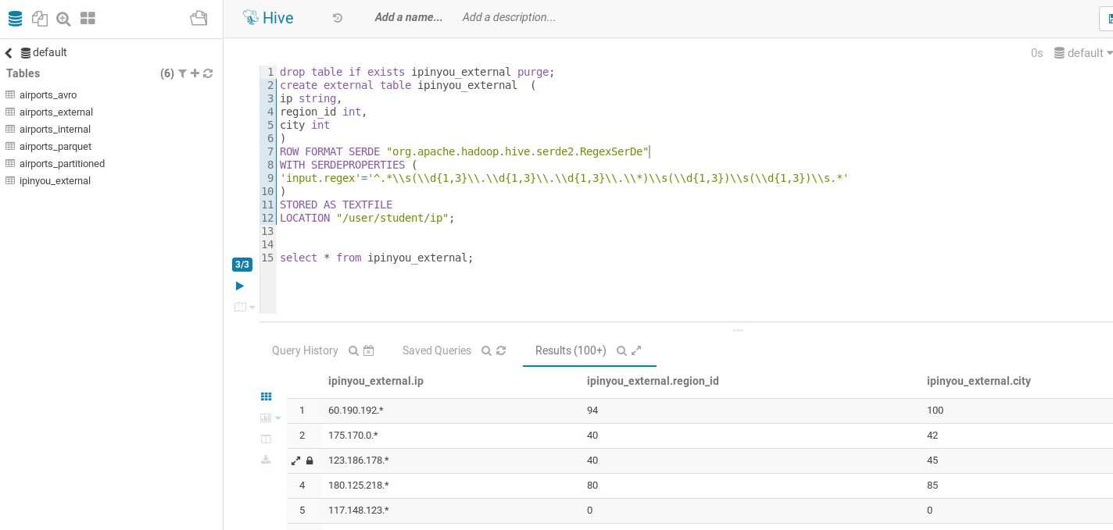

8.

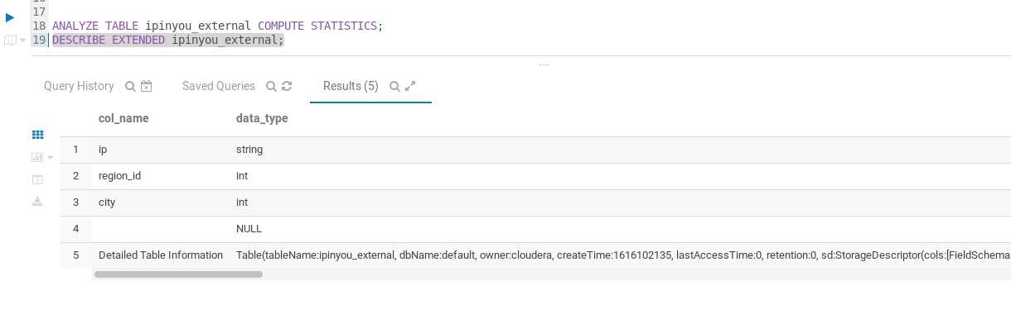

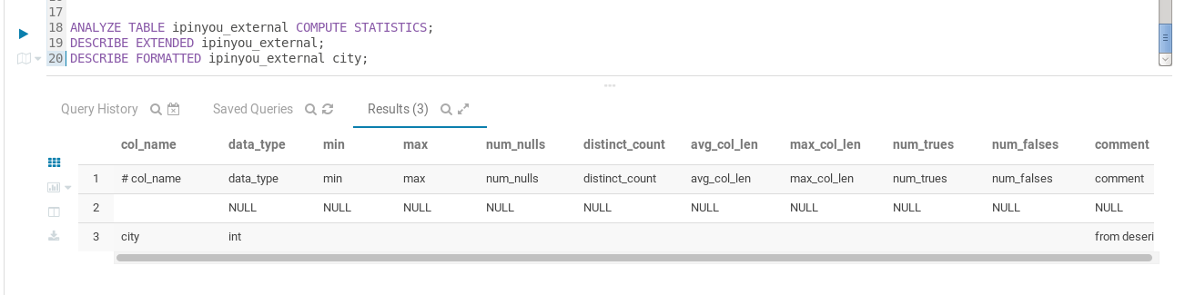

9.

Before drop  
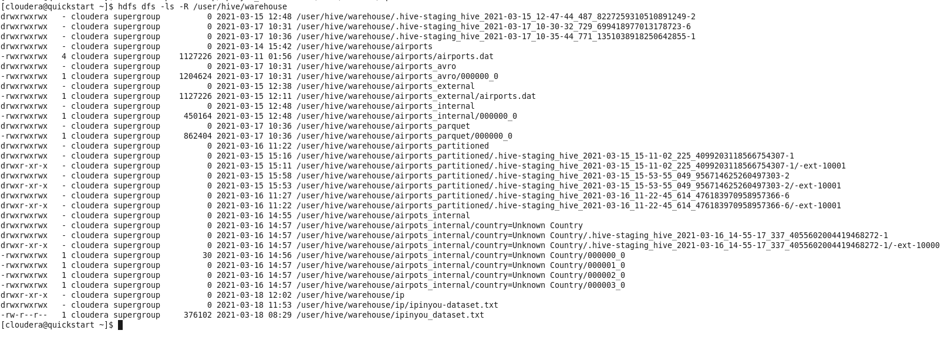

drop table if exists airports_avro purge;

drop table if exists airports_external purge;

drop table if exists airports_internal purge;

drop table if exists airports_avro purge;

drop table if exists airports_parquet purge;

drop table if exists airports_partitioned purge;

After removal

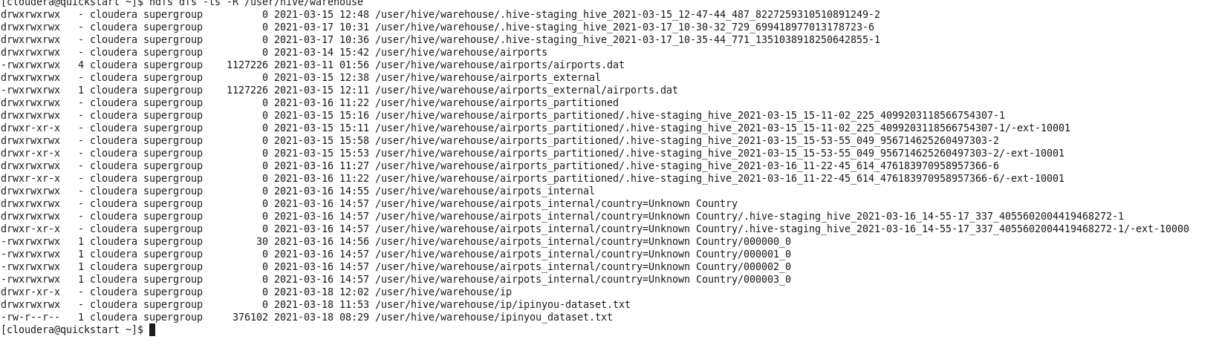

Everything remained in the cluster;