Manual

1. monitoring

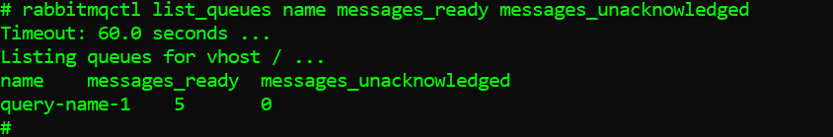

After restart

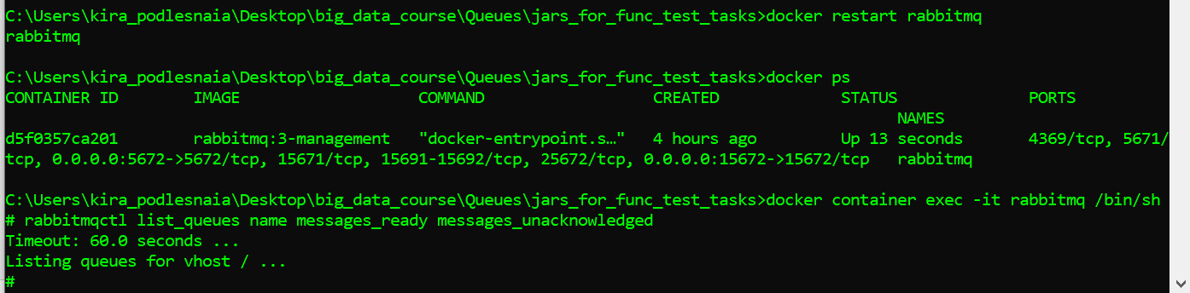

The q is no longer listed after restart. Apparently, it was not configured durable.

2. ack

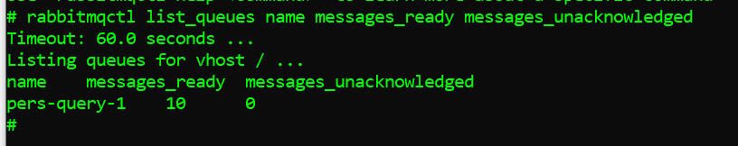

After restart

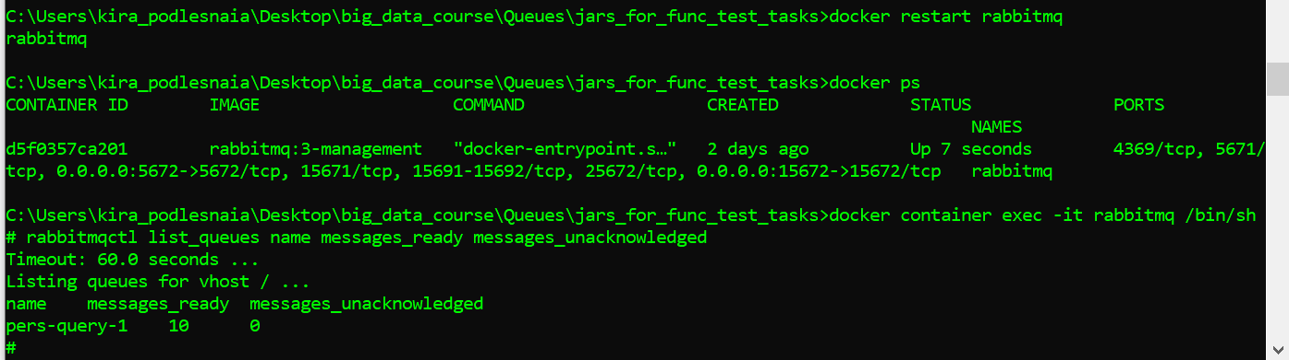

After restart q saves its state. Q is durable and messages are persistent. All were sent and ack-ed during the previous run before the restart.

3. round robin

1. 90 started receiving
2. 86 proceeded receiving
3. Connection was closed with receivers and no one picked new tasks from the round-robbin

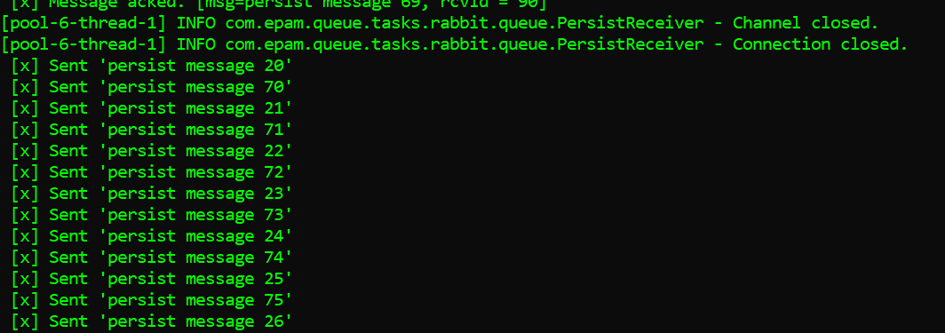

Automation

1.

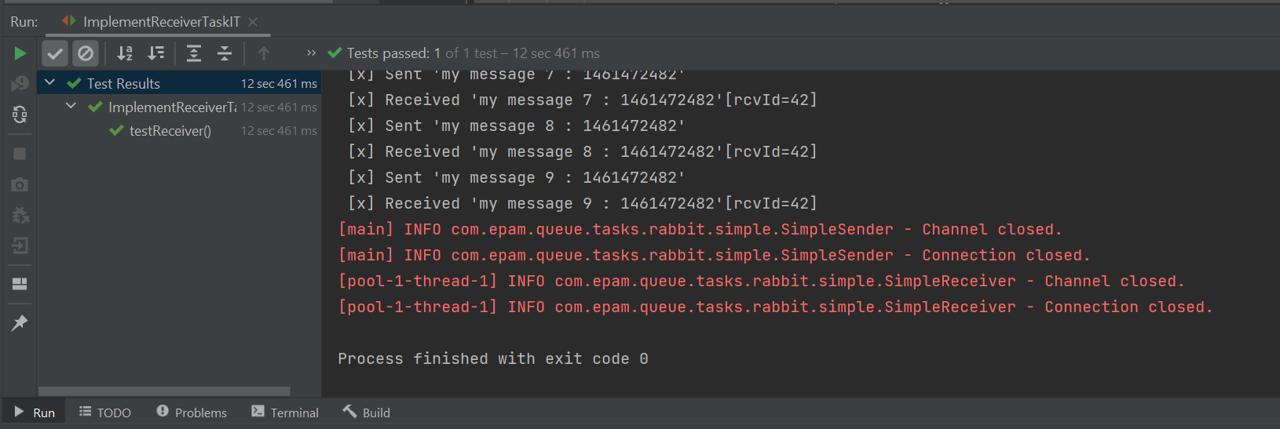

2.

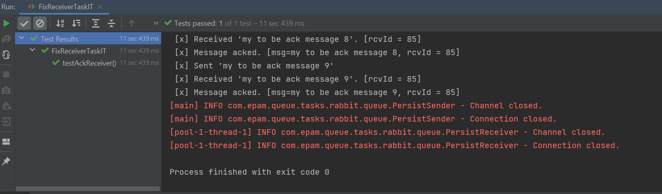

3.

