1)Using the data from nation database create the table ‘countryRank’ that will display

Ranking of countries by its area from largest to smallest. Ranking shold be calculated for regions and continent.

**create table:**

DROP TABLE IF EXISTS `countryRank`;

/*!40101 SET @saved_cs_client = @@character_set_client */;

SET character_set_client = utf8mb4 ;

CREATE TABLE `countryRank` (

`rank` int(11) NOT NULL,

`continent` varchar(50) NOT NULL,

`region` varchar(50) NOT NULL,

`name` varchar(50) NOT NULL,

`area` decimal(10,2) NOT NULL,

`country_code3` char(3) NOT NULL,

`national_day` date DEFAULT NULL

) ENGINE=InnoDB AUTO_INCREMENT=240 DEFAULT CHARSET=utf8;

/*!40101 SET character_set_client = @saved_cs_client */;

Insert values:

INSERT INTO countryRank

select * from (select DENSE_RANK() OVER (PARTITION BY continent, region ORDER BY area DESC), continents.name as continent, regions.name as region, countries.name as country, countries.area as area, countries.country_code3 as ccode3, countries.national_day as nday from regions

inner join continents on continents.continent_id = regions.continent_id

inner join countries on regions.region_id = countries.region_id) as sr

2)  
  
a)National holiday field shouldn’t contain NULL values, put ‘no data insead’

ALTER TABLE countryRank

MODIFY COLUMN national_day varchar(50);

SET SQL_SAFE_UPDATES=0;

UPDATE countryRank SET national_day='no data' WHERE national_day IS NULL;

SET SQL_SAFE_UPDATES=1;

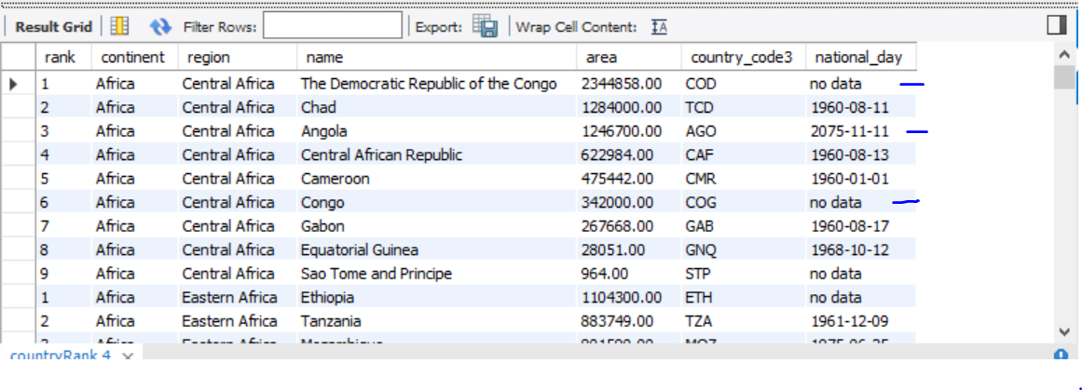

b)If notional holiday contains the date in future it should be changed to current date

SET SQL_SAFE_UPDATES=0;

UPDATE

countryRank

SET

national_day = CASE

WHEN cast(national_day as date) > curdate() THEN cast(curdate() as CHAR(50))

ELSE national_day

END

WHERE

national_day != 'no data';

SET SQL_SAFE_UPDATES=1;

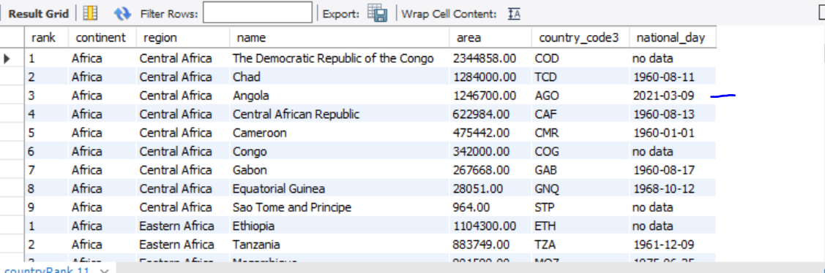

c)Get rid of the duplicates

**find duplicates:**

select rank, continent, region, name, area, country_code3, national_day, count(rank) as cnt

from countryRank

group by rank, continent, region, name, area, country_code3, national_day

having (cnt > 1);

8 duplicates

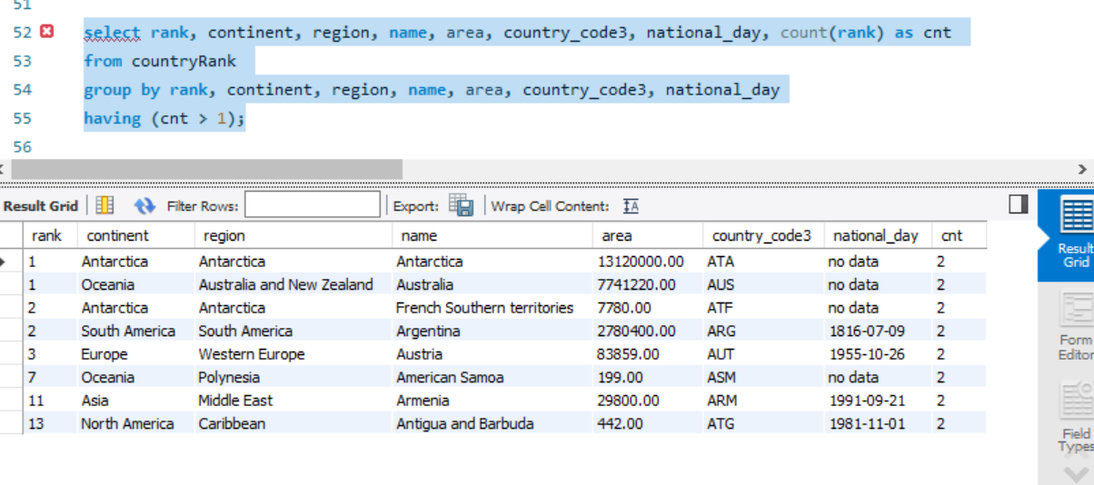

***I did not found how to remove them. Figured out that I need new table for it.***

Tried out this approach:

ALTER IGNORE TABLE countryRank ADD UNIQUE (rank, continent, region, name, area, country_code3, national_day);

But it corrupted ranking and mashed up all coutries

3)

Answer the question – what can be done on a database level to avoid problems with duplicates and Null values?

Duplicate values can be avoided by specifying more complex unique key

Null values can be avoided by restricting this data type in the field;