from pyspark.sql import SparkSession

spark = SparkSession.builder.getOrCreate()

flights = spark.read.csv('flights.csv', header=True)

flights.createOrReplaceTempView("tableFlights")

new_flights = spark.sql("select IFNULL(date_format(CAST(UNIX_TIMESTAMP(concat(YEAR, '-', MONTH, '-', DAY), 'yyyy-MM-dd') as TIMESTAMP),'yyyy-MM-dd'), date_format(to_timestamp('2015-01-01', 'yyyy-MM-dd'), 'yyyy-MM-dd')) as DEPARTURE_DATE, IFNULL(date_format(TO_TIMESTAMP(CAST(UNIX_TIMESTAMP(DEPARTURE_TIME, 'HHmm') AS TIMESTAMP)), 'HH:mm:ss'), date_format(to_timestamp('00:00:00', 'HH:mm:ss'), 'HH:mm:ss')) as DEPARTURE_TIME, AIRLINE, FLIGHT_NUMBER from tableFlights")

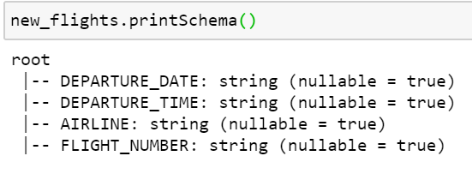

sequence = pyspark.sql.Window.partitionBy("DEPARTURE_DATE").orderBy("DEPARTURE_TIME")

new_flights.withColumn("flight_serial_number", pyspark.sql.functions.row_number().over(sequence)).show(10)

