Dedicated DICOM Daemon Setup for Scripting Exports
Varian DICOM Services + DCMTK + local script post-processing
Scope. Practical setup pattern for ESAPI or scripting exports. Screenshots are anonymized; AE titles, IP addresses, ports, paths and firewall rules must be adapted locally.

Architecture in one page
Clinical Varian DB and File Services can technically be reused. For scripting and automation, a dedicated route is preferable so export/test traffic does not compete with production DICOM paths used by machines, imaging devices or routine clinical workflows.
Component | Role | Endpoint | Key point
Varian DB Service | Database/import route + trusted AEs | <DB_AE_TITLE>:<DB_PORT> | Dedicated copy of clinical pattern
Varian File Service | Writes received objects to folder | <FILE_AE_TITLE>:<FILE_PORT> | Hand-off point for scripts
DCMTK endpoint | Test / send / receive / move | <DCMTK_AE_TITLE>:<DCMTK_PORT> | Own AE title and port
Script watcher (optional) | Sorts, validates, forwards | <LOCAL_STORAGE_PATH> | Local folder worked reliably
Use separate TCP ports for DB Service, File Service and DCMTK. Do not reuse clinical production ports.
If DCMTK is installed on the same DCF server, the IP address can be identical; AE title and port separate the endpoints.
The File Service folder is a controlled hand-off location, not the final archive.

References
Varian Code Samples Wiki: Scripting the Varian DICOM DB Daemon with ESAPI
Varian API Book, Chapter 4: VarianApiBook.pdf

Create services and configure the File Service
Open DICOM Services Configuration on the DCF/application server.
Create or clone a Varian DB Service with a scripting-specific name and AE title.
Create or clone a Varian File Service with a matching scripting/export name and AE title.
Bind both services to the correct network interface and restart after saving.
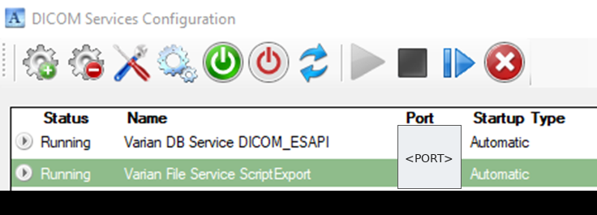  Figure 1. Dedicated services; ports anonymized. | File Service. All objects arriving through this route are written to the storage location. A local folder was most reliable here; UNC/network paths depend on firewall, SMB and service-account permissions.  <FILE_AE_TITLE>  <FILE_PORT>  <LOCAL_STORAGE_PATH>
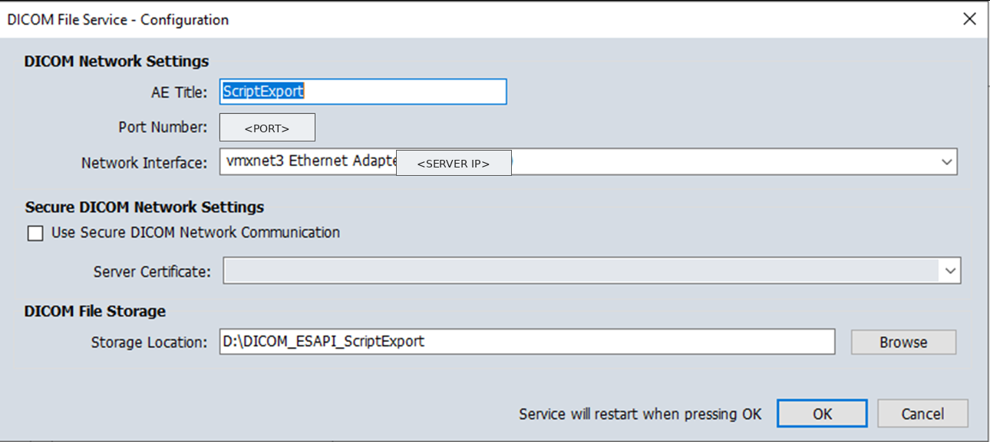
Figure 2. File Service configuration. The storage folder is where the script workflow starts.

Configure the DB Service and trusted AEs
Trusted Application Entities define which DICOM peers may communicate with the DB Service. For this scripting route, add at least the dedicated File Service and the DCMTK endpoint.
Use the same patient matching and patient creation policy as the equivalent clinical configuration unless there is a defined reason to differ.
Keep diagnostic options such as saving every IOD or SQL tracing disabled unless needed; they can create large data volumes.
AE title | IP address | Port
<FILE_AE_TITLE> | <DCF_SERVER_IP> | <FILE_PORT>
<DCMTK_AE_TITLE> | <DCF_SERVER_IP> | <DCMTK_PORT>
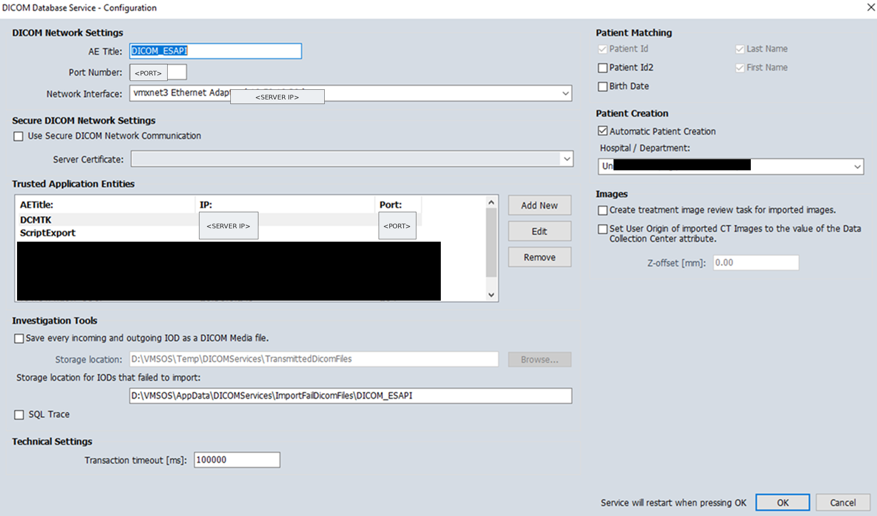
Figure 3. DB Service configuration with trusted AEs. IP addresses and ports are anonymized.

DCMTK, testing and post-processing
DCMTK is a robust choice for commissioning and scripting-related DICOM workflows. It provides tools such as echoscu, storescu, storescp, findscu and movescu.
Assign DCMTK its own AE title and port and add it as a trusted AE if it needs to query, move, send or receive objects.
Test first with a small, controlled DICOM object before connecting production scripts.
EvilDICOM is possible for .NET/C# workflows, but previous setups showed issues with German umlauts/character encoding. DCMTK was safer here.
echoscu -aec <DB_AE_TITLE> <DCF_SERVER_IP> <DB_PORT>
echoscu -aec <FILE_AE_TITLE> <DCF_SERVER_IP> <FILE_PORT>
storescu -aet <DCMTK_AE_TITLE> -aec <FILE_AE_TITLE> <DCF_SERVER_IP> <FILE_PORT> test.dcm

Post-processing pattern (optional, sorting with DICOM or ESAPI values)  Monitor <LOCAL_STORAGE_PATH>.  Wait until file activity has stopped.  Read routing tags: SOP Class UID, Modality, Patient ID, Study UID and Series UID.  Sort/validate/forward objects and write logs.  Move failed files to an error folder; delete only after validation. | Practical result  The Varian File Service receives the objects, DCMTK supports testing or routing, and local scripts do the deterministic downstream processing. In this setup the folder is shared/monitored after local write, then scripts sort by local rules.

