Prepared Statements, SQL Injection Prevention, PDO Transactions, and Production Configuration in PHP
This report explains how to run queries using prepared statements (MySQLi and PDO), how prepared statements thwart SQL injection, how to manage transactions using PDO, and the configuration/code changes to consider when moving a PHP application from development to production. Figures are included to illustrate prepared-statement flow and transaction workflow. The report draws on resources including WebsiteBeaver tutorials and the OWASP SQL Injection Prevention Cheat Sheet.

1. Running Queries Using Prepared Statements
Prepared statements (parameterised queries) separate SQL code from data by defining a query template with placeholders and binding values at execution time. This process reduces the risk of injecting malicious SQL. In MySQLi the typical steps are: create a mysqli connection, prepare the statement with ? placeholders, bind types and variables using bind_param (e.g., "si" for string and integer), execute, fetch results, then close the statement. Example:
$mysqli = new mysqli($host, $user, $pass, $db);
$stmt = $mysqli->prepare("SELECT * FROM users WHERE username = ? AND status = ?");
$stmt->bind_param("si", $username, $status);
$stmt->execute();
$result = $stmt->get_result();
PDO offers a database-agnostic interface and supports named (":name") and positional (?) placeholders. Typical PDO setup includes disabling emulated prepares and enabling exceptions:
$dsn = "mysql:host=localhost;dbname=myDB;charset=utf8mb4";
$options = [
PDO::ATTR_EMULATE_PREPARES => false,
PDO::ATTR_ERRMODE => PDO::ERRMODE_EXCEPTION,
PDO::ATTR_DEFAULT_FETCH_MODE => PDO::FETCH_ASSOC,
];
$pdo = new PDO($dsn, $user, $pass, $options);
Prepare and execute can be done via bindParam/bindValue or by passing an array to execute().

2. How Prepared Statements Thwart SQL Injection
SQL injection occurs when unsanitised user input is interpreted as SQL code. Prepared statements prevent this by ensuring that the SQL statement structure is parsed and compiled by the database before data values are supplied. Bound values are treated exclusively as data literals; they cannot change SQL syntax. For example, an attacker string such as "'; DROP TABLE users; --" when bound as a parameter is stored as a string value, not executed. OWASP explicitly recommends prepared statements as the primary defense, and warns against relying solely on escaping.
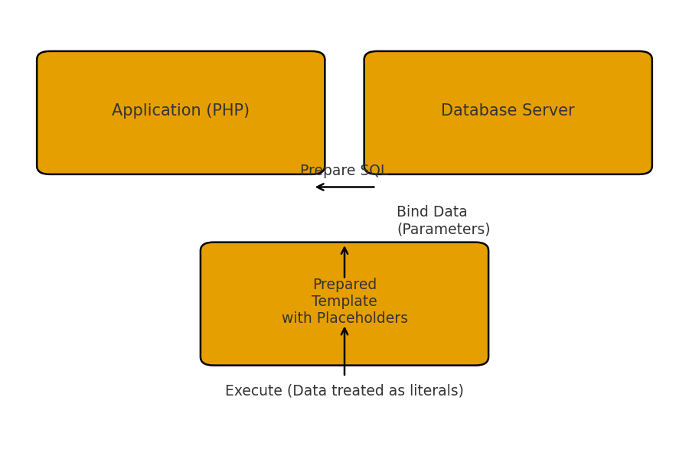
Figure 1: Prepared statement lifecycle — prepare, bind parameters, execute.

3. Running Transactions Using PDO
Transactions group multiple database operations into an atomic unit: either all changes commit or none do. PDO provides a simple API:
try {
$pdo->beginTransaction();
$stmt = $pdo->prepare("UPDATE accounts SET balance = balance - ? WHERE id = ?");
$stmt->execute([$amount, $fromId]);
$stmt2 = $pdo->prepare("UPDATE accounts SET balance = balance + ? WHERE id = ?");
$stmt2->execute([$amount, $toId]);
$pdo->commit();
} catch (Exception $e) {
$pdo->rollBack();
// handle or log
}
Using prepared statements inside transactions protects both query integrity and data consistency.
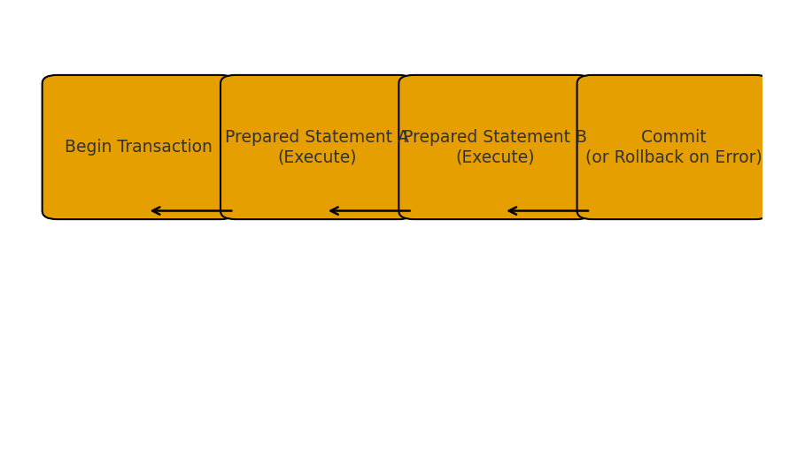
Figure 2: Transaction workflow — begin, execute statements, commit or rollback on error.

4. Moving from Development to Production: Configuration and Code Changes
When transitioning to production, several configuration and code hardening steps are critical:
1. Disable emulated prepares (PDO::ATTR_EMULATE_PREPARES => false) to ensure native prepared statement behavior.
2. Set PDO::ATTR_ERRMODE => PDO::ERRMODE_EXCEPTION and disable display_errors in php.ini; log errors instead.
3. Use explicit character sets (e.g., charset=utf8mb4 in DSN) to avoid encoding pitfalls.
4. Secure credentials using environment variables or secret stores; avoid hard-coding credentials in files within the web root.
5. Enforce least privilege for database accounts—grant only required permissions.
6. Validate inputs with allow-lists for identifiers (table or column names) and use prepared statements for data.
7. Avoid DDL inside transactions where databases implicitly commit.
8. Enable TLS for remote DB connections, configure firewalls, and ensure regular backups and monitoring.
Additionally, audit any third-party libraries or ORM layers to ensure they use parameterised queries rather than unsafe string concatenation.

Conclusion
Prepared statements are the cornerstone of SQL injection prevention by design: the database distinguishes SQL code from data. Using PDO with native prepared statements, proper error handling, and transactions for multi-step changes produces a robust, secure data-access layer. Moving to production requires disabling emulation, securing secrets, tuning error handling, and enforcing least privilege. Complementary OWASP recommendations — allow-listing, input validation, and defense-in-depth — further strengthen application security.

References
- OWASP Foundation. (n.d.). SQL Injection Prevention Cheat Sheet. Retrieved from
- https://cheatsheetseries.owasp.org/cheatsheets/SQL_Injection_Prevention_Cheat_Sheet.html
- WebsiteBeaver. (2017). PHP PDO Prepared Statements Tutorial to Prevent SQL Injection. Retrieved from
- https://websitebeaver.com/php-pdo-prepared-statements-to-prevent-sql-injection
- WebsiteBeaver. (2017). PHP MySQLi Prepared Statements Tutorial to Prevent SQL Injection. Retrieved
- from https://websitebeaver.com/prepared-statements-in-php-mysqli-to-prevent-sql-injection
- PHP Manual. (n.d.). PDO::beginTransaction. Retrieved from
- https://www.php.net/manual/en/pdo.begintransaction.php
- PHP Manual. (n.d.). MySQLi Prepared Statements. Retrieved from
- https://www.php.net/manual/en/mysqli.quickstart.prepared-statements.php

