# Database Schema - CV Processing Portal

This section describes the complete SQL Data Definition Language (DDL) schema for the CV Processing Portal project. The schema ensures data integrity, normalization, and supports the functional requirements of the system. The tables cover users, candidate details, resume file storage, skills, job postings, match scoring, and audit logs.  
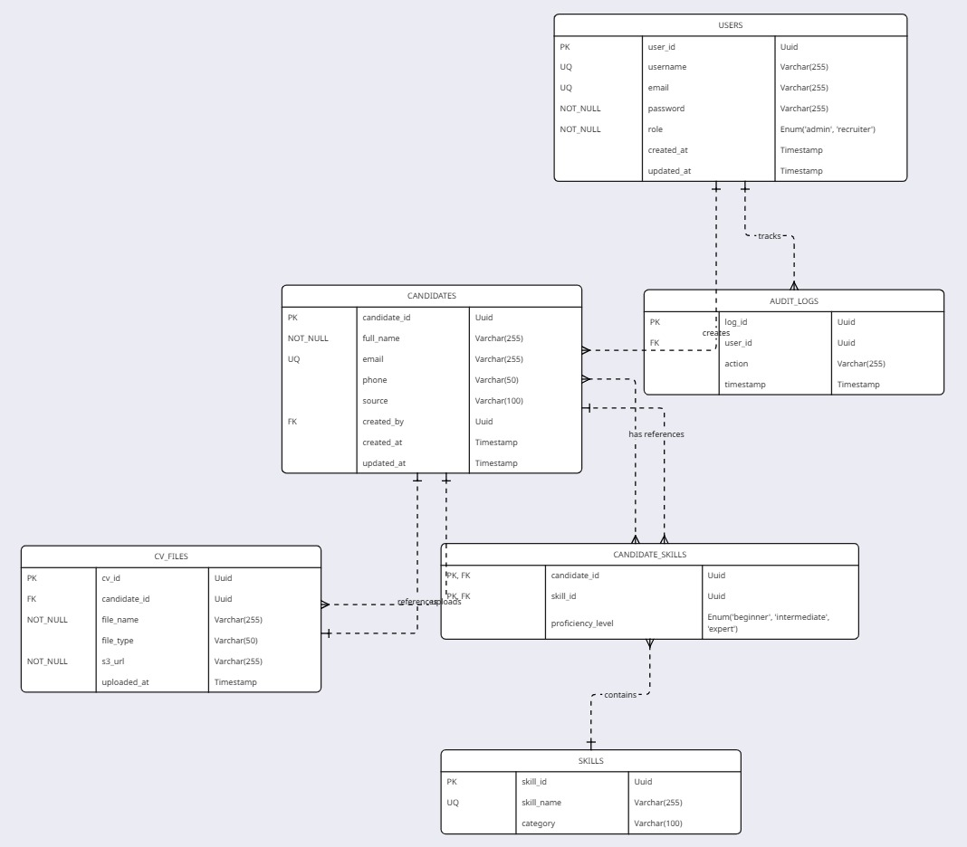

## SQL DDL Scripts

**-- USERS TABLE: Stores recruiters and admin details**CREATE TABLE users (  
 user_id SERIAL PRIMARY KEY,  
 username VARCHAR(50) NOT NULL UNIQUE,  
 email VARCHAR(100) NOT NULL UNIQUE,  
 password_hash VARCHAR(255) NOT NULL,  
 role VARCHAR(20) CHECK (role IN ('RECRUITER', 'ADMIN')),  
 created_at TIMESTAMP DEFAULT CURRENT_TIMESTAMP,  
 is_active BOOLEAN DEFAULT TRUE  
);  
  
-**- CANDIDATES TABLE: Extracted from uploaded CVs**  
CREATE TABLE candidates (  
 candidate_id SERIAL PRIMARY KEY,  
 full_name VARCHAR(100) NOT NULL,  
 email VARCHAR(100),  
 phone VARCHAR(20),  
 address TEXT,  
 created_at TIMESTAMP DEFAULT CURRENT_TIMESTAMP  
);  
  
**-- CV FILES TABLE: Stores uploaded CV file metadata and S3 path**CREATE TABLE cv_files (  
 cv_id SERIAL PRIMARY KEY,  
 candidate_id INT NOT NULL REFERENCES candidates(candidate_id) ON DELETE CASCADE,  
 file_name VARCHAR(255) NOT NULL,  
 s3_url TEXT NOT NULL,  
 upload_date TIMESTAMP DEFAULT CURRENT_TIMESTAMP,  
 uploaded_by INT REFERENCES users(user_id),  
 content_type VARCHAR(50),  
 file_size INT  
);  
  
**-- SKILLS TABLE: Skill dictionary and extracted mapping**CREATE TABLE skills (  
 skill_id SERIAL PRIMARY KEY,  
 candidate_id INT REFERENCES candidates(candidate_id) ON DELETE CASCADE,  
 skill_name VARCHAR(100) NOT NULL,  
 proficiency_level VARCHAR(50),  
 source VARCHAR(50),  
 UNIQUE(candidate_id, skill_name)  
);

**-**  
-- INDEXING FOR PERFORMANCE  
CREATE INDEX idx_candidates_email ON candidates(email);  
CREATE INDEX idx_cvfiles_candidate ON cv_files(candidate_id);  
CREATE INDEX idx_skills_name ON skills(skill_name);  
CREATE INDEX idx_auditlogs_user ON audit_logs(user_id);