**Problem Statement**

**Instructions:**

1. This is a coding challenge. The task is to create a webpage as per a given design mockup.
2. All the details and resources required for completing the challenge are available in the shared folder.
3. No internet access is allowed during the test.
4. The duration of the test is **120 minutes**.

**Task:**

You will be developing a dashboard for a fictional resume analysis service. The required design is captured in the mockup below:

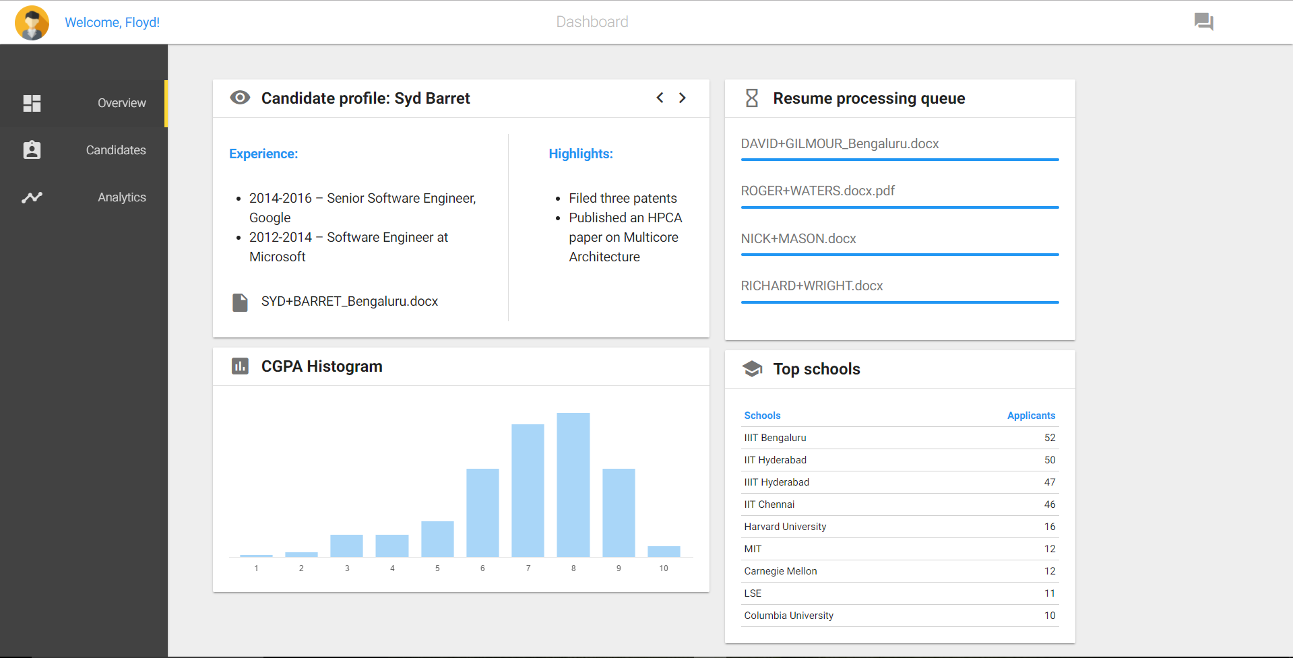

The design has 4 sections, a top bar and a side navigation bar. Each section is designed as a ‘Card’.

Card 1 contains candidate details.

Card 2 lists the progress of the resume processing.

Card 3 is a histogram based on the CGPA of the candidates.

Card 4 is a table of the top schools.

You should animate the progress of the top two resumes progress bar in the Card 2. On loading the page the two progress bars should start from zero and should complete in about 40-50 seconds.

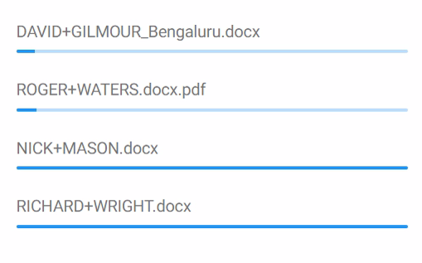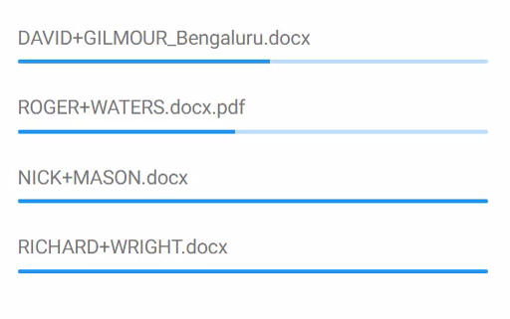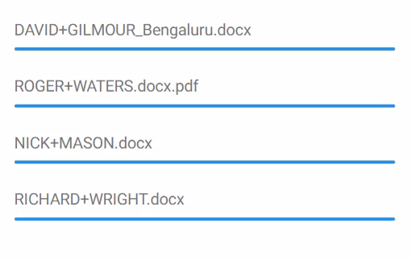

There should be a light hover effect for menu bar and arrows in Card 1 as shown below. You are not required to perform any action on click.

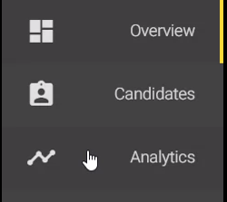

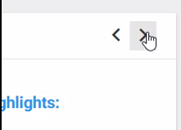

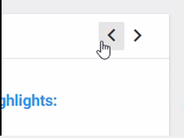

Data for Card 2 and Card 3 are in the file ‘data.js’ in js folder of the template.

Data for Card 1 and Card 4 can be taken from the mockup.

**Template and Resources:**

There is a folder ‘**template’** that contains all the libraries and a html template that you would use as your starting point.

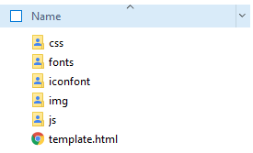

The folder **‘css**’ contains *materialize.css* which is the library file for materialize (refer section on Materialize for details), *materialize-fix-template.css* which you can use to add your custom CSS.

The folder **‘fonts’** contains the Roboto font which is the default materialize CSS font

The folder ‘**Iconfont’** includes Google material icons for offline access

The folder **‘img’** contains the image to be used as the profile picture

The folder **‘js’** contains the library file for chart.js (see section on ChartJS for details), jquery version 2.1.1, materialize.js and data.js which contains the data for the table and chart in JSON formats.

**template.html** contains the basic skeleton and all libraries are properly included. The template looks as below:

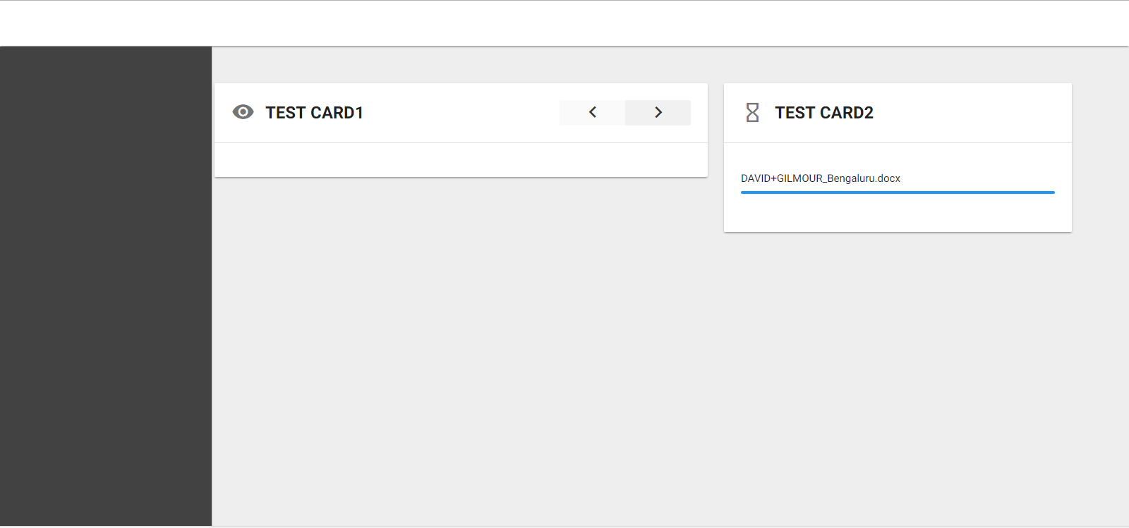

**Materialize**

Materializeis a front-end framework based on Material Design.

Material Design is a design language developed in 2014 by Google. Material Design makes liberal use of grid-based layouts, responsive animations and transitions, padding, and depth effects such as lighting and shadows. Google's goal is to develop a system of design that allows for a unified user experience across all their products on any platform.

Materialize is similar to other CSS libraries with features such as grid system, readymade classes etc.

There is a folder ‘MaterializeCSSDoc’ which contains the documentation for the library.

**ChartJS**

ChartJSprovides beautiful flat designs for charts. It uses HTML5 canvas element for rendering. Support for older browsers like IE7/8 is added through polyfill.

ChartJS charts are responsive by default and they work well on mobiles and tablets.

There is a folder ‘ChartJSDoc’ which contains the documentation about the library.

**Mark Distribution:**

You would be evaluated on completeness and quality of your dashboard. The number distribution is as follows:

* Card 1 – 16
* Card 2 – 16
* Card 3 – 16
* Card 4 – 10
* Top bar – 8
* Sidebar – 8
* Coding standards/ Reusability – 10
* Responsive design – 16