**DISASTER RECOVERY WITH IBM CLOUD VIRTUAL SERVERS**

**(Phase-2)**

**SUBMITTED BY:**

**KIRAN P**

**INNOVATION:**

Incorporating IBM Cloud virtual servers into your disaster recovery strategy can significantly enhance your organization's ability to respond to and recover from disasters. IBM Cloud offers a range of cloud-based solutions and services that can facilitate innovative disaster recovery approaches. Here are some ideas for innovation in disaster recovery with IBM Cloud virtual servers:

**1.GEOGRAPHICALLY DISTRIBUTED VIRTUAL SERVERS:** Deploy virtual servers across different IBM Cloud data centers in geographically diverse locations. This approach ensures redundancy and reduces the risk of a single point of failure.

**2.AUTOMATED FAILOVER:** Utilize IBM Cloud's automation tools and services to set up automatic failover for your virtual servers. This means that if one server or data center goes down, your workloads can automatically switch to a backup server or location, minimizing downtime.

**3.DISASTER RECOVERY AS A SERVICE (DRAAS):** IBM Cloud offers DRaaS solutions that provide a fully managed, turnkey approach to disaster recovery. You can replicate your virtual servers to a secondary data center, and in the event of a disaster, fail over to the secondary site seamlessly.

**4.ADVANCED BACKUP AND SNAPSHOT TECHNOLOGIES:** IBM Cloud offers advanced backup and snapshot technologies that allow you to create point-in-time copies of your virtual servers. These can be crucial for restoring your systems to a previous state in the event of data corruption or other issues.

**5.SOFTWARE-DEFINED NETWORKING (SDN):** Leverage SDN solutions on IBM Cloud to dynamically adjust your network configurations in response to disaster scenarios. This can improve network resilience and allow for real-time adjustments as conditions change.

**6.MULTI-CLOUD DISASTER RECOVERY:** Consider using IBM Cloud in conjunction with other cloud providers for multi-cloud disaster recovery. This approach ensures redundancy and flexibility, as well as the ability to choose the most cost-effective option at any given time.

**7.RESOURCE SCALING:** IBM Cloud virtual servers are highly scalable. You can leverage auto-scaling capabilities to ensure that your disaster recovery environment can handle increased workloads during or after a disaster.

**8.SECURITY AND COMPLIANCE:** IBM Cloud offers various security and compliance features, including encryption, identity and access management, and compliance certifications. Ensure that your disaster recovery plan adheres to the highest security standards to protect your data.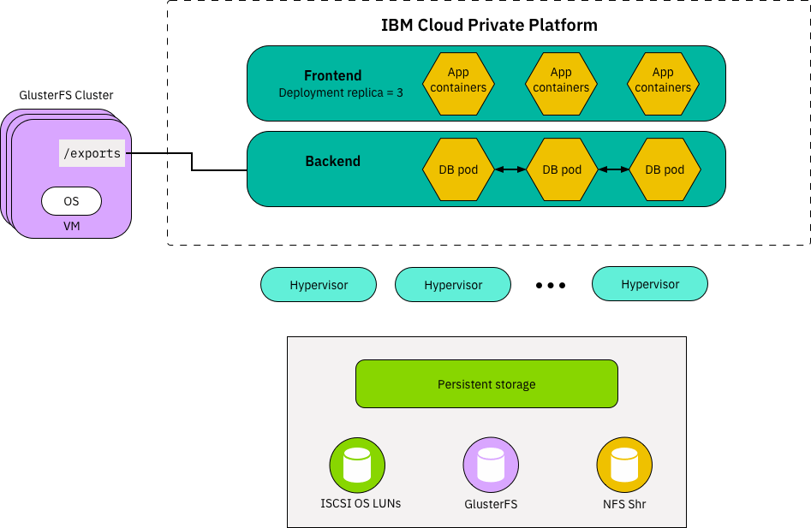

**9.TESTING AND SIMULATION:** Regularly test your disaster recovery plan using IBM Cloud virtual servers. You can simulate disaster scenarios to ensure your team is well-prepared and that your failover processes work as expected.

**10.MONITORING AND ALERTING:** Implement robust monitoring and alerting systems to keep a close eye on the health and performance of your virtual servers. This will help you identify issues and initiate recovery processes proactively.

**11.DOCUMENTATION AND TRAINING:** Invest in thorough documentation and training for your disaster recovery team. Ensure they understand the IBM Cloud environment and the specific procedures for disaster recovery.

**12.COST OPTIMIZATION:** Use IBM Cloud's cost optimization tools to ensure that your disaster recovery solution is cost-effective. You can automatically adjust resource allocation to optimize costs while maintaining performance.

In summary, IBM Cloud virtual servers offer a flexible and scalable platform for implementing innovative disaster recovery solutions. By combining IBM Cloud's capabilities with best practices in disaster recovery planning, automation, and testing, you can create a robust and reliable strategy for business continuity.

**DESIGN:**

Designing a disaster recovery (DR) plan with IBM Cloud virtual servers involves creating a comprehensive strategy to ensure the availability and integrity of your critical applications and data in the event of a disaster. Here's a step-by-step design for a disaster recovery plan using IBM Cloud virtual servers:

**1.ASSESSMENT AND ANALYSIS:**

Identify critical systems, applications, and data.Define RTO (Recovery Time Objective) and RPO (Recovery Point Objective) for each system.Determine the potential disaster scenarios and their impact on your business.

**2.SELECT IBM CLOUD VIRTUAL SERVERS:**

Choose the appropriate virtual server types based on your workload requirements. Consider redundancy and failover options available on IBM Cloud. Ensure that virtual servers are located in different geographical regions for redundancy.

**3.BACKUP AND REPLICATION:**

Implement regular backups of your virtual servers and data to secondary IBM Cloud locations. Set up asynchronous replication for near real-time data consistency. Use IBM Cloud Object Storage for storing backup copies securely.

**4.Automated Failover:**

Set up automated failover processes using IBM Cloud's automation tools like IBM Cloud Resource Controller, VPC, and Load Balancers. Create scripts or automation policies for instant failover in case of a disaster.

**5.NETWORK CONFIGURATION:**

Design a secure and robust network infrastructure using IBM Cloud Virtual Private Cloud (VPC).Implement VPNs or direct network connections for secure data transfer between primary and secondary data centers.

**6.SECURITY AND COMPLIANCE:**

Enforce security best practices using IBM Cloud Identity and Access Management (IAM) and encryption features.Ensure compliance with industry standards and regulations.

**7.MONITORING AND ALERTING:**

Set up monitoring and alerting using IBM Cloud Monitoring and AI-powered tools to track the health of virtual servers and infrastructure. Define alerting thresholds and response procedures.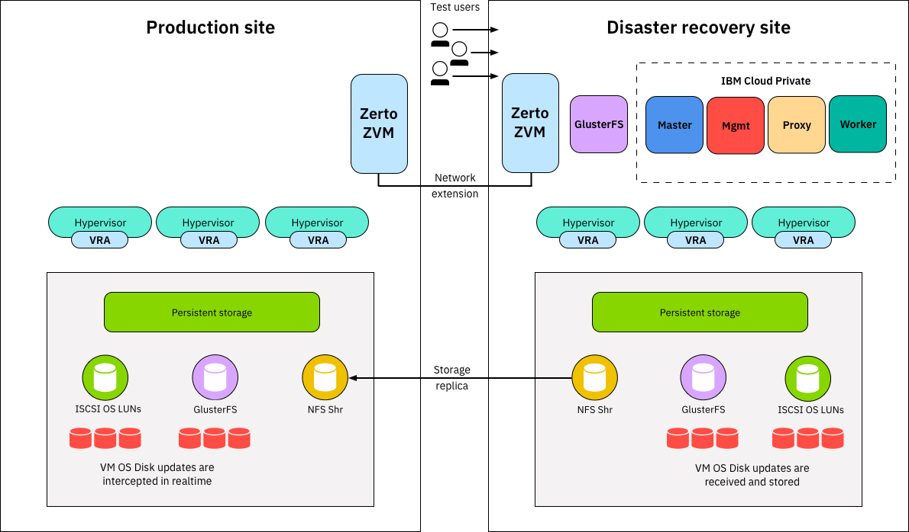

**8.TESTING AND VALIDATION:**

Regularly test your DR plan, including both planned and unplanned failover scenarios.Document the test results and update the plan as necessary based on findings.

**9.DOCUMENTATION AND RUNBOOKS:**

Maintain detailed documentation, including step-by-step runbooks for disaster recovery procedures. Ensure that your DR team is well-trained and has access to this documentation.

**10.COMMUNICATION PLAN:**

Establish a communication plan to ensure that all relevant stakeholders are informed during a disaster. Define roles and responsibilities for team members.

**11.COST MANAGEMENT:**

Use IBM Cloud's cost management tools to optimize resource usage and control costs. Regularly review and adjust your resource allocation based on business needs and budget constraints.

**12.REGULAR UPDATES AND REVIEWS:**

Periodically review and update your DR plan to accommodate changes in your IT environment, infrastructure, or business needs. Stay up to date with the latest IBM Cloud services and features for disaster recovery.

**13.THIRD-PARTY INTEGRATION:**

If required, integrate third-party disaster recovery solutions or tools with IBM Cloud to enhance your capabilities.

**14.REGULATORY COMPLIANCE:**

Ensure that your DR plan aligns with industry and regulatory compliance requirements specific to your business.

**15.TESTING AND AUDITING:**

Periodically conduct audits and compliance testing to ensure that your DR plan meets all the required standards.

**16.COMMUNICATION WITH IBM CLOUD SUPPORT:**

Establish a communication channel with IBM Cloud support for assistance during disaster recovery scenarios.

By following this design for disaster recovery with IBM Cloud virtual servers, you can create a resilient and responsive plan to safeguard your critical data and applications, ensuring business continuity even in the face of disasters.

