**PSG College of Technology**

Department of Applied Maths & Computational Sciences

**15XW87 Soft Computing Lab : Search Problem Sheet**

1. Code DFS, BFS, IDS on the graph given below:

Initial is Arad and goal is Bucharest

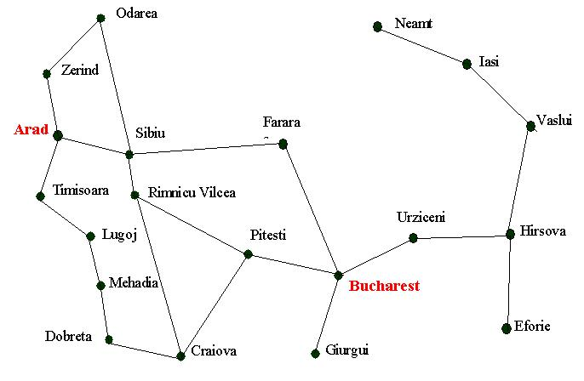

1. Apply blind search algorithms to the graph from A to M :

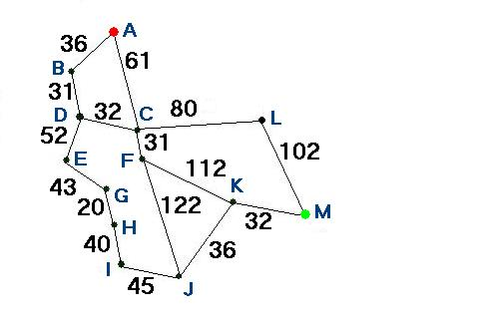

**/ END /**