**PSG College of Technology**

Department of Applied Maths & Computational Sciences

**15XW87 Soft Computing Lab : Search Problem Sheet 3**

1. Apply Genetic Algorithm to solve for Rastrigin’s function :

*Ras*(*x,y*)=20+*x2*+*y2*−10(cos2*πx*+cos2*πy*)

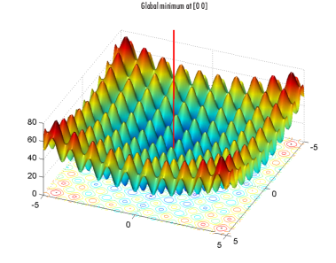

As the plot shows, Rastrigin's function has many local minima—the “valleys” in the plot. However, the function has just one global minimum, which occurs at the point [0 0] in the *x-y*plane, as indicated by the vertical line in the plot, where the value of the function is 0. At any local minimum other than [0 0], the value of Rastrigin's function is greater than 0. The farther the local minimum is from the origin, the larger the value of the function is at that point.

Rastrigin's function is often used to test the genetic algorithm, because its many local minima make it difficult for standard, gradient-based methods to find the global minimum.

The following contour plot of Rastrigin's function shows the alternating maxima and minima.

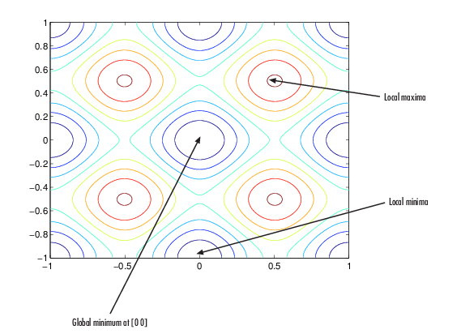

1. Apply Particle Swarm Optimization to solve : Find 10 operands to add upto 50 with 20 particles.

The results could be like

5 + -3 + 18 + 12 + 9 + 15 + 16 + 27 + -17 + -1 = 81

11 + 29 + -5 + 15 + -11 + 15 + -9 + 12 + -1 + 6 = 62

-10 + -2 + 5 + 12 + 14 + 21 + -23 + 10 + 5 + -5 = 27

23 + -10 + -3 + 12 + -9 + 1 + 7 + 8 + -42 + -15 = -28

23 + 1 + -9 + 12 + -12 + 23 + -9 + 12 + -1 + 10 = 50

22 + 19 + 36 + 8 + -18 + 3 + 36 + -17 + -1 + 0 = 88

-10 + -3 + 7 + 12 + 15 + 11 + 24 + -7 + 15 + -18 = 46

0 + -16 + -9 + -3 + 9 + 15 + 15 + 22 + 5 + 10 = 48

-10 + 25 + 30 + 12 + -18 + -3 + -9 + -7 + -1 + 10 = 29

0 + 2 + -9 + 12 + -1 + 6 + 26 + 7 + -36 + -17 = -10

-9 + -11 + -4 + 12 + -10 + 15 + -30 + 17 + 14 + -20 = -26

18 + -5 + 21 + -22 + -1 + 5 + 26 + 17 + 23 + -21 = 61

-20 + -17 + -10 + -8 + -1 + 6 + 13 + 14 + 21 + -8 = -10

23 + 1 + -1 + -18 + 7 + 13 + 9 + 18 + 25 + -6 = 71

23 + 25 + -9 + 12 + 26 + -19 + -9 + -7 + -1 + 10 = 51

-13 + 25 + 1 + 7 + 26 + -19 + -9 + 7 + -35 + -16 = -26

-11 + -4 + 21 + 3 + 9 + 20 + 36 + 9 + -15 + -5 = 63

20 + 2 + -14 + 3 + 18 + 21 + -9 + 25 + -1 + 10 = 75

0 + -12 + -9 + 12 + -7 + 4 + 7 + 14 + -1 + 10 = 18

4 + 6 + 34 + -20 + 8 + 23 + -9 + -25 + -18 + 10 = 13

epoch number: 103

Particle 4 has achieved target.

23 + 1 + -9 + 12 + -12 + 23 + -9 + 12 + -1 + 10 = 50

**/ END /**