**GROCERY BILLING SYSTEM**

Project submitted to the

SRM University – AP, Andhra Pradesh

for the partial fulfillment of the requirements to award the degree of

**Bachelor of Technology/Master of Technology**

In

**Computer Science and Engineering**

**School of Engineering and Sciences**

Submitted by

**Candidate Name**

**CH SHARAS CHANDRA SHASANK---AP21110010705**

**SK SHAHUL HAMEED---AP21110010696**

**M SRI SAI KIRAN---AP21110010698**

**A SIVA CHANDU---AP21110010702**

Under the Guidance of

**MOHAMMAD MISKEEN ALI**

**SRM University–AP**

**Neerukonda, Mangalagiri, Guntur**

**Andhra Pradesh – 522 240**

**[DECEMBER, 2022]**

# Certificate

Date: 6-Dec-22

This is to certify that the work present in this Project entitled “**GROCERY BILLING SYSTEM**” has been carried out by **CH SHARAS CHANDRA SHASANK (AP21110010705)** under my/our supervision. The work is genuine, original, and suitable for submission to the SRM University – AP for the award of Bachelor of Technology/Master of Technology in **School of Engineering and Sciences**.

**Supervisor**

(Signature)

Prof. / Dr. MOHAMMED MISKEEN ALI

Designation,

Affiliation.

**Co-supervisor**

(Signature)

Prof. / Dr. [Name]

Designation,

Affiliation.

# Certificate

Date: 6-Dec-22

This is to certify that the work present in this Project entitled “**GROCERY BILLING SYSTEM**” has been carried out by **M SRI SAI KIRAN (AP21110010698)** under my/our supervision. The work is genuine, original, and suitable for submission to the SRM University – AP for the award of Bachelor of Technology/Master of Technology in **School of Engineering and Sciences**.

**Supervisor**

(Signature)

Prof. / Dr. MOHAMMED MISKEEN ALI

Designation,

Affiliation.

**Co-supervisor**

(Signature)

Prof. / Dr. [Name]

Designation,

Affiliation.

# Certificate

Date: 6-Dec-22

This is to certify that the work present in this Project entitled “**GROCERY BILLING SYSTEM**” has been carried out by **SK SHAHUL HAMEED(AP21110010696)** under my/our supervision. The work is genuine, original, and suitable for submission to the SRM University – AP for the award of Bachelor of Technology/Master of Technology in **School of Engineering and Sciences**.

**Supervisor**

(Signature)

Prof. / Dr. MOHAMMED MISKEEN ALI

Designation,

Affiliation.

**Co-supervisor**

(Signature)

Prof. / Dr. [Name]

Designation,

Affiliation.

# Certificate

Date: 6-Dec-22

This is to certify that the work present in this Project entitled “**GROCERY BILLING SYSTEM**” has been carried out by **A SIVA CHANDU(AP21110010702)** under my/our supervision. The work is genuine, original, and suitable for submission to the SRM University – AP for the award of Bachelor of Technology/Master of Technology in **School of Engineering and Sciences**.

**Supervisor**

(Signature)

Prof. / Dr. MOHAMMED MISKEEN ALI

Designation,

Affiliation.

**Co-supervisor**

(Signature)

Prof. / Dr. [Name]

Designation,

Affiliation.

# Acknowledgments

# The satisfaction that accompanies the successful completion of any task would be

# incomplete without introducing the people who made it possible and whose

# constant guidance and encouragement crown all efforts with success.

I am extremely grateful and express my profound gratitude and indebtedness to my project guide, **Mr. MOHAMMED MISKEEN ALI**, Lecturer, Department of Computer Science & Engineering, SRM University, Andhra Pradesh, for her kind help and for giving me the necessary guidance and valuable suggestions in completing this project work.

# Table of Contents:

Certificate i

Certificate ii

Certificate iii

Certificate iv

Acknowledgments v

Table of Contents: vii

Abstract………………………………………………………………………………….…viii

List of Tables ixi

List of Figures xv

Abbreviations xi

Introduction: 1

REQUIREMENTS……………………………………………………………………1

Methodology 2

Discussion 3

Concluding Remarks: 4

Future Work: 5

References 6

Abstract:

The project deals with the automation of supermarket. This will help salespersons in managing the various types of records of customer. The product will help the user to work in a highly effective and efficient environment. Salesperson have been recording the customer information in the past and even in the present through their personal manual efforts. In manual system, there are number of inefficiencies that a salesperson faces. The information retrieval is one of the foremost problems. It is very difficult to gather the overall performance reports of the customer. Large record books v be stored. This automation deals with all such problems and tries to remove them in the best suitable fashion. The new system will cater to the need of the salesperson of any supermarket so that they can manage the system efficiently. The project is developed to make the system reliable, easier, fast, and more informative.

LIST OF TABLES:

Table 1.1…………………………………………………………...Software Requirements

Table 1.2…………………………………………………………...Hardware Requirements

Table 1.3……………………………………………………..Modules Used

# 

# List of Figures

Figure 1.1…………………………………………………………. Code of the project

Figure 1.2…………………………………………………………. output of the project

# Introduction:

Our project title is “GROCERY BILLING SYSTEM”. In this project console provides a bill of groceries based on customer requirement.

In our project the console will be displayed the list of the items which are needs of customer. Here we will be asking the user to select the items which they desire.

Grocery store is the place where customers come to purchase their daily using products and pay for that. There is a need to calculate how many products are sold and to generate the bill for the customer.

In our project and implementation, we have 3 users.

First is the data entry operator who will enter the products in database.

Second one is the administrator who will decide the taxes and commissions on the products and can see the report of any product.

The third one is the bill-calculating operator who will calculate the bill and print it.

SOFTWARE REQUIREMENTS:

|  |  |
| --- | --- |
| COMPONENT | REQUIREMENT |
| Operating System | Windows 10 or above |
| Language Used | Python Language |
| Compilers | Visual Studio Code |

Table 1.1

HARDWARE REQUIREMENTS:

|  |  |
| --- | --- |
| COMPONENT | REQUIREMENT |
| Processor | 10th Gen intel core i5 and above |
| RAM | 8 GB RAM |
| HDD/SSD | 512 SSD |

Table 1.2

# Methodology:

The grocery billing system is built on the idea to help **to help supermarkets calculate and display bills and serve the customer in a faster and efficient manner. Here user may add groceries, vegetables, fruits and snack items. This system makes simple to calculate the bill for each and every item you want to purchase. The entire project was created in the “python” programming** language using list, dictionaries and files were employed in its construction.

## Modules Used:

|  |  |
| --- | --- |
| Module Name | Uses |
| Date time | Used To tell current date and time |
| Random | Used to print random numbers |
| Math | Uses to math operations |

Table 1.3

**Source code of the project:**

from datetime import datetime

from math import *

from random import *

class grocery:

items_list:list

price_list:list

qua:int

qua_list:list

qua_u_list:list

price_u_list:list

class admin:

name:str

pass_w:str

class bill:

idi:eval

money:int

ext:float

final_price:float

bi=bill()

ad=admin()

gc=grocery()

gc.items_list=[]

gc.price_list=[]

gc.qua_list=[]

gc.qua_u_list=[]

gc.price_u_list=[]

c=""

#Bill No

def number():

bill=[]

bill.append(randint(0, 9))

for i in range(1, 10):

bill.append(randint(0,9))

for i in bill:

c+=str(i)

#Opening Items File

f=open("items.txt","r")

l=f.read().split(",")

for i in l:

j=i.replace(' ','')

gc.items_list.append(j)

f.close()

#Opening Prices File

f1=open("prices.txt","r")

l1=f1.read().split(",")

for i in l1:

j1=i.replace(' ','')

gc.price_list.append(eval(i))

f1.close()

#opening quantity file

f2=open("qua.txt","r")

l2=f2.read().split("\n")

for k in l2:

if k.strip():

gc.qua_u_list.append(int(k))

f2.close()

#Login function

def login():

inp=int(input("Press 1 If Your Admin or Press 2 If Your Customer \n"))

if inp==int(1):

ad.name=input("Enter your Name: ")

if len(ad.name)>3 and len(ad.name)<20:

pass_w1()

else:

print("Please Enter correct name")

login()

else:

items_list_fun()

#Login password function

def pass_w1():

ad.pass_w=input("Enter Your password: ")

if len(ad.pass_w)==4:

if ad.name=="admin" and ad.pass_w=="2116":

print("Login sucessfull!!!")

print("S.no\t\t\tItems\t\t\t\t\t\tPrices\t\t\tRemaining Quantity")

for i in range(1,len(gc.qua_u_list)+1):

print(f'{i:>=1}\t\t\t{gc.items_list[i-1]:<25}\t\t\t{gc.price_list[i-1]:<5}\t\t\t{gc.qua_u_list[i-1]:>0}')

else:

print("kindly check Your Username and Password")

login()

else:

pass_w1()

f3=open("qua.txt","w")

#Displaying Items List

def items_list_fun():

print("S.no\t\t\tItems\t\t\t\t\t\tPrices\t\t\tRemaining Quantity")

for i in range(1,len(gc.items_list)+1):

print(f'{i:>=1}\t\t\t{gc.items_list[i-1]:<25}\t\t\t{gc.price_list[i-1]:<5}\t\t\t{gc.qua_u_list[i-1]:>0}')

while(1):

opt=int(input("Select your Item : "))

for j in range(1,len(gc.items_list)+1):

if opt==j:

gc.qua=int(input("Enter Required quantity: "))

if (gc.qua_u_list[j-1]-gc.qua<0):

print("No quantity is avaliable")

items_list_fun()

else:

print("You have Selected {}".format(gc.items_list[opt-1]))

gc.qua_list.insert(opt-1,gc.qua)

gc.qua_u_list.insert(opt-1,gc.qua_u_list[opt-1]-gc.qua)

gc.price_u_list.insert(opt-1,gc.qua*gc.price_list[opt-1])

if gc.qua!=0:

for k in gc.qua_u_list:

f3.write(str(k))

f3.write("\n")

if opt==0:

payment()

pay()

break

f5=open("receipt.txt","w")

def payment():

name=input("Enter your Name: ")

ph_no=input("Enter Your Phone Number: ")

while(len(ph_no)!=10):

ph_no=input("Enter Correct Phone Number: ")

gst=((sum(gc.price_u_list)*5)/100)

bi.final_price=gst+sum(gc.price_u_list)

print(25*"-","SRM GROCERY STORE AND MANAGEMENT",21*"-")

f5.write("\n")

print(25*"-","SRM GROCERY STORE AND MANAGEMENT",21*"-",file=f5)

print(35*"-","WELCOME",35*"-")

print(35*"-","WELCOME",35*"-",file=f5)

print("BILL NO: ",bill)

print("BILL NO: ",bill,file=f5)

print("NAME: ",name,40*" ")

print("NAME: ",name,40*" ",file=f5)

print("DATE: ",datetime.now())

print("DATE: ",datetime.now(),file=f5)

print("PHONE NUMBER: ",ph_no)

print("PHONE NUMBER: ",ph_no,file=f5)

print(80*"-")

print(80*"-",file=f5)

print(f'{"S.no":>1}\t\t\t{"ITEMS":<15}\t\t{"QUANTITY":>10}\t\t{"PRICE":<5}')

print("S.no.",10*" ","ITEMS",10*" ","QUANTITY",5*" ","PRICE",file=f5)

for i in range(len(gc.qua_list)):

print(f'{i+1:>1}\t\t\t{gc.items_list[i-1]:<15}\t\t{gc.qua_list[i-1]:>10}\t\t{gc.price_list[i-1]:<5}')

for i in range(len(gc.qua_list)):

print(f'{i+1:>1}\t\t\t{gc.items_list[i-1]:<15}\t\t{gc.qua_list[i-1]:>10}\t\t{gc.price_list[i-1]:<5}',file=f5)

print(80*"-")

print(80*"-",file=f5)

print(25*" ","TOTAL AMOUNT: ","Rs",float(sum(gc.price_u_list)))

print(25*" ","TOTAL AMOUNT: ","Rs",float(sum(gc.price_u_list)),file=f5)

print("gst Amount ",10*" ","\t\tGst :\t Rs ",float(gst))

print("gst Amount ",10*" ","\t\tGst :\t Rs ",float(gst),file=f5)

print(80*"-")

print(80*"-",file=f5)

print(25*" ","FINAL AMOUNT: ","Rs",bi.final_price)

print(25*" ","FINAL AMOUNT: ","Rs",bi.final_price,file=f5)

print(80*"-")

print(80*"-",file=f5)

print(25*"","\t\t\tTHANKS FOR VISTING ")

print(25*"","\t\t\tTHANKS FOR VISTING ",file=f5)

print("\t\t\t COME BACK SOON")

print("\t\t\t COME BACK SOON",file=f5)

print(80*"-")

print(80*"-",file=f5)

def upi():

bi.ids=input("\nENTER UPI ID: ")

if len(bi.ids)==14:

print("\nOPEN THE UPI MOBILE APP AND APPROVE THE bill\nTHANKS FOR VISITING...COME BACK SOON")

else:

print("Please enter the correct upi id")

upi()

def cash():

amount=eval(input("Enter the Amount of Cash Payed: "))

if amount>bi.final_price:

re=amount-bi.final_price

print("Amount Returned",re)

print("Amount Payes Successfully...")

print("THANKS FOR VISITING...COME BACK SOON")

elif amount==bi.final_price:

print("Amount Payed Successfully...")

print("THANKS FOR VISITING...COME BACK SOON")

elif amount<bi.final_price:

bi.ext=bi.final_price-amount

print("Extra Amount is To Be Payed\n",bi.ext)

cash2()

print("Amount Payed Successfully...")

print("THANKS FOR VISITING...COME BACK SOON")

else:

print("Enter Correct amount")

cash()

def cash2():

Cash2=eval(input("Enter balance amount to be paid: "))

if Cash2==ceil(bi.ext):

pass

else:

print("Please enter correct amount")

cash2()

def pay():

print("*************************************************")

print("\nSELECT ONE OF THE bill OPTIONS\n")

print("**************************************************")

print("\n1)UPI\n2)Cash")

opt=int(input("Enter Your Payment Method: "))

if opt==1:

upi()

elif opt==2:

cash()

else:

print("Please Enter valid option")

pay()

login()

f3.close()

f5.close()

**Output of the project:**

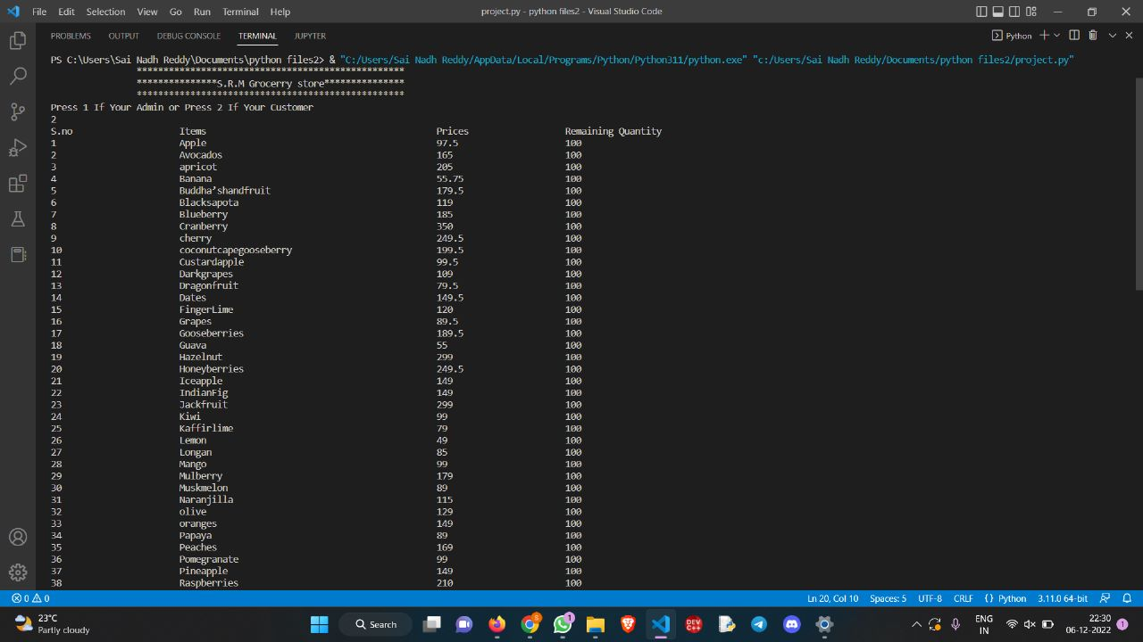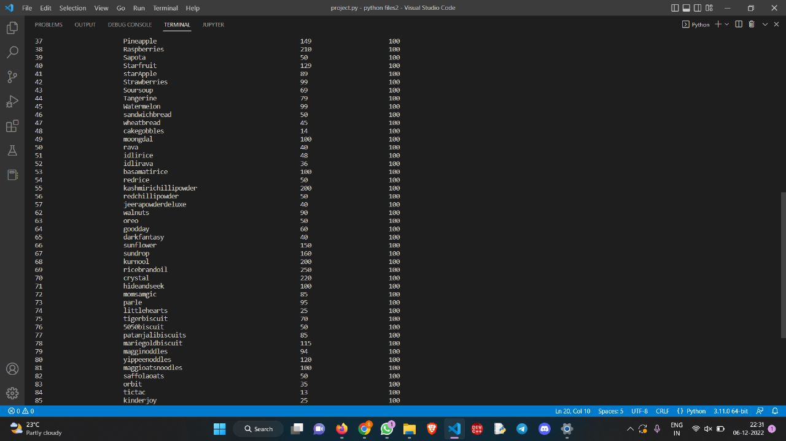

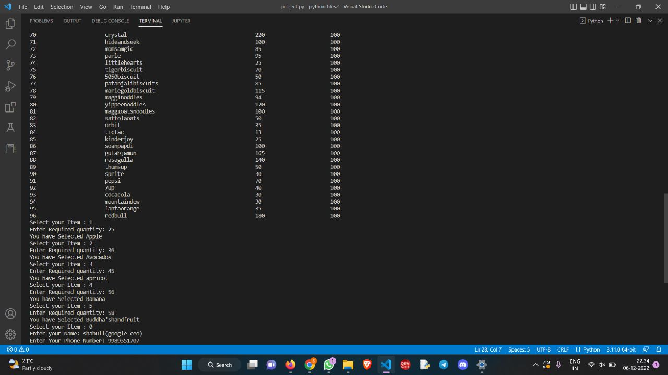

# 

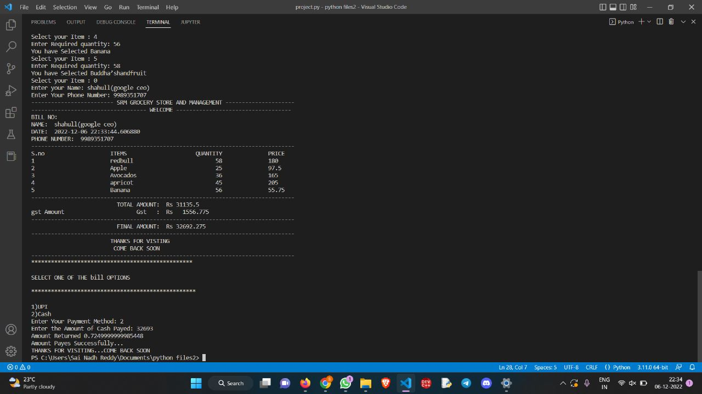

# Discussion

Steps to build Grocery Management system:

1.Import modules (datetime, math, random).

2. Define login (), items_list_function (), payment () functions.

3. Accessing Items, Prices and Quantity from files.

4. Creating different files for items, prices and quantity.

5. From items_list_function function, we can select the items by choosing it’s index and we can select their quantities.

6.Define pay () function.

7.From pay () function we can choose how to pay for total amount by selecting from upi or cash options.

8. Making a structure for bill to show to user.

9. Making separate function for admin to check the quantities being sold previously.

10. Admin can login through separate login details.

# Concluding Remarks:

The grocery billing system is an open-source business solution used by supermarkets, department stores, and more. On the other hand, with this, businesses can do their own repetitive tasks to minimize waste and provide specialized shopping information to customers. In addition to payment, many billing systems in supermarkets also aid in accounting and inventory-related processes. If you are a local supermarket, then this is a good fit for you. As it provides a single interface to manage these different major stores.

Billing system for grocery shop is built to calculate and display bills for different items and serve the customer in a faster and effic­­­­­­­ient manner. Grocery shop is the place where customers come to purchase their daily using products and pay for that. So, there is a need to calculate how many products are sold and to generate the bill for the customer. This system is built for fast data processing and bill generation for customers. It also allows the customer to purchase and pay for the item purchased. The user will consume less time in calculation and sales activity will be completed within a fraction of second whereas in a manual system will make a user to write it down which is a long procedure and it also consumes a lot of time. Because Only shopkeeper can use this software

Future Work:

1. If products expiry date is finished then the product is not shown
2. If quantity of product is finished then the product is not shown.
3. Adding GUI for our project.

# 

# References

1. Assist. Prof. Ansar Ahmad, Shakir Khan, Ajay Machhi, Ajay Baria, Akash Sabat” Store Hub an Android App”: International Journal of computer science and Technology (IJCST)Mar-Apr 2016 International Journal of Computer Science.
2. Priyanka S. Sahare, Anup Gade, Jayant Rohankar “Automated Smart Trolley System Using Raspberry PI Device “IOSR Journal of Engineering (IOSRJEN) ISSN (e): 2250-3021.