**Task on VPC = create 3 public and 2 priivate and each will have two ec2 instances.**

**check internet connection, internal communication**

Step: 1 Create VPC with CIDR IPV4

Created test-vpc as required details with CIDR manual ipv4 input – 20.0.0.0/16

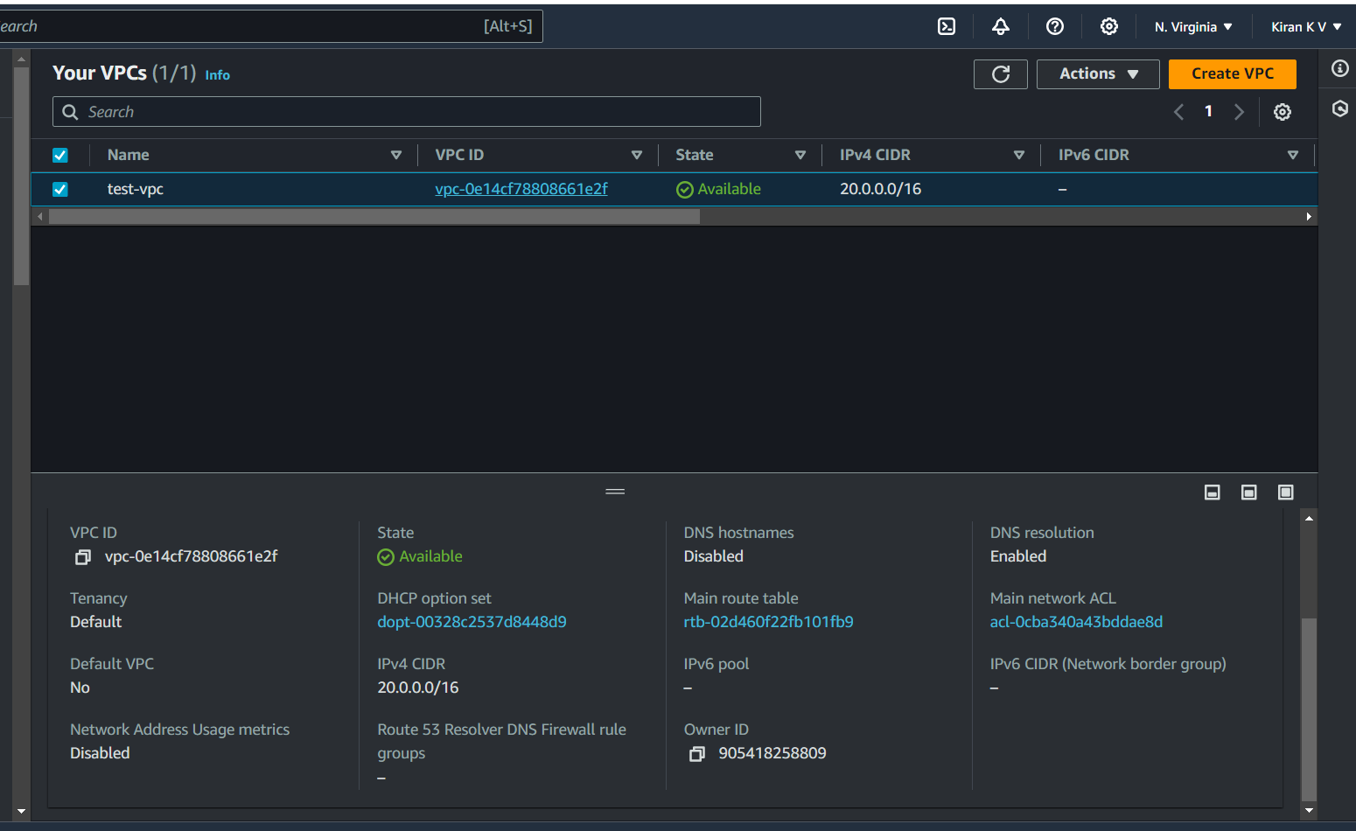

Step 2: Creation of Internet gateway – that is associated with public subnets and private subnets.

Created internet gateway named as IGW-test and attached with my test- vpc.

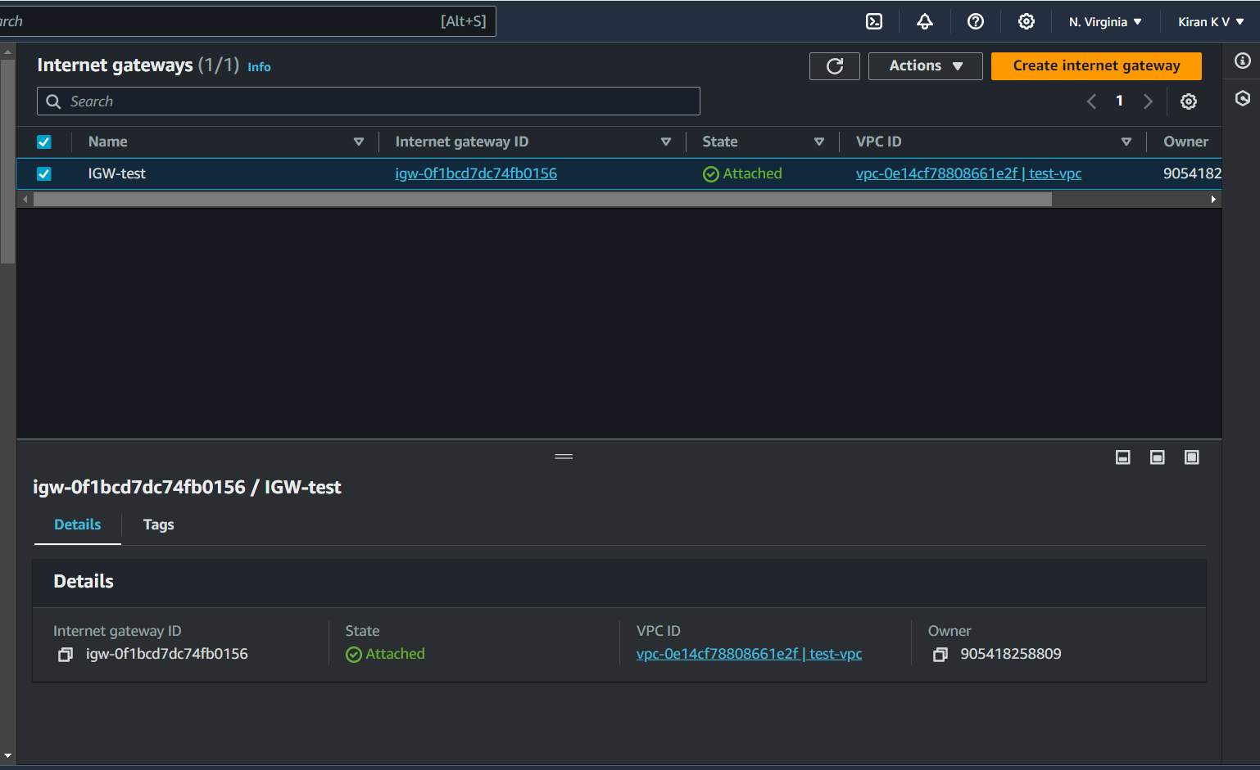

Step 3: Creation of public subnet and private subnet.

Created public subnet named as – test-public-subnet-1a with ipv4 CIDR range (20.0.1.0/24).

Created public subnet named as – test-public-subnet-2a with ipv4 CIDR range (20.0.2.0/24).

Created public subnet named as – test-public-subnet-3a with ipv4 CIDR range (20.0.3.0/24).

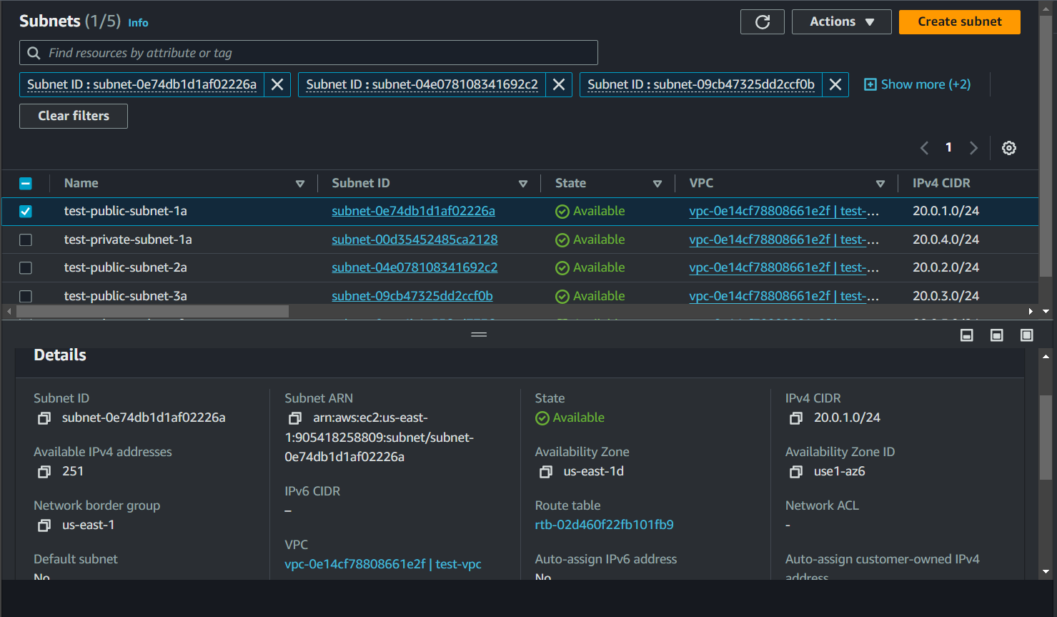

Created private subnet named as – test-private-subnet-1a with ipv4 CIDR range (20.0.4.0/24).

Created private subnet named as – test-private-subnet-2a with ipv4 CIDR range (20.0.5.0/24).

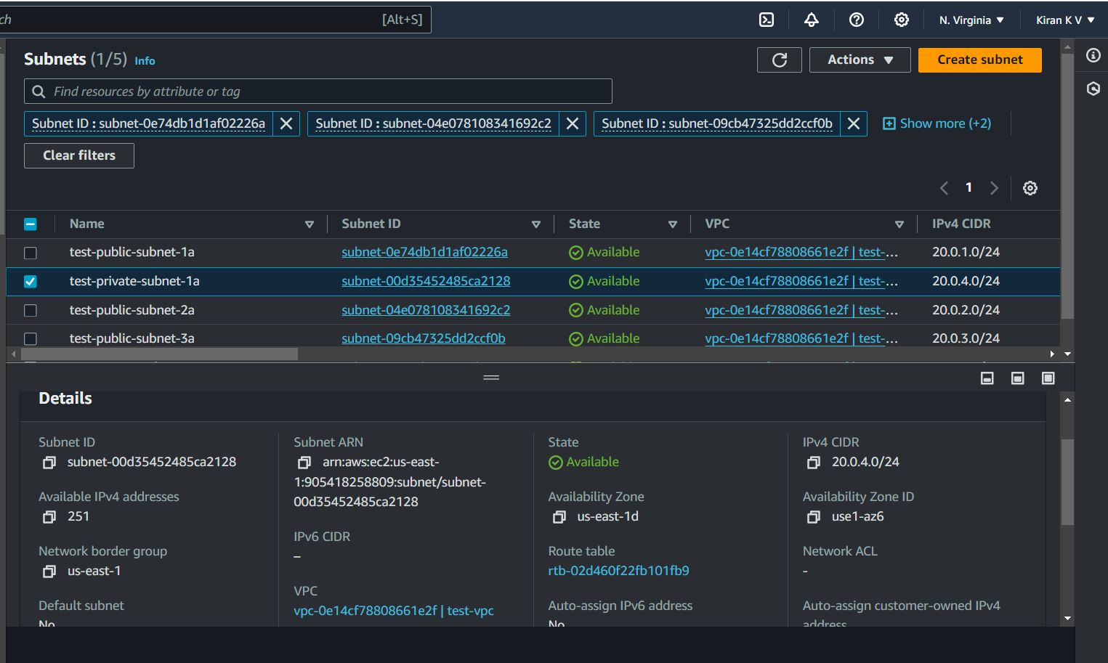

Step 4: Creating Route tables with respect to the public and private subnets.

Created public route table named as RT-test-public and public rout table have the internet access so given the route that is ipv4 anywhere ip (0.0.0.0/0) and assigned the target as internet gateway.

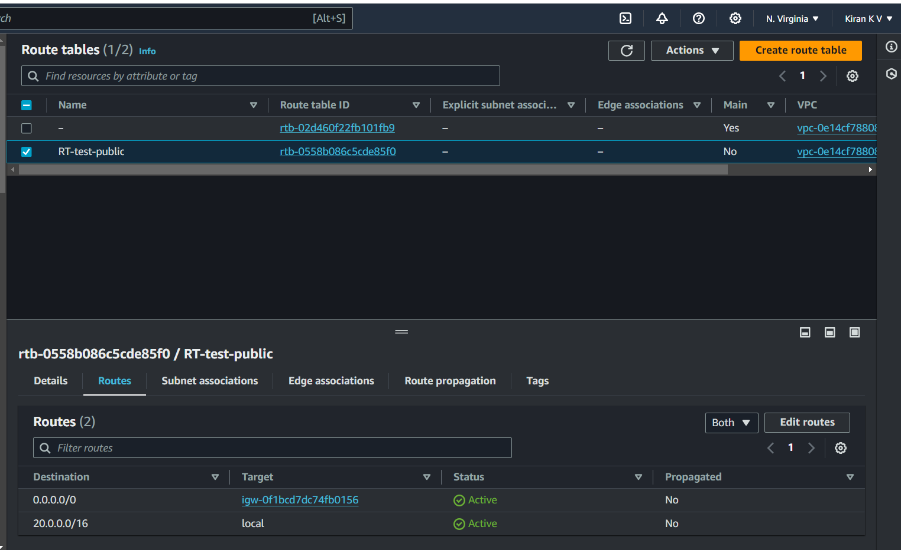

Created public rote table and associated with the public subnet.

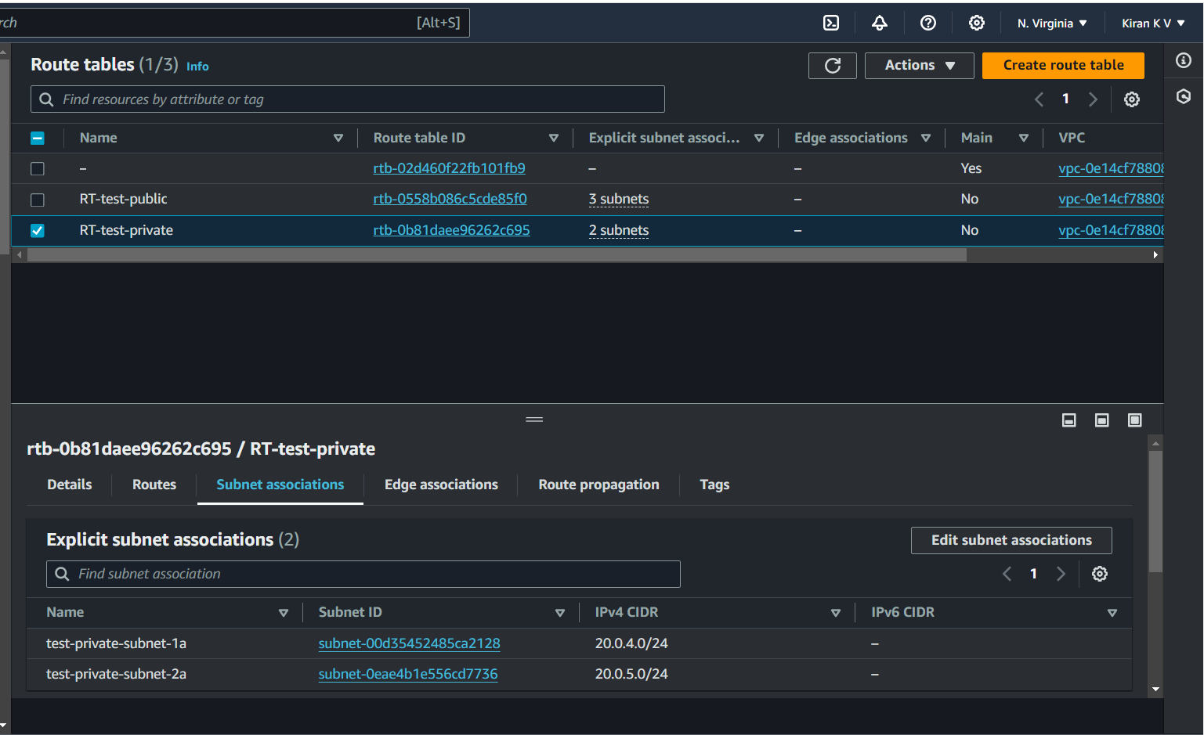

Created private route table named as RT-test-private and there is no internet access for private route table and associated with the private subnet

Basic Networking setup is created now I can able launch the public and private instances

Lunched two ec2 instance using public subnet 1 named as test-ec2-public-subnet-1a-1 and test-ec2-public-subnet-1a-2

Instance 1 = test-ec2-public-subnet-1a-1

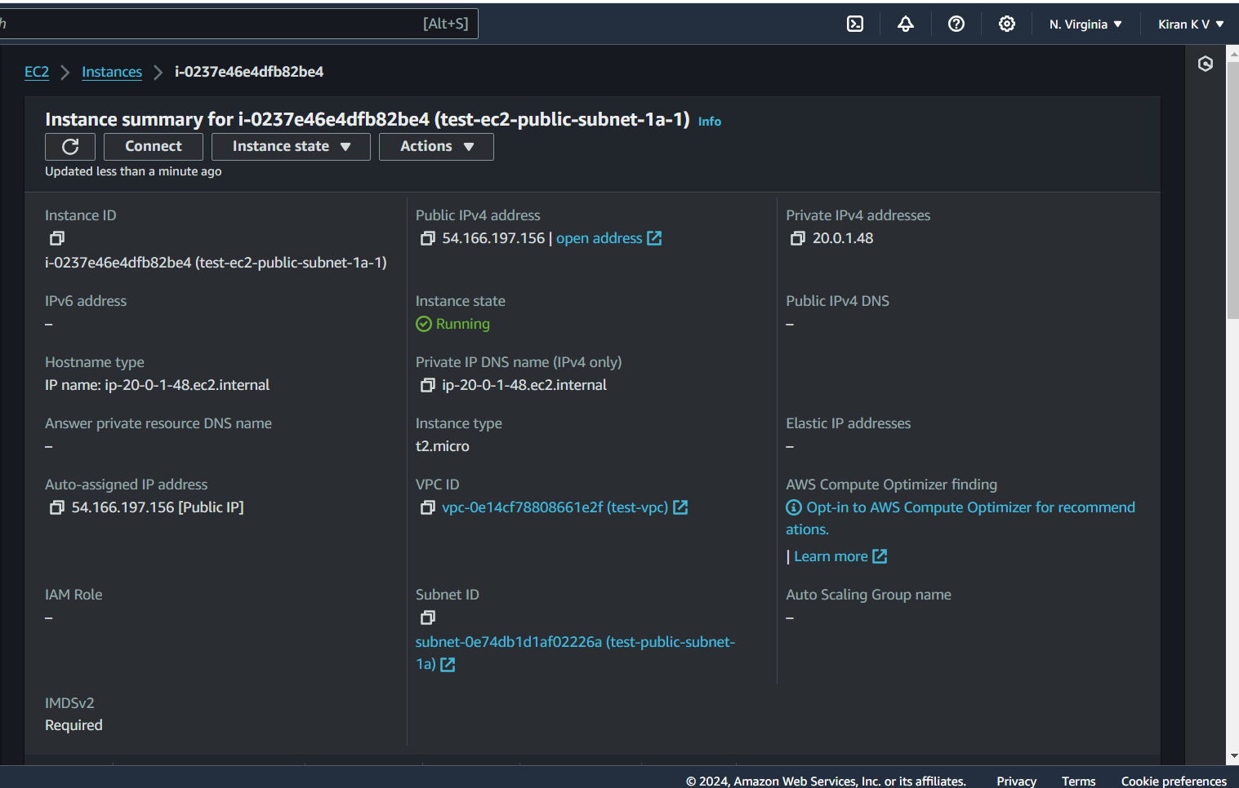

Internet access over the network

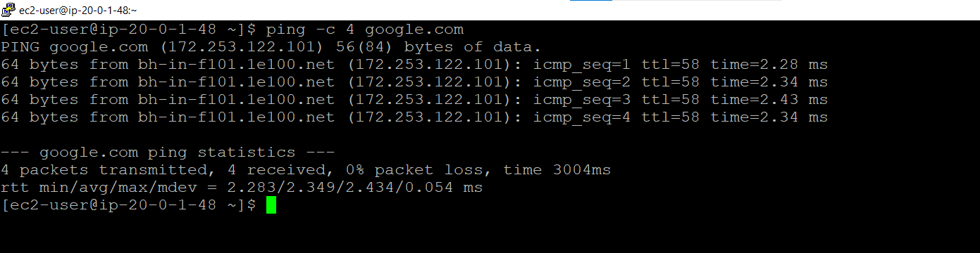

Instance 2 = test-ec2-public-subnet-1a-2

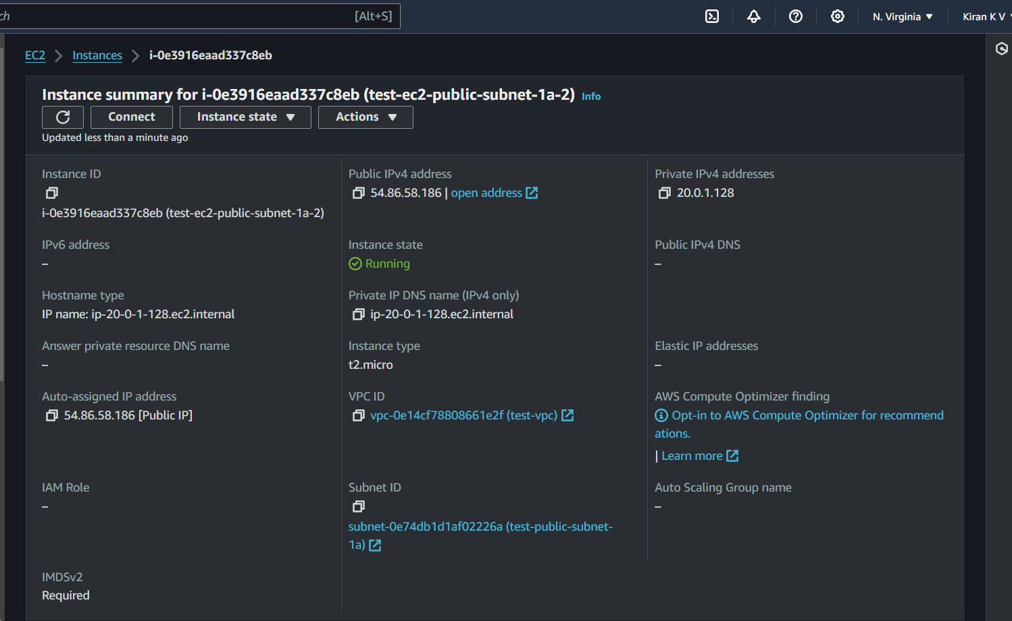

Internet access over the network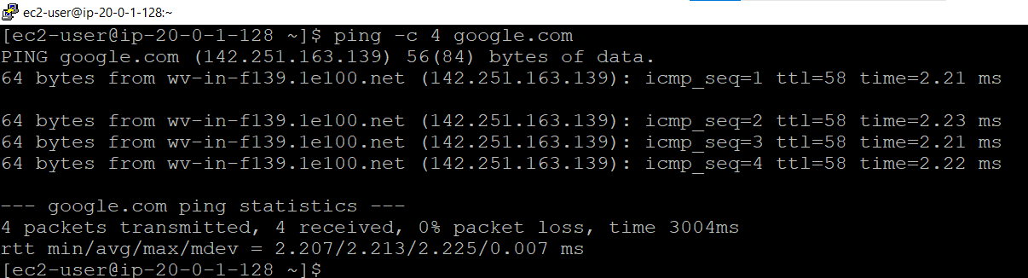

Lunched two ec2 instance using public subnet 2 named as test-ec2-public-subnet-2a-1 and test-ec2-public-subnet-2a-2

Instance 1 = test-ec2-public-subnet-2a-1

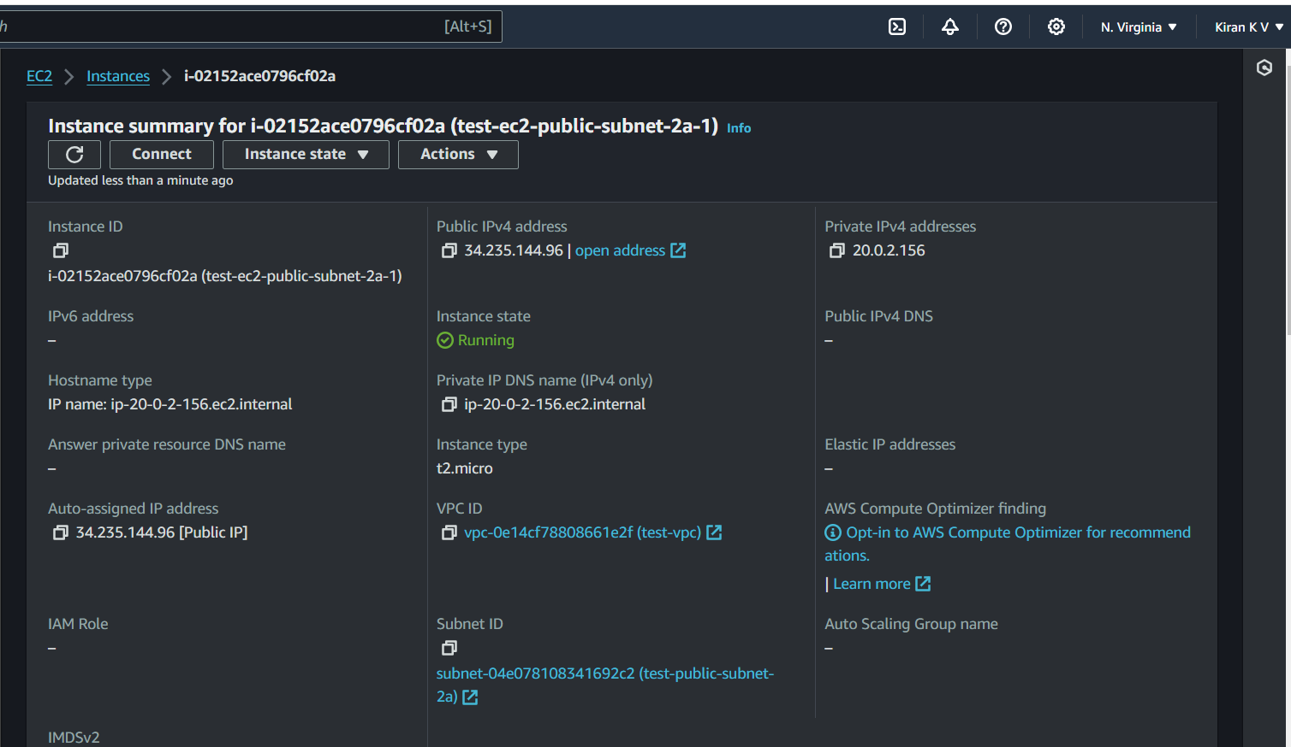

Internet access over the network

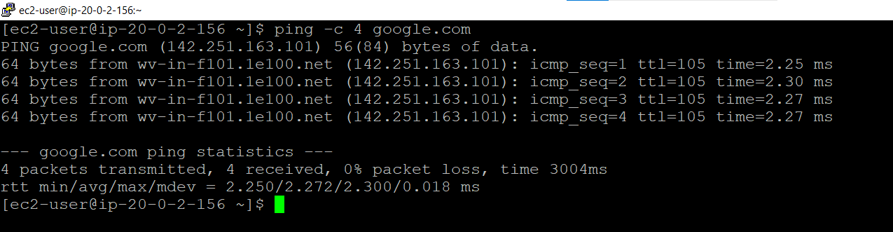

Instance 2 = test-ec2-public-subnet-2a-2

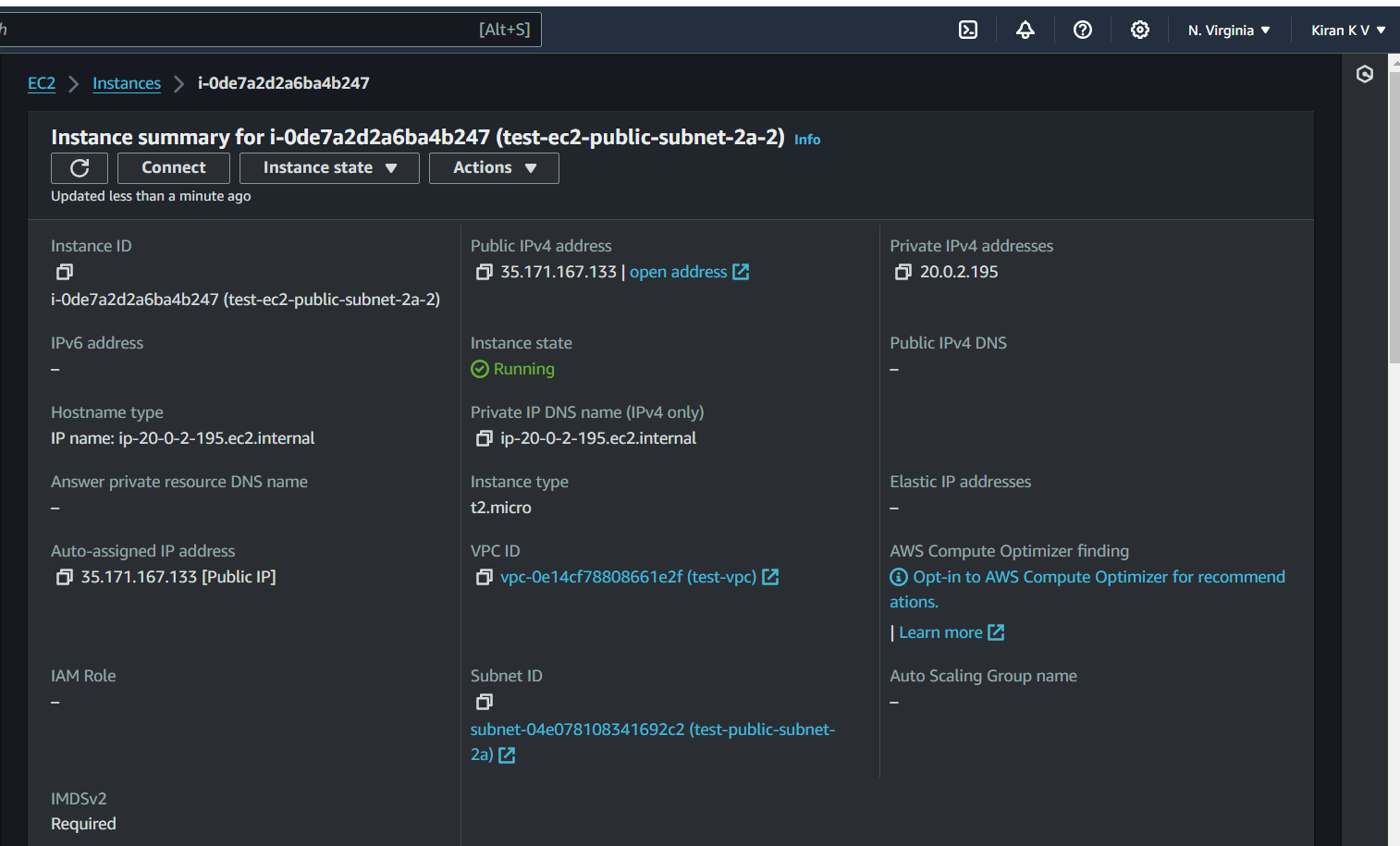

Internet access over the network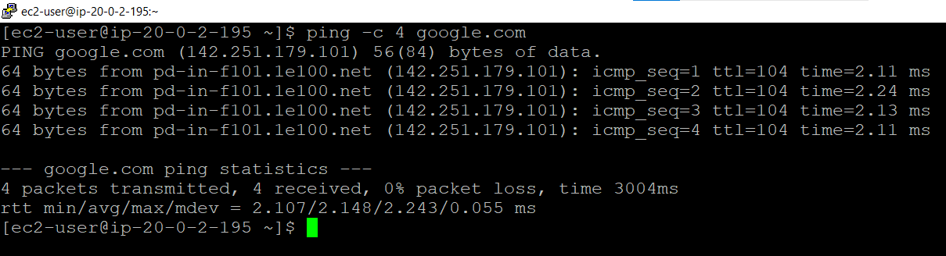

Lunched two ec2 instance using public subnet 3 named as test-ec2-public-subnet-3a-1 and test-ec2-public-subnet-3a-2

Instance 1 = test-ec2-public-subnet-3a-1

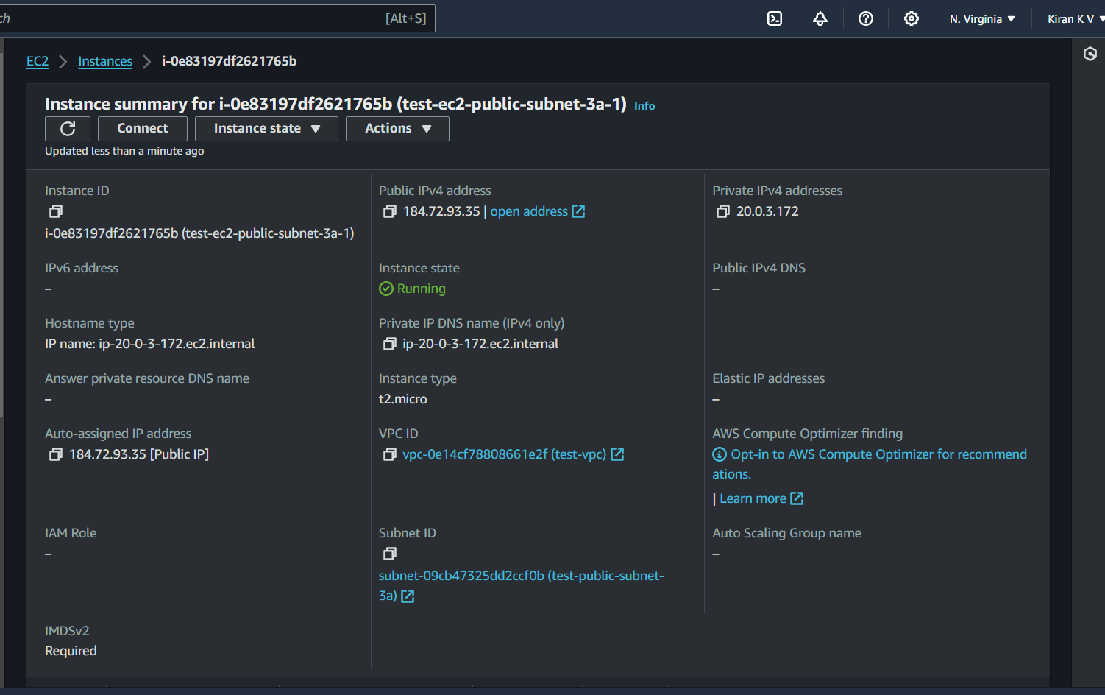

Internet access over the network

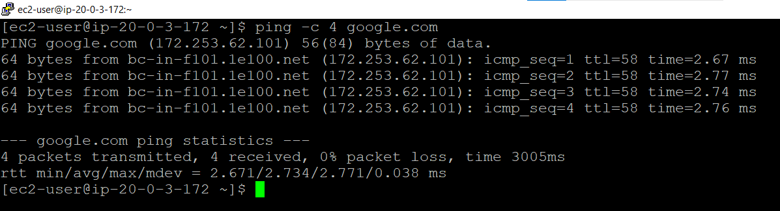

Instance 2 = test-ec2-public-subnet-3a-2

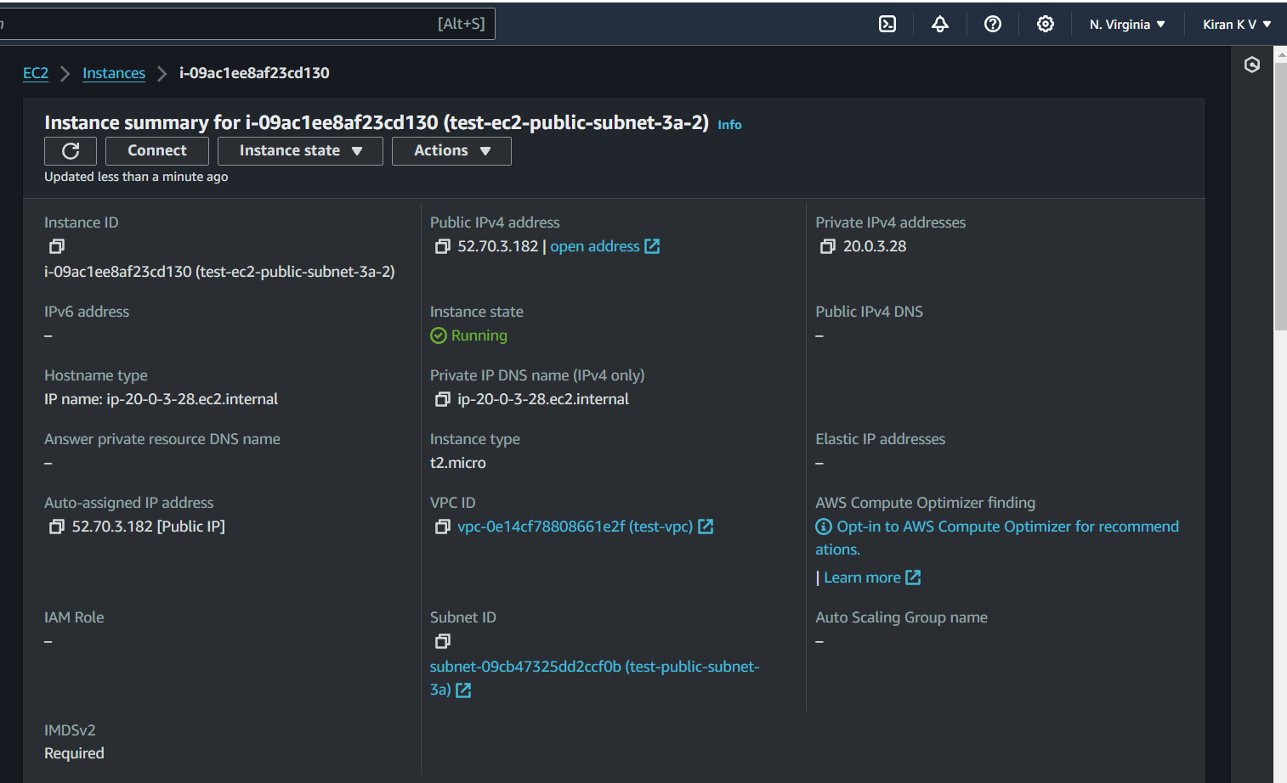

Internet access over the network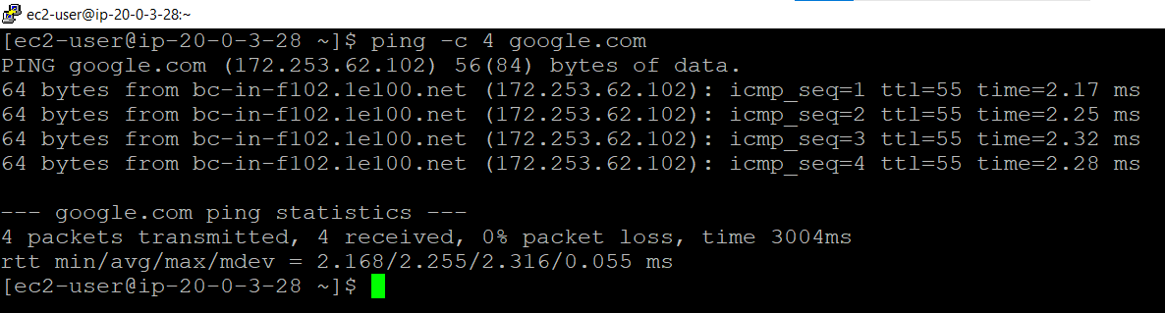

Lunched two ec2 instance using private subnet 1 named as test-ec2-private-subnet-1a-1 and test-ec2-private-subnet-1a-2

Instance 1 = test-ec2-private-subnet-1a-1

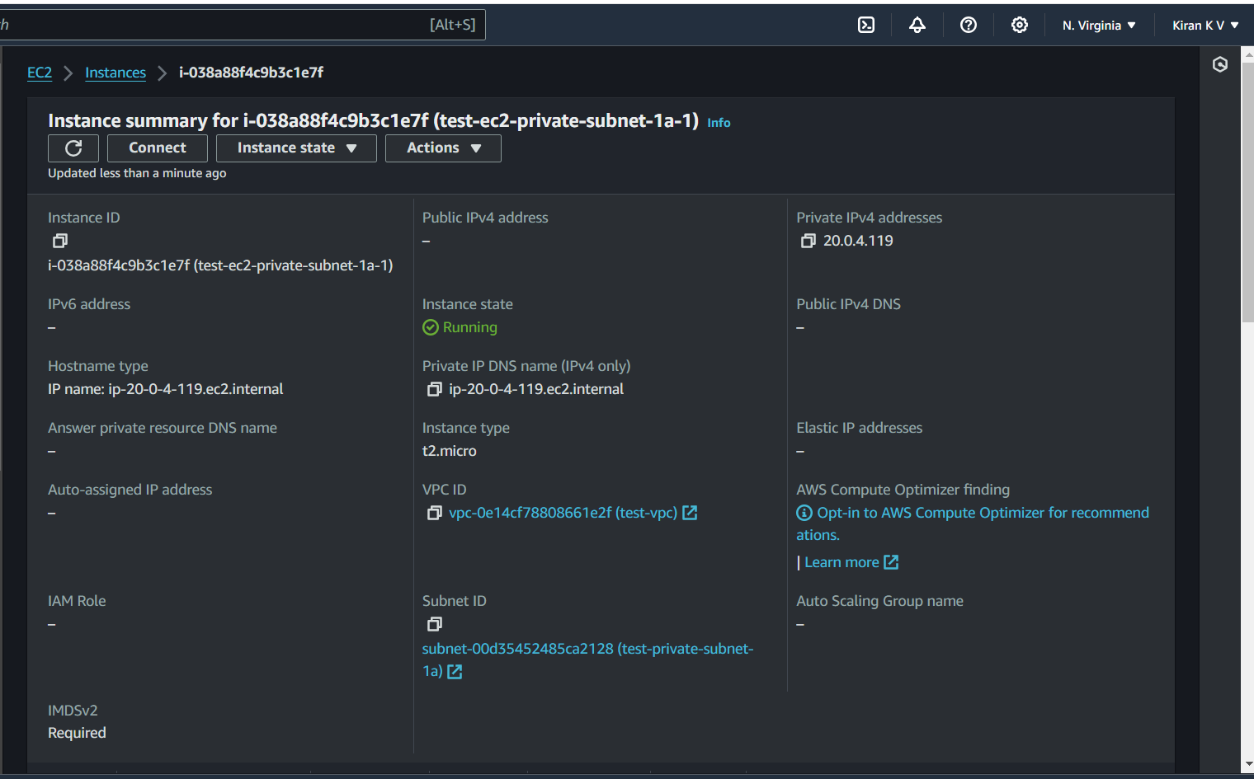

Internet access over the network

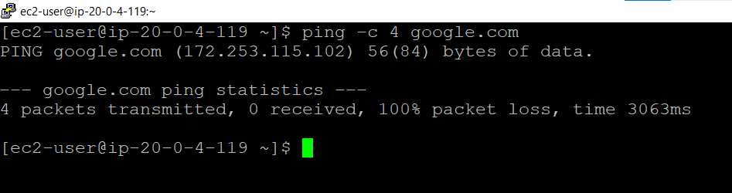

Instance 2 = test-ec2-private-subnet-1a-2

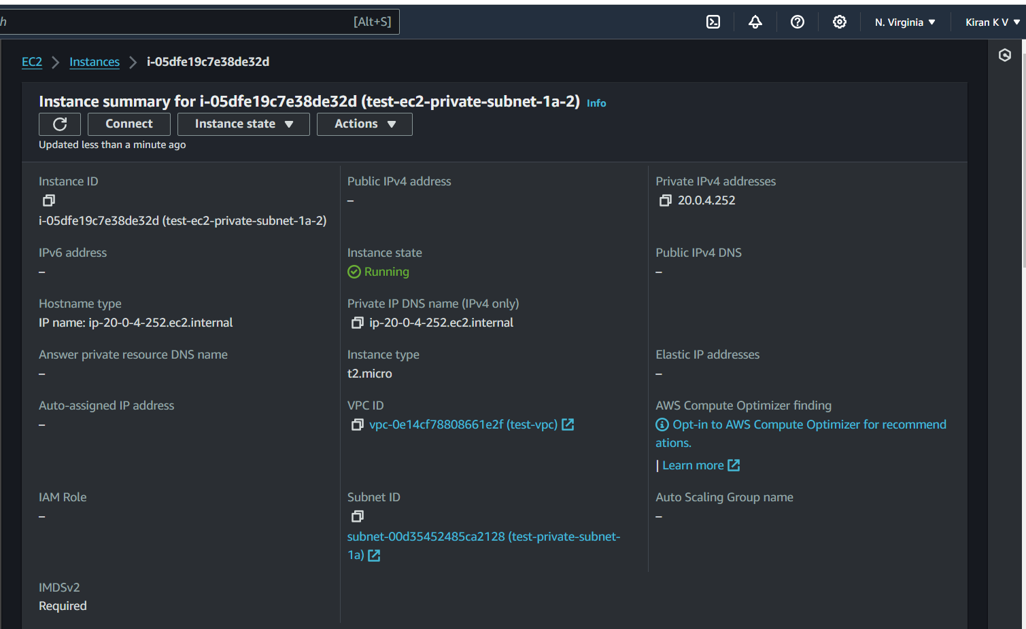

Internet access over the network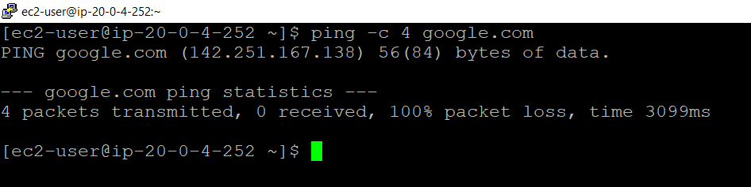

Lunched two ec2 instance using private subnet 2 named as test-ec2-private-subnet-2a-1 and test-ec2-private-subnet-2a-2

Instance 1 = test-ec2-private-subnet-2a-1

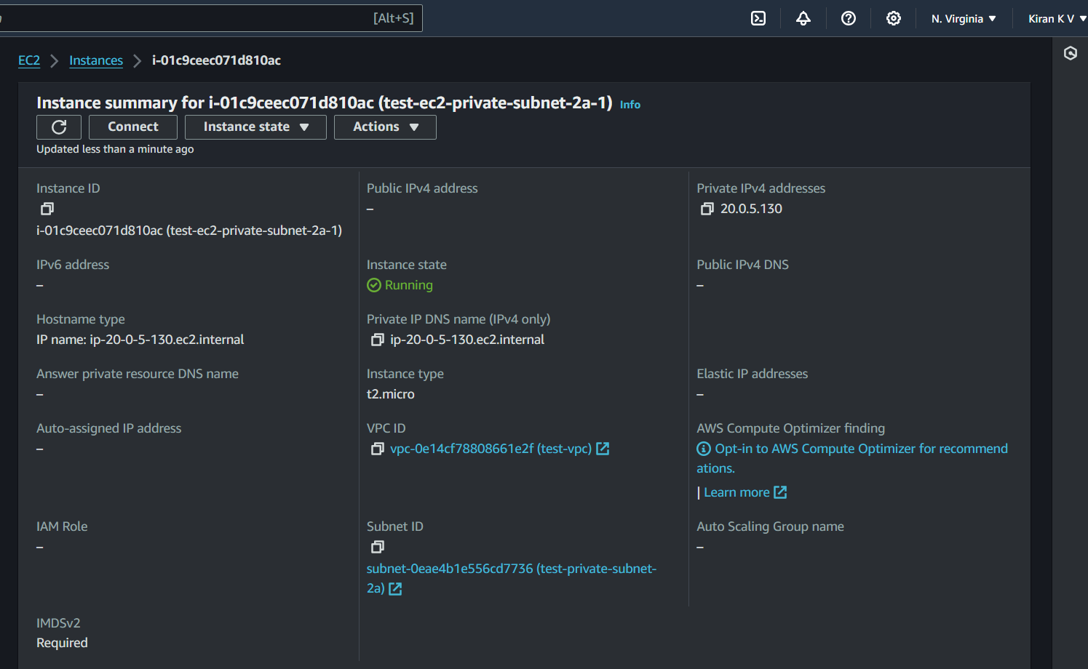

Internet access over the network

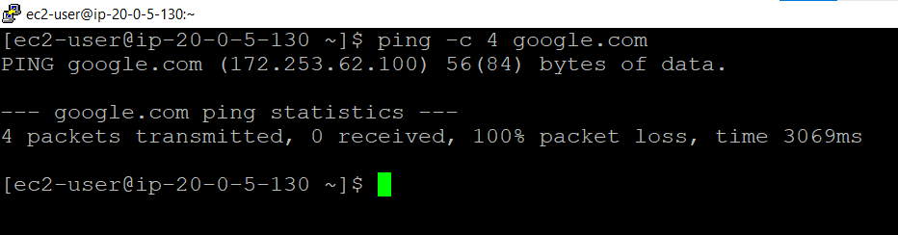

Instance 2 = test-ec2-private-subnet-2a-2

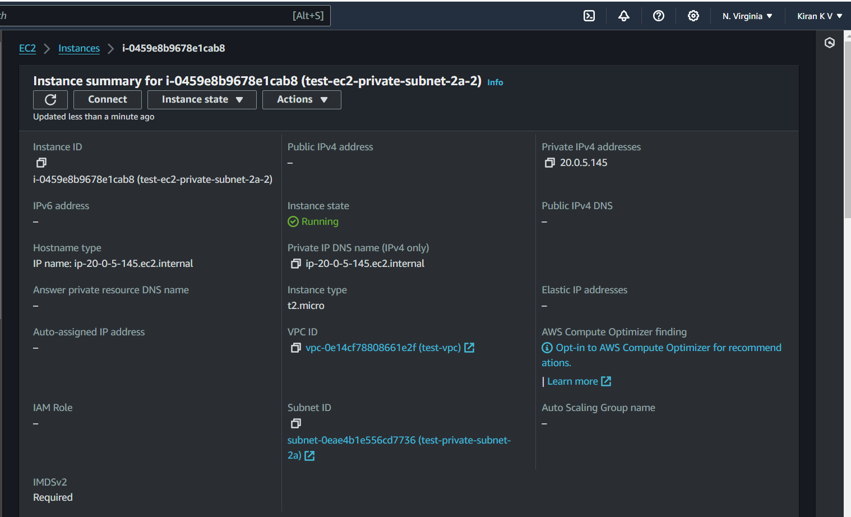

Internet access over the network

