INVENTION DISCLOSURE FORM
Adaptive Spiral Solar–Wind Renewable Energy Harvesting System for Electric Vehicles

SECTION A: TECHNICAL DETAIL REPORT
1. | Title of the Invention
 | Adaptive Spiral Solar–Wind Renewable Energy Harvesting System for Electric Vehicles with Intelligent Secondary Battery Storage and Swap Management.

2. | What is the Invention?  (Should include Problem and Solution statement and general purpose in relation with your invention)
Technical Problem:
- Dependence on External Charging Infrastructure: Conventional EVs rely almost entirely on grid-based charging, causing long charging times, limited charger availability in remote areas, and reduced convenience on long-distance travel.
- Limited Renewable Energy Harvesting: Flat rooftop solar panels used in existing solar-assisted EVs have limited surface area, restricting harvested energy and yielding only a marginal increase in driving range.
- Untapped Aerodynamic Energy: Significant airflow is generated around a moving vehicle, but this freely available kinetic energy is never captured by conventional EVs.
- Lack of Continuous Self-Charging: Existing EVs cannot continuously generate renewable energy while driving or parked, and cannot harvest energy at night.
- Inefficient Renewable Energy Management: Present systems lack an intelligent mechanism to capture, regulate, store, and utilize renewable energy without disturbing the main traction battery.
Technical Solution:
The proposed invention is an Adaptive Spiral Solar–Wind Renewable Energy Harvesting System for Electric Vehicles, comprising a roof-mounted, height-adjustable spiral structure that simultaneously functions as a photovoltaic collector and a wind-driven generator. The spiral automatically extends at low vehicle speed to maximize the harvesting area and retracts at high speed to reduce aerodynamic drag, using a control principle inspired by the conservation of angular momentum (moment-of-inertia trade-off between extended and compact states). Harvested solar and wind energy is regulated through a DC–DC converter and charge controller and stored in a dedicated, removable secondary battery that is kept electrically isolated from the main traction battery until the user chooses to either transfer the stored energy into the main pack or physically swap in the charged secondary pack.
General Purpose:
The primary purpose of the invention is to provide an intelligent, adaptive, self-optimizing dual renewable energy harvesting system that extends EV driving range, reduces dependency on external charging infrastructure, and harvests usable energy continuously — during both day and night, and during both vehicle motion and stationary parking — while protecting the main traction battery from any disturbance caused by the harvesting process.

3. | Search Terms  (Please provide key words and common industry phrases based on which this invention could relate to the prior art)
 | Dual Renewable Energy Harvesting for Electric Vehicles; Adaptive Spiral Solar–Wind Architecture; Dynamic Spiral Height Adjustment; Vehicle-Induced Wind Energy Recovery; Vehicle-Integrated Photovoltaics (VIPV); Rotational-Dynamics-Inspired Adaptive Geometry; Removable Secondary Battery for EV; Battery Swap and Transfer Management System; Renewable Range Extension for Electric Vehicles; Adaptive Aerodynamic Drag Reduction Structure; Intelligent Renewable Energy Charge Controller; Hybrid Photovoltaic–Wind Energy Harvesting Structure; Self-Optimizing Spiral Geometry Harvester; Predictive Renewable Charging Controller; Solar–Wind Assisted Electric Vehicle Battery Management.

4. | Background of the Invention  (Present state of Art)
a. Present State of the Art:
The present state of the art in renewable energy-assisted electric vehicles primarily focuses on battery-powered propulsion supported by external charging infrastructure or individual renewable energy harvesting techniques. Existing systems generally rely on independent solar photovoltaic panels or small wind energy harvesting mechanisms, which operate separately and do not provide an integrated, adaptive, and intelligent renewable energy solution. Existing renewable-energy assisted electric vehicles fall into four broad categories:
- Fixed rooftop solar-charging vehicles: Commercially demonstrated by vehicles such as the Lightyear 0, Aptera, Sono Motors' Sion, and after-market solar-roof options on the Toyota Prius and Hyundai Sonata. These integrate flat or body-conforming photovoltaic (VIPV) panels that generate power only from direct sunlight.
- Vehicle-mounted wind energy concepts: Various research prototypes and patents describe fixed-axis wind turbines mounted on a vehicle roof or grille to capture vehicle-induced airflow, generally as a standalone system independent of solar harvesting.
- EV battery-swapping networks: Commercial deployments such as NIO's Battery-as-a-Service, Gogoro, SUN Mobility, and Battery Smart allow a discharged battery to be exchanged for a pre-charged one at a dedicated swap station, where the replacement battery is charged from the grid.
- Conventional battery management systems (BMS): Standard EV battery management systems track state-of-charge (SOC) and health of a single traction pack, without any provision for a second, independently-charged renewable energy reservoir.
b. Limitations of the Same:
- Flat/body-conforming solar panels are constrained by available vehicle surface area and generate energy only during daylight hours, yielding a marginal range increase.
- Fixed-geometry wind harvesters remain permanently deployed, adding constant aerodynamic drag at all speeds and increasing mechanical stress at highway speeds.
- Solar and wind harvesting are treated as independent, non-integrated systems; no existing consumer EV simultaneously harvests both from a single compact structure.
- Battery-swapping networks depend entirely on external, grid-charged infrastructure and dedicated swap stations they do not incorporate onboard renewable generation.
- Present systems react only to current environmental conditions and cannot predict future renewable energy availability or optimize harvesting strategies based on vehicle speed, weather conditions, route characteristics, or expected driving conditions.
- Current renewable harvesting systems do not dynamically optimize structural parameters such as spiral height, diameter, pitch, or number of turns according to real-time operating conditions. Consequently, the harvesting structure cannot continuously operate at its maximum efficiency.
- Conventional BMS architectures manage only a single battery pack and provide no mechanism to isolate, monitor, or selectively transfer/swap a renewably-charged secondary energy source without disturbing the main traction battery.

5. | Prior Art  (Please provide the details of the product or process by the help of which the problem solved by the invention was tackled before this invention. Please provide details of prior technologies, patents, or publications relevant to this invention)
 | Existing renewable energy-assisted electric vehicles primarily utilize standalone solar photovoltaic systems, conventional wind energy harvesting devices, or battery management systems operating independently. Although these technologies improve energy utilization to a certain extent, none of the existing approaches integrates adaptive spiral geometry, real-time aerodynamic optimization, dual renewable energy harvesting, and intelligent energy management into a unified vehicle-mounted architecture, as summarized below:
Reference Category |  | Closest Prior Art Technology | Technical Limitation ("the Gap") | Technical Advancement of Present Invention
Vehicle-Integrated Solar Charging |  | Solar roof EVs (Lightyear, Aptera, Sono Motors) | Solar generation only during daytime; fixed flat-panel design; no wind energy utilization. | Adaptive spiral photovoltaic structure providing increased solar collection together with simultaneous wind energy harvesting.
Vehicle-Mounted Wind Harvesting |  | Fixed-axis roof or grille-mounted micro wind turbines | Constant geometry causes high aerodynamic drag and poor efficiency over varying vehicle speeds. | Adaptive spiral whose height automatically changes according to vehicle speed and wind conditions for improved harvesting and reduced drag.
Conventional EV Battery Systems |  | Single traction battery with Battery Management System (BMS) | Renewable energy directly loads the main battery; no dedicated renewable storage or independent management. | Dual-battery architecture with an independently managed renewable battery exclusively charged using harvested solar and wind energy.
Renewable Energy Control |  | Independent solar MPPT and wind controllers | Solar and wind systems operate separately without coordinated optimization. | Unified controller that optimizes solar harvesting, wind harvesting, spiral geometry, battery charging, and energy utilization simultaneously.
Renewable Harvesting Geometry |  | Fixed PV panels or fixed wind turbine structures | Harvesting area remains constant regardless of environmental conditions, resulting in inefficient energy capture. | Adaptive spiral geometry capable of dynamically modifying harvesting area to maximize renewable energy while maintaining aerodynamic efficiency.

6. | Has the work filled a major gap in the prior art?  If yes, a brief description of this gap.
Yes. The proposed invention addresses several significant technological gaps that are not collectively solved by existing vehicle-mounted renewable energy systems. Conventional approaches generally employ either fixed photovoltaic panels or standalone wind energy harvesters with independent battery management, resulting in limited renewable energy utilization and reduced operational adaptability. The present invention introduces an integrated adaptive renewable energy harvesting architecture that combines solar energy, vehicle-induced wind energy, intelligent structural adaptation, and dual-battery energy management into a single vehicle-mounted system.
The major gaps filled by the invention are:
- Integrated Dual Renewable Harvesting: Unlike existing systems that utilize either solar panels or wind turbines independently, the proposed invention simultaneously harvests solar energy and vehicle-induced wind energy through a single adaptive spiral structure, enabling continuous renewable energy generation under both day and night operating conditions.
- Adaptive Spiral Geometry with Dynamic Height Control: Existing renewable harvesting systems employ fixed geometries that cannot respond to changing driving conditions. The proposed invention dynamically adjusts the spiral height according to vehicle speed and wind conditions, maximizing renewable energy capture at low speeds while reducing aerodynamic drag and improving vehicle stability at high speeds.
- Independent Renewable Energy Storage Architecture: The invention incorporates a dedicated secondary battery charged exclusively from renewable energy sources. This architecture isolates harvested energy from the main traction battery, enabling renewable energy storage, backup operation, battery swapping, and controlled energy transfer without interfering with vehicle propulsion.
- Real-Time Intelligent Energy Management: The proposed system continuously monitors vehicle speed, ambient wind speed, solar irradiance, battery state-of-charge, charging current, and environmental conditions to optimize renewable energy harvesting, charging efficiency, and energy utilization in real time.
- Design Optimization and Predictive Control: Unlike conventional systems with fixed hardware configurations, the invention incorporates an adaptive design optimization engine that evaluates multiple spiral geometries and automatically selects the optimum configuration based on renewable energy generation, aerodynamic performance, and overall system efficiency.
- Data-Driven Renewable Energy Platform: The invention generates synchronized real-time operational datasets, including renewable power generation, battery performance, environmental conditions, and vehicle parameters. These datasets can be utilized for machine learning, predictive energy management, digital twin development, and future intelligent vehicle optimization.

7. | What are the components of the Invention?  (Explain the external and internal parts/blocks/systems-subsystems/composition/steps of process of your invention).
A. Subsystem 1: Adaptive Spiral Renewable Energy Harvester Assembly
This subsystem serves as the primary renewable energy harvesting unit mounted on the roof of the electric vehicle.
External Components
- Adaptive spiral-shaped renewable harvesting structure.
- Flexible photovoltaic (PV) panels integrated along the spiral surface.
- Aerodynamic support frame and central mounting mast.
- Spiral wind interaction channels designed to utilize both ambient wind and vehicle-generated airflow.
Internal Components
- Spiral height adjustment actuator.
- Wind turbine rotor coupled with a compact permanent magnet generator.
- Position sensors for monitoring spiral height.
- Structural vibration and loading sensors for stability monitoring.

B. Subsystem 2: Adaptive Height and Aerodynamic Control System
This subsystem continuously optimizes the spiral geometry according to vehicle operating conditions.
External Components
- Telescopic spiral lifting mechanism.
- Locking and stabilization assembly.
- Compact retractable housing integrated with the vehicle roof.
Internal Components
- Vehicle speed sensor interface.
- Ambient wind speed sensor.
- Aerodynamic control controller.
- Adaptive spiral positioning algorithm based on rotational dynamics principles for automatic extension and retraction.

C. Subsystem 3: Hybrid Solar–Wind Energy Conversion System
This subsystem converts harvested renewable energy into usable electrical energy.
Internal Components
- Solar photovoltaic energy harvesting circuit.
- Wind turbine generator.
- Maximum Power Point Tracking (MPPT) controller.
- DC–DC power conditioning circuit.
- Intelligent power combining unit that merges solar and wind energy into a common charging bus.

D. Subsystem 4: Dual Battery Energy Storage and Management System
This subsystem manages renewable energy storage independently from the vehicle propulsion system.
Components
- Main traction battery pack.
- Dedicated secondary renewable battery pack.
- Intelligent Battery Management System (BMS).
- Battery switching controller.
- Controlled energy transfer module between secondary and primary batteries.
- State-of-Charge (SOC), charging current, voltage, and temperature monitoring circuits.

E. Subsystem 5: Intelligent Energy Management and Optimization Engine
This subsystem acts as the central decision-making controller of the proposed invention.
Functions
- Monitors vehicle speed, wind speed, solar irradiance, battery condition, and environmental parameters.
- Optimizes spiral height for maximum renewable energy harvesting.
- Balances harvested energy with vehicle energy demand.
- Minimizes aerodynamic drag while maximizing charging efficiency.
- Predicts renewable energy generation and battery charging performance.

F. Subsystem 6: Design Optimization and Predictive Analysis Module
This subsystem continuously evaluates multiple renewable harvester configurations.
Functions
- Generates multiple spiral geometry candidates.
- Evaluates harvesting efficiency and aerodynamic drag.
- Selects the optimum spiral configuration automatically.
- Predicts charging power, renewable energy generation, vehicle range, and charging duration under varying operating conditions.

G. Subsystem 7: Real-Time Monitoring and Data Acquisition System
This subsystem continuously records operational data from all integrated components.
Recorded Parameters
- Vehicle speed.
- Ambient wind speed.
- Solar power.
- Wind power.
- Total charging power.
- Charging current.
- Renewable energy generated.
- Spiral height.
- Main battery status.
- Secondary battery status.
- Environmental conditions.
- Trip distance and energy consumption.
The recorded datasets may be utilized for performance evaluation, predictive analytics, machine learning model development, digital twin implementation, and future intelligent energy management.

H. Subsystem 8: Driver Interface and Trip Planning Module
This subsystem provides real-time visualization and predictive information to the driver.
Features
- Live renewable energy monitoring dashboard.
- Dual battery status visualization.
- Remaining driving range prediction.
- Renewable energy contribution estimation.
- Charging time prediction.
- Backup range estimation.
- Trip planning based on vehicle speed, renewable energy availability, and battery condition.

Overall System Integration
All subsystems operate under a centralized Energy Management System (EMS), which continuously coordinates renewable energy harvesting, adaptive spiral control, power conversion, battery charging, energy storage, and trip optimization. The integrated architecture enables intelligent real-time renewable energy harvesting while improving vehicle efficiency, extending driving range, reducing aerodynamic losses, and minimizing dependence on external charging infrastructure.

8. | How does the Invention work?  (This portion of your invention disclosure deals with the working of your invention, the processes involved and the interactive actions taking place between the various components of your invention to give the desired output.)
The proposed invention operates through an Adaptive Renewable Energy Harvesting and Intelligent Energy Management Protocol (AREH Protocol) that continuously optimizes renewable energy generation, aerodynamic performance, and battery charging based on vehicle operating conditions. The integrated operation of the invention is described below.

Phase 1: Vehicle Initialization and Environmental Monitoring
When the electric vehicle is switched ON, the Energy Management System (EMS) activates all sensing modules and continuously monitors:
- Vehicle speed
- Ambient wind speed
- Vehicle-induced airflow
- Solar irradiance
- Weather conditions
- Battery State of Charge (SOC)
- Secondary battery charging status
The controller evaluates these parameters in real time and determines the optimum harvesting configuration before energy generation begins.

Phase 2: Adaptive Spiral Deployment
Based on the sensed operating conditions, the intelligent controller adjusts the height of the spiral harvesting structure.
Low-Speed Operation
During city driving or when the vehicle is parked, the spiral extends to its maximum operating height, thereby increasing:
- Solar collection area
- Wind interception area
- Renewable energy harvesting efficiency
This configuration maximizes power generation when aerodynamic drag has minimal impact.
High-Speed Operation
When vehicle speed increases, the controller gradually retracts the spiral assembly.
This reduces
- aerodynamic drag,
- structural vibration,
- wind loading,
- mechanical stress,
while maintaining optimum harvesting efficiency.
The adaptive motion follows a rotational-dynamics-inspired control principle that balances renewable energy generation with vehicle stability.

Phase 3: Hybrid Solar–Wind Energy Harvesting
Unlike conventional renewable-assisted EVs, both energy sources operate simultaneously.
Solar Energy Collection
Flexible photovoltaic cells integrated over the spiral surface continuously convert incident solar radiation into electrical energy.
Wind Energy Collection
The same spiral structure captures
- ambient wind,
- natural airflow,
- vehicle-induced airflow,
which rotates the integrated wind turbine coupled to a compact generator.
Both renewable sources operate together using a single harvesting architecture, thereby improving total energy generation without increasing vehicle roof footprint.

Phase 4: Intelligent Power Conditioning and Energy Storage
Electrical power generated from the solar panels and wind generator is transferred to a hybrid power conditioning unit comprising
- Maximum Power Point Tracking (MPPT),
- DC–DC converter,
- charge controller,
- battery protection circuitry.
The controller continuously regulates voltage and current before directing energy into the dedicated renewable battery.
Unlike existing systems, harvested renewable energy is not directly supplied to the traction battery, thereby preventing battery stress and improving charging efficiency.

Phase 5: Secondary Battery Management
The invention incorporates an independent secondary battery exclusively dedicated to renewable energy storage.
The Energy Management System continuously monitors:
- battery voltage,
- charging current,
- State of Charge (SOC),
- charging efficiency,
- available renewable energy.
When sufficient renewable energy has been accumulated, the system provides two utilization modes:
Mode 1 – Intelligent Energy Transfer
Stored renewable energy is gradually transferred into the main traction battery under controlled charging conditions.
Mode 2 – Battery Swap
The fully charged secondary battery can be physically removed and exchanged with another compatible battery pack, enabling extended driving range without dependence on external charging infrastructure.
This dual utilization strategy is absent in existing renewable-assisted EV technologies.

Phase 6: Continuous Real-Time Optimization
Throughout vehicle operation, the Energy Management System continuously optimizes harvesting performance by dynamically balancing
- spiral height,
- harvested power,
- vehicle speed,
- aerodynamic efficiency,
- battery charging requirements.
This adaptive optimization ensures that maximum renewable energy is harvested under varying environmental and driving conditions while minimizing unnecessary drag losses.

Working Methodology
Scenario: Urban-to-Highway Driving
Step 1 – Vehicle Start
The driver starts the electric vehicle.
The Energy Management System initializes all sensing modules and continuously acquires environmental and vehicle operating parameters.

Step 2 – Urban Driving
The vehicle travels through city traffic at approximately 30–40 km/h.
The controller deploys the spiral harvesting assembly to its maximum operating height.
Solar panels receive maximum sunlight while the integrated wind turbine simultaneously captures vehicle-induced airflow.
Hybrid renewable energy generation begins immediately.

Step 3 – Highway Operation
As vehicle speed increases beyond the predefined threshold, the controller automatically retracts the spiral structure.
This minimizes aerodynamic drag, reduces structural loading, and improves vehicle stability while maintaining continuous renewable energy harvesting.

Step 4 – Renewable Energy Storage
The combined solar and wind power is processed through the MPPT controller and DC–DC converter before charging the dedicated secondary battery.
The battery management system continuously regulates charging voltage, current, and State of Charge to maximize battery life and charging efficiency.

Step 5 – Intelligent Energy Utilization
When the secondary battery reaches the required charge level, the Energy Management System either:
- transfers renewable energy to the main traction battery during vehicle operation, or
- allows replacement of the fully charged secondary battery with another battery pack for extended vehicle range.

Step 6 – Continuous Optimization
Throughout the journey, the controller continuously adapts the harvesting structure according to changing
- vehicle speed,
- wind conditions,
- solar intensity,
- weather,
- battery status.
This enables uninterrupted renewable energy harvesting during both daytime and nighttime operation while improving overall vehicle energy efficiency.

Technical Outcome
The invention achieves the following technical outcomes:
- Simultaneous harvesting of solar and wind energy using a single adaptive spiral architecture.
- Dynamic height adjustment for balancing energy generation and aerodynamic performance.
- Continuous renewable energy harvesting during both stationary and moving conditions.
- Independent renewable energy storage using a dedicated secondary battery.
- Intelligent transfer or battery-swap capability for extended driving range.
- Real-time optimization of harvesting efficiency using environmental and vehicle operating data.
- Reduced dependence on external charging infrastructure.
- Improved overall energy efficiency and driving range of electric vehicles.

9. | Novelty of the Invention / Inventive Step of the Invention  (Please state the unique/novel aspect of your invention and how it is different and/or better than the existing technologies):
The primary novelty of the present invention lies in the integration of an adaptive spiral renewable energy harvesting structure, intelligent height-control mechanism, hybrid solar–wind energy harvesting architecture, and an independent renewable energy storage system into a single electric vehicle platform. While solar-assisted EVs, vehicle-mounted wind turbines, and battery management systems exist independently, the present invention introduces a unified adaptive harvesting architecture that continuously optimizes renewable energy generation according to real-time vehicle operating conditions.

Inventive Step 1: Adaptive Spiral Height-Controlled Renewable Energy Harvester
Existing Technology
Current vehicle-integrated photovoltaic systems employ fixed flat solar panels, while vehicle-mounted wind harvesting systems generally utilize fixed-position turbines or external structures that cannot adapt to changing driving conditions.
The Novelty
The invention introduces a telescopic spiral renewable energy harvesting assembly whose height is automatically adjusted according to vehicle speed, wind conditions, and environmental parameters. The spiral expands during low-speed operation to maximize renewable energy capture and retracts during high-speed travel to reduce aerodynamic drag and structural loading.
Why it is Better
The adaptive harvesting mechanism enables higher renewable energy generation without permanently increasing vehicle drag, thereby improving overall vehicle efficiency, stability, and energy utilization.

Inventive Step 2: Hybrid Spiral Solar–Wind Energy Harvesting Architecture
Existing Technology
Conventional renewable-assisted electric vehicles generally utilize either rooftop solar panels or independent wind harvesting devices operating separately.
The Novelty
The present invention integrates flexible photovoltaic cells and a wind energy harvesting mechanism onto a single spiral structure, allowing simultaneous capture of solar irradiation and ambient or vehicle-induced airflow using one compact architecture.
Why it is Better
The unified spiral architecture increases renewable energy generation from the same installation area, reduces structural complexity, minimizes additional vehicle weight, and enables continuous renewable energy harvesting during both daytime and nighttime operation.

Inventive Step 3: Intelligent Renewable Energy Management with Independent Secondary Battery
Existing Technology
Existing EV renewable charging systems generally charge the main traction battery directly, causing charging interruptions, battery stress, and dependence on external charging infrastructure.
The Novelty
The invention incorporates a dedicated secondary battery exclusively for storing harvested renewable energy, controlled by an intelligent Energy Management System. The harvested energy can either be transferred to the main traction battery under controlled conditions or utilized through a removable battery-swapping mechanism.
Why it is Better
This architecture isolates renewable charging from the primary propulsion battery, improves battery life, enhances charging efficiency, enables uninterrupted renewable energy storage, and provides extended driving range without immediate dependence on external charging stations.

Inventive Step 4: Real-Time Adaptive Energy Optimization
Existing Technology
Most renewable-assisted EV systems operate using fixed charging strategies without continuously adapting to changing driving or environmental conditions.
The Novelty
The proposed Energy Management System continuously analyzes vehicle speed, wind speed, solar irradiance, weather conditions, and battery State of Charge to dynamically optimize spiral height, renewable energy harvesting, charging current, and battery utilization.
Why it is Better
Continuous real-time optimization maximizes renewable energy generation while simultaneously minimizing aerodynamic losses, improving charging efficiency, and enhancing overall vehicle performance under varying operating conditions.

Overall Novelty of the Invention
The proposed invention introduces a single integrated adaptive renewable energy harvesting ecosystem that combines:
- Adaptive spiral height-controlled harvesting geometry.
- Simultaneous solar and wind energy harvesting using one compact spiral structure.
- Intelligent aerodynamic optimization based on vehicle operating conditions.
- Dedicated renewable energy storage using an independent secondary battery.
- Intelligent energy transfer and battery-swapping capability.
- Real-time Energy Management System for adaptive renewable energy optimization.
Unlike existing renewable-assisted electric vehicles, the present invention integrates these technologies into a unified adaptive architecture that continuously maximizes renewable energy harvesting while reducing aerodynamic losses, improving battery utilization, and extending the operational range of electric vehicles.

10. | What are the advantages and improvements over the existing methods/devices?  (Please list advantages and improvements against closest patent and non-patent documents/products explaining technical advancement of present invention over the existing technologies)
The proposed Adaptive Spiral Solar–Wind Renewable Energy Harvesting System for Electric Vehicles introduces significant technical improvements over existing electric vehicles equipped with fixed solar panels, standalone wind energy harvesting systems, and conventional battery management architectures. The invention integrates adaptive renewable energy harvesting, intelligent aerodynamic control, hybrid power generation, and smart energy management into a single unified platform.
Technical Domain | Closest Existing Technology | Limitation of Existing Tech | Technical Advancement of Present Invention
Renewable Energy Harvesting | Conventional EV solar roofs and fixed wind harvesters | Utilizes only one renewable source or operates with fixed harvesting structures. | Simultaneously harvests solar energy and vehicle-induced/ambient wind energy using a single adaptive spiral structure.
Harvesting Geometry | Fixed rooftop solar panels and fixed wind turbines | Cannot adapt to changing vehicle speed or environmental conditions, resulting in lower efficiency and higher drag. | Adaptive telescopic spiral automatically adjusts its height according to vehicle speed, wind conditions, and renewable energy availability.
Aerodynamic Performance | Fixed renewable harvesting structures | Increased aerodynamic drag and structural loading during high-speed operation. | Automatic spiral retraction minimizes drag, vibration, and mechanical stress while maintaining optimum renewable energy generation.
Battery Management | Conventional single-battery EV systems | Renewable charging directly affects the traction battery and offers limited energy management flexibility. | Independent renewable secondary battery with intelligent energy transfer and battery-swapping capability for improved charging efficiency and extended vehicle range.
Energy Management | Conventional Battery Management Systems (BMS) | Fixed charging strategies with no adaptive renewable optimization. | Intelligent Energy Management System continuously optimizes harvesting, charging, spiral height, and battery utilization based on real-time operating conditions.

B. Detailed Explanation of Technical Improvements
1. Improvement in Renewable Energy Harvesting Efficiency
Advantage:
The invention enables simultaneous generation of electrical energy from solar radiation and vehicle-induced or ambient wind using a single adaptive spiral harvesting structure.
Technical Advancement:
Unlike existing renewable-assisted EVs that utilize fixed solar panels or independent wind harvesting devices, the proposed architecture integrates both renewable sources into one adaptive spiral assembly, increasing renewable energy utilization while reducing installation space and system complexity.

2. Improvement in Adaptive Aerodynamic Performance
Advantage:
The harvesting structure continuously adapts to varying driving conditions without compromising vehicle stability or structural safety.
Technical Advancement:
The telescopic spiral mechanism automatically extends during low-speed operation to maximize renewable energy harvesting and retracts during high-speed operation to reduce aerodynamic drag, vibration, and wind loading. The adaptive control strategy is inspired by rotational dynamics and conservation of angular momentum, enabling an optimized balance between renewable energy generation and aerodynamic efficiency.

3. Improvement in Intelligent Energy Storage and Battery Utilization
Advantage:
The harvested renewable energy is stored independently, improving charging flexibility and battery life.
Technical Advancement:
The invention introduces a dedicated renewable secondary battery controlled by an intelligent Energy Management System. Harvested energy may be transferred to the main traction battery or utilized through a removable battery-swapping mechanism, reducing dependence on external charging infrastructure while extending vehicle driving range.

4. Improvement in Intelligent Real-Time Energy Management
Advantage:
The system continuously adapts renewable energy harvesting according to changing environmental and vehicle operating conditions.
Technical Advancement:
The Energy Management System monitors vehicle speed, wind speed, solar irradiance, weather conditions, charging current, battery State of Charge, and harvesting efficiency to automatically optimize spiral height, charging strategy, and renewable energy utilization in real time, thereby improving overall system efficiency.

5. Improvement in Sustainable Vehicle Operation
Advantage:
The invention supports renewable-assisted charging during both vehicle motion and stationary conditions.
Technical Advancement:
By combining adaptive spiral solar–wind harvesting, intelligent energy management, and an independent renewable battery architecture, the proposed system enhances renewable energy utilization, extends driving range, reduces charging frequency, and improves overall energy sustainability compared with existing electric vehicle technologies.
Overall Technical Advancement
Compared with existing renewable-assisted electric vehicles, the proposed invention introduces an integrated adaptive renewable energy harvesting ecosystem that combines adaptive spiral geometry, simultaneous hybrid solar–wind energy harvesting, intelligent aerodynamic optimization, independent renewable energy storage, and real-time energy management within a single vehicle platform. This integrated architecture improves renewable energy utilization, charging efficiency, vehicle stability, battery management flexibility, and driving range while reducing dependence on external charging infrastructure. It therefore represents a significant technical advancement over current electric vehicle renewable energy systems.

11. | Do you have in mind alternative forms in which your Invention can be depicted or utilized, in addition to the basic embodiment described above?  (This will lay the foundation for making your patent as broad as possible)
Yes. While the primary embodiment describes an Adaptive Spiral Solar–Wind Renewable Energy Harvesting System integrated with an Electric Vehicle, the core inventive principles—including the adaptive spiral harvesting structure, intelligent height-control mechanism, hybrid solar–wind energy harvesting architecture, independent renewable energy storage, and real-time energy management—may be implemented in several alternative embodiments without departing from the scope of the invention.

Alternative Embodiment 1: Electric Bus and Commercial Vehicle Integration
Variation:
The adaptive spiral renewable energy harvesting system may be integrated into electric buses, delivery vans, trucks, and commercial transportation vehicles.
Application:
The larger roof area enables installation of multiple adaptive spiral modules, increasing renewable energy generation and supporting auxiliary vehicle loads such as air-conditioning, lighting, refrigeration systems, and battery charging while reducing dependence on external charging infrastructure.

Alternative Embodiment 2: Autonomous and Connected Electric Vehicles
Variation:
The invention may be integrated with autonomous or connected electric vehicles equipped with AI-based driving systems.
Application:
The Energy Management System automatically optimizes spiral height, harvesting efficiency, and battery utilization according to predicted routes, traffic conditions, weather forecasts, and vehicle operating patterns, improving overall energy efficiency and driving range.

Alternative Embodiment 3: Stationary Renewable Charging Platform
Variation:
The adaptive spiral harvesting system may be deployed as a stationary renewable charging unit for electric vehicle charging stations.
Application:
The adaptive spiral continuously harvests solar and wind energy and stores it in battery banks, providing renewable electricity for charging parked electric vehicles while reducing grid power consumption.

Alternative Embodiment 4: Marine and Offshore Electric Transportation
Variation:
The adaptive spiral renewable harvesting architecture may be integrated into electric boats, ferries, yachts, and autonomous marine vehicles.
Application:
The system simultaneously utilizes solar radiation and natural sea wind to generate renewable energy, extending operational range while reducing dependence on shore-based charging facilities.

Alternative Embodiment 5: Intelligent Renewable Energy Harvesting Network
Variation:
Multiple adaptive spiral harvesting units may communicate through wireless communication technologies such as IoT or V2X to form a cooperative renewable energy network.
Application:
The network enables intelligent sharing of renewable energy generation data, environmental conditions, battery status, and harvesting efficiency, allowing coordinated optimization of renewable energy utilization across multiple electric vehicles or charging infrastructures.

Preferred Embodiments
The invention may further include, either individually or in combination:
- Multiple adaptive spiral harvesting assemblies mounted on a single vehicle.
- Flexible or curved photovoltaic materials integrated into the spiral structure.
- Automatic spiral deployment based on vehicle speed, wind speed, weather conditions, or battery State of Charge.
- AI and Machine Learning-based prediction of renewable energy availability for adaptive harvesting optimization.
- Integration with regenerative braking and intelligent battery management systems for enhanced energy utilization.
- Modular and foldable spiral structures suitable for different classes of electric vehicles.
- Cloud or edge-based monitoring for real-time renewable energy analysis, predictive maintenance, and fleet energy management.
Overall Scope of the Invention
The invention is not limited to the embodiments described herein. Various modifications, equivalent structural configurations, adaptive control strategies, renewable energy harvesting mechanisms, and intelligent energy management techniques may be incorporated without departing from the spirit and scope of the invention. The adaptive spiral renewable energy harvesting concept may therefore be implemented across electric mobility, renewable charging infrastructure, autonomous transportation, marine applications, and future sustainable energy systems while retaining the inventive principles disclosed in the present specification.

12. | Please provide final CAD images, line diagrams and Schematic images of the final prototype which illustrate all essential elements of the invention.  (Please prepare images in two sets: one fully labeled, and one without any description/legends/labeling/numbering.)
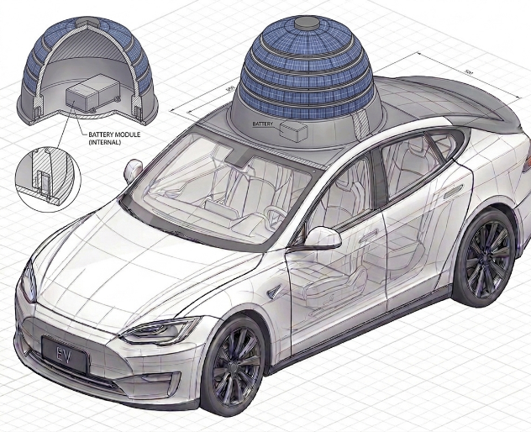
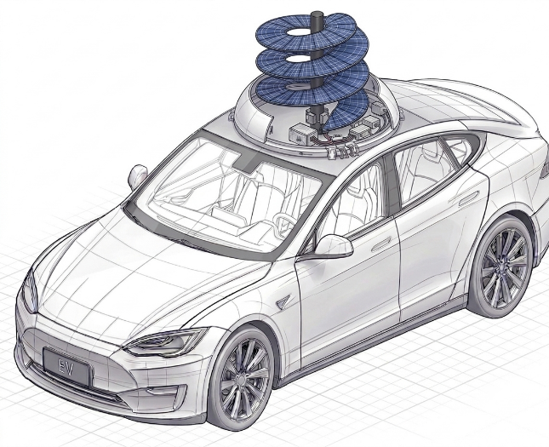

Figure 1. Adaptive Spiral Renewable Energy Harvester – Expanded Configuration
Illustrates the roof-mounted adaptive spiral renewable energy harvester in its fully deployed state for enhanced solar and wind energy harvesting.

Figure 2. Adaptive Dome Renewable Energy Harvester – Retracted Configuration
Illustrates the adaptive harvester in its compact dome configuration for reduced aerodynamic drag while maintaining renewable energy harvesting.

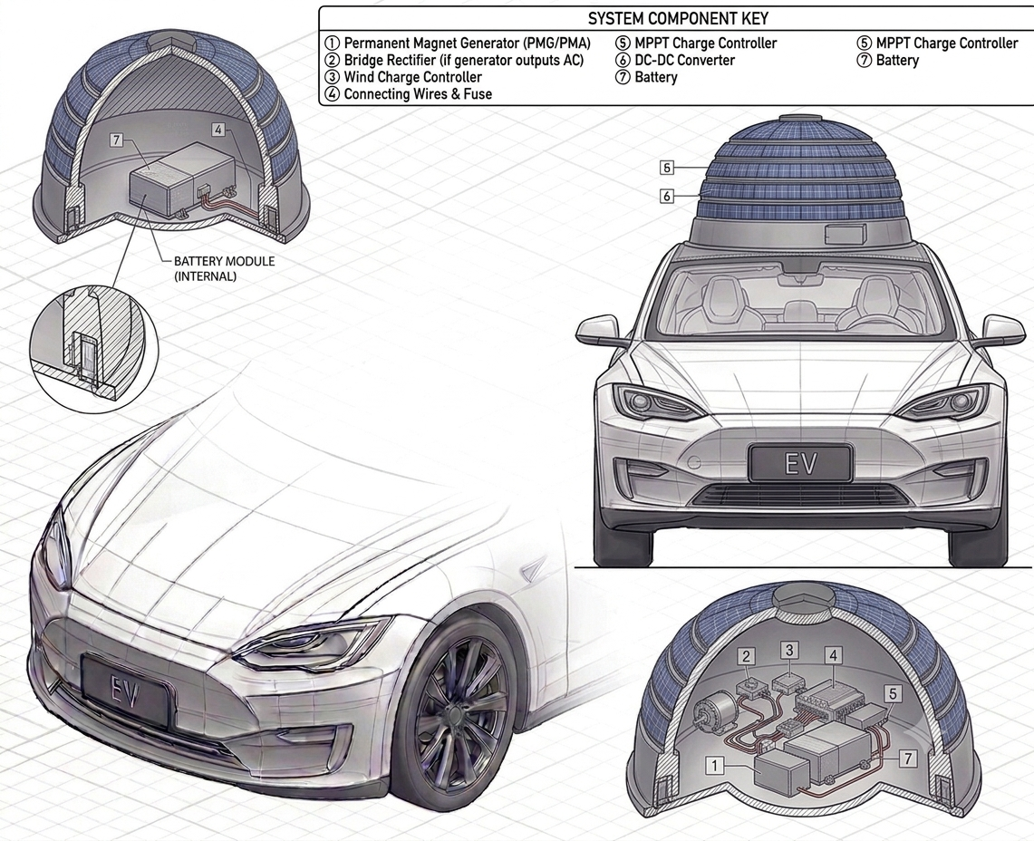
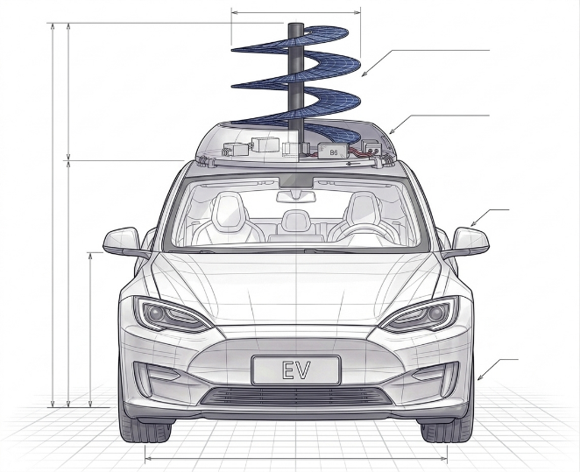

Figure 3. Front View of the Expanded Spiral Configuration
Shows the front elevation of the vehicle with the spiral renewable energy harvester fully deployed. The figure highlights the overall deployment height, central support mast, and spiral photovoltaic arrangement.

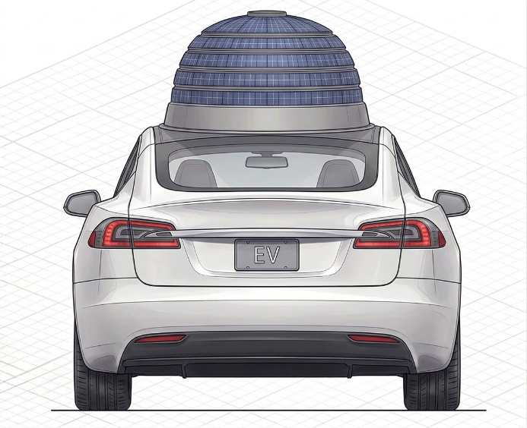
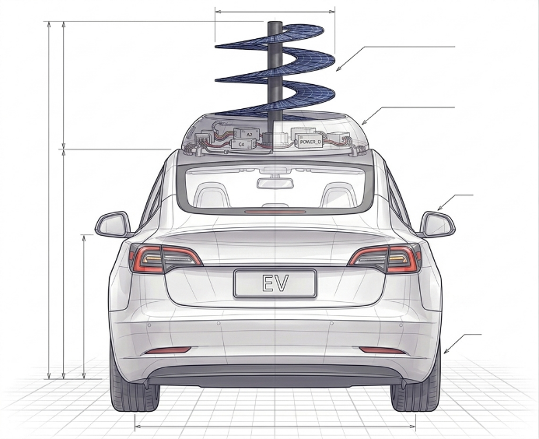

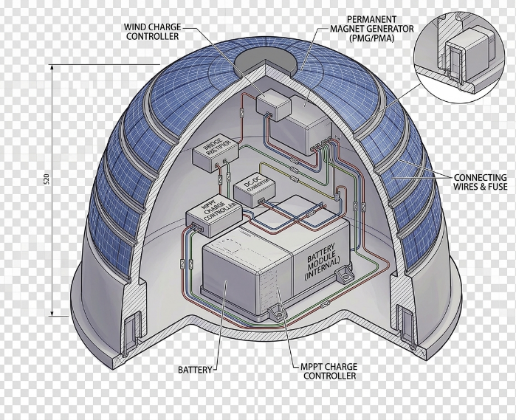
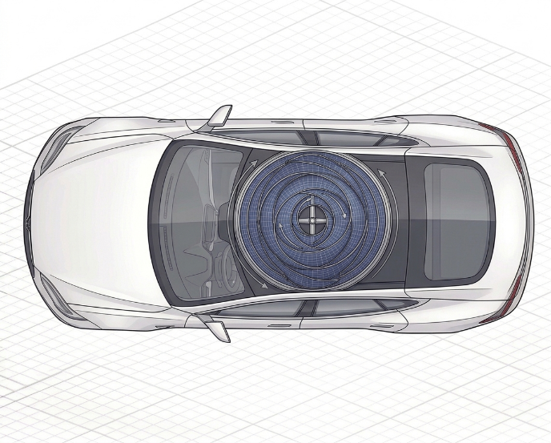
Figure 4. Rear Elevation Views of the Proposed Electric Vehicle
Rear elevation views of the proposed electric vehicle showing the adaptive renewable energy harvesting assembly in the deployed spiral configuration (left) and retracted dome configuration (right). The figure illustrates the adaptive height-control mechanism for renewable energy harvesting and aerodynamic optimization.

Figure 5. Top Plan View of the Proposed Electric Vehicle illustrating the roof-mounted adaptive spiral renewable energy harvesting assembly integrated with the vehicle for simultaneous solar photovoltaic and wind energy collection.

Figure 6. Cross-sectional view of the retractable dome assembly illustrating the internal arrangement of the photovoltaic layers, wind generator, charge controller, battery module, energy management electronics, and electrical interconnections forming the renewable energy harvesting system.
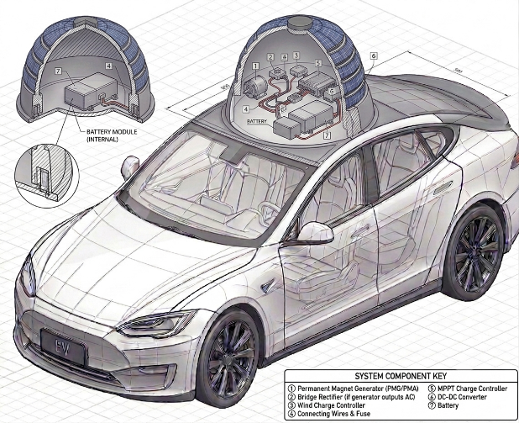
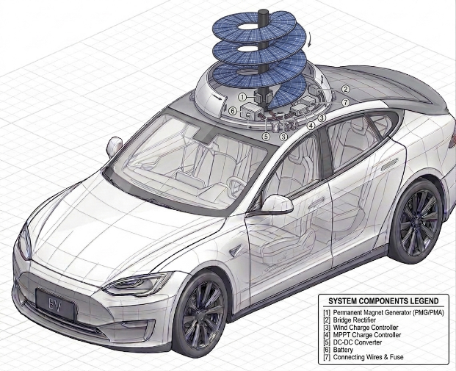

Figure 7. Complete assembly views of the proposed renewable energy harvesting electric vehicle illustrating the integrated architecture of the adaptive spiral solar–wind harvesting system. The left view presents the internal arrangement of the retractable dome assembly, including the battery module, power conversion electronics, generator, and control components, while the right view illustrates the fully deployed spiral photovoltaic–wind harvesting structure with the major system components identified, demonstrating the overall integration of the invention.
The following figures are available and are submitted alongside this disclosure:
- Figure 1 (labeled): Vehicle-integration render showing the spiral solar–wind harvester on the vehicle roof, sunlight and wind-flow directions, and the roof-to-trunk energy path to the Energy Management System (EMS) and secondary battery.
- Figure 2 (labeled): Energy flow block diagram — Solar Energy and Wind Energy inputs → DC–DC Converter → Charge Controller → Secondary Battery → (a) Transfer to Main Battery or (b) Swap for a charged pack.
- Figure 3 (labeled): Five-step battery swap sequence — energy captured while driving → stored in removable battery → removed from vehicle when main battery is low → charged pack inserted → vehicle continues running.
- Figure 4: Screen captures of the live interactive 3D simulation (3D vehicle visualization, live renewable monitoring, dual-battery monitoring, and trip/range planner modules) demonstrating the adaptive-height behaviour at low and high speed.
An unlabeled version of Figures 1–3 (with all text callouts, legends, and numbering removed) can be prepared as a companion image set on request, per patent office formatting requirements.

13. | Brief description from the researcher/inventor in his own words explaining the images/drawings.
The drawings (Figures 1 to 7) illustrate the complete architecture, operating mechanism, and integration of the proposed Adaptive Spiral Solar–Wind Renewable Energy Harvesting System for Electric Vehicles. The figures demonstrate how the invention combines solar energy harvesting, wind energy harvesting, adaptive aerodynamic control, and renewable energy storage into a single intelligent rooftop system for continuous energy generation.
Figures 1 and 2: Overall Renewable Energy Harvesting System
Figures 1 and 2 present the complete vehicle equipped with the adaptive spiral renewable energy harvester in its expanded and retracted configurations. These figures illustrate the dual operating modes of the rooftop assembly. The expanded spiral configuration maximizes solar exposure and wind capture during low-speed operation or vehicle parking, while the dome-shaped retracted configuration minimizes aerodynamic drag during high-speed travel without interrupting renewable energy harvesting.
Figures 3 and 4: Front and Rear Configuration
Figures 3 and 4 illustrate the front and rear elevations of the proposed vehicle. These views demonstrate the adaptive height adjustment mechanism that transforms the spiral structure into a compact dome configuration. The drawings highlight improved vehicle stability, reduced aerodynamic resistance, and optimized renewable energy harvesting under varying driving conditions.
Figure 5: Top View of Spiral Renewable Energy Harvester
Figure 5 illustrates the top layout of the spiral renewable energy harvesting structure mounted on the vehicle roof. The figure shows the spiral photovoltaic arrangement surrounding the central wind generation unit, enabling simultaneous utilization of solar radiation and airflow within a compact rooftop footprint.
Figure 6: Internal Cross-Section of the Renewable Energy Module
Figure 6 presents the sectional view of the renewable energy module. It illustrates the integration of the photovoltaic layers, permanent magnet wind generator, MPPT charge controller, DC–DC converter, battery management circuitry, and dedicated secondary battery. The diagram demonstrates the complete renewable energy conversion and storage pathway.
Figure 7: Complete System Integration
Figure 7 illustrates the fully integrated renewable energy harvesting system mounted on the electric vehicle. The figure combines the adaptive spiral structure, solar photovoltaic modules, wind generation system, power conditioning circuits, and secondary battery into a single coordinated architecture. It demonstrates the interaction of all major components to provide continuous renewable energy harvesting, storage, and battery charging during both stationary and driving conditions.

14. | Please give complete description including the working examples/working methodology of the invention.
The proposed invention operates by integrating an adaptive spiral photovoltaic structure, a vertical-axis wind energy harvesting mechanism, an intelligent height adjustment system, and a dedicated renewable energy storage unit. The system continuously utilizes available solar radiation and natural or vehicle-induced airflow to generate renewable electrical energy while automatically modifying its structure according to vehicle operating conditions.
The following working examples describe the operation of the invention under practical conditions.

Working Example A: Daytime Hybrid Renewable Energy Harvesting
This example illustrates the simultaneous harvesting of solar and wind energy during normal vehicle operation.
Initial State
The electric vehicle is operating during daytime under sunlight. The adaptive spiral renewable energy harvester is deployed into its expanded configuration to maximize energy collection.
Step 1: Solar Energy Collection
The spiral photovoltaic panels continuously absorb solar radiation and convert it into DC electrical energy.
Output:
Electrical power is supplied to the MPPT charge controller for maximum power extraction.

Step 2: Wind Energy Collection
As the vehicle moves, natural wind and vehicle-induced airflow rotate the spiral wind harvesting structure, driving the permanent magnet generator.
Output:
Additional electrical energy is produced simultaneously without requiring any external fuel source.

Step 3: Intelligent Power Conditioning
The electrical outputs from both the photovoltaic array and wind generator are regulated using the MPPT controller and DC–DC converter to maintain stable charging conditions.
Output:
Combined renewable energy is efficiently transferred to the secondary battery.

Step 4: Secondary Battery Charging
The dedicated secondary battery stores only renewable energy generated from the solar and wind harvesting systems.
Output:
Renewable energy storage is increased without affecting the vehicle's primary traction battery.

Step 5: Vehicle Energy Utilization
When additional vehicle energy is required, the stored renewable energy is transferred from the secondary battery to the main battery through the battery management system.
Result
The vehicle receives supplementary renewable energy, extending driving range while reducing dependence on external charging stations.

Working Example B: Adaptive Height Control During Vehicle Operation
This example demonstrates the automatic transformation of the renewable energy harvesting structure according to vehicle speed.
Initial State
The vehicle begins travelling from a stationary condition toward highway speed.

Step 1: Low-Speed Operation
At low vehicle speeds, the spiral harvesting structure remains fully expanded.
Output
Maximum photovoltaic exposure and maximum wind collection area are achieved, increasing renewable energy generation.

Step 2: Medium-Speed Operation
As vehicle speed increases, the electric linear actuator gradually lowers the spiral assembly.
Output
The harvesting structure maintains energy generation while reducing aerodynamic resistance.

Step 3: High-Speed Operation
At highway speed, the spiral structure completely retracts into the dome configuration.
Output
Aerodynamic drag, wind loading, vibration, and structural stress are significantly reduced while renewable energy harvesting continues.

Step 4: Automatic Deployment
When vehicle speed decreases or the vehicle is parked, the actuator automatically extends the spiral structure back to its harvesting position.
Result
The system continuously adapts its geometry to maximize renewable energy generation while maintaining vehicle stability and safety.

Working Example C: Renewable Energy Storage and Battery Swapping
This example demonstrates the flexible utilization of the stored renewable energy.
Initial State
The secondary battery has accumulated renewable energy generated during previous driving and parking periods.

Step 1: Renewable Energy Storage
Solar and wind energy continue charging the dedicated secondary battery independently of the vehicle's main battery.

Step 2: Intelligent Energy Transfer
When the main traction battery reaches a predefined threshold, the Battery Management System transfers stored renewable energy from the secondary battery to the main battery.

Step 3: Optional Battery Replacement
If immediate charging is required, the fully charged secondary battery may be physically replaced with another renewable-energy-charged battery module.

Result
The invention provides two independent methods of utilizing harvested renewable energy:
- Direct transfer to the main traction battery.
- Physical replacement of the charged secondary battery.
This improves vehicle operational flexibility while reducing charging downtime.

15. | Please provide details of experiments conducted / third party validation data if any.
At the current stage, the proposed Adaptive Spiral Solar–Wind Renewable Energy Harvesting System for Electric Vehicles has been validated through concept development, analytical engineering calculations, system-level design, and an interactive HTML-based functional visualization developed by the inventors.
The working methodology, adaptive spiral deployment mechanism, renewable energy harvesting process, aerodynamic height adjustment strategy, and hybrid battery charging architecture were evaluated using engineering principles, mathematical formulations, and software-based visualization.
The current validation includes:
- System architecture verification through AI-assisted conceptual design.
- Functional visualization using an interactive HTML simulation.
- Analytical calculations for solar power generation, wind power generation, aerodynamic drag, charging power, and battery energy flow.
- Verification of the adaptive operating logic under varying vehicle speeds, day/night conditions, weather conditions, and environmental parameters.
At the time of filing, no physical prototype, CAD model, laboratory testing, or third-party validation has been conducted. Experimental validation, structural analysis, aerodynamic testing, and prototype fabrication are planned as part of future development.

16. | Please provide details of any public disclosure done / any publication made.
The proposed Adaptive Spiral Solar–Wind Renewable Energy Harvesting System for Electric Vehicles has been maintained under strict confidentiality by the inventors prior to this patent filing.
The invention, including its adaptive spiral renewable energy harvesting mechanism, intelligent spiral geometry optimization, angular-momentum-inspired adaptive height control, hybrid solar–wind energy harvesting architecture, dual-battery energy management system, and environmental adaptation methodology, has not been published in any journal, conference proceedings, technical magazine, thesis, patent database, website, or other public platform.
The invention has not been publicly demonstrated, commercially disclosed, licensed, or released through any open-source repository or digital platform prior to the filing of this patent application. The HTML-based conceptual visualization and AI-generated conceptual illustrations were developed solely for internal design presentation and invention documentation and have not been made publicly available.
Accordingly, the inventors confirm that no prior public disclosure or publication has been made before the filing date of this invention.

17. | What is the stage/level of development of the Invention?
a. At a basic conceptualization stage?
No. The invention has progressed beyond the basic conceptualization stage and is currently at an advanced conceptual design and system architecture stage (approximately Technology Readiness Level – TRL 2–3).
The development completed to date includes:
- Complete conceptual design of the Adaptive Spiral Solar–Wind Renewable Energy Harvesting System for Electric Vehicles.
- Functional system architecture integrating adaptive spiral deployment, hybrid solar–wind energy harvesting, intelligent environmental adaptation, dual-battery energy management, and adaptive height control.
- Engineering calculations for renewable energy generation, aerodynamic performance, charging methodology, and energy flow.
- Interactive HTML-based functional visualization demonstrating the operating principle under different vehicle speeds, weather conditions, wind conditions, and day/night operation.
- AI-assisted conceptual illustrations prepared to visualize the proposed invention.
The invention is currently ready for detailed engineering design, CAD modelling, prototype fabrication, and experimental validation.

b. Completed and results validated?
No. The invention has not yet reached the prototype validation stage.
At present, the proposed invention has been conceptually validated through:
- Engineering design methodology.
- Mathematical and analytical calculations.
- Functional system architecture.
- Interactive HTML-based simulation demonstrating the complete operational workflow.
- AI-generated conceptual representations illustrating the proposed mechanical configuration.
Physical prototype fabrication, CAD modelling, laboratory testing, aerodynamic analysis, and real-world performance validation are planned as future stages of development following this patent filing.

18. | What are the aspects of your disclosure that you want to claim/monopolize? (Proposed Claims)
INDEPENDENT CLAIM 1 (Adaptive Spiral Hybrid Renewable Energy Harvesting System)
An adaptive renewable energy harvesting system for an electric vehicle comprising:
- a) A retractable spiral structure integrated with photovoltaic panels configured to harvest solar energy and vehicle-induced wind energy simultaneously;
- b) A height-adjustable spiral mechanism capable of extending or retracting according to vehicle operating conditions;
- c) A hybrid renewable energy management system configured to collect, regulate, and store electrical energy generated from both solar and wind sources into a secondary battery; and
- d) An intelligent controller configured to continuously optimize renewable energy harvesting based on real-time environmental and vehicle parameters.

DEPENDENT CLAIM 2 (Adaptive Spiral Geometry Optimization)
The system as claimed in Claim 1, wherein an adaptive optimization engine automatically generates and evaluates multiple spiral geometries based on vehicle speed, ambient wind speed, weather conditions, geographic location, and time of day, and selects the configuration providing maximum renewable energy harvesting with minimum aerodynamic drag.

DEPENDENT CLAIM 3 (Dynamic Height Control using Angular Momentum)
The system as claimed in Claim 1, wherein the spiral harvesting structure automatically adjusts its height according to vehicle speed based on the principle of conservation of angular momentum, thereby maintaining rotational stability, reducing aerodynamic resistance, and improving renewable energy harvesting efficiency.

DEPENDENT CLAIM 4 (Adaptive Environmental Operation)
The system as claimed in Claim 1, wherein the controller automatically switches between solar harvesting, wind harvesting, or hybrid harvesting according to real-time weather conditions, geographical location, daylight availability, seasonal variations, and ambient environmental parameters.

DEPENDENT CLAIM 5 (Machine Learning-Based Energy Prediction)
The system as claimed in Claim 1, wherein a machine learning module predicts renewable energy generation, battery charging behavior, harvesting efficiency, and optimal spiral configuration using historical operating data, environmental conditions, and real-time sensor information.

DEPENDENT CLAIM 6 (Dual-Battery Intelligent Energy Management)
The system as claimed in Claim 1, wherein a dual-battery management system prioritizes renewable energy charging to a secondary battery and intelligently transfers stored energy to the primary electric vehicle battery while monitoring charging efficiency, battery health, and power availability.

DEPENDENT CLAIM 7 (Retractable Dome Configuration)
The system as claimed in Claim 1, wherein the spiral renewable harvesting structure automatically transforms between an expanded spiral configuration and a compact dome-shaped configuration to improve vehicle aerodynamics, structural safety, and operational efficiency during different driving conditions.

DEPENDENT CLAIM 8 (Integrated Renewable Energy Management Platform)
The system as claimed in Claim 1, wherein all renewable energy harvesting, adaptive spiral control, aerodynamic optimization, environmental sensing, energy prediction, battery management, and real-time operating decisions are integrated into a single intelligent control platform for autonomous renewable energy optimization.

19. | Have you conducted novelty/inventiveness search for your invention?  If yes, what are the databases/references used by you? What are the search results?
Yes. A preliminary keyword-based novelty search was conducted using publicly available patent and academic databases to assess the uniqueness of the proposed invention.
1. Databases and References Consulted
- Google Patents
- WIPO PATENTSCOPE
- USPTO Patent Database
- EPO Espacenet
- Google Scholar
2. Search Results and Analysis
The preliminary search identified existing technologies related to electric vehicles, vehicle-mounted solar panels, wind energy harvesting systems, hybrid renewable energy systems, retractable photovoltaic structures, intelligent battery management systems, and renewable energy optimization methods. However, no identical invention was identified that combines all the essential features proposed in the present invention.
The proposed invention integrates the following features into a single renewable energy harvesting system:
- Adaptive spiral solar photovoltaic structure for electric vehicles.
- Retractable spiral mechanism capable of transforming into a compact dome configuration.
- Simultaneous harvesting of solar energy, vehicle-induced wind energy, and ambient wind energy using a single integrated structure.
- Adaptive height adjustment of the spiral harvesting structure according to vehicle operating conditions for improved aerodynamic performance and energy capture.
- Intelligent optimization of the spiral geometry based on vehicle speed, wind speed, solar irradiance, weather conditions, and operating environment.
- Machine learning-assisted prediction of renewable energy generation and charging performance.
- Dual-battery energy management for efficient storage and utilization of harvested renewable energy.
Conclusion
The preliminary search indicates that although several individual technologies associated with solar-powered vehicles, wind energy harvesting, retractable photovoltaic systems, and intelligent energy management are available in the existing literature and patent databases, no identical prior art was identified that discloses the integrated adaptive spiral solar–wind renewable energy harvesting architecture together with adaptive structural optimization, machine learning-based energy prediction, and intelligent dual-battery management for electric vehicles.
Accordingly, the proposed invention appears to provide a potentially novel and non-obvious integrated renewable energy harvesting system. The final determination of novelty and inventiveness will be made by the patent office during the patent examination process.

20. | Do you feel that a person of “average” skill (not extraordinary skill) in your area of technology would have arrived at your invention with existing knowledge in the public domain?  If no, what could be the reasons for the same?
No. It is believed that a person having ordinary skill in the fields of electric vehicles, renewable energy systems, or automotive engineering would not readily arrive at the present invention using existing public-domain knowledge. Although individual technologies such as solar panels, wind energy harvesting, battery management systems, and electric vehicles are known, the present invention integrates these technologies in a unique and functionally coordinated manner to improve renewable energy harvesting efficiency.
Reason 1: Integrated Adaptive Spiral Renewable Energy Architecture
Existing renewable energy systems generally employ flat photovoltaic panels or independent wind turbines. The present invention introduces an adaptive spiral photovoltaic structure that simultaneously harvests solar energy and vehicle-induced as well as ambient wind energy through a single integrated mechanism. This coordinated architecture is not an obvious extension of conventional renewable energy systems.
Reason 2: Adaptive Structural Reconfiguration
Conventional vehicle-mounted renewable energy systems are generally fixed in geometry during operation. The proposed invention incorporates a retractable spiral-to-dome configuration with adaptive height adjustment, allowing the harvesting structure to dynamically respond to vehicle speed and environmental conditions while balancing aerodynamic performance and renewable energy generation.
Reason 3: Intelligent Renewable Energy Optimization
The invention combines multiple operating parameters, including vehicle speed, wind speed, solar irradiance, weather conditions, and environmental factors, to optimize the harvesting structure in real time. Furthermore, machine learning-assisted energy prediction and intelligent charging strategies improve overall renewable energy utilization. Such an integrated optimization framework is not typically found in existing vehicle-mounted renewable energy systems.
Reason 4: Unified Energy Harvesting and Battery Management
Instead of treating solar harvesting, wind harvesting, and battery charging as separate subsystems, the invention provides a single coordinated renewable energy management architecture incorporating hybrid energy harvesting, intelligent power distribution, and dual-battery management to maximize charging efficiency and energy availability.

21. | Kindly provide broad workable ranges for all the parameters involved in your invention.
To ensure broad patent protection for the Adaptive Spiral Solar–Wind Renewable Energy Harvesting System for Electric Vehicles and to enable implementation across different electric vehicle platforms and environmental conditions, the invention is operable within the following engineering ranges.
1. Adaptive Retractable Spiral Renewable Energy Structure
- Spiral Structure Diameter: 0.5 m to 2.5 m.
- Spiral Structure Height: 0.3 m to 2.0 m.
- Number of Spiral Photovoltaic Layers: 2 to 12 layers.
- Gap Between Adjacent Spiral Layers: 5 mm to 100 mm to facilitate aerodynamic rotation and minimize friction.
- Spiral Rotation Speed: 20 RPM to 600 RPM depending on wind velocity.
- Automatic Deployment/Retraction Time: 2 seconds to 20 seconds.
- Spiral Operating Angle: 10° to 90° based on solar irradiance and vehicle operating conditions.

2. Hybrid Solar Energy Harvesting Parameters
- Solar Panel Capacity: 50 W to 1000 W.
- Solar Panel Conversion Efficiency: 15% to 35%.
- Operating Solar Irradiance: 200 W/m² to 1200 W/m².
- Output Voltage: 12 V DC to 800 V DC.
- MPPT Controller Efficiency: 90% to 99%.

3. Wind Energy Harvesting Parameters
- Operating Wind Speed: 2 m/s to 30 m/s.
- Wind Generator Speed: 100 RPM to 3000 RPM.
- Wind Generator Output: 20 W to 1000 W.
- Electrical Conversion Efficiency: 40% to 90%.

4. Intelligent Energy Management and Control Parameters
- Vehicle Speed Detection Range: 0 km/h to 150 km/h.
- Wind Speed Monitoring Range: 0 m/s to 35 m/s.
- Solar Irradiance Detection Range: 0 W/m² to 1500 W/m².
- Battery State-of-Charge Monitoring: 0% to 100%.
- Adaptive Deployment Response Time: 100 milliseconds to 5 seconds.
- Energy Source Switching Time: 100 milliseconds to 2 seconds.

5. Battery Charging and Energy Storage Parameters
- Battery Capacity: 5 kWh to 100 kWh.
- Battery Operating Voltage: 48 V to 800 V.
- Charging Current: 2 A to 100 A.
- Charging Efficiency: 80% to 98%.
- Hybrid Renewable Power Output: 100 W to 1500 W.

6. Machine Learning-Based Optimization Parameters
- Sensor Sampling Interval: 0.5 seconds to 10 seconds.
- Optimization Update Interval: 1 second to 60 seconds.
- Prediction Accuracy: 70% to 99%.
- Input Parameters: Vehicle speed, wind speed, solar irradiance, battery state-of-charge, ambient temperature, and environmental conditions.

7. Mechanical and Environmental Operating Parameters
- Vehicle Operating Speed: 0 km/h to 150 km/h.
- Operating Temperature: –20°C to 70°C.
- Relative Humidity: 10% to 95%.
- Operating Altitude: Sea level to 5000 m.
- Structural Load Capacity: 5 kg to 100 kg.
- Construction Materials: Aluminum alloy, carbon fiber composite, reinforced polymer composites, stainless steel, or equivalent lightweight structural materials.

22. | Commercialization Data  (at least a minimum of 2 companies must be provided and preferably up to 5)
- Companies that may be interested in commercial manufacture of this technology:
1. Tata Motors Limited
Why them: India's leading electric vehicle manufacturer with a strong focus on sustainable mobility. The proposed adaptive spiral solar–wind energy harvesting system can be integrated into future passenger and commercial electric vehicles.
Address:
Bombay House,
24 Homi Mody Street,
Fort, Mumbai – 400001,
Maharashtra, India.

2. Mahindra & Mahindra Limited (Automotive Division)
Why them: One of India's largest automobile manufacturers and a major developer of electric mobility solutions. The invention can enhance onboard renewable energy generation and battery charging efficiency in future EV platforms.
Address:
Mahindra Towers,
Dr. G. M. Bhosale Marg,
P.K. Kurne Chowk,
Worli,
Mumbai – 400018,
Maharashtra, India.
Reason: "Mahindra Electric Automobile Limited" was merged into Mahindra & Mahindra Ltd., so using the parent company is more appropriate.

3. Hyundai Motor India Limited
Why them: Developer of advanced electric vehicles and sustainable automotive technologies. The proposed renewable energy harvesting system can improve onboard energy utilization.
Address:
Plot No. H-1,
SIPCOT Industrial Park,
Irrungattukottai,
Sriperumbudur – 602117,
Tamil Nadu,
India.

4. Bosch Limited
Why them: Global leader in automotive electronics, battery management systems, electric powertrain technologies, and intelligent mobility solutions. The proposed system aligns with Bosch's future mobility initiatives.
Address:
Bosch Limited,
Post Box No. 3000,
Hosur Road,
Adugodi,
Bengaluru – 560030,
Karnataka,
India.
This is Bosch Limited's registered corporate office address.

5. Uno Minda Limited
Why them: Leading manufacturer of automotive electronics, sensors, switches, and EV components. The adaptive renewable energy controller and charging electronics can be integrated into future electric vehicles.
Address:
Village Nawada Fatehpur,
P.O. Sikanderpur Badda,
IMT Manesar,
Gurugram – 122004,
Haryana,
India.

b. Marketing profile:
Adaptive Spiral Solar–Wind Renewable Energy Harvesting System for Electric Vehicles
The present invention introduces an integrated renewable energy harvesting system that combines adaptive spiral solar panels, vertical-axis wind energy generation, intelligent deployment mechanism, and battery charging control into a single vehicle-mounted architecture.
Unlike existing electric vehicles that rely almost entirely on external charging stations or fixed rooftop solar panels, the proposed invention continuously harvests renewable energy while the vehicle is stationary or in motion.
Key Technical Advantages
- Simultaneous harvesting of solar and wind energy using a single integrated structure.
- Adaptive retractable spiral mechanism that automatically deploys and folds based on operating conditions.
- Rotating spiral structure capable of utilizing airflow generated during vehicle motion.
- Intelligent charging controller for efficient power conversion and battery charging.
- Compact integrated design requiring no external charging infrastructure during renewable energy harvesting.
- Reduced dependence on grid charging, resulting in improved vehicle range and lower operating cost.
- Suitable for passenger EVs, commercial vehicles, emergency vehicles, and autonomous transportation platforms.
Commercial Opportunity
The invention has significant commercialization potential within the rapidly growing electric vehicle and renewable energy sectors. It can be integrated into existing or future EV platforms as an onboard renewable charging solution, offering manufacturers a differentiated sustainable technology while improving vehicle energy efficiency and extending battery operating time. The technology is scalable for automotive manufacturers, EV component suppliers, public transportation systems, defense vehicles, and smart mobility applications.

23. | Provide available data or information on market potential/size, adoption trends, industry analysis, and projected growth.

24. | Please provide the names of the inventors involved in the Invention
- Kirankumar R(23BEC1365)
- Dr. Sukriti (53061)

25. | User Information
Name : Kirankumar R
Gender : Male
Nationality : Indian
Address : Student, School of Electronics Engineering, Vellore Institute of Technology, Chennai, Tamil Nadu

Name : Dr. Sukriti
Gender : Female
Nationality : Indian
Address : Assistant Professor, School of Electronics Engineering, Vellore Institute of Technology Chennai, Tamil Nadu

26. | What is Technology readiness level of your invention? (Tick the appropriate TRL)

27. | Any additional notes or remarks.

