Applicant: Kiran No. of Sheets: 4
Application No: Sheet No: 1 of 4

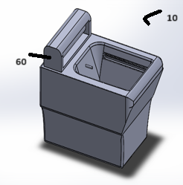

Fig 1

Albert Francis
Applicant Agent (INPA – 4655)

Applicant: Kiran No. of Sheets: 4
Application No: Sheet No: 2 of 4

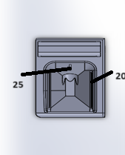

Fig 2

Albert Francis
Applicant Agent (INPA – 4655)

Applicant: Kiran No. of Sheets: 4
Application No: Sheet No: 3 of 4

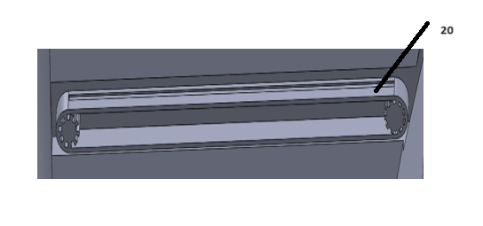

Fig 3

Albert Francis
Applicant Agent (INPA – 4655)

Applicant: Kiran No. of Sheets: 4
Application No: Sheet No: 4 of 4

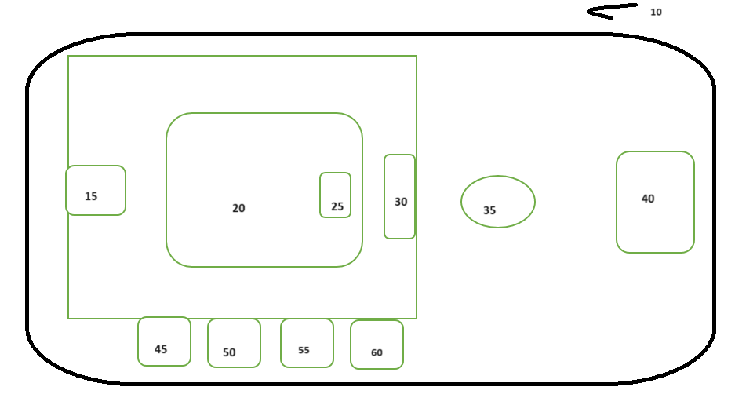

Fig 4

Albert Francis
Applicant Agent (INPA – 4655)

